Final Project Report

Community Food Wastage Reduction Portal



Project Supervisor
Hasnain Ahmed

Submitted By

S26PROJECT51921

Mohammad Ashir bc220408429

Software Projects & Research Section,
Department of Computer Sciences,
Virtual University of Pakistan


CERTIFICATE

This is to certify that Mohammad Ashir (bc220408429) have worked on and completed their Software Project at Software & Research Projects Section, Department of Computer Sciences, Virtual University of Pakistan in partial fulfillment of the requirement for the degree of BS in Computer Sciences under my guidance and supervision.

In our opinion, it is satisfactory and up to the mark and therefore fulfills the requirements of BS in Computer Sciences.

Supervisor / Internal Examiner

Hasnain Ahmed
Supervisor,
Software Projects & Research Section,
Department of Computer Sciences
Virtual University of Pakistan

___________________
(Signature)

External Examiner/Subject Specialist
<<External Supervisor Name>>

___________________
(Signature)

Accepted By:

_____________
(For office use)

EXORDIUM

In the name of Allah, the Compassionate, the Merciful.

Praise be to Allah, Lord of Creation,
The Compassionate, the Merciful,
King of Judgment-day!

You alone we worship, and to You alone we pray for help,
Guide us to the straight path

The path of those who You have favored,

Not of those who have incurred Your wrath,
Nor of those who have gone astray.

DEDICATION

I dedicate this project to my beloved parents, whose endless prayers, sacrifices, and unconditional support have made every milestone of my education possible. I also dedicate this work to my teachers and siblings for constantly motivating me to strive for excellence.

ACKNOWLEDGEMENT

All praises and thanks are due to Almighty Allah, the Most Merciful and the Most Gracious, for granting me the health, patience, and knowledge to complete this Final Year Project successfully.
I would like to express my deepest gratitude to my project supervisor, Hasnain Ahmed, for their valuable guidance, constructive feedback, and continuous encouragement throughout every phase of this project. Their technical insights and timely reviews were instrumental in turning this idea into a working system. Finally, I am thankful to the Department of Computer Science at the Virtual University of Pakistan and my family for their constant support during my academic journey.

PREFACE

This report has been prepared in partial fulfillment of the requirements for the degree of Bachelor of Science in Computer Science at the Virtual University of Pakistan. It documents the complete analysis, design, development, and testing phases of Community Food Wastage Reduction Portal.
The primary goal of this project is to connects donors (restaurants and kitchens) with verified NGOs so surplus food is posted, found nearby, claimed, and tracked to delivery—cutting waste and giving staff one place to handle listings, NGO checks, and basic admin reports Throughout this document, readers will find the Software Requirement Specification (SRS), system architecture, database design, implementation details, and testing results that demonstrate the functionality and reliability of the final deliverable

TABLE OF CONTENTS

1.1 Introduction 9
1.2 Purpose 9
1.3 Scope 9
1.4 Definitions, acronyms and abbreviations 9
1.5 Project requirements 9
1.5.1 Functional requirements 9
1.5.2 Non-functional requirements 10
1.6 Use cases and usage scenarios 10
1.6.1 Use case diagram 10
1.6.2 Usage scenarios 11
1.7 Development methodology 12
1.7.1 Chosen methodology 12
1.7.2 Reasons for chosen methodology 12
1.7.3 Work plan (Gantt chart) 12
1.7.4 Project schedule (submission calendar) 12
2.1 Introduction 14
2.2 Purpose 14
2.3 Scope 14
2.4 Definitions 14
2.5 Architectural representation 14
2.6 Dynamic model: sequence diagrams 15
2.7 Object model / logical model (classes) 18
2.8 Database model 19
2.9 Graphical user interfaces 20
2.9.1 Home Screen 20
2.9.2 Donor Dashboard 20
2.9.3 Register Donor 21
2.9.4 Donor: Post Food 22
2.9.5 Donor: My Listing 22
2.9.6 Admin: Moderate Food – View Pending 23
2.9.7 Admin: Moderate Food – Approve 23
2.9.8 Register NGO 24
2.9.9 NGO: Upload Verification Docs 25
2.9.10 Admin: View Pending Verifications 25
2.9.11 Admin: Approve Pending Verifications 26
2.9.12 NGO: Find Food Near Me 26
2.9.13 NGO: Claimed Foods 27
2.9.14 Donor: Deliver marked for Claimed Listing 27
2.9.15 Admin: Reports 28
3.1 Development plan (Architecture Diagram) 30
3.2 Development plan and implementation 30
3.2.1 Environment and database 30
3.2.2 Authentication module 30
3.2.3 Donor module 30
3.2.4 Recipient module 31
3.2.5 Admin and volunteer module 31
3.2.6 Notifications and feedback 31
3.2.7 Testing 31
3.2.8 Sample code (atomic claim) 31

CHAPTER 1
Gathering & Analyzing Info

1.1 Introduction
Cities produce a large amount of surplus food from restaurants, hotels, events, and households. At the same time, NGOs and community kitchens often lack enough food for people in need. Donors and receivers rarely find each other in time, so edible food expires and is thrown away. The Community Food Wastage Reduction Portal is a web portal that connects donors who have extra food with NGO recipients who can collect it before the best-before time. The system also supports admin reporting, user verification, listing moderation, dashboard notifications, volunteer pickup tasks, and feedback after delivery.

1.2 Purpose
This chapter records how requirements were gathered and analysed for the portal. It states what the system must do for donors, recipients, volunteers, and admins, and how development was planned using the Virtual University process model.

1.3 Scope
In scope: registration and login for donor, recipient, volunteer, and admin; food listings with category, quantity, expiry, and optional photo; GPS and city search; atomic claim so only one NGO gets each listing; status flow AVAILABLE → CLAIMED → DELIVERED (and EXPIRED when time runs out); notifications; NGO document upload and admin approval; admin user block/unblock and listing moderation; reports and CSV export; PHPUnit tests for search and concurrent claim.
Out of scope for this version: paid delivery integration, native mobile apps, multi-language UI, and email/SMS alerts (dashboard alerts are implemented instead).

1.4 Definitions, acronyms and abbreviations
Listing — One food offer stored in the food_listings table.
Donor — User with role donor who posts surplus food.
Recipient / NGO — User with role recipient who searches and claims food.
Volunteer — User who sees pickup tasks and can mark delivery complete.
Admin — Portal operator with reports and moderation tools.
Claim — Recipient reserves a listing; status becomes CLAIMED.
Haversine formula — SQL distance calculation using latitude and longitude.
SRS — Software Requirements Specification.
ERD — Entity–relationship diagram.
CSV — Comma-separated values file for report export.

1.5 Project requirements

1.5.1 Functional requirements
User Management

ID | Requirement
FR-01 | System shall allow Donor, Receiver/NGO, and Volunteer to register with basic details (name, email, password, role).
FR-02 | System shall allow all users to login and logout securely.
FR-03 | System shall support role-based access (donor sees donor features, NGO sees claim features, etc.).
FR-04 | Admin shall manage user accounts (approve, block, or update NGO/donor verification status).
FR-05 | NGO users may upload verification documents during or after registration (admin reviews).

2.2 Donation Listing (Donor)

ID | Requirement
FR-06 | Donor shall post a food listing with item name, category (Veg/Non-Veg), quantity (kg or servings), best-before time, pickup address, and optional photo.
FR-07 | Donor shall edit or delete their own active listings.
FR-08 | Donor shall view all their past and current donations on a dashboard.
FR-09 | Donor shall see pickup status (Available, Claimed, Picked Up / Delivered).
FR-10 | New listings shall go to admin for moderation before or after going live (based on project setup).

2.3 Search & Claim (Receiver / NGO)

ID | Requirement
FR-11 | Receiver shall search available food by city, area, or nearby location.
FR-12 | Receiver shall view listing details (food type, quantity, expiry, donor location).
FR-13 | Receiver shall claim an available listing so no other NGO can claim the same one.
FR-14 | Receiver shall update pickup status after collection.
FR-15 | Receiver shall view claim history.

2.4 Volunteer Module

ID | Requirement
FR-16 | Volunteer shall view assigned pickup/delivery tasks.
FR-17 | Volunteer shall update delivery task status (e.g. in progress, completed).
FR-18 | Volunteer shall view basic route/location info for pickup (map or address list).

2.5 Admin Module

ID | Requirement
FR-19 | Admin shall login to admin dashboard.
FR-20 | Admin shall moderate food listings (approve, reject, or remove).
FR-21 | Admin shall manage users (view, verify, block).
FR-22 | Admin shall view reports (total donations, claims, deliveries, city-wise stats).
FR-23 | Admin shall handle basic disputes between donor and receiver (notes or status update).

2.6 System / Automated Features

ID | Requirement
FR-24 | System shall automatically mark expired listings as unavailable when best-before time passes.
FR-25 | System shall send notification when new food is posted near an NGO area.
FR-26 | System shall send notification when pickup status is updated.
FR-27 | System shall generate report data for admin (from stored history).
FR-28 | Receiver may submit simple feedback/rating after pickup (optional trust feature).

1.5.2 Non-functional requirements
ID | Category | Requirement
NFR-01 | Performance | Main pages (login, search, dashboard) should load within 3–5 seconds on normal internet.
NFR-02 | Security | Passwords must be stored hashed; only logged-in users access their role features.
NFR-03 | Usability | UI should be simple and easy for non-technical users (clear buttons, readable forms).
NFR-04 | Reliability | System should keep donation status consistent (once claimed, others cannot claim same listing).
NFR-05 | Availability | Portal should be usable during normal hours; basic uptime target for demo/deployment phase.
NFR-06 | Scalability | Design should support more users/listings without major code rewrite (normal DB indexing).
NFR-07 | Compatibility | Web app should work on common browsers (Chrome, Edge, Firefox) and mobile screen sizes.
NFR-08 | Maintainability | Code should be modular (separate routes for donor, NGO, admin) with short comments on functions.
NFR-09 | Data Integrity | Donation records must not be lost after claim or delivery update; history kept for reports.
NFR-10 | Privacy | User documents (NGO verification) visible only to admin, not public.

1.6 Use cases and usage scenarios

1.6.1 Use case diagram
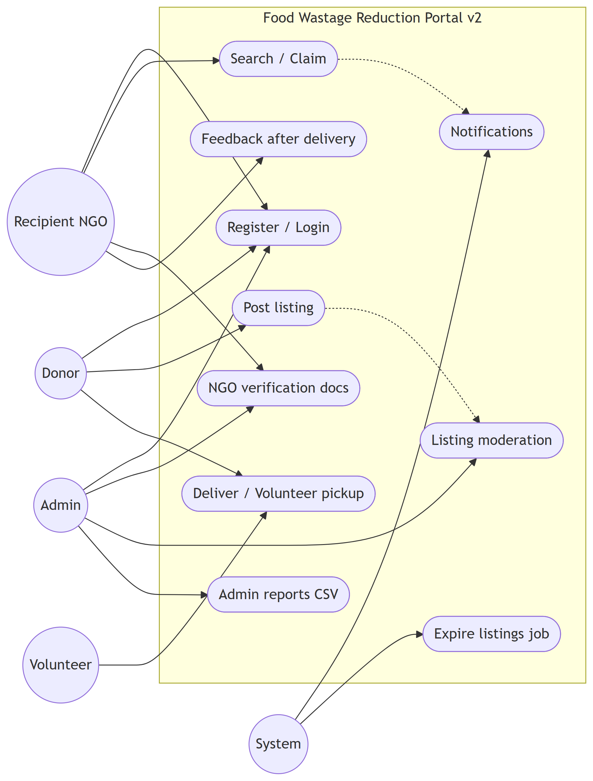
Figure 1.1 — Use case diagram (Community Food Wastage Reduction Portal v2)

Actors are Donor, Recipient (NGO), Admin, Volunteer, and System. Donors post and manage listings; recipients search and claim; admins verify users and view reports; volunteers complete pickup tasks; the system expires stale listings on a schedule.

1.6.2 Usage scenarios
UC-Post-Listing: A logged-in donor opens Post donation, enters food details and best-before time, and submits. The listing is stored with pickup coordinates from the donor profile. If moderation is on, admin approves it before it appears in search. Nearby NGOs get a dashboard notification.
UC-Search-Claim: A recipient opens Search food, enters map location or city, and runs search. The system returns available listings sorted by distance. The recipient claims one listing; a conditional database update ensures only one claim succeeds if two users try at once.
UC-Deliver: After pickup, the donor or volunteer marks the listing DELIVERED. The recipient can leave feedback. Meals-saved estimate updates on the donor dashboard.
UC-Admin-Report: Admin opens Reports, picks a date range, views trends and leader tables, and exports a CSV file for submission or analysis.
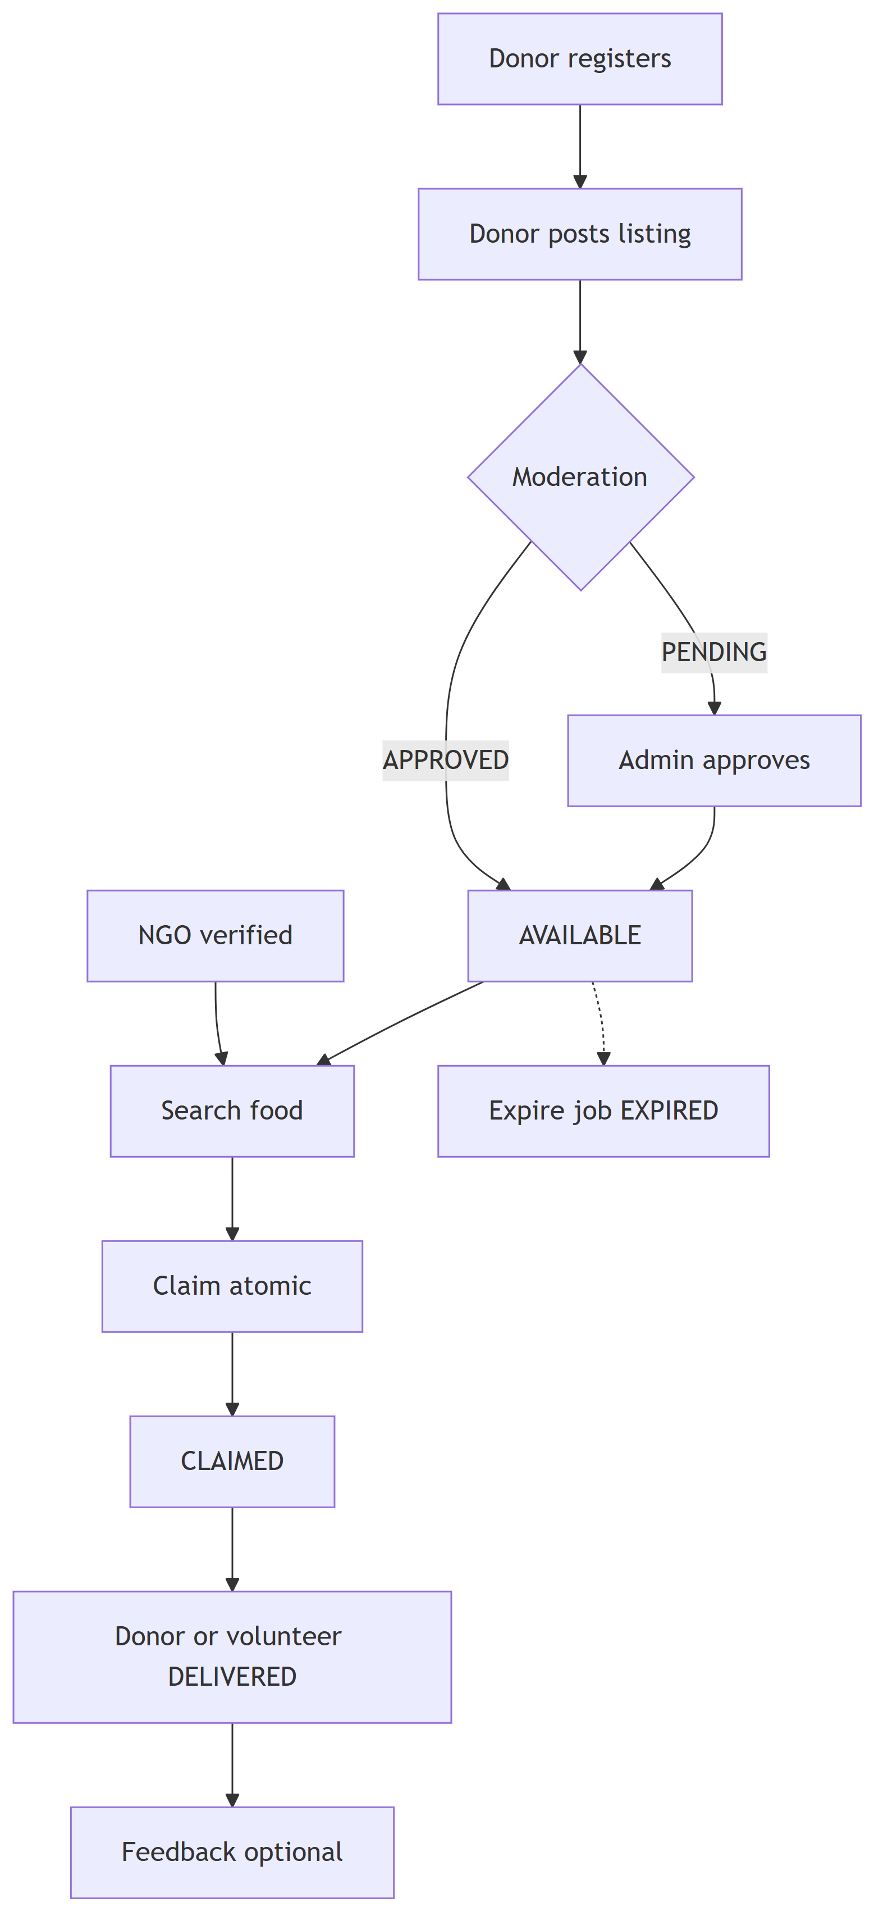
Figure 1.2 — End-to-end activity flow

1.7 Development methodology

1.7.1 Chosen methodology
The Virtual University Process Model was used. It combines structured documentation (like Waterfall) with review steps (like Spiral) so each phase produces a clear deliverable before coding continues.

1.7.2 Reasons for chosen methodology
Agile and RAD focus less on formal SRS and design documents required for IT601P. Pure Waterfall is hard to adjust after supervisor feedback. The VU model fits a small student team: SRS first, then design diagrams, then incremental development and testing.

1.7.3 Work plan (Gantt chart)
Work was split into: (1) SRS and environment setup, (2) design diagrams and database, (3) auth module, (4) donor listings, (5) search and claim, (6) admin reports, (7) portal extensions (notifications, verification, volunteer, moderation), (8) testing and final report. A detailed WBS with durations is in Documentation/Markdown/SRS-sections.md section 7; paste your MS Project Gantt screenshot here before submission.

1.7.4 Project schedule (submission calendar)
Align task dates with your VULMS calendar: SRS and design early in the semester, working prototype before mid-term review, full portal and tests before final zip upload (application + report + presentation in one folder).

CHAPTER 2
Designing the Project

2.1 Introduction
This chapter explains how the portal was designed: three-tier architecture, database schema, listing state machine, interaction sequences, and main UI screens.

2.2 Purpose
To show how user requirements map to architecture, data model, and screens before implementation.

2.3 Scope
Design covers the Laravel + Blade + MySQL system as built in this repository, not a separate mobile app.

2.4 Definitions
Same terms as Chapter 1. MVC means Model–View–Controller pattern used by Laravel.

2.5 Architectural representation
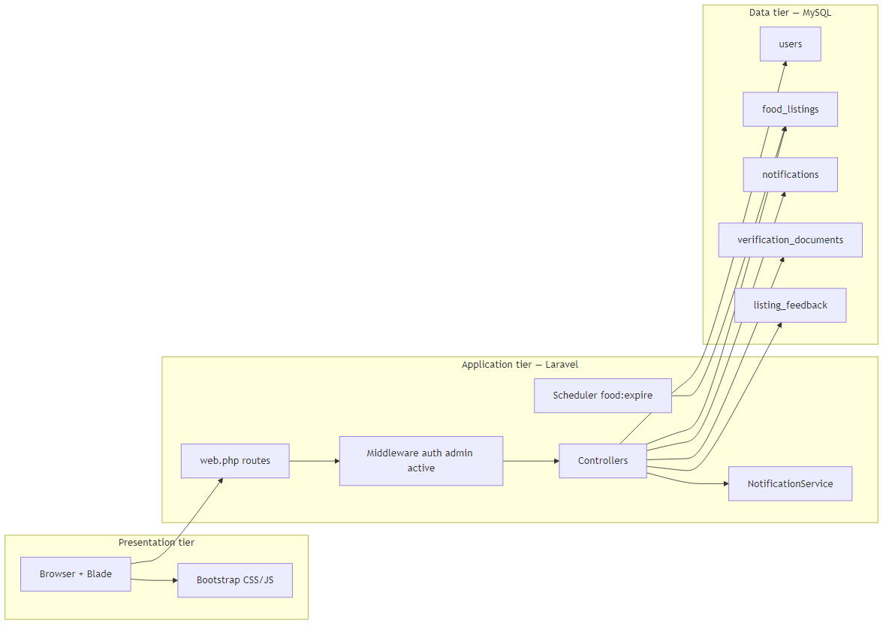
Figure 2.1 — Three-tier system architecture

Users access Blade views in the browser. Laravel routes requests through middleware (auth, admin, active user) to controllers. Eloquent models read and write MySQL tables. The scheduler runs food:expire hourly. The same web.php routes can return HTML or JSON.

2.6 Dynamic model: sequence diagrams
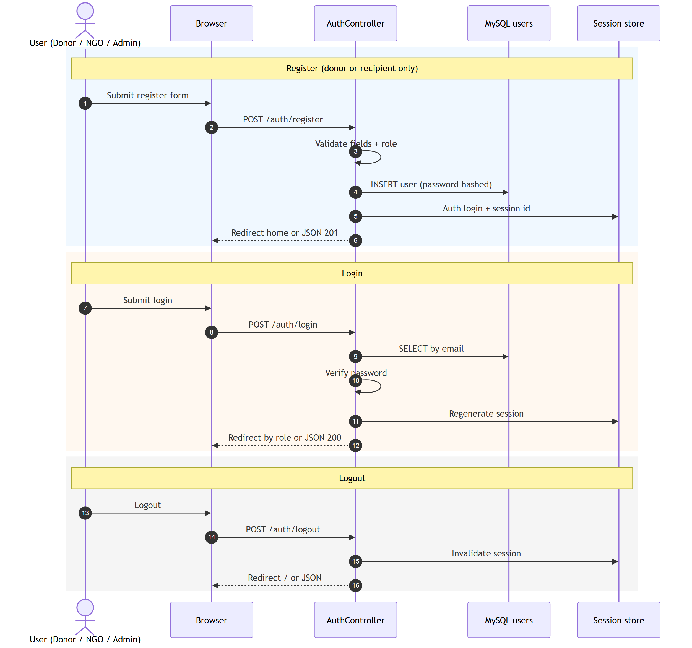
Figure 2.2 — Register and login sequence

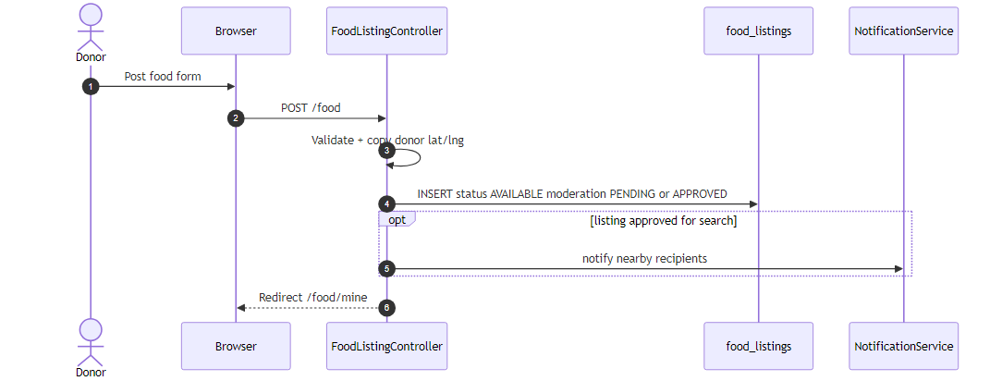
Figure 2.3 — Post food listing

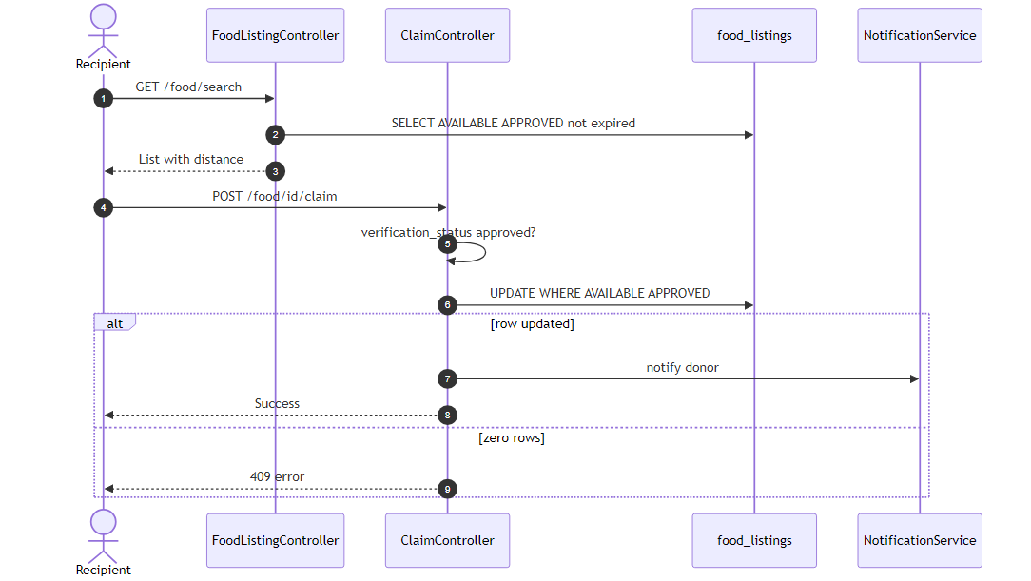
Figure 2.4 — Search and claim (race-safe update)

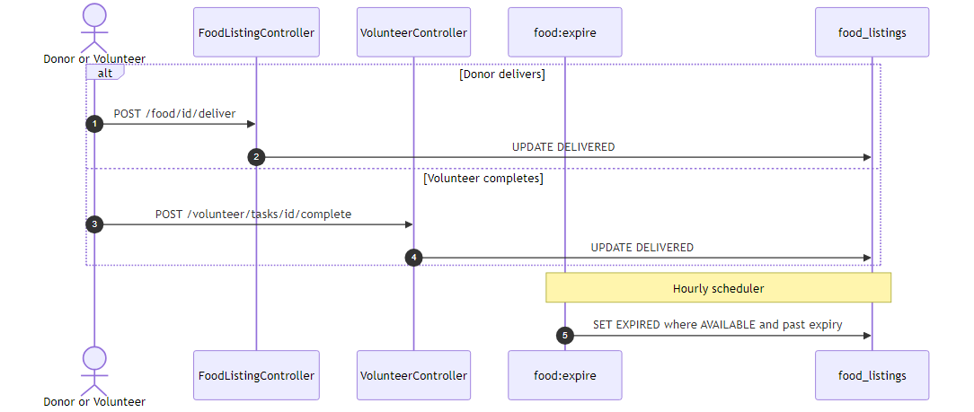
Figure 2.5 — Mark delivered and expire job

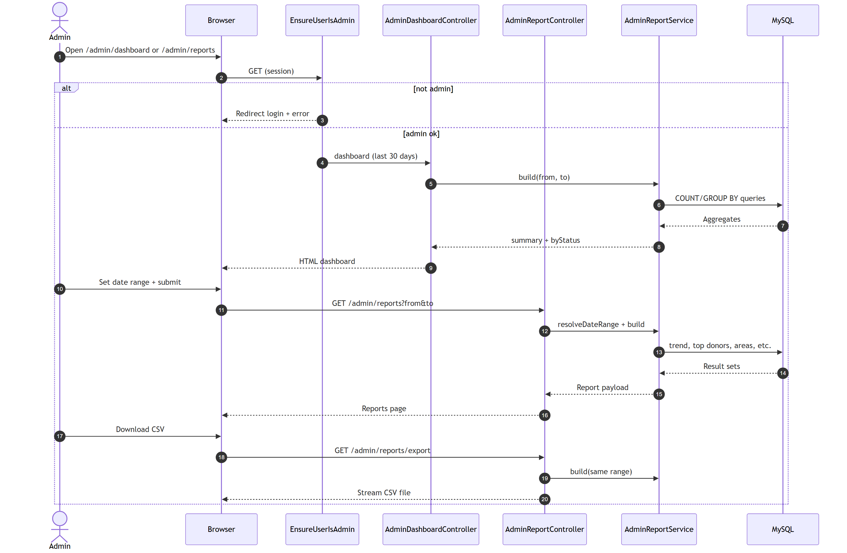
Figure 2.6 — Admin reports and CSV export

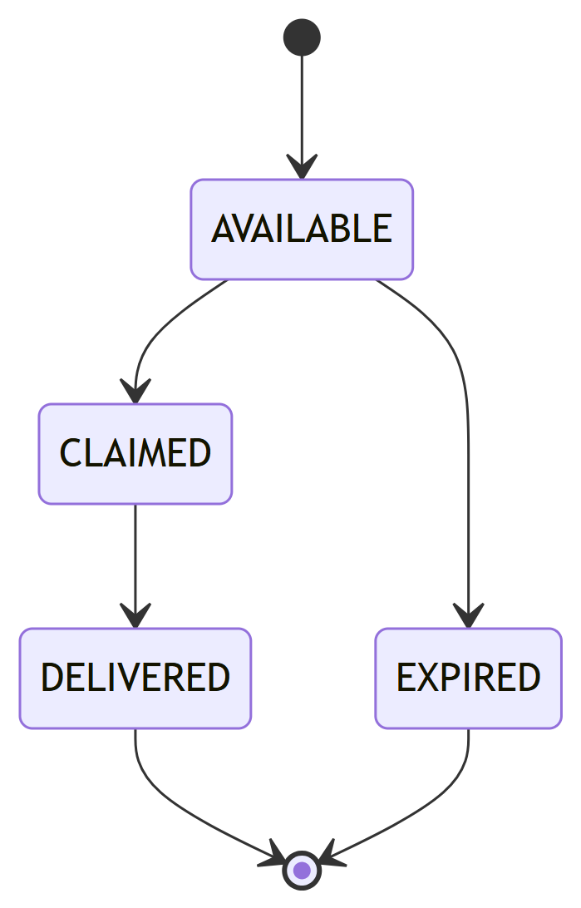
Figure 2.7 — Listing status state diagram

2.7 Object model / logical model (classes)
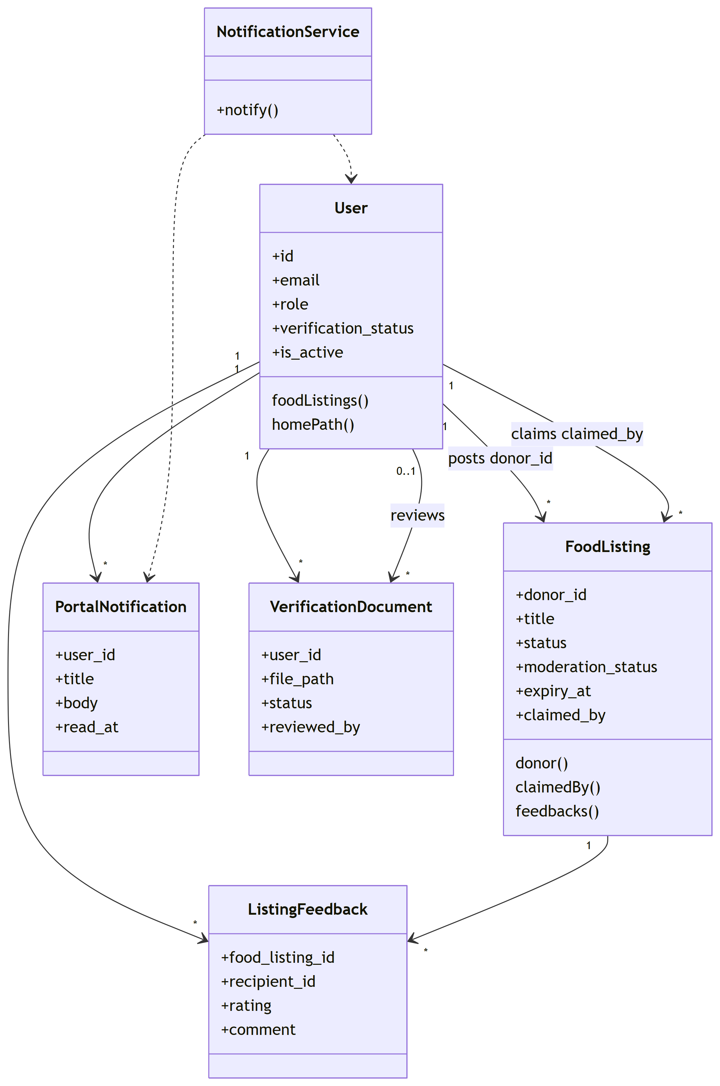
Figure 2.9 — Simplified class diagram (Laravel models)

The implementation uses Laravel models and thin controllers (simplified class view):
• User — authentication, role, profile fields, location; relations to listings and notifications.
• FoodListing — donor_id, food details, pickup snapshot, status, claimed_by, timestamps.
• PortalNotification — user_id, type, message, read flag.
• VerificationDocument — recipient upload metadata for admin review.
• ListingFeedback — rating and comment after delivery.
• AuthController, FoodListingController, ClaimController — core donation workflow.
• Admin* controllers — dashboard, reports, users, verification, listing moderation.
• NotificationService — create alerts when listings change.
A full multi-table design (separate donations, claims, items) is documented in Documentation/Markdown/Design-doc-sections.md for future migration; v2 keeps one claim per listing row.

2.8 Database model
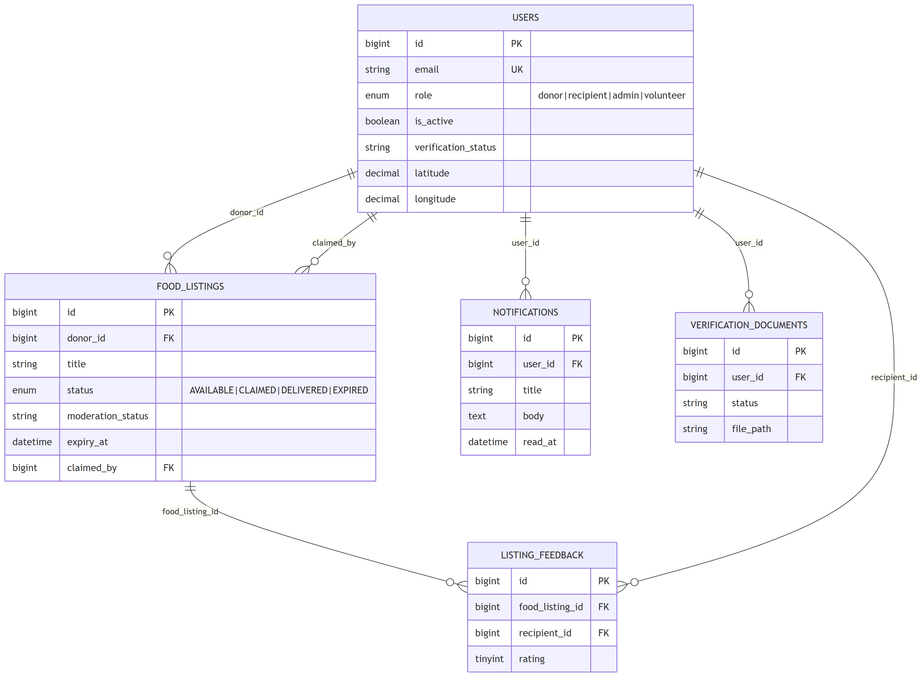
Figure 2.8 — Entity–relationship diagram (v2 core)

Core tables are users and food_listings. Phase-2 migrations add portal_notifications, verification_documents, listing_feedback, and moderation flags on listings. Foreign keys link listings to donor and recipient users.

2.9 Graphical user interfaces

2.9.1 Home Screen
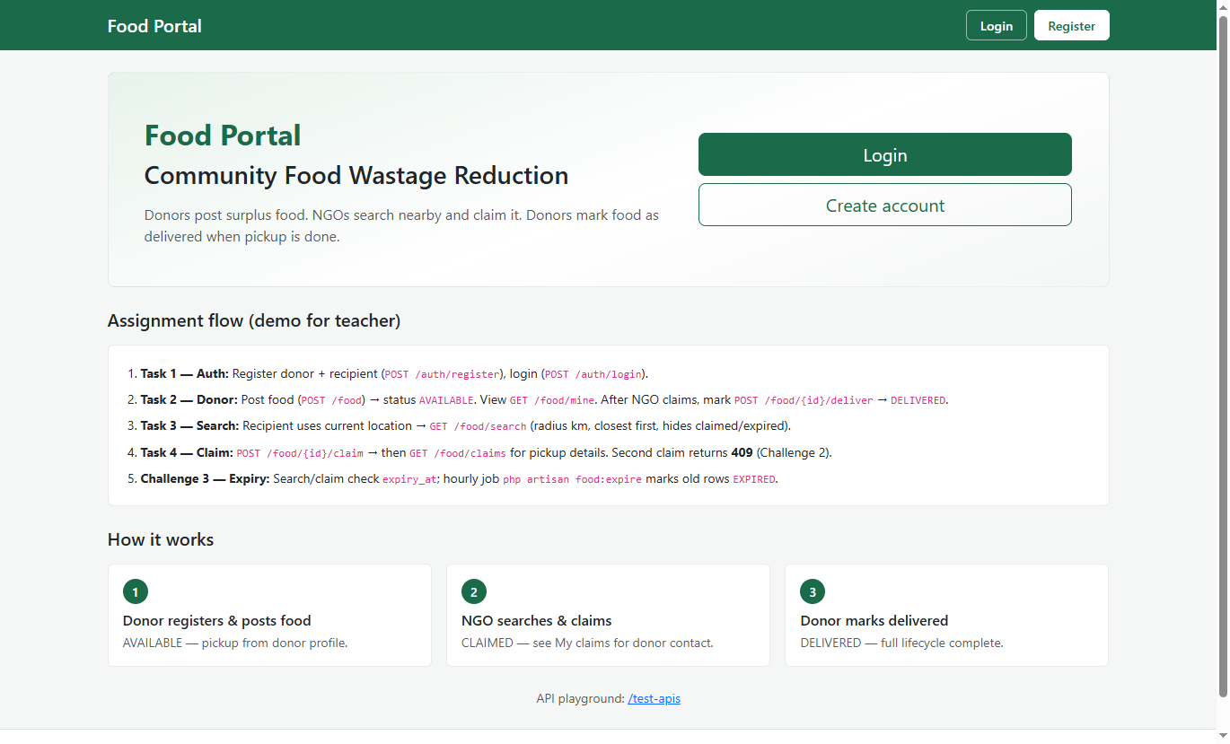
Figure 2.9.1 — Home Screen

2.9.2 Donor Dashboard
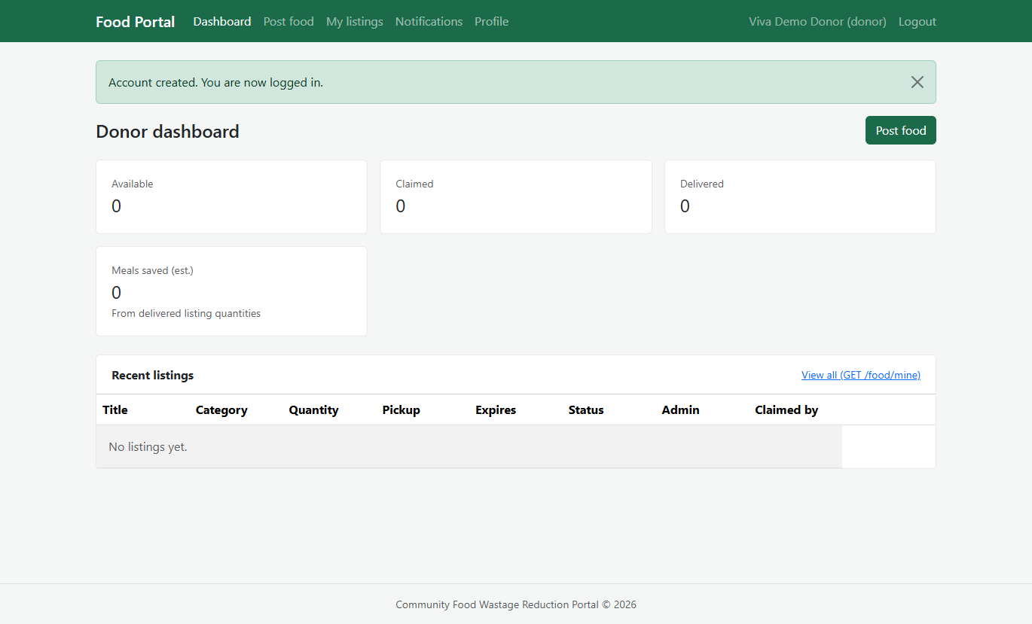
Figure 2.9.2 — Donor Dashboard

2.9.3 Register Donor
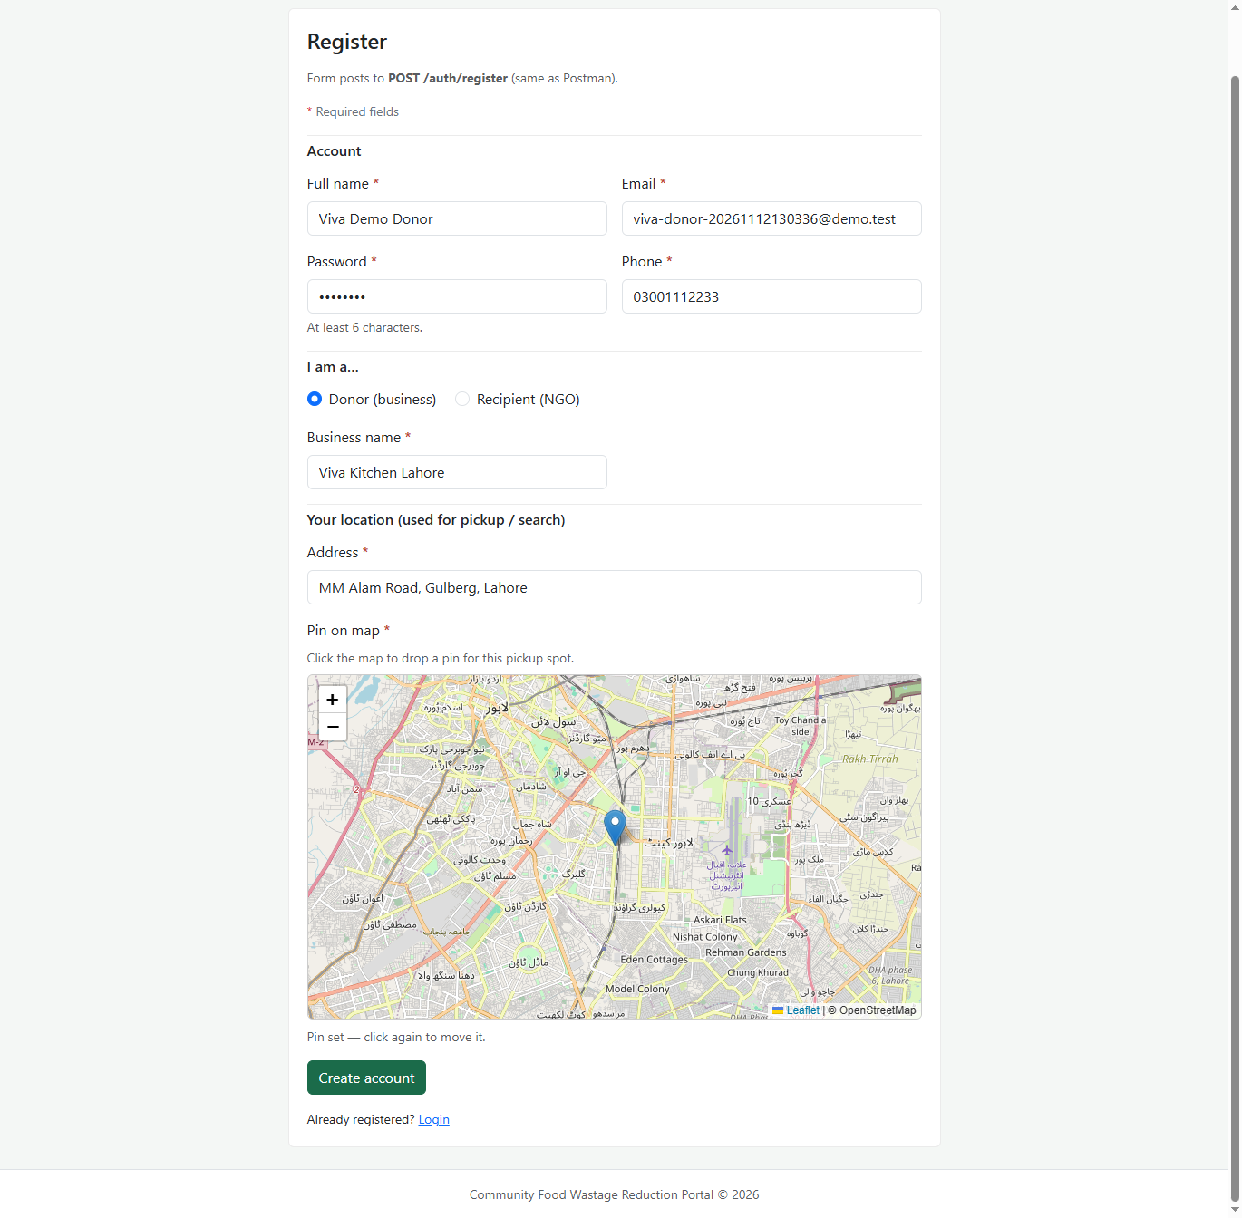 Figure 2.9.3 — Register Donor

2.9.4 Donor: Post Food
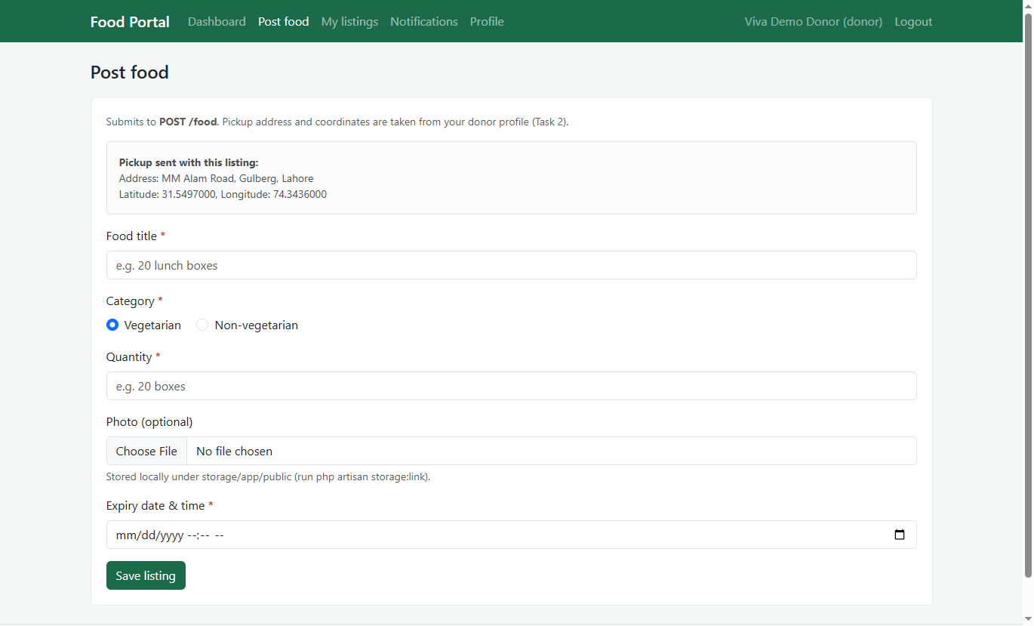 Figure 2.9.3 — Donor: Post Food

2.9.5 Donor: My Listing
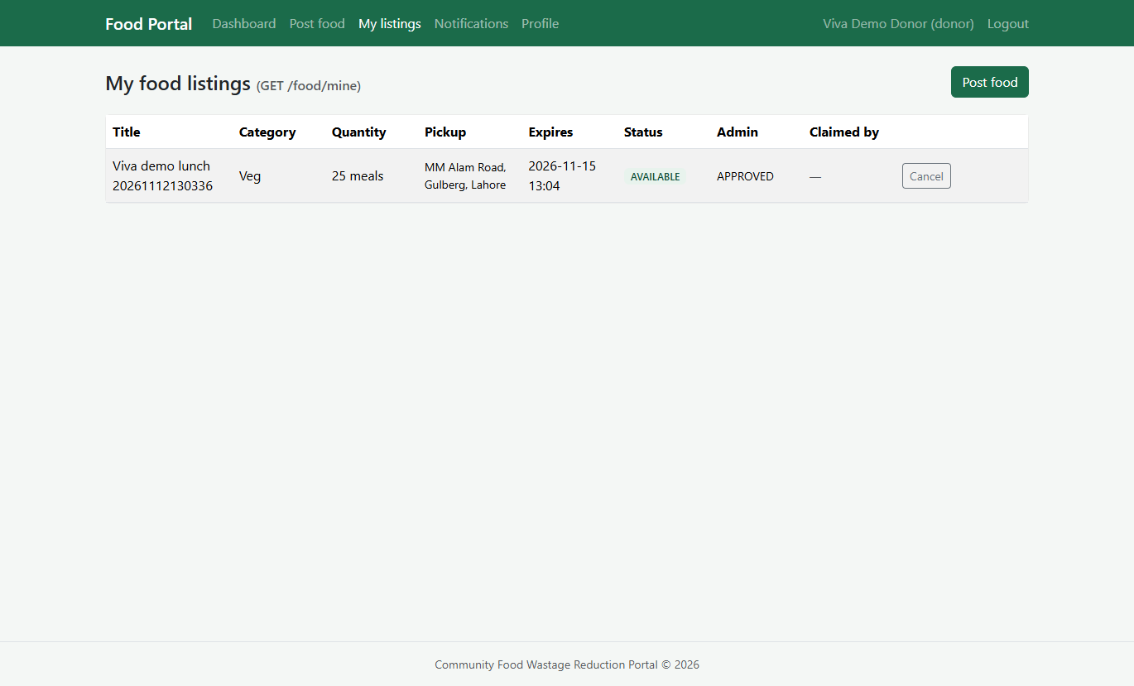 Figure 2.9.5 — Donor: My Listing

2.9.6 Admin: Moderate Food – View Pending
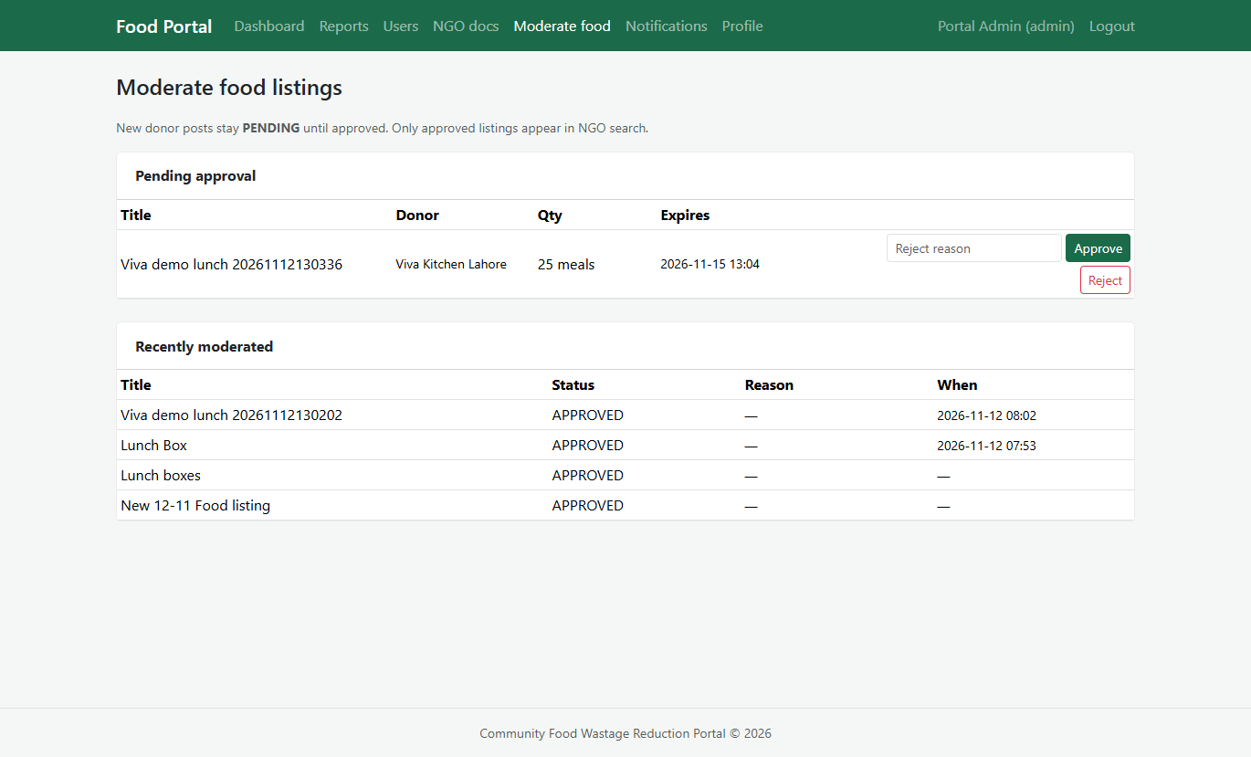 Figure 2.9.6 — Admin: Moderate Food – View Pending

2.9.7 Admin: Moderate Food – Approve
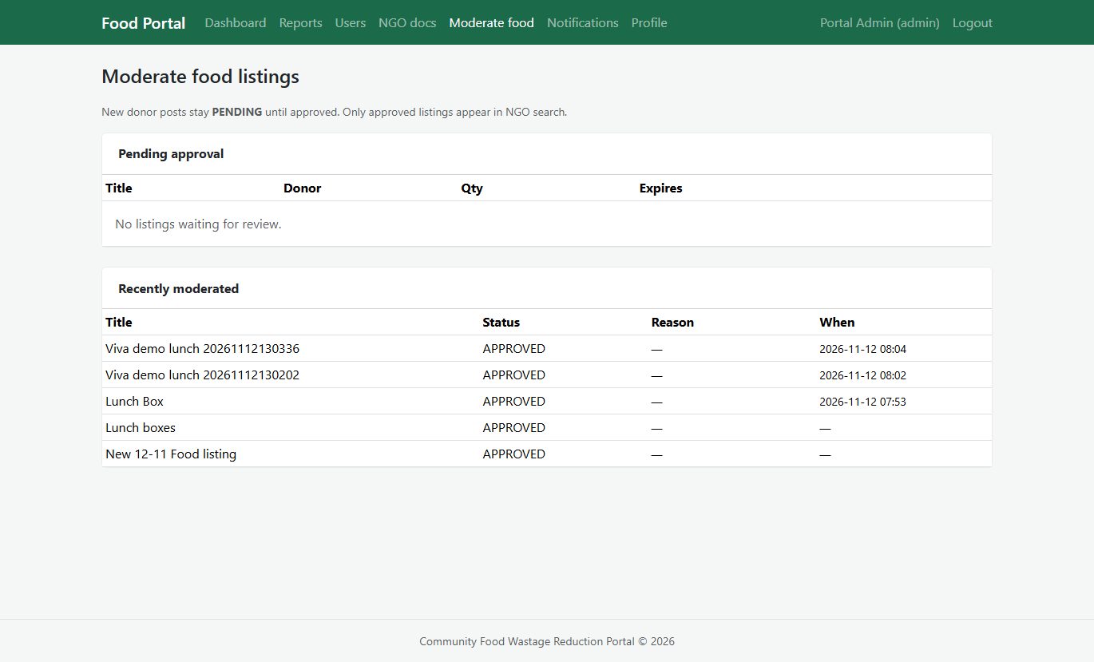 Figure 2.9.7 Admin: Moderate Food – View Pending

2.9.8 Register NGO
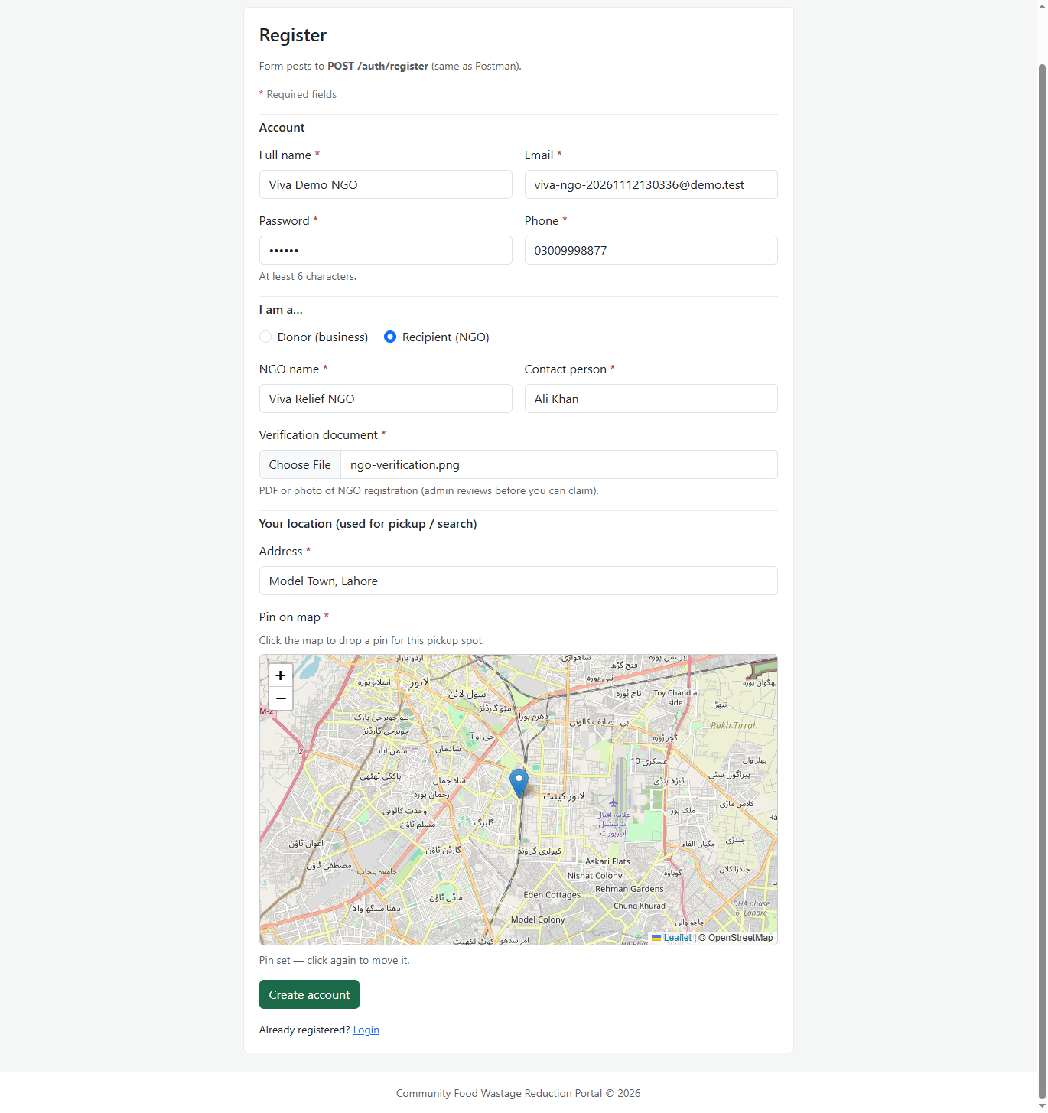 Figure 2.9.8 — Register NGO

2.9.9 NGO: Upload Verification Docs
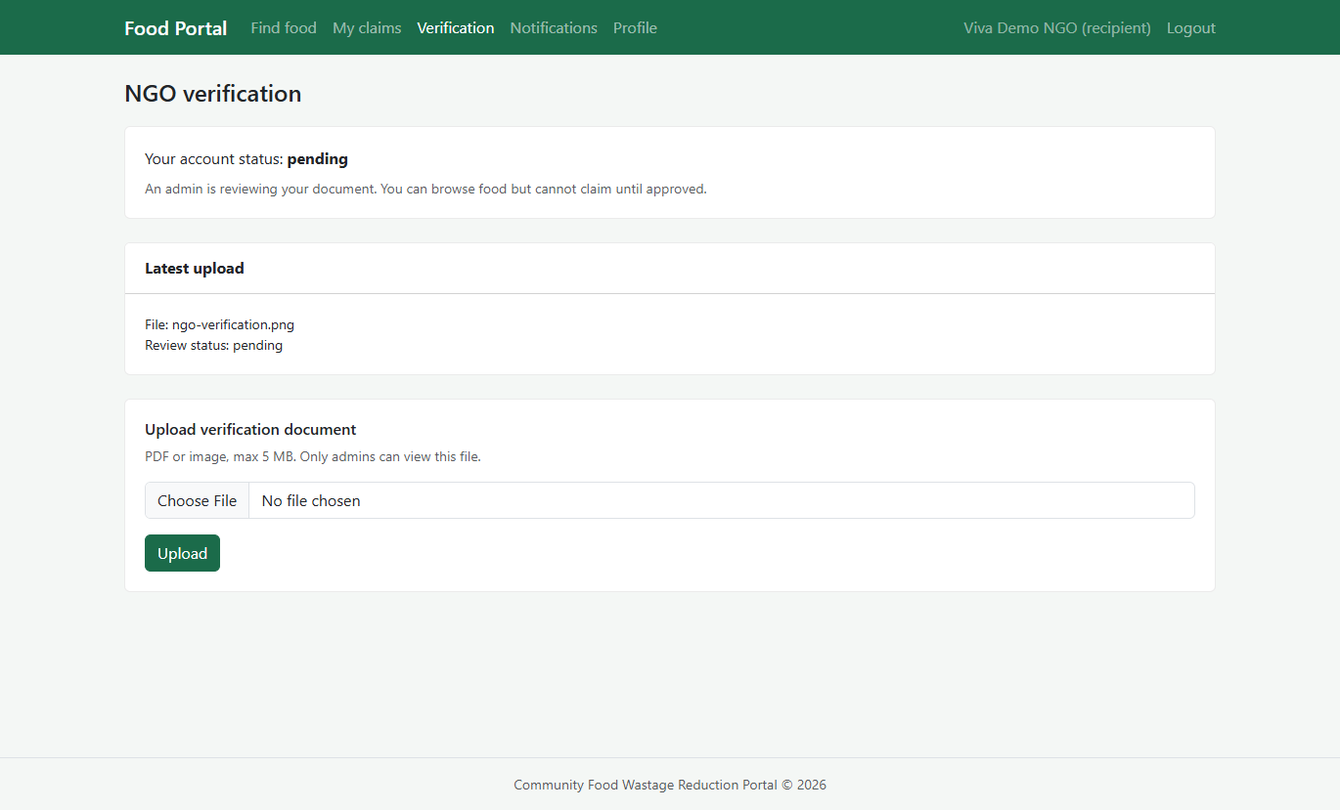 Figure 2.9.9 — NGO: Upload Verification Docs.

2.9.10 Admin: View Pending Verifications
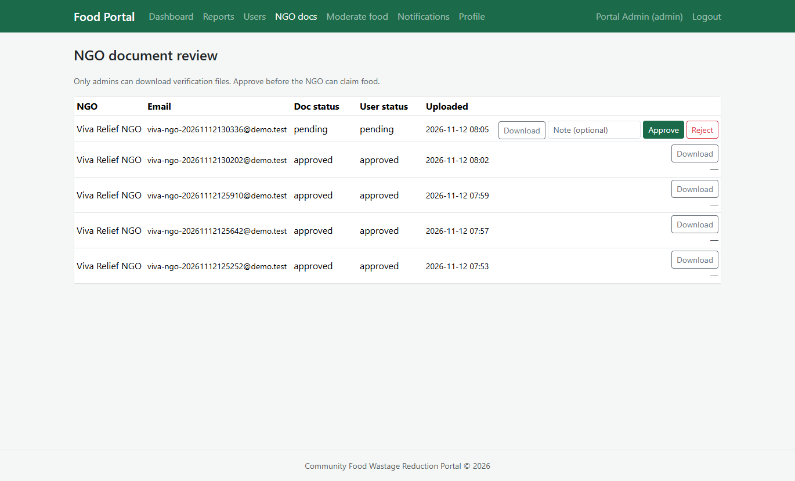 Figure 2.910 — Admin: View Pending Verifications

2.9.11 Admin: Approve Pending Verifications
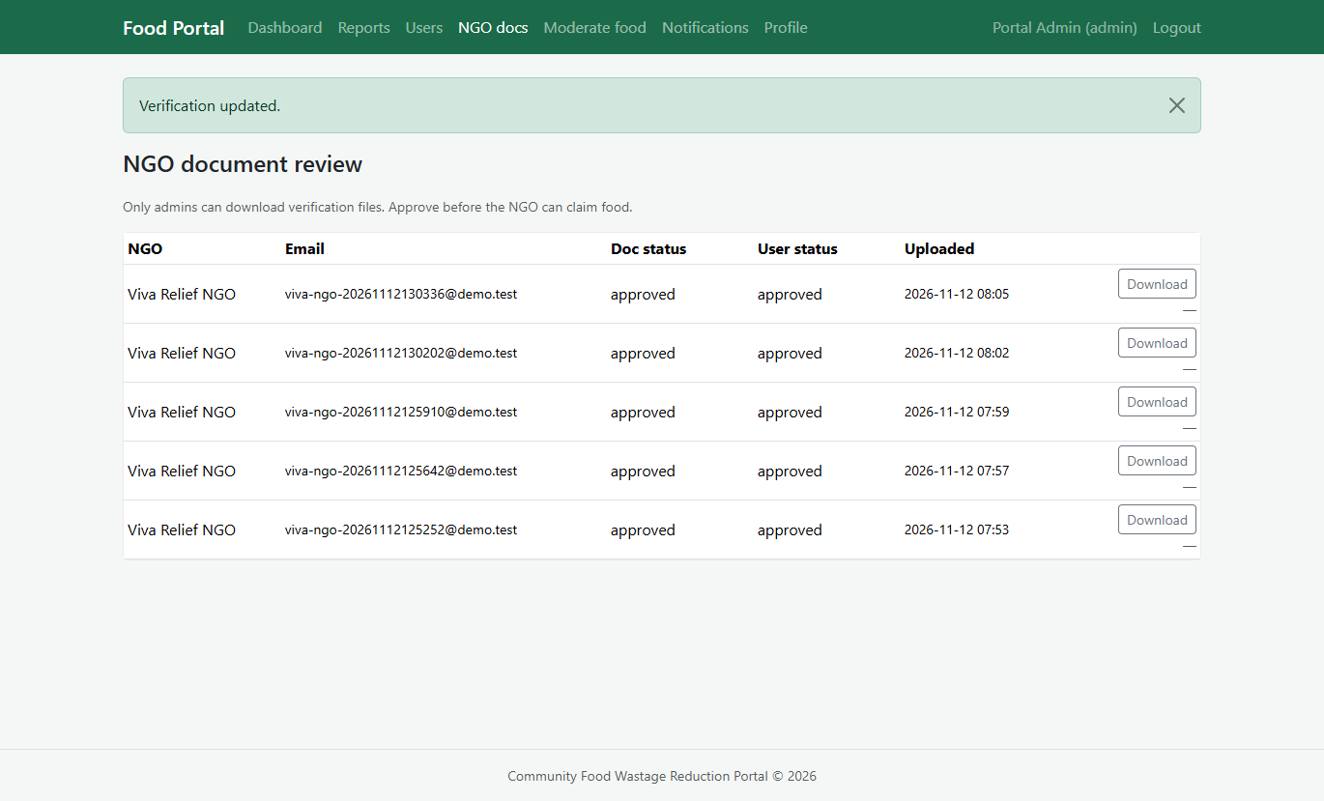 Figure 2.9.11 — Admin: Approve Pending Verifications

2.9.12 NGO: Find Food Near Me
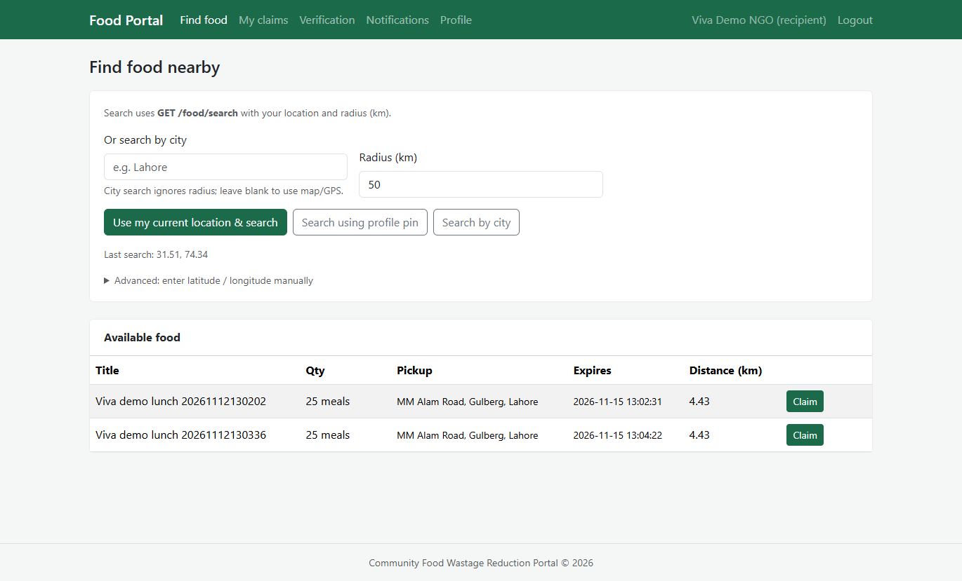 Figure 2.9.12 — NGO: Find Food Near Me

2.9.13 NGO: Claimed Foods
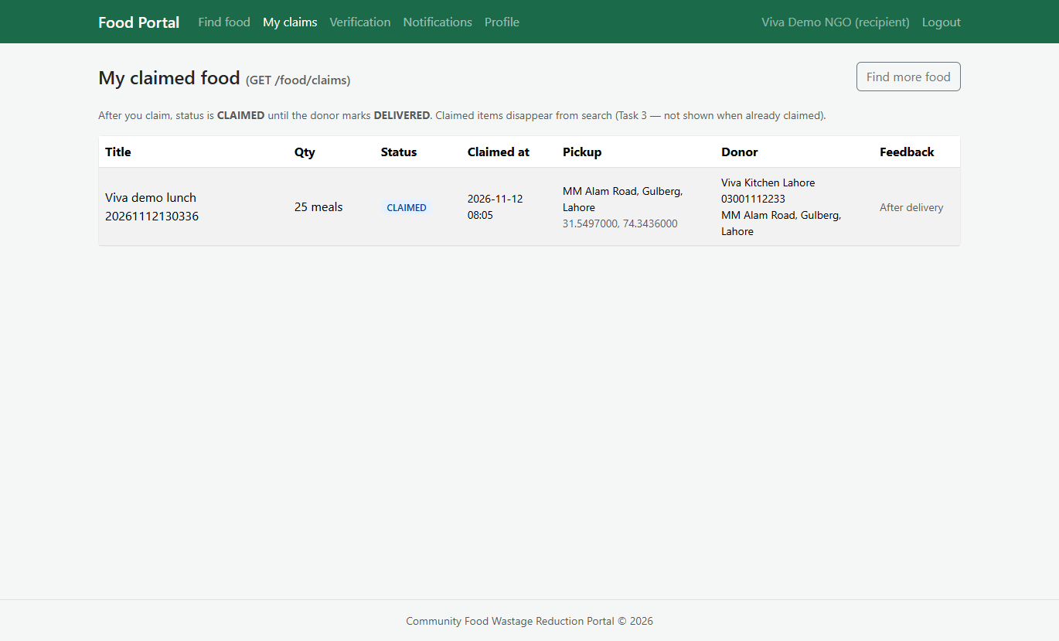 Figure 2.9.13 — NGO: Claimed Foods

2.9.14 Donor: Deliver marked for Claimed Listing
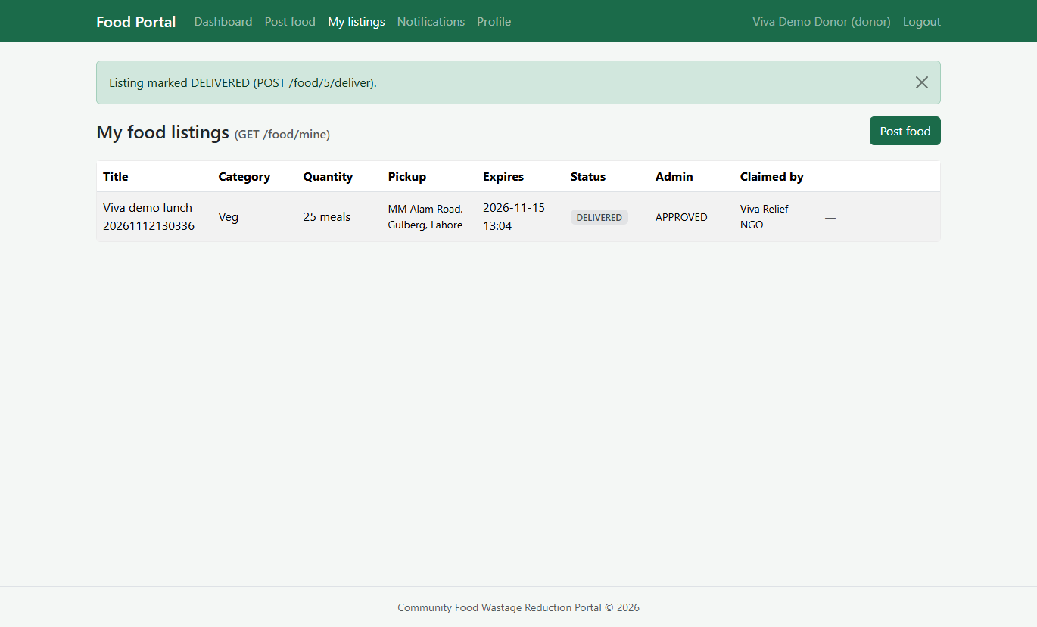 Figure 2.9.14 — Donor: Deliver marked for Claimed Listing

2.9.15 Admin: Reports
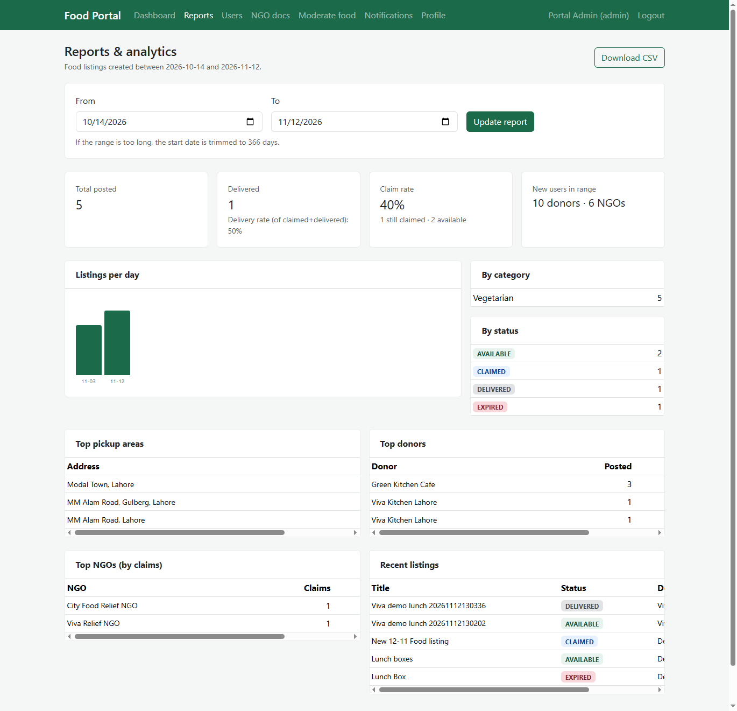 Figure 2.9.15 — Admin: Reports

CHAPTER 3
Development

3.1 Development plan (Architecture Diagram)

Figure 3.1 — Architecture Diagram

3.2 Development plan and implementation
Technology stack: PHP 8, Laravel 9+, Blade, Bootstrap 5, plain CSS/JS, MySQL 8. Development followed the architecture in Figure 2.1. Modules were built in order so each could be demoed separately.

3.2.1 Environment and database
composer install, .env configuration, php artisan migrate, and UserSeeder create demo accounts. Migrations define users, food_listings, and phase-2 portal tables. Legacy food table was removed in a later migration.

3.2.2 Authentication module
AuthController handles register, login, logout with validation and bcrypt hashing. RedirectIfAuthenticated sends each role to the correct dashboard. EnsureUserIsActive blocks disabled accounts.

3.2.3 Donor module
FoodListingController::store validates expiry in the future and copies donor coordinates. Donors view /food/mine, mark deliver on claimed rows, and cancel available listings. Optional photo upload uses local storage (php artisan storage:link).

3.2.4 Recipient module
FoodListingController::search applies Haversine distance, radius, or city filter. ClaimController runs one UPDATE … WHERE status = AVAILABLE to avoid double claims. RecipientVerificationController stores NGO documents for admin approval.

3.2.5 Admin and volunteer module
AdminReportController aggregates KPIs and exports CSV. AdminUserController blocks users; AdminVerificationController approves documents; AdminListingModerationController approves or rejects new listings. VolunteerController lists CLAIMED tasks and can complete delivery.

3.2.6 Notifications and feedback
NotificationService writes portal_notifications rows when listings are created, claimed, or delivered. FeedbackController saves listing_feedback after DELIVERED.

3.2.7 Testing
PHPUnit feature tests: FoodSearchTest (search filters) and FoodClaimTest (concurrent claim). Manual tests use Documentation/postman_collection.json and the /test-apis browser page. Demo script: Documentation/Markdown/demo-and-viva-script.md.

3.2.8 Sample code (atomic claim)
The claim action uses a conditional update so only one recipient wins under load (simplified excerpt from ClaimController):
UPDATE food_listings SET status = 'CLAIMED', claimed_by = ?, claimed_at = NOW() WHERE id = ? AND status = 'AVAILABLE' AND expiry_at > NOW()
If zero rows are updated, the API returns an error so the second client knows the listing is gone.

REFERENCES

[1] Virtual University of Pakistan, IT601P Software Project I course material.
[2] Laravel documentation — https://laravel.com/docs
[3] Bootstrap 5 documentation — https://getbootstrap.com/docs/5.3/
[4] Project SRS v2 — Documentation/Markdown/SRS-v2/SRS-v2-main.md
[5] MySQL 8 reference manual — https://dev.mysql.com/doc/

APPENDIX

A. Installation (short)

• composer install && cp .env.example .env && php artisan key:generate
• Create MySQL database cfwrp_v2; set DB_* in .env
• php artisan migrate && php artisan db:seed --class=UserSeeder
• php artisan storage:link
• php artisan serve → http://127.0.0.1:8000

B. Screenshot checklist
Paste screenshots here: login, donor post, search results, claim success, admin report, notification bell, NGO verification, listing moderation.

C. Demo accounts
Use accounts from UserSeeder (see README.md and demo-and-viva-script.md). Replace with your own VU group details on the title page before submission.

