**University Transport Management System**



**By**

**Zain Abbas**

**Talha Bilal**

**Shaheer Hamza(team lead)**

**Sabina Jaffar**

**Department of computer science**

**Quaid-e-Azam University Islamabad**

**Signature Page**

Zain Abbas ,Talha Bilal, Shaheer Hamza ,Sabina Jaffar at Quaid-e-Azam University created the original document named "University Transport Management System" throughout their academic period. The project proceeds with strict compliance to IEEE guidelines to establish secure coding standards. The document includes all data and content which has received proper citations and source attributions throughout the document. This document originates from the academic period at Quaid-e-Azam University but has never been submitted to any other academic event or public award competition. The document serves as proof of our dedicated work without dependency that brings together our computer science knowledge with personal dedication in the field.

**Date: 05/04/2025**

**Signature of Instructor:**

**___________________**

**Change History:**

|  |  |  |  |
| --- | --- | --- | --- |
| **Version** | **Date** | **Author** | **Summary of Changes** |
| Version 1.0 | 05/4/2025 | Zain Abbas  Talha Bilal  Shaheer Hamza(team lead)  Sabina Jaffar | Initial draft submission |
|  |  |  |  |
|  |  |  |  |

**Preface**

The University Transport Management System project management plan appears in this document. The document establishes project boundaries along with objectives and implementation approach that follows ISO/IEC/IEEE 16326 standards. The document presents the University Transport Management System project plan which contains project context alongside planning and risk management and supporting process plans.

**Table of Contents**

**List of figures ……………………………………………………………………………………. 5**

**List of tables …………..…………………………………………………...………………...........5**

**1. Project overview………………………………………………………………………………..6**

* **Project summary……………………………………………………6**
* **Purpose……………………………………………………6**
* **scope ……………………………………………………6**
* **objectives ……………………………………………………6**
* **Assumptions……………………………………………………6**
* **constraints ……………………………………………………6**
* **Project deliverables ……………………………………………………7**
* **Schedule summary ……………………………………………………7**

**2. References ……………………………………………………………………….......................8**

**3. Definitions …………………………………………………………………………………..…8**

* **Process model ……………………………………………………9**
* **Methods……………………………………………………….....9**
* **Tools ………………………………………………………............9**
* **Techniques ………………………………………………………...9**
* **Product acceptance plan …………………………………………9**

**5. Project planning.………………….………………………………………………………10**

**8. Supporting process plans ………………………………………………………….11**

* **Risk management ……………………………….…………………11**

**List of Figures**

1. Figure 1 - 3: Gantt Charts – Page # 10-11
2. Figure 4: Resource Allocation – Page #11

**List of Tables**

1. Table 1: Risk Management Table – Page #12

**Project Overview(Sabina Jaffar)**

**Summary:**

The University Transport Management System functions to simplify transportation operations in the educational site. The system provides services to keep track of all transport options while the system helps students determine which buses serve their intended routes. Through its features the system facilitates transport requests by departments by managing pick-up or drop-time specifications alongside chosen locations. The system keeps comprehensive records about vehicle service which guarantees operational effectiveness.

**Purpose:**

The creation of an efficient automated transport management system aims to improve accessibility through scheduling and requisition features for students and faculty members as well as administrative personnel.

**Scope:**

The system operates with user registration and regulation of bus schedules along with request tracking and maintenance tracking services in addition to administrative functionalities.

**Objectives:**

The objective of system is to

* Create a centralize system to manage university transport
* Maintain vehicle maintenance records.
* Create an interface which is accessible to both university staff members and students.
* Departments should be able to request transport service when their pick-up or drop-off areas have predetermined locations.

**Assumptions:**

* Through mobile or web applications students together with faculty members access the platform.
* The university has allocated funds to sustain the system operation.

**Constraints:**

* Budget limitations for advanced features.
* The current university databases possess integration difficulties that impede integration.

**Project Deliverables:**

* A web-based and mobile application constitutes our functional transport management platform.
* The database stores information about vehicles as well as schedules and keeps maintenance records.
* The department can access the transport requisition module through this system
* User manuals and documentation
* System testing and validation reports

**Schedule summary:**

|  |  |  |
| --- | --- | --- |
| **Phase** |  | **Weeks** |
| 1 | Requirements gathering | 2 |
| 2 | System design | 3 |
| 3 | Development | 5 |
| 4 | Testing and validation | 3 |
| 5 | Development and training | 2 |

**(Talha Bilal)**

**References:**

1. ISO/IEC/IEEE 16326 for Project Management Guideline.
2. University Transportation Guidelines and Policies

**Definitions:**

* **Admin:**T he University administration team conducts transport operation supervision while scheduling vehicles and processing transportation requests while tracking equipment documentation.
* **User**: Students and academic faculty members together with university staff compose the group of users who commute with university transport services.
* **Transport Requisition**: A university department or their designated personnel submits formal requests for additional transport services through the Transport Requisition system which indicates all required pickup sites, drop locations and service specifications.

**Project context(zain abbas )**

**Process Model:**

We will choose **Agile Process Model** for the development of university transport Management System. It is because

1. It allows for the incremental development, enabling us to deliver usable portions of the system in short cycles, ensuring feedback and adaptability to changing requirements.
2. It promotes a collaborative approach among team members and stakeholders.
3. Its iterative nature incorporates improvements.

**Tools:**

|  |  |
| --- | --- |
| Microsoft Word | For documentations |
| Project Libre | For Project Management and Scheduling |
| Visual Studio | For Code editing |
| Visual Studio Code | For Code editing |

**Methods:**

1. Requirements Analysis
2. Design
3. Coding and Development
4. Testing
5. Documentation

**Techniques:**

1. Requirements gathering techniques.
2. UML
3. Testing Techniques
4. Quality Assurance Techniques

**Project Planning:(Shaheer hamza )**

**Fig-1**

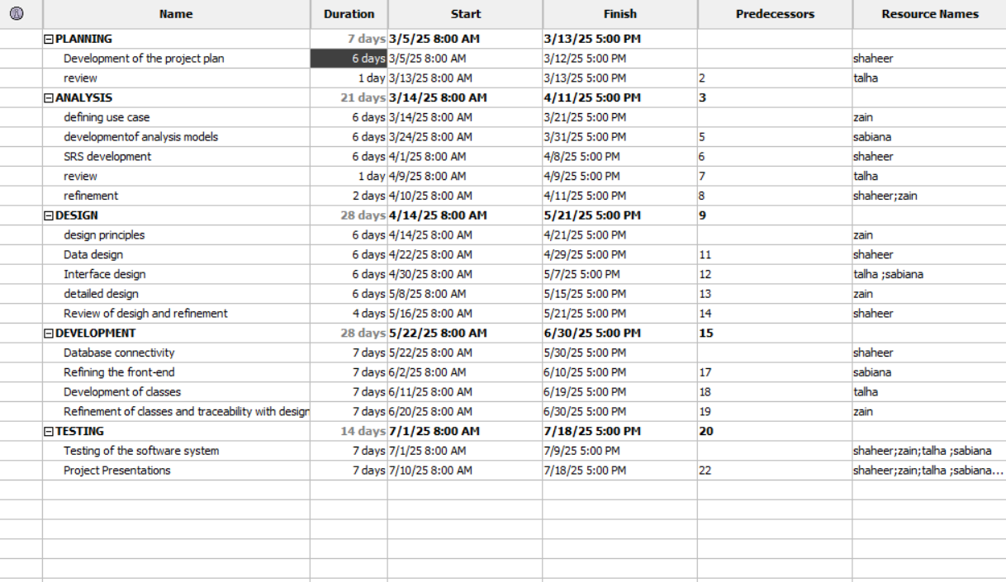

**Fig-2**

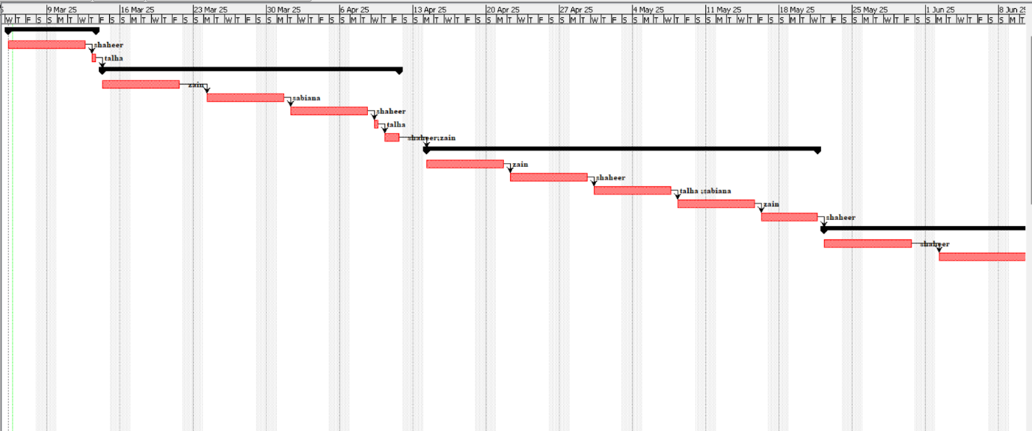

**Fig-3**

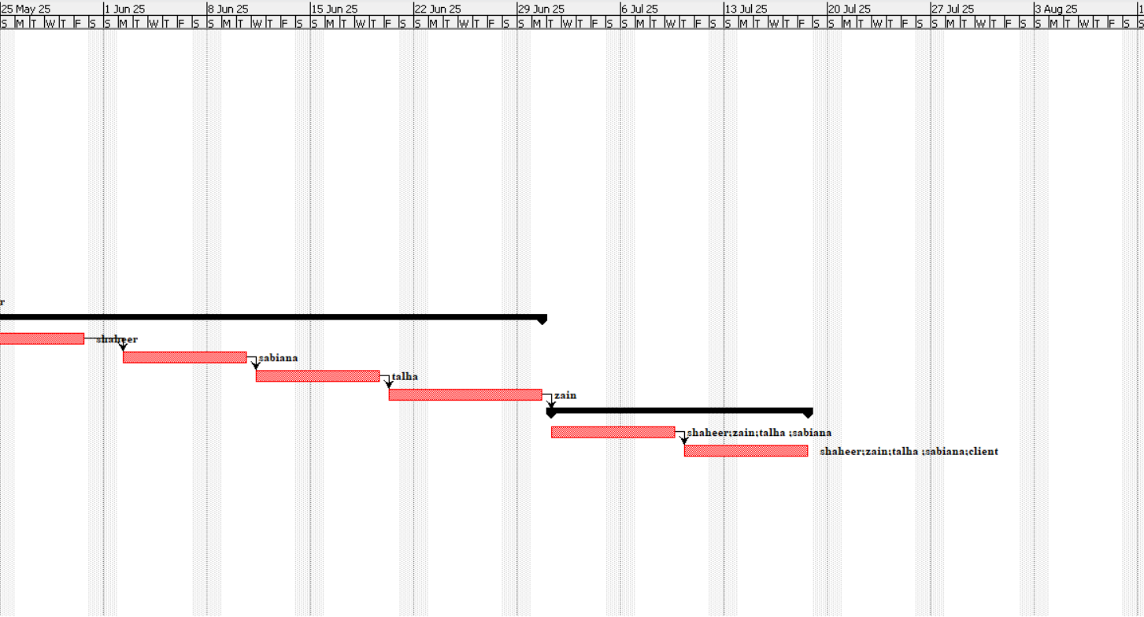

**Fig-4**

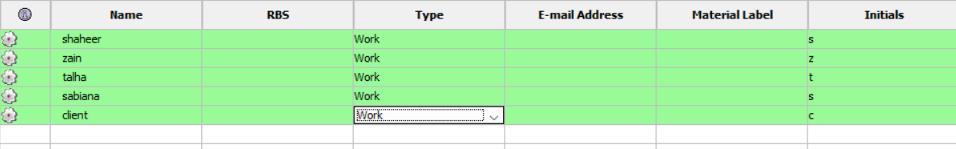

**Risk Management:(Talha Bilal)**

|  |  |  |  |
| --- | --- | --- | --- |
| **Risk** | **Probability** | **Impact** | **Mitigation Strategy** |
| System downtime | Medium | High | Implement redundancy and backups |
| Security breaches | High | High | Use encryption and access control |
| Budget overrun | Medium | Medium | Regular monitoring and cost control |
| User Resistance | Low | Medium | Conduct training and awareness sessions |