Jenkins  
  
Installation:

Steps for installation:

1. Download WAR file from the given URL

<https://www.jenkins.io/download/>

1. Copy paste the downloaded file in a folder and copy its path.

Open command prompt: and change it to the folder where Jenkins package is saved ( cd C:\Jenkins)

1. Run the following command to extract the package:

java -jar jenkins.war

1. On successful installation you will have initial password and ‘Jenkins is fully up and running message.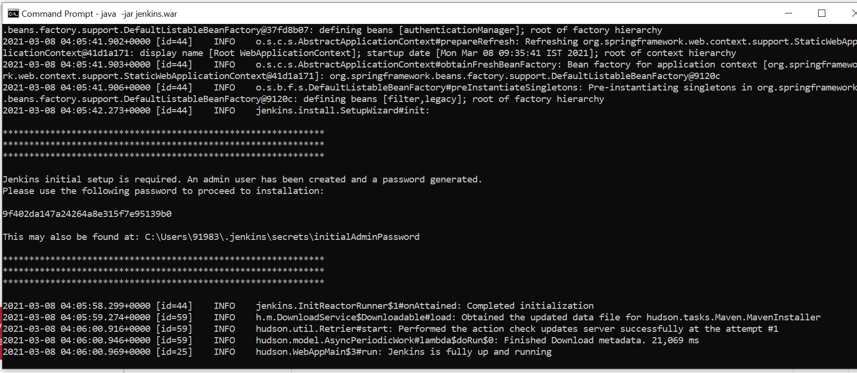
2. Once this is done go to [http://localhost:8080](http://localhost:8080/" \o "http://localhost:8080/" \t "_blank) you will see login screen

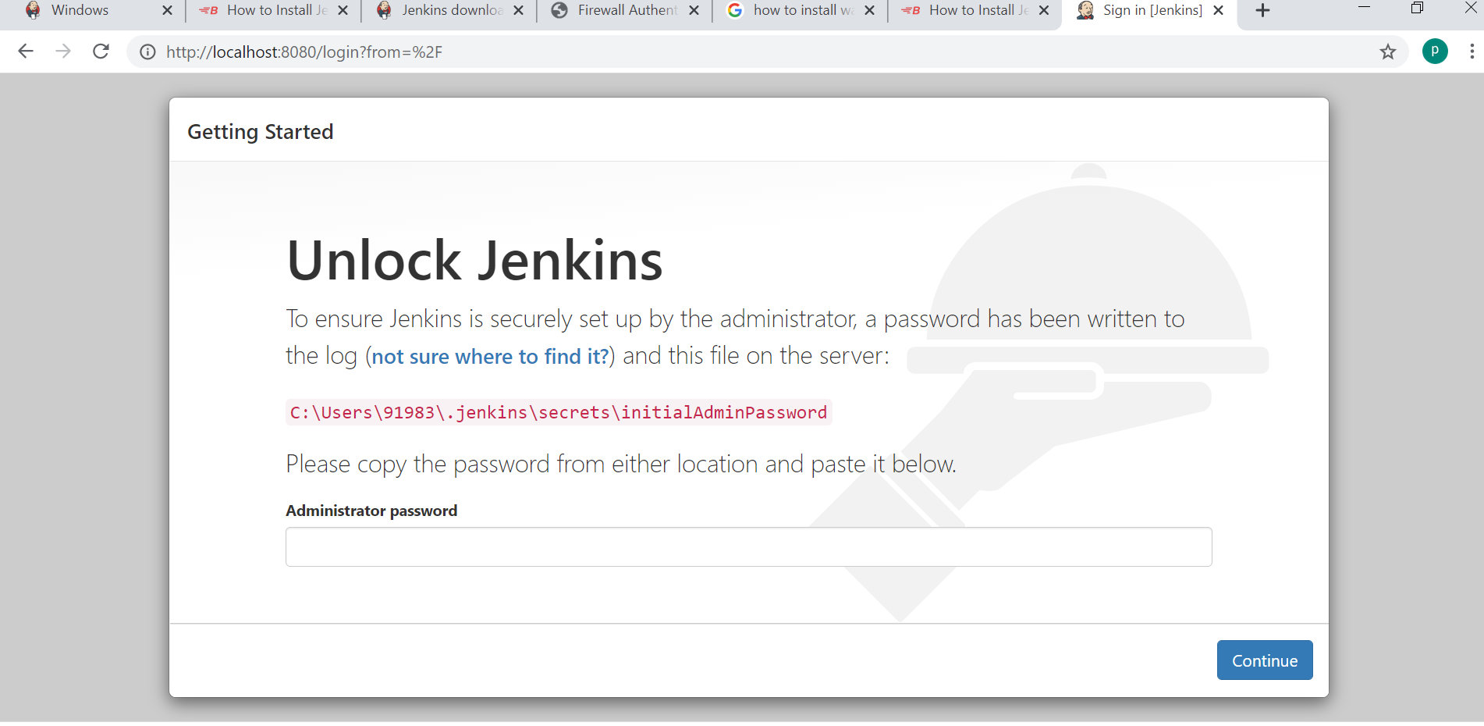

1. Copy paste the initial password and set username and password for admin account
2. Installation complete.

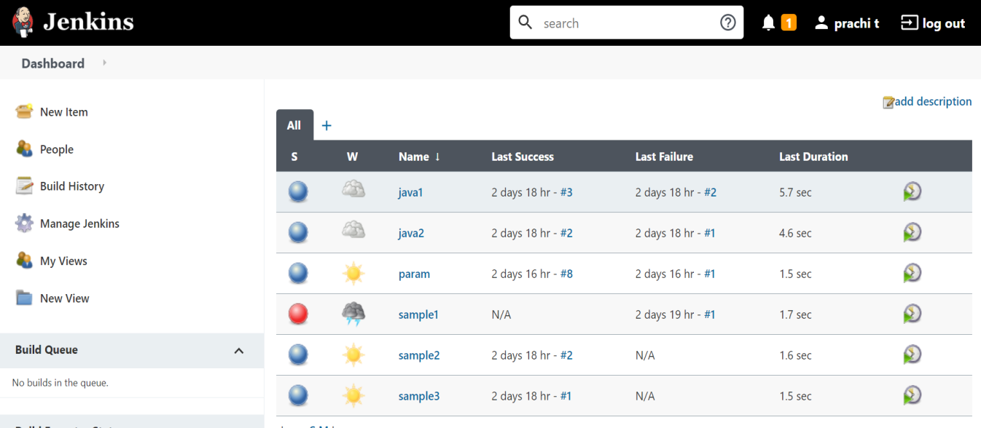

**Start jenkins:**

C:\Program Files\Jenkins

java -jar jenkins.war

<https://localhost:8080/.>

Creating job:

Go to add item->Enter name->select option on how it should be uploaded…

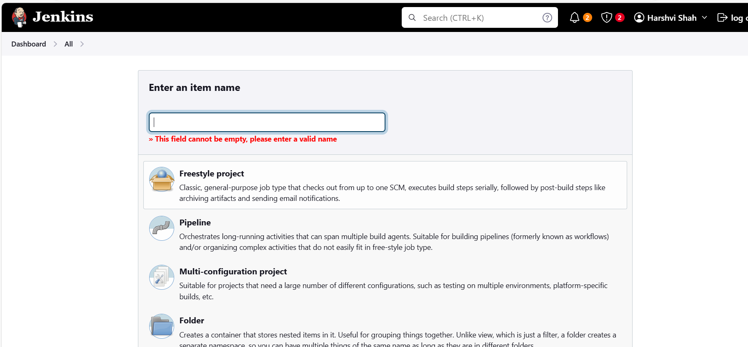

Give description:  
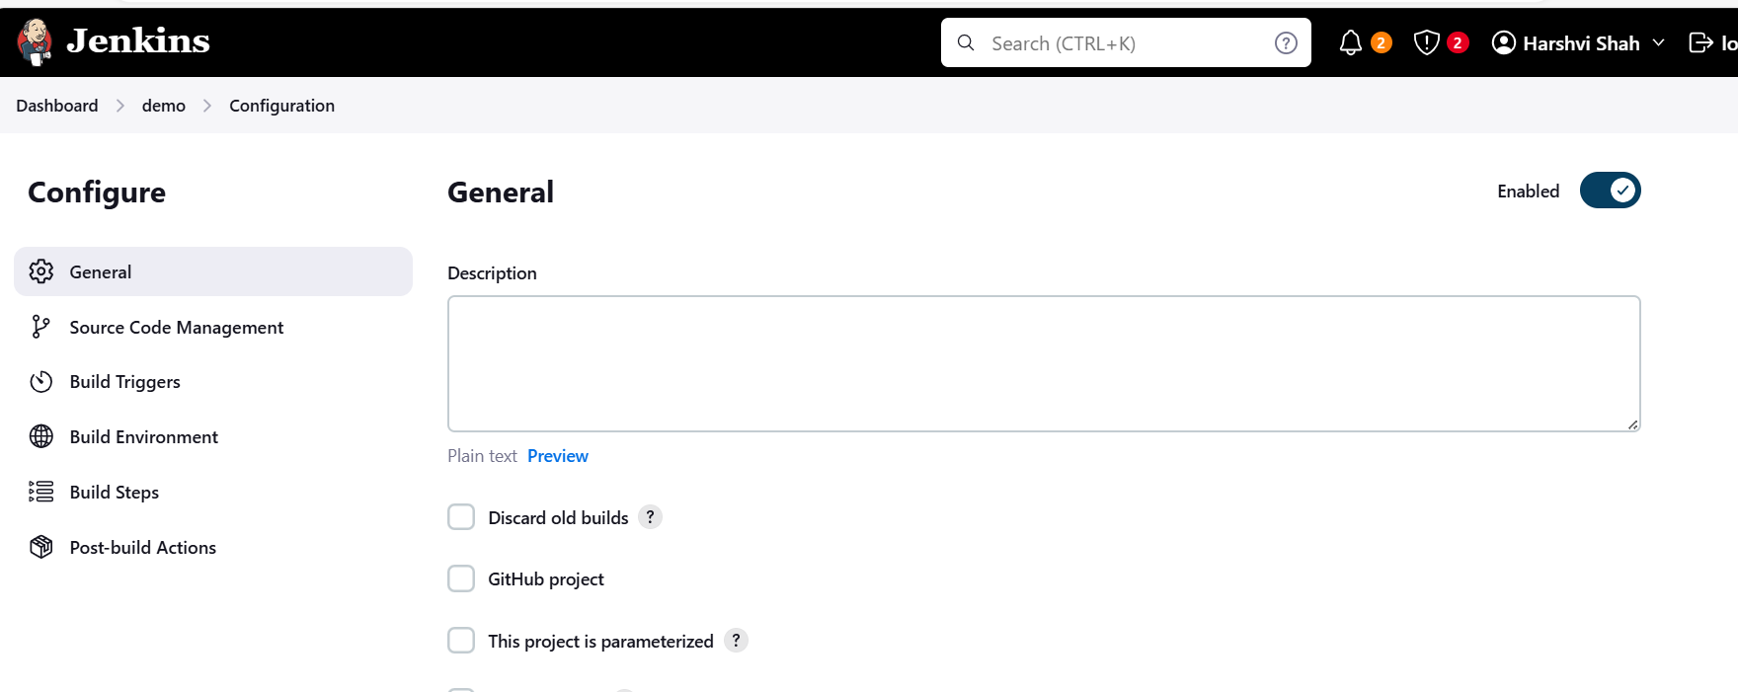

Add build steps:

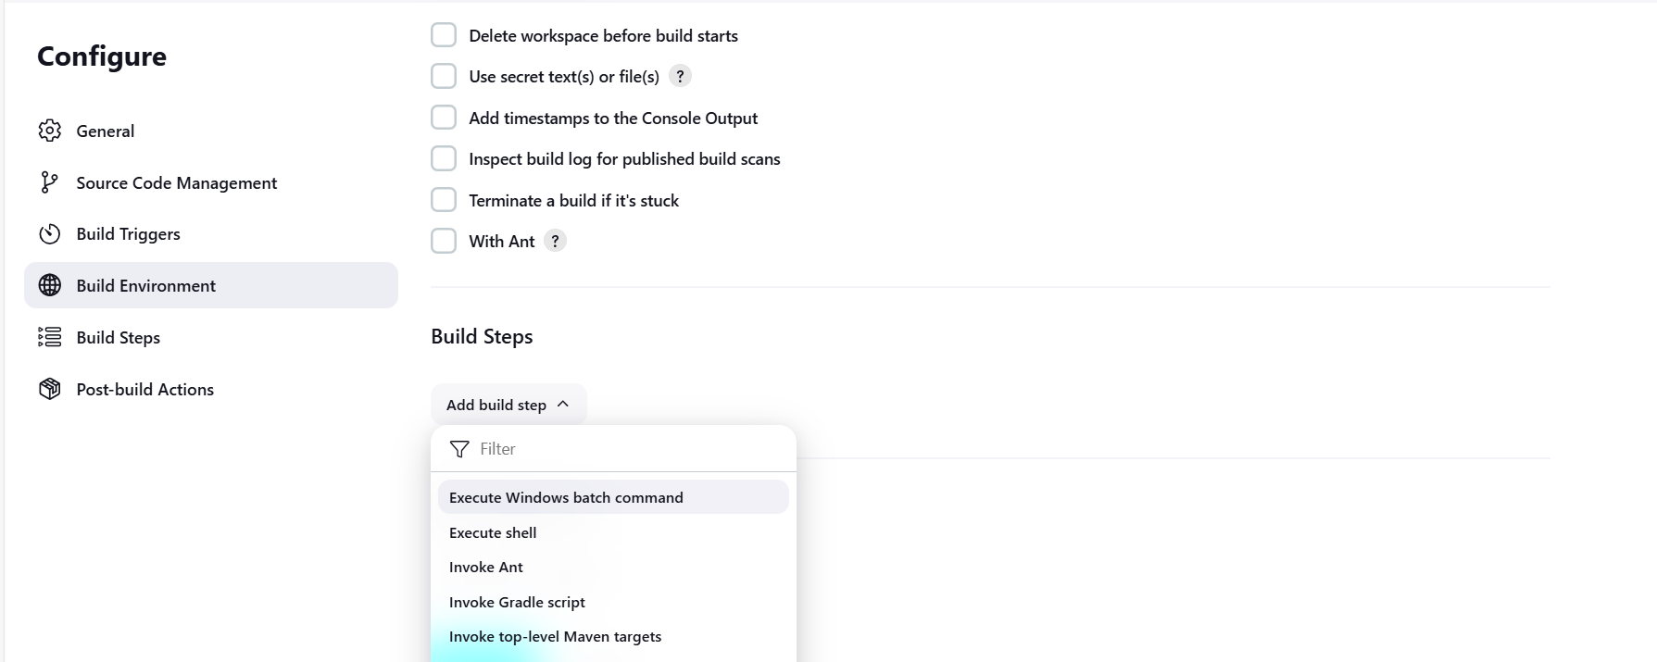

**For building job tap on build now**

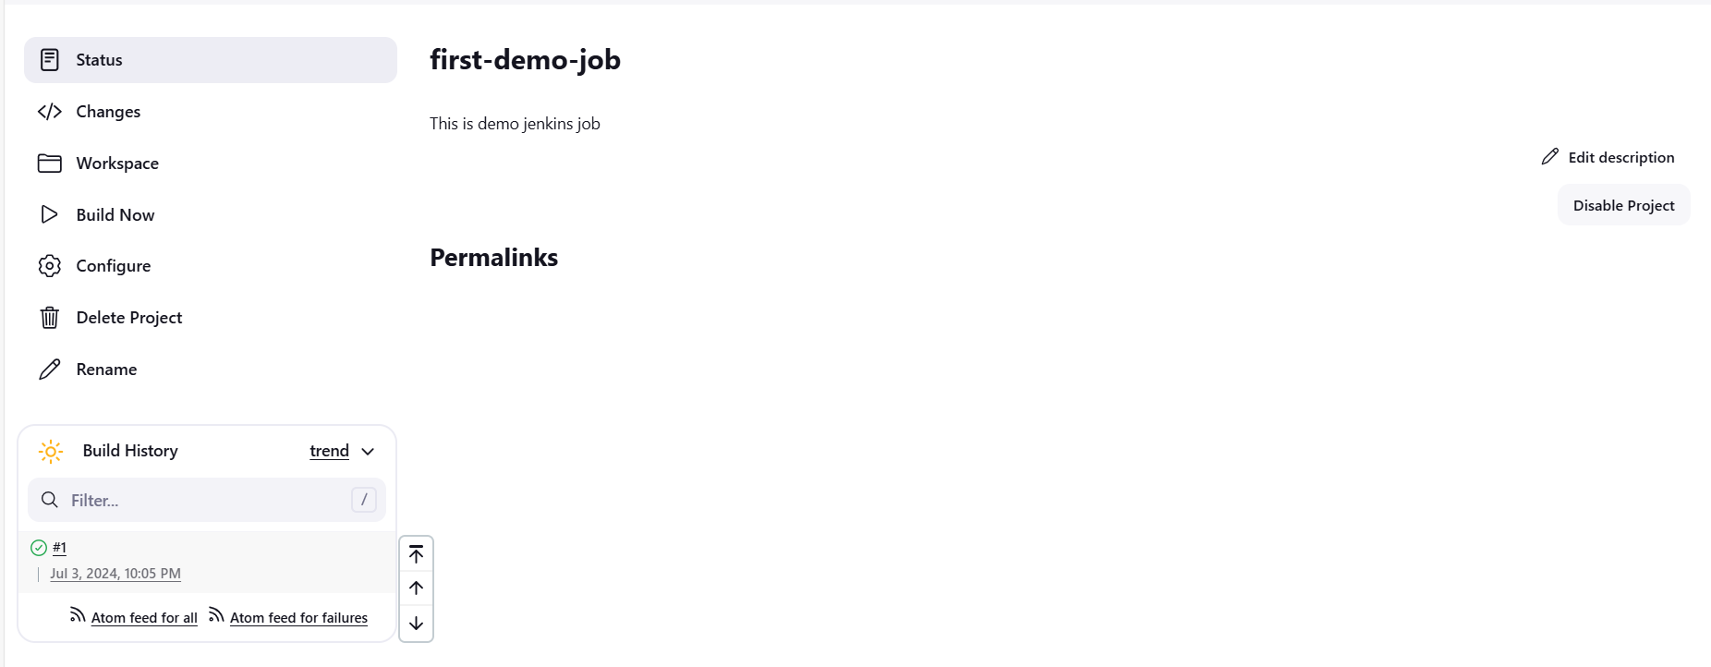

In build history you can see if build is successful or not



In console output :

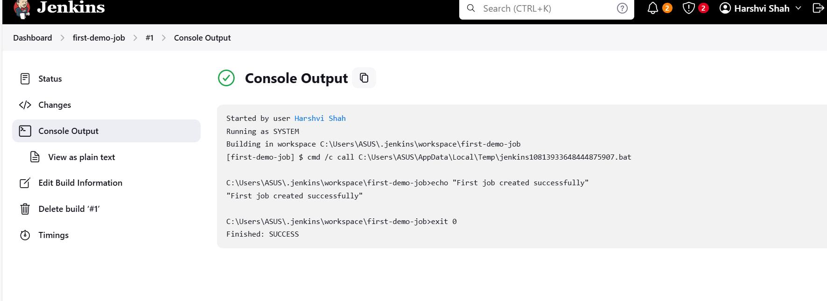

For unsuccessful output:

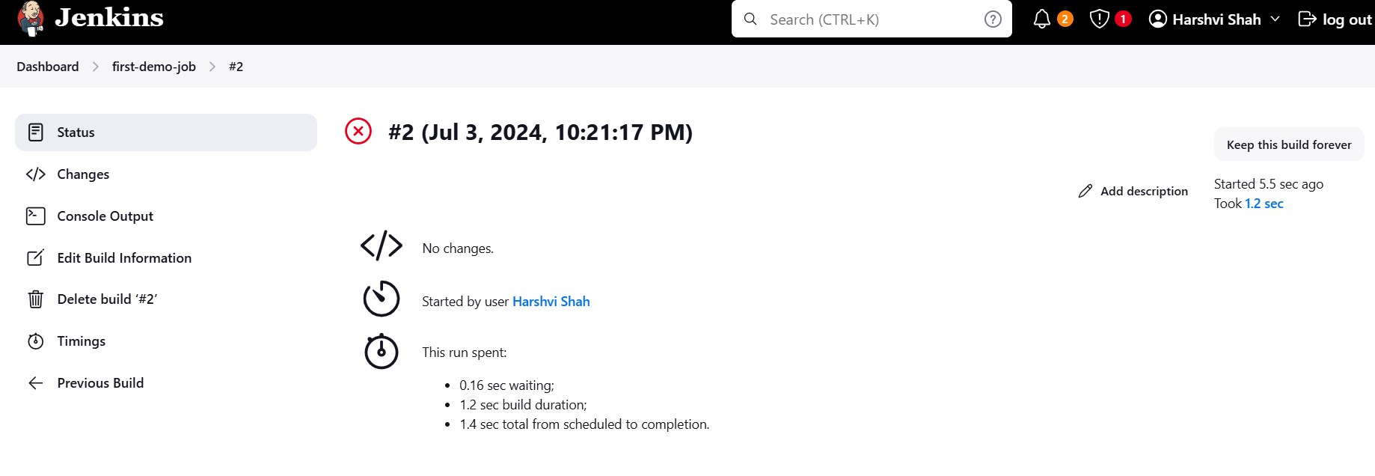

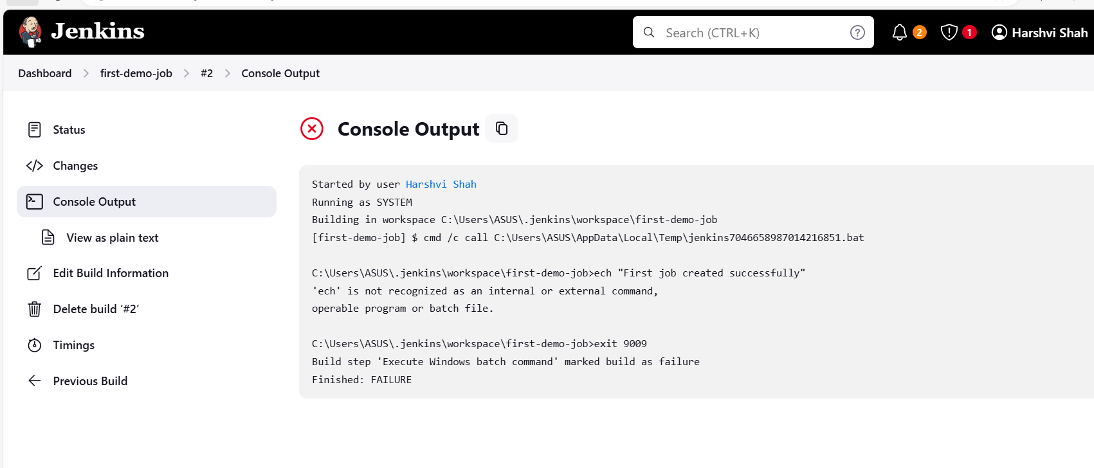

You can see the job created in dashboard and also status:  
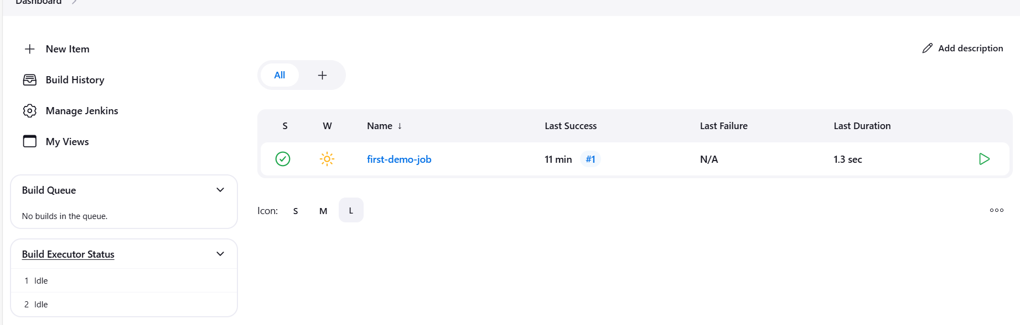

**Created a file:**

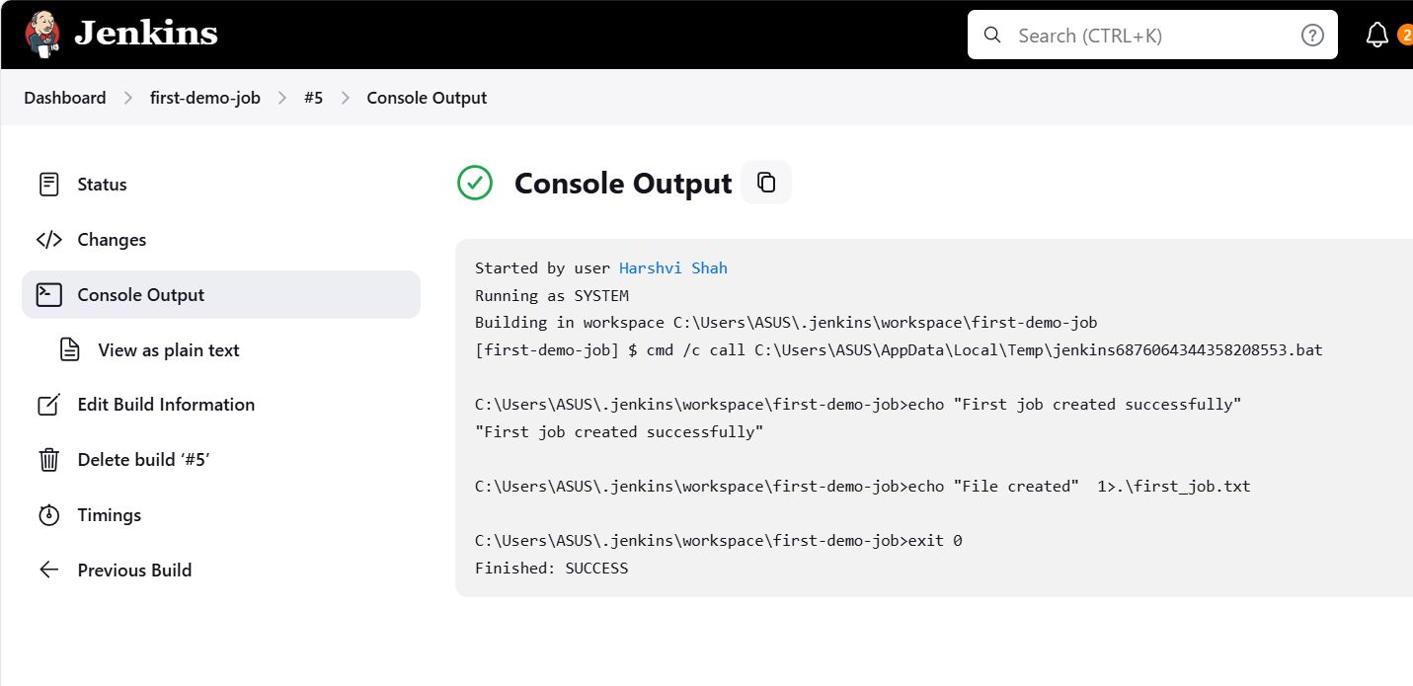

**Creating file path is displayed here:**

"C:\Users\ASUS\.jenkins\workspace\first-demo-job\first\_job.txt"

Job with parameters:

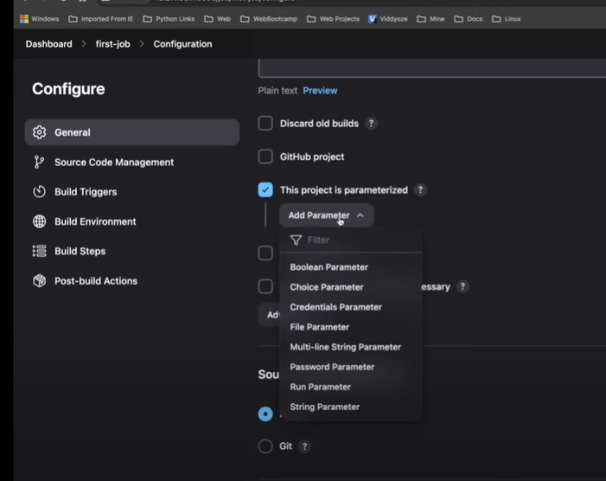

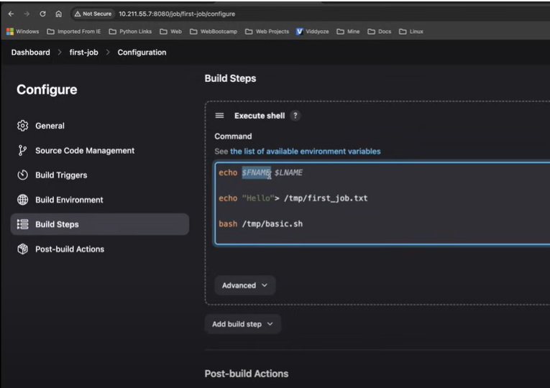

Asking for inputing parameters:

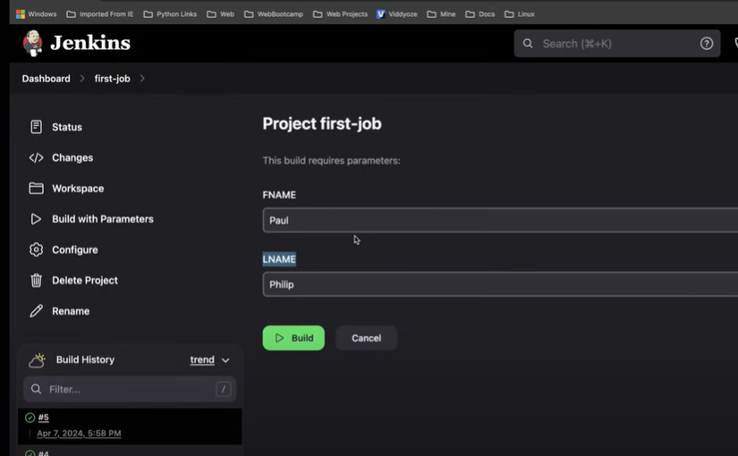

For auto scheduling build job:

1. Need to generate cron-time from here if performing build perodically :<https://crontab.cronhub.io/>
2. 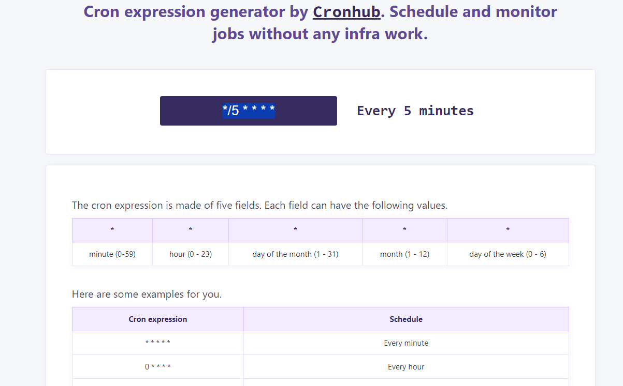
3. 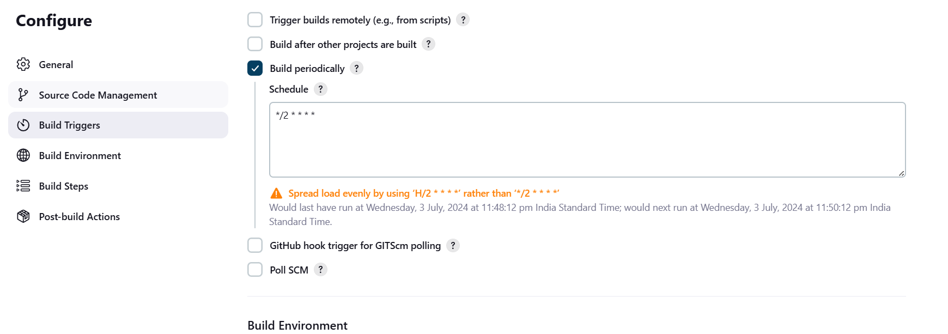
4. Build getting performed every 2 mins automatically:

