Task 1: Reconnaissance and Vulnerability Scanning

Objective
To perform reconnaissance and service enumeration on a test system using Nmap.

Tools Used
- Kali Linux
- Nmap

Command Used
nmap -sV scanme.nmap.org

Screenshot
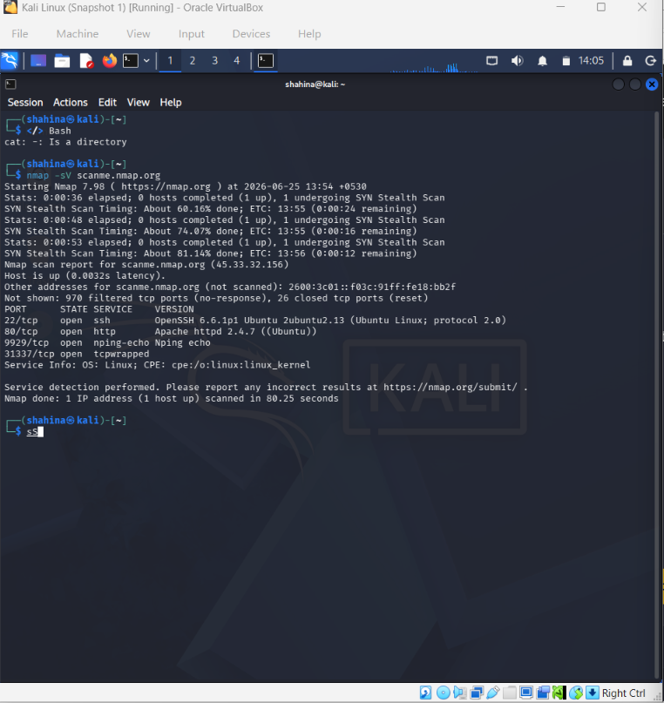

Findings
Open ports and services were identified on the target system, including SSH (22), HTTP (80), nping-echo (9929), and another service on port 31337. The target was identified as a Linux system.

Security Risks
Open ports increase the attack surface. Outdated or unnecessary services may expose the system to security vulnerabilities.

Recommendations
Keep services updated, close unused ports, implement firewall rules, and perform regular security scans.

Conclusion
The Nmap scan successfully identified active services and provided useful reconnaissance information.

