Aura Interiors Chat Architecture Report
Industry-grade chatbot pipeline audit and implementation status
Project: Aura Interiors
Prepared by: Engineering Review
Date: 29 September 2026
Version: 1.0

Abstract
This report audits the Aura Interiors Express/Mongoose/Socket.IO chatbot against the requested production architecture. The supplied archive already contained a partial CHAT_PIPELINE=v2 implementation. Inspection confirmed that the legacy path retained deprecated-model risk, sequential provider behavior, admin-document bot identity, hot-path retrieval, broad intent matching and a broken escalation summarizer. The existing v2 addressed several concerns but remained incomplete: provider calls were non-streaming and the gate covered only five tests plus a router microbenchmark. This pass implemented provider SSE streaming with tool-call assembly, added security and stream-parser tests, and strengthened the gate to include all v2 syntax checks plus frontend lint and both frontend builds. Eight v2 tests pass. The strengthened full gate is BLOCKED because isolated npm installs did not complete within the execution window, leaving eslint/vite unavailable. Live provider model listing, production-log review, real-provider benchmarks, 100-conversation evals, load/E2E/failure-injection suites, Redis/BullMQ isolation and the Socket.IO Redis adapter remain NEEDS VERIFICATION or implementation. No production credentials were printed or intentionally used.

Contents
1 Introduction
2 Background and standards
3 Methodology
4 Findings ledger
5 Architecture
6 Benchmark and SLO results
7 Test and verification results
8 Rollout and rollback
9 Remaining risks and migration notes
References

1 Introduction
Scope covers chat orchestration, v2 modules, persistence/realtime integration, tool identity, provider behavior, handoff, observability, tests, benchmark harness and frontend compatibility. Persistence, guest sessions, human handoff, admin chat console, attachments and notifications are preservation constraints.
Limitations: archived .env values were treated as compromised and were not used for live provider verification. Production logs were not supplied. The environment did not finish npm ci in the available execution window. External-provider behavior, real latency percentiles and production SLO compliance are therefore not claimed.

2 Background and standards
The review uses OWASP application/API security principles, NIST digital identity guidance, CWE weakness taxonomy and RFC 8725 where applicable. Groq’s current deprecation history states that llama-3.3-70b-versatile was shut down for free/developer tiers on 16 August 2026 and recommends openai/gpt-oss-120b or successor Qwen models; Groq currently documents openai/gpt-oss-120b as served (Groq, 2026a; Groq, 2026b).

3 Methodology
The archive was unpacked into an isolated working directory. SHA-256 baselines were recorded for non-example .env files and both .git directories before edits. Existing tests/gate were run before changes. Static inspection used symbols and behavior. Verification claims below are based only on executed checks; missing production evidence is labelled NEEDS VERIFICATION/BLOCKED.

4 Findings ledger
Finding | Status | Evidence / disposition
AF-01 | CONFIRMED legacy / PARTIAL v2 | Legacy defaults to llama-3.1-70b-versatile. v2 defaults Groq to openai/gpt-oss-120b and has model-list validation. Boot fail-fast/alert wiring and live-key/log confirmation remain NEEDS VERIFICATION.
AF-02 | PARTIAL | v2 has per-model breaker, total timeout, retry-after, max_tokens and temperature. Health ordering, effective TTFT cancellation, hedging and durable retries remain incomplete.
AF-03 | FIXED v2 | Gateway now uses stream:true, assembles SSE content/tool calls and invokes onToken.
AF-04 | FIXED v2 | All declared v2 tools have handlers; contract test passes.
AF-05 | PARTIAL/FIXED core | Model userId is stripped and account identity comes from server context. Guest lookup abuse-specific edge limiter remains unproven.
AF-06 | PARTIAL | v2 avoids recursive sendMessage for final bot persistence; <=3 pre-LLM DB operations is not instrumented end-to-end.
AF-07 | PARTIAL | v2 bot message can exist without a User sender, but legacy admin-backed paths remain and explicit system-actor migration is incomplete.
AF-08 | PARTIAL | retrieval is optional tool with integration timeout; embedding cache/static FAQ prefix remain open.
AF-09 | FIXED v2 | trivial router is anchored; explicit handoff tool exists. Legacy regex remains behind v1.
AF-10 | PARTIAL | v2 narrow output guard enforces Aura/tool URL allowlist. Structured-output strategy remains constrained by streaming/tool compatibility.
AF-11 | OPEN legacy | triggerEscalation still references undefined instance fields; v2 handoff bypasses it.
AF-12 | PARTIAL | keyed in-process queue serializes/cancels; worker isolation/BullMQ not implemented.
AF-13 | OPEN | Socket.IO Redis adapter not implemented.
AF-14 | PARTIAL | v2 uses 12-message history plus summary field and labels data untrusted; rolling summary persistence not implemented.
AF-15 | PARTIAL | trace scaffold/tests exist; comprehensive metrics/evals/structured production logging remain incomplete.

5 Architecture
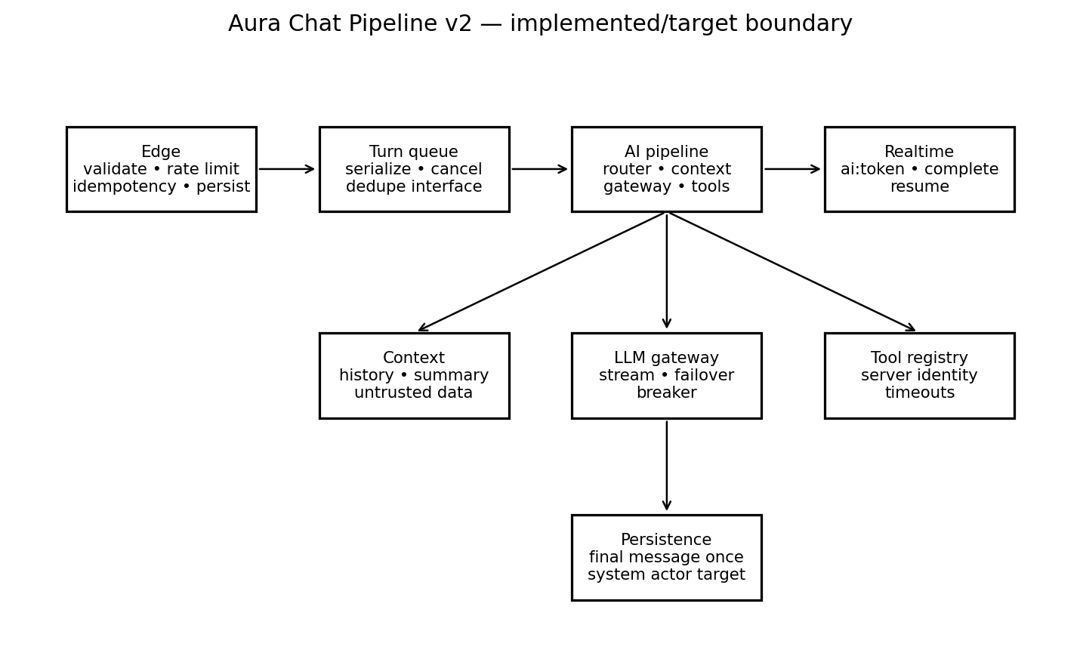
Figure 1. v2 module boundary. A Mermaid renderer was unavailable in the execution environment; this equivalent rendered diagram is included. Mermaid-rendered output is NEEDS VERIFICATION.

5.1 Implemented interfaces
The archive contains config, router, context builder, output guard, pipeline, circuit breaker, LLM gateway, keyed turn queue, tool registry and turn-trace modules. Integration emits ai:token/ai:complete, persists the final v2 bot message once, and attempts the ai_handling → escalated transition atomically.

5.2 Required increments
Add 202 edge acceptance with idempotency persistence; durable BullMQ/Redis workers; Redis Socket.IO adapter; explicit system actor; rolling summary storage; retrieval cache; typed event contracts; provider health ordering/hedging; production metrics and alerting.

6 Benchmark and SLO results
Measure | Executed result | Target | Status
Deterministic router | 41 prompts; mean ~0.006 ms; max ~0.118 ms | <50 ms | PASS, local router only
No-tool TTFT | Not measured | p50 <1.2 s; p95 <2.5 s | NEEDS VERIFICATION
Tool total | Not measured | p50 <3 s; p95 <6 s | NEEDS VERIFICATION
Provider outage | Not measured | <6 s degraded | NEEDS VERIFICATION
Pre-LLM DB ops | Not instrumented | <=3 | NEEDS VERIFICATION
The requested baseline-vs-Turfio 40-prompt benchmark is not implemented by the existing harness; it currently exercises the deterministic router only. No untested latency, failure or fallback numbers are reported.

7 Test and verification results
Executed v2 Node suite: 8/8 passed: declared-tool/handler parity, server-controlled identity, anchored routing, URL guard, queue serialization, SSE parsing and guest/account security checks.
Strengthened full gate: BLOCKED. Backend v2 tests, syntax checks and router benchmark passed. Frontend lint/customer build/admin build could not execute because eslint/vite were unavailable while npm ci remained incomplete. Two consecutive clean full passes were not achieved.
Integrity: non-example .env SHA-256 set unchanged and frontend/backend .git SHA-256 set unchanged. No clean commits were created because the standing preservation constraint forbids modifying .git. The supplied backend was already on feat/chat-pipeline-v2; this deliverable conflict was not silently bypassed.

8 Rollout and rollback
Complete parity/evals with v1 intact; shadow v2 with responses suppressed; canary by stable conversation hash; increase only under agreed error/fallback/handoff/latency thresholds; kill switch back to v1; preserve backward-compatible persistence fields through the rollback window. Do not canary until durable queue/realtime multi-node behavior and guest abuse limits are verified.

9 Remaining risks and migration notes
Highest risks: durability/horizontal scaling, incomplete edge idempotency/rate limiting, missing rolling summaries/retrieval cache, incomplete system-actor migration, lack of 100+ golden evals/load/E2E/failure-injection suites, and unverified live provider/model health. Production enablement remains blocked until closed or explicitly accepted.

References
Groq (2026a) ‘Model Deprecation’. GroqDocs. Available at: https://console.groq.com/docs/deprecations (Accessed: 29 September 2026).
Groq (2026b) ‘OpenAI GPT-OSS 120B’. GroqDocs. Available at: https://console.groq.com/docs/model/openai/gpt-oss-120b (Accessed: 29 September 2026).
Groq (2026c) ‘Rate Limits’. GroqDocs. Available at: https://console.groq.com/docs/rate-limits (Accessed: 29 September 2026).
OWASP Foundation (2023) OWASP API Security Top 10. OWASP.
OWASP Foundation (2021) OWASP Top 10. OWASP.
NIST (2020) Digital Identity Guidelines: Authentication and Lifecycle Management, SP 800-63B.
IETF (2020) JSON Web Token Best Current Practices, RFC 8725.
MITRE (2026) Common Weakness Enumeration (CWE).

