Host Preference Test
Priya Shahi
2026-04-23

Overview
This analysis examines the host preference of Bemisia tabaci (sweetpotato whitefly) in dual-choice bioassays comparing aromatic herb companions (Mint, Sage, Basil) against Cotton as the primary host. Eggs and nymphs deposited on each plant type serve as proxies for oviposition preference and nymphal establishment, respectively.
Three separate choice arenas were tested:
- Arena 1: Mint vs. Cotton
- Arena 2: Sage vs. Cotton
- Arena 3: Basil vs. Cotton

Load and Reshape Data
raw <- read_csv("Project_data.csv")
head(raw)
## # A tibble: 6 × 12
## Replication Plant Eggs Nymph Replication.1 Plant.1 Eggs.1 Nymph.1
## <dbl> <chr> <dbl> <dbl> <dbl> <chr> <dbl> <dbl>
## 1 1 Mint 99 52 1 Sage 33 7
## 2 1 Cotton 58 14 1 Cotton 40 31
## 3 2 Mint 10 5 2 Sage 17 2
## 4 2 Cotton 27 10 2 Cotton 98 77
## 5 3 Mint 25 0 3 Sage 25 10
## 6 3 Cotton 54 5 3 Cotton 212 160
## # ℹ 4 more variables: Replication.2 <dbl>, Plant.2 <chr>, Eggs.2 <dbl>,
## # Nymph.2 <dbl>
names(raw)
## [1] "Replication" "Plant" "Eggs" "Nymph"
## [5] "Replication.1" "Plant.1" "Eggs.1" "Nymph.1"
## [9] "Replication.2" "Plant.2" "Eggs.2" "Nymph.2"
find("select")
## [1] "package:MASS" "package:dplyr"
# Arena 1: Mint vs Cotton
arena1 <- raw %>%
dplyr::select(Replication, Plant, Eggs, Nymph) %>%
mutate(Arena = "Mint vs Cotton")
# Arena 2: Sage vs Cotton
arena2 <- raw %>%
dplyr::select(Replication = Replication.1, Plant = Plant.1,
Eggs = Eggs.1, Nymph = Nymph.1) %>%
mutate(Arena = "Sage vs Cotton")
# Arena 3: Basil vs Cotton
arena3 <- raw %>%
dplyr::select(Replication = Replication.2, Plant = Plant.2,
Eggs = Eggs.2, Nymph = Nymph.2) %>%
mutate(Arena = "Basil vs Cotton")
# Combine all arenas
df <- rbind(arena1, arena2, arena3) %>%
mutate(
Plant = as.factor(Plant),
Arena = as.factor(Arena),
Replication = as.factor(Replication)
)
head(df)
## # A tibble: 6 × 5
## Replication Plant Eggs Nymph Arena
## <fct> <fct> <dbl> <dbl> <fct>
## 1 1 Mint 99 52 Mint vs Cotton
## 2 1 Cotton 58 14 Mint vs Cotton
## 3 2 Mint 10 5 Mint vs Cotton
## 4 2 Cotton 27 10 Mint vs Cotton
## 5 3 Mint 25 0 Mint vs Cotton
## 6 3 Cotton 54 5 Mint vs Cotton
glimpse(df)
## Rows: 180
## Columns: 5
## $ Replication <fct> 1, 1, 2, 2, 3, 3, 4, 4, 5, 5, 6, 6, 7, 7, 8, 8, 9, 9, 10, …
## $ Plant <fct> Mint, Cotton, Mint, Cotton, Mint, Cotton, Mint, Cotton, Mi…
## $ Eggs <dbl> 99, 58, 10, 27, 25, 54, 23, 64, 2, 35, 18, 51, 0, 62, 10, …
## $ Nymph <dbl> 52, 14, 5, 10, 0, 5, 2, 14, 1, 19, 7, 18, 0, 36, 0, 7, 3, …
## $ Arena <fct> Mint vs Cotton, Mint vs Cotton, Mint vs Cotton, Mint vs Co…

Summary Statistics
summary_stats <- df %>%
group_by(Arena, Plant) %>%
summarise(
n = n(),
mean_eggs = mean(Eggs, na.rm = TRUE),
sd_eggs = sd(Eggs, na.rm = TRUE),
se_eggs = sd_eggs / sqrt(n),
mean_nymph = mean(Nymph, na.rm = TRUE),
sd_nymph = sd(Nymph, na.rm = TRUE),
se_nymph = sd_nymph / sqrt(n),
.groups = "drop"
)
knitr::kable(summary_stats, digits = 2,
caption = "Summary statistics: Mean eggs and nymphs per plant type per arena")
Summary statistics: Mean eggs and nymphs per plant type per arena
Arena | Plant | n | mean_eggs | sd_eggs | se_eggs | mean_nymph | sd_nymph | se_nymph
Basil vs Cotton | Basil | 30 | 13.67 | 15.82 | 2.89 | 5.27 | 9.85 | 1.80
Basil vs Cotton | Cotton | 30 | 40.47 | 30.44 | 5.56 | 30.00 | 23.63 | 4.31
Mint vs Cotton | Cotton | 30 | 42.77 | 30.60 | 5.59 | 12.50 | 7.66 | 1.40
Mint vs Cotton | Mint | 30 | 18.93 | 21.99 | 4.01 | 6.00 | 10.75 | 1.96
Sage vs Cotton | Cotton | 30 | 64.90 | 46.92 | 8.57 | 46.77 | 36.63 | 6.69
Sage vs Cotton | Sage | 30 | 26.37 | 22.42 | 4.09 | 13.80 | 16.89 | 3.08

Preference Index (PI)
The Preference Index quantifies the relative attractiveness of each plant in a dual-choice arena:
$$PI=\frac{N_{herb}−N_{cotton}}{N_{herb}+N_{cotton}}$$
PI > 0: preference for herb; PI < 0: preference for Cotton; PI = 0: no preference.
pi_data <- df %>%
group_by(Arena, Replication, Plant) %>%
summarise(Eggs = sum(Eggs), Nymph = sum(Nymph), .groups = "drop") %>%
pivot_wider(names_from = Plant, values_from = c(Eggs, Nymph)) %>%
mutate(
herb_eggs = case_when(
Arena == "Mint vs Cotton" ~ Eggs_Mint,
Arena == "Sage vs Cotton" ~ Eggs_Sage,
Arena == "Basil vs Cotton" ~ Eggs_Basil
),
herb_nymph = case_when(
Arena == "Mint vs Cotton" ~ Nymph_Mint,
Arena == "Sage vs Cotton" ~ Nymph_Sage,
Arena == "Basil vs Cotton" ~ Nymph_Basil
)
)
# Compute PI per arena dynamically
pi_calc <- df %>%
group_by(Arena, Replication) %>%
summarise(
herb_plant = Plant[Plant != "Cotton"][1],
herb_eggs = Eggs[Plant != "Cotton"],
cotton_eggs = Eggs[Plant == "Cotton"],
herb_nymph = Nymph[Plant != "Cotton"],
cotton_nymph = Nymph[Plant == "Cotton"],
.groups = "drop"
) %>%
mutate(
PI_eggs = (herb_eggs - cotton_eggs) / (herb_eggs + cotton_eggs + 1e-6),
PI_nymph = (herb_nymph - cotton_nymph) / (herb_nymph + cotton_nymph + 1e-6)
)
pi_summary <- pi_calc %>%
group_by(Arena, herb_plant) %>%
summarise(
mean_PI_eggs = mean(PI_eggs, na.rm = TRUE),
se_PI_eggs = sd(PI_eggs, na.rm = TRUE) / sqrt(n()),
mean_PI_nymph = mean(PI_nymph, na.rm = TRUE),
se_PI_nymph = sd(PI_nymph, na.rm = TRUE) / sqrt(n()),
.groups = "drop"
)
knitr::kable(pi_summary, digits = 3,
caption = "Preference Index (PI): negative = preference for Cotton")
Preference Index (PI): negative = preference for Cotton
Arena | herb_plant | mean_PI_eggs | se_PI_eggs | mean_PI_nymph | se_PI_nymph
Basil vs Cotton | Basil | -0.484 | 0.087 | -0.725 | 0.071
Mint vs Cotton | Mint | -0.395 | 0.095 | -0.444 | 0.103
Sage vs Cotton | Sage | -0.342 | 0.096 | -0.409 | 0.113

Figures

Figure 1 — Mean Eggs Deposited per Plant Type per Arena
egg_plot <- ggplot(summary_stats,
aes(x = Plant, y = mean_eggs, fill = Plant)) +
geom_col(color = "black", width = 0.6) +
geom_errorbar(aes(ymin = mean_eggs - se_eggs,
ymax = mean_eggs + se_eggs),
width = 0.2, linewidth = 0.6) +
facet_wrap(~ Arena, scales = "free_x") +
scale_fill_manual(values = c(
"Mint" = "#4CAF50",
"Sage" = "#8BC34A",
"Basil" = "#2E7D32",
"Cotton" = "#E8C96A"
)) +
labs(
title = expression(paste(italic("Bemisia tabaci"), " Oviposition Preference — Dual Choice Bioassay")),
x = "Plant Species",
y = "Mean Eggs Deposited (± SE)",
fill = "Plant"
) +
theme_classic(base_size = 12) +
theme(
plot.title = element_text(hjust = 0.5, face = "bold", size = 11),
strip.background = element_rect(fill = "grey90", color = "black"),
strip.text = element_text(face = "bold"),
legend.position = "none"
)
egg_plot
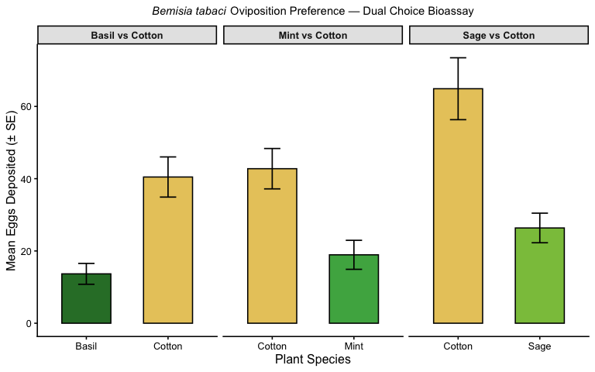
Mean number of eggs deposited on herb vs. Cotton across three choice arenas. Error bars represent ± 1 SE.

Figure 2 — Mean Nymphs per Plant Type per Arena
nymph_plot <- ggplot(summary_stats,
aes(x = Plant, y = mean_nymph, fill = Plant)) +
geom_col(color = "black", width = 0.6) +
geom_errorbar(aes(ymin = mean_nymph - se_nymph,
ymax = mean_nymph + se_nymph),
width = 0.2, linewidth = 0.6) +
facet_wrap(~ Arena, scales = "free_x") +
scale_fill_manual(values = c(
"Mint" = "#4CAF50",
"Sage" = "#8BC34A",
"Basil" = "#2E7D32",
"Cotton" = "#E8C96A"
)) +
labs(
title = expression(paste(italic("Bemisia tabaci"), " Nymphal Establishment — Dual Choice Bioassay")),
x = "Plant Species",
y = "Mean Nymphs (± SE)",
fill = "Plant"
) +
theme_classic(base_size = 12) +
theme(
plot.title = element_text(hjust = 0.5, face = "bold", size = 11),
strip.background = element_rect(fill = "grey90", color = "black"),
strip.text = element_text(face = "bold"),
legend.position = "none"
)
nymph_plot
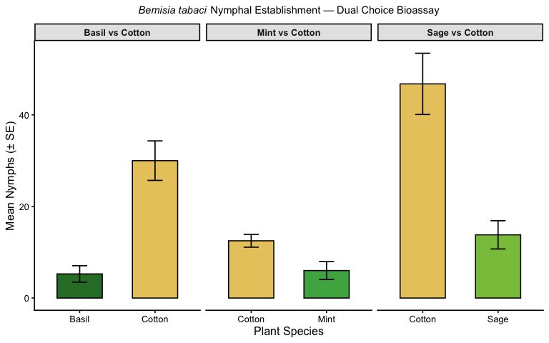
Mean number of nymphs recorded on herb vs. Cotton across three choice arenas. Error bars represent ± 1 SE.

Figure 3 — Preference Index by Arena
pi_long <- pi_summary %>%
pivot_longer(
cols = c(mean_PI_eggs, mean_PI_nymph),
names_to = "Metric",
values_to = "PI"
) %>%
mutate(
se = ifelse(
Metric == "mean_PI_eggs",
pi_summary$se_PI_eggs[match(Arena, pi_summary$Arena)],
pi_summary$se_PI_nymph[match(Arena, pi_summary$Arena)]
),
Metric = recode(Metric,
mean_PI_eggs = "Eggs",
mean_PI_nymph = "Nymphs"
)
)
pi_plot <- ggplot(pi_long, aes(x = Arena, y = PI, fill = Metric)) +
geom_col(position = position_dodge(0.7), width = 0.6, color = "black") +
geom_errorbar(aes(ymin = PI - se, ymax = PI + se),
position = position_dodge(0.7), width = 0.2) +
geom_hline(yintercept = 0, linetype = "dashed", color = "red", linewidth = 0.7) +
scale_fill_manual(values = c("Eggs" = "#5B8DB8", "Nymphs" = "#F4A460")) +
labs(
title = "Preference Index: Aromatic Herb vs Cotton",
x = "Choice Arena",
y = "Preference Index (PI)",
fill = "Life Stage"
) +
coord_flip() + # ✅ THIS MAKES IT HORIZONTAL
theme_classic(base_size = 12) +
theme(
plot.title = element_text(hjust = 0.5, face = "bold"),
axis.text.x = element_text(angle = 0), # no need to tilt anymore
legend.position = "right"
)
pi_plot
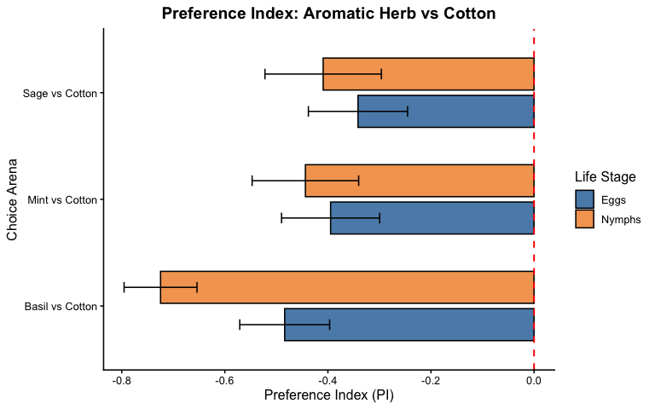
Preference Index (PI) for eggs and nymphs per arena. PI < 0 indicates preference for Cotton over the aromatic herb.

Statistical Analysis

Wilcoxon Signed-Rank Test
# ---- EGGS ----
cat("=== ARENA 1: Mint vs Cotton (Eggs) ===\n")
## === ARENA 1: Mint vs Cotton (Eggs) ===
mint_eggs <- df %>%
filter(Arena == "Mint vs Cotton") %>%
dplyr::select(Replication, Plant, Eggs) %>%
pivot_wider(names_from = Plant, values_from = Eggs)
print(wilcox.test(mint_eggs$Mint, mint_eggs$Cotton, paired = TRUE))
##
## Wilcoxon signed rank test with continuity correction
##
## data: mint_eggs$Mint and mint_eggs$Cotton
## V = 76, p-value = 0.001331
## alternative hypothesis: true location shift is not equal to 0
cat("\n=== ARENA 2: Sage vs Cotton (Eggs) ===\n")
##
## === ARENA 2: Sage vs Cotton (Eggs) ===
sage_eggs <- df %>%
filter(Arena == "Sage vs Cotton") %>%
dplyr::select(Replication, Plant, Eggs) %>%
pivot_wider(names_from = Plant, values_from = Eggs)
print(wilcox.test(sage_eggs$Sage, sage_eggs$Cotton, paired = TRUE))
##
## Wilcoxon signed rank test with continuity correction
##
## data: sage_eggs$Sage and sage_eggs$Cotton
## V = 79, p-value = 0.001645
## alternative hypothesis: true location shift is not equal to 0
cat("\n=== ARENA 3: Basil vs Cotton (Eggs) ===\n")
##
## === ARENA 3: Basil vs Cotton (Eggs) ===
basil_eggs <- df %>%
filter(Arena == "Basil vs Cotton") %>%
dplyr::select(Replication, Plant, Eggs) %>%
pivot_wider(names_from = Plant, values_from = Eggs)
print(wilcox.test(basil_eggs$Basil, basil_eggs$Cotton, paired = TRUE))
##
## Wilcoxon signed rank test with continuity correction
##
## data: basil_eggs$Basil and basil_eggs$Cotton
## V = 62.5, p-value = 0.0004887
## alternative hypothesis: true location shift is not equal to 0
# ---- NYMPHS ----
cat("\n=== ARENA 1: Mint vs Cotton (Nymph) ===\n")
##
## === ARENA 1: Mint vs Cotton (Nymph) ===
mint_nymph <- df %>%
filter(Arena == "Mint vs Cotton") %>%
dplyr::select(Replication, Plant, Nymph) %>%
pivot_wider(names_from = Plant, values_from = Nymph)
print(wilcox.test(mint_nymph$Mint, mint_nymph$Cotton, paired = TRUE))
##
## Wilcoxon signed rank test with continuity correction
##
## data: mint_nymph$Mint and mint_nymph$Cotton
## V = 77.5, p-value = 0.002532
## alternative hypothesis: true location shift is not equal to 0
cat("\n=== ARENA 2: Sage vs Cotton (Nymph) ===\n")
##
## === ARENA 2: Sage vs Cotton (Nymph) ===
sage_nymph <- df %>%
filter(Arena == "Sage vs Cotton") %>%
dplyr::select(Replication, Plant, Nymph) %>%
pivot_wider(names_from = Plant, values_from = Nymph)
print(wilcox.test(sage_nymph$Sage, sage_nymph$Cotton, paired = TRUE))
##
## Wilcoxon signed rank test with continuity correction
##
## data: sage_nymph$Sage and sage_nymph$Cotton
## V = 65, p-value = 0.000591
## alternative hypothesis: true location shift is not equal to 0
cat("\n=== ARENA 3: Basil vs Cotton (Nymph) ===\n")
##
## === ARENA 3: Basil vs Cotton (Nymph) ===
basil_nymph <- df %>%
filter(Arena == "Basil vs Cotton") %>%
dplyr::select(Replication, Plant, Nymph) %>%
pivot_wider(names_from = Plant, values_from = Nymph)
print(wilcox.test(basil_nymph$Basil, basil_nymph$Cotton, paired = TRUE))
##
## Wilcoxon signed rank test with continuity correction
##
## data: basil_nymph$Basil and basil_nymph$Cotton
## V = 19.5, p-value = 1.235e-05
## alternative hypothesis: true location shift is not equal to 0

