Homework_DataVis2
Priya Shahi
2026-02-26

Figure2a
library(ggplot2)
library(ggpubr)
library(ggrepel)
library(tidyverse)
## ── Attaching core tidyverse packages ──────────────────────── tidyverse 2.0.0 ──
## ✔ dplyr 1.2.0 ✔ readr 2.1.6
## ✔ forcats 1.0.1 ✔ stringr 1.6.0
## ✔ lubridate 1.9.4 ✔ tibble 3.3.1
## ✔ purrr 1.2.1 ✔ tidyr 1.3.2
## ── Conflicts ────────────────────────────────────────── tidyverse_conflicts() ──
## ✖ dplyr::filter() masks stats::filter()
## ✖ dplyr::lag() masks stats::lag()
## ℹ Use the conflicted package (<http://conflicted.r-lib.org/>) to force all conflicts to become errors
cbbPalette <- c("#E69F00", "#56B4E9", "#009E73")
sample.data.bac <- read.csv("BacterialAlpha.csv", na.strings = "na")
head(sample.data.bac)
## Code Crop Time_Point Replicate Water_Imbibed shannon invsimpson simpson
## 1 S01_13 Soil 0 1 NA 6.624921 210.7279 0.9952545
## 2 S02_16 Soil 0 2 NA 6.612413 206.8666 0.9951660
## 3 S03_19 Soil 0 3 NA 6.660853 213.0184 0.9953056
## 4 S04_22 Soil 0 4 NA 6.660671 204.6908 0.9951146
## 5 S05_25 Soil 0 5 NA 6.610965 200.2552 0.9950064
## 6 S06_28 Soil 0 6 NA 6.650812 199.3211 0.9949830
## richness even
## 1 3319 0.8171431
## 2 3079 0.8232216
## 3 3935 0.8046776
## 4 3922 0.8049774
## 5 3196 0.8192376
## 6 3481 0.8155427
sample.data.bac$Time_Point <- as.factor(sample.data.bac$Time_Point)
sample.data.bac$Crop <- as.factor(sample.data.bac$Crop)
sample.data.bac$Crop <- factor(sample.data.bac$Crop, levels = c("Soil", "Cotton", "Soybean"))
str(sample.data.bac)
## 'data.frame': 70 obs. of 10 variables:
## $ Code : chr "S01_13" "S02_16" "S03_19" "S04_22" ...
## $ Crop : Factor w/ 3 levels "Soil","Cotton",..: 1 1 1 1 1 1 1 1 1 1 ...
## $ Time_Point : Factor w/ 4 levels "0","6","12","18": 1 1 1 1 1 1 2 2 2 2 ...
## $ Replicate : int 1 2 3 4 5 6 1 2 3 4 ...
## $ Water_Imbibed: num NA NA NA NA NA NA NA NA NA NA ...
## $ shannon : num 6.62 6.61 6.66 6.66 6.61 ...
## $ invsimpson : num 211 207 213 205 200 ...
## $ simpson : num 0.995 0.995 0.995 0.995 0.995 ...
## $ richness : int 3319 3079 3935 3922 3196 3481 3250 3170 3657 3177 ...
## $ even : num 0.817 0.823 0.805 0.805 0.819 ...
####### Bacterial evenness; Figure 2a ########
bac.even <- ggplot(sample.data.bac, aes(x = Time_Point, y = even, color = Crop)) + # Define aesthetics: x-axis as Time.Point, y-axis as even, and color by Crop
geom_boxplot(position = position_dodge(0.85)) + # Add boxplots with dodged positions to avoid overlap
geom_point(position = position_jitterdodge(0.05)) + # Add jittered points to show individual data points, avoiding overlap
ylab("Pielou's evenness") + # Label the y-axis
xlab("Hours post sowing") + # Label the x-axis
scale_color_manual(values = cbbPalette, name = "", labels = c("Soil no seeds", "Cotton spermosphere", "Soybean spermosphere")) + # Manually set colors and labels for the Crop variable
theme_classic() # Use a classic theme for the plot
bac.even
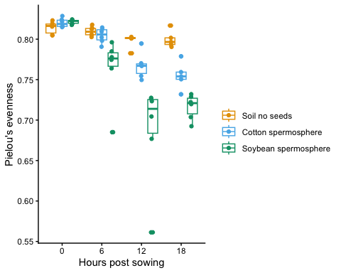
bac.even <- ggplot(sample.data.bac,
aes(x = Time_Point, y = even, color = Crop)) +
geom_boxplot(position = position_dodge(0.85)) +
geom_point(shape = 21, fill = "white", color = "black",
position = position_jitterdodge(jitter.width = 0.2, dodge.width = 0.85)) +
ylab("Pielou's evenness") +
xlab("Hours post sowing") +
scale_color_manual(
values = c("#E69F00", "#56B4E9", "#009E73"), # three distinct colors
name = "",
labels = c("Soil no seeds", "Cotton spermosphere", "Soybean spermosphere")
) +
theme_classic()
bac.even
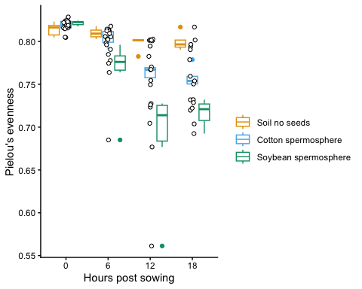

Figure2b
####### Water Imbibition correlate with bacterial evenness; Figure 2b #####
sample.data.bac.nosoil <- subset(sample.data.bac, Crop != "Soil")
water.imbibed <- ggplot(sample.data.bac.nosoil,
aes(Time_Point, 1000 * Water_Imbibed, color = Crop)) +
geom_jitter(width = 0.5, alpha = 0.5) +
stat_summary(fun = mean, geom = "line", aes(group = Crop)) +
stat_summary(fun.data = mean_se, geom = "errorbar", width = 0.5) +
xlab("Hours post sowing") +
ylab("Water Imbibed (mg)") +
scale_color_manual(
values = c("#56B4E9", "#009E73"), # two valid colors
name = "",
labels = c("Cotton", "Soybean")
) +
theme_classic() +
theme(strip.background = element_blank(), legend.position = "none") +
facet_wrap(~Crop, scales = "free")
water.imbibed
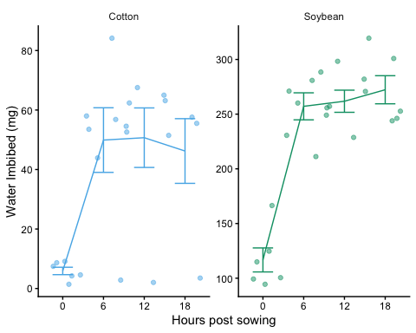

Figure2c
##### Figure 2c #####
water.imbibed.cor <- ggplot(sample.data.bac.nosoil,
aes(x = 1000 * Water_Imbibed,
y = even,
color = Crop)) +
geom_point(aes(shape = Time_Point), size = 3) + # Points indexed by Time_Point
geom_smooth(method = lm,
se = FALSE,
aes(group = Crop)) + # One regression line per Crop
xlab("Water Imbibed (mg)") +
ylab("Pielou's evenness") +
scale_color_manual(
values = c(cbbPalette[[1]], cbbPalette[[2]]),
name = ""
) +
scale_shape_manual(
values = c(15, 16, 17, 18),
name = "",
labels = c("0 hrs", "6 hrs", "12 hrs", "18 hrs")
) +
theme_classic() +
theme(strip.background = element_blank()) +
facet_wrap(~Crop, scales = "free")
water.imbibed.cor
## `geom_smooth()` using formula = 'y ~ x'
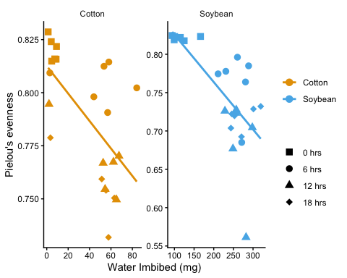
library(ggpubr)

Combine Figure2
# Arrange multiple ggplot objects into a single figure
figure2 <- ggarrange(
water.imbibed, # First plot: water.imbibed
bac.even, # Second plot: bac.even
water.imbibed.cor, # Third plot: water.imbibed.cor
labels = "auto", # Automatically label the plots (A, B, C, etc.)
nrow = 3, # Arrange the plots in 3 rows
ncol = 1, # Arrange the plots in 1 column
legend = FALSE # Do not include a legend in the combined figure
)
## `geom_smooth()` using formula = 'y ~ x'
figure2
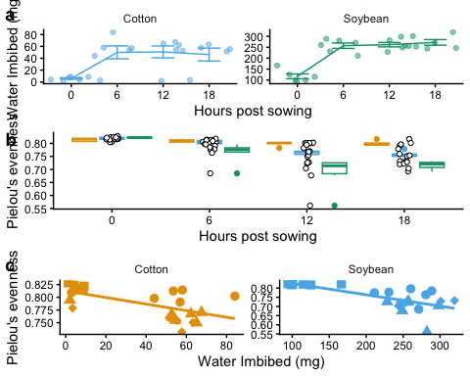

Signficance
bac.even +
stat_compare_means(method = "anova") # apply an anova to the groups
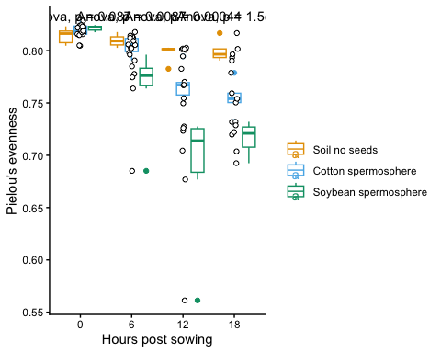
### Example with pvalues as significance levels
bac.even +
geom_pwc(aes(group = Crop), method = "t_test", label = "p.adj.format")
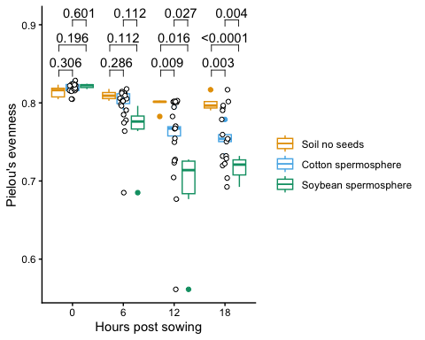
### example with * as significance levels
bac.even +
geom_pwc(aes(group = Crop), method = "t_test", label = "p.adj.signif")
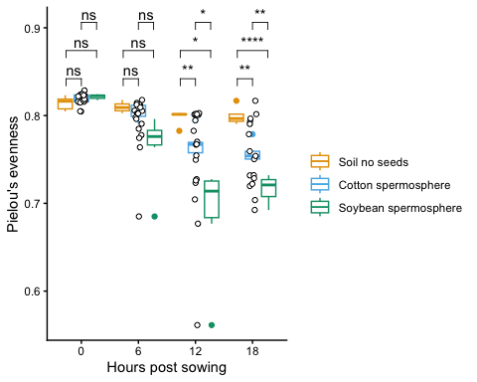
### Example with combined pvalue and * to indicate significance
bac.even +
geom_pwc(aes(group = Crop), method = "t_test", label = "{p.adj.format}{p.adj.signif}")
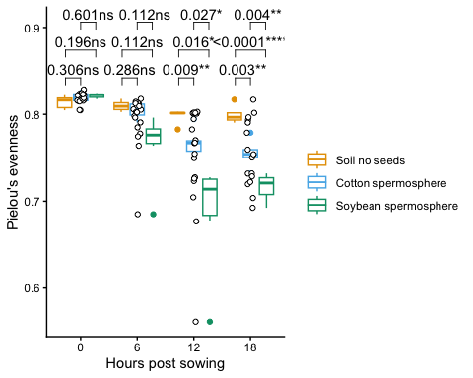
water.imbibed.cor +
stat_cor()
## `geom_smooth()` using formula = 'y ~ x'
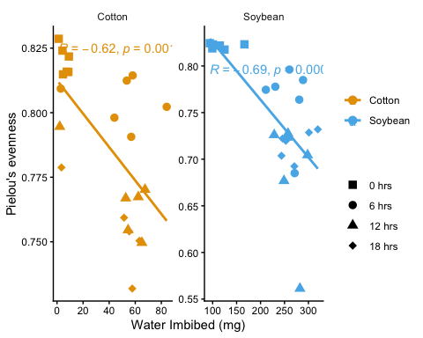
water.imbibed.cor +
stat_cor(label.y = 0.7) +
stat_regline_equation()
## `geom_smooth()` using formula = 'y ~ x'
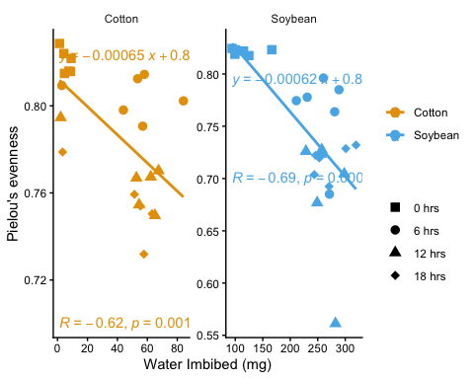
diff.abund <- read.csv("diff_abund.csv", na.strings = 'na')
str(diff.abund)
## 'data.frame': 2375 obs. of 16 variables:
## $ taxon : chr "BOTU_1387" "BOTU_1197" "BOTU_2475" "BOTU_1574" ...
## $ lfc_CropCotton : num 0.016 0.1019 -0.0503 0.1019 0.0791 ...
## $ lfc_CropSoybean : num -0.305 0.191 -0.0213 0.2592 0.9588 ...
## $ p_CropCotton : num 0.947 0.572 0.806 0.531 0.846 ...
## $ p_CropSoybean : num 0.193 0.28 0.915 0.103 0.016 ...
## $ q_CropCotton : num 1 1 1 1 1 1 1 1 1 1 ...
## $ q_CropSoybean : num 1 1 1 1 1 ...
## $ diff_CropCotton : logi FALSE FALSE FALSE FALSE FALSE FALSE ...
## $ diff_CropSoybean: logi FALSE FALSE FALSE FALSE FALSE FALSE ...
## $ Kingdom : chr "Bacteria" "Bacteria" "Bacteria" "Bacteria" ...
## $ Phylum : chr "Proteobacteria" "Proteobacteria" "Proteobacteria" "Proteobacteria" ...
## $ Class : chr "Gammaproteobacteria" "Gammaproteobacteria" "Gammaproteobacteria" "Gammaproteobacteria" ...
## $ Order : chr "Legionellales" "Diplorickettsiales" "Diplorickettsiales" "Diplorickettsiales" ...
## $ Family : chr "Legionellaceae" "Diplorickettsiaceae" "Diplorickettsiaceae" "Diplorickettsiaceae" ...
## $ Genus : chr "Legionella" "Aquicella" "Aquicella" "unidentified" ...
## $ Label : chr "BOTU_1387_Legionella" "BOTU_1197_Aquicella" "BOTU_2475_Aquicella" "BOTU_1574_Diplorickettsiaceae" ...
head(diff.abund)
## taxon lfc_CropCotton lfc_CropSoybean p_CropCotton p_CropSoybean
## 1 BOTU_1387 0.01600622 -0.30500531 0.9466551 0.192827692
## 2 BOTU_1197 0.10186637 0.19098423 0.5724439 0.279743828
## 3 BOTU_2475 -0.05031331 -0.02134244 0.8056191 0.915091288
## 4 BOTU_1574 0.10186637 0.25924872 0.5310377 0.103462114
## 5 BOTU_3 0.07914320 0.95882067 0.8457297 0.016049136
## 6 BOTU_145 0.47348726 1.09432567 0.1379480 0.000461554
## q_CropCotton q_CropSoybean diff_CropCotton diff_CropSoybean Kingdom
## 1 1 1 FALSE FALSE Bacteria
## 2 1 1 FALSE FALSE Bacteria
## 3 1 1 FALSE FALSE Bacteria
## 4 1 1 FALSE FALSE Bacteria
## 5 1 1 FALSE FALSE Bacteria
## 6 1 1 FALSE FALSE Bacteria
## Phylum Class Order Family
## 1 Proteobacteria Gammaproteobacteria Legionellales Legionellaceae
## 2 Proteobacteria Gammaproteobacteria Diplorickettsiales Diplorickettsiaceae
## 3 Proteobacteria Gammaproteobacteria Diplorickettsiales Diplorickettsiaceae
## 4 Proteobacteria Gammaproteobacteria Diplorickettsiales Diplorickettsiaceae
## 5 Proteobacteria Gammaproteobacteria Pseudomonadales Pseudomonadaceae
## 6 Proteobacteria Gammaproteobacteria Pseudomonadales Pseudomonadaceae
## Genus Label
## 1 Legionella BOTU_1387_Legionella
## 2 Aquicella BOTU_1197_Aquicella
## 3 Aquicella BOTU_2475_Aquicella
## 4 unidentified BOTU_1574_Diplorickettsiaceae
## 5 Pseudomonas BOTU_3_Pseudomonas
## 6 Pseudomonas BOTU_145_Pseudomonas

Make a volcano plot for Soybean vs. Soil
#Make a volcano plot for Soybean vs. Soil
diff.abund$log10_pvalue <- -log10(diff.abund$p_CropSoybean)
diff.abund.label <- diff.abund[diff.abund$log10_pvalue > 30,]
#Make the plot
ggplot() +
geom_point(data = diff.abund, aes(x = lfc_CropSoybean, y = log10_pvalue, color = diff_CropSoybean)) +
theme_classic() +
geom_text_repel(data = diff.abund.label, aes(x = lfc_CropSoybean, y = log10_pvalue, color = diff_CropSoybean, label = Label))
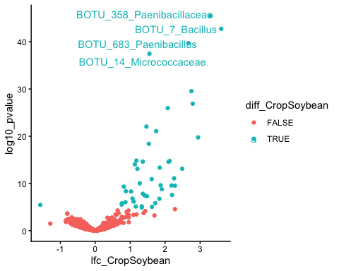

Volcano 1
volcano <- ggplot() +
geom_point(data = diff.abund, aes(x = lfc_CropSoybean, y = log10_pvalue, color = diff_CropSoybean)) +
geom_text_repel(data = diff.abund.label, aes(x = lfc_CropSoybean, y = log10_pvalue, color = diff_CropSoybean, label = Label)) +
scale_color_manual(values = cbbPalette, name = "Significant") +
theme_classic() +
xlab("Log fold change Soil vs. Soybean") +
ylab("-log10 p-value")
volcano
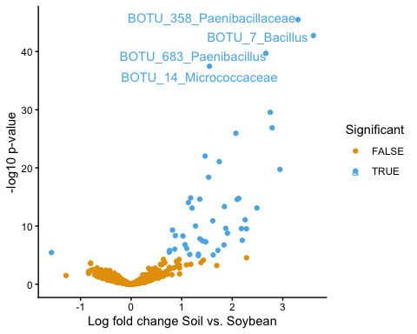

Volcano 2
volcano <- ggplot() +
geom_point(data = diff.abund, aes(x = lfc_CropSoybean, y = log10_pvalue)) +
geom_point(data = diff.abund.label, aes(x = lfc_CropSoybean, y = log10_pvalue), color = "red", shape = 17, size = 4) +
geom_text_repel(data = diff.abund.label, aes(x = lfc_CropSoybean, y = log10_pvalue, label = Label), color = "red") +
theme_classic() +
xlab("Log fold change Soil vs. Soybean") +
ylab("-log10 p-value")
volcano
