CodingChallenge5
Priya Shahi
2026-03-05
Table of Contents
Question 1 1
Question 2 1
Question 3 1
Question 4 2
Question 5 2
Question 6 3

Question 1
DiversityData <-read.csv("DiversityData.csv")
Metadata<- read.csv("Metadata.csv")

Question 2
alpha <- merge(DiversityData, Metadata, by = "Code")
colnames(alpha)
## [1] "Code" "shannon" "invsimpson" "simpson"
## [5] "richness" "Crop" "Time_Point" "Replicate"
## [9] "Water_Imbibed"

Question 3
library(dplyr)
##
## Attaching package: 'dplyr'
## The following objects are masked from 'package:stats':
##
## filter, lag
## The following objects are masked from 'package:base':
##
## intersect, setdiff, setequal, union
alpha_even <- alpha %>%
mutate(Pielou_evenness = shannon / log(richness))
colnames(alpha_even)
## [1] "Code" "shannon" "invsimpson" "simpson"
## [5] "richness" "Crop" "Time_Point" "Replicate"
## [9] "Water_Imbibed" "Pielou_evenness"

Question 4
library(tidyverse)
## ── Attaching core tidyverse packages ──────────────────────── tidyverse 2.0.0 ──
## ✔ forcats 1.0.1 ✔ readr 2.1.6
## ✔ ggplot2 4.0.2 ✔ stringr 1.6.0
## ✔ lubridate 1.9.4 ✔ tibble 3.3.1
## ✔ purrr 1.2.1 ✔ tidyr 1.3.2
## ── Conflicts ────────────────────────────────────────── tidyverse_conflicts() ──
## ✖ dplyr::filter() masks stats::filter()
## ✖ dplyr::lag() masks stats::lag()
## ℹ Use the conflicted package (<http://conflicted.r-lib.org/>) to force all conflicts to become errors
alpha_average <- alpha_even %>%
group_by(Crop, Time_Point) %>%
summarise(
Mean.even = mean(Pielou_evenness),
n = n(),
sd.dev = sd(Pielou_evenness)
) %>%
mutate(std.err = sd.dev / sqrt(n))
## `summarise()` has regrouped the output.
## ℹ Summaries were computed grouped by Crop and Time_Point.
## ℹ Output is grouped by Crop.
## ℹ Use `summarise(.groups = "drop_last")` to silence this message.
## ℹ Use `summarise(.by = c(Crop, Time_Point))` for per-operation grouping
## (`?dplyr::dplyr_by`) instead.

Question 5
alpha_average2 <- alpha_average %>%
select(Time_Point, Crop, Mean.even) %>%
pivot_wider(names_from = Crop, values_from = Mean.even) %>%
mutate(
diff.cotton.even = Soil - Cotton,
diff.soybean.even = Soil - Soybean
)

Question 6
plot_data <- alpha_average2 %>%
select(Time_Point, diff.cotton.even, diff.soybean.even) %>%
pivot_longer(
c(diff.cotton.even, diff.soybean.even),
names_to = "diff"
)
ggplot(plot_data, aes(x = Time_Point, y = value, color = diff)) +
geom_line() +
theme_minimal(base_size = 8, base_family = "Arial") + theme(panel.grid = element_blank(), axis.line = element_line(colour = "Black")) + labs(x = "Time (hrs)",
y = "Difference from soil in Pielou's evenness",
color = "diff"
)
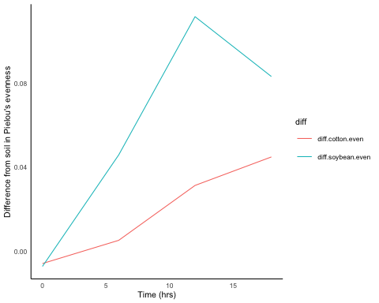 # Question 7 CodingChallenge5

