Programming Fundamentals Assignment

All questions and answers written below.
Some programs have been written in C, and some in C++.
Done by Mohammad Shahib

Question 1: What is a variable in C/C++?
Answer:
A variable is a named memory location used to store data in a program. Its value can change during program execution.
Example:
int age = 18;
Here, age is a variable that stores the value 18.

Question 2: Why do we use variables in programs?
Answer:
Variables are used to store data in a program so that it can be used, changed, and processed whenever needed.
Example:
int marks = 90;
Here, marks stores a student's marks.

Question 3: What is the difference between a variable name and its value?
Answer:
A variable name is the identifier of a variable, while a variable value is the data stored inside it.
Example:
int age = 18;
- Variable Name: age
- Variable Value: 18

Question 4: Which of the following is a valid variable name?
a) 2num
b) total_marks
c) for
d) my marks
Answer:
The correct answer is b) total_marks
Reason:
- 2num is invalid because variable names cannot start with a number.
- for is invalid because it is a reserved keyword.
- my marks is invalid because spaces are not allowed.
- total_marks is a valid variable name.
Question 5: Why is Age different from age?
Answer:
C/C++ is a case-sensitive language, meaning uppercase and lowercase letters are treated differently.
Example:
int Age = 20;
int age = 18;
Here, Age and age are considered two different variables.

Question 6: Can a variable name contain spaces? Why?
Answer:
No, a variable name cannot contain spaces because the compiler treats spaces as separators.
Wrong Example:
int my age = 18;
Correct Example:
int my_age = 18;

Question 7: Can a variable name start with an underscore (_) ?
Answer:
Yes, a variable name can start with an underscore (_).
Example:
int _marks = 95;

Question 8: What happens if two variables have the same name in the same scope?
Answer:
The compiler gives an error because two variables cannot have the same name in the same scope.
Example:
int age = 18;
int age = 20;
This will generate an error.

Question 9: Write three meaningful variable names for storing student information.
Answer:
- studentName
- studentAge
- studentMarks
These variable names are meaningful because they clearly describe the stored information.

Question 10: Which naming convention is better and why: studentMarks or sm?
Answer:
studentMarks is better because it is meaningful, readable, and easy to understand.
sm is not clear and may confuse programmers about what data it stores.
Question 11: What is a data type?
Answer:
A data type defines the type of data a variable can store in a program.
Example:
- int stores integers
- float stores decimal numbers
- char stores characters
int age = 18;
float marks = 89.5;
char grade = 'A';

Question 12: Which data type is used to store whole numbers?
Answer:
The int data type is used to store whole numbers.
Example:
int age = 20;
Here, 20 is a whole number stored using int.

Question 13: Which data type is used to store decimal values?
Answer:
The float or double data type is used to store decimal values.
Example:
float price = 99.99;

Question 14: What is the difference between float and double?
Answer:
float stores decimal numbers with less precision, while double stores decimal numbers with higher precision.
Example:
float num1 = 3.14;
double num2 = 3.1415926535;
double can store more digits after the decimal point.

Question 15: Which data type stores a single character?
Answer:
The char data type is used to store a single character.
Example:
char grade = 'A';

Question 16: Which data type stores True/False values?
Answer:
The bool data type is used to store True/False values.
Example:
bool isPassed = true;

Question 17: What data type is suitable for storing a person's name?
Answer:
The string data type is suitable for storing a person's name.
Example:
string name = "Rahul";

Question 18: Predict the output:
int age = 18;
cout << age;
Answer:
Output:
18
Explanation:
The value stored in age variable is 18, so cout displays 18.

Question 19: Identify the data type: 25, 3.14, 'A', true.
Answer:
Value | Data Type
25 | int
3.14 | float/double
'A' | char
true | bool

Question 20: What happens if you store a decimal number in an int variable?
Answer:
The decimal part gets removed automatically because int stores only whole numbers.
Example:
int num = 5.9;
cout << num;
Output:
5
The decimal part (.9) is removed.
Question 21: What is the purpose of cin?
Answer:
cin is used to take input from the user in C++.
Example:
int age;
cin >> age;
Here, the user enters a value for age.

Question 22: What is the purpose of cout?
Answer:
cout is used to display output on the screen in C++.
Example:
cout << "Hello";
This will display Hello on the screen.

Question 23: Which symbol is used with cin?
Answer:
The extraction operator (>>) is used with cin.
Example:
cin >> age;

Question 24: Which symbol is used with cout?
Answer:
The insertion operator (<<) is used with cout.
Example:
cout << age;

Question 25: Explain:
cin >> age;
Answer:
This statement takes input from the user and stores it in the variable age.
Explanation:
- cin → takes input
- >> → extraction operator
- age → variable where input is stored
Example:
If user enters 18, then age = 18.

Question 26: Explain:
cout << age;
Answer:
This statement displays the value stored in the variable age on the screen.
Explanation:
- cout → displays output
- << → insertion operator
- age → variable whose value will be printed
Example:
If age = 18, output will be:
18

Question 27: What is the purpose of endl?
Answer:
endl is used to move the cursor to the next line.
Example:
cout << "Hello" << endl;
cout << "World";
Output:
Hello
World

Question 28: Write a statement to input a student's marks.
Answer:
int marks;
cin >> marks;
This statement takes marks as input from the user.

Question 29: Write a statement to display 'Welcome to C++'.
Answer:
cout << "Welcome to C++";

Question 30: Predict the output:
cout << "Programming";
Answer:
Output:
Programming
Explanation:
cout prints the text written inside double quotation marks.
Question 31: What is an operator?
Answer:
An operator is a symbol used to perform operations on variables and values.
Examples of Operators:
- + → Addition
- - → Subtraction
- * → Multiplication
- / → Division
Example:
int sum = 10 + 5;
Here, + is an operator.

Question 32: Which operator is used for addition?
Answer:
The + (plus) operator is used for addition.
Example:
int sum = 10 + 5;
cout << sum;
Output:
15

Question 33: What is the result of 10 % 3?
Answer:
The result is 1.
Explanation:
The % (modulus) operator gives the remainder after division.
10 % 3 = 1
Because:
10 ÷ 3 = 3 remainder 1

Question 34: What is the result of 8 % 2?
Answer:
The result is 0.
Explanation:
8 % 2 = 0
Because:
8 is completely divisible by 2, so remainder is 0.

Question 35: Which operator checks equality?
Answer:
The == operator is used to check equality.
Example:
if (a == b)
This checks whether a is equal to b.

Question 36: What is the difference between = and == ?
Answer:
Operator | Purpose
= | Assignment operator
== | Equality operator
Example:
int a = 10;
= assigns value 10 to a.
if (a == 10)
== checks if a is equal to 10.

Question 37: What is the result of 5 > 3?
Answer:
The result is True.
Explanation:
Since 5 is greater than 3, the condition becomes true.
5 > 3 = true

Question 38: What does && represent?
Answer:
&& represents the Logical AND operator.
It returns true only when both conditions are true.
Example:
if (age > 18 && marks > 50)
Both conditions must be true.

Question 39: What does || represent?
Answer:
|| represents the Logical OR operator.
It returns true if at least one condition is true.
Example:
if (age > 18 || marks > 50)
Only one condition needs to be true.

Question 40: What does ! represent?
Answer:
! represents the Logical NOT operator.
It reverses the result of a condition.
Example:
!(5 > 3)
Since 5 > 3 is true, applying ! makes it false.
Result = false

Question 41: Write a program to print "Hello World"
Problem Statement
Write a program to display "Hello World" on the screen.
Algorithm
- Start the program
- Display "Hello World" using cout
- End the program
C++ Program
#include <iostream>
using namespace std;

int main()
{
cout << "Hello World";

return 0;
}
Explanation
- #include <iostream> → Used for input/output operations
- using namespace std; → Allows use of cout without std::
- cout → Displays output on screen
- return 0; → Ends the program successfully
Output
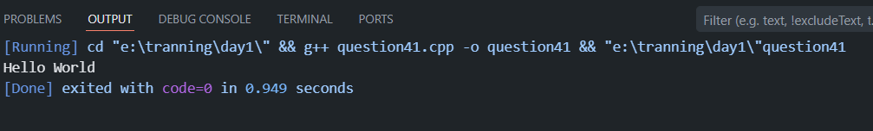

Question 42: Write a program to input two numbers and display their sum
Problem Statement
Write a program to take two numbers from the user and display their sum.
Algorithm
- Start the program
- Declare two variables
- Take input from user
- Add both numbers
- Display the result
- End the program
C++ Program
#include <iostream>
using namespace std;

int main()
{
int num1, num2, sum;

cout << "Enter first number: ";
cin >> num1;

cout << "Enter second number: ";
cin >> num2;

sum = num1 + num2;

cout << "Sum = " << sum;

return 0;
}
Explanation
- cin takes input from the user
- num1 + num2 adds both numbers
- Result is stored in sum
- cout displays the result
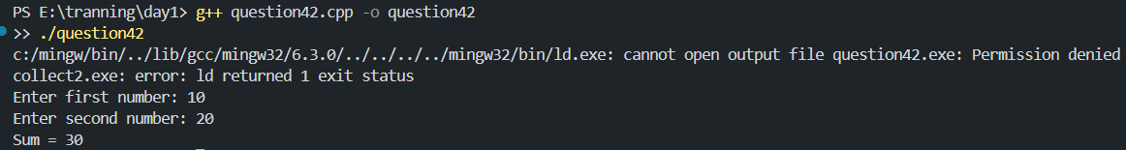

Question 43: Write a program to calculate the area of a rectangle
Problem Statement
Write a program to calculate the area of a rectangle.
Formula:
Area = Length × Breadth
Algorithm
- Start the program
- Declare variables for length and breadth
- Take input from user
- Calculate area
- Display area
- End the program
C Program
#include <stdio.h>

int main()
{
float length, breadth, area;

printf("Enter length: ");
scanf("%f", &length);

printf("Enter breadth: ");
scanf("%f", &breadth);

area = length * breadth;

printf("Area of Rectangle = %.2f", area);

return 0;
}
Explanation
- scanf() takes input
- length * breadth calculates area
- printf() displays output
- %.2f shows decimal values up to 2 places
Sample Run
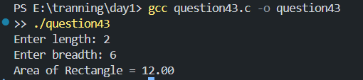
Question 44: What formula is used to calculate Simple Interest?
Answer
The formula used to calculate Simple Interest (SI) is:
SI = \frac{P \times R \times T}{100}
Where:
- P = Principal Amount
- R = Rate of Interest
- T = Time
- SI = Simple Interest
Example
If:
P = 1000, R = 5, T = 2
Then:
SI = (1000 × 5 × 2) / 100 = 100

Question 45: Write a program to calculate Simple Interest
Problem Statement
Write a program to calculate Simple Interest using principal, rate, and time.
Algorithm
- Start the program
- Declare variables
- Take principal, rate, and time as input
- Apply formula
- Display result
- End the program
C Program
#include <stdio.h>

int main()
{
float principal, rate, time, SI;

printf("Enter Principal Amount: ");
scanf("%f", &principal);

printf("Enter Rate of Interest: ");
scanf("%f", &rate);

printf("Enter Time: ");
scanf("%f", &time);

SI = (principal * rate * time) / 100;

printf("Simple Interest = %.2f", SI);

return 0;
}
Explanation
- User enters principal amount, rate, and time
- Formula is applied to calculate simple interest
- Result is displayed using printf()
Sample Run
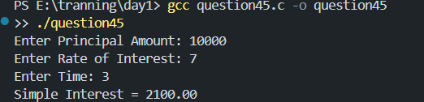

Question 46: Why is a temporary variable used while swapping two numbers?
Answer
A temporary variable is used to safely store one value while swapping two numbers so that the original value is not lost.
Example
Suppose:
a = 10
b = 20
If we directly do:
a = b;
b = a;
Both values become 20, which is wrong.
So we use a temporary variable:
temp = a;
a = b;
b = temp;
Now values are swapped correctly.

Question 47: Swap the values: a = 10, b = 20
Problem Statement
Write a program to swap two numbers using a temporary variable.
Algorithm
- Start the program
- Declare variables a, b, and temp
- Store value of a in temp
- Assign value of b to a
- Assign value of temp to b
- Display swapped values
- End the program
C++ Program
#include <iostream>
using namespace std;

int main()
{
int a = 10, b = 20, temp;

cout << "Before Swapping:" << endl;
cout << "a = " << a << endl;
cout << "b = " << b << endl;

temp = a;
a = b;
b = temp;

cout << "After Swapping:" << endl;
cout << "a = " << a << endl;
cout << "b = " << b << endl;

return 0;
}
Explanation
- temp = a stores value of a
- a = b copies value of b into a
- b = temp restores original value of a into b
- This swaps both numbers successfully
Output
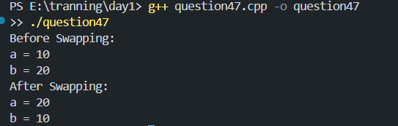
Question 48: What formula is used to convert Celsius into Fahrenheit?
Answer
The formula used to convert Celsius into Fahrenheit is:
F = \left(\frac{9}{5} \times C\right) + 32
Where:
- F = Fahrenheit
- C = Celsius
Example
If Celsius = 0°C
Then:
F = (9/5 × 0) + 32
F = 32°F

Question 49: What is the Fahrenheit value of 0°C?
Answer
Using the formula:
F = \left(\frac{9}{5} \times C\right) + 32
When:
C = 0°C
Calculation:
F = (9/5 × 0) + 32
F = 32°F
Final Answer:
The Fahrenheit value of 0°C is 32°F.

Question 50: Why can integer division give incorrect results in the Celsius-to-Fahrenheit program?
Answer
Integer division can give incorrect results because integers remove the decimal part.
For example:
5 / 9
This becomes:
0
instead of:
0.555...
So, if integer division is used in the Celsius-to-Fahrenheit formula, the answer may become wrong.
Correct Way
Use float or double for accurate decimal calculations.
Example Program (C)
#include <stdio.h>

int main()
{
float celsius, fahrenheit;

printf("Enter temperature in Celsius: ");
scanf("%f", &celsius);

fahrenheit = (9.0 / 5.0 * celsius) + 32;

printf("Temperature in Fahrenheit = %.2f", fahrenheit);

return 0;
}
Sample Run
