Ex. No.: 3b | Reverse Engineering
Date:

Aim:
To perform forward engineering by converting a UML model into executable database schema or source code. To understand the process of transforming system design diagrams into physical implementation. To automatically generate structured database tables or program code from the designed model using Visual Paradigm.
Description:
Reverse engineering is the process of analysing an existing implementation, such as source code or database schema, and converting it back into a higher-level design model. Unlike forward engineering, which moves from design to implementation, reverse engineering moves from implementation back to design.
In software development, reverse engineering is used when documentation is unavailable, incomplete, or outdated. By analysing source code, tools like Visual Paradigm can automatically extract class structures, attributes, methods, and relationships to generate a Class Diagram.
During reverse engineering from C++ code:
- Header and source files are scanned.
- Classes are identified.
- Attributes are extracted as class data members.
- Functions are recognized as methods.
- Inheritance and associations are reconstructed.
This process helps developers:
- Understand legacy systems
- Recover lost documentation
- Analyse system architecture
- Improve maintainability
- Validate consistency between code and design
Reverse engineering ensures that the generated UML diagram accurately reflects the current implementation of the system.

Procedure:
- Open Visual Paradigm.
- From the top menu, select
Tools → Code → Reverse C++ Code.
- Select the folder containing the existing .h and .cpp files.
- Choose the target package or diagram location in the project.
- Configure reverse engineering options (include relationships, detect inheritance, etc.).
- Click Reverse to allow Visual Paradigm to analyze the source files.
- The system automatically generates the corresponding Class Diagram.
- Verify that classes, attributes, methods, and relationships are correctly reconstructed.
- Save the generated diagram.
- Document the output.

Output:
Student Course Registration System Class Diagram generated automatically from existing C++ source code using Visual Paradigm.

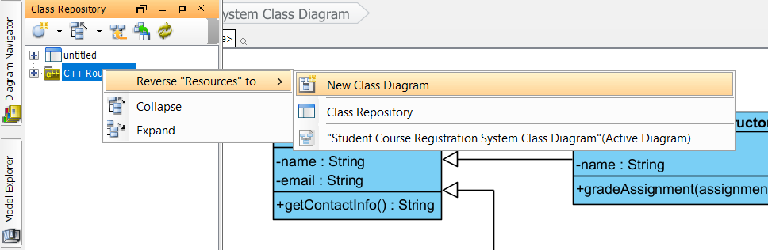
Selecting Reverse C++ Code option in Visual Paradigm

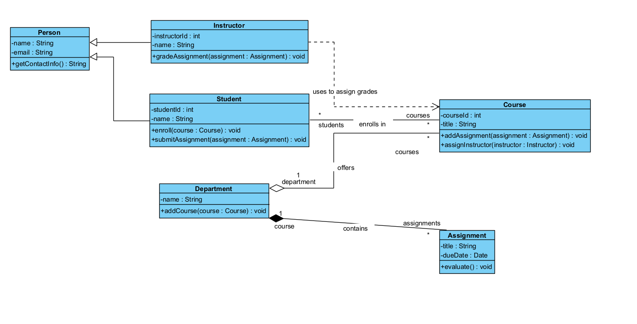
Class Diagram generated through Reverse Engineering
Result:
Reverse engineering was successfully performed to generate the Class Diagram from C++ source code. All classes, attributes, and relationships were accurately reconstructed using Visual Paradigm.

