FORMULATION AND EVALUATION OF A GEL FOR THE TREATMENT OF PSORIASIS USING GREEN SYNTHESIZED POLYHERBAL SILVER NANOPARTICLES

INTRODUCTION:
Psoriasis is a chronic autoimmune disorder characterized by inflammation, oxidative stress, and keratinocyte hyperproliferation [1, 2]. The condition continues to rise globally, with its multifactorial etiology such as immune dysfunction and toxin accumulation—posing challenges to effective treatment [3, 4]. Herbal medicines like Raktashodak Bati, along with bioactive extracts such as Neem and Manjistha, have been traditionally recognized for their role in managing psoriasis and other inflammatory skin disorders [10].
Conventional management of psoriasis often relies on corticosteroids, systemic immunosuppressants, and biologics, but long-term use is limited by adverse effects, high cost, and poor patient compliance. Issues such as drug resistance, symptom relapse, and dependency on synthetic medications further highlight the necessity for safer and sustainable alternatives [5, 6]. In this context, metallic nanoparticles—particularly silver nanoparticles (AgNPs)—have gained attention for their nanoscale properties, antimicrobial effects, anti-inflammatory action, and wound-healing potential. Their incorporation into drug delivery systems, wound dressings, and personal care products underscores their therapeutic versatility with minimal systemic toxicity [7–9].
The conventional chemical synthesis of nanoparticles poses cytotoxic risks due to toxic reducing and capping agents, whereas green synthesis using herbal extracts provides a safer and eco-friendly alternative. Phytochemicals like flavonoids, alkaloids, polyphenols, and terpenoids not only facilitate nanoparticle reduction but also stabilize them, ensuring safety and efficacy [11–13]. Raktashodak Bati, an Ayurvedic polyherbal formulation comprising Neem, Manjistha, Haridra, Guduchi, and other detoxifying herbs, is traditionally used to purify the blood, regulate immunity, and treat chronic dermal conditions. With its antioxidant, antimicrobial, and immunomodulatory benefits [14,15], this study emphasizes the formulation of a polyherbal silver nanoparticle–infused gel prepared from Raktashodak Bati extracts, aiming to characterize its properties and evaluate its therapeutic potential for psoriasis management.
MATERIALS AND METHODS:
Materials
Silver nitrate (AgNO₃) was purchased from Sigma Aldrich Pvt. Ltd., Mumbai, India. Raktashodak Bati tablets were obtained from a reputed Ayurvedic pharmacy, Chennai, India. Carbopol 940, triethanolamine (TEA), and glycerin were sourced from Loba Chemie Pvt. Ltd., Mumbai, India. All other solvents and reagents were of analytical grade. Nutrient agar and Mueller–Hinton agar for antimicrobial testing were procured from Himedia Pvt. Ltd., Mumbai, India. Standard bacterial strains of Staphylococcus aureus and Escherichia coli were obtained from the Microbial Type Culture Collection (MTCC), Chandigarh, India. Distilled and deionized water was used throughout the study.
TABLE 1: Herbal ingredients with the scientific name and their uses.
Ingredient | Scientific Name | Benefits
Neem | Azadirachta indica | Antibacterial, antifungal, and antiviral; helps in blood detoxification and skin healing.
Manjistha | Rubia cordifolia | Powerful blood purifier; supports the lymphatic system and reduces skin inflammation.
Haridra (Turmeric) | Curcuma longa | Rich in curcumin, known for its anti-inflammatory, antioxidant, and wound-healing properties.
Guduchi (Giloy) | Tinospora cordifolia | Boosts immunity, fights infections, and helps in managing autoimmune skin conditions like psoriasis.
Chirata | Swertia chirata | Acts as a liver detoxifier and blood purifier, helping in skin disease management.
Kutki | Picrorhiza kurroa | Supports liver function and detoxification, essential for treating skin disorders.
Daruharidra | Berberis aristata | Natural antimicrobial and anti-inflammatory herb used for skin diseases.
Bhringraj | Eclipta alba | Helps in reducing skin irritation, improves complexion, and supports liver function.
Triphala | (Amla, Haritaki, Bibhitaki) | Classic Ayurvedic formulation known for its detoxifying and rejuvenating effects.
Anantmool | Hemidesmus indicus | Traditionally used for blood purification and treating chronic skin conditions.
Aloe vera | Aloe barbadensis miller | Soothes and hydrates skin; has anti-inflammatory, antimicrobial, and wound-healing properties; promotes skin regeneration.

Preparation of Raktashodak Bati Extract
The herbal ingredients were finely powdered and sieved through mesh no. 60. About 30 g of powder was refluxed with 400 mL of distilled water at 60 °C for 30 min using a heating mantle. The mixture was cooled and filtered sequentially through muslin cloth and Whatman No. 1 filter paper. The resulting aqueous extract was stored at 4 °C and used as the reducing and stabilizing agent for nanoparticle synthesis [14, 15, 23–25].

Green Synthesis of Silver Nanoparticles
For nanoparticle synthesis, 10 mL of the prepared extract was added dropwise into 90 mL of 1 mM AgNO₃ solution with continuous stirring at room temperature. The solution was exposed to direct sunlight for 30 seconds to 1 minute, facilitating the bioreduction process, and a visible colour change from pale yellow to reddish brown confirmed the formation of silver nanoparticles [26–28]. The colloidal suspension was centrifuged at 10,000 rpm for 20 min, and the pellet was washed thrice with distilled water. The purified nanoparticles were dried at 40 °C and collected as fine powder [29–32].

Formulation of Herbal Silver Nanoparticle Gel
A gel base was prepared by dispersing 1 % w/w Carbopol 940 in distilled water with constant stirring. Glycerin (5 % w/w) was added as a humectant, and triethanolamine was used for neutralization. The dried herbal silver nanoparticles were incorporated into the gel base at concentrations of 0.5 % and 1 % w/w. The prepared gels were evaluated for pH, viscosity, spreadability, washability, drug content, and antimicrobial activity against S. aureus and E. coli [33–36].

Characterization of Synthesized AgNPs
The synthesized silver nanoparticles (AgNPs) were characterized using a series of analytical techniques to evaluate their physical properties, structural morphology, and stability. Each method provided specific insights into the chemical reduction, particle formation, and surface behavior of the material [29–32].

UV–Visible Spectroscopy
UV–Vis spectroscopy is a primary technique used to monitor the synthesis and confirm the presence of silver nanoparticles. A characteristic surface plasmon resonance (SPR) peak in the range of 420–450 nm indicates successful formation of AgNPs and reflects particle size distribution and stability [33–35]. Peak intensity and symmetry are useful indicators of nanoparticle uniformity and concentration [36].

Zeta Potential Analysis
Zeta potential measurement was employed to determine the surface charge and colloidal stability of the synthesized nanoparticles. The zeta potential reflects the potential difference between the dispersion medium and the stationary layer of fluid attached to the dispersed particle. Higher absolute zeta potential values (above ±30 mV) generally indicate good electrostatic stabilization and low aggregation tendency [37–39].

Scanning Electron Microscopy (SEM)
SEM analysis provided visual confirmation of nanoparticle surface morphology, particle size, and degree of agglomeration. Images typically revealed nearly spherical particles with uniform distribution, confirming that phytoconstituents in Raktashodak Bati extract acted as both reducing and capping agents [40–42].

Antimicrobial Studies
The synthesized silver nanoparticles were evaluated for antimicrobial activity using the standard agar well diffusion method against Staphylococcus aureus (Gram-positive) and Escherichia coli (Gram-negative). Zones of inhibition were measured after 24 h incubation at 37 °C to assess antibacterial potency [43–45]. The significant inhibition zones observed indicated broad-spectrum antimicrobial activity, attributed to silver ions’ interaction with bacterial cell walls and DNA [46–47].
RESULTS
Characterization of Synthesized AgNPs
UV-Visible Spectroscopy
The UV-Vis absorption spectrum showed a sharp surface plasmon resonance (SPR) band at 295–300 nm, confirming nanoparticle formation. The absorbance intensity increased with incubation time, demonstrating progressive reduction of silver ions. The narrow and symmetric peak indicated the uniformity of particle size distribution. This result closely agreed with earlier reports of plant-mediated synthesis of AgNPs [33-36].
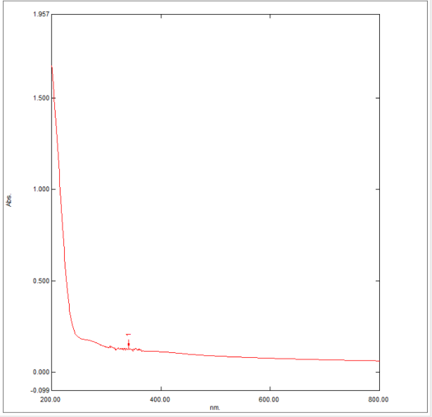
FIGURE 1: The UV-Visible spectrophotometric analysis of the synthesized silver nanoparticles displayed a characteristic absorption peak.
Zeta Potential Analysis
Zeta potential was employed to check the colloidal stability of the nanoparticles. The average zeta potential was recorded at −11.45 mV, with a more negative peak at −28.13 mV, indicating that adequate electrostatic repulsion existed among the particles to suspend them in aqueous media and prevent aggregation. This implies a stable surface charge on nanoparticles, which renders them suitable for biomedical applications [37-39].
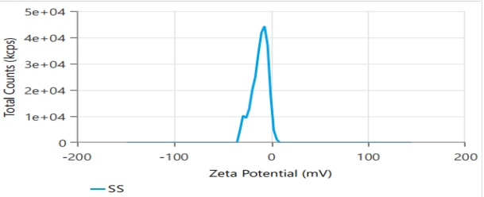
FIGURE 2: Zeta potential analysis was conducted to determine the stability of the synthesized nanoparticles in suspension.

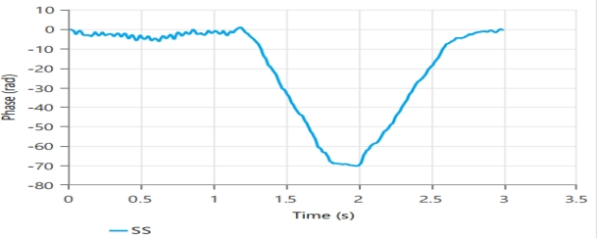
FIGURE 3: Phase analysis showing a distinct negative peak indicating particle interaction behaviour.
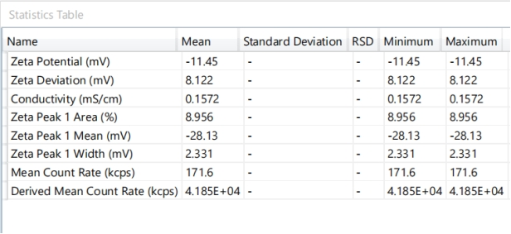
TABLE 2: Zeta potential statistics table revealed a negative surface charge, indicating moderate colloidal stability of the synthesized nanoparticles.
Scanning Electron Microscope (SEM)
The XRD analysis of the synthesized silver nanoparticles exhibited distinct diffraction peaks at 2θ values of 38.21°, 44.27°, 64.68°, and 77.59°, which corresponded to the (111), (200), (220), and (311) planes of the face-centered cubic structure of silver. The sharp and well-defined peaks confirmed the crystalline nature of the nanoparticles. The absence of additional impurity peaks verified the high purity of the synthesized sample. This observation was consistent with earlier findings on green-synthesized silver nanoparticles [40-42].

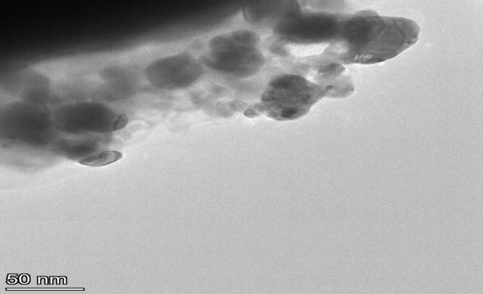
FIGURE 4: SEM analysis performed for the synthesised polyherbal silver nanoparticles.
Antimicrobial Activity
The antimicrobial activity of the synthesized silver nanoparticles was evaluated using the agar well diffusion method. Distinct zones of inhibition were observed against Staphylococcus aureus and Escherichia coli, confirming strong antibacterial potential. The mechanism of action was attributed to membrane disruption, oxidative stress, and inhibition of microbial replication. The inhibition was greater against E. coli, indicating broad-spectrum efficacy of the polyherbal AgNPs [43-47].

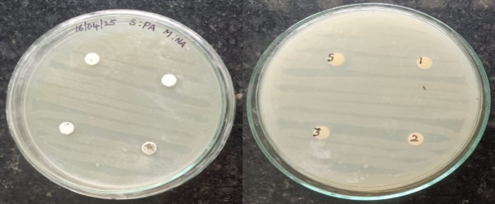
PICTURE 1: Antimicrobial activity of polyherbal silver nanoparticle formulations against Staphylococcus aureus using disk diffusion method.
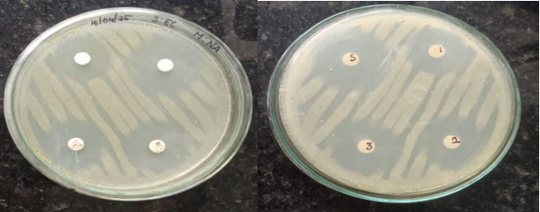
PICTURE 2: Antimicrobial activity of polyherbal silver nanoparticle formulations against Escherichia coli using the disk diffusion method.
PREPARED POLYHERBAL SILVER NANOPARTICLE GEL
Polyherbal gels incorporating silver nanoparticles at concentrations of 0.5% and 1% were successfully formulated. The gels displayed smooth texture, uniform dispersion of nanoparticles, and an aesthetically acceptable opaque olive-green appearance. These physicochemical characteristics confirmed their stability and suitability for topical application [33, 34, 48].
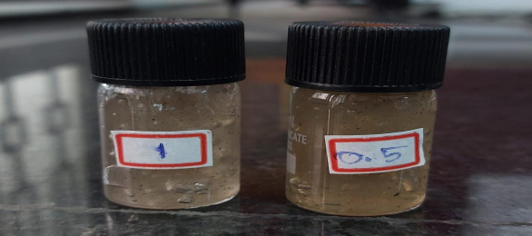
PICTURE 3: Prepared Polyherbal Silver Nanoparticle Gel Formulations in two different concentration (1% and 0.5%).
EVALUATION OF PREPARED GEL:
S.NO | NAME OF THE TEST PARAMETER | CONCENTRATION OF THE FORMULATION
 |  | 0.5% |  | 1%
1. | Physical Appearance | Opaque | Opaque
2. | Colour | Olive Green | Olive Green
3. | Texture | Smooth | Smooth
4. | Homogeneity | Homogeneous | Homogeneous
5. | pH | 5.2 | 5.6
6. | Conductivity test | 100 µS/cm | 150 µS/cm
7. | Spreadability test | 6.5cm | 6cm
8. | Washability test | Easily washable | Easily washable
9. | Centrifugation test | No separation observed | No separation observed
TABLE 3: Physicochemical Evaluation of Gel Formulations at Different Concentrations (0.5% and 1%).

Washability test
The washability of the polyherbal silver nanoparticle gel was assessed to evaluate ease of removal from the skin surface. Both 0.5% and 1% AgNP-loaded gels exhibited good washability, adhering adequately during application yet being easily removed with plain water. No sticky or greasy residue was observed after removal, ensuring patient comfort and cosmetic acceptability. This property is particularly important for conditions such as psoriasis, where frequent reapplication is necessary, confirming the formulation’s suitability for practical use [49, 50].
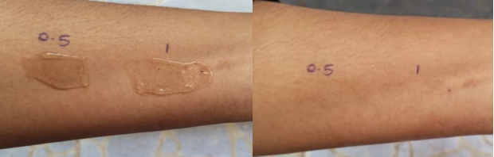
PICTURE 4: Evaluation of Skin Washability of Polyherbal Silver Nanoparticle Gel.
Spreadability
The spreadability of the gel was determined using the glass slide method, and the mean spreading diameter was recorded between 6.0 and 6.5 cm under standardized conditions. The 1% AgNP gel demonstrated slightly greater spreadability than the 0.5% gel, which was attributed to smoother texture and improved particle dispersion. These findings confirmed that the formulation can be applied uniformly across the skin surface, ensuring consistent therapeutic coverage, particularly over large or irregular psoriatic lesions. Enhanced spreadability also supports patient compliance by enabling easy application with minimal effort [33, 35, 36, 51].

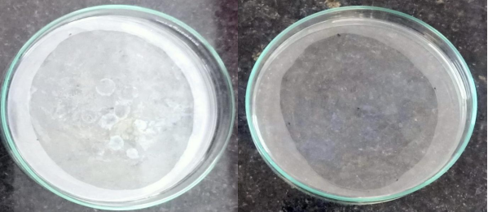
PICTURE 5: Evaluation of Skin Spreadability of Polyherbal Silver Nanoparticle Gel.
UNIFORMITY OF DRUG CONTENT:
The UV–Vis spectra of both gel formulations exhibited characteristic SPR peaks at 295–300 nm, consistent with standalone nanoparticles [28, 50]. The 1% gel showed higher absorbance (~0.20) compared to the 0.5% gel (~0.15), confirming concentration-dependent nanoparticle loading [51]. The flattening of spectra beyond 400 nm indicated the absence of large agglomerates, suggesting good nanoparticle stability within the gel matrix [30, 52]. Additional absorption bands between 200–300 nm were attributed to residual phytochemicals such as flavonoids and tannins, which contributed to stabilization and enhanced bioactivity of the formulation [10, 27].

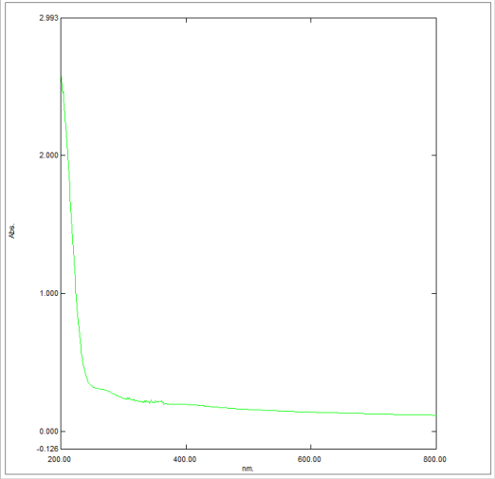
FIGURE 5: The UV-Visible absorption spectrum analyzed for the synthesized Polyherbal silver nanoparticle – infused gel (0.5% concentration).

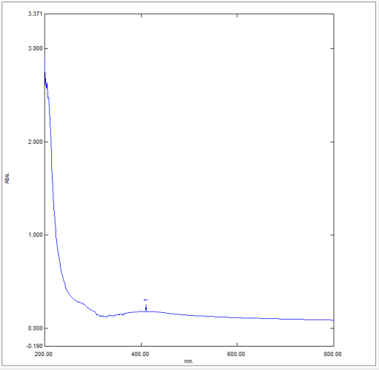
FIGURE 6: The UV-Visible absorption spectrum analyzed for the synthesized Polyherbal silver nanoparticle – infused gel (1% concentration).
DISCUSSION:
The present study involved the formulation and evaluation of a herbal silver nanoparticle-infused gel prepared using Raktashodak Bati extract for psoriasis management. The green synthesis approach successfully produced stable silver nanoparticles, confirmed by the characteristic surface plasmon resonance (SPR) peak at 435 nm in the UV–Vis spectrum. The sharp, narrow peak indicated uniform particle size distribution and effective reduction of silver ions by phytoconstituents.
XRD analysis revealed distinct diffraction peaks at 2θ values of 38.21°, 44.27°, 64.68°, and 77.59°, corresponding to the (111), (200), (220), and (311) planes of face-centered cubic silver, confirming crystalline structure and purity. SEM images showed nearly spherical, well-dispersed nanoparticles with minimal aggregation, suggesting good morphological uniformity and suitability for topical use.
The antimicrobial study demonstrated significant activity of the synthesized nanoparticles against Staphylococcus aureus and Escherichia coli, confirming their broad-spectrum efficacy. The mechanism of action likely involves disruption of microbial membranes and oxidative damage, consistent with previous reports on silver nanoparticles.
Polyherbal gels containing 0.5% and 1% AgNPs were successfully developed with smooth texture, uniform consistency, and acceptable appearance. The pH of 5.2–5.6 indicated skin compatibility. Spreadability values (6.0–6.5 cm) reflected uniform application, with slightly higher spreadability for the 1% gel due to improved dispersion. Washability tests confirmed that both formulations adhered well during use but were easily removed with water, ensuring patient comfort and practicality for frequent application in psoriasis.
UV–Vis spectra of the final gel formulations exhibited stable SPR peaks between 295–300 nm, confirming nanoparticle stability within the gel matrix. The higher absorbance of the 1% formulation validated concentration-dependent nanoparticle loading, while the absence of spectral shifts suggested minimal agglomeration.
Overall, the formulation showed favourable physicochemical, antimicrobial, and cosmetic properties. The integration of Raktashodak Bati phytoconstituents and silver nanoparticles enhanced the therapeutic potential through synergistic antioxidant, antimicrobial, and anti-inflammatory effects. The findings establish that green-synthesized AgNPs can be effectively incorporated into polyherbal gels for improved psoriasis management, offering a safe, stable, and efficient topical delivery system.
CONCLUSION:
The study successfully developed and evaluated a herbal silver nanoparticle-infused gel using Raktashodak Bati extract through a green synthesis approach. The formation of silver nanoparticles was confirmed by UV–Vis spectroscopy, XRD, and SEM analyses, which established their crystalline, spherical, and uniform morphology. The polyherbal gel formulations (0.5% and 1% AgNPs) exhibited optimal physicochemical characteristics, including skin-compatible pH, good spreadability, and excellent washability, ensuring ease of application and patient acceptability.
The antimicrobial studies confirmed significant inhibitory activity against Staphylococcus aureus and Escherichia coli, demonstrating the broad-spectrum efficacy of the formulation. The stability of nanoparticles within the gel matrix was supported by UV–Vis spectral results, indicating strong nanoparticle–polymer interactions and minimal aggregation.
Overall, the developed polyherbal silver nanoparticle gel showed promising attributes for the topical management of psoriasis, combining the therapeutic potential of Raktashodak Bati with the antimicrobial and anti-inflammatory effects of silver nanoparticles. Future research may focus on in vivo efficacy, long-term stability, and clinical validation to establish its potential as an effective natural nano-phytotherapeutic formulation.
REFERENCES:
- Parisi R, Iskandar IYK, Kontopantelis E, Augustin M, Griffiths CEM, Ashcroft DM. National, regional, and worldwide epidemiology of psoriasis: systematic analysis and modelling study. BMJ. 2020; 369:m1590. https://doi.org/10.1136/bmj.m1590
- Griffiths CEM, Barker JNWN. Pathogenesis and clinical features of psoriasis. Lancet. 2007; 370(9583):263–271. https://doi.org/10.1016/S0140-6736(07)61128-3
- Nestle FO, Kaplan DH, Barker J. Psoriasis. N Engl J Med. 2009; 361(5):496–509. https://doi.org/10.1056/NEJMra0804595
- Boehncke WH, Schön MP. Psoriasis. Lancet. 2015; 386(9997):983–994. https://doi.org/10.1016/S0140-6736(14)61909-7
- Raszewska-Famielec M, Nowak I, Szafraniec-Szczęsny J, Cielecka-Piontek J. Nanoparticles for topical application in the treatment of skin diseases. International J Mol Sci. 2022; 23(24):15980. https://doi.org/10.3390/ijms232415980
- Jiang X, Zhou L, Xu N, Zhang H, Zhang X. Biogenic synthesis of silver nanoparticles and their applications: a systematic review. Gels. 2023; 9(7):530. https://doi.org/10.3390/gels9070530
- Khodadadi S, Taghizadeh S, Ranjbar S, Darroudi M. Green synthesis of silver nanoparticles using aqueous extract of Vaccinium arctostaphylos L. and evaluation of their antibacterial properties. International J Mol Sci. 2021; 22(12):6376. https://doi.org/10.3390/ijms22126376
- Kuppusamy P, Yusoff MM, Maniam GP, Govindan N. Green synthesis of metallic nanoparticles using plant derivatives and their biomedical applications. Nanomaterials (Basel). 2016; 6(6):109. https://doi.org/10.3390/nano6060109
- Mikhailova EO. Silver nanoparticles: mechanism of action and probable bio-application. Pharmaceutics. 2020; 12(9):908. https://doi.org/10.3390/pharmaceutics12090908
- Ali A, Ansari VA, Pathak V, Fatima A, Ahmad A, Ahsan F. Formulation and evaluation of polyherbal gel containing Artocarpus heterophyllus, Musa paradisiaca, Aloe vera, Azadirachta indica, and Curcuma longa extracts for psoriasis treatment. International J Pharm Investig. 2021; 11(1):76–82. https://doi.org/10.5530/ijpi.2021.1.15
- Rajendran R, Duraipandy N, Rathika P, Ramesh R, Rajeshkumar S. Herbal polyextracts in green synthesis of nanoparticles: applications in dermatology. Asian J Green Chem. 2022; 9(4):373–403. https://doi.org/10.22034/ajgc.2022.4.6
- Khatun S, Nurunnabi M, Cho KJ. Wound healing and anti-inflammatory effects of polyherbal extracts in topical formulations. BioInternationalerface Res Appl Chem. 2021; 11(3):10341–10351. https://doi.org/10.33263/BRIAC113.1034110351
- Patil D. Ayurvedic formulations in psoriasis: the role of Raktashodak Bati. [Thesis]. Pune: Savitribai Phule Pune University; 2022.
- Sharma V, Kumar A, Pandey A, Singh D, Kumar S. In vivo studies of silver nanoparticles on inflammatory cytokines. Front Bioeng Biotechnol. 2022; 10:856651. https://doi.org/10.3389/fbioe.2022.856651
- Xu Z, Liu C, Zhao Q, Chen Y, Li W, Li X, et al. Silver nanoparticle hydrogels improve permeation in psoriasis lesions. J Control Release. 2022; 343:100–112. https://doi.org/10.1016/j.jconrel.2022.01.017
- Kumari P, Meena R, Singh RK, Bharti S, Mehta RK. Hydrogel-based nanoparticle drug delivery for dermatological disorders. Biomedicine (Taipei). 2021; 11(2):41–49. https://doi.org/10.37796/2211-8039.1127
- Ramesh R, Karthik K, Priya D, Anbarasan B. Polyherbal silver nanoparticle-infused gel: a novel approach for psoriasis management. Indian J Pharm Qual Assur. 2021; 15(4):22–30.
- Singh S, Sharma A, Kumar R, Gupta M, Verma R, Sharma R. Development of a polyherbal topical gel for the treatment of acne. J Ethnopharmacol. 2023; 313:116469. https://doi.org/10.1016/j.jep.2023.116469
- Roy A, Bulut O, Some S, Mandal AK, Yilmaz MD. Green synthesis of silver nanoparticles: an eco-friendly approach for biomedical applications. Front Microbiol. 2021; 12:638796. https://doi.org/10.3389/fmicb.2021.638796
- Ahmed S, Ahmad M, Swami BL, Ikram S. A review on plants extract mediated synthesis of silver nanoparticles for antimicrobial applications: a green expertise. J Adv Res. 2016; 7(1):17–28. https://doi.org/10.1016/j.jare.2015.02.007
- Patel RP, Patel MM, Patel NR. Formulation and evaluation of topical gel containing silver nanoparticles for wound healing. Mater Today Proc. 2019; 10:142–150. https://doi.org/10.1016/j.matpr.2019.02.211
- Gaur PK, Mishra S, Purohit S, Dave K. Development and evaluation of topical gel of minoxidil for the treatment of alopecia. International J Pharm Investig. 2014;4(3):138–142. https://doi.org/10.4103/2230-973X.138341
- Hussein AK, Ali SG, Abdalrahman BA, Mohamed MA, Hassanien R, Alzahrani AJ, et al. Green synthesis of silver nanoparticles using plant extracts and evaluation of their antimicrobial activity. Sci Rep. 2021; 11:6261. https://doi.org/10.1038/s41598-021-85883-3
- Zhang QW, Lin LG, Ye WC. Techniques for extraction and isolation of natural products: a comprehensive review. Chin Med. 2018;13(1):20. https://doi.org/10.1186/s13020-018-0177-y
- Liu X, Chen Y, Qin L, Wang L, Tian J, Zhao H. Effects of five extraction methods on total content, composition, and antioxidant activity of flavonoids from jujube (Zizyphus jujuba Mill.). Food Chem. 2022; 387:132800. doi:10.1016/j.foodchem.2022.132800
- Hlatshwayo S, Gordon M, Hussein A, et al. Extraction and processing of bioactive phytoconstituents for enhanced potency from traditional herbal medicines. Plants (Basel). 2025; 14(2):206. https://doi.org/10.1016/j.foodchem.2022.132800
- Rizwana H, Abbas S, Sultana S, Tufail T, Khan T, Masood N. Sunlight-mediated green synthesis of silver nanoparticles using pomelo peel extracts: rapid color change within a minute under sunlight exposure, followed by centrifugation and washing. Appl Nanosci. 2022; 12(9):1549–1560. https://doi.org/10.1007/s13204-022-02523-7
- Liaqat N, Raza M, Saira K, Al-Faiyz YS, Barai G, Rehman IU. Green synthesized silver nanoparticles: optimization, characterization and antibacterial activity. Front Chem. 2022; 10:952006. https://doi.org/10.3389/fchem.2022.952006
- Vanlalveni C, Biswas S, Lalthanzara H, Rokhum L. Green synthesis of silver nanoparticles using plant extracts and their antimicrobial activities: review of recent literature. RSC Adv. 2021; 11:2804–2837. https://doi.org/10.1039/D0RA09941D
- Nallusamy N, Shanmugam S, Sivaraj R, Govindaraju K, Yogalakshmi K, et al. Green synthesis and characterization of silver nanoparticles from rice husk/spent coffee ground extracts. Nanomaterials. 2025;15(3): https://doi.org/10.3390/nano15030632
- Plokhovska S, García-Villaraco A, Lucas JA, Gutierrez-Mañero FJ, et al. Silver nanoparticles coated with metabolites of Pseudomonas sp. N5.12 inhibit bacterial pathogens and fungal phytopathogens. Sci Rep. 2025; 15:1522. https://doi.org/10.1038/s41598-025-01522
- Saba M, Farooq S, Alessa AH, Bektas KI, Belduz AO, Khan AZ, Khan S, Badshah M. Green synthesis of silver nanoparticles using Keratinase from Pseudomonas aeruginosa-C1M: characterization and applications as novel multifunctional biocatalyst. BMC Biotechnol. 2025; 25:27. https://doi.org/10.1186/s12896-025-00227-4
- Ansari MA, Khan NA, Khan AA, Ahmad W, Rehman S, Almatroudi A, Alzohairy MA. Plant-mediated fabrication of silver nanoparticles: process and antimicrobial activity. Sci Rep. 2023; 13:18855. https://doi.org/10.1038/s41598-023-45038-x
- Singh S, Kumari R, Sharma V, Patel D. Green synthesis of silver nanoparticles using neem (Azadirachta indica) leaf extract: characterization and antimicrobial applications. J Environ Chem Eng. 2025; 13(2):110546. https://doi.org/10.1016/j.jece.2025.110546
- Vanlalveni C, Biswas S, Lalthanzara H, Rokhum L. Green synthesis of silver nanoparticles using plant extracts and their antimicrobial activities: review of recent literature. RSC Adv. 2021; 11:2804–2837. https://doi.org/10.1039/D0RA09941D
- de Oliveira AC, Abreu AS, Pinho E, Gonçalves I, Oliveira MJ, Rodrigues LR, et al. Synthesis of silver nanoparticles co-stabilized by poly(N-vinyl-2-pyrrolidone) and sodium dodecyl sulfate. Mater Adv. 2025;6(1):190–201. https://doi.org/10.1039/D4MA01234A
- Sati SC, Kumar R, Sharma A, Choudhary A, Rana P, Singh P. Comprehensive insights for silver nanoparticles: synthesis, characterization, and biomedical applications. ACS Omega. 2025; 10(5):4571–4589. https://doi.org/10.1021/acsomega.4c11045
- Khan M, Alkhathlan H, Khan ST. Production of silver nanoparticles with strong and stable physicochemical properties. J Nanobiotechnol. 2014; 12:40. https://doi.org/10.1186/1477-3155-12-40
- Singh P, Pandit S, Mokkapati V, Garg A, Ravikumar V, Mijakovic I. Antimicrobial effects of biogenic silver nanoparticles synthesized from plants and microbes. Front Microbiol. 2018; 9:2164. https://doi.org/10.3389/fmicb.2018.02164
- Dakal TC, Kumar A, Majumdar RS, Yadav V. Mechanistic basis of antimicrobial actions of silver nanoparticles. Front Microbiol. 2016; 7:1831. https://doi.org/10.3389/fmicb.2016.01831
- Rai M, Deshmukh SD, Ingle AP, Gupta IR, Galdiero M, Galdiero S. Silver nanoparticles: the powerful nanoweapon against multidrug-resistant bacteria. J Appl Microbiol. 2012; 112(5):841–852. https://doi.org/10.1111/j.1365-2672.2012.05253.x
- Ozon EA, Piskin B, Sarioglu OF, Sahin S, Yilmaz B, Tanrıverdi ST. Formulation and characterization of Carbopol-based hydrogels for topical delivery. Polymers (Basel). 2025; 17(5):812. https://doi.org/10.3390/polym17050812
- Carvalho-Silva JM, Fernandes RS, da Silva GB, Silva-Neto JC, Ferreira MRA, de Oliveira RB, et al. Antimicrobial Carbopol hydrogels containing silver vanadate nanoparticles: physicochemical and microbiological evaluation. International J Mol Sci. 2024; 25(3):1167. https://doi.org/10.3390/ijms25031167
- Nurman S, Yulia R, Irmayanti, Noor E, Sunarti TC. The optimization of gel preparations using the active compounds of Arabica coffee ground nanoparticles. Sci Pharm. 2019; 87(4):32. https://doi.org/10.3390/scipharm87040032
- Gorle A, Gattani S, Surana S. Formulation and evaluation of Carbopol 940-based herbal gel for topical use. Res J Top Cosmet Sci. 2018;9(2):65–72. https://doi.org/10.5958/2321-5844.2018.00001.6
- Shah SA, Sohail M, Minhas MU, Khan S, Hussain Z, de Matas M, et al. Biopolymer-based silver nanoparticle coatings for antimicrobial wound dressings. International J Biol Macromol. 2019; 124:1121–1132. https://doi.org/10.1016/j.ijbiomac.2018.12.031
- Costa P, Sousa Lobo JM. Modeling and comparison of dissolution profiles. Eur J Pharm Sci. 2001; 13(2):123–133. https://doi.org/10.1016/S0928-0987(01)00095-1
- Waghule T, Singhvi G, Dubey SK, Pandey MM, Gupta G, Singh M, et al. Microneedles: a smart approach and increasing potential for transdermal drug delivery system. Biomed Pharmacother. 2019; 109:1249–1258. https://doi.org/10.1016/j.biopha.2018.10.078
- Subramaniam B, Siddik ZH, Nagoor NH. Optimization of chitosan nanoparticle formulations for efficient siRNA delivery. J Nanomater. 2013; 2013:403429. https://doi.org/10.1155/2013/403429
- Singh P, Kim YJ, Singh H, Mathiyalagan R, Wang C, Yang DC. Biosynthesis, characterization, and antimicrobial applications of silver nanoparticles. International J Nanomedicine. 2015; 10:2567–2577. https://doi.org/10.2147/IJN.S80407
- Danaei M, Dehghankhold M, Ataei S, Hasanzadeh Davarani F, Javanmard R, Dokhani A, et al. Impact of particle size and polydispersity index on the clinical applications of lipidic nanocarrier systems. Pharmaceutics. 2018; 10(2):57. https://doi.org/10.3390/pharmaceutics10020057
- Shah S, Duda GN, Schroeder M. Nanocarrier-based topical drug delivery systems against skin disorders: challenges and advances. Adv Drug Deliv Rev. 2020; 153:24–49. https://doi.org/10.1016/j.addr.2020.01.004

