SMART PLANT HEALTH MONITORING AND AUTOMATED WATERING SYSTEM

NAME: MOHAMED SHAHID H
RRN: 230171601111
DEPT: B. TECH AI & DS
COURSE: IOT AND EMBEDDED SYSTEM
COUSRE CODE: CSD 3252
ABSTRACT
The advancement of embedded systems and sensor-based automation has significantly improved modern agricultural and home gardening practices. This project presents the design and implementation of a Smart Plant Health Monitoring and Automated Watering System using the Arduino UNO microcontroller. The primary objective of the system is to monitor essential environmental parameters affecting plant growth and to automate the watering process based on real-time soil conditions.
The system measures soil moisture, ambient temperature, relative humidity, and light intensity using dedicated sensors. The soil moisture sensor determines the water content in the soil, while the DHT22 sensor provides temperature and humidity readings. A Light Dependent Resistor (LDR) detects surrounding light intensity. All sensor values are processed by the Arduino and converted into percentage values for easy interpretation.
A predefined soil moisture threshold is implemented in the program logic. When the moisture level drops below 30%, the system activates a servo motor to simulate watering and triggers a buzzer as an alert. Once adequate moisture is restored, the servo returns to its default position and the system resumes monitoring. All environmental parameters and system status are displayed in real time on a 20x4 I2C LCD screen.
The proposed system reduces manual monitoring effort, prevents overwatering and underwatering, and promotes efficient water usage. It demonstrates the practical application of embedded systems and automation techniques in sustainable agriculture and smart home environments while maintaining simplicity, cost-effectiveness, and scalability.

INTRODUCTION
In modern urban lifestyles, maintaining plant health can be challenging due to irregular watering and lack of environmental monitoring. Overwatering and underwatering are common issues that negatively impact plant growth.
The Smart Plant Health Monitoring System addresses this issue by continuously monitoring environmental parameters and automatically watering plants when necessary. The project integrates multiple sensors with Arduino-based decision-making to create a low-cost and efficient automation solution.
OBJECTIVES
The main objectives of this project are:
- To monitor soil moisture levels.
- To measure ambient temperature and humidity.
- To detect surrounding light intensity.
- To automate plant watering using a servo motor.
- To provide alert notifications using a buzzer.
- To display real-time sensor data on an LCD screen.

SYSTEM COMPONENTS
The hardware components used in this project include:
- Arduino UNO
- DHT22 Temperature and Humidity Sensor
- Soil Moisture Sensor (Simulated using Potentiometer in Wokwi)
- Light Dependent Resistor (LDR)
- Servo Motor
- Buzzer
- 20x4 I2C LCD Display
SYSTEM ARCHITECTURE
The system consists of multiple sensors connected to the Arduino UNO. The microcontroller processes the sensor data and makes decisions based on predefined threshold values.
Circuit Diagram:
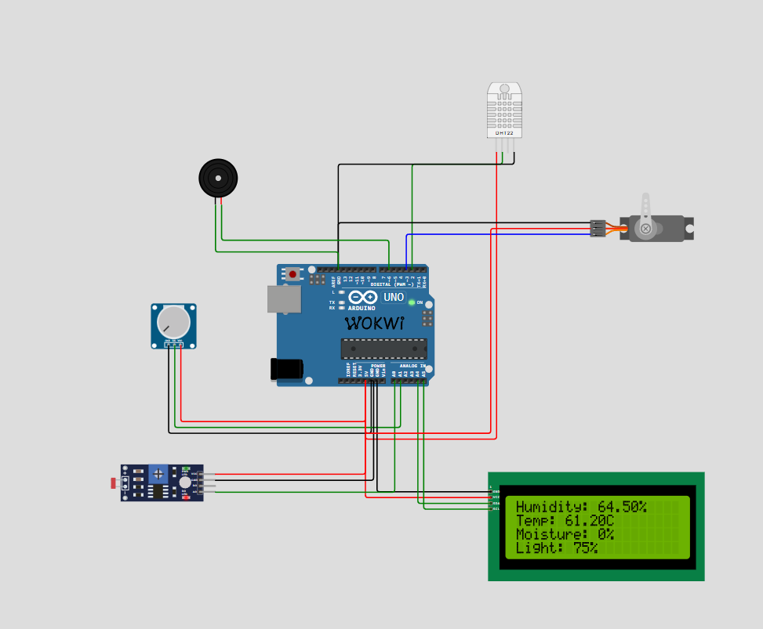
Figure 1: Complete Circuit Diagram of the Smart Plant Monitoring System

The connections are as follows:
- DHT22 → Digital Pin D2
- Servo Motor → Digital Pin D3
- Buzzer → Digital Pin D6
- Soil Moisture Sensor → Analog Pin A1
- LDR → Analog Pin A0
- LCD (I2C) → SDA (A4), SCL (A5)

HARDWARE IMPLEMENTATION
1.Soil Moisture Sensor
The soil moisture sensor provides an analogue output between 0 and 1023. This value is mapped to a percentage scale (0–100%). If moisture falls below 30%, watering is triggered.
2.DHT22 Sensor
The DHT22 sensor measures:
- Ambient Temperature
- Relative Humidity
These parameters help assess the plant’s environmental conditions.
3.Light Dependent Resistor (LDR)
The LDR measures surrounding light intensity, which is converted into a percentage value using the map function.

4.Servo Motor
The servo motor rotates to 90° when watering is required and returns to 0° after watering is complete.
5.Buzzer
The buzzer provides an audible alert when soil moisture is below the threshold level.
SOFTWARE IMPLEMENTATION
The system is programmed using the Arduino IDE. The following libraries are used:
- Wire.h
- LiquidCrystal_I2C.h
- DHT.h
- Servo.h
Key functions used in the program:
- analogRead() – Reads soil moisture and light intensity
- dht.readHumidity() – Reads humidity
- dht.readTemperature() – Reads temperature
- map() – Converts raw analog values into percentages
- tone() / noTone() – Controls buzzer
- Servo.write() – Controls servo position
The program continuously reads sensor data, updates the LCD display, and executes watering logic based on soil moisture percentage.

WORKING PRINCIPLE
- The Arduino reads environmental sensor data.
- Moisture percentage is calculated using analogue mapping.
- If moisture < 30%:
  - LCD displays watering message.
  - Buzzer activates.
  - Servo rotates to simulate watering.
- If moisture ≥ 30%:
  - System displays healthy plant message.
  - Buzzer remains OFF.
  - Servo remains at default position.

RESULTS AND OBSERVATIONS
The system successfully:
- Displayed humidity, temperature, moisture, and light values on the LCD.
- Activated watering mechanism when soil moisture dropped below 30%.
- Provided audible alert through buzzer.
- Returned to monitoring state after watering.
The simulation in Wokwi verified correct sensor readings and proper system response under varying moisture conditions.

ADVANTAGES
- Low-cost and easy to implement
- Prevents overwatering and underwatering
- Reduces manual plant monitoring
- Expandable to IoT-based remote monitoring
LIMITATIONS
- Soil sensor requires calibration in real-world conditions
- Servo motor used instead of actual water pump
- No cloud-based monitoring implemented
FUTURE ENHANCEMENTS
The system can be improved by:
- Integrating WiFi module for remote monitoring
- Adding a relay-controlled water pump
- Creating a web-based dashboard
- Storing historical plant data in cloud database
- Implementing AI-based predictive watering

CONCLUSION
The Smart Plant Health Monitoring and Automated Watering System demonstrates an effective application of embedded systems in agricultural automation. By integrating environmental sensing and automated control, the system ensures optimal plant growth conditions while minimizing human effort.
The project highlights the potential of IoT-enabled smart systems for sustainable agriculture and smart home applications.
APPENDIX A
Arduino Source Code
#include <Wire.h>
#include <LiquidCrystal_I2C.h>
#include <DHT.h>
#include <Servo.h>
#define DHTPIN 2
#define DHTTYPE DHT22
#define BUZZER 6
DHT dht(DHTPIN, DHTTYPE);
Servo plantServo;
const int ldrPin = A0;
const int potPin = A1;
const int servoPin = 3;
LiquidCrystal_I2C lcd(0x27, 20, 4);
void setup() {
dht.begin();
lcd.init();
lcd.backlight();
plantServo.attach(servoPin);
pinMode(BUZZER, OUTPUT);
// Intro Screen (Only Once)
lcd.setCursor(0, 0);
lcd.print("Mohamed Shahid");
lcd.setCursor(0, 1);
lcd.print("Student ID:");
lcd.setCursor(0, 2);
lcd.print("230171601111");
delay(3000);
lcd.clear();
}
void loop() {
float humidity = dht.readHumidity();
float temperature = dht.readTemperature();
int moistureRaw = analogRead(potPin);
int lightRaw = analogRead(ldrPin);
int moisturePercent = map(moistureRaw, 0, 1023, 0, 100);
int lightPercent = map(lightRaw, 1023, 0, 0, 100);
// Display Sensor Data
lcd.setCursor(0, 0);
lcd.print("Humidity: ");
lcd.print(humidity);
lcd.print("% ");
lcd.setCursor(0, 1);
lcd.print("Temp: ");
lcd.print(temperature);
lcd.print("C ");
lcd.setCursor(0, 2);
lcd.print("Moisture: ");
lcd.print(moisturePercent);
lcd.print("% ");
lcd.setCursor(0, 3);
lcd.print("Light: ");
lcd.print(lightPercent);
lcd.print("% ");
delay(2000);
// Watering Logic
if (moisturePercent < 30) {
lcd.clear();
lcd.setCursor(0, 0);
lcd.print("Soil Dry!");
lcd.setCursor(0, 1);
lcd.print("Watering Plant...");
tone(BUZZER, 1000); // Beep alert
delay(300);
noTone(BUZZER);
plantServo.write(90); // Water ON
delay(2000);
plantServo.write(0); // Reset position
}
else {
noTone(BUZZER); // Ensure buzzer OFF
plantServo.write(0);
lcd.clear();
lcd.setCursor(0, 0);
lcd.print("Plant Healthy");
lcd.setCursor(0, 1);
lcd.print("No Water Needed");
delay(2000);
}
lcd.clear();}

