CSS display Property

## Definition and Usage

The display property specifies the display behavior (the type of rendering box) of an element.

In HTML, the default display property value is taken from the HTML specifications or from the browser/user default style sheet.

## CSS Syntax

display: *value*;

## Property Values

|  |  |
| --- | --- |
| **Value** | **Description** |
| inline | Displays an element as an inline element (like <span>). Any height and width properties will have no effect |
| block | Displays an element as a block element (like <p>). It starts on a new line, and takes up the whole width |
| contents | Makes the container disappear, making the child elements children of the element the next level up in the DOM |
| flex | Displays an element as a block-level flex container |
| grid | Displays an element as a block-level grid container |
| inline-block | Displays an element as an inline-level block container. The element itself is formatted as an inline element, but you can apply height and width values |
| inline-flex | Displays an element as an inline-level flex container |
| inline-grid | Displays an element as an inline-level grid container |
| inline-table | The element is displayed as an inline-level table |
| list-item | Let the element behave like a <li> element |
| run-in | Displays an element as either block or inline, depending on context |
| table | Let the element behave like a <table> element |
| table-caption | Let the element behave like a <caption> element |
| table-column-group | Let the element behave like a <colgroup> element |
| table-header-group | Let the element behave like a <thead> element |
| table-footer-group | Let the element behave like a <tfoot> element |
| table-row-group | Let the element behave like a <tbody> element |
| table-cell | Let the element behave like a <td> element |
| table-column | Let the element behave like a <col> element |
| table-row | Let the element behave like a <tr> element |
| none | The element is completely removed |
| initial | Sets this property to its default value. [Read about *initial*](https://www.w3schools.com/cssref/css_initial.php) |
| inherit | Inherits this property from its parent element. [Read about *inherit*](https://www.w3schools.com/cssref/css_inherit.php) |

# CSS Flex box Property

# 

## CSS Flexbox Layout Module

Before the Flexbox Layout module, there were four layout modes:

* Block, for sections in a webpage
* Inline, for text
* Table, for two-dimensional table data
* Positioned, for explicit position of an element

The Flexible Box Layout Module, makes it easier to design flexible responsive layout structure without using float or positioning.

## Flexbox Elements

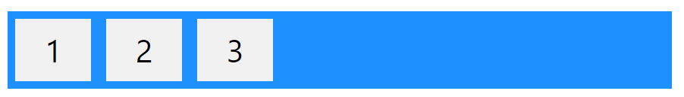

The element above represents a flex container (the blue area) with three flex items.

### Example

A flex container with three flex items:

<div class="flex-container">  
  <div>1</div>  
  <div>2</div>  
  <div>3</div>  
</div>

CSS Flex Container

## Parent Element (Container)

Like we specified in the previous chapter, this is a flex **container**(the blue area) with three flex **items**:

# 

The flex container becomes flexible by setting the display property to flex:

### Example

.flex-container {  
  display: flex;  
}

The flex container properties are:

* [flex-direction](https://www.w3schools.com/css/css3_flexbox_container.asp#flex-direction)
* [flex-wrap](https://www.w3schools.com/css/css3_flexbox_container.asp#flex-wrap)
* [flex-flow](https://www.w3schools.com/css/css3_flexbox_container.asp#flex-flow)
* [justify-content](https://www.w3schools.com/css/css3_flexbox_container.asp#justify-content)
* [align-items](https://www.w3schools.com/css/css3_flexbox_container.asp#align-items)
* [align-content](https://www.w3schools.com/css/css3_flexbox_container.asp#align-content)

## The flex-direction Property

The flex-direction property defines in which direction the container wants to stack the flex items.

### Example

The column value stacks the flex items vertically (from top to bottom):

.flex-container {  
  display: flex;  
  flex-direction: column;  
}

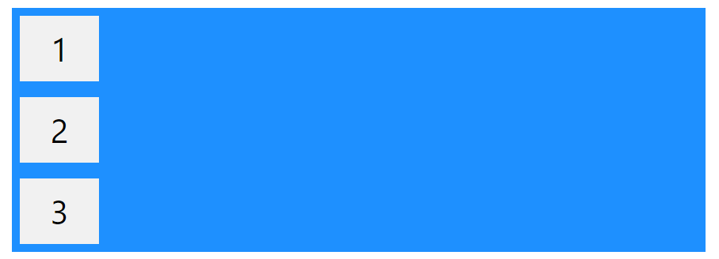

### Example

The column-reverse value stacks the flex items vertically (but from bottom to top):

.flex-container {  
  display: flex;  
  flex-direction: column-reverse;  
}

# 

### Example

The row value stacks the flex items horizontally (from left to right):

.flex-container {  
  display: flex;  
  flex-direction: row;  
}

# 

### Example

The row-reverse value stacks the flex items horizontally (but from right to left):

.flex-container {  
  display: flex;  
  flex-direction: row-reverse;  
}

# 

## The flex-wrap Property

The flex-wrap property specifies whether the flex items should wrap or not.

The examples below have 12 flex items, to better demonstrate the flex-wrap property.

# 

### Example

The wrap value specifies that the flex items will wrap if necessary:

.flex-container {  
  display: flex;  
  flex-wrap: wrap;  
}

# 

### Example

The nowrap value specifies that the flex items will not wrap (this is default):

.flex-container {  
  display: flex;  
  flex-wrap: nowrap;  
}

# 

### Example

The wrap-reverse value specifies that the flexible items will wrap if necessary, in reverse order:

.flex-container {  
  display: flex;  
  flex-wrap: wrap-reverse;  
}

# 

## The flex-flow Property

The flex-flow property is a shorthand property for setting both the flex-direction and flex-wrap properties.

### Example

.flex-container {  
  display: flex;  
  flex-flow: row wrap;  
}

# 

## The justify-content Property

The justify-content property is used to align the flex items:

### Example

The center value aligns the flex items at the center of the container:

.flex-container {  
  display: flex;  
  justify-content: center;  
}

# 

### Example

The flex-start value aligns the flex items at the beginning of the container (this is default):

.flex-container {  
  display: flex;  
  justify-content: flex-start;  
}

# 

### Example

The flex-end value aligns the flex items at the end of the container:

.flex-container {  
  display: flex;  
  justify-content: flex-end;  
}

# 

### Example

The space-around value displays the flex items with space before, between, and after the lines:

.flex-container {  
  display: flex;  
  justify-content: space-around;  
}

# 

### Example

The space-between value displays the flex items with space between the lines:

.flex-container {  
  display: flex;  
  justify-content: space-between;  
}

# 

## The align-items Property

The align-items property is used to align the flex items.

### Example

The center value aligns the flex items in the middle of the container:

.flex-container {  
  display: flex;  
  height: 200px;  
  align-items: center;  
}

# 

### Example

The flex-start value aligns the flex items at the top of the container:

.flex-container {  
  display: flex;  
  height: 200px;  
  align-items: flex-start;  
}

# 

### Example

The flex-end value aligns the flex items at the bottom of the container:

.flex-container {  
  display: flex;  
  height: 200px;  
  align-items: flex-end;  
}

# 

### Example

The stretch value stretches the flex items to fill the container (this is default):

.flex-container {  
  display: flex;  
  height: 200px;  
  align-items: stretch;  
}

# 

### Example

The baseline value aligns the flex items such as their baselines aligns:

.flex-container {  
  display: flex;  
  height: 200px;  
  align-items: baseline;  
}

# 

## The align-content Property

The align-content property is used to align the flex lines.

### Example

The space-between value displays the flex lines with equal space between them:

.flex-container {  
  display: flex;  
  height: 600px;  
  flex-wrap: wrap;  
  align-content: space-between;  
}

# 

### Example

The space-around value displays the flex lines with space before, between, and after them:

.flex-container {  
  display: flex;  
  height: 600px;  
  flex-wrap: wrap;  
  align-content: space-around;  
}

# 

### Example

The stretch value stretches the flex lines to take up the remaining space (this is default):

.flex-container {  
  display: flex;  
  height: 600px;  
  flex-wrap: wrap;  
  align-content: stretch;  
}

# 

### Example

The center value displays display the flex lines in the middle of the container:

.flex-container {  
  display: flex;  
  height: 600px;  
  flex-wrap: wrap;  
  align-content: center;  
}

# 

### Example

The flex-start value displays the flex lines at the start of the container:

.flex-container {  
  display: flex;  
  height: 600px;  
  flex-wrap: wrap;  
  align-content: flex-start;  
}

### Example

The flex-end value displays the flex lines at the end of the container:

.flex-container {  
  display: flex;  
  height: 600px;  
  flex-wrap: wrap;  
  align-content: flex-end;  
}

## Perfect Centering

In the following example we will solve a very common style problem: perfect centering.

# 

## The CSS Flexbox Container Properties

The following table lists all the CSS Flexbox Container properties:

|  |  |
| --- | --- |
| **Property** | **Description** |
| [align-content](https://www.w3schools.com/cssref/css3_pr_align-content.asp) | Modifies the behavior of the flex-wrap property. It is similar to align-items, but instead of aligning flex items, it aligns flex lines |
| [align-items](https://www.w3schools.com/cssref/css3_pr_align-items.asp) | Vertically aligns the flex items when the items do not use all available space on the cross-axis |
| [display](https://www.w3schools.com/cssref/pr_class_display.asp) | Specifies the type of box used for an HTML element |
| [flex-direction](https://www.w3schools.com/cssref/css3_pr_flex-direction.asp) | Specifies the direction of the flexible items inside a flex container |
| [flex-flow](https://www.w3schools.com/cssref/css3_pr_flex-flow.asp) | A shorthand property for flex-direction and flex-wrap |
| [flex-wrap](https://www.w3schools.com/cssref/css3_pr_flex-wrap.asp) | Specifies whether the flex items should wrap or not, if there is not enough room for them on one flex line |
| [justify-content](https://www.w3schools.com/cssref/css3_pr_justify-content.asp) | Horizontally aligns the flex items when the items do not use all available space on the main-axis |

CSS Flex Items

## Child Elements (Items)

The direct child elements of a flex container automatically becomes flexible (flex) items.

# 

### Example

<div class="flex-container">  
  <div>1</div>  
  <div>2</div>  
  <div>3</div>  
  <div>4</div>  
</div>

The flex item properties are:

* [order](https://www.w3schools.com/css/css3_flexbox_items.asp#order)
* [flex-grow](https://www.w3schools.com/css/css3_flexbox_items.asp#flex-grow)
* [flex-shrink](https://www.w3schools.com/css/css3_flexbox_items.asp#flex-shrink)
* [flex-basis](https://www.w3schools.com/css/css3_flexbox_items.asp#flex-basis)
* [flex](https://www.w3schools.com/css/css3_flexbox_items.asp#flex)
* [align-self](https://www.w3schools.com/css/css3_flexbox_items.asp#align-self)

## The order Property

The order property specifies the order of the flex items.

# 

The first flex item in the code does not have to appear as the first item in the layout.

The order value must be a number, default value is 0.

### Example

The order property can change the order of the flex items:

<div class="flex-container">  
  <div style="order: 3">1</div>  
  <div style="order: 2">2</div>  
  <div style="order: 4">3</div>  
  <div style="order: 1">4</div>  
</div>

## The flex-grow Property

The flex-grow property specifies how much a flex item will grow relative to the rest of the flex items.

### Example

Make the third flex item grow eight times faster than the other flex items:

<div class="flex-container">  
  <div style="flex-grow: 1">1</div>  
  <div style="flex-grow: 1">2</div>  
  <div style="flex-grow: 8">3</div>  
</div>

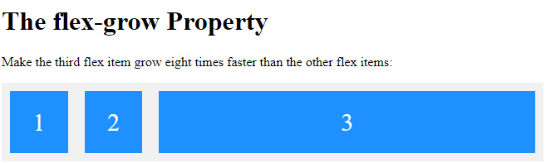

## The flex-shrink Property

The flex-shrink property specifies how much a flex item will shrink relative to the rest of the flex items.

The value must be a number, default value is 1.

### Example

Do not let the third flex item shrink as much as the other flex items:

<div class="flex-container">  
  <div>1</div>  
  <div>2</div>  
  <div style="flex-shrink: 0">3</div>  
  <div>4</div>  
  <div>5</div>  
  <div>6</div>  
  <div>7</div>  
  <div>8</div>  
  <div>9</div>  
  <div>10</div>  
</div>

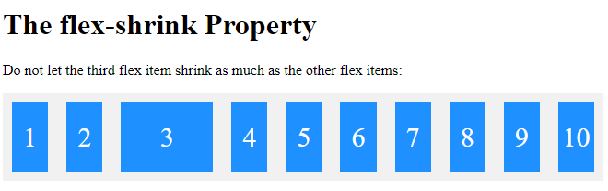

## The flex-basis Property

The flex-basis property specifies the initial length of a flex item.

### Example

Set the initial length of the third flex item to 200 pixels:

<div class="flex-container">  
  <div>1</div>  
  <div>2</div>  
  <div style="flex-basis: 200px">3</div>  
  <div>4</div>  
</div>

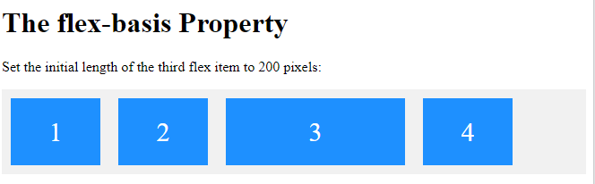

## The flex Property

The flex property is a shorthand property for the flex-grow, flex-shrink, and flex-basis properties.

### Example

Make the third flex item not growable (0), not shrinkable (0), and with an initial length of 200 pixels:

<div class="flex-container">  
  <div>1</div>  
  <div>2</div>  
  <div style="flex: 0 0 200px">3</div>  
  <div>4</div>  
</div>

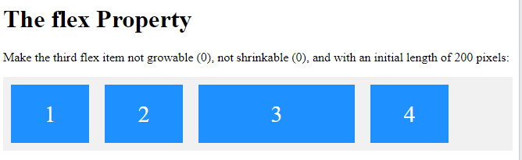

## The align-self Property

The align-self property specifies the alignment for the selected item inside the flexible container.

The align-self property overrides the default alignment set by the container's align-items property.

### Example

Align the third flex item in the middle of the container:

<div class="flex-container">  
  <div>1</div>  
  <div>2</div>  
  <div style="align-self: center">3</div>  
  <div>4</div>  
</div>

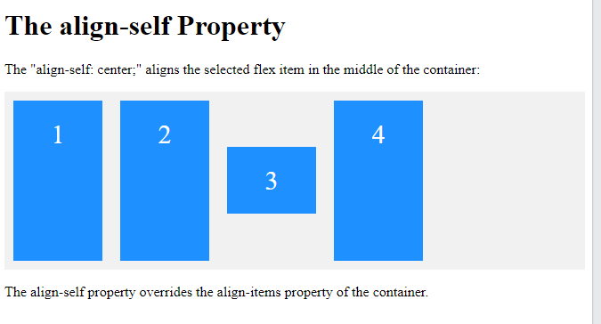

### Example

Align the second flex item at the top of the container, and the third flex item at the bottom of the container:

<div class="flex-container">  
  <div>1</div>  
  <div style="align-self: flex-start">2</div>  
  <div style="align-self: flex-end">3</div>  
  <div>4</div>  
</div>

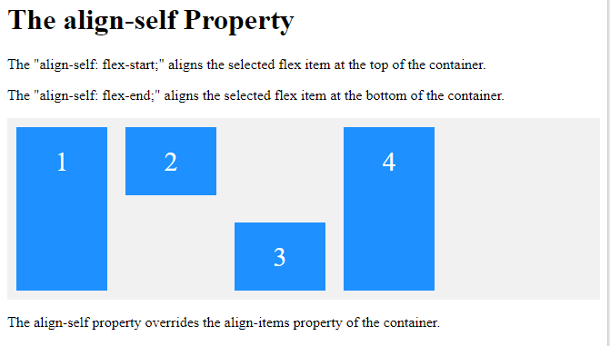

## The CSS Flexbox Items Properties

The following table lists all the CSS Flexbox Items properties:

|  |  |
| --- | --- |
| **Property** | **Description** |
| [align-self](https://www.w3schools.com/cssref/css3_pr_align-self.asp) | Specifies the alignment for a flex item (overrides the flex container's align-items property) |
| [flex](https://www.w3schools.com/cssref/css3_pr_flex.asp) | A shorthand property for the flex-grow, flex-shrink, and the flex-basis properties |
| [flex-basis](https://www.w3schools.com/cssref/css3_pr_flex-basis.asp) | Specifies the initial length of a flex item |
| [flex-grow](https://www.w3schools.com/cssref/css3_pr_flex-grow.asp) | Specifies how much a flex item will grow relative to the rest of the flex items inside the same container |
| [flex-shrink](https://www.w3schools.com/cssref/css3_pr_flex-shrink.asp) | Specifies how much a flex item will shrink relative to the rest of the flex items inside the same container |
| [order](https://www.w3schools.com/cssref/css3_pr_order.asp) | Specifies the order of the flex items inside the same container |