HTML Tutorial

# HTML Introduction

HTML is the standard markup language for creating Web pages.

## What is HTML?

* HTML stands for Hyper Text Markup Language
* HTML is the standard markup language for creating Web pages
* HTML describes the structure of a Web page
* HTML consists of a series of elements
* HTML elements tell the browser how to display the content
* HTML elements label pieces of content such as "this is a heading", "this is a paragraph", "this is a link", etc.

## A Simple HTML Document

### Example

<!DOCTYPE html>  
<html>  
<head>  
<title>Page Title</title>  
</head>  
<body>  
  
<h1>My First Heading</h1>  
<p>My first paragraph.</p>  
  
</body>  
</html>

### Example Explained

* The <!DOCTYPE html> declaration defines that this document is an HTML5 document
* The <html> element is the root element of an HTML page
* The <head> element contains meta information about the HTML page
* The <title> element specifies a title for the HTML page (which is shown in the browser's title bar or in the page's tab)
* The <body> element defines the document's body, and is a container for all the visible contents, such as headings, paragraphs, images, hyperlinks, tables, lists, etc.
* The <h1> element defines a large heading
* The <p> element defines a paragraph

## What is an HTML Element?

An HTML element is defined by a start tag, some content, and an end tag:

<tagname> Content goes here... </tagname>

The HTML **element** is everything from the start tag to the end tag:

<h1>My First Heading</h1>

<p>My first paragraph.</p>

|  |  |  |
| --- | --- | --- |
| **Start tag** | **Element content** | **End tag** |
| <h1> | My First Heading | </h1> |
| <p> | My first paragraph. | </p> |
| <br> | none | none |

**Note:** Some HTML elements have no content (like the <br> element). These elements are called empty elements. Empty elements do not have an end tag!

## Web Browsers

The purpose of a web browser (Chrome, Edge, Firefox, Safari) is to read HTML documents and display them correctly.

A browser does not display the HTML tags, but uses them to determine how to display the document:

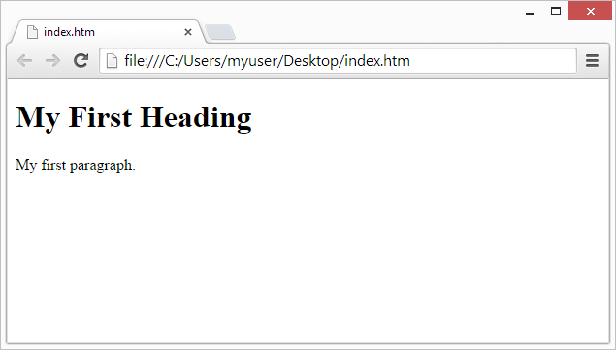

## HTML Page Structure

Below is a visualization of an HTML page structure:

<html>

<head>

<title>Page title</title>

</head>

<body>

<h1>This is a heading</h1>

<p>This is a paragraph.</p>

<p>This is another paragraph.</p>

</body>

</html>

**Note:** The content inside the <body> section (the white area above) will be displayed in a browser. The content inside the <title> element will be shown in the browser's title bar or in the page's tab.

## HTML History

|  |  |
| --- | --- |
| **Year** | **Version** |
| 1989 | Tim Berners-Lee invented www |
| 1991 | Tim Berners-Lee invented HTML |
| 1993 | Dave Raggett drafted HTML+ |
| 1995 | HTML Working Group defined HTML 2.0 |
| 1997 | W3C Recommendation: HTML 3.2 |
| 1999 | W3C Recommendation: HTML 4.01 |
| 2000 | W3C Recommendation: XHTML 1.0 |
| 2008 | WHATWG HTML5 First Public Draft |
| 2012 | [WHATWG HTML5 Living Standard](http://whatwg.org/html/) |
| 2014 | [W3C Recommendation: HTML5](http://www.w3.org/TR/html5/) |
| 2016 | W3C Candidate Recommendation: HTML 5.1 |
| 2017 | [W3C Recommendation: HTML5.1 2nd Edition](http://www.w3.org/TR/html51/) |
| 2017 | [W3C Recommendation: HTML5.2](http://www.w3.org/TR/html52/) |

Since the early days of the World Wide Web, there have been many versions of HTML:

This tutorial follows the latest HTML5 standard.