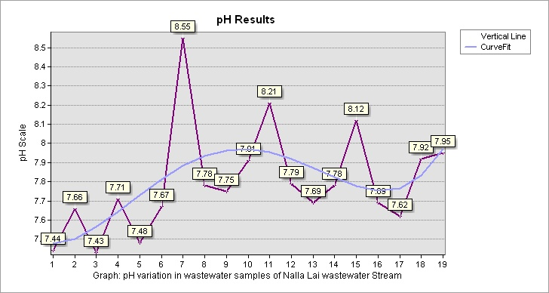

**Graph 1|** **pH** variation in wastewater samples of Nalla Lai stream

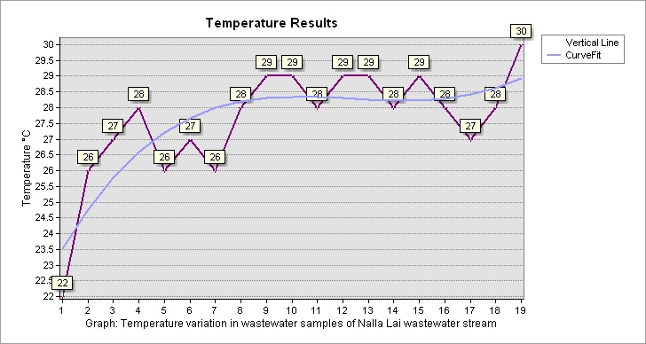

**Graph 2|** **Temperature** variation in wastewater samples of Nalla Lai stream

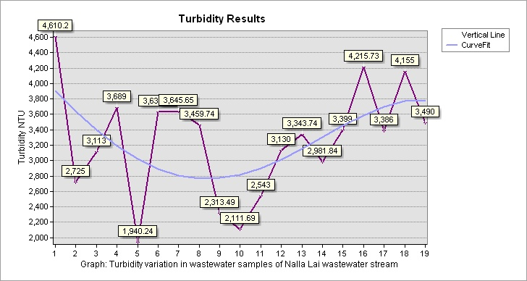

**Graph 3| Turbidity** variation in wastewater samples of Nalla Lai stream

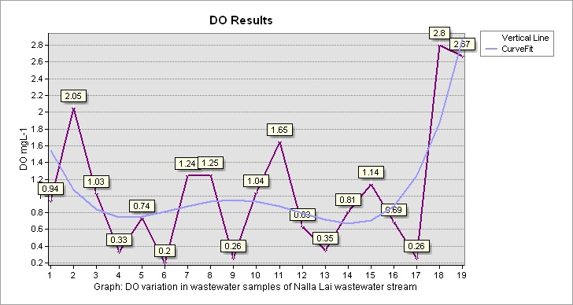

**Graph 4|** **Dissolved Oxygen** variation in wastewater samples of Nalla Lai stream

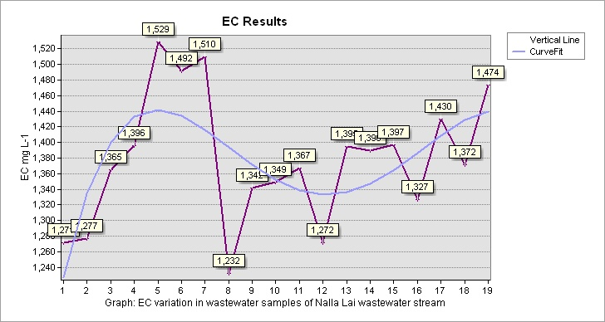

**Graph 5|** **Electric Conductivity** variation in wastewater samples of Nalla Lai stream

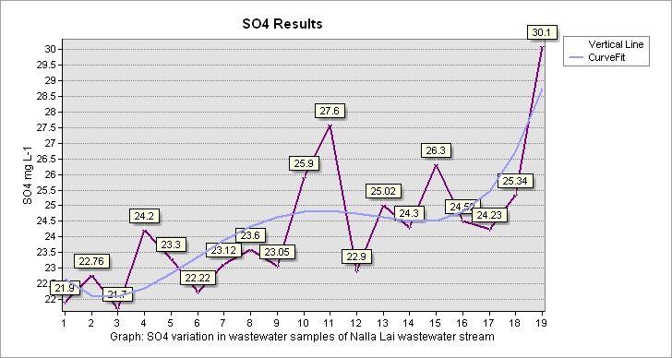

**Graph 6|** **Sulfate** variation in wastewater samples of Nalla Lai stream

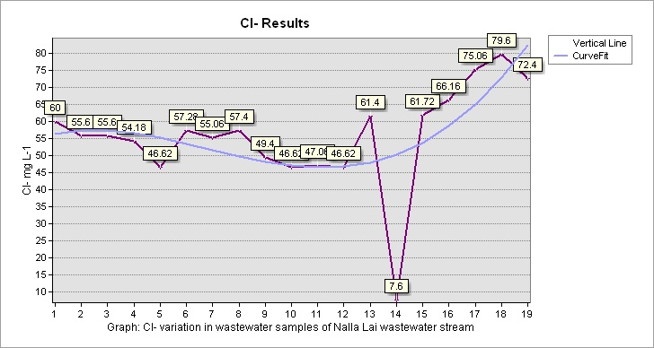

**Graph 7|** **Chloride** variation in wastewater samples of Nalla Lai stream

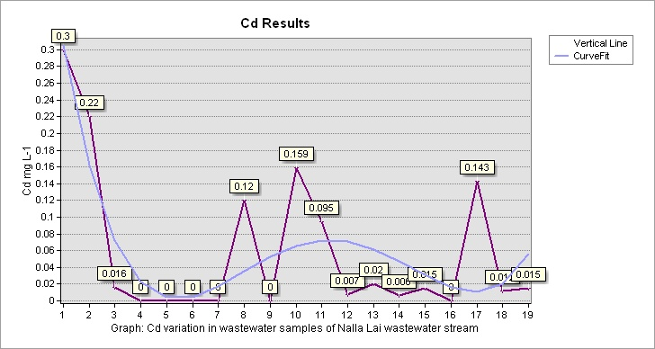

**Graph 8|** **Cadmium** variation in wastewater samples of Nalla Lai stream

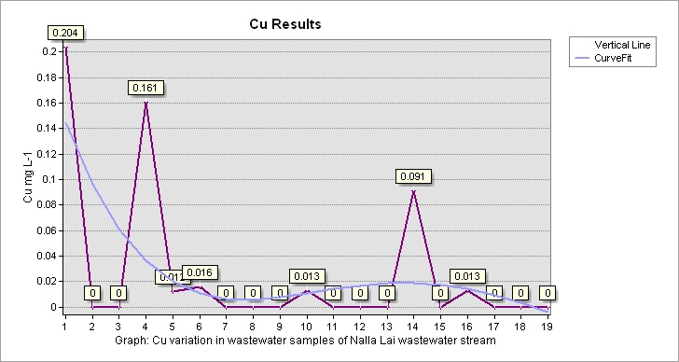

**Graph 9|** **Copper** variation in wastewater samples of Nalla Lai stream

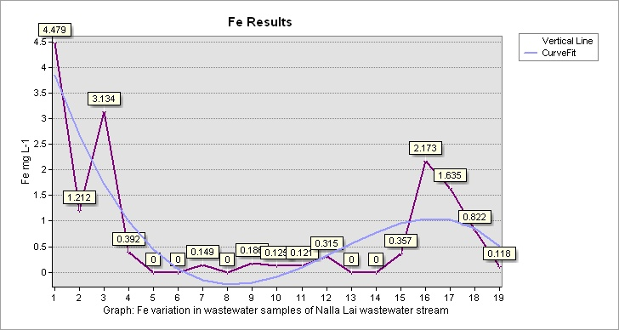

**Graph 10| Iron** variation in wastewater samples of Nalla Lai stream

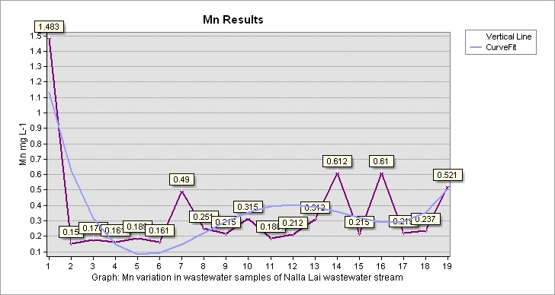

**Graph 11|** **Manganese** variation in wastewater samples of Nalla Lai stream

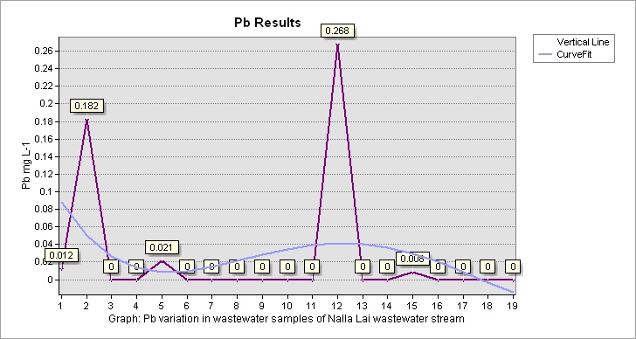

**Graph 12|** **Lead** variation in wastewater samples of Nalla Lai stream

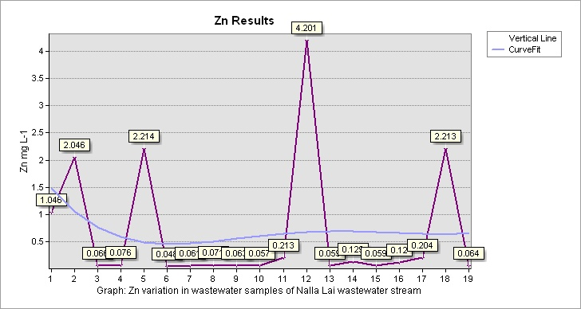

**Graph 13|** **Zinc** variation in wastewater samples of Nalla Lai stream

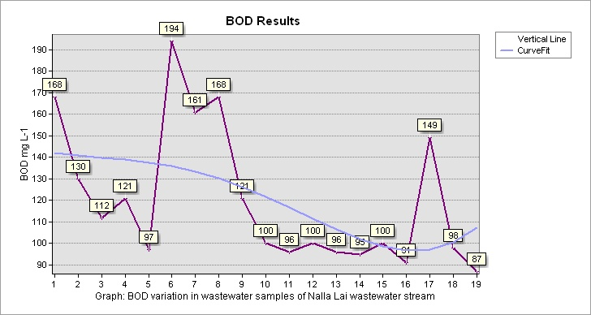

**Graph 14|** **Biological Oxygen Demand** variation in wastewater samples of Nalla Lai stream

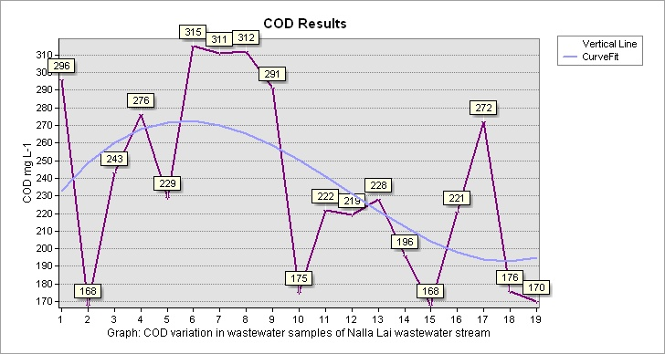

**Graph 15|** **Chemical Oxygen Demand** variation in wastewater samples of Nalla Lai stream