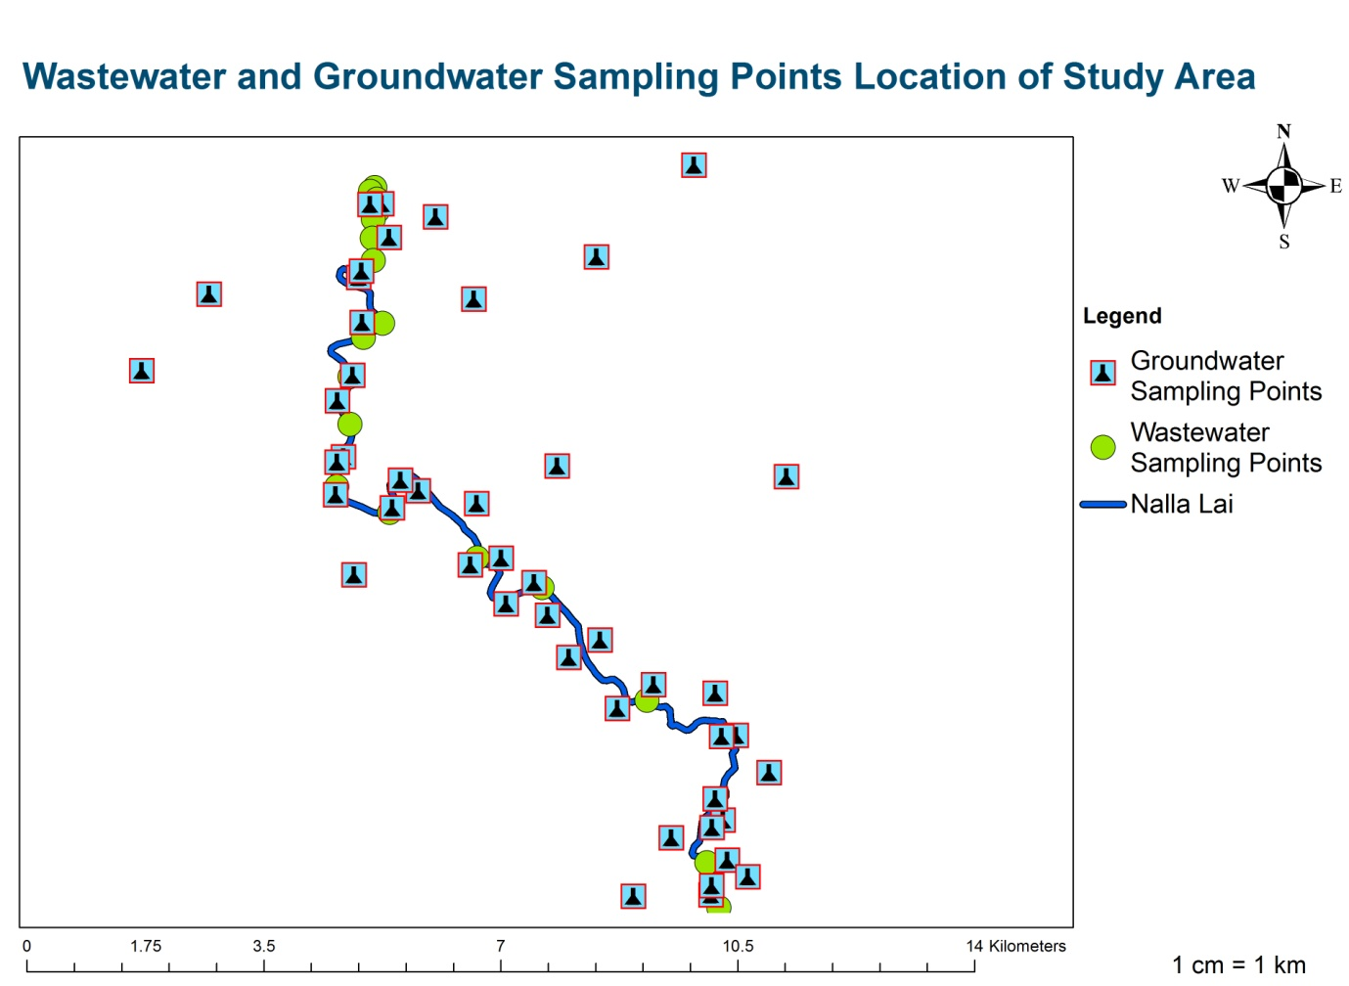

**Figure 1** **|** GIS Map of Sampling Points Location along with Nalla Lai (Study Area)

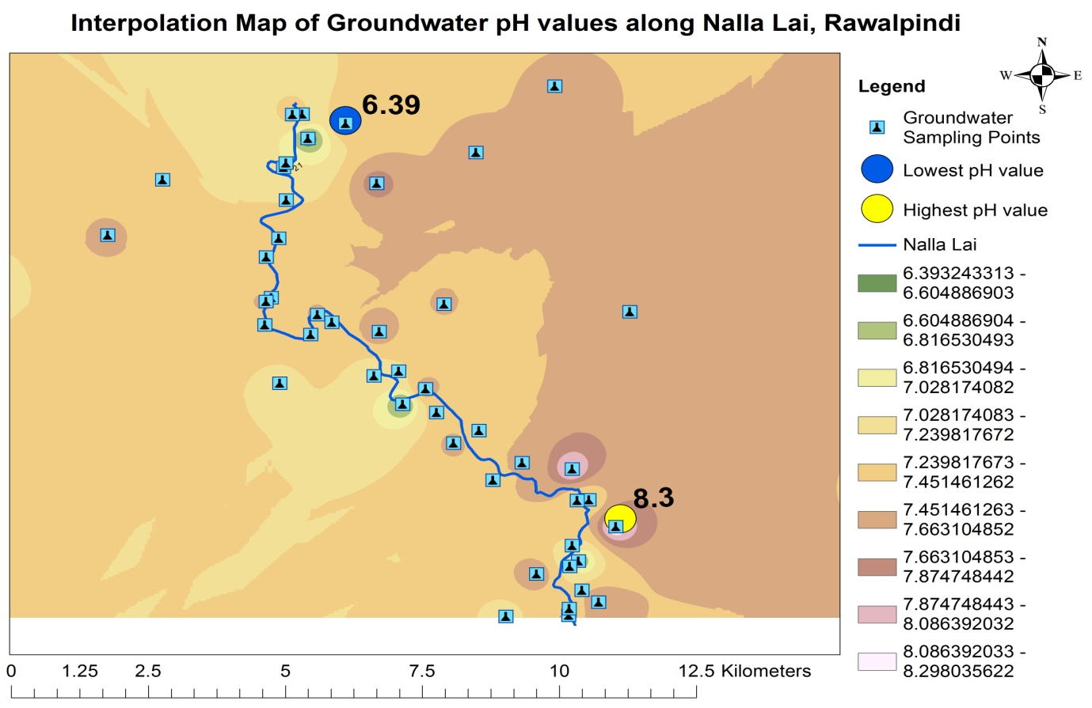

**Figure 2 |** Interpolation Map Showing Highest and Lowest pH Location Points of Groundwater

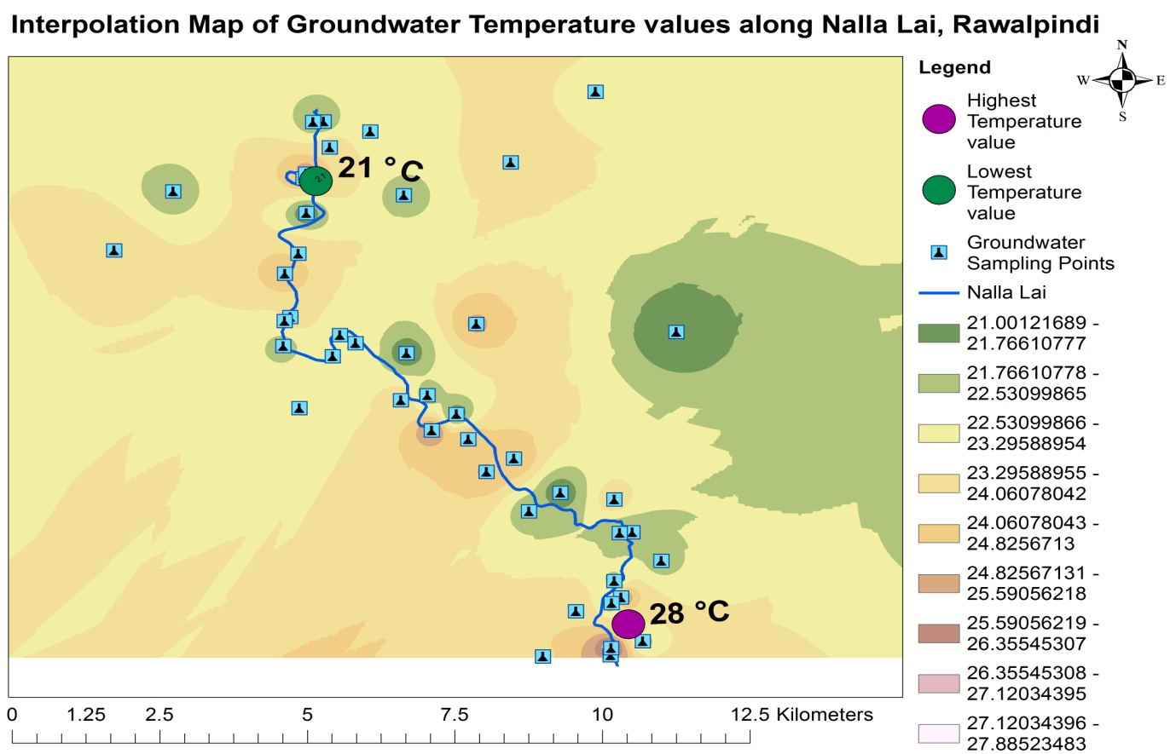

**Figure 3 |** Interpolation Map Showing Highest and Lowest Temperature Location Points of Groundwater

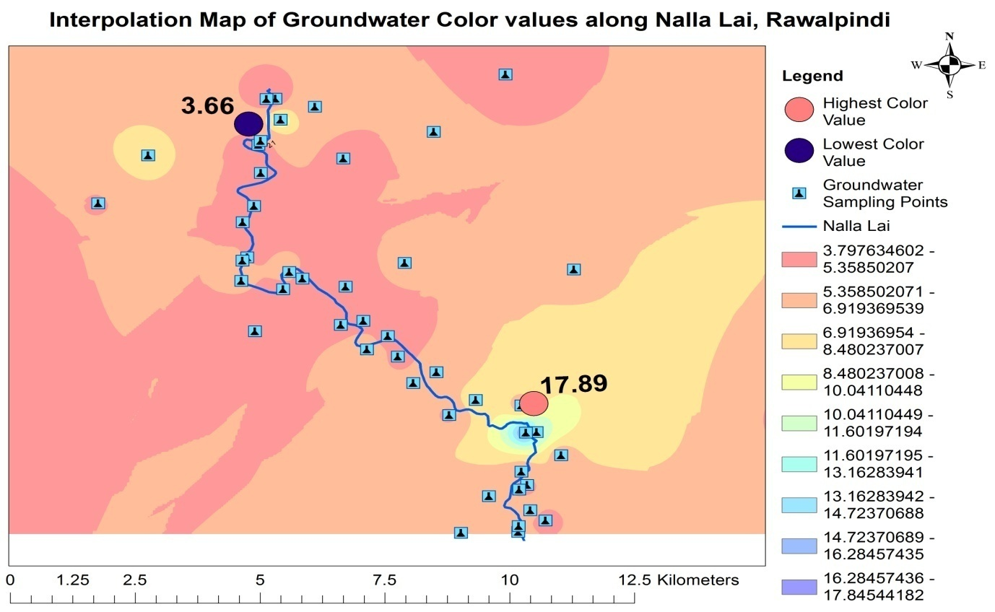

**Figure 4 |** Interpolation Map Showing Highest and Lowest Color Location Points of Groundwater

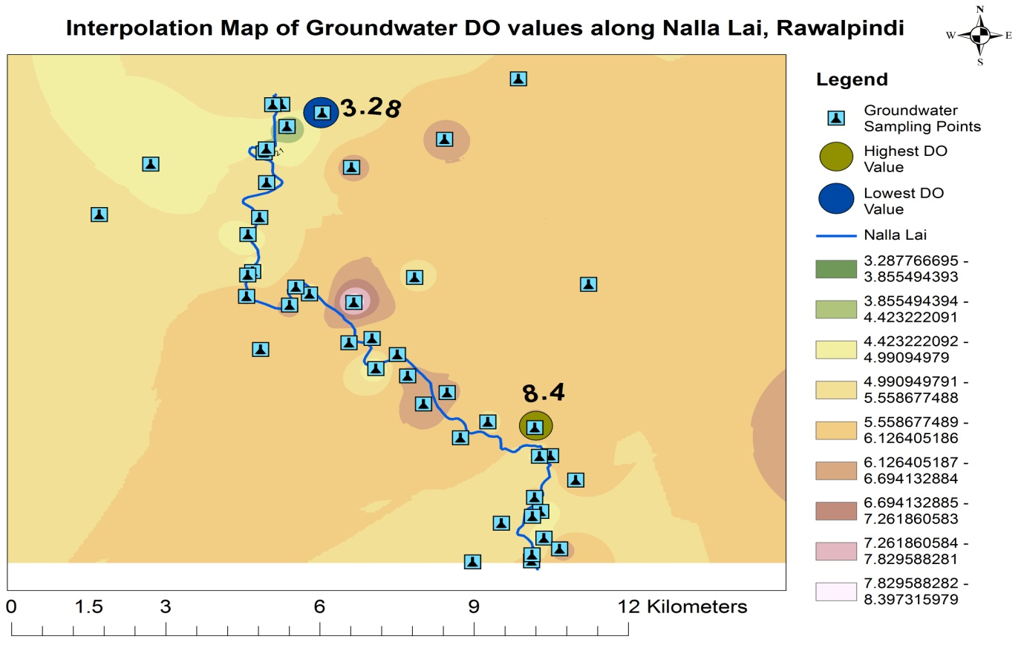

**Figure 5 |** Interpolation Map Showing Highest and Lowest DO Location Points of Groundwater

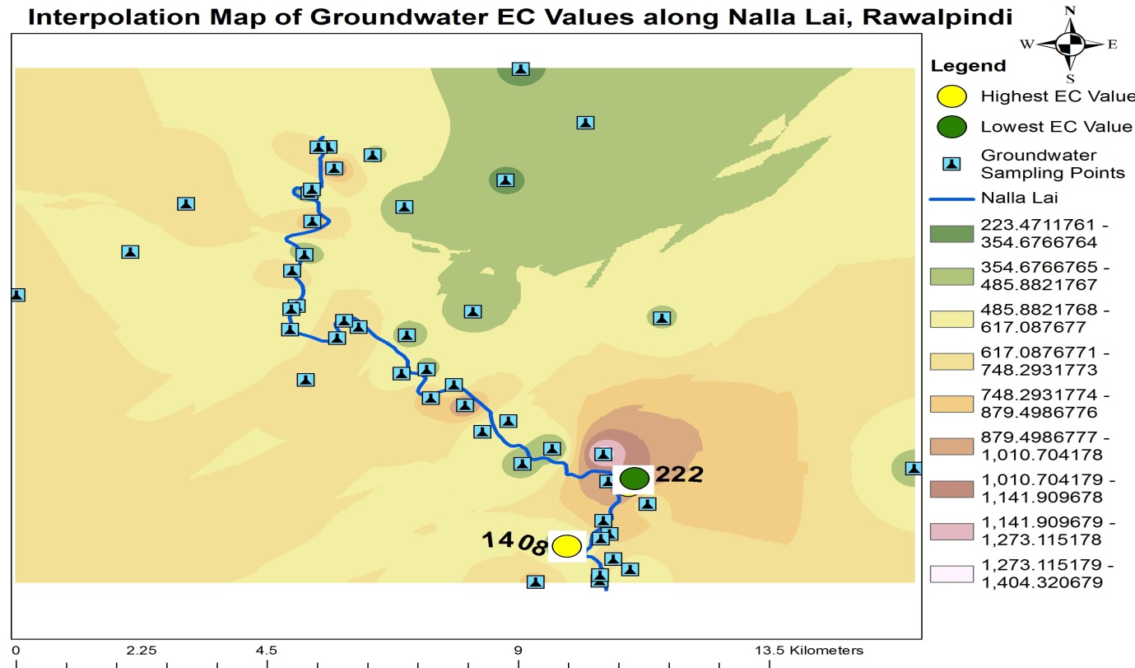

**Figure 6 |** Interpolation Map Showing Highest and Lowest EC Location Points of Groundwater

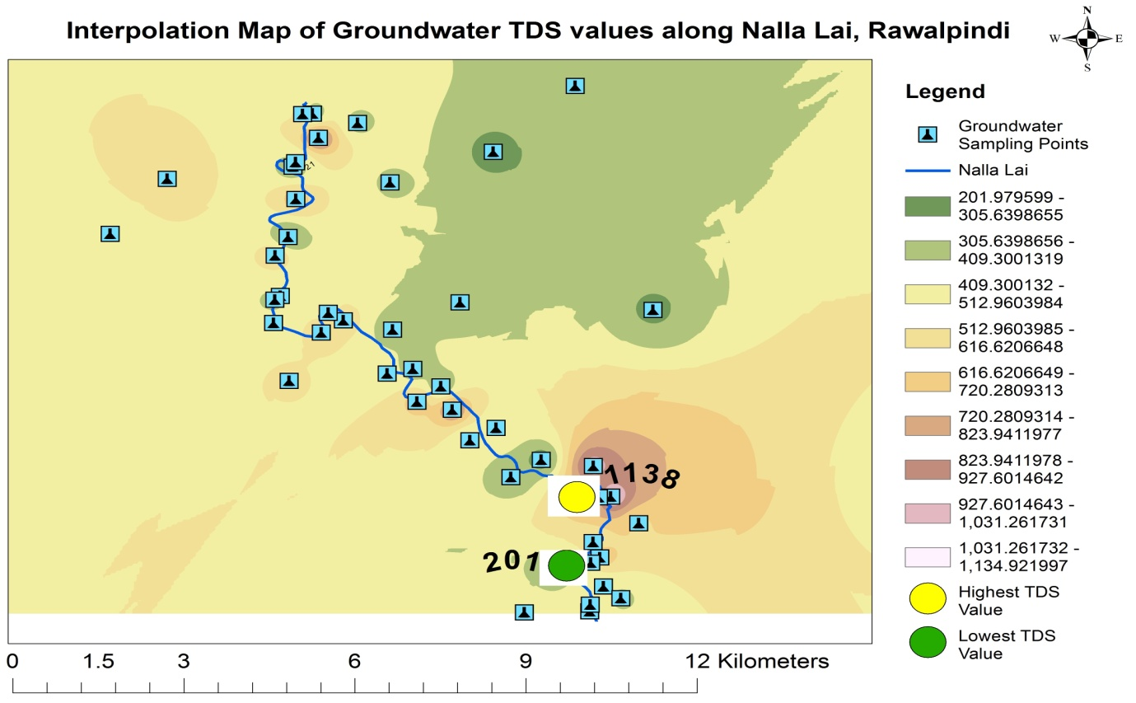

**Figure 7 |** Interpolation Map Showing Highest and Lowest TDS Location Points of Groundwater

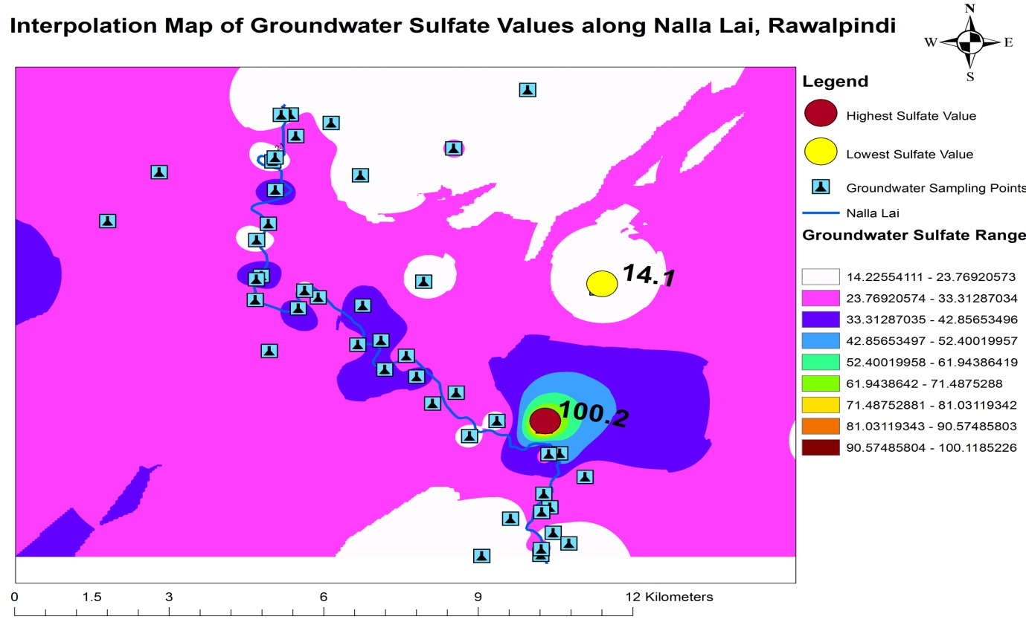

**Figure 8 |** Interpolation Map Showing Highest and Lowest (-SO4) Location Points of Groundwater

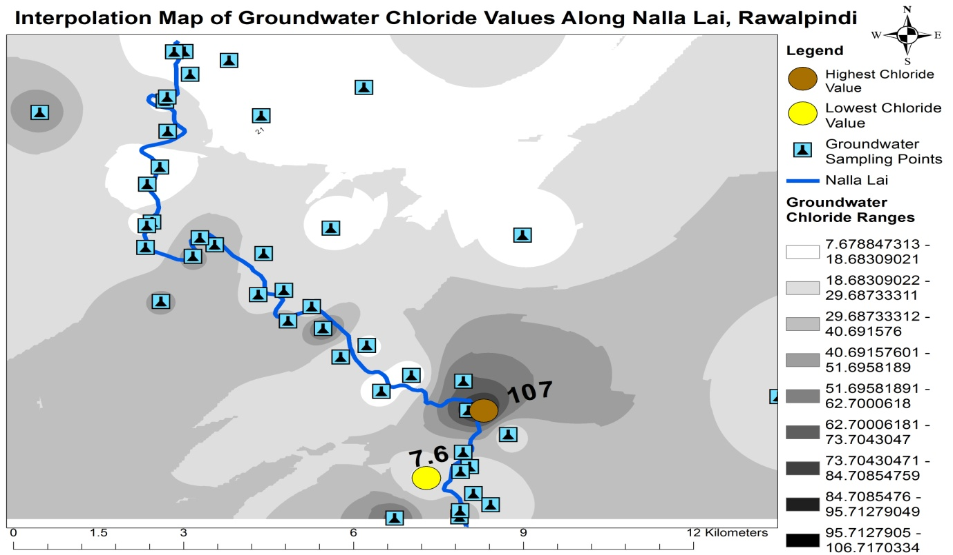

**Figure 9 |** Interpolation Map Showing Highest and Lowest Cl- Location Points of Groundwater

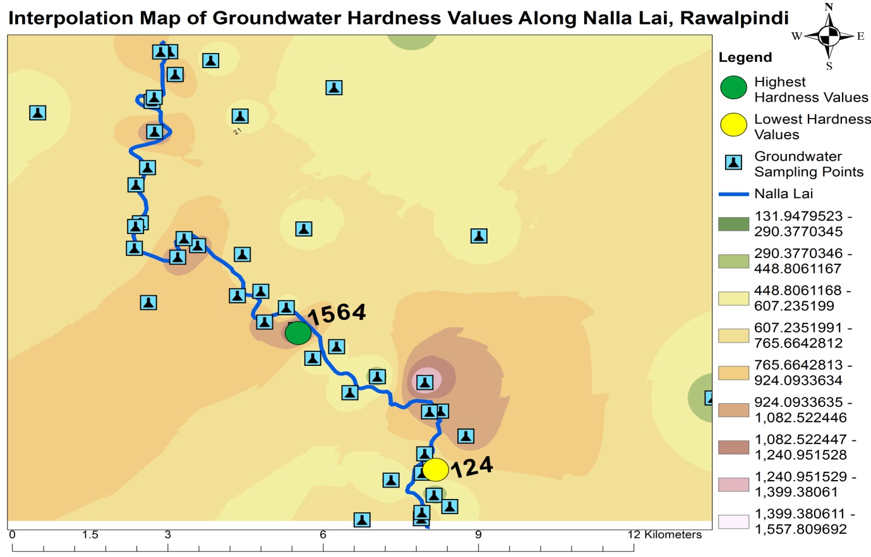

**Figure 10 |** Interpolation Map Showing Highest and Lowest Ha Location Points of Groundwater

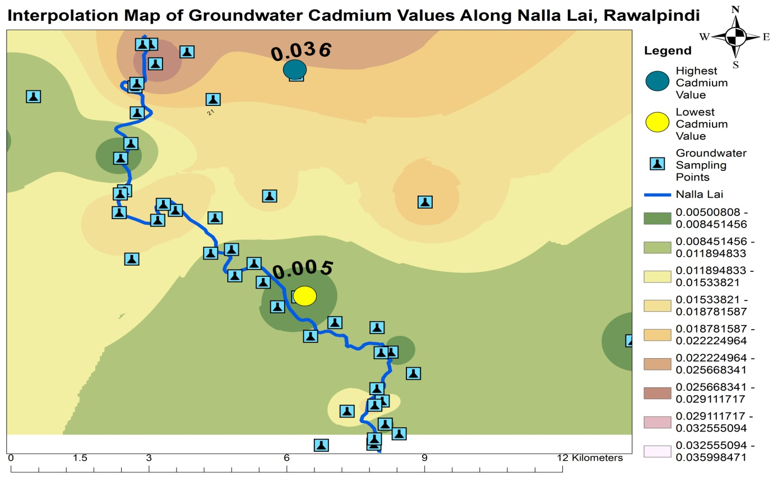

**Figure 11 |** Interpolation Map Showing Highest and Lowest Cd Location Points of Groundwater

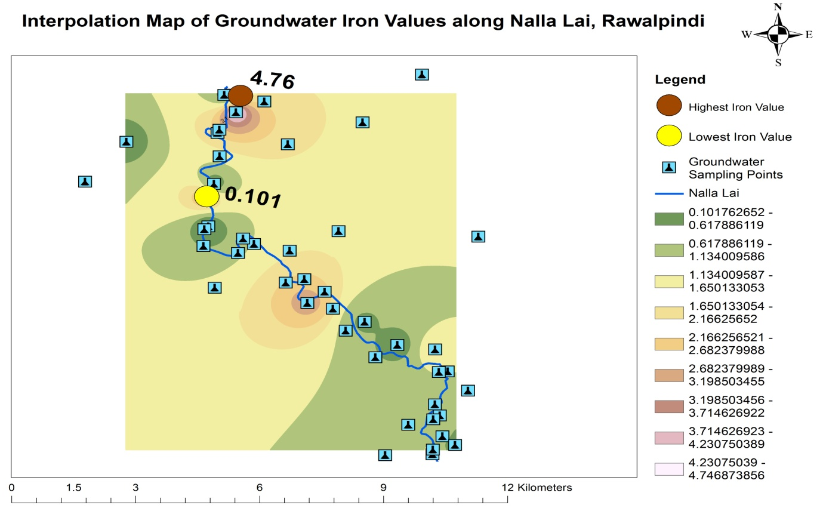

**Figure 12 |** Interpolation Map Showing Highest and Lowest Fe Location Points of Groundwater

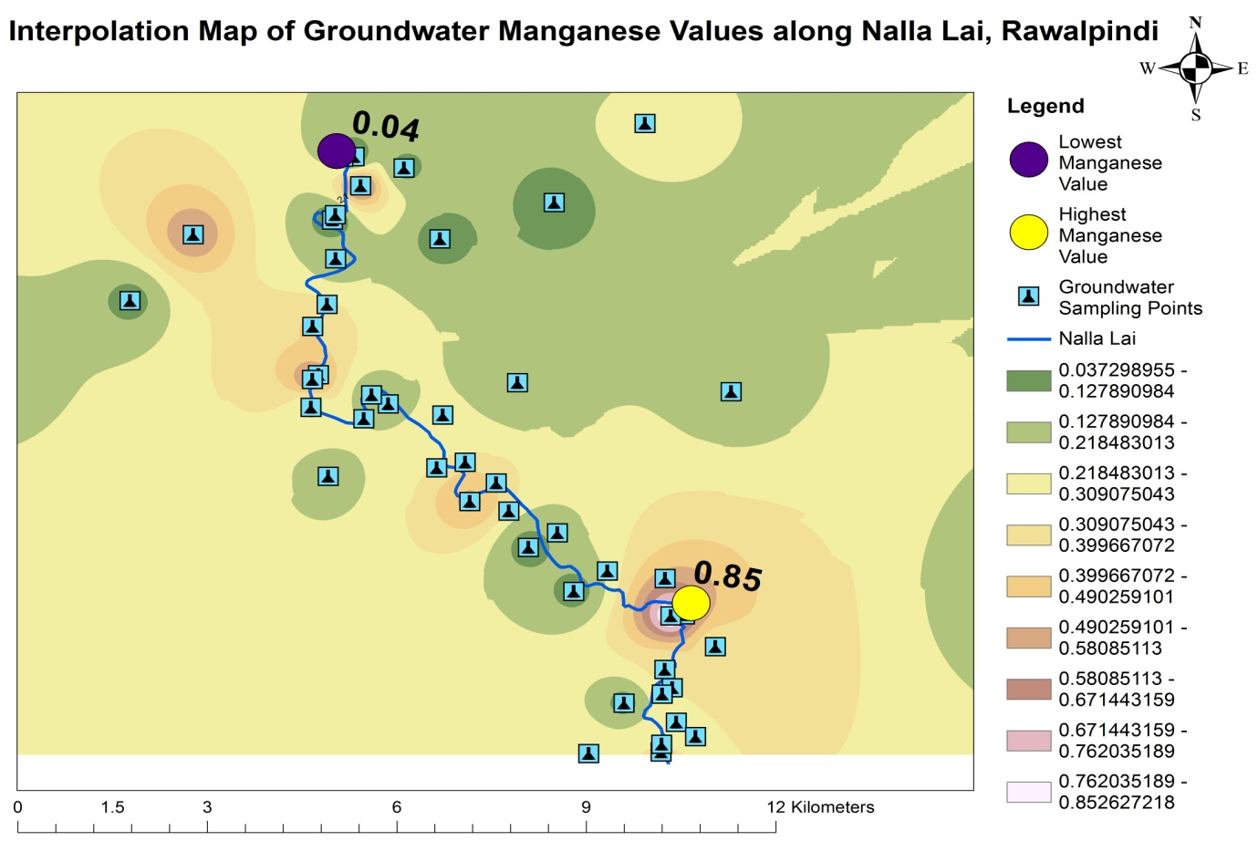

**Figure 13 |** Interpolation Map Showing Highest and Lowest Mn Location Points of Groundwater

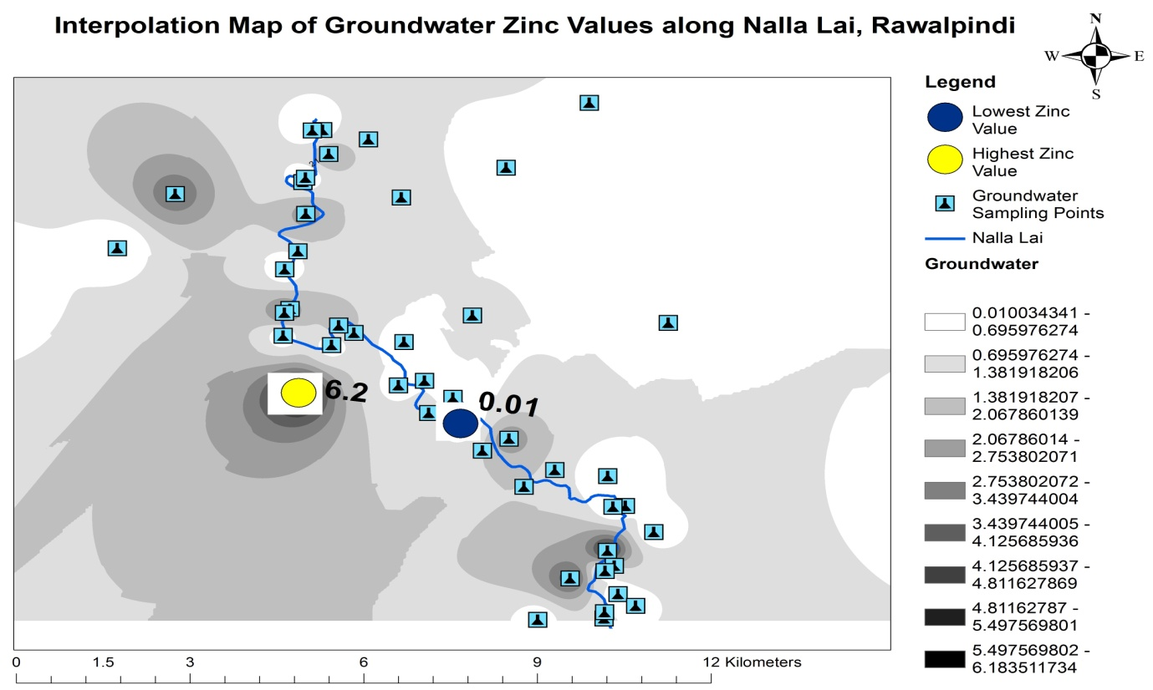

**Figure 14 |** Interpolation Map Showing Highest and Lowest Zn Location Points of Groundwater

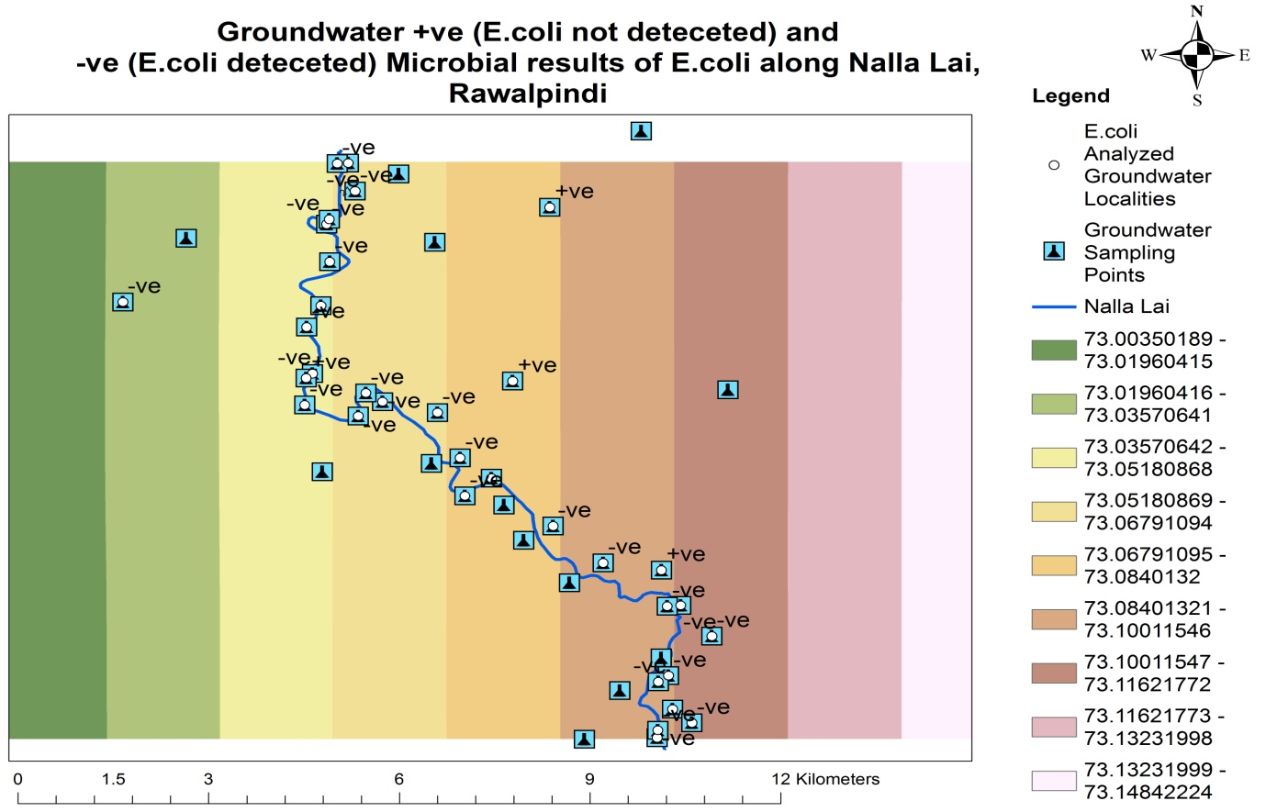

**Figure 15 |** Location Points of Positive (+ve) and Negative (-ve) Results of Fecal coliform (*E. coli*) in Groundwater

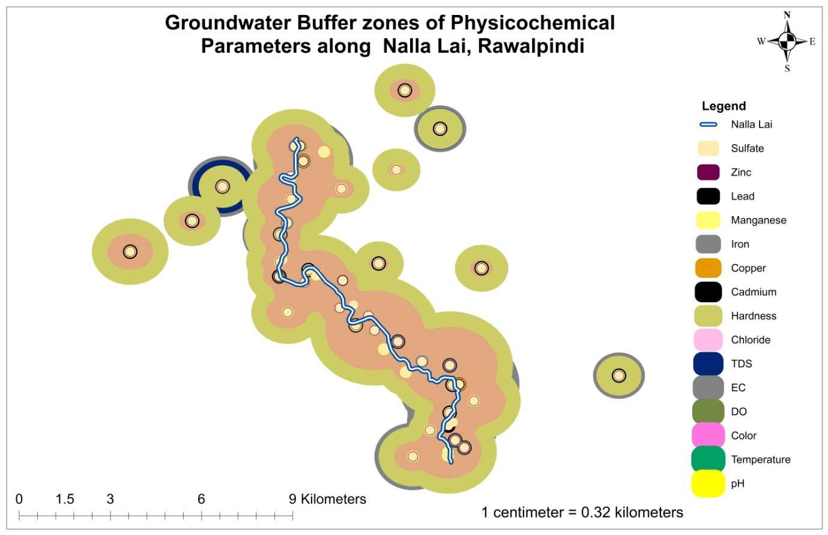

**Figure 16 |** Buffer Zones of Analyzed Physicochemical Parameter values of Groundwater along Nalla Lai, Rawalpindi.