The scientific report assessed the impact of Nalla lai wastewater on the groundwater quality of Rawalpindi city, Pakistan. A total of nineteen wastewater and forty-nine groundwater samples were collected during September and October 2016 and have been analyzed in the laboratory to detect different water quality parameters. The results revealed that BOD (Biological Oxygen Demand), COD (Chemical Oxygen Demand), Iron and Cadmium values in many wastewater samples were beyond the recommended value of the National Environmental Quality Standards 1997 (NEQs, 1997). In groundwater samples, the results of iron, cadmium, manganese, zinc, TDS (Total Dissolved Solids), pH, color and hardness were found elevated from the standard values in one or more samples as compared to the National Standard for Drinking Water Quality, 2010 (NSDWQ, 2010). The decreasing metal concentration order in groundwater samples was Iron > Zinc > Manganese > Copper > Cadmium. Very interestingly, hardness was found at elevated levels in 75% of investigated groundwater samples. Microbiological contamination was detected in 83% of the analyzed groundwater samples. The study revealed the percolation of heavy metals and microbial contamination in the bore water, tube wells, hand pumps, springs, and hand-dug wells located nearby the Nalla lai wastewater stream.

**Keywords:** Groundwater, Wastewater, Percolation, Nalla lai, E.coli, Rawalpindi

* This scientific study evaluates the impact of the Nalla lai wastewater stream on the groundwater quality of Rawalpindi city, Pakistan.
* BOD, COD, Iron and Cadmium concentration in many wastewater samples were beyond the recommended value of the National Environmental Quality Standards, 1997.
* Iron, Cadmium, Manganese, Zinc, TDS, pH, Color and Hardness concentration in groundwater samples were detected elevated in one or more samples as compared to the National Standards for Drinking Water Quality, 2010.
* The decreasing metal concentration order in groundwater samples was Iron > Zinc > Manganese > Copper > Cadmium.
* Hardness was elevated from the standard value in 75% of the investigated groundwater samples and microbial contamination was detected in 85% of the analyzed groundwater samples.

Groundwater is the drinking water source of one-third of the global population. It is a valuable freshwater resource used for household, farming, and industrial purposes (Li et al. 2013; International Association of Hydrogeologists 2020). The freshwater of Earth is about 2.5 % and 30 % of this resource exists in groundwater (USGS 2016). The world is facing a crisis of water quality due to the contamination of freshwater resources from rapid urbanization and industrialization (Poonia et al. 2021). Groundwater contamination is a very noteworthy environmental concern of the time (Momodu & Anyakora 2010). Regardless of its importance, water resource is not properly managed on earth (Fakayode, 2005). As compared to other water resources, groundwater can be less polluting by open discarding of waste (Tariq et al, 2008). Various research has been conducted to determine the fate of emerging organic pollutants in the sub-surface through the downward movement of wastewater and industrial effluents (Lapworth et al., 2012). Groundwater contamination can be resulting from the leakage of sewage (Eiswirth & Hotzl 1997). The primary source of groundwater contamination in Lahore, Pakistan is leakage of sewer lines and landfill sites where percolation of leachate and sewage contaminates the groundwater quality (Akhtar et al., 2014). The main sources of groundwater pollution in Pakistan are the discharging of waste effluents into water bodies by many industrial units including textiles, fertilizers, pesticides, steel, dying chemicals, cement, leather, etc (Tariq et al, 2006). The groundwater quality deterioration resulting from leachate percolation mainly occurs during monsoon season and escalates the diseases related to groundwater contamination. Groundwater contamination occurs mostly in the vicinity of landfill and municipal waste disposal sites and increases the chances of percolation in aquifers (Butt & Ghaffar 2012). The organic pollutants such as oil and pesticides in groundwater are present mostly due to anthropogenic activities whereas geological sources are the cause of inorganic pollutants in groundwater (Memon et al. 2011). In groundwater heavy metals can be present from natural and anthropogenic sources (Reza & Singh 2019; Singh & Kamal 2017). Environmental contaminants including heavy metals, pesticides, trace organic contaminants, nanoparticles, hydrocarbons and microplastic are a menace to both human health and ecological services, and also to sustainable social and economic development (Li 2020; Li & Wu 2019). Groundwater contamination is a well-known topic in research studies which is a huge challenge to human populations (Lin 2010). Groundwater remediation is challenging as well as costly because it is found in surface geological strata (Wang et al. 2020; Su et al. 2020). Due to the presence of groundwater in subsurface geological strata, its remediation is challenging as well as expensive. The sources of groundwater pollution in metropolitan areas include point sources, non-point sources, and linear sources (Choi et al. 2005). The natural remediation process of groundwater can take ten years to hundreds of years, even if the contamination source is removed (Tatti et al. 2019). Heavy metals and metalloids are a danger to both human health and the natural environment. The metals present in groundwater include zinc, mercury, chromium, lead, cadmium and metalloids such as arsenic and selenium. Although a small concentration of these elements is a necessary micronutrient but exposure to these chemical substances can cause severe poisoning (Hashim et al. 2011). Groundwater used for irrigation if contaminated with heavy metals can results in health risks due to the accumulation of toxic elements in vegetables and cereals (Jenifer & Jha 2018; Yuan et al. 2019; Njuguna et al. 2019). Groundwater contamination is an environmental as well as a social issue. Therefore a mutual collaboration between the natural scientist and social scientist is mandatory (Ciner et al. 2021). The rapid economic development and population growth have built pressure on groundwater resources. There are 2.8 million wells only in China (Han 2003) and the heavy extractions of groundwater have dropped their level. Groundwater contamination is the most important concern because it is connected to the survival of humans. The identification, remediation, and assessment of groundwater contamination are the most significant topics these years (Mariani et al. 2004). Globally 3.4 million deaths occur due to waterborne diseases (Berman 2009). In developing countries, 2.2 million people lost their lives each year because of drinking contaminated water and inappropriate sanitation system (WHO & UNICEF, 2000; UNESCO 2003). Water contamination is the paramount health and environmental issue in Pakistan. Waterborne disease such as hepatitis, diarrhea, typhoid, dysentery and cholera occupies 20-40 % of the beds in the hospital and become a cause of one-third of all mortalities in Pakistan (Farooq et al. 2008; Azizullah et al. 2011). Drinking water contaminated with heavy metals can affect vital human organs like the liver, kidney, and central nervous system (Khan & Zahoor 2011). The surface and groundwater quality is polluted by microbial and a variety of toxic chemicals (Azizullah et al., 2011). The underground lithological environment is the principal influencing factor of contaminant migration to groundwater (Rahman, 2008). The research study is conducted along the Nalla Lai which is a perennial wastewater stream containing both domestic and industrial effluents. It is an open sewer of twin cities (Rawalpindi and Islamabad). The study has been conducted by keeping the given prime objective to evaluate the impact of the Nalla wastewater stream on groundwater quality in its proximity.

**2.1 Description of Study Area**

Rawalpindi is the city of Punjab province and it is located near the capital city of Islamabad.The population of the city is 2.09 million with an area of 259 km2 (Atta et al. 2020). The latitude of Rawalpindi city is 33.5984° N and the longitude of the city is 73.0441° E (Shahid et al. 2019). Due to rapid urbanization, the city is facing extreme environmental conditions (Mehmood et al. 2019). Five different seasons are experienced by Rawalpindi city such as winter, summer, spring, autumn, and monsoon. June is the hottest month and January is the coldest month in Rawalpindi city with the highest and lowest recorded temperatures of 48 °C and -3.9 °C (Asghar et al. 2012; Khan et al. 2019). Water pollution, inappropriate sanitation facilities and solid waste dumping are the most significant environmental problems in the city (Nisar et al. 2008). Energy-efficient buildings, urbanization impact on groundwater, and seismic mapping are the relevant issues in the city (Maqsoom et al. 2021).

**2.2 Preliminary Visit and Sampling Plan**

A previsit of the research area was carried out to delineate the sampling boundary of the research area and to select the sampling point’s location by using the Global Positioning System (GPS) from IJP road to Soan River. A weekly sampling plan was prepared for the effective implementation of the sampling strategy. The sampling plan includes the preparation of a list of pre-selected sampling points location, requisition or hiring of transportation, selection of sampling day and time, cleaning of water sampling bottles, preparation of preservative, Icebox, personal protective equipment (PPE), first aid box, DO meter, pH meter, TDS meter, notebook, permanent marker, ballpoint pen, and checklist.

**2.3 Sample Collection**

To characterize the wastewater and groundwater quality of the research area the samples were collected by following the internationally recognized sampling procedure “Standard Methods for the Examination of Water and Wastewater” APHA (2012). Water sampling of the study area was divided into two types.

1. Groundwater sampling
2. Wastewater sampling

**II. Groundwater Sampling**

Groundwater samples were collected by using the grab sampling technique (Kamble 2015).Forty-nine groundwater water samples were collected in pre-sterilized polypropylene bottles. Before sterilization, the bottles were properly washed with water (hot) and detergents followed by thrice rinsing with distilled water. The samples were collected from both source and consumer levels in September 2016 at least one week after rainfall. Thirty-six groundwater samples were collected from the proximity of Nalla lai. Thirteen control samples were taken from at least a 1 km distance from both sites of Nalla lai.

The water samples of (17) tube wells, (29) boreholes, (1) dug well and (2) springs were collected from different inhabitant colonies of the study area. Used 1000 ml (1 Litre) sampling bottle and collected a water sample from each sampling point for the detection of non-metals. Similarly, a 500 ml sampling bottle was used to collect a water sample from the same point to analyze heavy metals and added preservatives of Nitric acid (-HNO3) to bring the water sample pH <2. The sampling bottles were properly tagged or labeled with sampling type, sample number, date, time/ hour, location, and source.

**II. Wastewater Sampling**

Wastewater samples of Nalla Lai were collected by using a composite sampling technique (Raashid & Hussain 2014). The wastewater sampling of Nalla Lai was collected in October 2016. Wastewater samples were collected in pre-sterilized polypropylene bottles properly washed with hot tap water followed by detergent, water reagent, and then thrice rinsed with distilled water. A total of nineteen wastewater samples of Nalla Lai were collected from various distances. Sample (1) and sample (2) were collected from wastewater streams passing through the I-9 and I-10 Industrial sectors of Islamabad whereas sample (3) was collected from a junction point of 1-9 and I-10 industrial wastewater streams at the point of Kataria Bridge while remaining 15 samples were collected from various distances along with Nalla Lai till Soan River. Used 1000 ml (1 Litre) wastewater sampling container and collected samples from each sampling point to detect non-metals. Likewise, a 500 ml sampling container was used to collect wastewater from the same point to analyze heavy metals and added preservatives of Nitric acid (-HNO3) to bring the pH of the wastewater sample i.e. less than 2 pH. The sampling bottles were properly labeled with sampling type, sample number, date, time/ hour, location, and source.

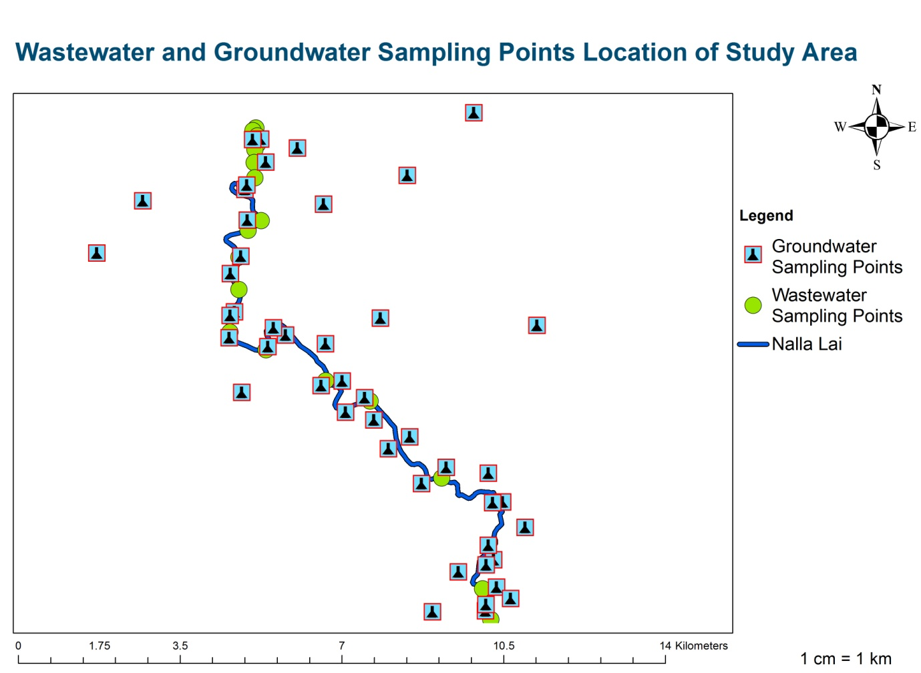

**Figure 1** **|** GIS Map of Sampling Points Location along with Nalla Lai (Study Area)

**2.4 Analytical Procedure**

**I) In situ Analysis**

Insitu water testing of parameters like pH (pH scale), Temperature (), DO (mg L-1), EC (µ S/cm), and TDS (mg L-1) were determined by pH Meter, Thermometer, DO Meter, and TDS Meter respectively and followed the “Standard Methods for the Examination of Water and Wastewater” (APHA 2012).

**II) Detection of *E. coli* in Groundwater**

Microbial samples of groundwater were collected by using the grab sampling technique (Tahir et al. 2011). A total of thirty-six samples were collected in October 2016 from the study area for bacteriological tests. Took 50 ml water sample in a sterile container for the qualitative analysis of drinking water quality by using water check kits of “Merck company”. First, put the blister pack in a sterile container with care and shook well to dissolve the granules and not touch the inner part of the container. Left enough air space in the sampling container and screwed the cap firmly. Placed the container at room temperature for 48 hours. The color changed to Blue and Green showing bacterial contamination and the samples having yellow, off-white, and brownish or no change in color represented that water was fit for drinking purposes.

**III) Physico-chemical Analysis**

The analysis of physicochemical parameters was performed by shifting the water samples to CLEAN laboratory Pak-EPA and left in a refrigerator at 4 ºC to preserve the integrity of the samples. The analysis of chemical parameters of both groundwater and wastewater samples was performed by using the instrument mentioned in Table 1.

**Table 1 |** Parameters with respective abbreviations Units, Holding time, Preservatives, and Analytical Methods

|  |  |  |  |  |  |
| --- | --- | --- | --- | --- | --- |
| **Parameters** | **Abbreviations** | **Units** | **Holding Time** | **Preservatives** | **Analytical Methods/ Instruments** |
| Potential Hydrogen | pH |  | In Situ | None | pH Meter |
| Temperature | Temp | °C | In situ | None | Thermometer |
| Turbidity | TU | NTU | 4 hours | None | Water Analyzer |
| Color | Col | TCU | 4 hours | None | Water Analyzer |
| Dissolved Oxygen | DO | mg L-1 | In situ | None | DO Meter |
| Electric Conductivity | EC | µ S/cm | In Situ | None | TDS Meter |
| Total Dissolved Solids | TDS | mg L-1 | In situ | None | TDS Meter |
| Sulfate | 0 | mg L-1 | 4 days | 4 °C | UV/Visible Spectrometer |
| Chloride | Cl- | mg L-1 | 4days | 4 °C | APHA 2012, 22nd edition, part 4500 Cl- |
| Hardness | Ha | mg L-1 | 5days | 4 °C | APHA 2012, 22nd edition, part 2340 |
| Cadmium | Cd | mg L-1 | 30 days | HNO3, pH<2 | (AAS) Model: A ANALYST 800 |
| Copper | Cu | mg L-1 | 31 days | HNO3, pH<2 | (AAS) Model: A ANALYST 800 |
| Iron | Fe | mg L-1 | 32 days | HNO3, pH<2 | (AAS) Model: A ANALYST 800 |
| Manganese | Mn | mg L-1 | 33 days | HNO3, pH<2 | (AAS) Model: A ANALYST 800 |
| Lead | Pb | mg L-1 | 34 days | HNO3, pH<2 | (AAS) Model: A ANALYST 800 |
| Zinc | Zn | mg L-1 | 35 days | HNO3, pH<2 | (AAS) Model: A ANALYST 800 |

**IV) Data Analysis**

The statistical analysis and interpolation maps of wastewater and groundwater high vulnerable localities were performed by using Microsoft Excel Environment, XLSTAT, and GIS tools.

The results of many analyzed samples of wastewater of Nalla lai were beyond the standard value of NEQs, 1997. Iron was detected elevated from the recommended value in 3 wastewater samples, cadmium value was higher in 5 wastewater samples. BOD results of all wastewater samples and COD values of 13 samples were elevated from the standard values of NEQs, 1997. Maximum contamination was observed in the groundwater samples which were collected from the proximity of Nalla lai. Out of the total of forty-nine groundwater samples, thirty-six groundwater samples were collected from the proximity of Nalla lai. The analyzed results showed that iron concentration was elevated from the recommended limit value in 10 groundwater samples, cadmium was higher in 5 groundwater samples, manganese was detected in elevation concentration in 4 groundwater samples, zinc and TDS were beyond the standard limit 1 in groundwater sample, pH value was very low in 3 groundwater samples, the color value was high in 1 groundwater samples, hardness concentration was beyond the recommended value in 30 groundwater samples and microbial contamination of fecal coliform was detected in 30 groundwater samples.

|  |  |  |  |  |  |  |  |  |  |  |  |  |  |  |  |
| --- | --- | --- | --- | --- | --- | --- | --- | --- | --- | --- | --- | --- | --- | --- | --- |
| **Table 2 |** Physico-chemical results of wastewater parameters of Nalla Lai. ( n=19) | | | | | | | | | | | | | | | |
| **S. No** | **pH** | **Temp** | **Turbidity** | **DO** | **EC** | **S04** | **Cl-** | **Cd** | **Cu** | **Fe** | **Mn** | **Pb** | **Zn** | **BOD** | **COD** |
| 1 | 7.44 | 22 | 4610.20 | 0.94 | 1271 | 21.9 | 60 | 0.3 | 0.204 | 4.479 | 1.483 | 0.012 | 1.046 | 168 | 296 |
| 2 | 7.66 | 26 | 2725 | 2.05 | 1277 | 22.76 | 55.6 | 0.22 | BDL | 1.212 | 0.15 | 0.182 | 2.046 | 130 | 168 |
| 3 | 7.43 | 27 | 3113 | 1.03 | 1365 | 21.70 | 55.6 | 0.016 | BDL | 3.134 | 0.176 | BDL | 0.066 | 112 | 243 |
| 4 | 7.71 | 28 | 3689 | 0.33 | 1396 | 24.2 | 54.18 | BDL | 0.161 | 0.392 | 0.161 | BDL | 0.076 | 121 | 276 |
| 5 | 7.48 | 26 | 1940.24 | 0.74 | 1529 | 23.3 | 46.62 | BDL | 0.012 | BDL | 0.189 | 0.021 | 2.214 | 97 | 229 |
| 6 | 7.67 | 27 | 3635.84 | 0.20 | 1492 | 22.22 | 57.28 | BDL | 0.016 | BDL | 0.161 | BDL | 0.048 | 194 | 315 |
| 7 | 8.55 | 26 | 3645.65 | 1.24 | 1510 | 23.12 | 55.06 | BDL | BDL | 0.149 | 0.49 | BDL | 0.061 | 161 | 311 |
| 8 | 7.78 | 28 | 3459.74 | 1.25 | 1232 | 23.6 | 57.4 | 0.12 | BDL | BDL | 0.251 | BDL | 0.071 | 168 | 312 |
| 9 | 7.75 | 29 | 2313.49 | 0.26 | 1342 | 23.05 | 49.4 | BDL | BDL | 0.186 | 0.215 | BDL | 0.063 | 121 | 291 |
| 10 | 7.91 | 29 | 2111.69 | 1.04 | 1349 | 25.9 | 46.62 | 0.159 | 0.013 | 0.125 | 0.315 | BDL | 0.057 | 100 | 175 |
| 11 | 8.21 | 28 | 2543 | 1.65 | 1367 | 27.6 | 47.06 | 0.095 | BDL | 0.121 | 0.188 | BDL | 0.213 | 96 | 222 |
| 12 | 7.79 | 29 | 3130 | 0.63 | 1272 | 22.9 | 46.62 | 0.007 | BDL | 0.315 | 0.212 | 0.268 | 4.201 | 100 | 219 |
| 13 | 7.69 | 29 | 3343.74 | 0.35 | 1395 | 25.02 | 61.4 | 0.02 | BDL | BDL | 0.312 | BDL | 0.059 | 96 | 228 |
| 14 | 7.78 | 28 | 2981.84 | 0.81 | 1390 | 24.3 | 7.6 | 0.006 | 0.091 | BDL | 0.612 | BDL | 0.129 | 95 | 196 |
| 15 | 8.12 | 29 | 3399 | 1.14 | 1397 | 26.3 | 61.72 | 0.015 | BDL | 0.357 | 0.215 | 0.008 | 0.059 | 100 | 168 |
| 16 | 7.69 | 28 | 4215.73 | 0.69 | 1327 | 24.52 | 66.16 | BDL | 0.013 | 2.173 | 0.61 | BDL | 0.12 | 91 | 221 |
| 17 | 7.62 | 27 | 3386 | 0.26 | 1430 | 24.23 | 75.06 | 0.143 | BDL | 1.635 | 0.219 | BDL | 0.204 | 149 | 272 |
| 18 | 7.92 | 28 | 4155 | 2.80 | 1372 | 25.34 | 79.6 | 0.012 | BDL | 0.822 | 0.237 | BDL | 2.213 | 98 | 176 |
| 19 | 7.95 | 30 | 3490 | 2.67 | 1474 | 30.10 | 72.4 | 0.015 | BDL | 0.118 | 0.521 | BDL | 0.064 | 87 | 170 |

**Table 3 |** Descriptive statistics of wastewater samples of the study area: n=19

|  |  |  |  |  |
| --- | --- | --- | --- | --- |
| **Variables** | **Unit** | **Maximum** | **Minimum** | **Average** |
| pH |  | 8.55 | 7.43 | 7.8 |
| Temp | °C | 30 | 22 | 27.58 |
| Turbidity | NTU | 4610.20 | 1940.24 | 3257.27 |
| DO | mg L-1 | 2.80 | 0.20 | 1.06 |
| EC | µ S/cm | 1529 | 1232 | 1378.26 |
| SO4 | mg L-1 | 30.10 | 21.70 | 24.32 |
| Cl- | mg L-1 | 79.6 | 7.6 | 55.55 |
| Cd | mg L-1 | 0.3 | 0.006 | 0.09 |
| Cu | mg L-1 | 0.204 | 0.012 | 0.08 |
| Fe | mg L-1 | 4.48 | 0.12 | 1.09 |
| Mn | mg L-1 | 1.48 | 0.15 | 0.35 |
| Pb | mg L-1 | 0.268 | 0.008 | 0.10 |
| Zn | mg L-1 | 4.20 | 0.05 | 0.68 |
| BOD | mg L-1 | 194 | 87 | 120.21 |
| COD | mg L-1 | 315 | 168 | 240.15 |

**Table 4 |** Physicochemical and Microbial Results of Groundwater of Study Area. (n=49)

|  |  |  |  |  |  |  |  |  |  |  |  |  |  |  |  |  |  |
| --- | --- | --- | --- | --- | --- | --- | --- | --- | --- | --- | --- | --- | --- | --- | --- | --- | --- |
| **S.No** | **pH** | **Tem** | **TU** | **Color** | **DO** | **EC** | **TDS** | **SO4** | **Cl-** | **Ha** | **Cd** | **Cu** | **Fe** | **Mn** | **Pb** | **Zn** | **E.coli** |
| 1 | 7.25 | 22 | 0 | 4.4 | 5.7 | 356 | 291 | 24.14 | 12.7 | 616 | BDL | 0.11 | 0.26 | 0.038 | 0.003 | 0.52 | -ve |
| 2 | 6.39 | 24 | 0 | 10.04 | 3.28 | 1121 | 958 | 36.7 | 13.3 | 1065 | 0.028 | 0.139 | 4.757 | 0.685 | 0.002 | 2.26 | -ve |
| 3 | 7.34 | 24 | 0 | 3.66 | 5.83 | 323 | 267 | 18.34 | 11.32 | 616 | BDL | BDL | BDL | 0.036 | BDL | BDL | -ve |
| 4 | 7.45 | 24 | 0 | 4.79 | 5.64 | 302 | 254 | 26.11 | 9.1 | 552 | BDL | BDL | 0.219 | BDL | BDL | BDL | -ve |
| 5 | 7.35 | 25 | 0 | 4.62 | 4.58 | 619 | 498 | 45 | 23.5 | 536 | BDL | BDL | 0.101 | BDL | BDL | BDL | -ve |
| 6 | 7.41 | 23 | 0 | 5.06 | 6.48 | 772 | 584 | 41.33 | 49.7 | 1121 | BDL | BDL | BDL | BDL | BDL | 0.18 | -ve |
| 7 | 7.59 | 21 | 0 | 4.39 | 8.4 | 405 | 319 | 37.18 | 21.1 | 596 | BDL | BDL | BDL | BDL | 0.004 | 0.131 | -ve |
| 8 | 7.23 | 22 | 0 | 4.72 | 5.8 | 407 | 322 | 46.24 | 19 | 656 | BDL | BDL | BDL | BDL | BDL | BDL | -ve |
| 9 | 7.65 | 21 | 0 | 4.11 | 5.87 | 433 | 293 | 21.4 | 13.1 | 372 | BDL | BDL | BDL | BDL | BDL | 0.096 | -ve |
| 10 | 7.29 | 25 | 0 | 5.7 | 6.2 | 540 | 449 | 29.1 | 14 | 568 | 0.005 | BDL | 0.529 | BDL | BDL | 2.476 | -ve |
| 11 | 7.47 | 21 | 0 | 7.73 | 5.36 | 289 | 229 | 18.9 | 8.21 | 332 | BDL | BDL | 0.345 | BDL | BDL | BDL | -ve |
| 12 | 8.19 | 24 | 0 | 5.86 | 6.68 | 1380 | 996 | 100.2 | 64.4 | 1528 | 0.009 | BDL | 1.512 | BDL | BDL | 0.089 | +ve |
| 13 | 7.22 | 22 | 0 | 10.24 | 6.19 | 1408 | 1138 | 59.64 | 107 | 1122 | 0.005 | 0.038 | BDL | BDL | 0.038 | BDL | -ve |
| 14 | 8.3 | 22 | 0 | 5.91 | 5.9 | 637 | 595 | 22.6 | 17.1 | 1076 | BDL | BDL | BDL | 0.344 | BDL | 0.093 | -ve |
| 15 | 6.41 | 27 | 0 | 4.84 | 3.85 | 1019 | 844 | 28 | 22.7 | 896 | BDL | BDL | BDL | BDL | BDL | BDL | -ve |
| 16 | 7.3 | 21 | 0 | 5.17 | 5.46 | 446 | 358 | 34 | 19.32 | 564 | 0.021 | BDL | BDL | BDL | BDL | 0.014 | -ve |
| 17 | 7.65 | 23 | 0 | 5.78 | 4.39 | 722 | 419 | 20.1 | 12.21 | 124 | 0.007 | BDL | 0.786 | BDL | BDL | 0.23 | +ve |
| 18 | 7.7 | 22 | 0 | 4.74 | 6.93 | 442 | 360 | 14.7 | 25.1 | 556 | 0.009 | BDL | 0.134 | BDL | BDL | 0.404 | -ve |
| 19 | 7.35 | 22 | 0 | 4.63 | 5.61 | 731 | 551 | 16.8 | 17.32 | 976 | BDL | BDL | 0.396 | BDL | BDL | 0.071 | -ve |
| 20 | 6.86 | 26 | 0 | 6.22 | 3.73 | 549 | 451 | 22.2 | 29.1 | 604 | BDL | BDL | BDL | BDL | BDL | 0.092 | -ve |
| 21 | 7.25 | 21 | 0 | 4.96 | 5.46 | 905 | 691 | 44.34 | 28.2 | 1144 | BDL | BDL | BDL | 0.162 | BDL | 2.413 | -ve |
| 22 | 6.59 | 25 | 0 | 5 | 4.45 | 783 | 609 | 15.7 | 10.9 | 776 | 0.005 | BDL | 2.914 | 0.412 | BDL | 0.121 | -ve |
| 23 | 7.35 | 22 | 0 | 5.39 | 6.33 | 549 | 439 | 24.45 | 20.43 | 656 | 0.018 | BDL | BDL | 0.189 | 0.04 | 0.09 | -ve |
| 24 | 7.41 | 23 | 0 | 4.5 | 5.25 | 794 | 581 | 30.41 | 37.53 | 1064 | BDL | BDL | BDL | 0.218 | BDL | BDL | -ve |
| 25 | 7.07 | 24 | 0 | 4.94 | 5.88 | 566 | 464 | 29.91 | 28 | 776 | BDL | BDL | BDL | BDL | BDL | 0.386 |  |
| 26 | 7.28 | 25 | 0 | 5.13 | 6.41 | 1173 | 885 | 37.84 | 74.61 | 1564 | BDL | BDL | BDL | BDL | BDL | 0.095 | -ve |
| 27 | 7.40 | 22 | 0 | 4.99 | 6.15 | 375 | 301 | 20.42 | 10.7 | 520 | BDL | BDL | BDL | 0.091 | BDL | BDL |  |
| 28 | 7.32 | 22 | 0 | 17.89 | 4.4 | 894 | 719 | 21.54 | 77.72 | 928 | 0.012 | BDL | 1.965 | 0.853 | BDL | 0.015 | -ve |
| 29 | 7.25 | 22 | 0 | 6.11 | 5.89 | 907 | 485 | 31.4 | 36.64 | 680 | 0.009 | BDL | BDL | 0.321 | BDL | 5.108 |  |
| 30 | 7.68 | 24 | 0 | 5.75 | 5.35 | 222 | 201 | 14.5 | 7.6 | 384 | BDL | BDL | BDL | 0.085 | BDL | 3.95 |  |
| 31 | 7.61 | 25 | 0 | 5.77 | 6.71 | 306 | 346 | 19.63 | 13.8 | 372 | BDL | BDL | BDL | 0.418 | BDL | BDL | -ve |
| 32 | 7.16 | 28 | 0 | 5.18 | 4.36 | 762 | 611 | 28.65 | 59.73 | 1132 | BDL | BDL | 1.249 | 0.195 | BDL | BDL | -ve |
| 33 | 7.48 | 23 | 0 | 6.16 | 5.63 | 593 | 482 | 17.9 | 34.64 | 724 | 0.019 | BDL | BDL | 0.131 | BDL | 1.821 | -ve |
| 34 | 7.53 | 22 | 0 | 6.4 | 5.16 | 494 | 325 | 33.17 | 12 | 720 | BDL | BDL | BDL | 0.629 | BDL | 2.981 | +ve |
| 35 | 6.45 | 26 | 0 | 7.45 | 4.09 | 868 | 691 | 38.31 | 34.2 | 1044 | 0.009 | BDL | 2.933 | 0.512 | BDL | 1.251 | -ve |
| 36 | 7.53 | 25 | 0 | 5.39 | 6.56 | 472 | 383 | 25.6 | 17.54 | 480 | BDL | BDL | BDL | 0.091 | BDL | BDL |  |
| 37 | 7.54 | 24 | 0 | 5.63 | 6.34 | 332 | 272 | 23.9 | 12.21 | 452 | BDL | BDL | BDL | 0.089 | BDL | 0.018 | +ve |
| 38 | 7.48 | 23 | 0 | 5.36 | 5.23 | 445 | 366 | 20.4 | 18.7 | 464 | BDL | BDL | BDL | 0.091 | BDL | BDL |  |
| 39 | 7.76 | 22 | 0 | 4.74 | 6.43 | 376 | 391 | 17.44 | 13.1 | 564 | BDL | BDL | BDL | 0.082 | BDL | 1.036 |  |
| 40 | 7.47 | 25 | 0 | 5.94 | 5.31 | 387 | 301 | 18.09 | 10 | 480 | 0.016 | BDL | BDL | 0.149 | BDL | 0.785 | +ve |
| 41 | 7.64 | 21 | 0 | 6.56 | 6.08 | 473 | 288 | 14.21 | 8.43 | 524 | 0.021 | BDL | BDL | 0.164 | BDL | 0.25 |  |
| 42 | 7.52 | 23 | 0 | 4.9 | 5.75 | 468 | 392 | 21.36 | 28 | 412 | 0.023 | BDL | BDL | 0.301 | BDL | 0.018 |  |
| 43 | 7.29 | 24 | 0 | 5.26 | 5.15 | 327 | 375 | 15.07 | 10.7 | 628 | 0.036 | BDL | BDL | 0.12 | 0.025 | 1.337 |  |
| 44 | 7.44 | 22 | 0 | 4.9 | 6.78 | 462 | 378 | 20.37 | 19.32 | 408 | 0.008 | BDL | BDL | 0.104 | BDL | 0.041 | -ve |
| 45 | 7.26 | 22 | 0 | 8.17 | 4.53 | 701 | 597 | 25.52 | 50 | 448 | 0.009 | BDL | 0.316 | 0.569 | BDL | 3.242 |  |
| 46 | 7.49 | 24 | 0 | 5.31 | 5.49 | 524 | 435 | 32.19 | 24.2 | 576 | 0.007 | BDL | BDL | 0.098 | BDL | 0.051 | -ve |
| 47 | 7.19 | 23 | 0 | 4.43 | 5.17 | 705 | 503 | 37.17 | 36.2 | 844 | 0.021 | BDL | BDL | 0.161 | BDL | 0.01 | +ve |
| 48 | 7.12 | 23 | 0 | 5.21 | 5.75 | 653 | 535 | 27.86 | 43.74 | 788 | BDL | BDL | BDL | 0.17 | BDL | 6.195 |  |
| 49 | 7.13 | 24 | 0 | 5.81 | 5.56 | 807 | 506 | 17.7 | 68.17 | 732 | BDL | BDL | BDL | 0.269 | BDL | 0.2 |  |

|  |  |
| --- | --- |
| **Legends** | |
| -ve | *E. coli* is detected in the analyzed water sample |
| +ve | *E. coli* is not detected in the analyzed water sample |

**Table 5 |** Descriptive Statistics of Groundwater Samples of Study Area: n=49

|  |  |  |  |  |
| --- | --- | --- | --- | --- |
| **Variables** | **Unit** | **Maximum** | **Minimum** | **Average** |
| pH |  | 8.3 | 6.39 | 7.35 |
| Temp | °C | 28 | 21 | 23.27 |
| TU | NTU | 0 | 0 | 0 |
| Color | TCU | 17.89 | 3.66 | 5.83 |
| DO | mg L-1 | 8.4 | 3.28 | 5.58 |
| EC | µ S/cm | 1408 | 222 | 616.83 |
| TDS | mg L-1 | 1138 | 201 | 484.24 |
| SO4 | mg L-1 | 100.2 | 14.1 | 28.2 |
| Cl- | mg L-1 | 107 | 7.6 | 27.7 |
| Ha | mg L-1 | 1564 | 124 | 709 |
| Cd | mg L-1 | 0.036 | 0.005 | 0.01 |
| Cu | mg L-1 | 0.139 | 0.038 | 0.09 |
| Fe | mg L-1 | 4.76 | 0.101 | 1.23 |
| Mn | mg L-1 | 0.85 | 0.04 | 0.25 |
| Pb | mg L-1 | 0.04 | 0.002 | 0.02 |
| Zn | mg L-1 | 6.2 | 0.01 | 1.06 |

**3.1 pH**

pH stands for potential hydrogen. It determines the concentration of hydrogen ions in a solution. pH specifies the acidity and basicity of water. pH values ranging from 7-14 are alkaline or basic. pH values from 0-6 are acidic whereas 7 pH is neutral (Dohare et al., 2014). As stated by Dohare et al. (2014) that both acidity and basicity are specified by the pH values. The NSDWQ, 2010 (National Environmental Quality Standards, 2010) range value of pH in drinking water is 6.5 – 8.5 and NEQs, 1997 (National Environmental Quality Standards, 1997) range value for pH in wastewater is 6 – 10.

The average pH value in groundwater and wastewater samples was 7.35 and 7.8. The range values of pH in groundwater samples was 6.39 - 8.3 whereas the pH values in wastewater samples were in the range of 7.43 - 8.55 respectively. The descriptive statistics of pH in wastewater and groundwater samples are shown in Table 3 and Table 5. The highest and lowest pH location points of groundwater samples are highlighted in Figure 2. The pH value in all the samples of groundwater was within the recommended range of 6.5-8.5 except for the three bore water samples where the pH value was detected below 6.5 in the analyzed results. The pH value in all wastewater samples was below the recommended limit of NEQs, 1997. pH results of all the wastewater and groundwater samples are mentioned in Table 2 and Table 4. The analyzed results were comparatively similar to the work conducted by Nasrullah et al. (2006) when evaluating the impact of industrial wastewater on the groundwater chemistry of Swabi, Pakistan.

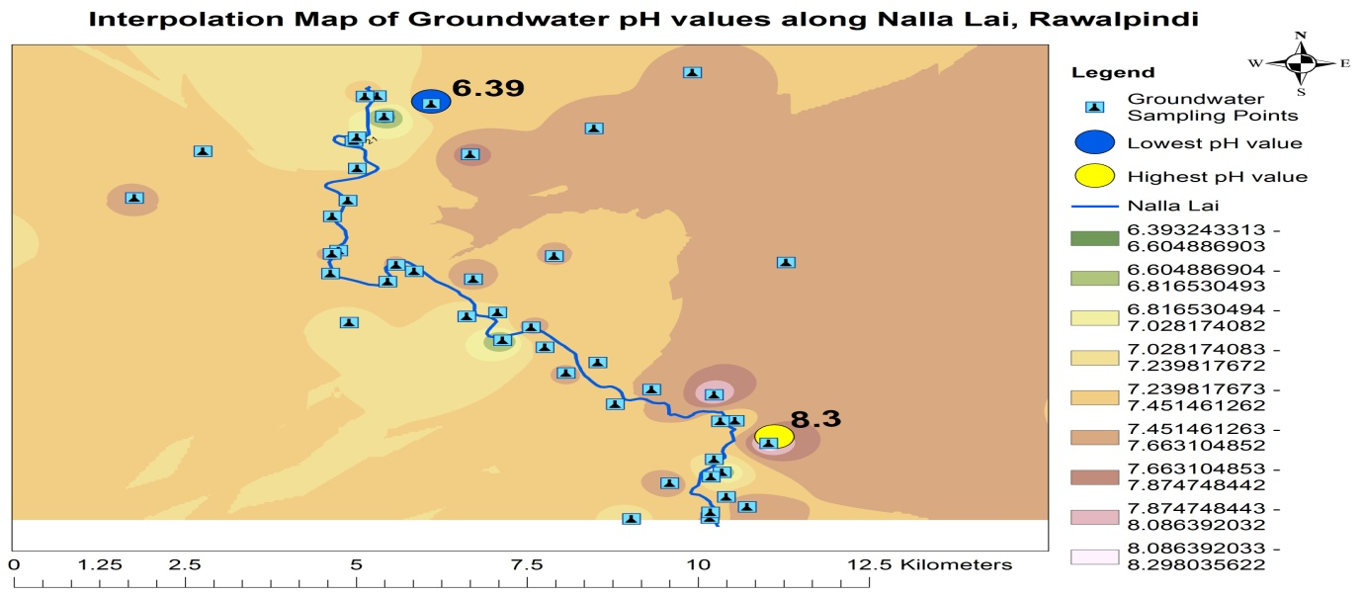

**Figure 2 |** Interpolation Map Showing Highest and Lowest pH Location Points of Groundwater

**3.2 Temperature**

As reported by Ahmed et al. (2013) temperature plays a key role to detect microbial contamination and it has a significant role in the survival of aquatic life (Akbari et al. 2017). The NEQs, 1997 standard value of temperature in wastewater is 40 ºC.

The average temperature value in groundwater and wastewater samples was 23.27 °C and 27.58 °C. The range value of temperature in groundwater samples was 21 °C - 28 °C whereas temperature values in wastewater samples were in a range of 22 °C - 30 °C respectively. The descriptive statistics of temperature in wastewater and groundwater samples are shown in Table 3 and Table 5. The highest and lowest temperature location points of groundwater samples are highlighted in Figure 3. The analyzed results of temperature in all wastewater samples were detected below the standard limit value of NEQs, 1997. Low temperature is not favorable for the growth of thermotolerant coliform (*E. coli*) bacteria. Temperature values of all the wastewater and groundwater samples are mentioned in Table 2 and Table 4. The wastewater temperature of Nalla lai almost resembled the ambient air temperature. According to the scientific study conducted by Nicholson et al. (2016) air temperature has a significant effect on surface water of low velocity but a minor effect on groundwater. The increased temperature in the summer season gives a favorable environment for fecal coliform (E.coli) to grow in the wastewater stream which finally contaminates the groundwater quality by the action of percolation.

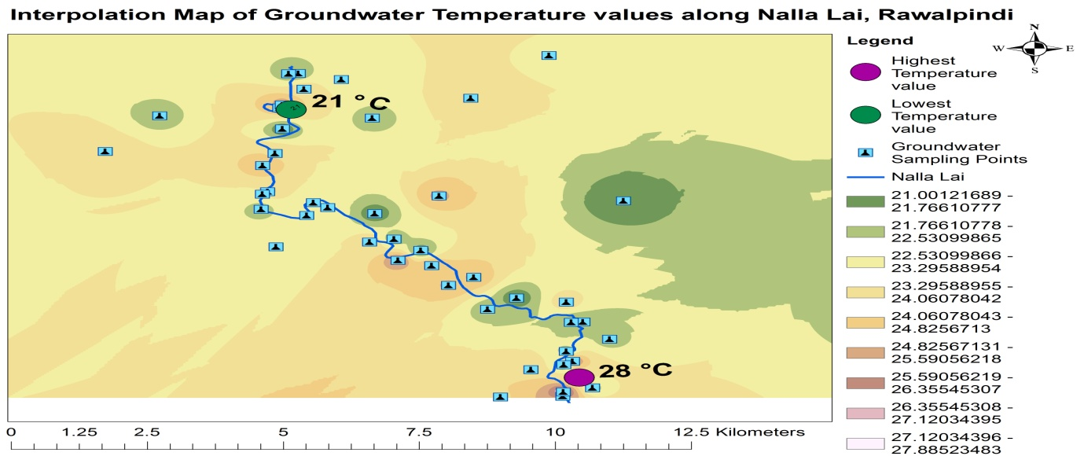

**Figure 3 |** Interpolation Map Showing Highest and Lowest Temperature Location Points of Groundwater

**3.3 Turbidity**

Turbidity in water is the cloudiness that happens due to pollutants such as silt, wood ash, coal, chemicals, colloidal dispersions, and microorganisms (Akhtar et al. 2014; Srivastava & Pandey 2012). According to WHO and NSDWQ, 2010 the standard value of turbidity in drinking water is < 5NTU.

Turbidity was detected at zero in all groundwater samples. In wastewater samples, the average turbidity value was 3257.27 NTU. The turbidity values in wastewater samples of Nalla lai were in the range of 1940.24 NTU - 4610.20 NTU. The descriptive statistics of turbidity in wastewater and groundwater samples are shown in Table 3 and Table 5. Turbidity values of all the groundwater and wastewater samples are mentioned in Table 2 and Table 4. The analyzed wastewater samples of Nalla lai showed that turbidity value was very high in sample number 1 which was collected from the wastewater stream carrying industrial wastewater of sector I-9, Islamabad and finally merged with the main wastewater stream of Nalla. The analyzed results resembled the work done by Tariq et al. (2006) on groundwater contamination due to the discharge of wastewater from the industrial locality in Hayatabad, Peshawar. Because of the high load of organic matter and various kinds of effluents, very high turbidity was observed in the wastewater of Nalla lai. The elevated level of turbidity ultimately decreases the dissolved oxygen level in the water stream. Aquatic life cannot survive in such a kind of environment.

**3.4 Color**

According to Tiwari (2015) color of the water is very important for domestic and industrial uses and they generally prefer colorless water. The WHO standard value of Color in drinking water is < 15 TCU.

The average color value in groundwater samples was 5.83 TCU. Color values in groundwater samples were in a range of 3.66 TCU - 17.89 TCU. The descriptive statistics of color in groundwater samples are shown in Table 5. The highest and lowest location points of color in groundwater samples are highlighted in Figure 4. Color values of all the groundwater samples are mentioned in Table 4. Color values of all the groundwater samples were below the recommended limit except sample number 28 which was dug well water. Sample 28 was located less than a hundred meters distance from the proximity of the wastewater stream (Nalla Lai). The elevated color value in this sample shows different dissolved chemicals and it also represents the percolation of wastewater pollutants from Nalla Lai into dug well water. Water quality in this location is not safe for drinking purposes because it also contains trace metals in high concentrations along with an elevated level of hardness and bacterial contamination. Drinking water in this locality can cause adverse health impacts.

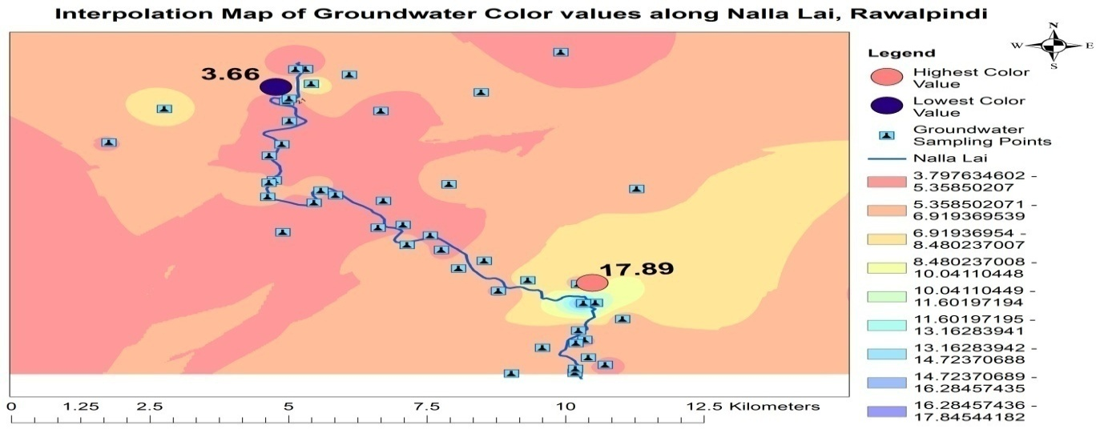

**Figure 4 |** Interpolation Map Showing Highest and Lowest Color Location Points of Groundwater

**3.5 DO**

Dissolved oxygen is an important marker to judge the quality of water (Subramani & Damodarasamy 2005). It represents the physical and biological processes occurring in the aquatic environment. DO concentration is the indicator of pollution level in the water. It is the dissolved concentration of gaseous oxygen in water (Prajapati & Dwivedi 2016).

The groundwater and wastewater samples have average DO values of 5.58 mg L-1 and 1.06 mg L-1. The range value of DO in groundwater samples was 3.28 mg L-1 - 8.4 mg L-1 whereas DO values in wastewater samples were in a range of 0.20 mg L-1 - 2.80 mg L-1 respectively. The descriptive statistics of DO in wastewater and groundwater samples are shown in Table 3 and Table 5. The highest and lowest DO location points of groundwater samples are highlighted in Figure 5. DO values of all the wastewater and groundwater samples are mentioned in Table 2 and Table 4. Due to the elevated level of pollutants in the wastewater of Nalla lai the dissolved concentration of oxygen was low in the analyzed results.

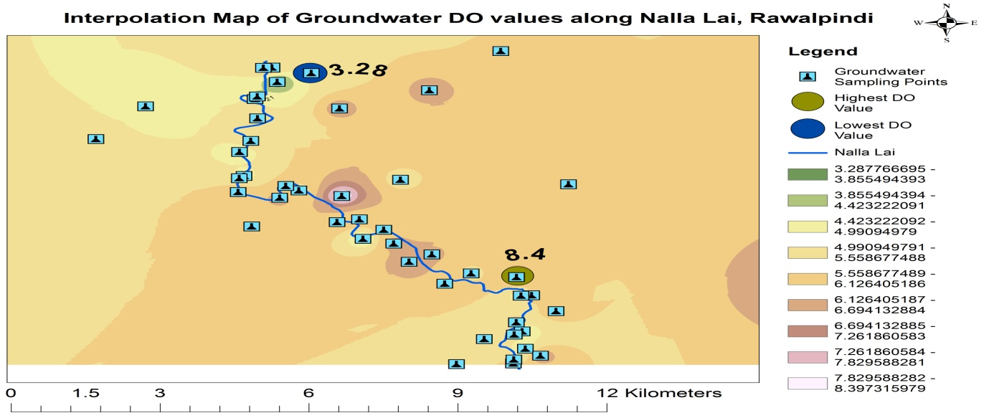

**Figure 5 |** Interpolation Map Showing Highest and Lowest DO Location Points of Groundwater

**3.6 EC**

Electric conductivity (EC) is the capability to pass an electric current. EC in water estimates the amount of TDS or ions (Pal et al. 2015).

The average EC value in groundwater and wastewater samples was 616.83 µ S/cm and 1378.26 µ S/cm. The range value of EC in groundwater samples was 222 µ/cm - 1408 µ/cm whereas EC level in wastewater samples was in the range of 1232 µ S/cm - 1529 µ S/cm respectively. The descriptive statistics of EC in wastewater and groundwater samples are shown in Table 3 and Table 5. The highest and lowest EC location points of groundwater samples are highlighted in Figure 6. EC values of all the wastewater and groundwater samples are mentioned in Table 2 and Table 4. The buffer zones of EC values in groundwater samples are highlighted with color in Figure 16. The average values of EC in groundwater and wastewater samples were comparatively higher than the research results of Tariq et al. (2006) on groundwater contamination in Hayatabad Industrial Estate, Peshawar. The elevated concentration of EC in the analyzed samples revealed the higher concentration of dissolved ions in the wastewater stream of Nalla lai. The capacity of water to pass an electric current is measured by the EC value because it depends on the presence of free ions in water (Nasrullah et al. 2006).

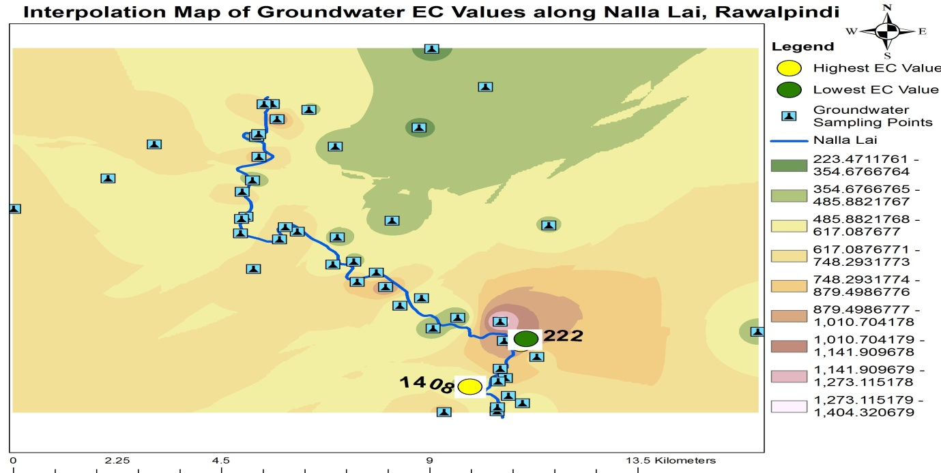

**Figure 6 |** Interpolation Map Showing Highest and Lowest EC Location Points of Groundwater

**3.7 TDS**

TDS include minerals, salts, or metals dissolved in water (Sagar & Chavan 2015). WHO standard value of TDS in drinking water is < 1000 mg L-1. The concentration of TDS elevated from 1000 mg L-1 is not fit for drinking purposes (Akhtar et al. 2014). The TDS value indicates both salinity and quality of water and a high concentration of TDS alters the taste and hardness of water (Pande et al. 2015; Akhtar et al. 2014).

In groundwater samples, the average value of TDS was 484.24 mg L-1. The range value of TDS in groundwater samples was between 201 mg L-1 - 1138 mg L-1 respectively. The descriptive statistics of TDS in groundwater samples are shown in Table 5. The highest and lowest EC location points of groundwater samples are highlighted in Figure 7 and buffer zones of TDS values are highlighted with color in Figure 16. TDS values of all the groundwater samples are mentioned in Table 4. TDS concentration in one bore water sample was elevated from the standard value which was collected from the proximity of Nalla lai. A high level of TDS may be due to the percolation of the pollutants from the wastewater of Nalla lai. As mentioned by Choi et al. (2005) the average values of TDS in groundwater are increasing due to differences in land use and the average values are escalating from forest vicinity (151 mg/l), agricultural territory (446 mg/l), residential region (374 mg/l), traffic site (446 mg/l) and industrial sector (585 mg/l). The average values reflect anthropogenic pollution.

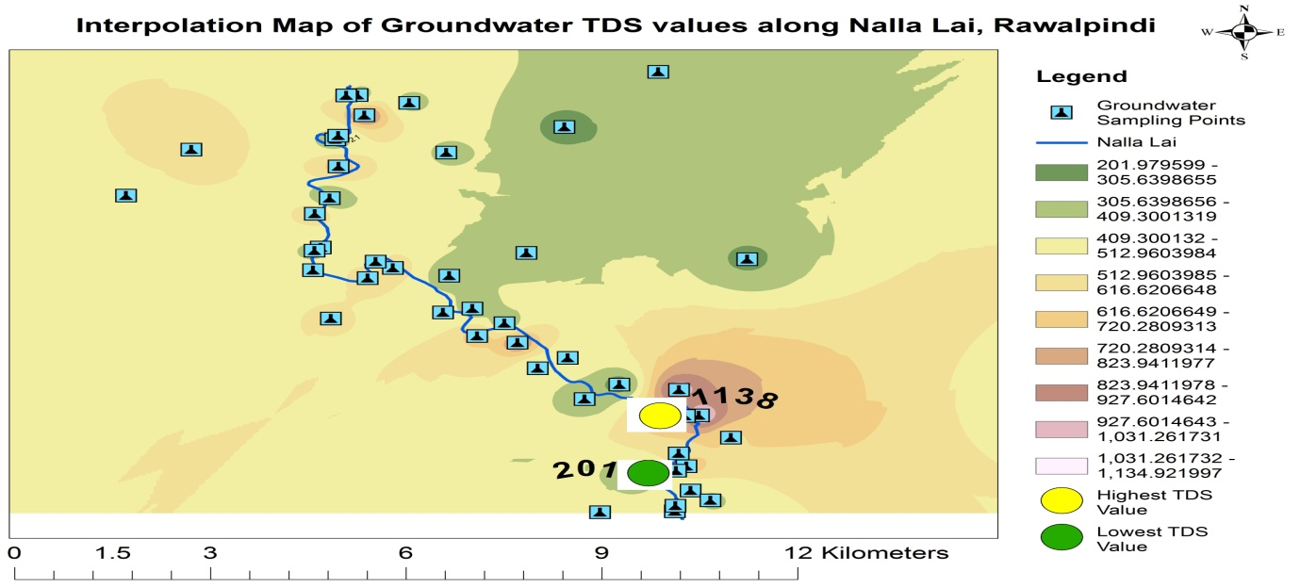

**Figure 7 |** Interpolation Map Showing Highest and Lowest TDS Location Points of Groundwater

**3.8 Sulfate**

The mineral Sulfur occurs in different valence states i.e S2-, S0, S4+, and S6+. Sulfate (S6+) has six electrons in its valence shell for chemical bonding and exists in tetrahedral coordination with oxygen (Hawthorne et al. 2000). The US EPS standard value of Sulfate in drinking water is 250 mg L-1 and the NEQs, 1997 wastewater standard of Sulfate is 600 mg L-1.

The groundwater and wastewater samples have average Sulfate values of 28.2 mg L-1 - 24.32 mg L-1. The range value of Sulfate in groundwater samples was 14.1 mg L-1 - 100.2 mg L-1 whereas the value of Sulfate in wastewater samples was in a range of 21.70 mg L-1 - 30.10 mg L-1 respectively. The descriptive statistics of Sulfate in wastewater and groundwater samples are shown in Table 3 and Table 5. The highest and lowest Sulfate location points of groundwater samples are highlighted in Figure 8. The analyzed results of Sulfate in the groundwater and wastewater samples were detected below the recommended standard of NSDWQ, 2010, NEQs 1997 as mentioned in Table 2 and Table 4. The results of wastewater are in contrast with the study conducted by Raashid & Hussain (2014) on industrial effluents of two pulp and paper industries in Punjab. The results showed that the values of sulfate were beyond the recommended value of NEQs, 1997. Due to the absence of any anthropogenic source in the vicinity of Nalla lai the concentration of Sulfate was detected with the permissible limit in both surface water and groundwater in the proximity of Nalla lai. Sulfate is founded in any water supply but its elevated level can be detected in water due to the influence of anthropogenic discharges (Miao et al. 2012; Srivastava & Pandey, 2012).

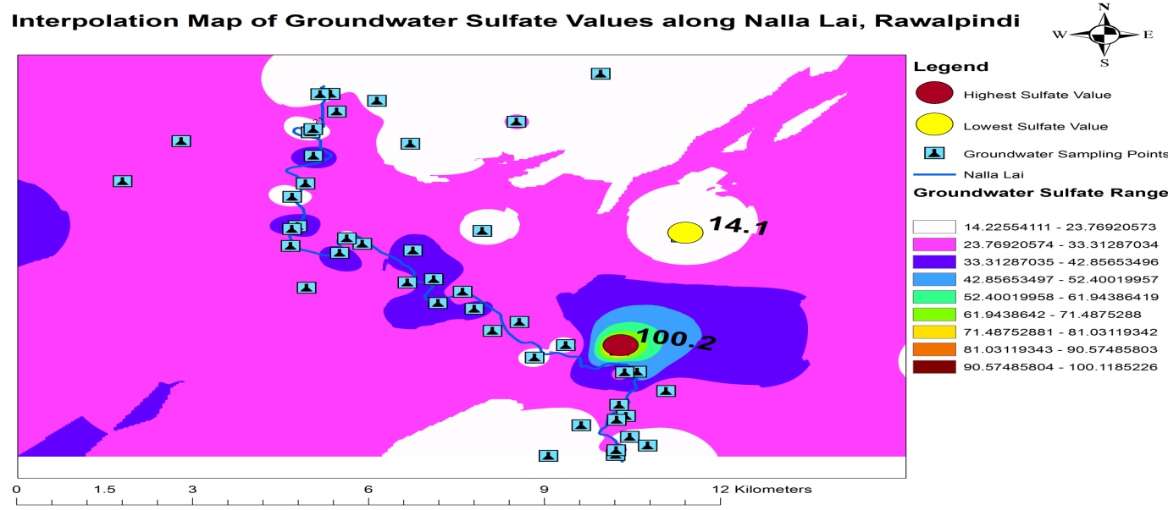

**Figure 8 |** Interpolation Map Showing Highest and Lowest (-SO4) Location Points of Groundwater

**3.9 Chloride**

Chloride (Cl-) is one of the most important inorganic anions in sea and freshwater. Both sodium chloride and calcium chloride dissociate and form Chloride in water (Alkhateeb 2014). The WHO standard value of Chloride in drinking water is 250 mg L-1 whereas the NEQs, 1997 standard of Chloride in wastewater is 1000 mg L-1. The average Chloride value in groundwater and wastewater samples was 27.68 mg L-1 and 55.55 mg L-1. The range value of Chloride in groundwater samples was 7.6 mg L-1 - 107 mg L-1 whereas Chloride values in wastewater samples were in a range of 7.6 mg L-1 - 79.6 mg L-1 respectively. The descriptive statistics of Chloride in wastewater and groundwater samples are shown in Table 3 and Table 5. The highest and lowest Chloride location points of groundwater samples are highlighted in Figure 9. Chloride values in groundwater and wastewater samples were within the permissible limit of NSDWQ, 2010, and NEQs 1997 as mentioned in Table 2 and Table 4. Chloride occurs in natural water but both agricultural and industrial activities are responsible for its elevated concentration in any water body (Dohare et al. 2014). Its high concentration indicates heavy pollution due to inorganic fertilizers, landfill leachate, and septic tank effluents (Sarada & Bhushavanthi 2015; Subramani & Damodarasamy 2005). Due to the absence of a potential source of Chloride in the study area low concentration of Sulfate was detected in both surface wastewater and groundwater samples.

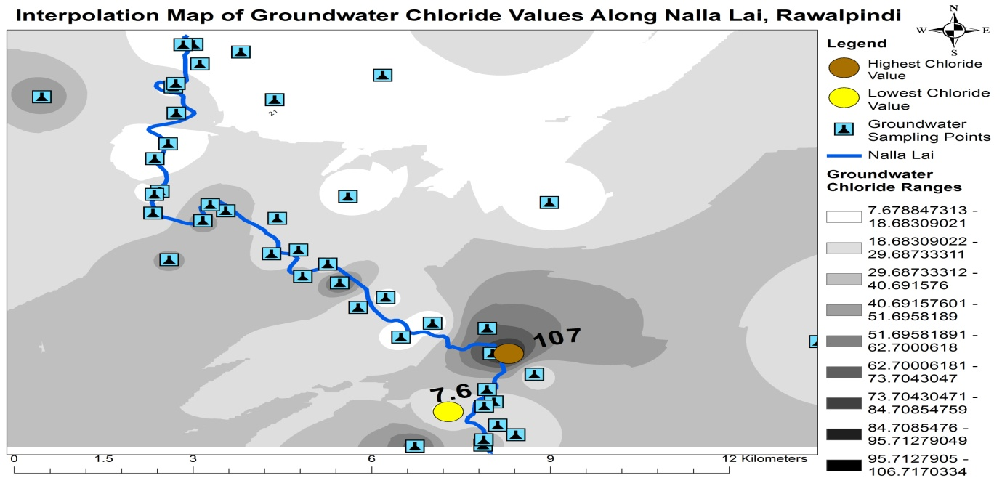

**Figure 9 |** Interpolation Map Showing Highest and Lowest Cl- Location Points of Groundwater

**3.10 Hardness**

As reported by Rao (2011) and Ramya et al. (2015) water hardness primarily depends on the concentration of calcium and magnesium ions in water. The prime reason for the excess concentration of hardness in groundwater samples was the presence of high mineral contents i.e. calcium and magnesium cations. The NSDWQ, 2010 standard value of Hardness in drinking water is < 500 mg L-1.

The average hardness value in groundwater samples was 709 mg L-1. Its value in groundwater samples was in the range of 124 mg L-1 - 1564 mg L-1. The descriptive statistics of Hardness in groundwater samples are shown in Table 5. The highest and lowest Hardness location points of groundwater samples are highlighted in Figure 10. The hardness was found at elevated levels in 75% of investigated groundwater samples including (17) bore water samples, (11) tube wells, (1) spring, and (1) dug well water. The analyzed values of Hardness in all the groundwater samples are mentioned in Table 4. The buffer zones of hardness values in groundwater samples are highlighted with color in Figure 16. According to the National Research Council of the US (1974) Iron, zinc, strontium, magnesium, and aluminum can also contribute to water hardness, but these metals are found in very minute concentrations. Ramya et al. (2015) mentioned that water with high mineral contents is called hard water. Carbonate hardness can remove by boiling whereas non-carbonate hardness cannot be removed by boiling.

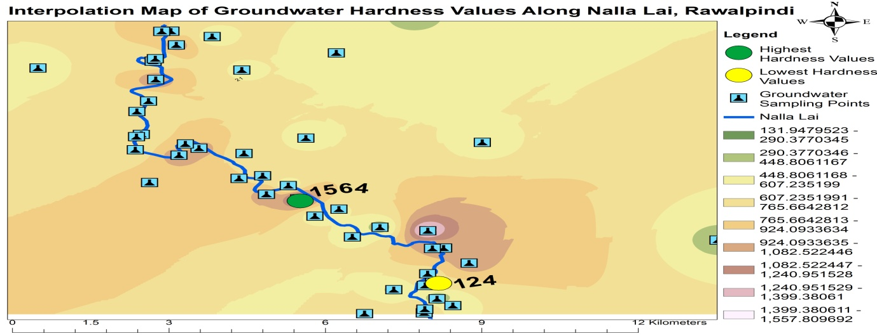

**Figure 10 |** Interpolation Map Showing Highest and Lowest Ha Location Points of Groundwater

**3.11 Cadmium**

The NSDWD, 2010, and WHO standard value of Cadmium in drinking water is 0.01mg L-1 and 0.003 mg L-1. The average Cadmium value in groundwater and wastewater samples was 0.01 mg L-1 and 0.09 mg L-1. The range value of Cadmium in groundwater samples was 0.005 mg L-1 – 0.036 mg L-1 whereas the Cadmium value in wastewater samples was in a range of 0.006 mg L-1 - 0.3 mg L-1 respectively. The descriptive statistics of Cadmium in wastewater and groundwater samples are shown in Table 3 and Table 5. The highest and lowest Chloride location points of groundwater samples are highlighted in Figure 11. Cadmium results of all the wastewater and groundwater samples are mentioned in Table 2 and Table 4. The cadmium value in 5 groundwater samples was higher than the standard value of NSDWQ, 2010, and WHO the samples were collected from the proximity of Nalla lai. The cadmium value in 5 wastewater samples was elevated than the standard of NEQS, 1997. Both surface and groundwater values of Cadmium revealed that Cadmium is also percolating from the surface wastewater of Nalla Lai to groundwater in its proximity. The research conducted by Nasrullah et al. (2006) on industrial effluents and groundwater quality revealed that Cadmium concentration was detected above the permissible limit in one tube well water sample. Nasrullah et al. (2006) reported that the Cd high concentration in drinking water (groundwater) was analyzed due to the percolation of waste effluents in the marble, steel, and aluminum industries. The major source of Cadmium in wastewater of the Nalla lai is due to the discharge of waste effluents from Iron industries, steel, and paint industries in the I-9 and I-10 Industrial areas of Islamabad. Cadmium seeks attention due to its toxic nature (Azizullah et al. 2011). Cadmium can be toxic if the concentration exceeds 0.01 mg L-1 in both drinking and irrigation water (Hem 1980). Industrial and mining activities are the potential sources of Cadmium in water (Taha 2004). Cadmium ingestion can cause gastrointestinal diseases like vomiting and diarrhea (Nordberg 2004). Its long-term exposure can cause Kidney failure (Barbier et al. 2005), Reproductive diseases (Frery et al. 1993; Piasek & Laskey 1999; Johnson et al. 2006), Bones damage (Kazantzis 1979), and cancer disease (Waalkes et al. 1988).

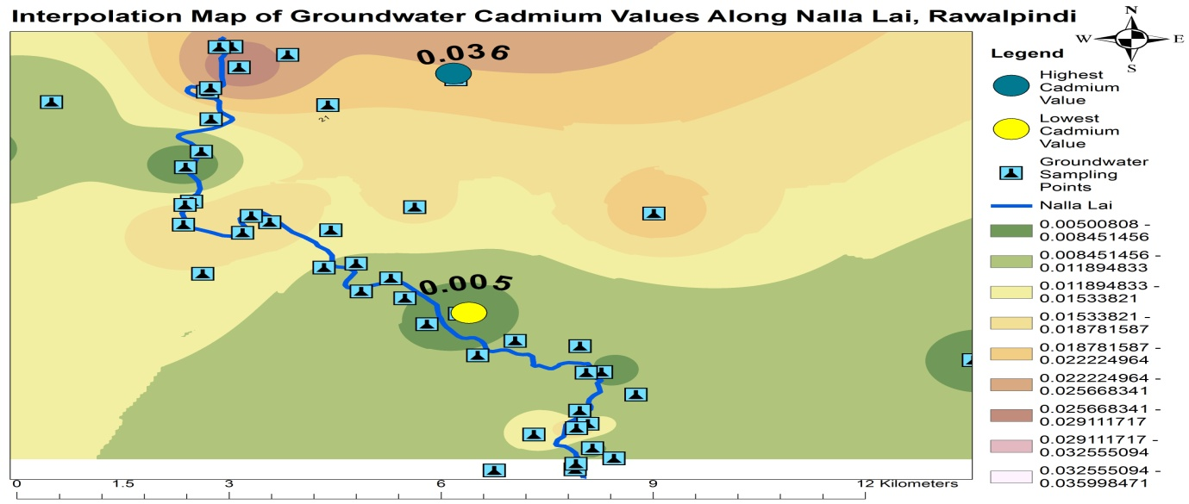

**Figure 11 |** Interpolation Map Showing Highest and Lowest Cd Location Points of Groundwater

**3.12 Copper**

The WHO standard value of Copper in drinking water is 2 mg L-1. The NEQs, 1997 standard value of Copper in wastewater is 1 mg L-1.The average copper value in groundwater and wastewater samples was 0.09 mg L-1 and 0.08 mg L-1. The range value of Copper in groundwater samples was 0.038 mg L-1 - 0.139 mg L-1 whereas the Copper value in wastewater samples was in a range of 0.012 mg L-1 - 0.204 mg L-1 respectively.The descriptive statistics of Copper in wastewater and groundwater samples are shown in Table 3 and Table 5. Copper results in all the wastewater and groundwater samples are mentioned in Table 2 and Table 4. Copper was detected in seven wastewater samplesand three groundwater samples, it was observed above the BDL (Below Detection Limit) value. Nasrullah et al. (2006) analyzed the concentration of Copper higher than the permissible limit in groundwater near the Industrial area of Swabi as well as in the wastewater sample collected from the main drain of the marble industry. Although several marble factories are located in the industrial area of Islamabad it was detected in low concentration because the marble factory’s waste and effluents are not discharging in the wastewater stream (Nalla lai). Although Copper is a necessary element present in enzymes and its minute concentration is critical for the synthesis of hemoglobin (Tiwari et al. 2013). But Copper excess concentration can cause neurological problems, hypertension, kidney and liver failure (Krishna & Govil 2004). In infants, its intake can cause death, vomiting of short-lived, and diarrhea (Barzilay et al. 1999).

**3.13 Iron**

The WHO standard value of Iron in drinking water is 0.3 mg L-1. The NEQs, 1997 standard value of Iron in wastewater is 1 mg L-1. The average Iron value in groundwater and wastewater samples was 1.23 mg L-1 and 1.09 mg L-1. The range value of Iron in groundwater samples was 0.101 mg L-1 - 4.76 mg L-1 whereas Iron in wastewater samples was in the range of 0.12 mg L-1 - 4.48 mg L-1 respectively. The descriptive statistics of Iron in wastewater and groundwater samples are shown in Table 3 and Table 5. The highest and lowest Iron location points of groundwater samples are highlighted in Figure 12. Iron values of all the wastewater and groundwater samples are mentioned in Table 2 and Table 4. Ten groundwater samples near Nalla showed Iron concentrations higher than the set standard of NSDWQ, 2010 and WHO. Iron concentration in 3 wastewater samples was exceeding the wastewater standards of NEQS, 1997. The analyzed results revealed that Iron is percolating from the surface wastewater of Nalla Lai to groundwater in its vicinity. The major source of Iron in wastewater of Nalla lai is the discharge of waste effluents from the Iron and steel industries in the I-9 and I-10 industrial areas of Islamabad. Aderemi et al. (2011) revealed that 75% of the analyzed groundwater samples (well water) collected near municipal solid waste landfill sites were contaminated with Iron concentrations above the permissible limit set by WHO. Iron is an essential micronutrient but its high consumption through drinking water can leads to liver disease (Gyamfi et al. 2012). As compared to its deficiency its excess and overexposure can cause numerous health problems such as cancer (Beckman et al. 1999; Parkkila et al. 2001), Diabetes (Ellervik et al. 2001; Parkkila et al. 2001), Heart and Liver diseases (Milman et al. 2001; Yang et al. 1998; Rasmussen et al. 2001) and neurological problems as well (Sayre et al. 2000; Berg et al. 2001).

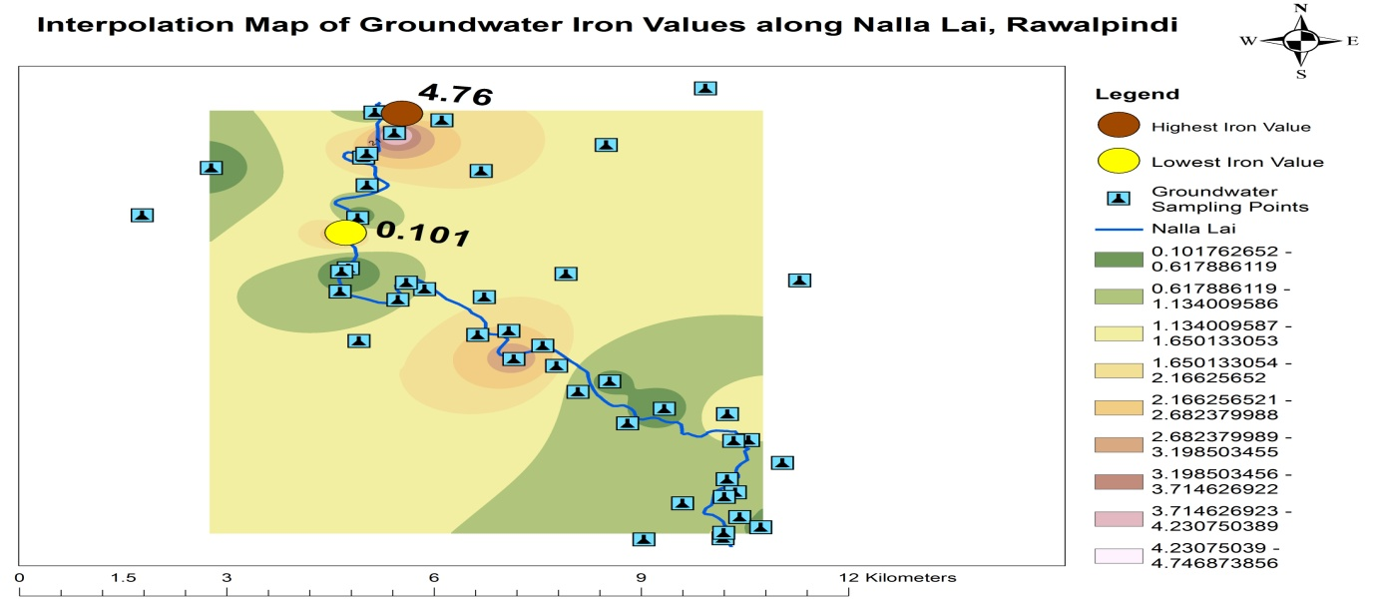

**Figure 12 |** Interpolation Map Showing Highest and Lowest Fe Location Points of Groundwater

**3.14 Manganese**

The WHO standard value of Manganese in drinking water is 0.5 mg L-1. The NEQs, 1997 standard value of Manganese in wastewater is 1.5 mg L-1. The average Manganese value in groundwater and wastewater samples was 0.25 mg L-1 and 0.35 mg L-1. The range value of Manganese in groundwater samples was 0.04 mg L-1 – 0.85 mg L-1 whereas manganese values in wastewater samples were in a range of 0.15 mg L-1 - 1.48 mg L-1 respectively. The descriptive statistics of Manganese in wastewater and groundwater samples are shown in Table 3 and Table 5. The highest and lowest Manganese location points of groundwater samples are highlighted in Figure 13. Manganese values in all the groundwater and wastewater samples are mentioned in Table 2 and Table 4. Manganese was detected in all the samples of wastewater within the permissible limit value of NEQs 1997. Manganese was detected in elevated concentration in 4 groundwater samples which were collected from the proximity of the wastewater stream of Nalla lai. Manganese’s high concentration depicts that it may be percolated from the surface wastewater of Nalla Lai. Manganese is an important trace nutrient for all living organisms (Emsley 2003). It regulates numerous enzymes of the human body but the excess dose of Manganese harms the nervous system of the brain (Crossgrove & Zheng 2004). Excess intake causes permanent neurological diseases (Barbeau 1984; Inoue 1996).

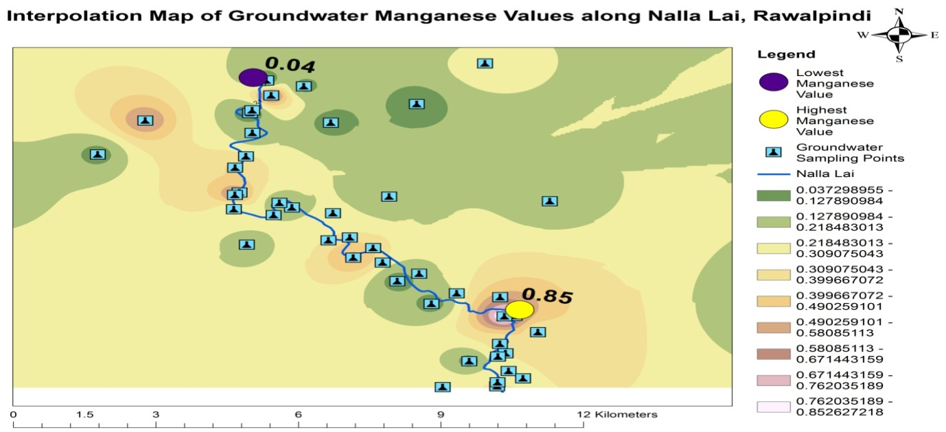

**Figure 13 |** Interpolation Map Showing Highest and Lowest Mn Location Points of Groundwater

**3.15 Lead**

The WHO standard value of Lead in drinking water is 0.01 mg L-1 and the NEQs, 1997 standard value of Lead in wastewater is 0.5 mg L-1. The average Lead value in groundwater and wastewater samples was 0.02 mg L-1 and 0.10 mg L-1. The range value of Lead in groundwater samples was 0.002 mg L-1 - 0.04 mg L-1 whereas the Lead value in wastewater samples was in the range of 0.008 mg L-1 - 0.268 mg L-1 respectively. The descriptive statistics of Lead in wastewater and groundwater samples are shown in Table 3 and Table 5. Lead values in all the wastewater and groundwater samples are mentioned in Table 2 and Table 4. The minute level of lead naturally exists in soil and water (Raviraja et al. 2008). As mentioned by Haq et al. (2009) the concentration of lead detected in drinking water is due to industrial discharges, waste dumping, gaseous emissions from traffic sources, and domestic paints (Haq et al. 2009). Its chronic exposure can damage human organs like the digestive and nervous system, cardiovascular system, reproductive system, haematopoietic system, skeleton, and kidney (Gidlow 2004; Venkatesh 2004).

**3.16 Zinc**

The WHO standard value of Zinc in drinking water is 3 mg L-1. The NEQs, 1997 standard value of Zinc in wastewater is 5 mg L-1. The average Zinc value in groundwater and wastewater samples was 1.06 mg L-1 and 0.68 mg L-1. The range value of Zinc in groundwater was 0.01 mg L-1 – 6.2 mg L-1 whereas zinc value in wastewater samples was in the range of 0.05 mg L-1 - 4.20 mg L-1 respectively. The descriptive statistics of Zinc in wastewater and groundwater samples are shown in Table 3 and Table 5. The highest and lowest Zinc location points of groundwater samples are highlighted in Figure 14. Zinc values in all the wastewater and groundwater samples are mentioned in Table 2 and Table 4. Zinc was detected below the permissible limit in all the wastewater samples of Nalla lai. Zinc was analyzed in high concentration in one bore water sample which was collected from the proximity of Nalla lai. The elevated level depicts that zinc may also be percolated from the surface wastewater of Nalla Lai. Zinc is a necessary element for human health (Solomons & Ruz 1998). Maintaining zinc concentration in body cells is vital for human survival. Zinc releases as free ions from food during digestion in the body (Roohani et al. 2013). Its high concentration can cause health problems (Fosmire 1990; Singh et al. 2006).

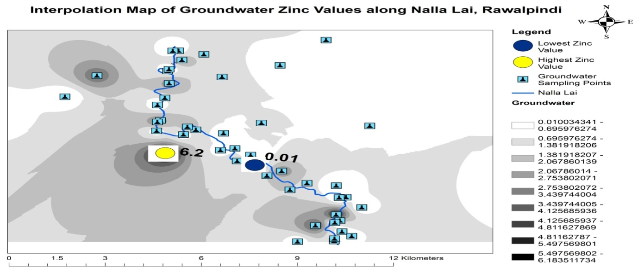

**Figure 14 |** Interpolation Map Showing Highest and Lowest Zn Location Points of Groundwater

**3.17 BOD**

The NEQs, 1997 standard value of BOD in wastewater is 80 mg L-1. The average BOD value in wastewater samples of Nalla lai was 120.21 mg L-1. BOD values in wastewater samples were in the range of 87 mg L-1 - 194 mg L-1. BOD values in all wastewater samples of Nalla lai were elevated from the recommended value of NEQs, 1997. The descriptive statistics of BOD in wastewater samples are shown in Table 3. BOD results of all the wastewater samples are mentioned in Table 2. The elevated values of BOD in the analyzed samples revealed the presence of a high load of organic pollutants in the wastewater stream of Nalla lai. The guideline range of BOD in domestic wastewater is 100-300 mg/L-1 (Abdalla & Hammam 2014). BOD measures the organic pollutants and level of gaseous oxygen in the water and BOD value reveals the microbial utilization of oxygen in the water to break down the organic substances (Anju 2015).

**3.18 COD**

The NEQs, 1997 standard value of COD in wastewater is 150 mg L-1. The average COD value in wastewater samples was 240.15 mg L-1. The range value of COD in groundwater samples was 186 mg L-1 - 315 mg L-1. COD results of all wastewater samples were elevated from the recommended value of NEQs 1997. The descriptive statistics of COD in wastewater samples are shown in Table 3. COD results of all the wastewater samples are mentioned in Table 2. The elevated COD values revealed the presence of a high concentration of both organic and inorganic pollutants in the wastewater stream of Nalla lai. Chemical Oxygen Demand is the measure of the oxygen level required to decompose both organic and inorganic matter in water (Bhatnagar 2015). COD is the chemical breakdown of pollutants where oxygen is necessary to execute absolute oxidation to carbon dioxide and water (Dogar et al. 2013).

**3.19 *E. coli***

Microbial contamination of *E. coli* was detected in thirty groundwater samples out of a total of thirty-six analyzed samples. *E. coli* in groundwater samples was analyzed by using qualitative research method. The symbol –ve in the groundwater sample represents that *E. coli* is detected in the water sample whereas the symbol +ve shows that *E. coli* is not detected in the analyzed water sample as shown in Figure 15. The groundwater samples were collected from the proximity of Nalla lai. The potential source of groundwater contamination was the wastewater stream of Nalla lai. The wastewater of Nalla lai percolates downward and contaminates the groundwater in its surrounding area. The research conducted by Haq et al. (2007) revealed that due to the discharge of untreated domestic wastewater the bacteria can reach the groundwater because of the puncturing of rocks positioned below the soil. As mentioned by Shahid et al. (2015) microbial contaminations in drinking water can outbreak diseases such as diarrhea, gastroenteritis, dysentery, typhoid, nausea, etc.

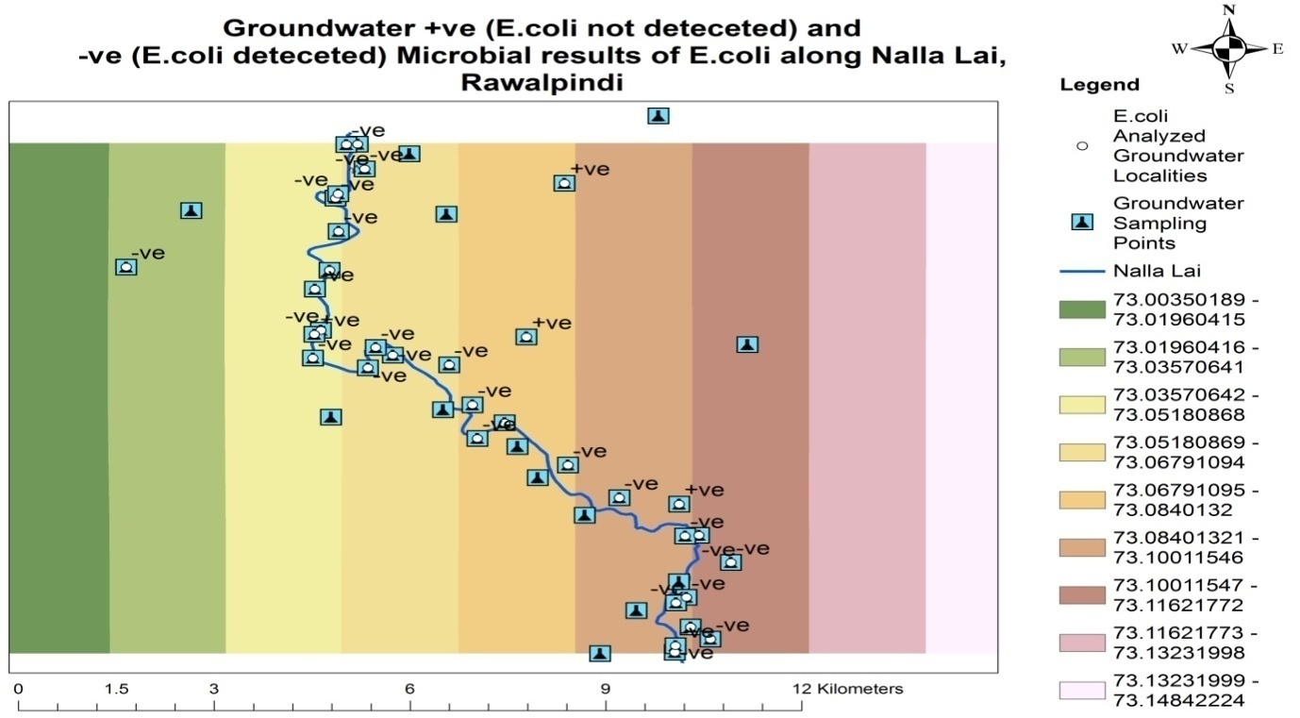

**Figure 15 |** Location Points of Positive (+ve) and Negative (-ve) Results of Fecal coliform (*E. coli*) in Groundwater

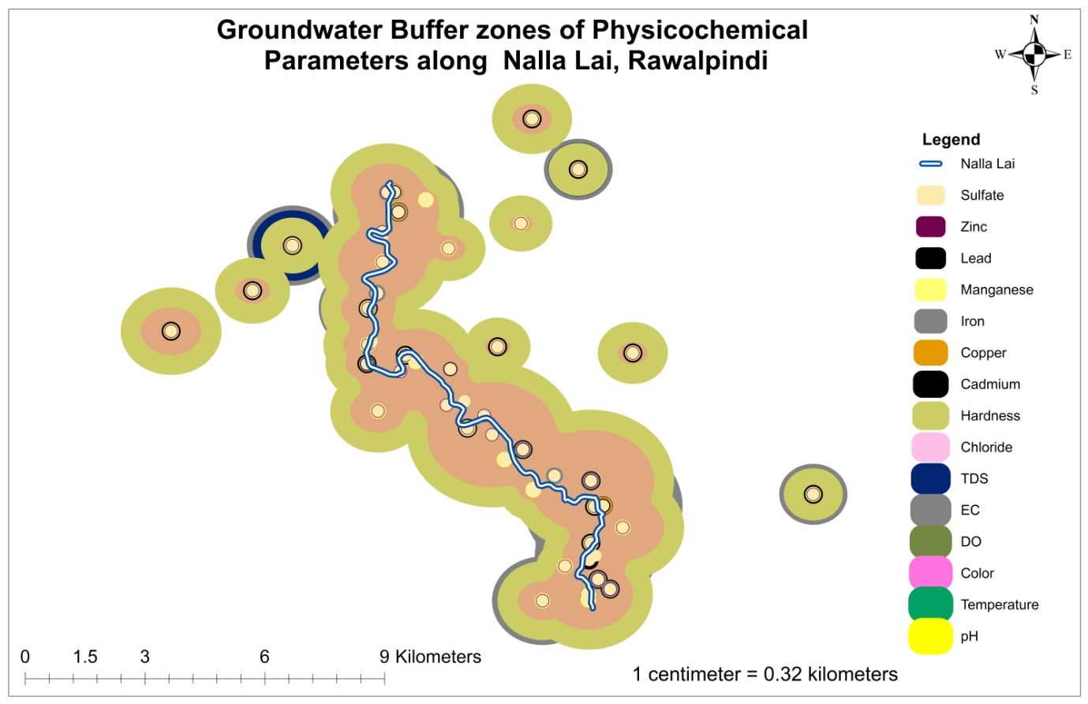

**Figure 16 |** Buffer Zones of Analyzed Physicochemical Parameter values of Groundwater along Nalla Lai, Rawalpindi.

**3.20 Correlation**

The reciprocal relationship between two variables is called correlation. The increase in one variable causes the increase in another variable is called positive correlation whereas the increase in one variable tends to decrease in another variable is called negative correlation. The correlation coefficient is a value that ranges from +1 to -1. A value of 0 means there is no linear correlation between the two variables. The strong correlation between the two parameters ranges from + 0.8 to + 1.0, the moderate correlation ranges from ± 0.5 to ± 0.8, weak correlation ranges from 0.0 to ± 0.5 (Shroff et al. 2015). The correlation coefficient (r) of groundwater quality parameters is calculated in Table 6 and the values are highlighted with blue, white, and red colors.

|  |  |  |  |  |  |  |  |  |  |  |  |  |  |  |  |
| --- | --- | --- | --- | --- | --- | --- | --- | --- | --- | --- | --- | --- | --- | --- | --- |
|  | **pH** | **Tem** | **Color** | **DO** | **EC** | **TDS** | **SO4** | **Cl-** | **Ha** | **Cd** | **Cu** | **Fe** | **Mn** | **Pb** | **Zn** |
| **pH** | 1 |  |  |  |  |  |  |  |  |  |  |  |  |  |  |
| **Tem** | -0.4314 | 1 |  |  |  |  |  |  |  |  |  |  |  |  |  |
| **Color** | -0.1536 | -0.09521 | 1 |  |  |  |  |  |  |  |  |  |  |  |  |
| **DO** | 0.61907 | -0.41903 | -0.336 | 1 |  |  |  |  |  |  |  |  |  |  |  |
| **EC** | -0.3052 | 0.17838 | 0.36722 | -0.2494 | 1 |  |  |  |  |  |  |  |  |  |  |
| **TDS** | -0.3402 | 0.23945 | 0.40717 | -0.2744 | 0.96017 | 1 |  |  |  |  |  |  |  |  |  |
| **SO4** | 0.05994 | 0.04074 | 0.06407 | 0.11531 | 0.63748 | 0.6086 | 1 |  |  |  |  |  |  |  |  |
| **Cl-** | -0.0937 | 0.09486 | 0.45553 | -0.0048 | 0.74195 | 0.7187 | 0.49175 | 1 |  |  |  |  |  |  |  |
| **Ha** | -0.1809 | 0.20162 | 0.16708 | -0.0713 | 0.78764 | 0.8047 | 0.60882 | 0.6266 | 1 |  |  |  |  |  |  |
| **Cd** | -0.1012 | -0.09663 | -0.0686 | -0.2114 | -0.3257 | -0.216 | -0.2264 | -0.34 | -0.0304 | 1 |  |  |  |  |  |
| **Cu** | -0.7 | 0.72164 | -0.2679 | -0.8215 | -0.4865 | -0.4297 | -0.8027 | -0.959 | -0.3373 | 1 | 1 |  |  |  |  |
| **Fe** | -0.7244 | 0.39459 | 0.602 | -0.6195 | 0.65067 | 0.719 | 0.1863 | 0.0116 | 0.51514 | 0.6942 | 1 | 1 |  |  |  |
| **Mn** | -0.3652 | -0.00995 | 0.77172 | -0.6052 | 0.59983 | 0.6368 | 0.27393 | 0.3975 | 0.36613 | -0.15915 | 1 | 0.64972 | 1 |  |  |
| **Pb** | 0.30359 | -0.05465 | 0.18443 | 0.13458 | 0.26353 | 0.2606 | 0.16818 | 0.5474 | 0.16108 | -0.59553 | -0.9669 | -1 | -0.3747 | 1 |  |
| **Zn** | -0.1724 | -0.0151 | 0.06282 | -0.1609 | 0.03768 | 0.0128 | -0.0104 | -0.009 | -0.0484 | -0.06143 | 1 | 0.12878 | 0.09132 | -0.32646 | 1 |

**Table 6 |** Correlation Matrix of Physicochemical Parameters of Groundwater of Study Area.

The values of the correlation coefficient ranging in blue colors are representing strong, moderate, and weak positive correlation among water quality parameters and the values in white color shows no correlation whereas the correlation coefficient values ranging in red colors represent negative correlation among water quality parameters.

The study revealed that groundwater reflects the wastewater stream of Nalla lai in terms of heavy metals and microbial contamination. The heavy metals detected in high concentrations in the wastewater stream of Nalla lai were also examined in an elevated concentration in the groundwater of the vicinity area, especially within a 100-meter distance along both sites of Nalla lai. Physicochemical and microbial contamination was detected in many groundwater samples collected from bore water, hand pumps, tube wells, and dug wells located in the proximity of Nalla lai. Cadmium, Iron, BOD, and COD level was elevated from the recommended values in many wastewater samples. Nalla lai is an open sewer and the potential anthropogenic source of groundwater contamination that also carries both domestic and commercial effluents of Rawalpindi as well as the industrial effluents of sectors –I-9 and I-10, Islamabad. Iron, steel, and paints industries of Islamabad are discharging waste effluents directly into the wastewater stream of Nalla lai without adequate treatment in wastewater treatment plants. Many drinking water quality parameters such as pH, color, hardness, TDS, manganese, and zinc were exceeding the national standards in one or more groundwater samples that were collected from the nearest distance of Nalla lai. Microbiological contamination of fecal coliform was detected in 83% of the analyzed groundwater samples. A similar kind of study was conducted on the groundwater quality of Nalla lai, Rawalpindi city, Pakistan. Water samples were collected from (220) tubewells from different locations in the year 2007. The analyzed results revealed that 50% of groundwater samples of tubewells showed bacterial contamination. The prime source of microbial contamination is the percolation of Lai Nalla wastewater. Nalla lai acts as an open sewer that carries 65% sewage of the city (Haq et al. 2007). Maximum contamination was observed in the thirty-six analyzed samples, collected from bore water and dug well located adjacent to the Nalla lai wastewater stream and minimum contamination results were obtained from the thirteen control samples that were taken from at least a 1 km distance along both sites of Nalla lai. The study concluded that pollutants enter the wastewater stream from domestic, commercial, and industrial sources due to the unavailability of a proper wastewater treatment facility and percolate downward and finally contaminating the groundwater quality in the vicinity.

* Tube wells, boreholes, hand pumps and dug wells should be installed at least 300-400 meters away from Nalla lai to prevent any type of percolation and leaching from the wastewater of Nalla lai.
* There should be proper laboratory testing of physicochemical and microbiological parameters of newly installed tube well or bore water before water supply to the public.
* Periodic monitoring of all tube wells and bore water should be conducted to cope with wastewater percolation issues.
* Groundwater extraction should be promoted from the deeper aquifer and increase the depth of existing shallow water boreholes.
* Enforce effective and efficient management plan for domestic and commercial solid waste of Rawalpindi and Industrial waste effluents of sectors I-9 and I-10, Islamabad.
* Solid waste should not dump on the banks of Nalla water which increases the chances of leachate formation and percolation of contaminants into groundwater.
* Groundwater percolation can be prevented through proper management of wastewater of Nalla lai which includes the proper sanitation system of Rawalpindi city.
* Water filtration plants should be installed in each inhabitant colony to ensure public health.
* The percolation of wastewater from Nalla lai can be fully prevented through proper cementation by using concrete in the base of Nalla Lai and by the construction of concrete walls on the banks of Nalla lai.

**REFERENCES**

Abdalla, K. Z., & Hammam, G. 2014 Correlation between biochemical oxygen demand and chemical oxygen demand for various wastewater treatment plants in Egypt to obtain the biodegradability indices. International Journal of Sciences: Basic and Applied Research, 13(1), 42-48.

Aderemi, A. O., Oriaku, A. V., Adewumi, G. A., & Otitoloju, A. A. 2011 Assessment of groundwater contamination by leachate near a municipal solid waste landfill. African Journal of Environmental Science and Technology, 5(11), 933-940. DOI: 10.5897/AJEST11.272

Ahmed, A., Noonari, T., Magsi, H., & Mahar, A. 2013 Risk assessment of total and fecal coliform bacteria from drinking water supply of Badin city, Pakistan. *Journal of Environmental Professionals Sri Lanka*, *2*(1).

Akbari, E., Alavipanah, S. K., Jeihouni, M., Hajeb, M., Haase, D., & Alavipanah, S. 2017 A review of ocean/sea subsurface water temperature studies from remote sensing and non-remote sensing methods. *Water*, *9*(12), 936.  <https://doi.org/10.3390/w9120936>

Akhtar, M. M., Tang, Z., & Mohamadi, B. 2014 Contamination potential assessment of potable groundwater in Lahore, Pakistan. *Polish Journal of Environmental Studies*, *23*(6), 1905-1916.

Alkhateeb, R. A. I. D. (2014). Influence of Chloride Concentration on Water Quality. *International Journal of Applied Engineering Research and Development (IJAERD)*, *4*(1), 63-68.

APHA., AWWA., WEF., 2012 ‘Standard methods for the examination of water and wastewater’ 22th ed., American Public Health Association, American Water Works Association and Water Environment Federation., Washington, DC, USA.

Asghar, A., Ali, S. M., & Yasmin, A. 2012 Effect of climate change on apple (Malus domestica var. ambri) production: A case study in Kotli Satian, Rawalpindi, Pakistan. Pakistan Journal of Botany, 44(6), 1913-1918.

Atta, U., Hussain, M., & Malik, R. N. 2020 Environmental impact assessment of municipal solid waste management value chain: A case study from Pakistan. Waste Management & Research, 38(12), 1379-1388. [https://doi.org/10.1177/0734242X20942595](https://doi.org/10.1177%2F0734242X20942595)

Azizullah, Azizullah, Muhammad Nasir Khan, S., & Zahoor Khattak, Peter Richter, and Donat-Peter Häder. "Water pollution in Pakistan and its impact on public health—a review." Environment International 37, no. 2 2011 479-497. <https://doi.org/10.1016/j.envint.2010.10.007>

Azizullah, A., Khattak, M. N. K., Richter, P., & Häder, D. P. (2011). Water pollution in Pakistan and its impact on public health—a review. *Environment international*, *37*(2), 479-497.

Barbeau, A. 1984 Manganese and extrapyramidal disorders (a critical review and tribute to Dr. George C. Cotzias). Neurotoxicology, 5(1), 13-35.

Barbier, O., Jacquillet, G., Tauc, M., Cougnon, M., & Poujeol, P. 2005 Effect of heavy metals on, and handling by, the kidney. Nephron Physiology, 99(4), p105-p110. <https://doi.org/10.1159/000083981>

Berman, J. 2009 WHO: Waterborne disease is world's leading killer. *VOA News*, *29*.

Barzilay, J. I., Weinberg, W. G., & Eley, J. W. 1999 The water we drink: Water quality and its effects on health. Rutgers University Press.

Beckman, L. E., Van Landeghem, G. F., Sikstrom, C., Wahlin, A., Markevarn, B., Hallmans, G., & Beckman, L. 1999 Interaction between haemochromatosis and transferrin receptor genes in different neoplastic disorders. Carcinogenesis, 20(7), 1231-1233. <https://doi.org/10.1093/carcin/20.7.1231>

Berg, D., Gerlach, M., Youdim, M. B. H., Double, K. L., Zecca, L., Riederer, P., & Becker, G. 2001 Brain iron pathways and their relevance to Parkinson's disease. Journal of neurochemistry, 79(2), 225-236.  <https://doi.org/10.1046/j.1471-4159.2001.00608.x>

Bhatnagar, A. 2015 Assessment of physico-chemical characteristics of paper industry effluents. Rasayan J Chem, 8, 143-145.

Butt, I., & Ghaffar, A. (2012). Ground water quality assessment near Mehmood Boti landfill, Lahore, Pakistan. *Aslan journal of social sciences and humanities*, *1*(2).

Choi, B. Y., Yun, S. T., Yu, S. Y., Lee, P. K., Park, S. S., Chae, G. T., & Mayer, B. 2005 Hydrochemistry of urban groundwater in Seoul, South Korea: effects of land-use and pollutant recharge. Environmental Geology, 48(8), 979-990. DOI 10.1007/s00254-004-1205-y

Ciner, F., Sunkari, E. D., & Şenbaş, B. A. 2021 Geochemical and multivariate statistical evaluation of trace elements in groundwater of Niğde Municipality, South-Central Turkey: implications for arsenic contamination and human health risks assessment. Archives of Environmental Contamination and Toxicology, 80(1), 164-182. <https://doi.org/10.1007/s00244-020-00759-2>

Crossgrove, J., & Zheng, W. 2004 Manganese toxicity upon overexposure. NMR in Biomedicine: An International Journal Devoted to the Development and Application of Magnetic Resonance In Vivo, 17(8), 544-553. <https://doi.org/10.1002/nbm.931>

Dogar, N. A., Nawaz, M., Majeed, M., & Saeed, A. B. Characterization and Treatment of Wastewater from Sapphire Textile Industry, Pakistan.

Dohare, D., Deshpande, S., & Kotiya, A. 2014 Analysis of groundwater quality parameters: a Review. Research Journal of Engineering Sciences ISSN, 2278, 9472.

Domínguez-Mariani, E., Carrillo-Chávez, A., Ortega, A., & Orozco-Esquivel, M. T. 2004 Wastewater reuse in Valsequillo agricultural area, Mexico: environmental impact on groundwater. Water, air, and soil pollution, 155(1), 251-267.

Eiswirth, M., & Hötzl, H. (1997). The impact of leaking sewers on urban groundwater. *Groundwater in the urban environment*, *1*, 399-404.

Ellervik, C., Mandrup-Poulsen, T., Nordestgaard, B. G., Larsen, L. E., Appleyard, M., Frandsen, M & Birgens, H. 2001 Prevalence of hereditary haemochromatosis in late-onset type 1 diabetes mellitus: a retrospective study. The Lancet, 358(9291), 1405-1409. <https://doi.org/10.1016/S0140-6736(01)06526-6>

Emsley, J. 2003 Book Review: Nature's building blocks: an AZ guide to the elements/Oxford University Press, New York, 538 pp., 2002, ISBN 0-198-50341-5. Astronomy, 31(2), 87-88.

Farooq, S., Hashmi, I., Qazi, I. A., Qaiser, S., & Rasheed, S. 2008 Monitoring of coliforms and chlorine residual in water distribution network of Rawalpindi, Pakistan. Environmental monitoring and assessment, 140(1), 339-347. DOI 10.1007/s10661-007-9872-2

Fakayode, S. O. (2005). Impact assessment of industrial effluent on water quality of the receiving Alaro River in Ibadan.

Fosmire, G. J. 1990 Zinc toxicity. The American journal of clinical nutrition, 51(2), 225-227. <https://doi.org/10.1093/ajcn/51.2.225>

Frery, N., Nessmann, C., Girard, F., Lafond, J., Moreau, T., Blot, P., ... & Huel, G. 1993 Environmental exposure to cadmium and human birthweight. Toxicology, 79(2), 109-118. <https://doi.org/10.1016/0300-483X(93)90124-B>

Gidlow, D. A. 2004 Lead toxicity. Occupational Medicine, 54(2), 76-81. <https://doi.org/10.1093/occmed/kqh019>

Gyamfi, E. T., Ackah, M., Anim, A. K., Hanson, J. K., Kpattah, L., Enti-Brown, S., ... & Nyarko, E. S. 2012 Chemical analysis of potable water samples from selected suburbs of Accra, Ghana. Proceedings of the international academy of ecology and environmental sciences, 2(2), 118.

Han, Z. 2003 Groundwater resources protection and aquifer recovery in China. Environmental Geology, 44(1), 106-111.

HAQ, N. 2009 Drinking water contamination by chromium and lead in industrial lands of Karachi. J Pak Med Assoc, 59(5), 270.

Hashim, M. A., Mukhopadhyay, S., Sahu, J. N., & Sengupta, B. 2011 Remediation technologies for heavy metal contaminated groundwater. Journal of environmental management, 92(10), 2355-2388. <https://doi.org/10.1016/j.jenvman.2011.06.009>

Hem, J. D. 1980 Redox coprecipitation mechanisms of manganese oxides. Particulates in water, 45-72. DOI: 10.1021/ba-1980-0189.ch003

Hawthorne, F. C., Krivovichev, S. V., & Burns, P. C. (2000). The crystal chemistry of sulfate minerals.

Inoue, N. 1996 Neurological aspects in human exposure to manganese. Toxicology of metals.

International Association of Hydrogeologists 2020 Groundwater—more about the hidden resource. https ://iah.org/education/general-public/groundwate r-hidden-resource. Accessed 13 Nov 2020

Islam-Ul-Haq, C. W., & Ahmed, C. N. 2007, December Multifaceted groundwater quality and recharge mechanism issues in a mega-city (Rawalpindi, Pakistan), and mitigation strategies. In 6th International IAHS Ground Water Quality Conference (2–7 December 2007), Fremantle, western Australia.

Jenifer, M. A., & Jha, M. K. 2018 Comprehensive risk assessment of groundwater contamination in a weathered hard-rock aquifer system of India. Journal of Cleaner Production, 201, 853-868. <https://doi.org/10.1016/j.jclepro.2018.08.005>

Johnson, S., Saikia, N., & Kumar, A. 2006 Analysis of pesticide residues in soft drinks. Centre for Science and Environment Report 41, 2006, Tughlakabad institutional area, New Delhi, 110062.

Kamble, R. K. 2015 Comparison of Two Analytical Methods for Measurement of Iron Concentration in Groundwater in Chandrapur District, Central India. International Journal of Scientific Research in Environmental Sciences, 3(4), 129. DOI:[10.12983/ijsres-2015-p0129-0136](http://dx.doi.org/10.12983/ijsres-2015-p0129-0136)

Kazantzis, G. 1979 Renal tubular dysfunction and abnormalities of calcium metabolism in cadmium workers. *Environmental health perspectives*, *28*, 155-159. <https://doi.org/10.1289/ehp.7928155>

Khan, A. A., Ashraf, M. I., Malik, S. U., Gulzar, S., & Amin, M. 2019 Spatial trends in surface runoff and influence of climatic and physiographic factors: A case study of watershed areas of Rawalpindi district. Soil & Environment, 38(2). DOI:10.25252/SE/19/81787

Khan, S., & Zahoor, S., & Zahoor, U. 2011 Ihsanullah and Zubair, A., Levels of selected heavy metals in drinking water of Peshawar City. Int. J. Sci. Nat, 2, 648-652.

Krishna, A. K., & Govil, P. K. 2004 Heavy metal contamination of soil around Pali industrial area, Rajasthan, India. Environmental Geology, 47(1), 38-44. DOI 10.1007/s00254-004-1124-y

Lapworth, D. J., Baran, N., Stuart, M. E., & Ward, R. S. (2012). Emerging organic contaminants in groundwater: a review of sources, fate and occurrence. *Environmental pollution*, *163*, 287-303.

Li, P. 2020 To make the water safer. Exposure and health, 12(3), 337-342. <https://doi.org/10.1007/s12403-020-00370-9>

Li, P., & Wu, J. 2019 Sustainable living with risks: meeting the challenges. Human and Ecological Risk Assessment: An International Journal, 25(1-2), 1-10. <https://doi.org/10.1080/10807039.2019.1584030>

Li, P., Wu, J., & Qian, H. 2013 Assessment of groundwater quality for irrigation purposes and identification of hydrogeochemical evolution mechanisms in Pengyang County, China. Environmental Earth Sciences, 69(7), 2211-2225. DOI 10.1007/s12665-012-2049-5

Lin, H. 2010 Earth's Critical Zone and hydrogeology: concepts, characteristics, and advances. Hydrology and Earth System Sciences, 14(1), 25-45. https://doi.org/10.5194/hess-14-25-2010

Maqsoom, A., Aslam, B., Gul, M. E., Ullah, F., Kouzani, A. Z., Mahmud, M. A., & Nawaz, A. 2021 Using Multivariate Regression and ANN Models to Predict Properties of Concrete Cured under Hot Weather. Sustainability, 13(18), 10164. <https://doi.org/10.3390/su131810164>

Mehmood, Y., Zahoor, H., & Ullah, F. 2019 Economic-efficiency analysis of rawalpindi bypass project: A case study. In Innovative Production and Construction: Transforming Construction Through Emerging Technologies (pp. 531-555). <https://doi.org/10.1142/9789813272491_0030>

Memon, M., Soomro, M. S., Akhtar, M. S., & Memon, K. S. 2011 Drinking water quality assessment in Southern Sindh (Pakistan). *Environmental monitoring and assessment*, *177*(1), 39-50.

Miao, Z., Brusseau, M. L., Carroll, K. C., Carreón-Diazconti, C., & Johnson, B. 2012 Sulfate reduction in groundwater: characterization and applications for remediation. Environmental geochemistry and health, 34(4), 539-550. DOI 10.1007/s10653-011-9423-1

Milman, N., Pedersen, P. A., á Steig, T., Byg, K. E., Graudal, N., & Fenger, K. 2001 Clinically overt hereditary hemochromatosis in Denmark 1948–1985: epidemiology, factors of significance for long-term survival, and causes of death in 179 patients. Annals of hematology, 80(12), 737-744. DOI 10.1007/s002770100371

Momodu, M. A., & Anyakora, C. A. (2010). Heavy metal contamination of ground water: the Surulere case study. *Res J Environ Earth Sci*, *2*(1), 39-43.

Nasrullah, R. N., Bibi, H., Iqbal, M., & Durrani, M. I. 2006 Pollution load in industrial effluent and groundwater of Gadoon Amazai Industrial Estate (GAIE) Swabi, NWFP. *Journal of agricultural and biological science*, *1*(3), 18-24.

National Research Council (US). Subcommittee on Nutrient, & Toxic Elements in Water. 1974 Nutrients and Toxic Substances in Water for Livestock and Poultry: A Report. National Academy Press.

Nicholson, K., Hayes, E., Neumann, K., Dowling, C., & Sharma, S. 2016 Drinking water quality in the Sagarmatha national park, Nepal. *Journal of Geoscience and Environment Protection*, *4*(04), 43. DOI: [10.4236/gep.2016.44007](http://dx.doi.org/10.4236/gep.2016.44007)

Nisar, H., Ejaz, N., Naushad, Z., & Ali, Z. 2008 Impacts of solid waste management in Pakistan: a case study of Rawalpindi city. WIT Transactions on Ecology and the Environment, 109, 685-691. DOI 10.2495/WM080701

Njuguna, S. M., Makokha, V. A., Yan, X., Gituru, R. W., Wang, Q., & Wang, J. 2019 Health risk assessment by consumption of vegetables irrigated with reclaimed wastewater: a case study in Thika (Kenya). Journal of environmental management, 231, 576-581. <https://doi.org/10.1016/j.jenvman.2018.10.088>

Nordberg, G. F. 2004 Cadmium and health in the 21st century–historical remarks and trends for the future. Biometals, 17(5), 485-489.

Pal, M., Samal, N. R., Roy, P. K., & Roy, M. B. (2015). Electrical conductivity of lake water as environmental monitoring–A case study of Rudrasagar Lake. *IOSR J. Environ. Sci. Toxicol. Food Technol*, *9*, 66-71.

Pande, G., Sinha, A., & Agrawal, S. 2015 Impacts of leachate percolation on groundwater quality: a case study of Dhanbad City. Glob. Nest J, 17, 162-174.

Parkkila, S., Niemelä, O., Savolainen, E. R., & Koistinen, P. 2001 HFE mutations do not account for transfusional iron overload in patients with acute myeloid leukemia. Transfusion, 41(6), 828-831. <https://doi.org/10.1046/j.1537-2995.2001.41060828.x>

Piasek, M., & Laskey, J. W. 1999 Effects of in vitro cadmium exposure on ovarian steroidogenesis in rats. Journal of applied toxicology, 19(3), 211-217. [https://doi.org/10.1002/(SICI)1099-1263(199905/06)19:3<211::AID-JAT568>3.0.CO;2-4](https://doi.org/10.1002/(SICI)1099-1263(199905/06)19:3%3C211::AID-JAT568%3E3.0.CO;2-4)

Poonia, T., Singh, N., & Garg, M. C. 2021 Contamination of Arsenic, Chromium and Fluoride in the Indian groundwater: a review, meta-analysis and cancer risk assessment. *International Journal of Environmental Science and Technology*, *18*(9), 2891-2902.

Prajapati, U. B., & Dwivedi, A. K. 2016 Free oxygen budget of a polluted tropical river. Hydrology Current Research, 7(2), 5-8. <http://dx.doi.org/10.4172/2157-7587.1000235>

Raashid, M., & Hussain, Z. 2014 Management of industrial effluent from paper and pulp industries using gravimetric circular clarifier technique. In Proceeding of 3rd International Conference on Environment, Chemistry and Biology (Vol. 78, pp. 11-14). DOI: 10.7763/IPCBEE. 2014. V78. 3

Rahman, A. (2008). A GIS based DRASTIC model for assessing groundwater vulnerability in shallow aquifer in Aligarh, India. *Applied geography*, *28*(1), 32-53.

Ramya, P., Jagadeesh Babu, A., Reddy, E. T., & Rao, L. V. 2015 A study on the estimation of hardness in groundwater samples by EDTA tritrimetric method. International Journal of Recent Scientific Research, 6(6), 4505-4507.

Rao, V. B. 2011 Physicochemical analysis of selected groundwater samples of Vijayawada rural and urban in Krishna district, Andhra Pradesh, India. International journal of environmental sciences, 2(2), 710.

Rasmussen, M. L., Folsom, A. R., Catellier, D. J., Tsai, M. Y., Garg, U., & Eckfeldt, J. H. 2001 A prospective study of coronary heart disease and the hemochromatosis gene (HFE) C282Y mutation: the Atherosclerosis Risk in Communities (ARIC) study. Atherosclerosis, 154(3), 739-746. <https://doi.org/10.1016/S0021-9150(00)00623-7>

Raviraja, A., Babu, V., Narayanamurthy, G., Bijoor, A. R., Menezes, G., & Venkatesh, T. 2008 Lead toxicity in a family as a result of occupational exposure. Arhiv za higijenu rada i toksikologiju, 59(2), 127-133. DOI: 10.2478/10004-1254-59-2008-1861

Reza, R. I. Z. W. A. N., & Singh, G. U. R. D. E. E. P. 2019 Application of heavy metal pollution index for groundwater quality assessment in Angul District of Orissa, India. *International Journal of Environmental Sciences*, *5*(1), 118-122.

Roohani, N., Hurrell, R., Kelishadi, R., & Schulin, R. 2013 Zinc and its importance for human health: An integrative review. Journal of research in medical sciences: the official journal of Isfahan University of Medical Sciences, 18(2), 144.

Sarada P D., and Bhushanavathi P D., 2015 Analysis Of Groundwater Samples of Gnanapuram Area of Visakhapatnam City in Andhra Pradesh, India for Sodium, Potassium And Chloride : The Potability Concern., GJRA - Global Journal For Research Analysis, Volume-4, Issue-10, ISSN No 2277

Sagar, S. S., Chavan, R. P., Patil, C. L., Shinde, D. N., & Kekane, S. S. (2015). Physico-chemical parameters for testing of water-A review. *International Journal of Chemical Studies*, *3*(4), 24-28.

Sayre, L. M., Perry, G., Atwood, C. S., & Smith, M. A. 2000 The role of metals in neurodegenerative diseases. Cellular and molecular biology (Noisy-le-Grand, France), 46(4), 731-741.

Shahid, I., Chishtie, F., Bulbul, G., Shahid, M. Z., Shafique, S., & Lodhi, A. 2019 State of air quality in twin cities of Pakistan: Islamabad and Rawalpindi. Atmósfera, 32(1), 71-84.  <https://doi.org/10.20937/atm.2019.32.01.06>.

Shahid, N., Zia, Z., Shahid, M., Faiq Bakhat, H., Anwar, S., Mustafa Shah, G., & Rizwan Ashraf, M. 2015 Assessing Drinking Water Quality in Punjab, Pakistan. Polish Journal of Environmental Studies, 24(6). [DOI: https://doi.org/10.15244/pjoes/41533](https://doi.org/10.15244/pjoes/41533)

Shroff, P., Vashi, R. T., Champaneri, V. A., & Patel, K. K. (2015). Correlation study among water quality parameters of groundwater of Valsad district of south Gujarat (India). *Journal of fundamental and applied sciences*, *7*(3), 340-349.

Singh, K. P., Singh, V. K., Malik, A., & Basant, N. 2006 Distribution of nitrogen species in groundwater aquifers of an industrial area in alluvial Indo-Gangetic Plains—a case study. Environmental geochemistry and health, 28(5), 473-485. DOI 10.1007/s10653-006-9053-1

Singh, G., & Kamal, R. K. 2017 Heavy metal contamination and its indexing approach for groundwater of Goa mining region, India. *Applied Water Science*, *7*(3), 1479-1485.

Solomons, N. W., & Ruz, M. 1998 Trace element requirements in humans: an update. The Journal of Trace Elements in Experimental Medicine: The Official Publication of the International Society for Trace Element Research in Humans, 11(2‐3), 177-195. [https://doi.org/10.1002/(SICI)1520-670X(1998)11:2/3<177::AID-JTRA9>3.0.CO;2-5](https://doi.org/10.1002/(SICI)1520-670X(1998)11:2/3%3C177::AID-JTRA9%3E3.0.CO;2-5)

Srivastava, R. K., & Pandey, D. 2012 Physico-chemical and microbiological quality evaluation of groundwater for human domestic consumption in adjoining area of Omti Nallah, Jabalpur (MP), India. International Journal of Environmental Sciences, 3(3), 1089-1096. DOI: 10.6088/ijes.2012030133017

Su, Z., Wu, J., He, X., & Elumalai, V. 2020 Temporal changes of groundwater quality within the groundwater depression cone and prediction of confined groundwater salinity using Grey Markov model in Yinchuan area of northwest China. Exposure and Health, 12(3), 447-468.

https://doi.org/10.1007/s12403-020-00355-8

Subramani, T., Elango, L., & Damodarasamy, S. R. 2005 Groundwater quality and its suitability for drinking and agricultural use in Chithar River Basin, Tamil Nadu, India. Environmental Geology, 47(8), 1099-1110. DOI 10.1007/s00254-005-1243-0

Taha, A. A., El-Mahmoudi, A. S., & El-Haddad, I. M. 2004 Pollution sources and related environmental impacts in the new communities southeast Nile Delta, Egypt. Emirates Journal for Engineering Research, 9(1), 35-49.

Tahir, A., Kanwal, F., & Mateen, B. 2011 Surveillance of microbial indicators and physicochemical parameters to investigate pollution status of Lahore canal. Pakistan Journal of Botany, 43(6), 2821-2824.

Tariq, M., Ali, M., & Shah, Z. J. S. E. 2006 Characteristics of industrial effluents and their possible impacts on quality of underground water. *Soil Environ*, *25*(1), 64-69.

Tariq, S. R., Shah, M. H., Shaheen, N., Jaffar, M., & Khalique, A. (2008). Statistical source identification of metals in groundwater exposed to industrial contamination. *Environmental Monitoring and Assessment*, *138*(1), 159-165.

Tatti, F., Papini, M. P., Torretta, V., Mancini, G., Boni, M. R., & Viotti, P. 2019 Experimental and numerical evaluation of Groundwater Circulation Wells as a remediation technology for persistent, low permeability contaminant source zones. Journal of contaminant hydrology, 222, 89-100. <https://doi.org/10.1016/j.jconhyd.2019.03.001>

Tiwari, R. N., Mishra, S., & Pandey, P. 2013 Study of major and trace elements in groundwater of Birsinghpur Area, Satna District Madhya Pradesh, India. International Journal of water resources and Environmental Engineering, 5(7), 380-386. DOI: 10.5897/IJWREE2012.0408

Tiwari, S. 2015 Water quality parameters–A review. International Journal of Engineering Science Invention Research & Development, 1(9), 319-324.

UNESCO. 2003 Water for people water for life. The United Nations world water development report. United Nations Educational, Scientific and Cultural Organization (UNESCO) and Berghahn Books.

USGS. 2016 The world’s water. U.S. department of the Interior. U.S. Geological Survey. Retrieved from <http://water.usgs.gov/edu/earthwherewater.html>.

Venkatesh, T. 2004 The effects of environmental lead on human health-a Challenging Scenario. Health Focus, 2, 8-16.

Waalkes, M. P., Rehm, S., Riggs, C. W., Bare, R. M., Devor, D. E., Poirier, L. A., ... & Balaschak, M. S. 1988 Cadmium carcinogenesis in male Wistar [Crl:(WI) BR] rats: dose-response analysis of tumor induction in the prostate and testes and at the injection site. Cancer research, 48(16), 4656-4663.

Wang, D., Wu, J., Wang, Y., & Ji, Y. 2020 Finding high-quality groundwater resources to reduce the hydatidosis incidence in the Shiqu County of Sichuan Province, China: analysis, assessment, and management. Exposure and Health, 12(2), 307-322. <https://doi.org/10.1007/s12403-019-00314-y>

WHO, and UNISEF. 2000 Global water supply and sanitation assessment 2000 report. USA: World Health Organization and United Nations Children’s Fund. Retrieved from: http:// [www.who.int/water_sanitation_health/monitoring/jmp2000.pdf](http://www.who.int/water_sanitation_health/monitoring/jmp2000.pdf)

Yang, Q., McDonnell, S. M., Khoury, M. J., Cono, J., & Parrish, R. G. 1998 Hemochromatosis-associated mortality in the United States from 1979 to 1992: an analysis of Multiple-Cause Mortality Data. Annals of Internal Medicine, 129(11_Part_2), 946-953. <https://doi.org/10.7326/0003-4819-129-11_Part_2-199812011-00005>

Yuan, Y., Xiang, M., Liu, C., & Theng, B. K. 2019 Chronic impact of an accidental wastewater spill from a smelter, China: a study of health risk of heavy metal (loid) s via vegetable intake. Ecotoxicology and Environmental Safety, 182, 109401. <https://doi.org/10.1016/j.ecoenv.2019.109401>