**1. Set Up Jenkins Job**

1. **Open Jenkins:**
   * Go to your Jenkins dashboard.
2. **Create a New Job:**
   * Click on **New Item**.

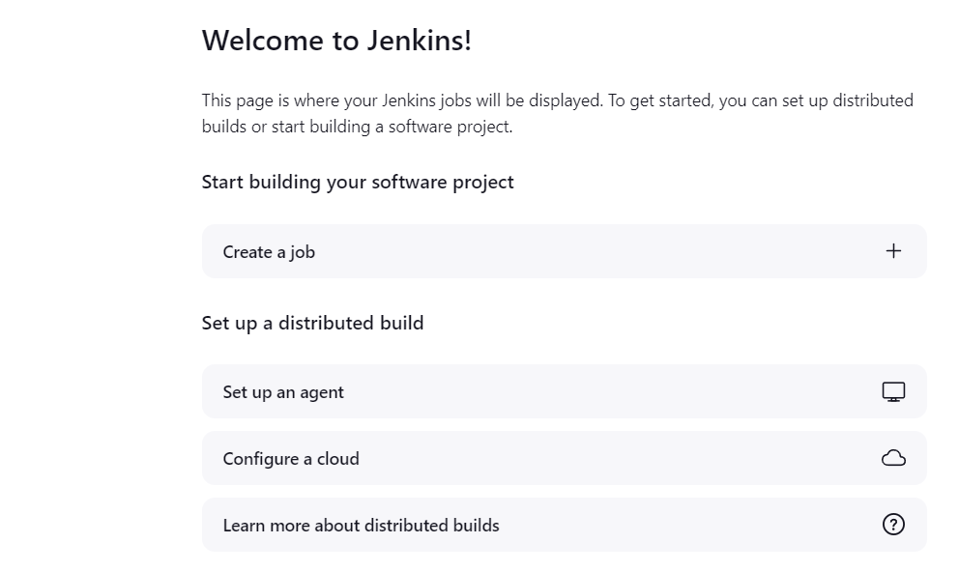

* + Enter a name for your job (e.g., Deploy on Develop Branch).

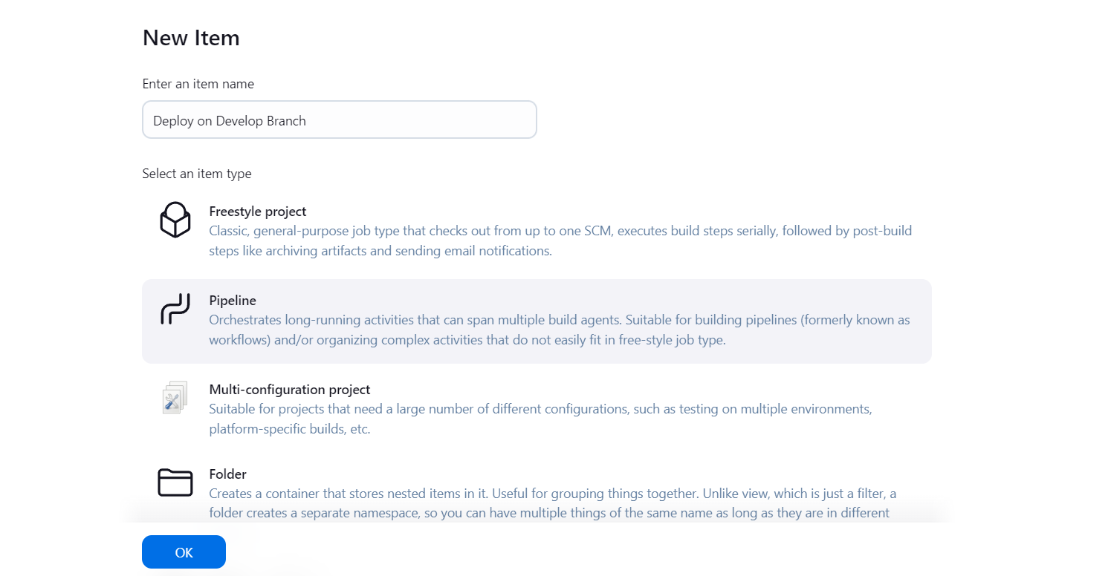

* + Select **Pipeline** and click **OK**.

1. **Configure the Pipeline:**
   * **Pipeline Section:**
     + In the **Pipeline** section, you’ll configure the pipeline script.

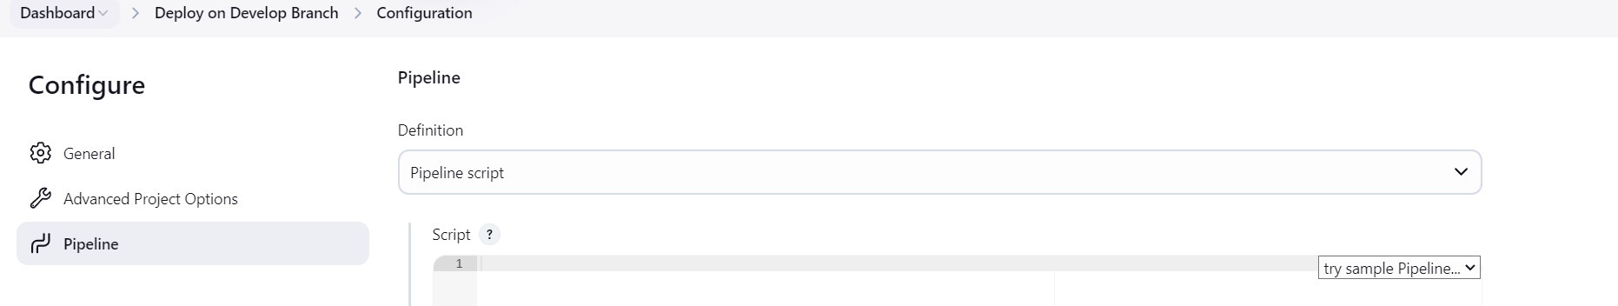

**2. Configure Pipeline Job:**

* In the job configuration page:
  + Scroll to the **Pipeline** section.
  + Set **Definition** to **Pipeline script from SCM**.
  + Choose **Git** as the SCM.
  + Enter the **Repository URL** and credentials if necessary.
  + Set **Branch Specifier** to */develop.
  + In **Script Path**, enter the path to your Jenkinsfile (if it’s in the root of the repository, just enter Jenkinsfile).

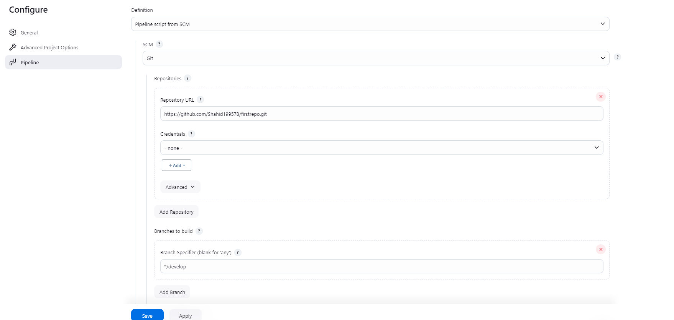

1. **Configure Build Triggers:**

* Go to the **Build Triggers** section.
* Check **GitHub hook trigger for GITScm polling** if using GitHub, or **Poll SCM** if you want Jenkins to periodically check for changes.

jenkinsfile

pipeline {

agent any

environment {

// Define the folder where the Git content will be pulled

FOLDER_NAME = 'develop'

REPO_URL = ' https://github.com/Shahid199578/firstrepo.git '

BRANCH_NAME = 'develop'

}

stages {

stage('Checkout') {

steps {

script {

// Clean up previous workspace

deleteDir()

// Create a directory for the Git content

sh "mkdir -p ${env.FOLDER_NAME}"

// Checkout code from Git into the specific folder

dir(env.FOLDER_NAME) {

git branch: env.BRANCH_NAME, url: env.REPO_URL

}

}

}

}

stage('Build') {

steps {

// Build steps here

echo 'Building...'

}

}

stage('Deploy') {

steps {

// Deploy steps here

echo 'Deploying...'

}

}

}

}

**5. Save and Test**

1. **Save the Jenkins Job:**
   * Click Save to apply your changes.
2. **Test the Setup:**
   * Make a change to your develop branch and push it to your Git repository.
   * Jenkins should automatically trigger the pipeline and execute the steps defined in your Jenkinsfile.

**6. Verify**

* Ensure that Jenkins pulls the content to the specified folder and triggers the pipeline on each push to the develop branch.

