1. **Terraform Installed:**
2. **AWS Credentials Configured:** You should have your AWS credentials set up using the AWS CLI (aws configure) or environment variables.

**Steps:**

1. **Create a new directory for the Terraform project:**

mkdir terraform

cd terraform

1. **Create the Terraform Configuration File:** Create a file called main.tf inside the directory with the following content:

provider "aws" {

  region = "us-east-2"

}

resource "aws_instance" "terraform" {

  ami           = "ami-085f9c64a9b75eed5" # Ubuntu 22.04 AMI for Ohio region

  instance_type = "t2.micro"

  tags = {

    Name = "terraform-ec2"

  }

}

1. **Initialize Terraform:** Initialize your Terraform workspace by running the following command:

terraform init

1. **Preview the Changes:** After initialization, you can preview the changes Terraform will make by running:

terraform plan

1. **Apply the Changes:** Apply the configuration to create the EC2 instance in the default VPC's subnet:

terraform apply

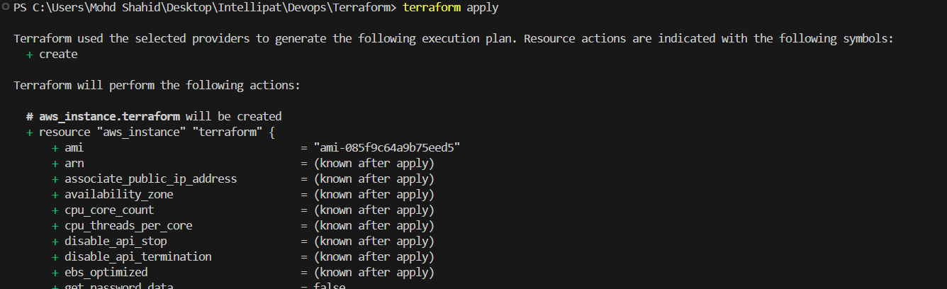

When prompted, type yes to confirm the action.

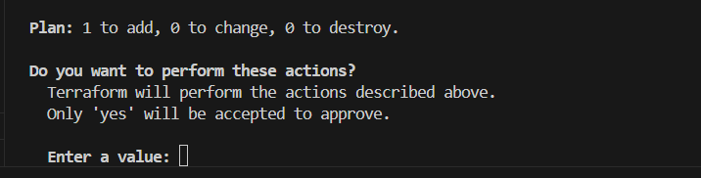



**Explanation:**

* **Provider Block (provider "aws"):** Specifies the AWS region to use. Ohio is us-east-2.
* **Resource Block (aws_instance "example"):** Defines an EC2 instance resource. The ami is an Ubuntu 22.04 AMI specific to the Ohio region, and the instance_type is t2.micro, which is eligible for the free tier.