**1. Create IAM Users**

1. **Login to AWS Management Console**.
2. **Navigate to IAM** (Identity and Access Management).
3. In the left navigation pane, click on **Users**.

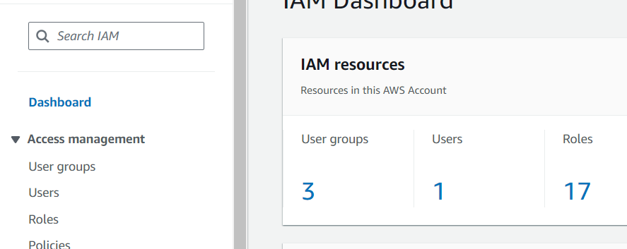

1. Click on **Add user**.
2. For each user:
   * Enter the user name (Dev1, Dev2, Test1, Test2).
   * Select **AWS Management Console access**.
   * Set a custom password or let AWS auto-generate it.
   * Uncheck the option for "User must create a new password at next sign-in" if you do not want them to change the password at the first login.

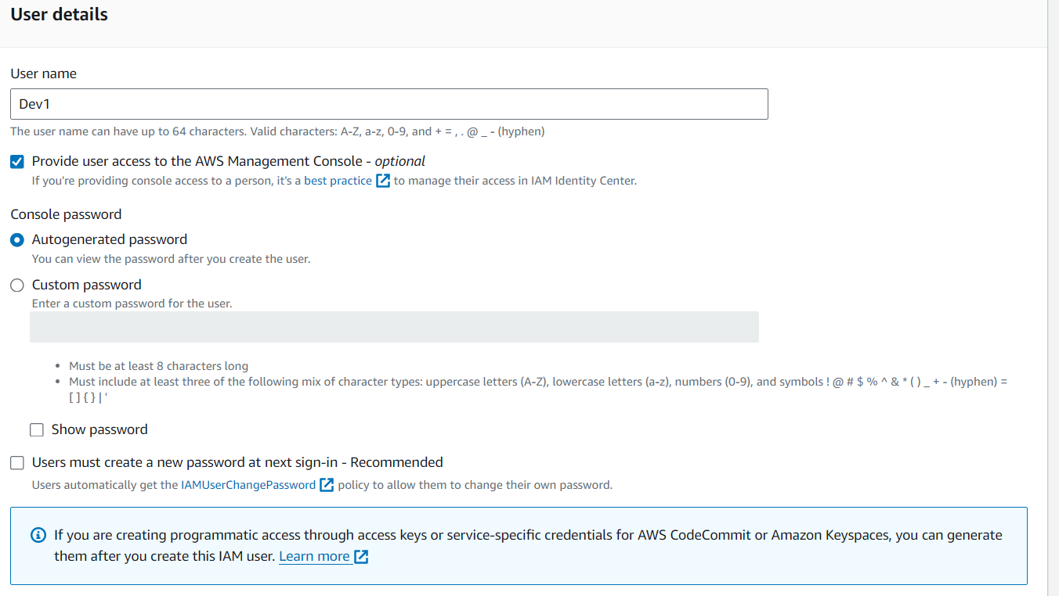

* + Click **Next: Permissions**.
  + On the Set permissions page, select **Attach policies directly** or **Add user to group**.
  + Click **Next: Tags**.
  + Add any tags if needed (optional).
  + Click **Next: Review**.
  + Review the details and click **Create user**.

Repeat these steps for each user: Dev1, Dev2, Test1, and Test2.

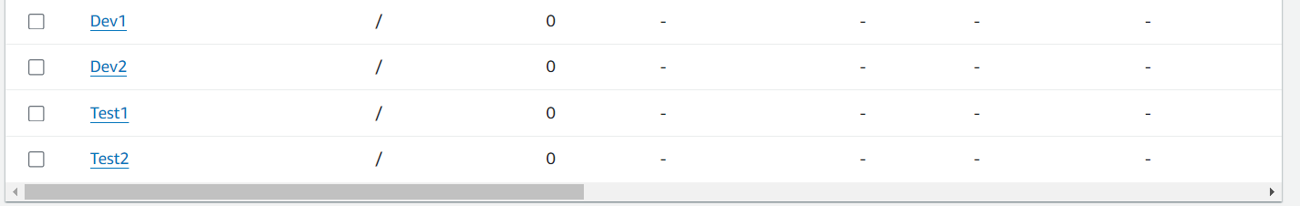

**2. Create IAM Groups**

1. In the IAM Dashboard, click on **User groups** in the left navigation pane.
2. Click on **Create group**.
3. For **Group name**, enter **Dev Team**.
4. Click **Next step**.
5. Attach policies as needed (optional).
6. Click **Create group**.

Repeat these steps to create the **Ops Team** group.



**3. Add Dev1 and Dev2 to the Dev Team**

1. Go to the **Dev Team** group.
2. Click on **Add users to group**.
3. Select **Dev1** and **Dev2**.
4. Click **Add users**.

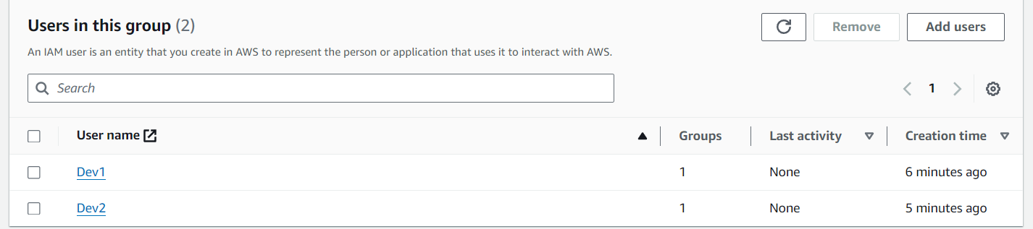

**4. Add Dev1, Test1, and Test2 to the Ops Team**

1. Go to the **Ops Team** group.
2. Click on **Add users to group**.
3. Select **Dev1**, **Test1**, and **Test2**.
4. Click **Add users**.

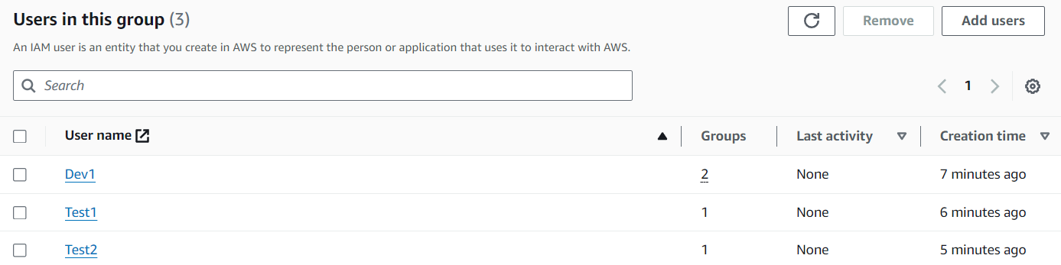

**5. Create Policy Number 1**

1. **Login to AWS Management Console**.
2. **Navigate to IAM** (Identity and Access Management).
3. In the left navigation pane, click on **Policies**.
4. Click on **Create policy**.

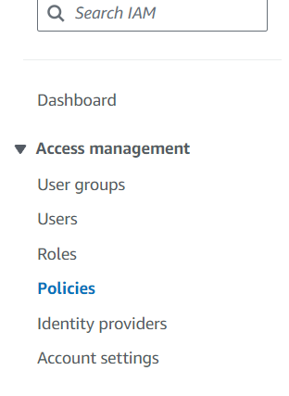

**Step 1: Add S3 Full Access**

1. Under the **Service** dropdown, type and select **S3**.
2. Under **Actions**, check the box for **All S3 actions**.
3. Under **Resources**, check the box for **All resources**.

**Step 2: Add EC2 RunInstances Permission**

1. Click on **Add additional permissions**.
2. Under the **Service** dropdown, type and select **EC2**.
3. Under **Actions**, check the box for **Specific actions**.
4. Expand the **Write** section and check the box for **RunInstances**.
5. Under **Resources**, check the box for **All resources**.

**Step 3: Add RDS Full Access**

1. Click on **Add additional permissions**.
2. Under the **Service** dropdown, type and select **RDS**.
3. Under **Actions**, check the box for **All RDS actions**.
4. Under **Resources**, check the box for **All resources**.
5. Click on **Next: Tags** (optional).
6. Click on **Next: Review**.
7. Enter a **Name** (e.g., PolicyNumber1) and **Description** (optional).
8. Click on **Create policy**.

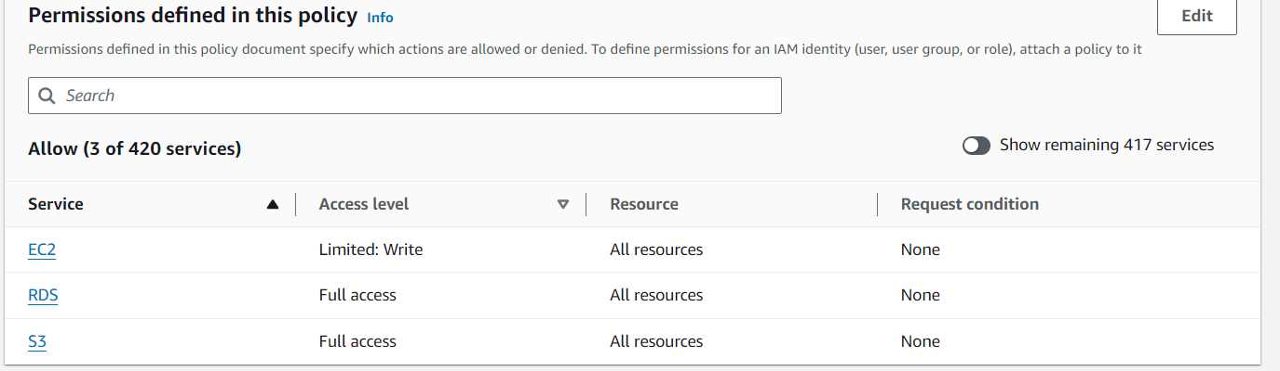

**Create Policy Number 2**

1. In the left navigation pane, click on **Policies**.
2. Click on **Create policy**.
3. Click on the **Visual editor** tab.

**Step 1: Add CloudWatch Full Access**

1. Under the **Service** dropdown, type and select **CloudWatch**.
2. Under **Actions**, check the box for **All CloudWatch actions**.
3. Under **Resources**, check the box for **All resources**.

**Step 2: Add Billing Full Access**

1. Click on **Add additional permissions**.
2. Under the **Service** dropdown, type and select **Billing**.
3. Under **Actions**, check the box for **All Billing actions**.

**Step 3: Add EC2 List Permission**

1. Click on **Add additional permissions**.
2. Under the **Service** dropdown, type and select **EC2**.
3. Under **Actions**, check the box for **Specific actions**.
4. Expand the **List** section and check the boxes for **DescribeInstances** and **DescribeVolumes**.
5. Under **Resources**, check the box for **All resources**.

**Step 4: Add S3 List Permission**

1. Click on **Add additional permissions**.
2. Under the **Service** dropdown, type and select **S3**.
3. Under **Actions**, check the box for **Specific actions**.
4. Expand the **List** section and check the box for **ListBucket**.
5. Under **Resources**, check the box for **All resources**.
6. Click on **Next: Tags** (optional).
7. Click on **Next: Review**.
8. Enter a **Name** (e.g., PolicyNumber2) and **Description** (optional).
9. Click on **Create policy**.

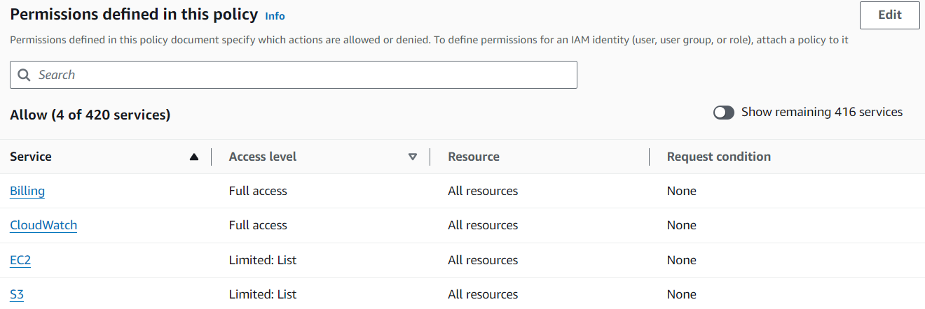

**6. Attach Policy Number 1 to the Dev Team**

1. In the IAM Dashboard, click on **User groups** in the left navigation pane.
2. Select **Dev Team**.
3. Click on the **Permissions** tab.
4. Click on **Add permissions**.
5. Select **Attach policies**.
6. Search for PolicyNumber1.
7. Select the policy and click on **Next: Review**.
8. Click on **Add permissions**.

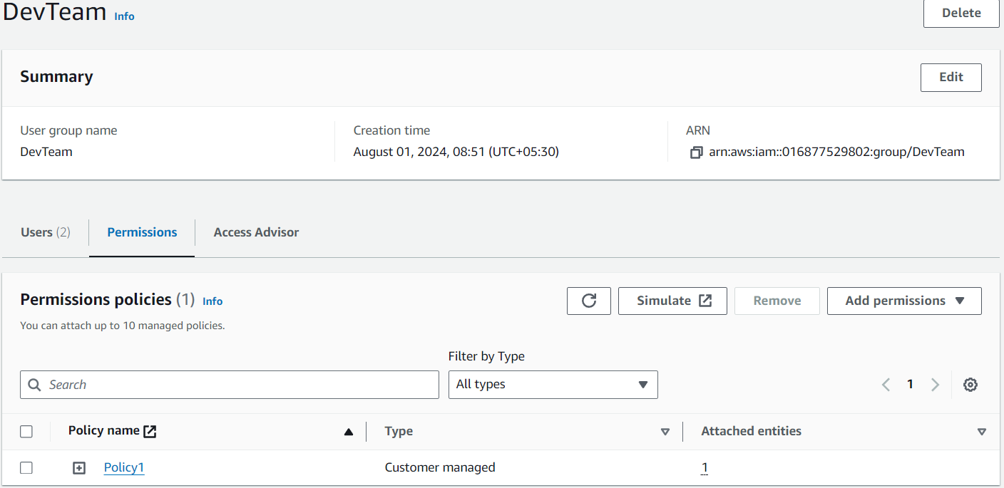

**7. Attach Policy Number 2 to the Ops Team**

1. In the IAM Dashboard, click on **User groups** in the left navigation pane.
2. Select **Ops Team**.
3. Click on the **Permissions** tab.
4. Click on **Add permissions**.
5. Select **Attach policies**.
6. Search for PolicyNumber2.
7. Select the policy and click on **Next: Review**.
8. Click on **Add permissions**.

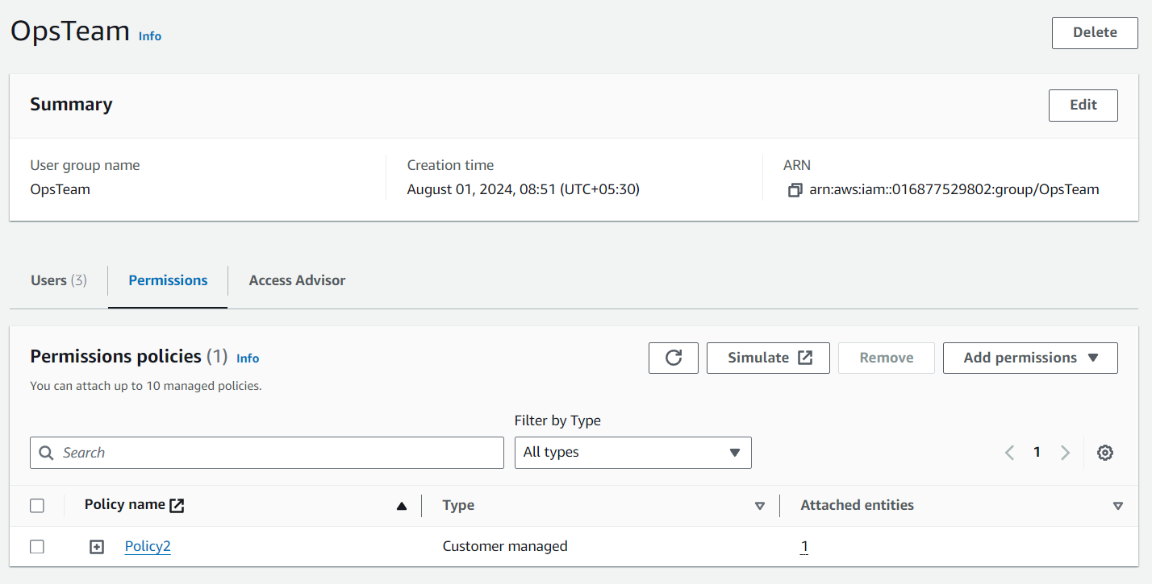

**Steps to Create a Role and Test It**

**Steps to Create the Role**

1. **Login to AWS Management Console.**
2. **Navigate to IAM (Identity and Access Management).**
3. **In the left navigation pane, click on Roles.**
4. **Click on Create role.**

**Step 1: Select Trusted Entity**

1. **Under Trusted entity type, select AWS account.**
2. **Select This account.**
3. **Check the box for Require external ID and enter a unique identifier (optional).**
4. **Click on Next: Permissions.**

**Step 2: Attach Policies**

**Create a Custom Policy for Complete Access to VPCs and DynamoDB**

1. **In the IAM Dashboard, click on Policies in the left navigation pane.**
2. **Click on Create policy.**
3. **Click on the Visual editor tab.**
4. **Under Service, type and select VPC.**
5. **Under Actions, check the box for All VPC actions.**
6. **Under Resources, check the box for All resources.**
7. **Click on Add additional permissions.**
8. **Under Service, type and select DynamoDB.**
9. **Under Actions, check the box for All DynamoDB actions.**
10. **Under Resources, check the box for All resources.**
11. **Click on Next: Tags (optional).**
12. **Click on Next: Review.**
13. **Enter a Name (e.g., VPCDynamoDBFullAccess) and Description (optional).**
14. **Click on Create policy.**

**Attach the Custom Policy to the Role**

1. **Go back to Create role.**
2. **Click on Refresh in the Attach permissions policies step.**
3. **Search for VPCDynamoDBFullAccess.**
4. **Select the policy and click on Next: Tags (optional).**
5. **Click on Next: Review.**

**Step 3: Role Name and Description**

1. **Enter a Role name (e.g., VPCDynamoDBRole) and Description (optional).**
2. **Click on Create role.**

**2. Allow Only Specific Users to Assume the Role**

**Edit the Trust Relationship**

1. **In the IAM Dashboard, click on Roles in the left navigation pane.**
2. **Select the role you created (e.g., VPCDynamoDBRole).**
3. **Go to the Trust relationships tab.**
4. **Click on Edit trust relationship.**
5. **Replace the existing policy with the following JSON, modifying AccountID with your AWS account ID and replacing User1 and User2 with the actual user names:**

**json**

**{**

**"Version": "2012-10-17",**

**"Statement": [**

**{**

**"Effect": "Allow",**

**"Principal": {**

**"AWS": [**

**"arn:aws:iam::AccountID:user/User1",**

**"arn:aws:iam::AccountID:user/User2"**

**]**

**},**

**"Action": "sts:AssumeRole"**

**}**

**]**

**}**

1. **Click on Update Trust Policy.**

**3. Test the Role with User1**

**Login as User1**

1. **Sign out from your current AWS session.**
2. **Login as User1.**

**Assume the Role**

1. **In the AWS Management Console, navigate to IAM.**
2. **In the left navigation pane, click on Roles.**
3. **Find and click on the role you created (e.g., VPCDynamoDBRole).**
4. **Click on Assume role.**
5. **Confirm the switch.**

**Test Access**

1. **Navigate to VPC and DynamoDB services in the AWS Management Console.**
2. **Ensure that User1 has complete access to both VPCs and DynamoDB.**