---------------------------------Git------------------------------------
Version control -> also called as SCM (Source code management) helps to keep track of changes made to the code in a project.
Git -> is an open source version control system used to keep track of changes made in source code during the s/w development. It allows multiple developers to work together and collaborate easily.
GitHub -> is a cloud based version control system, that offers git repository where team members store there source code.

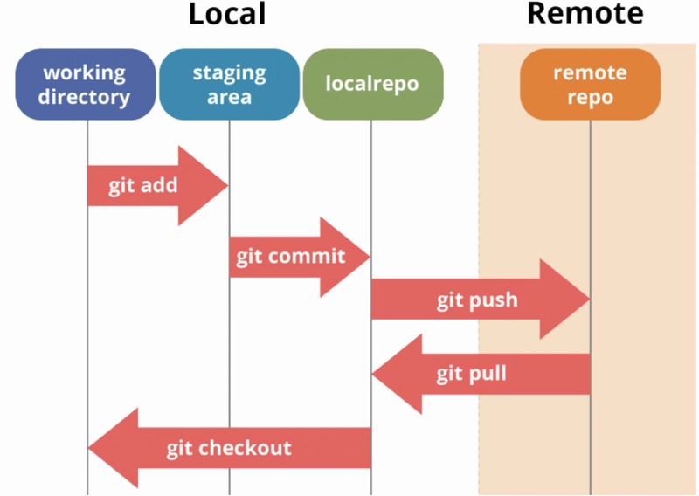
To check git version -> git –version
Set global username and email -> git config –global user.name “UserName”, git config –global user.email “mailId”
Initialize local git repository -> git init
Clone a repository -> git clone “URL”
Create a local branch -> git branch “branchName” / git checkout –b “branchName”
See all the local branch -> git branch
Switch to any local branch - > git checkout “branchName”
Take pull from central repository branch -> git pull origin “branchName”
Add changes made in local working directory - > git add “fileName” / git add .
Commit the changes made -> git commit –m “any msg”
Push the code to central repository - > git push origin “branchName”
See local branch status -> git status
See entire commit history -> git log
Synchronizes your local repository with all the remote repositories -> git fetch –all
git fetch origin “branchName” -> git checkout localBranchName (optinal) -> git merge origin/branchName
Difference b/w fetch and pull ->
Fetch - is used to fetch all changes from the remote repository to the local repository. It doesn’t make any changes to the current working directory. It stores all the changes in a separate branch called the remote-tracking branch. git merge or git rebase command is used to merge these changes into our current working directory.
Pull – this command is the combination of fetch and merge. It pull or copies all the changes from a remote repository directly into your local working directory.
git stash -> command in Git allows you to temporarily save changes in your working directory that are not yet ready to be committed. This is useful when you need to switch branches or work on something else without losing your current work. (git stash -> git stash apply)
Difference b/w merge and rebase ->
Merge: Useful when you want to preserve the complete history of changes and see how different branches interacted.
Rebase: Useful when you want a clean, linear history, as if all changes were made in a straight line without branches.

