**Deliverable # 3**

**Software Design and Architecture**

**Course Instructor**: Sir Atif Jillani

**Submitted By:**   
Aashir Aftab (20i-0523)

Shahid Hameed (20i-0980)

Suleiman Afzal (20i-1791)

**Date: 29-04-2022**

**Spring 2022**



**Department of Computer Science FAST –**

National University of Computer & Emerging Sciences

**Table of Contents**

Sequence Diagrams 3

Sequence Diagram UC-01: Registration Application Evaluation 3

Sequence Diagram UC-02: Transfer Ownership of property 4

Sequence Diagram UC-03: Complaint Registration 5

Sequence Diagram UC-04: Check Complaint Status 6

Sequence Diagram UC-05: Make Announcements 7

Sequence Diagram UC-06: Search Property 9

Sequence Diagram UC-07: Seeking Resident Care Services 10

Sequence Diagram UC-08: Renting Application Evaluation 11

Sequence Diagram UC-9: Vehicle E-tag Application Evaluation 12

Sequence Diagram UC-10: Bills Initiation 13

Sequence Diagram UC-11: Password Change 14

Sequence Diagram UC-12 Property Registration Application 16

Sequence Diagram UC-13: Ownership Transfer Application 17

Sequence Diagram UC-14: Renting Property Application 18

Sequence Diagram UC-15: Vehicle E-tag Application 19

Sequence Diagram UC-16: Manage Resident Records 20

Sequence Diagram UC-17: Manage Property Records 21

22

Sequence Diagram UC-18: Rent Post 23

# **Use Case Registration Application Evaluation**

## SD- Decide Application

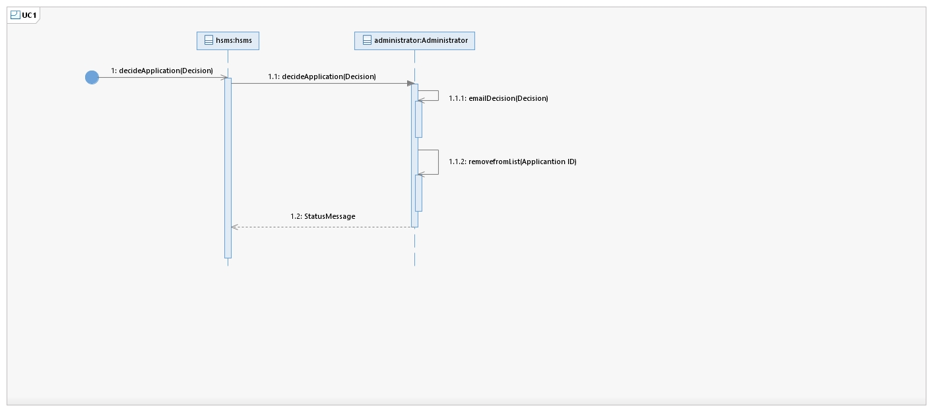

## SD- Evaluate Application

## SD- View Registration

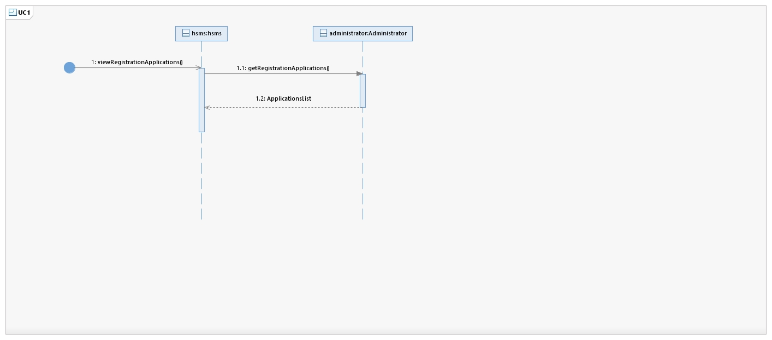

# **Sequence Diagram UC-02: Transfer Ownership of property**

## SD- View Transfer Application

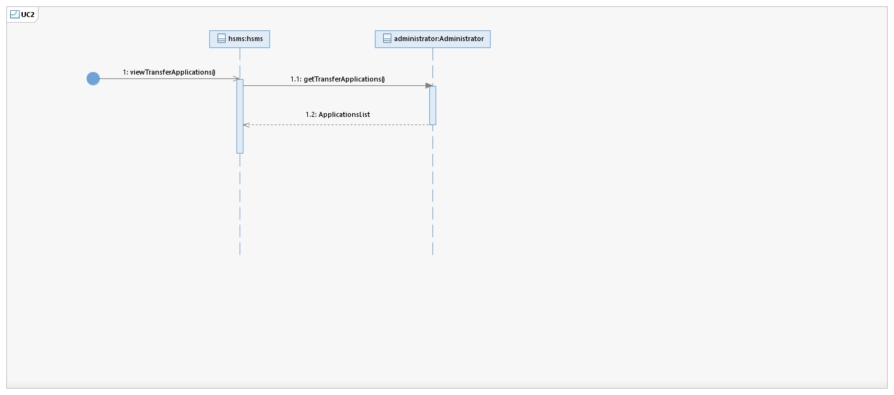

1. **Sequence Diagram** **UC-03: Complaint Registration**

## SD- Launch Complaint

# **Sequence Diagram UC-04: Evaluate Complaints**

# **Sequence Diagram UC-05: Make Announcements**

# **Sequence Diagram UC-06: Search Property**

## Property Search

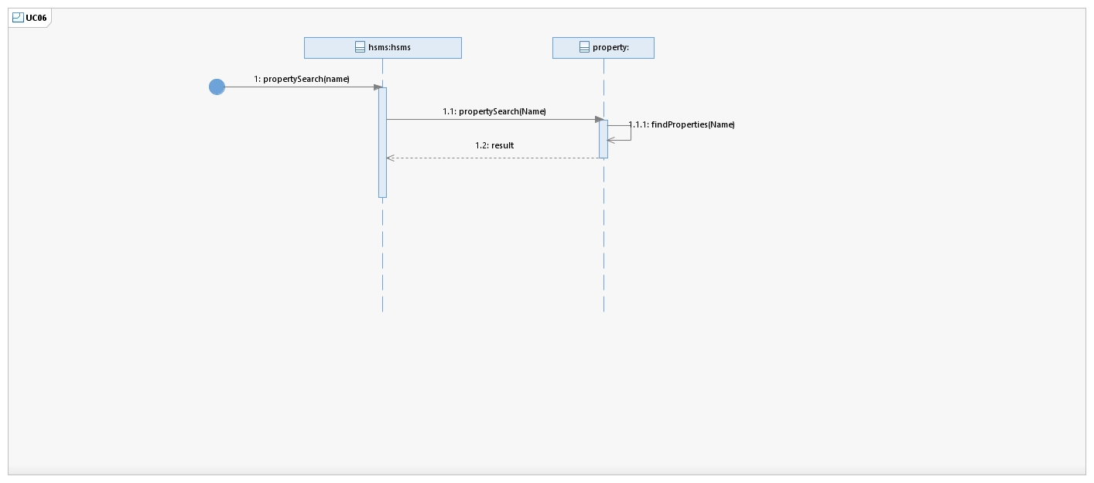

## Filter

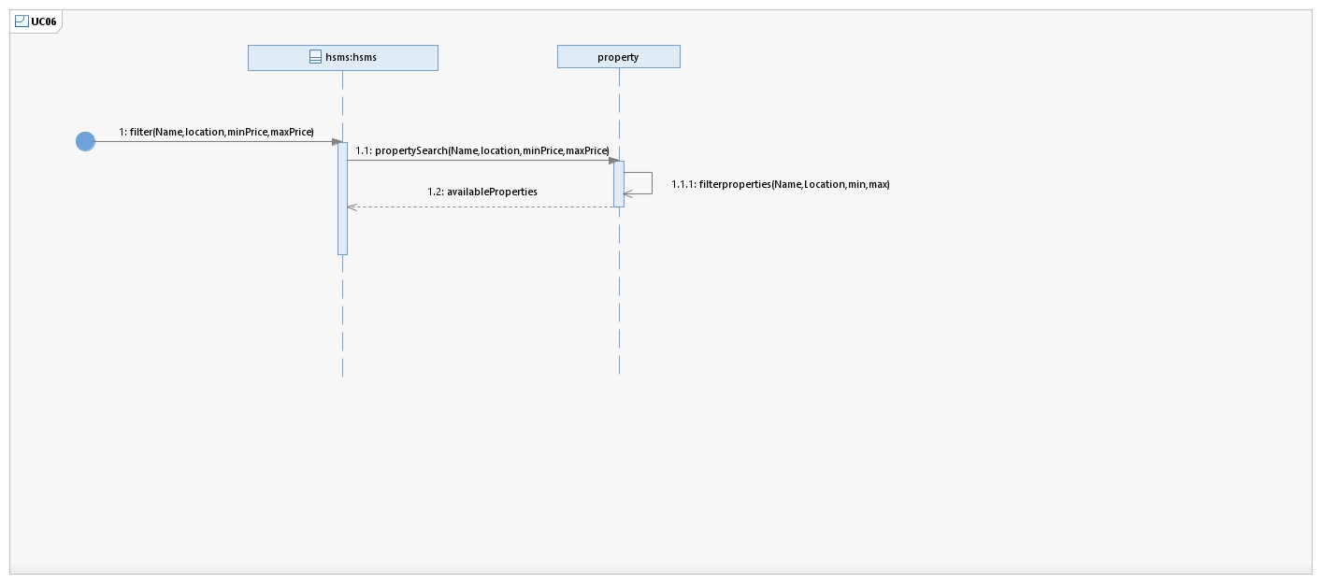

# **Sequence Diagram UC-07: Seeking Resident Care Services**

## Opt for Services

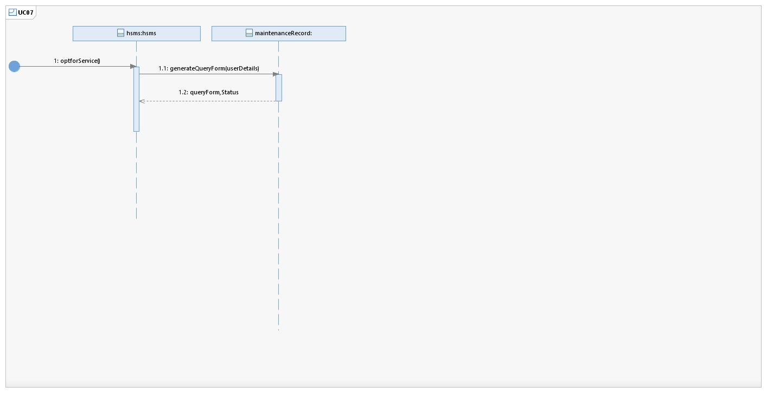

## Submit Query Form

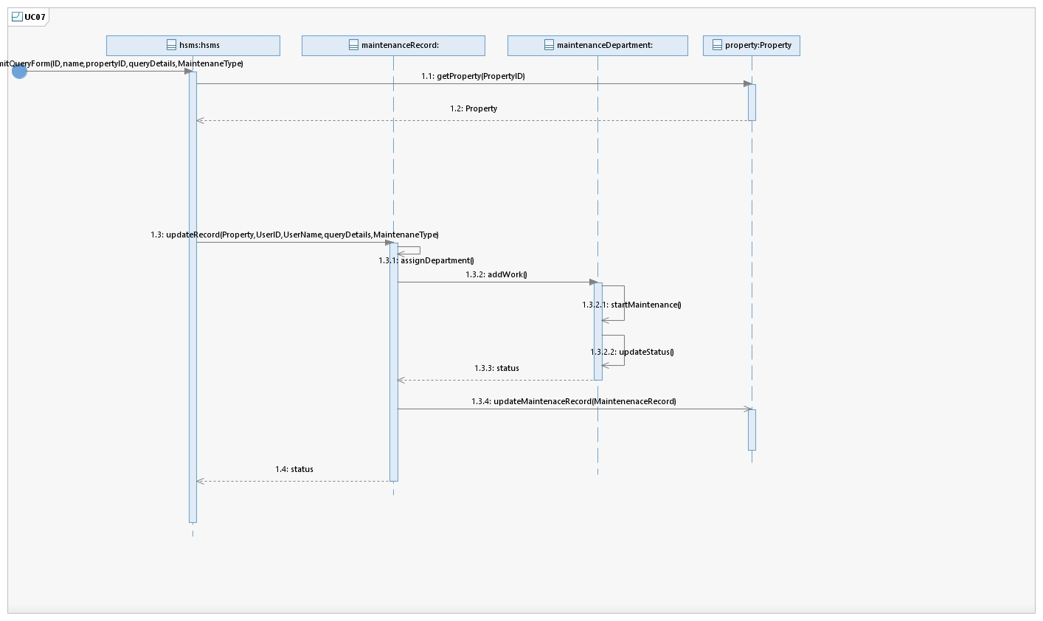

## Provide Feedback

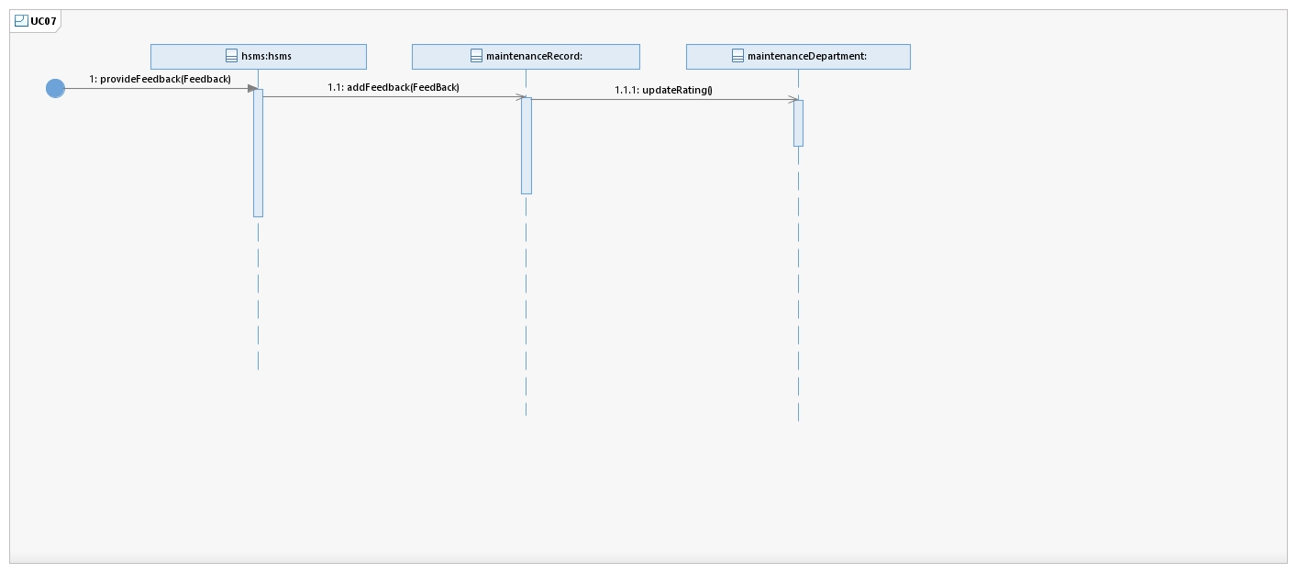

# **Sequence Diagram UC-08: Renting Application Evaluation**

## Display Application

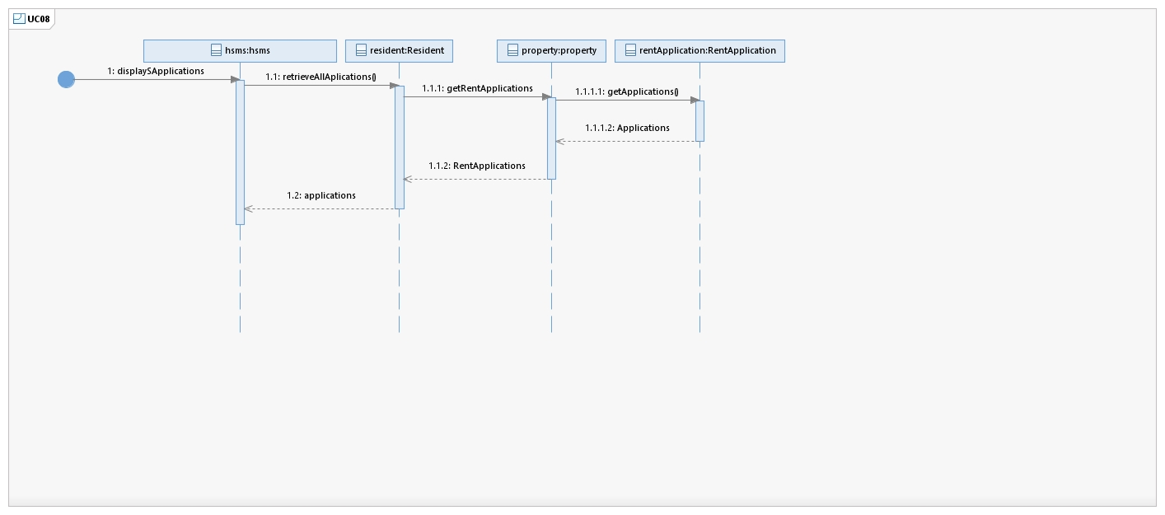

## Evaluate Application

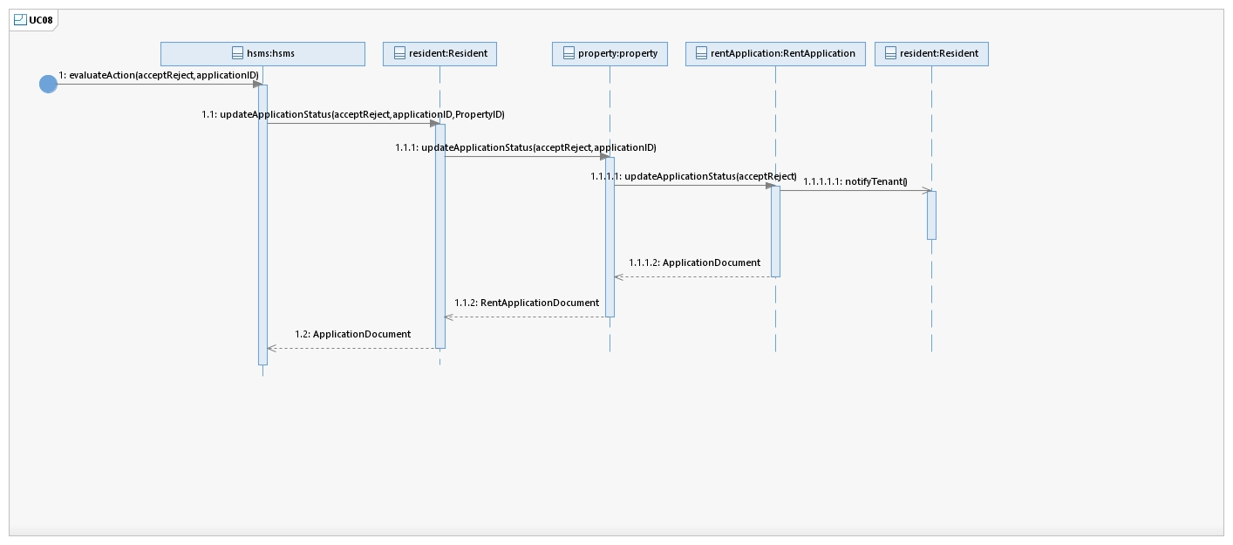

# **Sequence Diagram UC-9: Vehicle E-tag Application Evaluation**

## Display Application

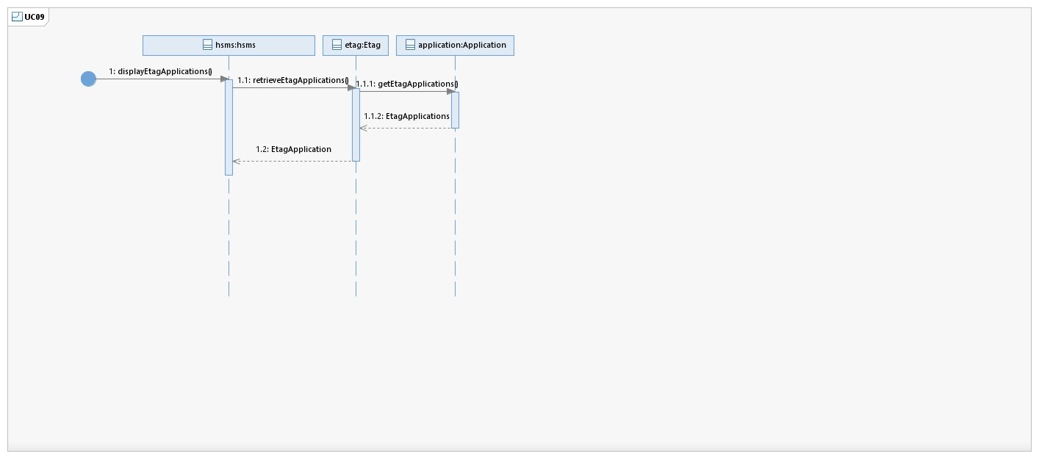

# **Sequence Diagram UC-10: Bills Initiation**

## Initiate Bills

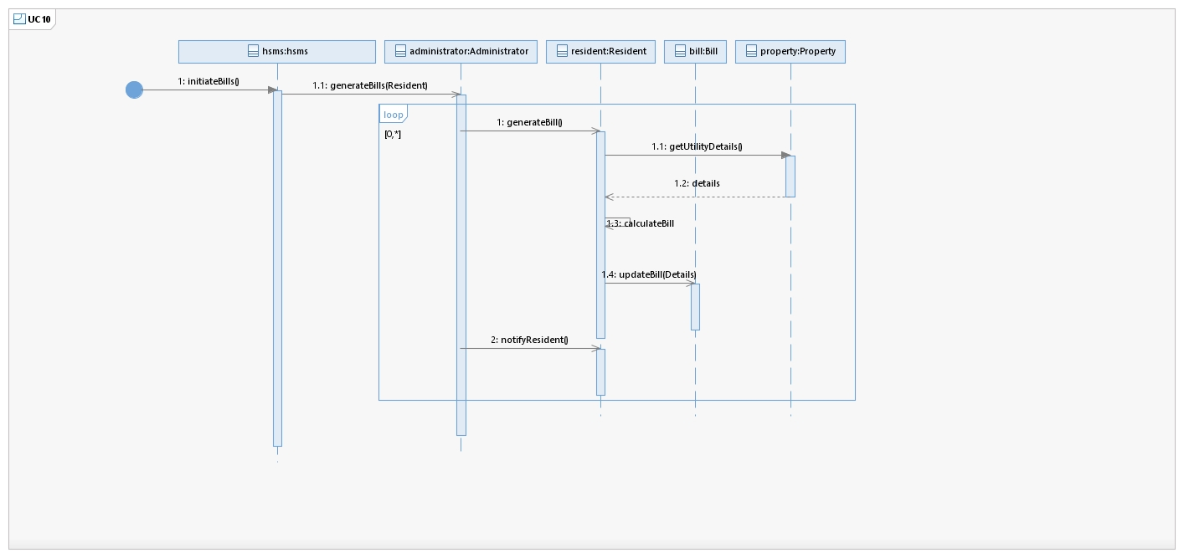

# **Sequence Diagram UC-11: Password Change**

## Initiate Password Change

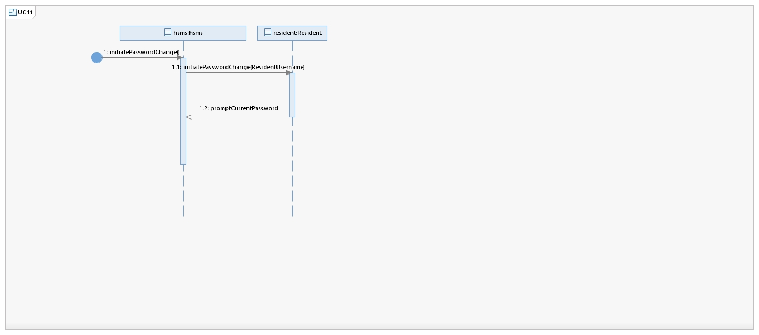

## Change Password

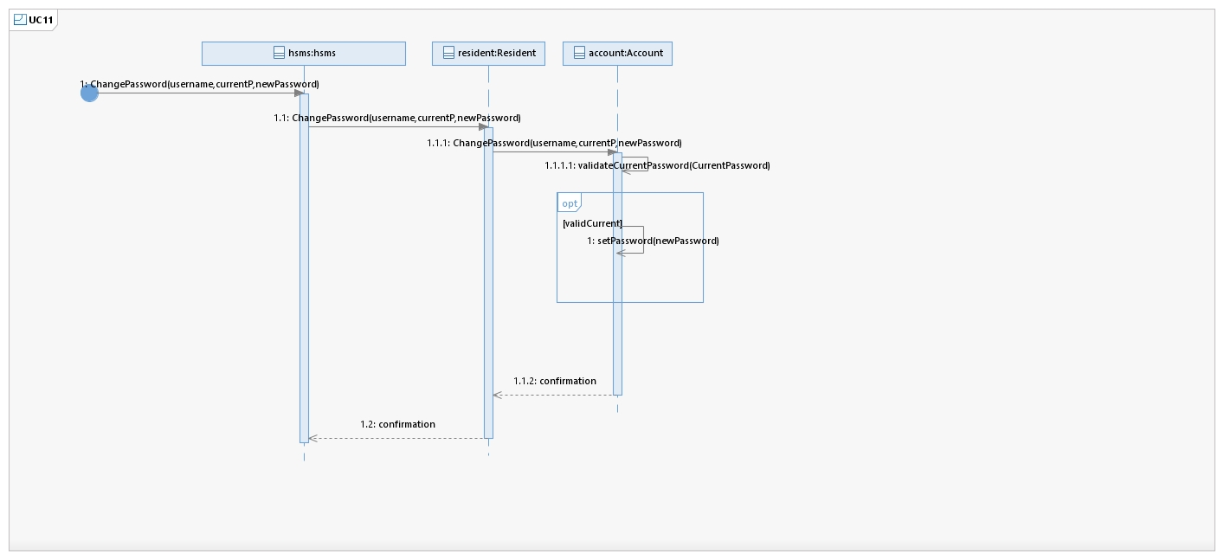

# **Sequence Diagram UC-12 Property Registration Application**

## I. Create Application

## Property Registration Application

## Fee Chalan Application

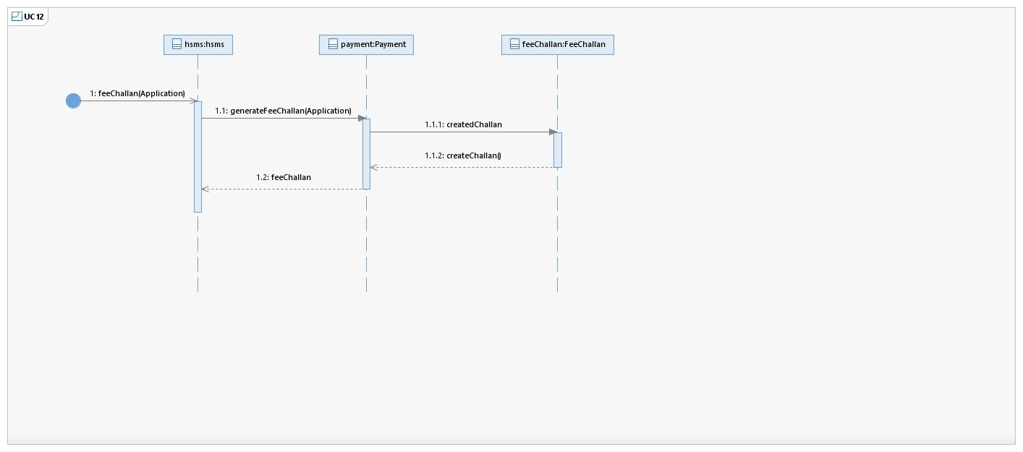

# **Sequence Diagram UC-13: Ownership Transfer Application**

## I. Create Application

## Ownership Transfer

# **Sequence Diagram UC-14: Renting Property Application**

## I. Create Application

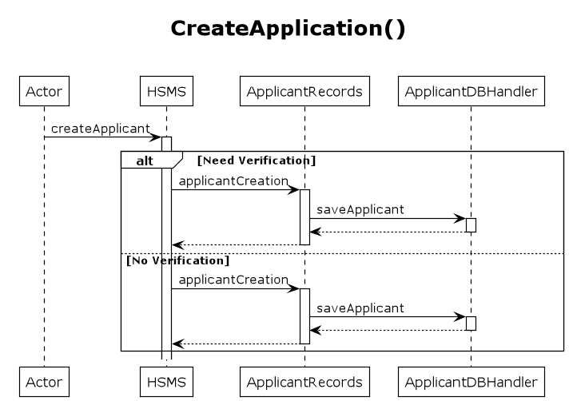

## Rent Property

## Update

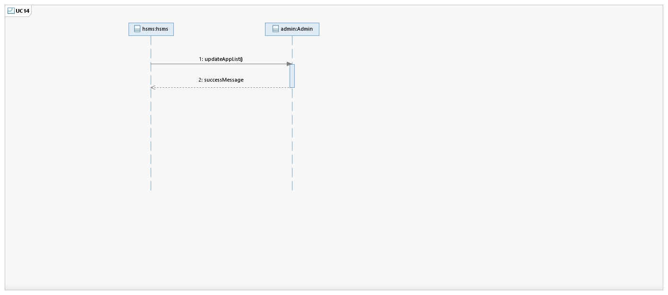

# **Sequence Diagram UC-15: Vehicle E-tag Application**

## I. Create Application

## II. E-tag Registration

# **Sequence Diagram UC-16: Manage Resident Records**

## Manage Records

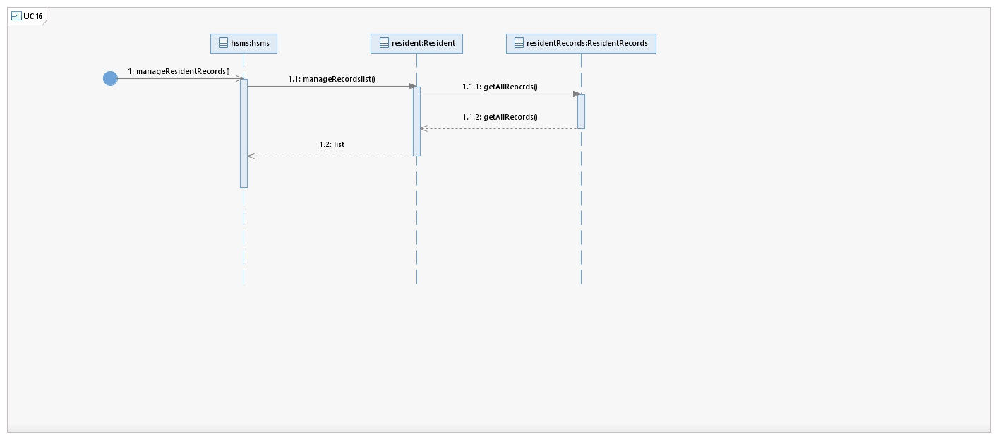

## Delete Records

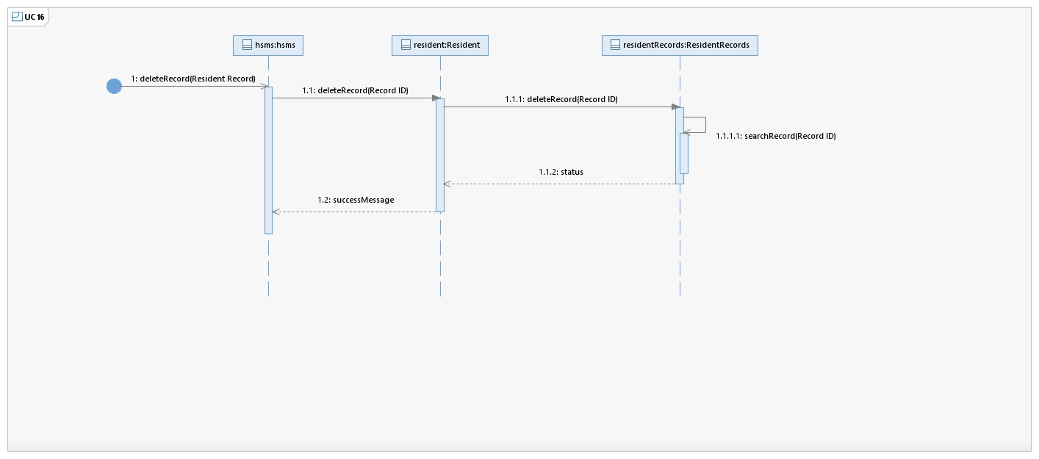

## Edit Records

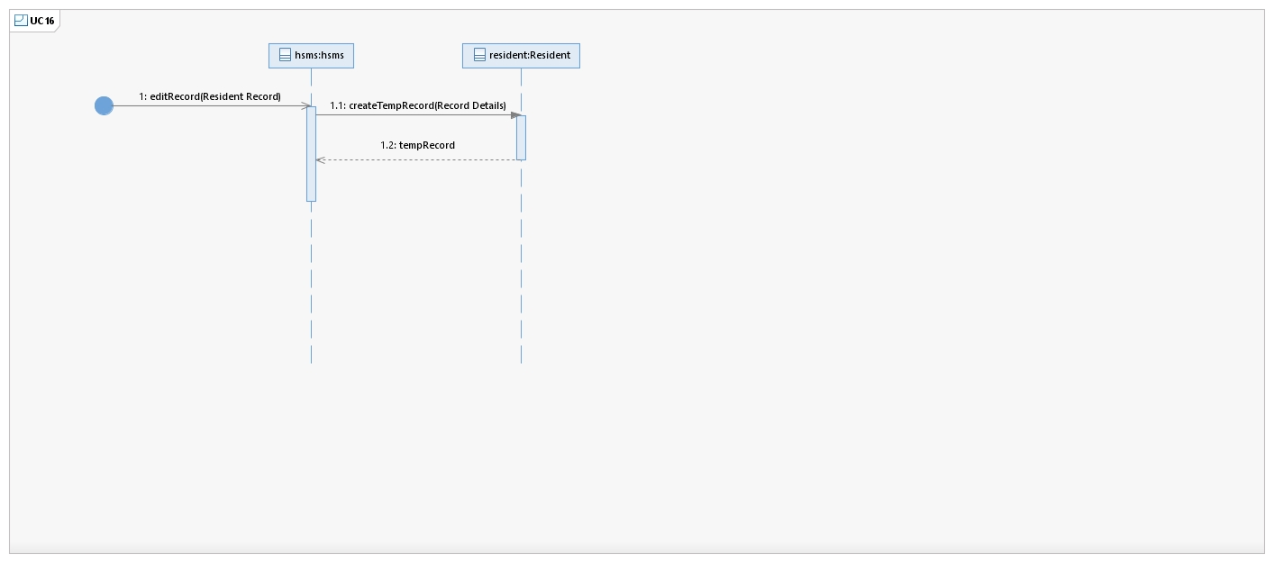

## Update Records

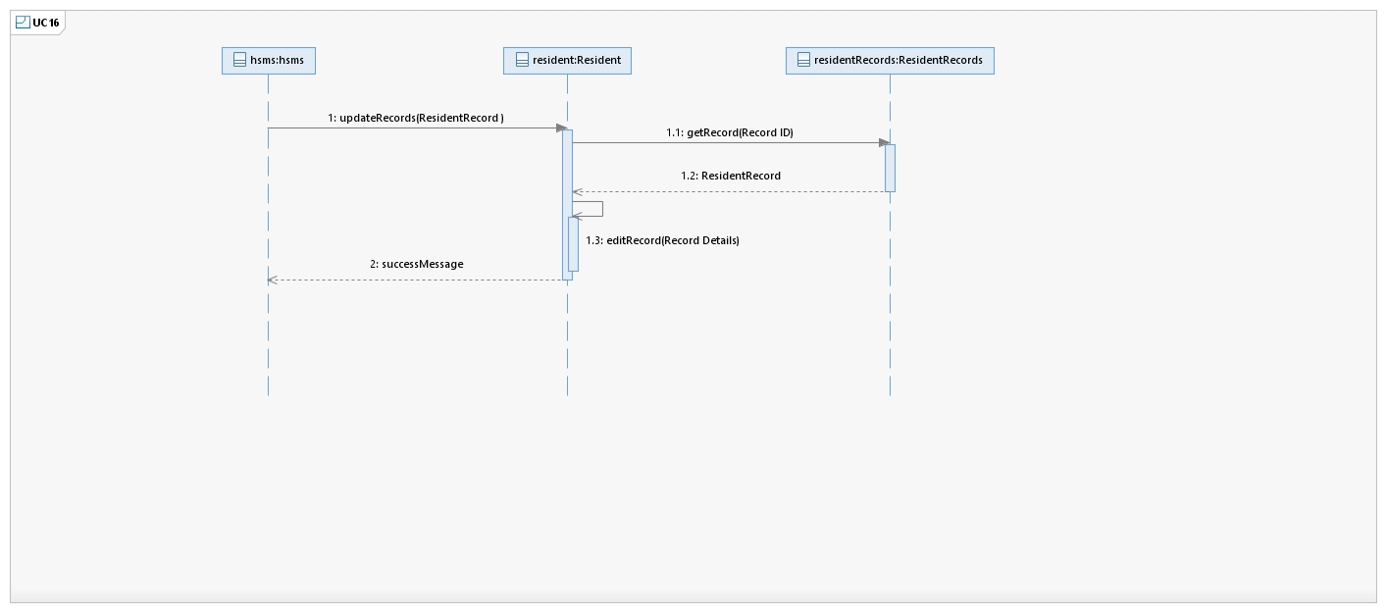

# **Sequence Diagram UC-17: Manage Property Records**

## Manage Records

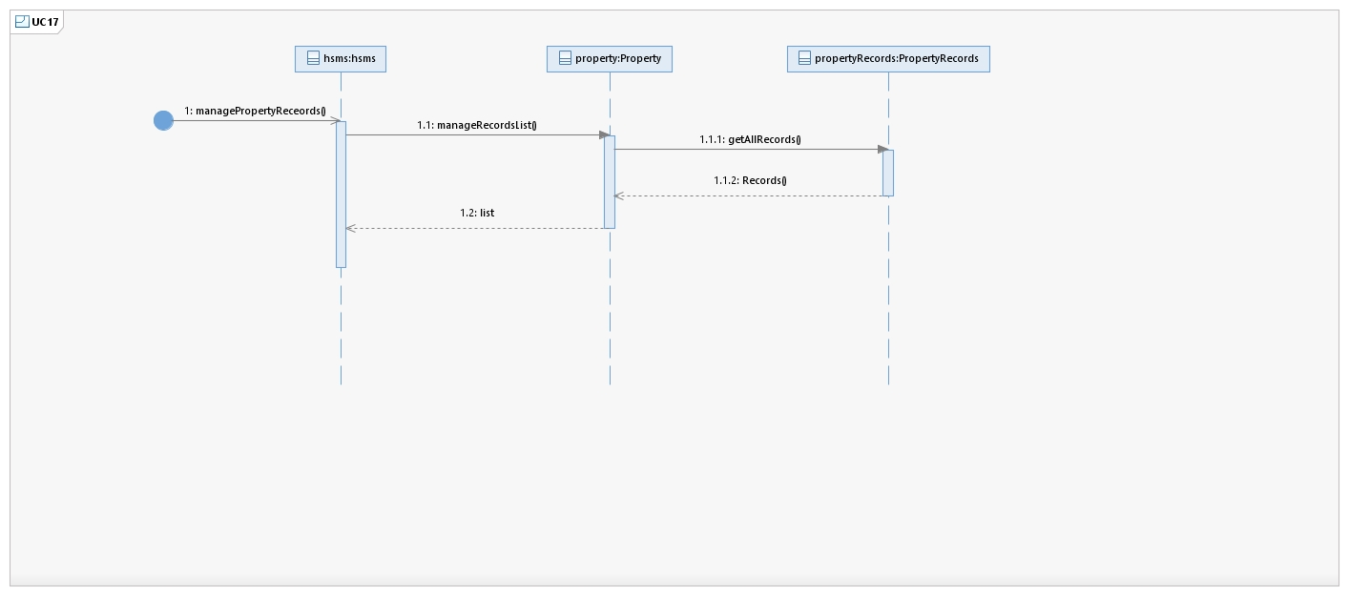

## Delete Records

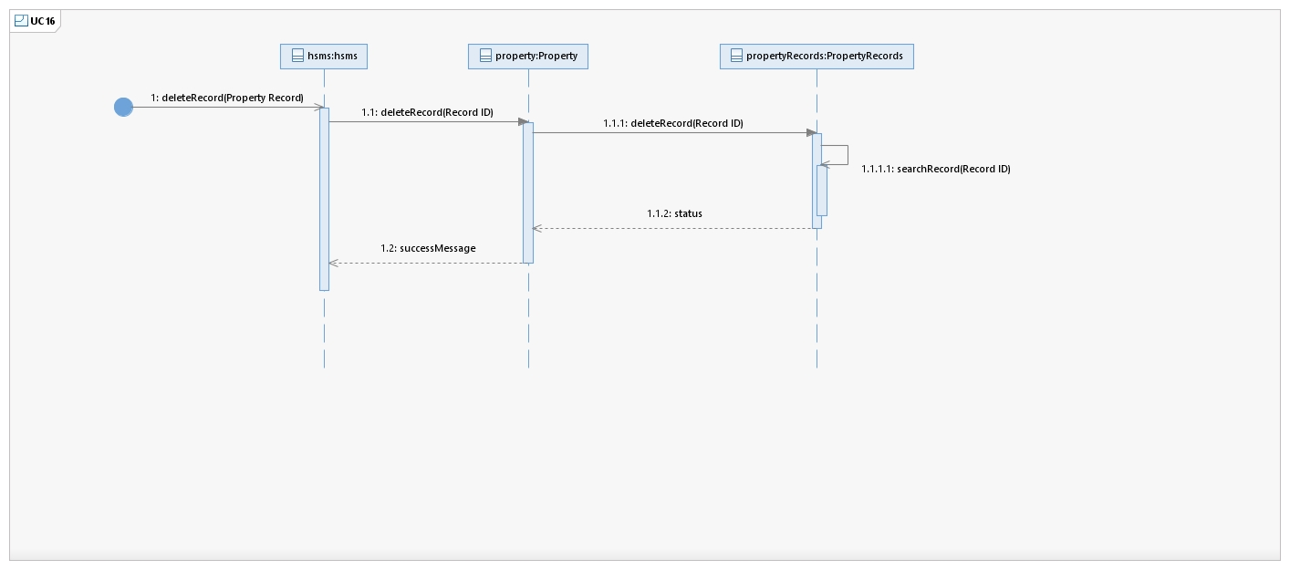

## Edit Records

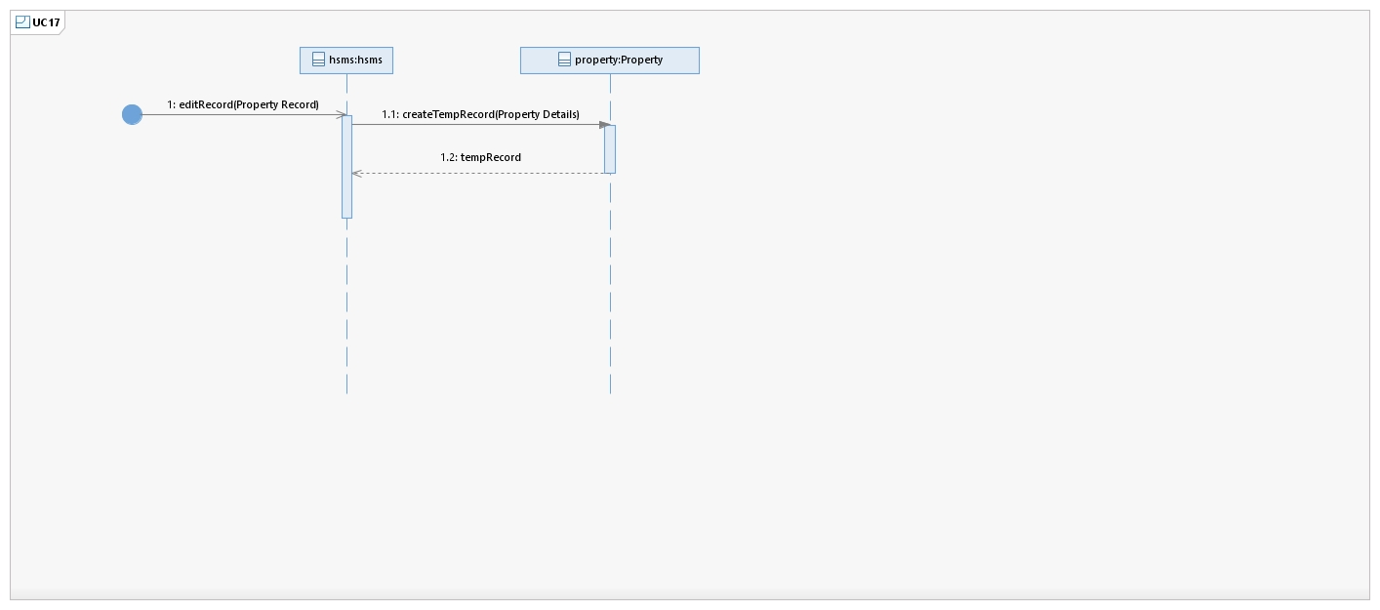

## Update Records

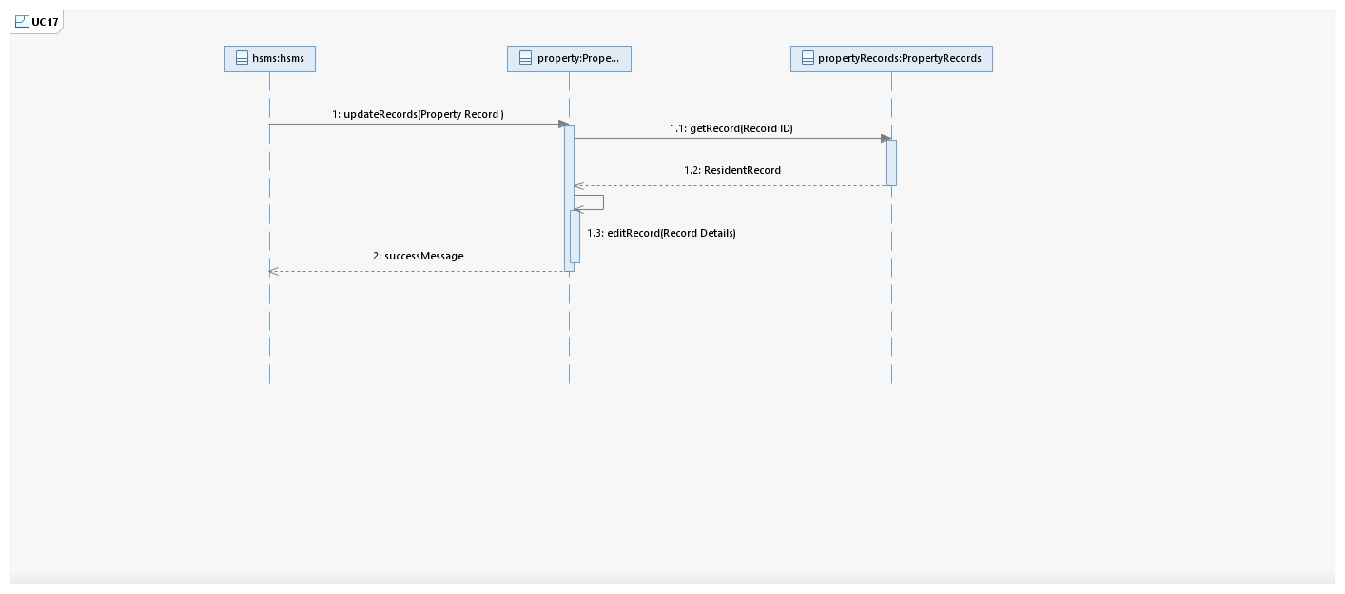

# **Sequence Diagram UC-18: Rent Post**

## Rent Post

