SECOND MID-TERM PROJECT REPORT
RAG-ENHANCED SEMANTIC AI SEARCH ENGINE
Final Year B.Tech – Computer Science & Engineering
Garden City University, Bengaluru
2026

Abstract – Updated
The project is upgraded from a basic semantic search engine to a RAG-enhanced Semantic AI Search Engine for context-aware information retrieval. The system ingests PDF, DOCX and TXT documents, extracts and chunks text, converts chunks into sentence embeddings, stores embeddings in a FAISS vector index, retrieves semantically relevant candidates, and optionally re-ranks them using a cross-encoder. In RAG mode, the retrieved context is supplied to a language model to generate a grounded answer with source references. This architecture combines information retrieval, NLP embeddings, vector search, re-ranking and retrieval-augmented generation in a single end-to-end system.

1. Updated Problem Statement
- Keyword-only search can miss relevant information when user wording differs from document wording or when contextual meaning is important.
- Even semantic retrieval systems may require a second stage that converts retrieved evidence into a useful, context-aware answer rather than only displaying ranked documents.
- The proposed system combines semantic retrieval, re-ranking and RAG so that users receive relevant evidence together with an answer grounded in the retrieved documents.

2. Updated Objectives
- Implement semantic document retrieval using transformer embeddings.
- Use FAISS for scalable vector similarity search.
- Add chunking and metadata-based document ingestion.
- Add cross-encoder re-ranking to improve the ordering of retrieved candidates.
- Implement a RAG pipeline that passes retrieved context to an LLM.
- Provide source-aware answers and reduce unsupported generation.
- Evaluate both retrieval quality and answer quality.

3. Advanced Architecture
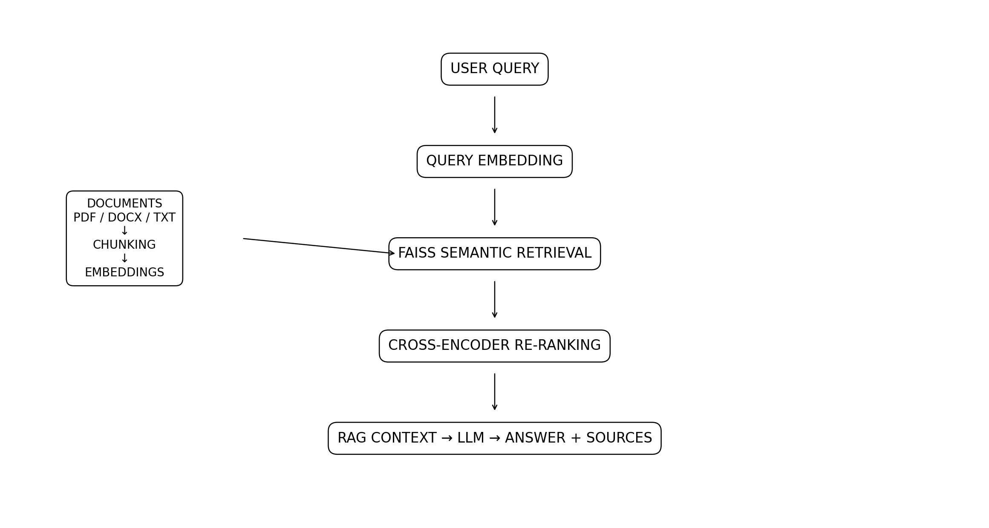
Document ingestion → extraction → chunking → embeddings → FAISS. Query → embedding → semantic retrieval → cross-encoder re-ranking → top-K context → RAG/LLM → grounded answer + sources.

4. Advanced Methodology
1. Document ingestion: accept PDF, DOCX and TXT files.
2. Text extraction: convert uploaded documents into plain text.
3. Chunking: divide long documents into overlapping text segments.
4. Embedding: generate normalized sentence embeddings.
5. Vector indexing: store embeddings in a FAISS inner-product index.
6. Retrieval: retrieve multiple candidate chunks for a query.
7. Re-ranking: score query-candidate pairs with a cross-encoder and keep the best results.
8. RAG: construct a context from retrieved chunks and provide it to an LLM.
9. Grounding: instruct the LLM to answer only from supplied context and cite source labels.
10. Evaluation: measure retrieval and answer quality.

5. Technology Stack – Updated
Layer | Technology
Frontend | Streamlit
Backend / Application | Python
Embeddings | Sentence Transformers – all-MiniLM-L6-v2
Vector Index | FAISS
Re-ranking | Cross-Encoder – ms-marco-MiniLM-L-6-v2
Document Extraction | pypdf, python-docx
RAG / LLM | OpenAI-compatible API layer (optional configuration)
Data Processing | NumPy
Future Metadata Store | SQLite/PostgreSQL

6. Retrieval Pipeline
The system retrieves more candidates than the final number of results, then applies cross-encoder re-ranking. This separates fast candidate retrieval from more accurate pairwise relevance scoring.

7. RAG Pipeline
The RAG module builds a context from the top retrieved chunks. The LLM is instructed to answer using only that context and to cite source labels. If no LLM key is configured, the application still performs retrieval and explicitly reports that answer generation is unavailable.

8. Current Implementation Status
- PDF/DOCX/TXT upload and text extraction implemented.
- Overlapping text chunking implemented.
- Transformer embeddings implemented.
- FAISS vector index implemented.
- Semantic Top-K retrieval implemented.
- Cross-encoder re-ranking implemented.
- Optional RAG answer generation and source display implemented.
- Streamlit interface implemented.

9. Evaluation Plan
- Retrieval: Precision@K, Recall@K, Mean Reciprocal Rank (MRR), and nDCG.
- RAG answer quality: faithfulness/groundedness, relevance, and citation correctness using a manually reviewed test set.
- Baseline comparison: keyword/BM25 versus semantic retrieval versus semantic + re-ranking.
- RAG comparison: retrieved context only versus generated answer grounded in retrieved context.
Numerical results should be added only after the actual system is executed against the chosen evaluation dataset.

10. Research Gap – Updated
The updated project addresses the gap between retrieval and answer generation. A retrieval system may find relevant documents but still require users to read and synthesize them. The proposed RAG architecture connects semantic retrieval with grounded generation while retaining a visible source trail.

11. Future Work
- Hybrid BM25 + vector retrieval and rank fusion.
- Better domain-specific embedding and re-ranking models.
- Advanced metadata filters and document-level permissions.
- Persistent production database and distributed vector search.
- Conversation-aware query rewriting.
- Automated evaluation and monitoring dashboard.
- Local/private LLM deployment where data privacy requires it.

12. Expected Final Outcome
The final system is expected to provide meaning-aware retrieval and context-grounded answers over a user-provided document collection. Users will be able to upload documents, ask natural-language questions, inspect retrieved sources, and receive an answer generated from the retrieved evidence.

13. References
- Devlin, J., Chang, M.-W., Lee, K., and Toutanova, K. (2019). BERT: Pre-training of Deep Bidirectional Transformers for Language Understanding.
- Reimers, N. and Gurevych, I. (2019). Sentence-BERT: Sentence Embeddings using Siamese BERT-Networks.
- Lewis, P. et al. (2020). Retrieval-Augmented Generation for Knowledge-Intensive NLP Tasks.
- Manning, C. D., Raghavan, P., and Schütze, H. Introduction to Information Retrieval.

