**Section 1 : DUT Description**

Dut receives input packet at Data_in port (each bit on posedge of clk, so 64 bit packet need 64 clk cycles). After processing, DUT send packet to output port based on configured value in register “Output_port_enable”.

When valid_in is high data_in will be valid. When valid_out is high data_out is valid.

In output data packet, DUT interchange the src addr & dest_addr.

Id & data remains same in packet. Each packet has unique id and DUT send out transaction in out of order.

DUT registers can be programmed by APB interface.

**Section 2 : Design Diagram**

DUT

Data_in Data_out_P1

Valid_in Data_out_P2

Clk Data_out_P3

Rst Data_out_P4

Valid_out

P_addr

P_wdata

P_write

P_sel

P_en

P_rdata

**Pin List:**

|  |  |  |
| --- | --- | --- |
| **Pin** | **Width** | **Description** |
| Clk | 1 bit | Input |
| RST | 1 bit | Input |
| Data_in | 1 bit | Input |
| Valid_in | 1 bit | Input |
| P_addr | 32bit | Input |
| P_wdata | 32bit | Input |
| P_write | 1bit | Input |
| P_sel | 1bit | Input |
| P_en | 1bit | Input |
| P_rdata | 32bit | Output |
| Data_out_P1 | 1 bit | Output |
| Data_out_P2 | 1 bit | Output |
| Data_out_P3 | 1 bit | Output |
| Data_out_P4 | 1 bit | Output |
| Valid_out | 1 bit | Output |

**Section 3 : Registers**

|  |  |  |  |  |  |  |
| --- | --- | --- | --- | --- | --- | --- |
| Sr.No | Address | Name | Type | Default Value | Reg. Width | Description |
| 1 | 0x0 | Chip_enable | RW | 0x1 | 1 bit | 0: Chip Disable , no output  1:Chip Enabled,normal working mode |
| 2 | 0x4 | Chip Id | RO | 0xAA | 8 bit | Chip Id |
| 3 | 0x8 | Output_Port_enable | RW | 0x1 | 4 bit | 4’b0001= Output Port P1 enable  4’b0010= Output Port P2 enable  4’b0100= Output Port P3 enable  4’b1000= Output Port P4 enable |

**Section 4 : Packet formats**

Input packet format

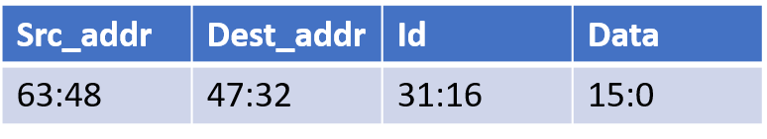

Output Packet format

