Figure 5.35: Photo Gallery Bottom Sheet [Photo Gallery Bottom Sheet ka SS]
Figure 5.34: Firebase Data Initializer Screen [Firebase Data Initializer Screen ka SS]
Figure 5.33: Example User Car Listing [User Submitted Car Record Example ka SS]
Figure 5.32: Example User Hotel Listing [User Submitted Hotel Record Example ka SS]
Figure 5.31: My Listings Cars Tab [My Listings Screen - Cars Tab ka SS]
Figure 5.30: My Listings Hotels Tab [My Listings Screen - Hotels Tab ka SS]
Figure 5.29: Add Car Screen [Add Car Screen ka SS]
Figure 5.28: Add Hotel Screen [Add Hotel Screen ka SS]
Figure 5.27: Tourist Spot Detail Bottom Sheet [Tourist Spot Details Bottom Sheet ka SS]
Figure 5.26: Map Screen [Map Screen ka SS]
Figure 5.25: Profile Image Upload or Settings Area [Profile Image Upload and Settings Section ka SS]
Figure 5.24: Profile Screen [Profile Screen ka SS]
Figure 5.23: Booking History Filtered Tabs [Booking History Screen - Filtered Tabs ka SS]
Figure 5.22: Booking History Main View [Booking History Screen - All Tab ka SS]
Figure 5.21: Booking Success Screen [Booking Success or Confirmation Screen ka SS]
Figure 5.20: Payment Screen Using Wallet Method [Payment Screen - JazzCash-EasyPaisa Method ka SS]
Figure 5.19: Payment Screen Using Card Method [Payment Screen - Card Method ka SS]
Figure 5.18: Car Route and Fare Details [Car Route and Fare Calculation Section ka SS]
Figure 5.17: Car Booking Screen [Car Booking Screen ka SS]
Figure 5.16: Hotel Booking Summary and Price View [Hotel Booking Details and Price Summary ka SS]
Figure 5.15: Hotel Selection Screen [Hotel Selection Screen ka SS]
Figure 5.14: Hotel Search Screen [Hotel Search Screen ka SS]
Figure 5.13: Transport Selection Screen [Transport Selection Screen ka SS]
Figure 5.12: Tour Booking Summary Screen [Tour Booking Summary Screen ka SS]
Figure 5.11: Multi-City Hotel Selection Screen [Multi-City Hotel Selection Screen ka SS]
Figure 5.10: Destination Highlights and Booking Call-to-Action [Destination Highlights and Booking CTA ka SS]
Figure 5.9: Destination Detail Screen [Destination Detail Screen ka SS]
Figure 5.8: Bottom Navigation on Home [Home Screen Bottom Navigation ka SS]
Figure 5.7: Home Services Grid [Home Screen Services Grid ka SS]
Figure 5.6: Multi-City Tour Section [Multi-City Tour Packages Section ka SS]
Figure 5.5: Single Destination Cards on Home [Single Destination Section ka SS]
Figure 5.4: Home Screen [Home Screen ka SS]
Figure 5.3: Social Authentication Options [Social Login Buttons ka SS]
Figure 5.2: Sign Up Screen [Sign Up Screen ka SS]
Figure 5.1: Login Screen [Login Screen ka SS]
Figure 4.12: Deployment Diagram [DG-12 Deployment Diagram]
Figure 4.11: Navigation Structure Diagram [DG-11 Navigation Structure Diagram]
Figure 4.10: Firestore Schema Diagram [DG-10 Firestore Schema Diagram]
Figure 4.9: Class Diagram [DG-09 Class Diagram]
Figure 4.8: Sequence Diagram for Payment and Confirmation [DG-08 Sequence Diagram - Payment and Confirmation]
Figure 4.7: Sequence Diagram for Authentication [DG-07 Sequence Diagram - Authentication]
Figure 4.6: Activity Diagram for Tour Booking [DG-06 Activity Diagram - Tour Booking]
Figure 4.5: Activity Diagram for Login [DG-05 Activity Diagram - Login]
Figure 4.4: Data Flow Diagram Level 1 [DG-04 DFD Level 1]
Figure 4.3: Data Flow Diagram Level 0 [DG-03 DFD Level 0]
Figure 4.2: Use Case Diagram [DG-02 Use Case Diagram]
Figure 4.1: Proposed System Architecture Diagram [DG-01 System Architecture Diagram]

Chapter 1
Introduction

1.1 Introduction
Technology has changed how people find, compare, and use services in almost every field. Tourism is one of the most visible examples of this shift because travelers now expect route information, accommodation choices, digital profiles, booking confirmations, and support tools to be available directly on their mobile devices. Applications that combine these features are no longer treated as convenience tools only. They have become central to travel planning and service delivery.
The Tours & Travel Mobile Application project is a response to this shift. It proposes a mobile application that brings together the most common user needs in a domestic tourism case: discovering destinations, evaluating travel packages, selecting hotels, booking vehicles, viewing tourist locations on a map, confirming a booking through a payment interface, and managing personal profile and listing information. The project is not only a UI demo. It is built as a modular app with clear services, models, and user flows.
This project gives a good chance to apply software engineering ideas in a real app that has both booking logic and UI work. The application includes authentication logic, local and cloud storage, navigation flow design, reusable widgets, validation rules, and device-level features like image selection and location handling. These features make it a good final year project because it connects theory with practical development.

1.2 Background of the Study
Pakistan’s tourism sector has gradually gained national and international attention due to improved connectivity, social media exposure, and broader awareness of scenic regions like Hunza, Skardu, Swat, Fairy Meadows, and Naran. Even with this visibility, travelers often rely on fragmented channels like travel agency pages, hotel portals, ride-hailing tools, social media posts, and direct phone calls to plan complete journeys. This dependence on scattered systems causes inefficiency, repeated data entry, and uncertainty in planning.
The rise of mobile-based behavior among young travelers highlights the need for combined travel systems tailored to local requirements. A user interested in a northern areas tour may want destination details, approximate budget, hotel options, transport arrangements, and map support in one place. If each task is separated across multiple services, the planning burden shifts to the traveler. A single platform can reduce this friction by organizing common travel tasks into a unified flow.
So this project uses the mobile app as a practical bridge between what travelers want and the services they need. By focusing on the Pakistan tourism context, the project also aligns technical design with cultural, geographic, and affordability-related realities. This makes the solution useful not only as a student prototype but also as a product idea that can grow later.

1.3 Problem Statement
Travel planning in the local tourism market is often handled through disconnected and semi-manual processes. Users may discover destinations on social platforms, inquire about tours through messaging apps, search hotels through unrelated services, and arrange transport separately. This causes delays, poor visibility into total cost, inconsistent information, and a higher risk of missed communication between travelers and service providers.
The lack of one simple mobile app for tours, hotels, transport, and travel support makes planning harder for users and less efficient for service providers. A traveler may have interest in a destination but no reliable mechanism to move from discovery to booking confirmation in a smooth, digital flow. Similarly, service providers often lack a structured platform to present options or manage user-facing interactions consistently.
The main problem solved by the Tours & Travel Mobile Application is the lack of one tourism app that supports exploration, booking, navigation, profile management, and future growth in a single product for Pakistan tourism use.

1.4 Objectives of the Study
The main goal of this project is to design and build a Flutter tourism mobile app that puts destination browsing, hotel booking, car rental, and trip support in one interface. The solution should show both good project quality and practical ease of use, so different modules connect well instead of working like isolated screens.
• To build a unified mobile experience for travel discovery and booking.
• To integrate authentication, bookings, maps, profile management, and listings.
• To apply Firebase and Flutter in a practical academic software project.
• To demonstrate modular design and reusable UI design.
• To provide a scalable base for future commercial or research-oriented extensions.

1.5 Scope of the Project
The project scope covers the design and development of a mobile application focused on the traveler side of the tourism flow. It includes authentication, destination display, single-destination and multi-city tour support, hotel selection, car booking, map visualization, payment simulation, booking history, profile handling, and user-submitted listings for hotels and cars.
The current scope does not include real payment gateway integration, full production launch, advanced recommendation systems, analytics dashboards, or full admin moderation. These are treated as future enhancements so that the current project remains technically meaningful while still achievable within academic timelines.

1.6 Significance of the Project
The importance of the project is that it turns a common real-world problem into a clear mobile solution. It shows how software engineering methods can be used to structure user requirements, convert them into screen flows, connect them with server side services, and deliver a product that is both technically demonstrable and socially useful.
The project is also significant because it highlights the value of multi-platform development in contexts where budget, device diversity, and development time are important limits. Flutter provides an effective foundation for building a modern interface across multiple platforms, while Firebase reduces server side complexity for a student-led project.

1.7 Research Questions
The project is guided by a few practical research questions: How can a mobile application reduce fragmentation in domestic travel planning? Which modules provide the highest utility when grouped together for tourism users? How can hybrid storage improve demonstration resilience in educational projects? What design choices make a travel app more accessible and intuitive for first-time users?
These questions shape both the design and the evaluation criteria of the project. Rather than measuring success only through development completion, the thesis also considers flow clarity, modular design, ease of use, and extendibility as indicators of quality.

1.8 Report Organization
This report is organized into eight chapters. Chapter 1 introduces the problem domain, motivation, objectives, and importance of the project. Chapter 2 reviews related technologies, travel application patterns, and the gap addressed by the proposed solution. Chapter 3 explains requirement engineering and feasibility considerations.
Chapter 4 presents the system analysis and design artifacts, including architecture, flows, schema, and diagrams. Chapter 5 describes implementation details module by module. Chapter 6 discusses testing, validation, and evaluation. Chapter 7 summarizes results, limitations, and deployment considerations, while Chapter 8 concludes the thesis and outlines future enhancements.

Chapter 2
Literature Review and Technology Rationale

2.1 Tourism Applications and Digital Service Aggregation
Modern tourism platforms aim to reduce the planning burden on users by aggregating content, booking actions, and trip support in a single channel. Large-scale platforms typically offer packages, hotel options, reviews, route guidance, and promotional content, but they are often improved for global markets rather than localized domestic travel patterns. In the Pakistan context, users frequently rely on informal sources like social media posts, messaging groups, or individual agent contacts, which do not provide the consistency of a structured digital product.
A review of digital tourism services suggests that the most valuable systems are those that shorten the path from interest to action. This means users should be able to move from inspiration to choice, and from choice to confirmation, without switching tools repeatedly. The proposed application adopts this principle by keeping destination exploration, hotel selection, car booking, maps, and profile-linked history inside one mobile flow.

2.2 Cross-Platform Mobile Development with Flutter
Cross-platform development has become a preferred choice for many startups and academic projects because it reduces development cost while preserving a consistent experience across multiple operating systems. Flutter, in particular, supports widget-based interface composition, expressive UI design, and rapid prototyping. Its hot reload features, layered design, and strong community support make it a compelling framework for building feature-rich mobile applications within constrained timelines.
Flutter was chosen not only for speed but also for design flexibility. The application requires lists, grids, transitions, image handling, form validation, bottom navigation, and custom-styled components. Flutter’s rendering model allows these experiences to be built with high visual consistency, which is especially useful in travel applications where aesthetics and clarity strongly influence user trust and engagement.

2.3 Firebase as a Backend Service
Firebase is widely used in student and startup projects because it provides authentication, cloud database features, file storage, and analytics-oriented services without requiring full custom server side development. For mobile-based projects, this reduces infrastructure burden and enables faster focus on domain flows, user interface logic, and incremental feature delivery.
In the present project, Firebase supports account management, profile storage, sample data storage, and image upload feature. The design also shows a practical academic insight: cloud services are powerful, but educational and demo environments can benefit from fallback strategies when setup or connectivity is incomplete. The inclusion of SharedPreferences-backed fallback services so complements rather than replaces the Firebase approach.

2.4 User Experience Design in Travel Applications
Travel apps need both a nice look and simple use. Users are making choices related to cost, comfort, destinations, and trust. A cluttered interface or confusing navigation can weaken confidence even if the underlying logic is correct. Successful travel interfaces so use cards, imagery, progressive disclosure, clear pricing, and strongly signposted actions.
The app follows this idea by showing destination cards, tour package cards, booking tabs, summary sections, and payment choices in clear layouts. The use of animations, gradients, and image-backed discovery sections is not only cosmetic. it also serves to draw attention to meaningful user decisions while keeping the app experience modern and engaging.

2.5 Location-Based Services and Tourism Support
Location-aware features are especially useful in tourism systems because they improve orientation, route planning, and attraction awareness. Map integration can support both discovery and reassurance. Even simple tourist markers with descriptions can make an application feel substantially more useful by helping users connect abstract package names with real geographic context.
This project incorporates Google Maps and geolocation services to strengthen the user’s mental model of destinations. By showing markers for selected tourist spots and optionally showing the user’s current location, the app provides an additional layer of travel support that goes beyond booking. This aligns with broader literature indicating that travel platforms benefit from context-aware design and place-based information presentation.

2.6 Payment Interfaces and Trust in Booking Systems
Payment is one of the most trust-sensitive parts of any travel system. Even if a student project does not include a live payment gateway, the design of the payment screen still matters because it affects user trust and booking confidence. A well-designed payment module should summarize the booking, offer familiar methods, and communicate the booking status clearly.
The project so includes a payment simulation interface with multiple options like card, JazzCash, EasyPaisa, and cash on delivery. While the current version does not perform real transactions, it models the interaction pattern and immediate booking confirmation flow, thereby supporting future integration with production payment APIs and improving the realism of the prototype.

2.7 Comparison of Existing Systems
A comparative study of existing systems shows that many solutions are either specialized or fragmented. Standalone hotel booking apps may excel in accommodation search but ignore route planning and local attraction support. Transport apps solve mobility problems but rarely integrate tourism-specific package browsing. Travel agency websites provide information but often lack app-level interactivity and persistent profile experiences.
The proposed application positions itself as a unified domestic travel solution rather than a narrow specialist tool. Its strength lies in bringing several moderately scoped but highly connected modules together. This comparison informs the system’s research gap and justifies why integration itself is treated as a core innovation objective.
Table 2.1: Comparative View of Existing Travel-Related Systems
System Type | Strength | Limitation | Relevance to Proposed App
Travel Agency Pages | Localized packages and informal support | Fragmented, weak booking automation | Shows need for a structured mobile platform
Hotel Booking Apps | Strong accommodation coverage | Weak integrated tour and transport support | Justifies hotel-plus-travel aggregation
Ride Hailing Apps | Transport convenience | No tourism package or destination planning | Useful reference for travel mobility module
Global Travel Portals | Broad inventory and polish | Less localized for domestic travel context | Demonstrates the value of local relevance
Proposed App | Unified domestic tourism workflow | Needs future production hardening | Addresses local integration gap

2.8 Research Gap
The literature and market scan indicate a clear gap between generalized travel apps and locally useful tourism tools that reflect Pakistan-specific user journeys. There is space for a solution that combines destination discovery, package presentation, hotel selection, local payment patterns, city-to-city vehicle booking, and user-managed listings inside a mobile-based interface.
This project covers that gap by showing a travel-focused prototype that is modular and easy to extend. It is not a full commercial product. Instead, it is a well-structured student development that shows how one tourism app can be planned, built, and evaluated in an undergraduate project.

Chapter 3
Requirement Engineering and Feasibility Study

3.1 Stakeholder Identification
The primary users of the proposed system include travelers, potential tourists, hotel owners, vehicle owners, project evaluators, and system maintainers. Travelers represent the main consumer-facing user group because they interact with destination cards, booking screens, maps, and history modules. Hotel and vehicle owners are secondary users who benefit from the user-listings feature, which allows them to register service offerings inside the app.
Academic evaluators and supervisors also act as users in the project because the application must be understandable, demonstrable, and technically structured enough to support assessment. Their presence influences the need for clean design, readable documentation, and stable demonstration flows. System maintainers, whether future developers or project owners, depend on modular design, naming clarity, and service separation to extend the application.

3.2 Functional Requirements
Functional requirements define what the system must do from the user’s perspective. These requirements include user account creation, login, social sign-in, destination browsing, tour package browsing, hotel search, hotel selection, city-to-city car booking, interactive map access, payment interface support, booking confirmation, booking history viewing, profile update, and creation of user-submitted hotel and car listings.
Each functional requirement is mapped to one or more screens and services. For example, authentication is supported through login and signup screens backed by LocalAuthService, while booking confirmation depends on PaymentScreen and LocalBookingStore or BookingService depending on the booking type. This requirement-to-module mapping ensures traceability between what the user expects and how the software is organized.
Table 3.1: Core Functional Requirements
Requirement ID | Description | Primary Module
FR-01 | User registration and login | Authentication
FR-02 | Destination browsing | Home and Discovery
FR-03 | Multi-city tour browsing | Tour Packages
FR-04 | Hotel search and selection | Hotel Booking
FR-05 | City-to-city car booking | Car Rental
FR-06 | Map and tourist marker exploration | Maps
FR-07 | Payment and confirmation flow | Payment
FR-08 | Booking history view | Booking History
FR-09 | Profile update and image upload | Profile
FR-10 | User-created hotel and car listings | User Listings

3.3 Non-Functional Requirements
Non-functional requirements describe the quality expectations of the system. In this project, ease of use, responsiveness, modular design, clarity of interface, and graceful behavior under incomplete setup are especially important. The app must feel understandable to users without requiring training, and it should present travel options in a visually clear way.
easy maintenance is another critical requirement because the system contains multiple connected modules. Naming conventions, service boundaries, reusable widgets, and single constants are so important architectural choices. Security is also useful, particularly for authentication and profile features, which is why official server side support through Firebase is used when set up.
Table 3.2: Non-Functional Requirements
Category | Expectation
Usability | Clear, mobile-friendly, and easy-to-understand screens
Performance | Smooth enough for demonstration on typical student devices
Maintainability | Modular code structure with reusable utilities
Reliability | Reasonable fallback behavior where cloud dependencies are incomplete
Scalability | Architecture should support future backend enhancement
Security | Use authenticated access where required and validate user input

3.4 Hardware and Software Requirements
The project requires a development machine capable of running Flutter tooling, Android emulators or physical devices, and an IDE like Android Studio or Visual Studio Code. On the software side, Flutter SDK, Dart SDK, Android tooling, and Firebase setup files are required for smooth development and testing. Maps integration additionally requires a valid API key.
From the launch perspective, the app is primarily designed for mobile usage, but the repository structure also includes web, desktop, and platform scaffolding generated by Flutter. This reflects the multi-platform potential of the framework even though the project focus remains on mobile user cases.
Table 3.3: Hardware and Software Requirements
Type | Requirement
Development Hardware | Laptop or desktop capable of running Flutter tooling
Development Software | Flutter SDK, Dart SDK, Android Studio or VS Code
Target Platform | Android mobile device or emulator
Backend Support | Firebase project configuration
Maps Support | Google Maps API key
Optional Assets | Destination images and test profile images

3.5 Feasibility Study
The technical feasibility of the project is high because Flutter and Firebase collectively provide the tools necessary to implement authentication, cloud storage, mobile UI, and location features without excessive server side overhead. The domain problem itself is also well suited to modular app development because it can be divided into clear user journeys like account access, discovery, booking, payment, and profile management.
Economic feasibility is good because the selected technologies reduce cost and development time. Operational feasibility is also good because users are already familiar with common smartphone patterns. Users already understand logins, cards, maps, lists, and confirmation screens, so the learning curve remains manageable.

3.6 Risk Assessment
Project risks include incomplete Firebase setup, inconsistent internet connectivity during demonstration, limited test coverage, and the possibility of state inconsistency across modules if booking logic is not centrally aligned. These risks are important because a visually polished app can still fail during demonstration if environmental assumptions are not controlled.
The project handles some of these risks by using fallback login, local listing storage, and in-memory booking confirmation. These strategies do not remove every risk, but they make the app more reliable during student demos and reduce dependence on full server side availability.
Table 3.4: Risk Assessment Matrix
Abbreviation | Full Form
API | Application Programming Interface
BaaS | Backend as a Service
CRUD | Create, Read, Update, Delete
DFD | Data Flow Diagram
ERD | Entity Relationship Diagram
GPS | Global Positioning System
JSON | JavaScript Object Notation
OTP | One-Time Password
PKR | Pakistani Rupee
SDK | Software Development Kit
UI | User Interface
UML | Unified Modeling Language
UX | User Experience
URL | Uniform Resource Locator
MBaaS | Mobile Backend as a Service

3.7 Requirement Traceability
Requirement traceability ensures that every major user need is reflected in development artifacts. In this project, traceability is showed by mapping requirements to screens, services, data models, and test cases. This improves the document and also makes future changes easier to understand.
For example, a requirement like 'The user should be able to register their own hotel listing' can be traced to AddHotelScreen, UserListingsService, the UserHotel model, SharedPreferences storage, and targeted manual test cases. Similar mappings exist for profile image upload, map display, and booking history presentation.
Table 3.5: Requirement Traceability Matrix
Requirement | Screen/Module | Service | Validation Focus
FR-01 | Login / Signup | LocalAuthService | Credential flow and routing
FR-04 | Hotel Search / Hotel Selection | DatabaseService | Search and selection display
FR-05 | Car Booking | LocalBookingStore | Route, price, and booking visibility
FR-07 | Payment Screen | BookingService / LocalBookingStore | Confirmation behavior
FR-09 | Profile Screen | AuthService / Firebase Storage | Profile update and image upload
FR-10 | Add Hotel / Add Car / My Listings | UserListingsService | Local persistence and tab display

3.8 Summary
The requirement engineering phase establishes the foundation for the rest of the system design. It clarifies who the users are, what tasks they expect to complete, what quality properties matter, and what risks must be acknowledged. With these requirements in place, the project can move confidently into architectural planning and module-level system design.

Chapter 4
System Analysis and Design

4.1 Proposed System Architecture
The proposed design follows a layered approach that separates presentation concerns from business logic and data storage. The user interface is composed of screens, reusable widgets, and card-based components. Beneath this layer, services handle authentication, database access, booking flow management, and local storage. Supporting utilities like theme setup, validators, animations, constants, and extensions reduce duplication and improve consistency across the app.
This design is especially suitable for an academic project because it balances clarity and practical development. It avoids unnecessary overengineering while still demonstrating structured separation of concerns. As a result, modules can be explained, tested, and extended in relative isolation, which is helpful for both viva presentation and future development.
Table 4.1: Proposed Technology Stack
Layer | Technology
Frontend | Flutter and Dart
Authentication | Firebase Auth and LocalAuthService fallback
Cloud Database | Cloud Firestore
File Storage | Firebase Storage
Local Persistence | SharedPreferences and in-memory stores
Maps and Location | Google Maps Flutter and Geolocator
UI Support | Google Fonts, animations, cached image tools

4.2 Use Case Perspective
From a use case perspective, the system revolves around a registered or guest user interacting with travel services through a mobile app. Core use cases include creating an account, logging in, browsing destinations, selecting a tour, searching hotels, reserving a car, viewing a map, managing profile settings, and confirming a booking. Additional use cases support the registration of personal hotel and vehicle listings.
The use case perspective is important because it shifts analysis from screens to actor intentions. Instead of describing the system only in terms of interface elements, it asks what tasks matter to the user and what sequence of actions the application must support. This helps maintain alignment between software design and user goals.

4.3 Navigation Design
Navigation design in the project is screen-oriented and imperative. The application opens with an authentication-dependent entry point and moves users into the home screen once they are logged in. From there, the bottom navigation and card-based action routes guide users toward tours, history, profile, maps, and listings.
A strong navigation structure matters in a travel app because users often switch between discovery, comparison, and confirmation tasks. The design so favors visible actions, familiar transitions, and summary screens that reduce confusion. Each booking-related path attempts to preserve context so that users understand what they selected and why they are being asked for the next piece of information.

4.4 Data Design and Firestore Schema
The data design combines structured models and flexible storage strategies. Firestore collections store user profiles, destinations, hotels, and bookings when cloud connectivity is available. Data models like Destination, Hotel, TourPackage, Booking, CarBooking, and HotelBooking provide typed structures for internal use and conversion between UI and storage layers.
The schema design intentionally remains simple enough for academic manageability while still representing real-world relationships. A user can be linked to profile data, bookings can reference destinations or service selections, and listings can be grouped by owner identity. Also, local storage is used strategically for user-generated listings and fallback behavior where cloud dependency would complicate demonstration.
Table 4.2: Key Firestore Collections and Their Roles
Collection | Purpose | Typical Fields
users | User profile storage | uid, email, fullName, createdAt, profileImageUrl
destinations | Tour destination data | name, description, imageUrl, rating, price
hotels | Hotel information | name, city, pricePerNight, amenities
bookings | Tour-related booking records | userId, destinationName, bookingDate, totalPrice
profile_images | Firebase Storage path for user images | file metadata and download URLs

4.5 Class and Service Design
The project uses service classes as the main coordinators of non-trivial operations. LocalAuthService manages hybrid authentication and login state. DatabaseService retrieves destinations, hotels, and booking records. BookingService manages booking-related interactions, while UserListingsService stores locally registered hotels and cars. LocalBookingStore supports immediate session-level booking visibility after confirmation.
This service-oriented class design gives the codebase a practical shape that students and reviewers can reason about quickly. It also creates a clear distinction between data representation and behavior. Models describe what a booking or hotel is, while services describe how these objects are retrieved, modified, or displayed to the user.
Table 4.3: Screen-to-Service Mapping
Screen | Primary Services
LoginScreen / SignupScreen | LocalAuthService, AuthService
HomeScreen | DatabaseService, AuthService
HotelSearchScreen / HotelSelectionScreen | DatabaseService
TourBookingScreen / PaymentScreen | BookingService, LocalBookingStore
ProfileScreen | AuthService, LocalAuthService, Firebase Storage
MyListingsScreen / Add Screens | UserListingsService
BookingHistoryScreen | LocalBookingStore, BookingService

4.6 Interface and Experience Design
The interface design uses cards, gradients, icons, images, tabs, and summary boxes to create a polished travel-focused identity. Typography, spacing, and color contrast are applied to ensure that destinations, prices, ratings, and confirmation actions are visually easy to parse. Animations support the premium feel of the app without becoming the main functional dependency.
Travel apps depend heavily on emotional engagement because destinations are aspirational products. The design so does not treat UI as a secondary concern. Instead, it uses imagery and motion intentionally to communicate atmosphere while preserving clear interaction patterns. This is particularly visible on the home screen, destination cards, and booking confirmation flows.

4.7 Security and Validation Design
Security design in the current project focuses primarily on authenticated access, controlled profile operations, and validated form inputs. Firebase Authentication provides the main security boundary for supported cloud-based login flows, while validators help ensure that email, password, phone number, and payment-like fields meet expected formats before proceeding.
Although the application is not yet a production launch, validation logic is critical because it shapes user trust and reduces invalid state transitions. The design so includes client-side checks, local session awareness, and controlled storage operations. Future versions can build upon this base with stronger access rules, encryption, and server-side verification.

4.8 Summary
The design phase translates requirements into an actionable system blueprint. It defines how users move through the app, where data is stored, how services collaborate, and how diagrams can represent the software structure. These design decisions directly guide the development described in the next chapter.
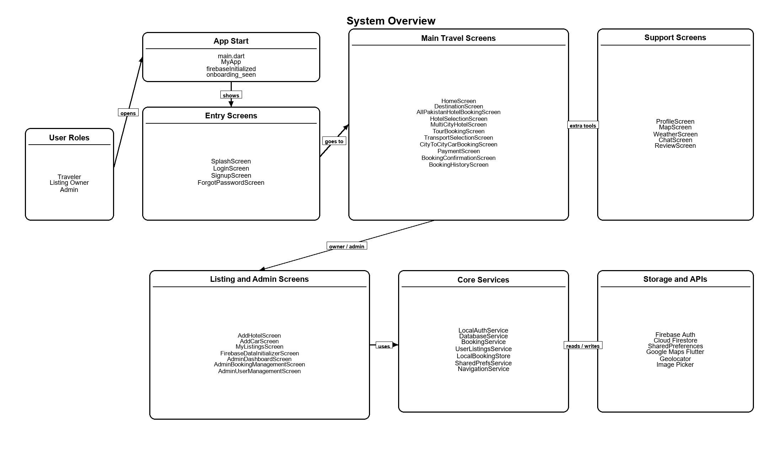
Figure 4.1: Proposed System Architecture Diagram

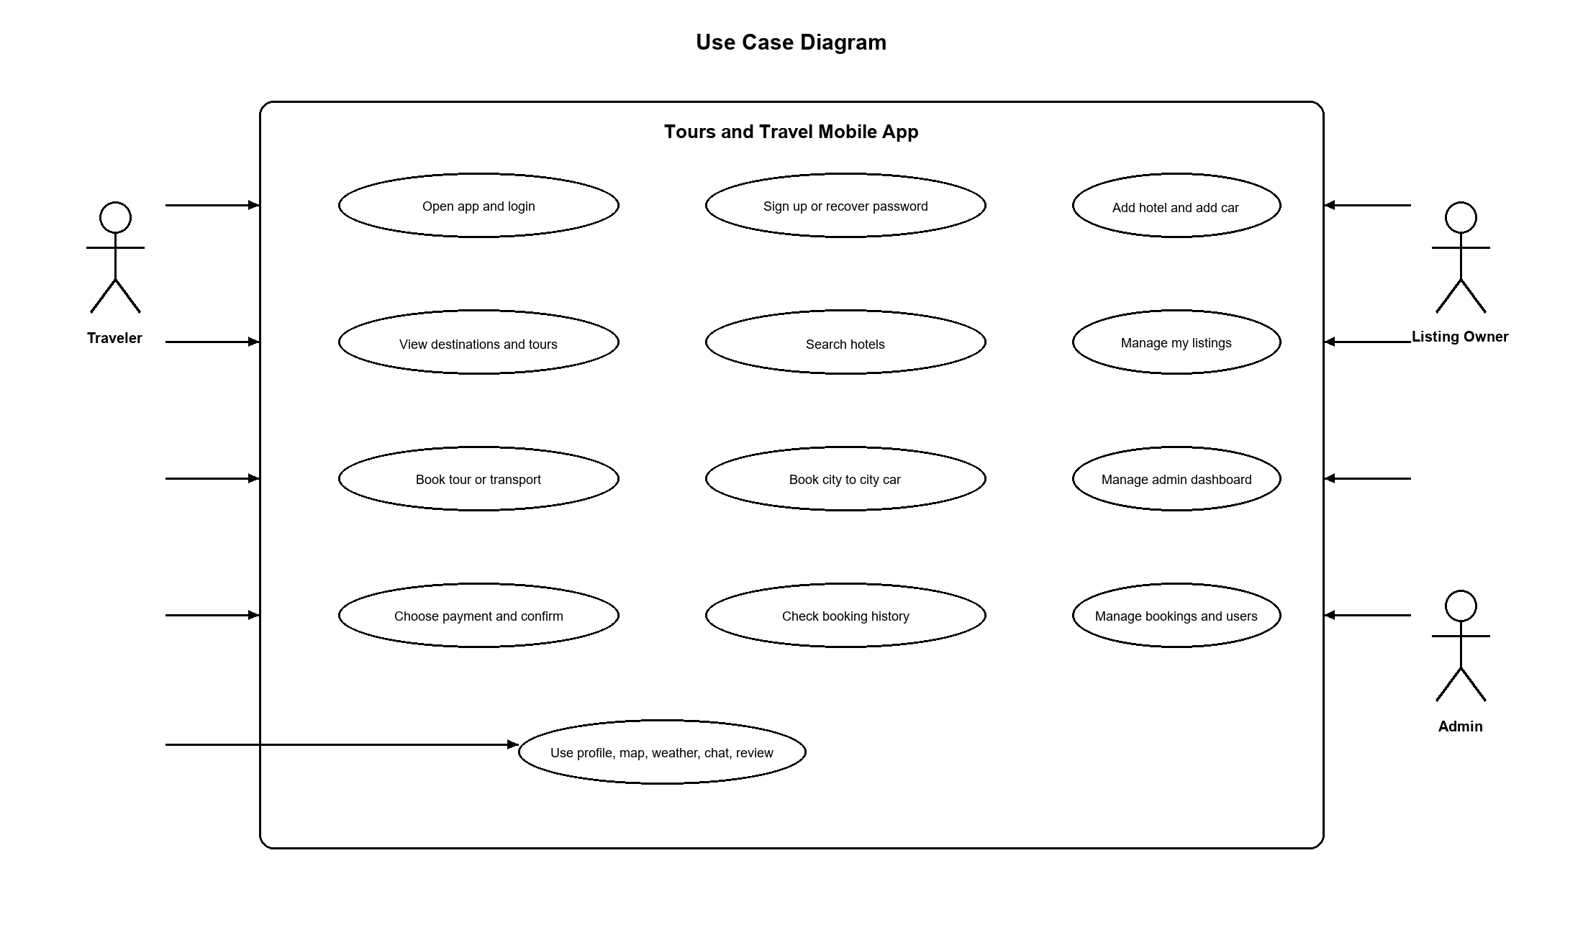
Figure 4.2: Use Case Diagram

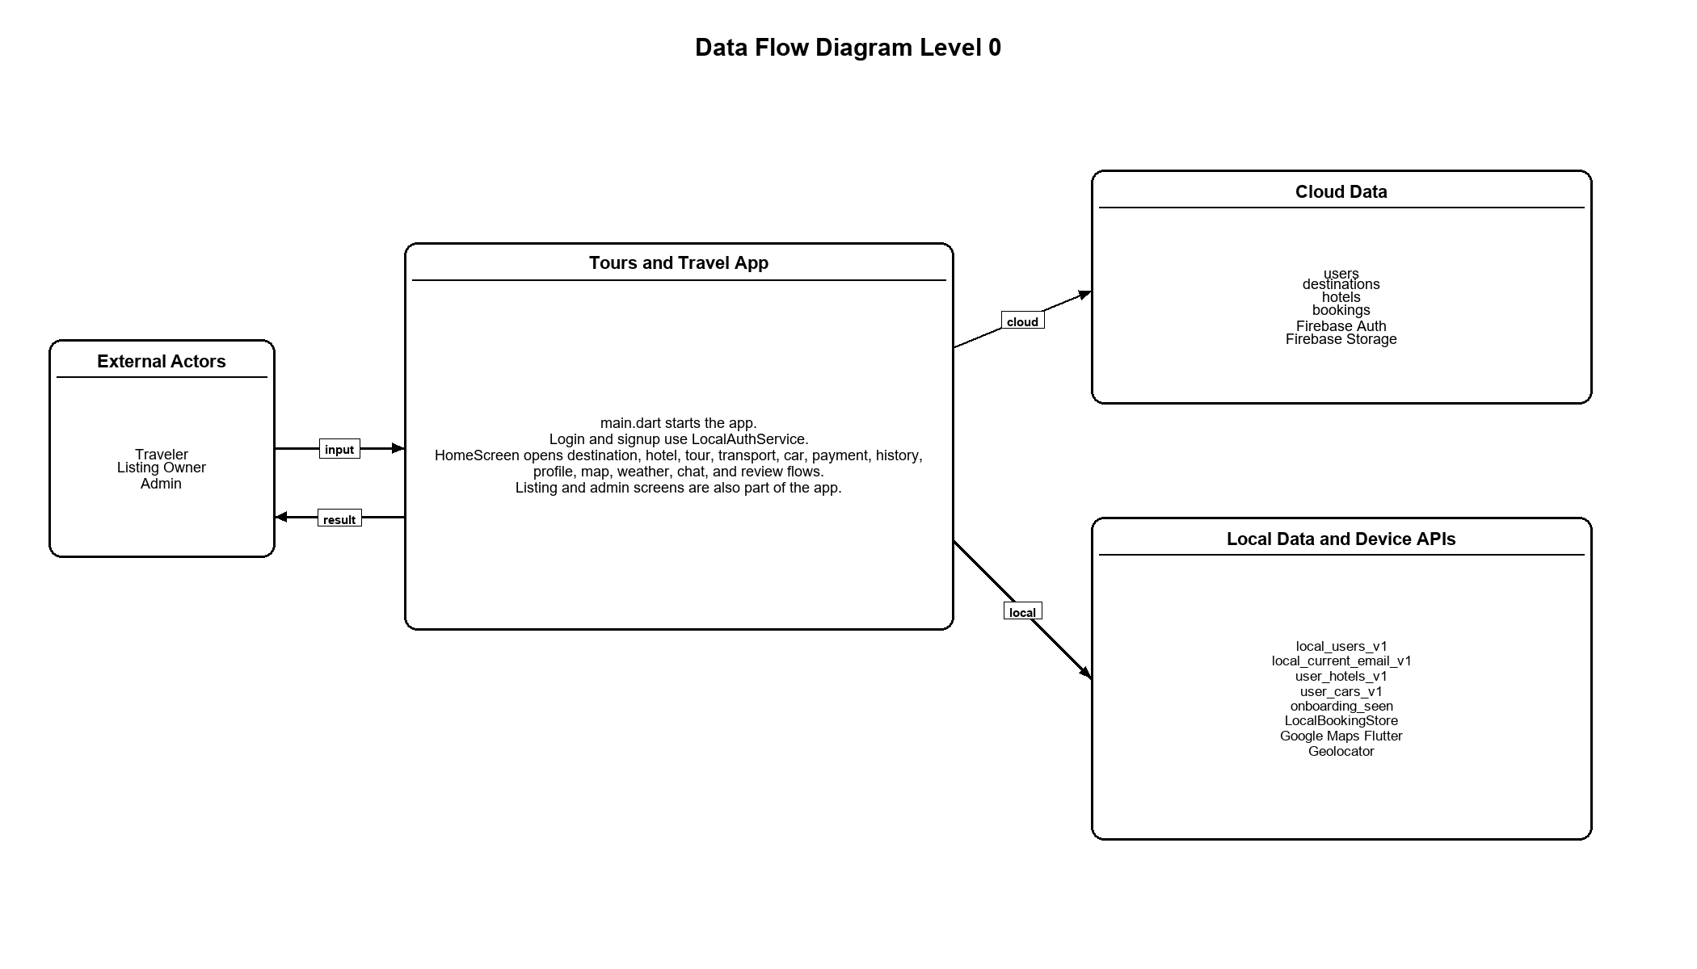
Figure 4.3: Data Flow Diagram Level 0

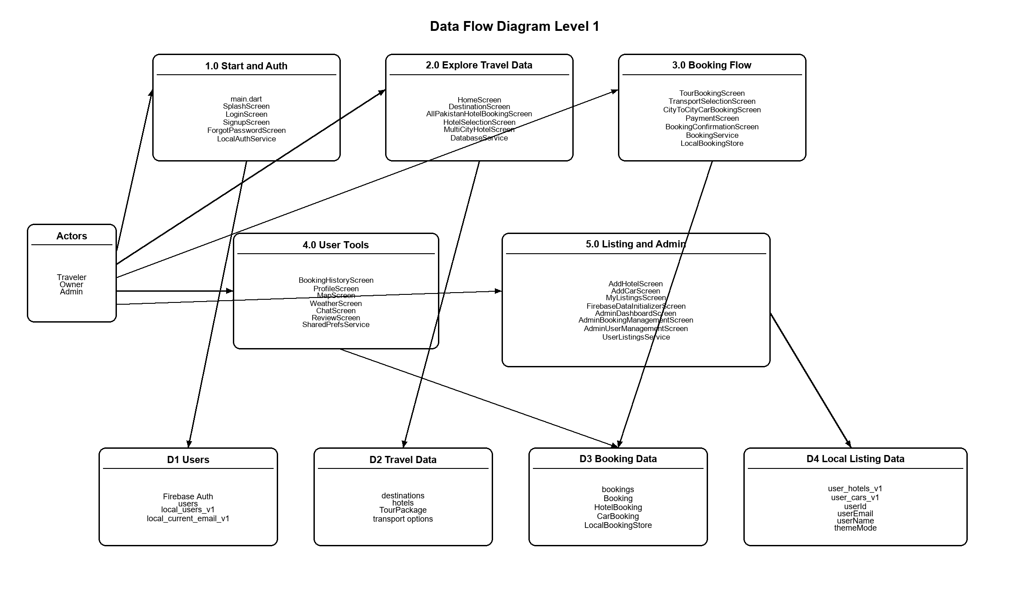
Figure 4.4: Data Flow Diagram Level 1

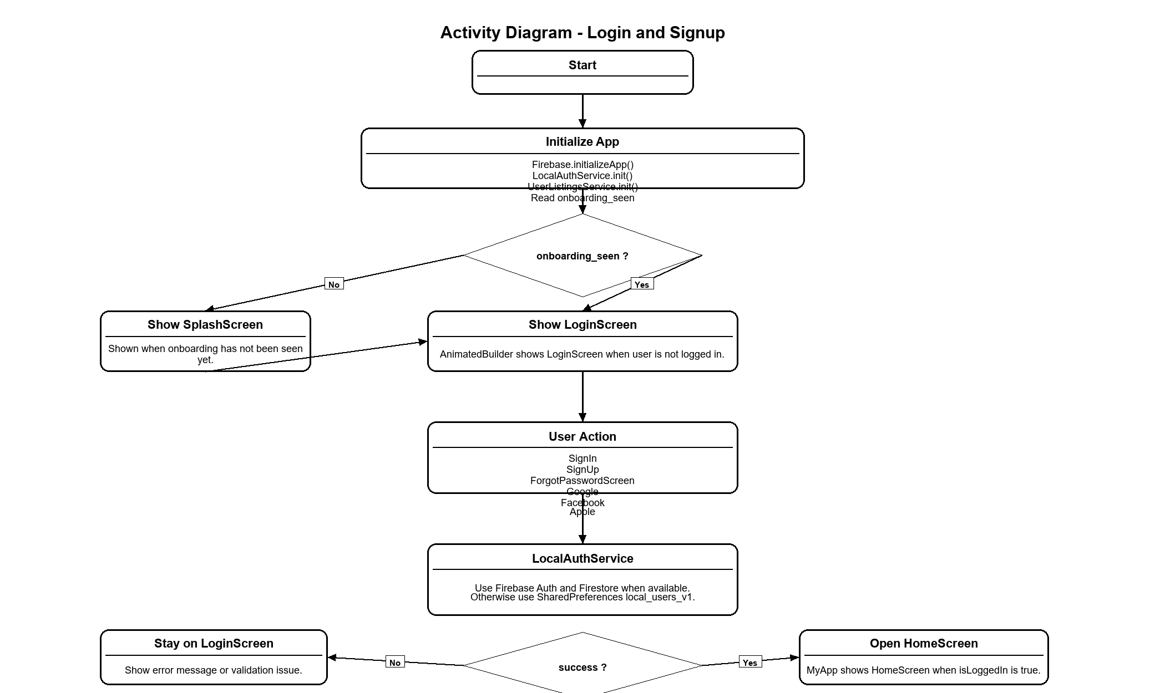
Figure 4.5: Activity Diagram for Login

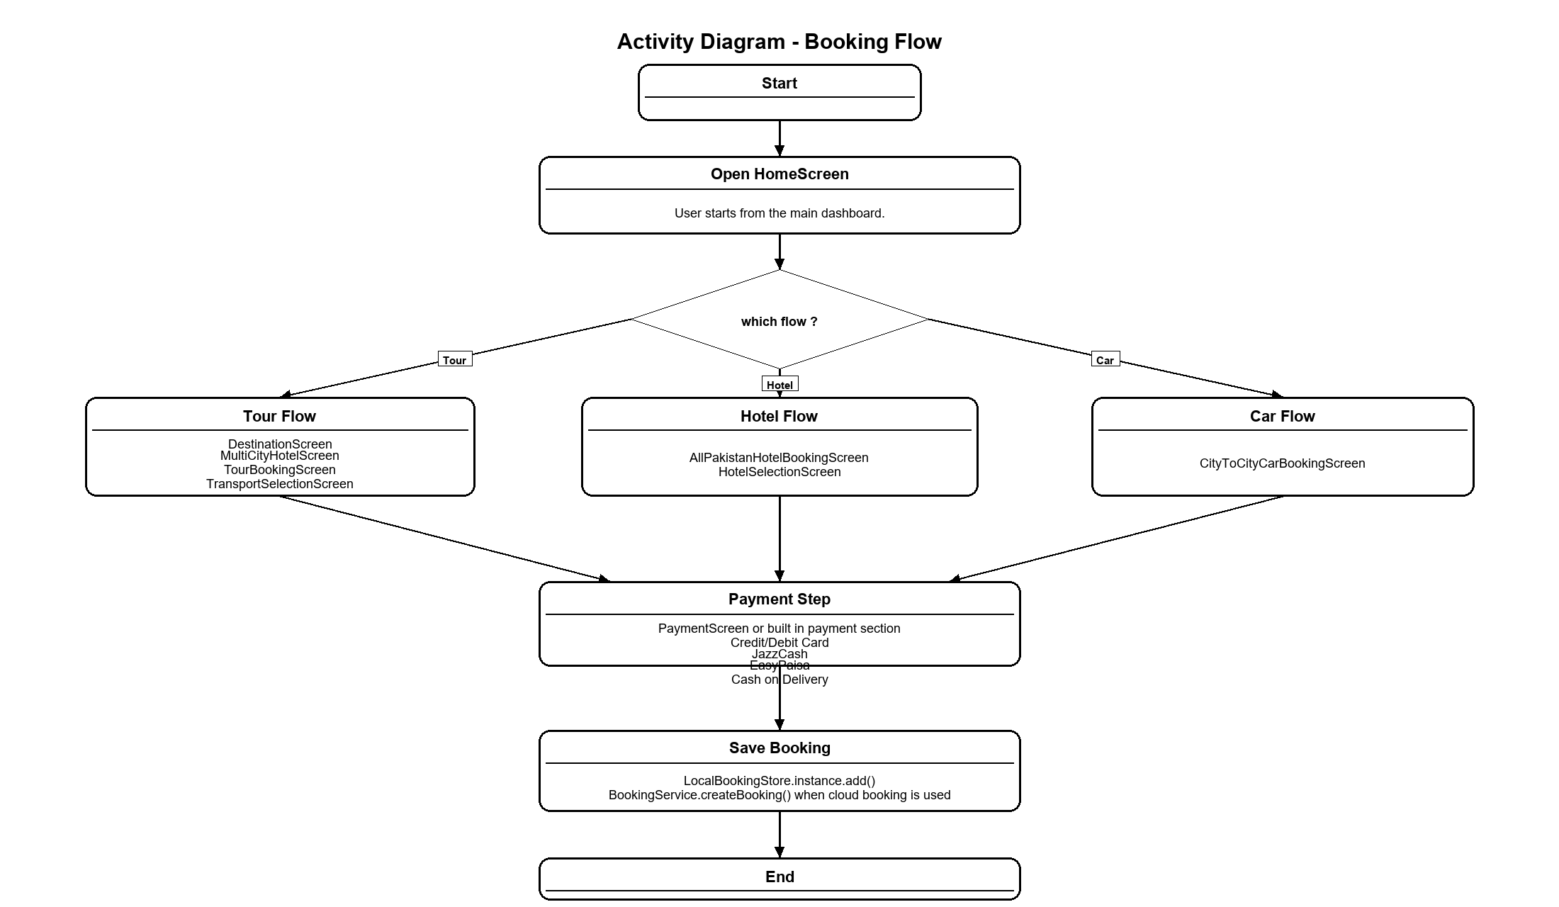
Figure 4.6: Activity Diagram for Tour Booking

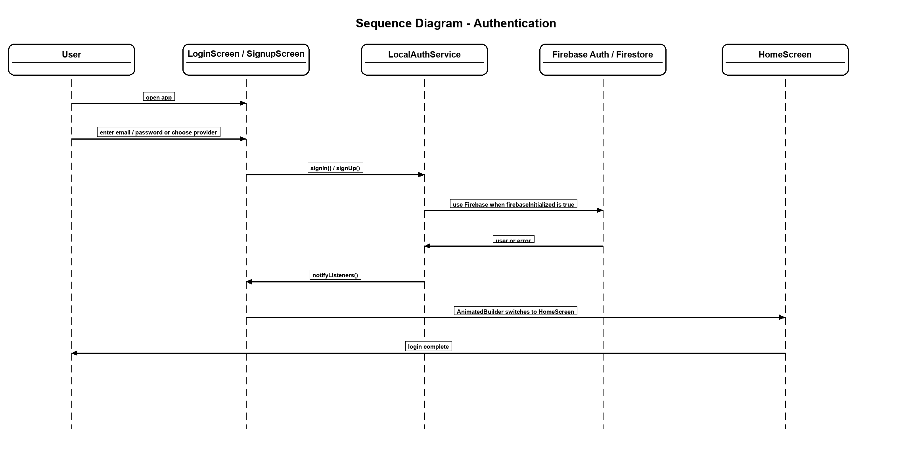
Figure 4.7: Sequence Diagram for Authentication

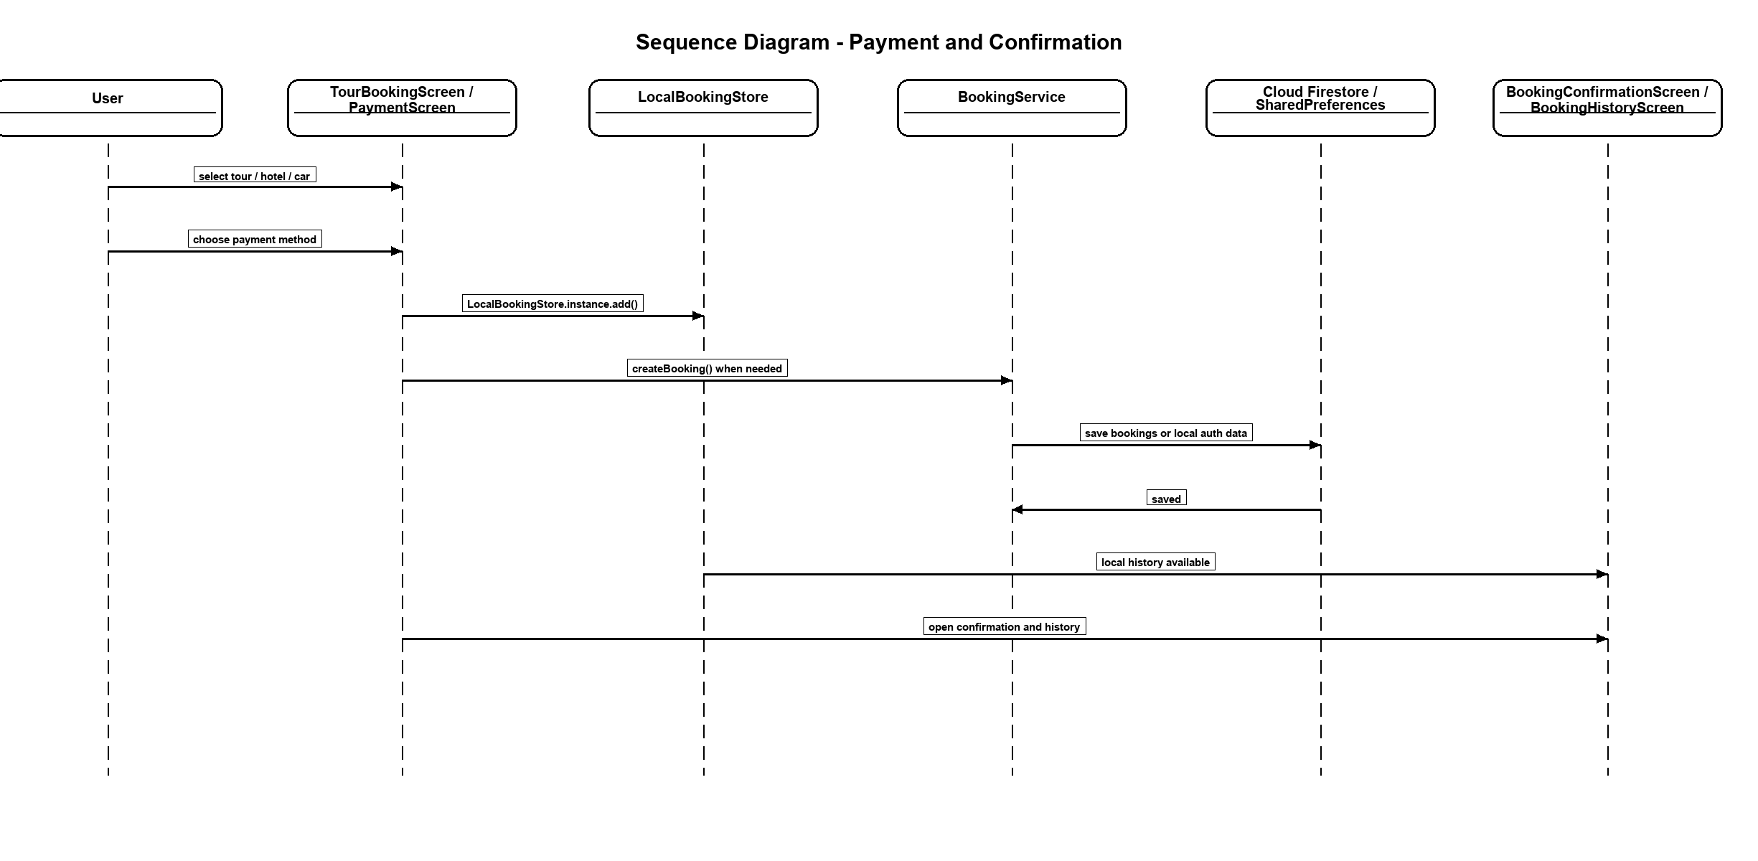
Figure 4.8: Sequence Diagram for Payment and Confirmation

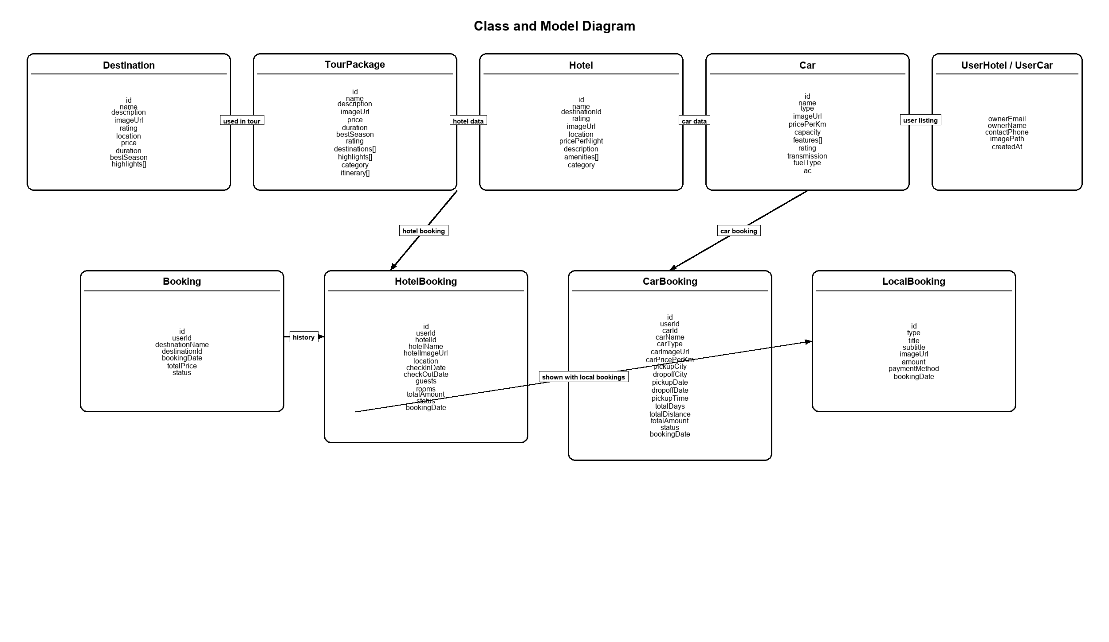
Figure 4.9: Class Diagram

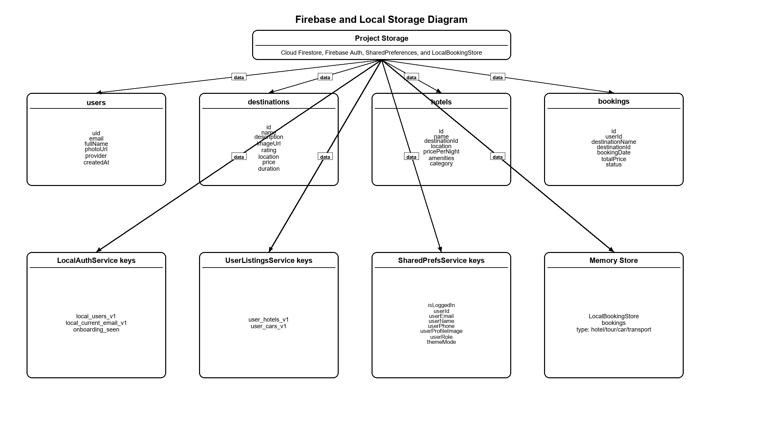
Figure 4.10: Firestore Schema Diagram

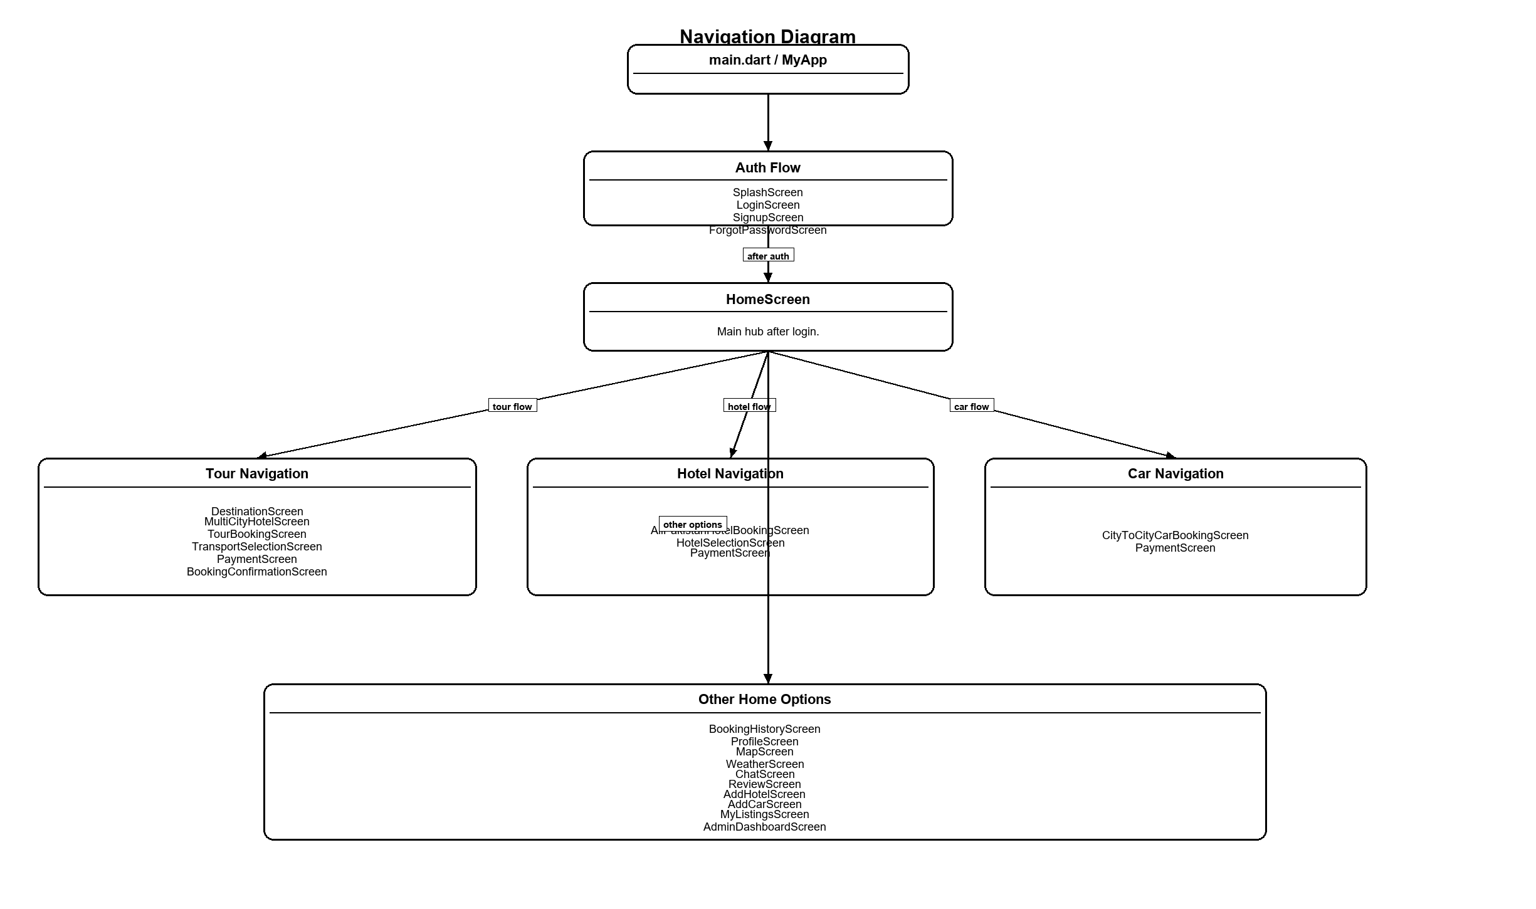
Figure 4.11: Navigation Structure Diagram

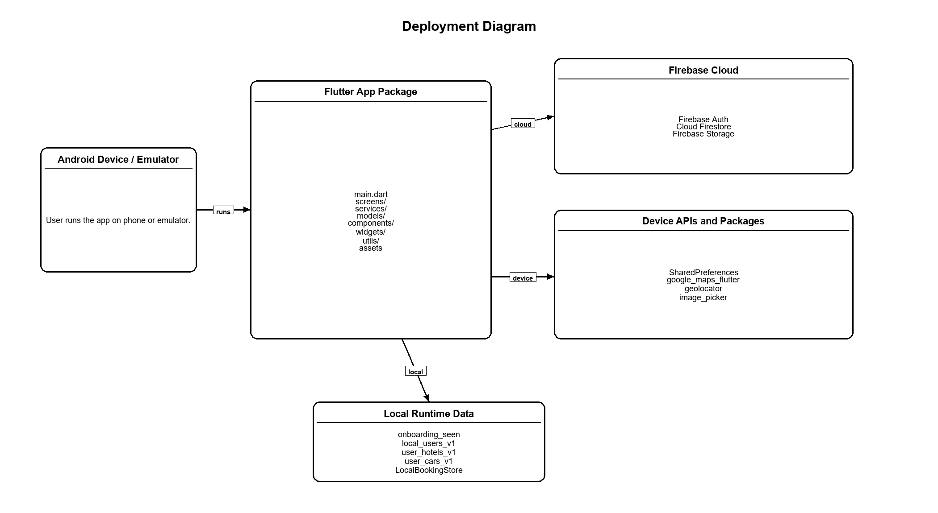
Figure 4.12: Deployment Diagram

Chapter 5
System Implementation

5.1 Development Environment
The application was built using Flutter and Dart inside a standard mobile development environment supported by Android Studio or Visual Studio Code. Firebase was set up for authentication, Firestore, and storage support. Additional packages were included for maps, location, shared preferences, fonts, image handling, and travel-oriented interface behavior.
From a software engineering point of view, the development environment was selected to balance productivity and feature richness. Flutter provides rapid iteration through hot reload, while package management through pub.dev makes it practical to incorporate specialized features like Google Maps integration, image picking, and cached media rendering.

5.2 Project Structure
The repository follows common Flutter structure with separate folders for screens, services, models, widgets, components, and utilities. This structure makes it easier to explain the project during review because both user-facing and technical responsibilities are visibly separated.
This structure also makes maintenance easier. A new developer can quickly understand where booking logic is built, where a model lives, or where reusable UI pieces are defined. This is useful in student projects where code readability and explanation are also important.
Table 5.1: Project Directory Summary
Directory | Role
lib/screens | All major user-facing screens
lib/services | Business logic, storage, and backend interactions
lib/models | Data entities and conversion logic
lib/widgets | Reusable generic UI widgets
lib/components | Travel-specific reusable cards
lib/utils | Theme, constants, validators, animations, extensions
assets/images | Destination and visual assets
docs | Project documentation and thesis artifacts

5.3 Authentication Module
The purpose of the Authentication Module is to provide secure sign up, sign in, sign out, and hybrid session continuity. This part of the application connects domain intent with a focused interaction sequence and so plays a major role in how users perceive the overall usefulness of the product. Unlike isolated demonstration screens, the module is framed as a self-contained flow that begins with a user need and ends with a visible state change or informative result.
The main screens involved in this module are LoginScreen, SignupScreen. The user opens the application, enters email and password or selects a social login option, and is routed to the home screen after successful authentication. New users can create accounts from the signup screen and provide core identity details like name, email, and password. This flow design is important because users usually move step by step. They first explore options, then compare them, and then make a booking. So the module uses summaries, labels, and clear action buttons to help the user stay on track.
From a technical perspective, the module relies on LocalAuthService, AuthService. Data and state are handled through Firebase Authentication, Firestore user collection, and SharedPreferences fallback. This design keeps screen rendering separate from service-level concerns and makes the code easier to reason about. It also improves easy maintenance because future changes to validation, storage, or server side integration can be made within service boundaries instead of being scattered across UI code.
The module is intentionally built with both cloud-backed and fallback behavior so that the app can still be showed when Firebase initialization fails in a partial setup environment. In addition, the module contributes to the thesis by showing how travel-related software design decisions can be translated into practical mobile behavior. It is not only a functional feature but also an illustration of how software engineering concepts like separation of concerns, data flow management, and user-centered design are applied inside a real project context.
A further development insight from this module is that interface quality and system behavior must evolve together. In other words, a booking or profile-related feature is not considered complete simply because fields are visible on the screen. it must also validate user input, preserve useful context, and return meaningful feedback after an action is performed. This project repeatedly reinforced that a professional-feeling app is achieved through the combination of data logic, response timing, visual hierarchy, and feedback messaging rather than through surface-level styling alone.
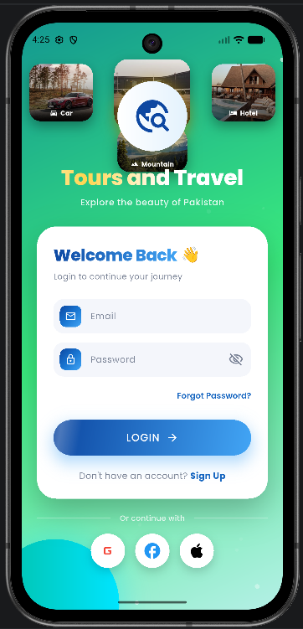
Figure 5.1: Login Screen

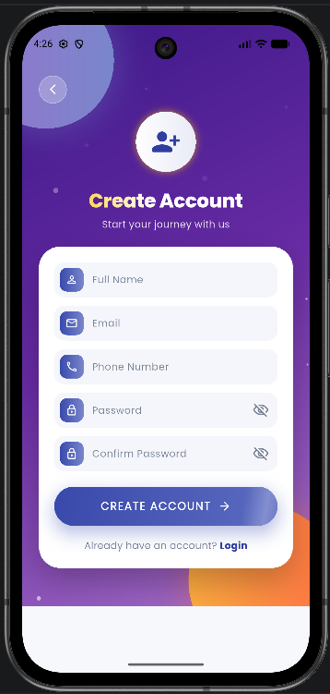
Figure 5.2: Sign Up Screen

5.4 Home Screen and Travel Discovery Module
The purpose of the Home Screen and Travel Discovery Module is to present destinations, tour categories, services, quick actions, and visual entry points into the rest of the system. This part of the application connects domain intent with a focused interaction sequence and so plays a major role in how users perceive the overall usefulness of the product. Unlike isolated demonstration screens, the module is framed as a self-contained flow that begins with a user need and ends with a visible state change or informative result.
The main screens involved in this module are HomeScreen. Once authenticated, the user lands on the home screen where single-destination trips, multi-city packages, services, and promotional sections are presented through a visually rich layout. From here the user can continue into tours, hotels, maps, cars, listings, or profile areas. This flow design is important because users usually move step by step. They first explore options, then compare them, and then make a booking. So the module uses summaries, labels, and clear action buttons to help the user stay on track.
From a technical perspective, the module relies on DatabaseService, AuthService. Data and state are handled through Firestore-backed or demo destination data with in-app screen state. This design keeps screen rendering separate from service-level concerns and makes the code easier to reason about. It also improves easy maintenance because future changes to validation, storage, or server side integration can be made within service boundaries instead of being scattered across UI code.
The home screen acts as a dashboard, reducing friction by exposing several travel decisions within one space while also preserving clear content grouping and bottom-navigation context. In addition, the module contributes to the thesis by showing how travel-related software design decisions can be translated into practical mobile behavior. It is not only a functional feature but also an illustration of how software engineering concepts like separation of concerns, data flow management, and user-centered design are applied inside a real project context.
A further development insight from this module is that interface quality and system behavior must evolve together. In other words, a booking or profile-related feature is not considered complete simply because fields are visible on the screen. it must also validate user input, preserve useful context, and return meaningful feedback after an action is performed. This project repeatedly reinforced that a professional-feeling app is achieved through the combination of data logic, response timing, visual hierarchy, and feedback messaging rather than through surface-level styling alone.
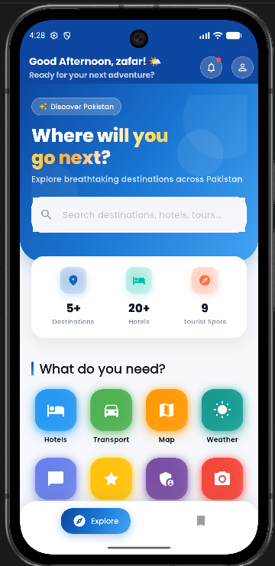
Figure 5.4: Home Screen

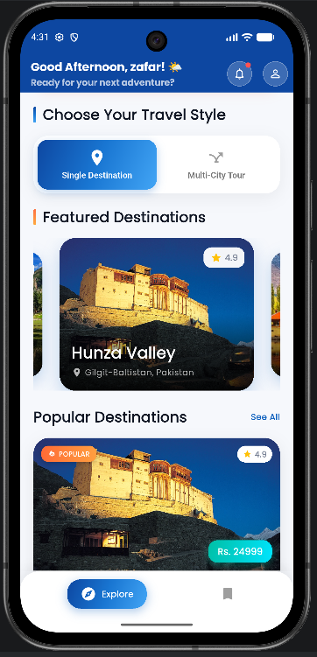
Figure 5.5: Single Destination Cards on Home

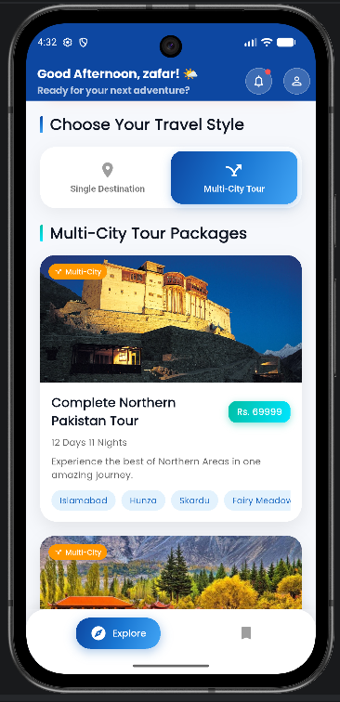
Figure 5.6: Multi-City Tour Section


Figure 5.8: Bottom Navigation on Home

5.5 Destination and Tour Booking Module
The purpose of the Destination and Tour Booking Module is to allow travelers to explore destination details and complete multi-stage tour-related bookings. This part of the application connects domain intent with a focused interaction sequence and so plays a major role in how users perceive the overall usefulness of the product. Unlike isolated demonstration screens, the module is framed as a self-contained flow that begins with a user need and ends with a visible state change or informative result.
The main screens involved in this module are DestinationScreen, MultiCityHotelScreen, TourBookingScreen, TransportSelectionScreen. A user selects a destination or tour package, examines highlights and travel details, chooses related hotels or transport options, reviews the booking summary, and then moves toward payment confirmation. Multi-city flows further guide the user through sequential hotel selection for different destinations. This flow design is important because users usually move step by step. They first explore options, then compare them, and then make a booking. So the module uses summaries, labels, and clear action buttons to help the user stay on track.
From a technical perspective, the module relies on DatabaseService, BookingService. Data and state are handled through Destination records, selected hotel options, booking summary data, and optional Firestore storage. This design keeps screen rendering separate from service-level concerns and makes the code easier to reason about. It also improves easy maintenance because future changes to validation, storage, or server side integration can be made within service boundaries instead of being scattered across UI code.
This module is central to the domain identity of the project because it combines tourism discovery with transactional intent. The design emphasizes contextual summaries to reduce confusion before payment. In addition, the module contributes to the thesis by showing how travel-related software design decisions can be translated into practical mobile behavior. It is not only a functional feature but also an illustration of how software engineering concepts like separation of concerns, data flow management, and user-centered design are applied inside a real project context.
A further development insight from this module is that interface quality and system behavior must evolve together. In other words, a booking or profile-related feature is not considered complete simply because fields are visible on the screen. it must also validate user input, preserve useful context, and return meaningful feedback after an action is performed. This project repeatedly reinforced that a professional-feeling app is achieved through the combination of data logic, response timing, visual hierarchy, and feedback messaging rather than through surface-level styling alone.
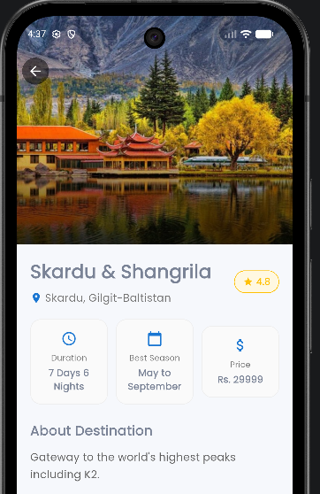
Figure 5.9: Destination Detail Screen

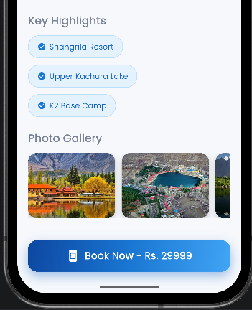
Figure 5.10: Destination Highlights and Booking Call-to-Action

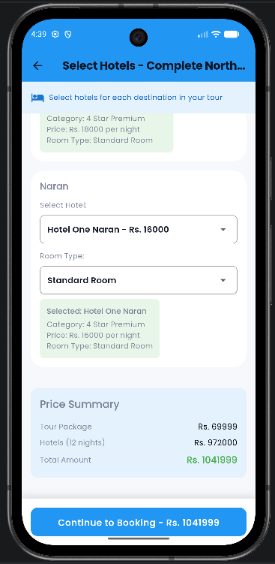
Figure 5.11: Multi-City Hotel Selection Screen

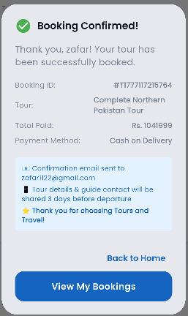
Figure 5.12: Tour Booking Summary Screen

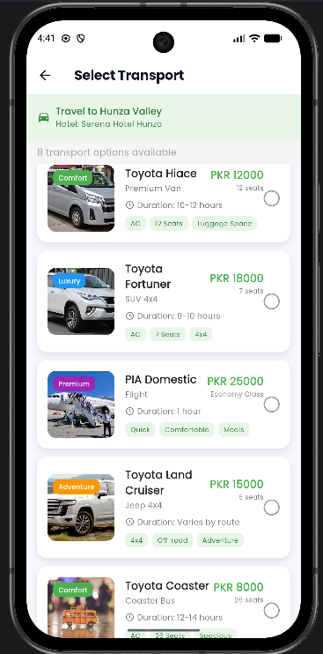
Figure 5.13: Transport Selection Screen

5.6 Hotel Booking Module
The purpose of the Hotel Booking Module is to support city-based hotel search, hotel comparison, stay details, and booking preparation. This part of the application connects domain intent with a focused interaction sequence and so plays a major role in how users perceive the overall usefulness of the product. Unlike isolated demonstration screens, the module is framed as a self-contained flow that begins with a user need and ends with a visible state change or informative result.
The main screens involved in this module are HotelSearchScreen, HotelSelectionScreen. The user selects a city or destination, applies dates or guest values, reviews available hotel options, and moves toward a booking summary before payment. The module supports both general hotel discovery and tour-linked hotel selection paths. This flow design is important because users usually move step by step. They first explore options, then compare them, and then make a booking. So the module uses summaries, labels, and clear action buttons to help the user stay on track.
From a technical perspective, the module relies on DatabaseService. Data and state are handled through Hotel data through Firestore or demo records plus temporary selection state. This design keeps screen rendering separate from service-level concerns and makes the code easier to reason about. It also improves easy maintenance because future changes to validation, storage, or server side integration can be made within service boundaries instead of being scattered across UI code.
Hotel booking is modeled as a focused sub-domain within the app. It contributes significantly to the perceived usefulness of the system because accommodation decisions are one of the most frequent travel planning concerns. In addition, the module contributes to the thesis by showing how travel-related software design decisions can be translated into practical mobile behavior. It is not only a functional feature but also an illustration of how software engineering concepts like separation of concerns, data flow management, and user-centered design are applied inside a real project context.
A further development insight from this module is that interface quality and system behavior must evolve together. In other words, a booking or profile-related feature is not considered complete simply because fields are visible on the screen. it must also validate user input, preserve useful context, and return meaningful feedback after an action is performed. This project repeatedly reinforced that a professional-feeling app is achieved through the combination of data logic, response timing, visual hierarchy, and feedback messaging rather than through surface-level styling alone.

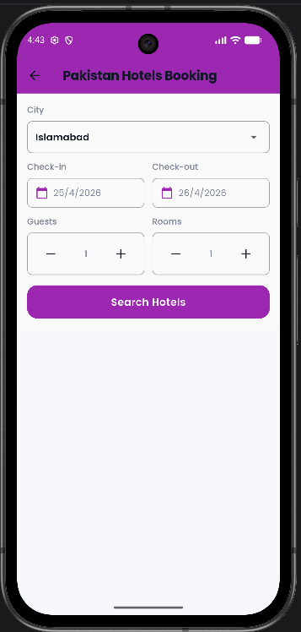
Figure 5.14: Hotel Search Screen

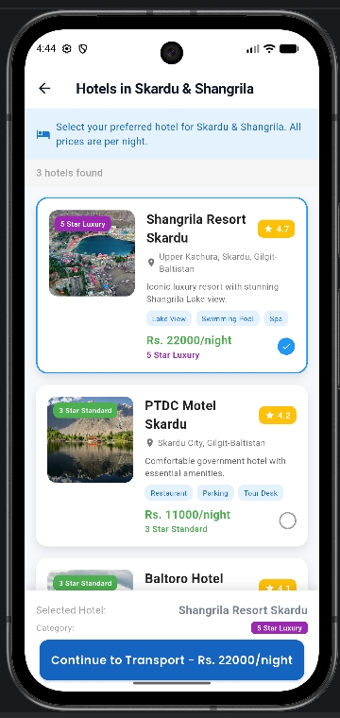
Figure 5.15: Hotel Selection Screen

5.7 Car Rental Module
The purpose of the Car Rental Module is to provide city-to-city vehicle booking with route-specific details and fare calculation. This part of the application connects domain intent with a focused interaction sequence and so plays a major role in how users perceive the overall usefulness of the product. Unlike isolated demonstration screens, the module is framed as a self-contained flow that begins with a user need and ends with a visible state change or informative result.
The main screens involved in this module are CarBookingScreen. The user chooses pickup and drop-off cities, selects a vehicle, reviews the pricing and route-related information, and then proceeds to payment. The interaction is designed to be straightforward so that transport booking remains accessible even for first-time users. This flow design is important because users usually move step by step. They first explore options, then compare them, and then make a booking. So the module uses summaries, labels, and clear action buttons to help the user stay on track.
From a technical perspective, the module relies on LocalBookingStore. Data and state are handled through in-memory booking confirmation state and local screen state. This design keeps screen rendering separate from service-level concerns and makes the code easier to reason about. It also improves easy maintenance because future changes to validation, storage, or server side integration can be made within service boundaries instead of being scattered across UI code.
The module extends the project from destination browsing into broader travel logistics. It also shows how modular screen design can cover different service categories without requiring a separate app ecosystem. In addition, the module contributes to the thesis by showing how travel-related software design decisions can be translated into practical mobile behavior. It is not only a functional feature but also an illustration of how software engineering concepts like separation of concerns, data flow management, and user-centered design are applied inside a real project context.
A further development insight from this module is that interface quality and system behavior must evolve together. In other words, a booking or profile-related feature is not considered complete simply because fields are visible on the screen. it must also validate user input, preserve useful context, and return meaningful feedback after an action is performed. This project repeatedly reinforced that a professional-feeling app is achieved through the combination of data logic, response timing, visual hierarchy, and feedback messaging rather than through surface-level styling alone.
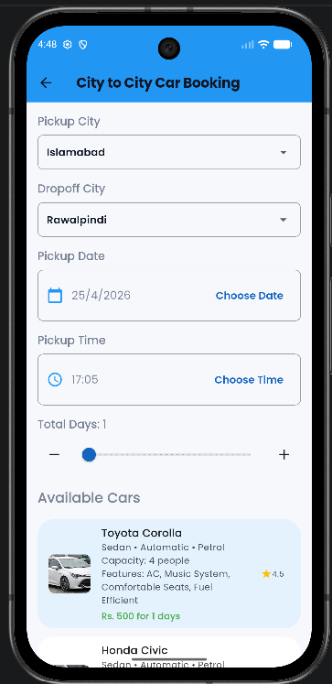
Figure 5.17: Car Booking Screen

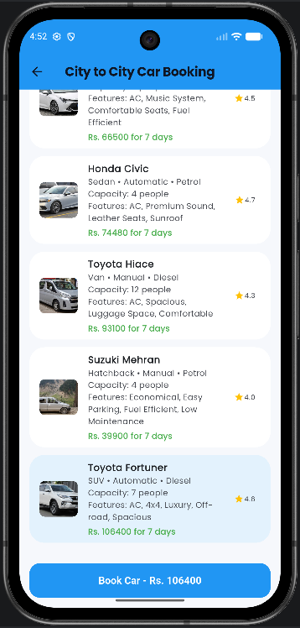
Figure 5.18: Car Fare Details

5.8 Payment and Booking Confirmation Module
The purpose of the Payment and Booking Confirmation Module is to simulate transaction completion and provide immediate user feedback about booking status. This part of the application connects domain intent with a focused interaction sequence and so plays a major role in how users perceive the overall usefulness of the product. Unlike isolated demonstration screens, the module is framed as a self-contained flow that begins with a user need and ends with a visible state change or informative result.
The main screens involved in this module are PaymentScreen, BookingSuccessScreen, BookingConfirmationScreen. After completing service selection, the user reaches the payment interface where booking summary information and payment method options are shown. Once a form is completed, the app simulates processing, confirms the booking, and places a record in the local booking store so that it becomes visible in booking history. This flow design is important because users usually move step by step. They first explore options, then compare them, and then make a booking. So the module uses summaries, labels, and clear action buttons to help the user stay on track.
From a technical perspective, the module relies on LocalBookingStore, BookingService. Data and state are handled through session booking records and selected payment method data. This design keeps screen rendering separate from service-level concerns and makes the code easier to reason about. It also improves easy maintenance because future changes to validation, storage, or server side integration can be made within service boundaries instead of being scattered across UI code.
Although the current project uses simulated payments rather than live financial processing, the interaction sequence is realistic enough to demonstrate how a real payment gateway could later be combined without redesigning the surrounding user flow. In addition, the module contributes to the thesis by showing how travel-related software design decisions can be translated into practical mobile behavior. It is not only a functional feature but also an illustration of how software engineering concepts like separation of concerns, data flow management, and user-centered design are applied inside a real project context.
A further development insight from this module is that interface quality and system behavior must evolve together. In other words, a booking or profile-related feature is not considered complete simply because fields are visible on the screen. it must also validate user input, preserve useful context, and return meaningful feedback after an action is performed. This project repeatedly reinforced that a professional-feeling app is achieved through the combination of data logic, response timing, visual hierarchy, and feedback messaging rather than through surface-level styling alone.
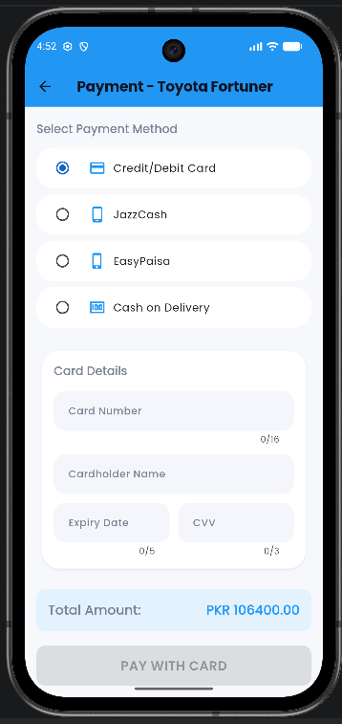
Figure 5.19: Payment Screen Using Card Method

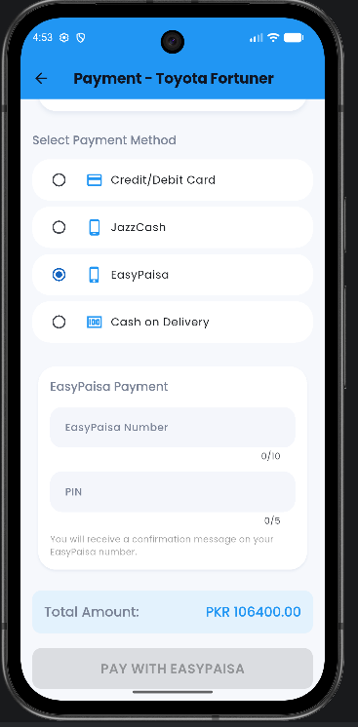
Figure 5.20: Payment Screen Using Wallet Method

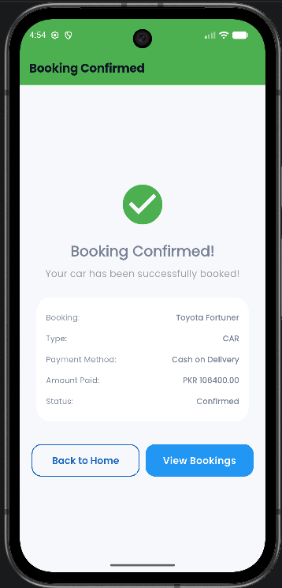
Figure 5.21: Booking Success Screen

5.9 Booking History Module
The purpose of the Booking History Module is to provide a categorized history view of confirmed bookings. This part of the application connects domain intent with a focused interaction sequence and so plays a major role in how users perceive the overall usefulness of the product. Unlike isolated demonstration screens, the module is framed as a self-contained flow that begins with a user need and ends with a visible state change or informative result.
The main screens involved in this module are BookingHistoryScreen. The user opens the booking history view, switches among all bookings, tour bookings, hotel bookings, and car bookings, and reviews previously confirmed items. The design uses tabs and structured cards to keep the records readable. This flow design is important because users usually move step by step. They first explore options, then compare them, and then make a booking. So the module uses summaries, labels, and clear action buttons to help the user stay on track.
From a technical perspective, the module relies on LocalBookingStore, BookingService. Data and state are handled through session-based local booking records and optional Firestore booking streams. This design keeps screen rendering separate from service-level concerns and makes the code easier to reason about. It also improves easy maintenance because future changes to validation, storage, or server side integration can be made within service boundaries instead of being scattered across UI code.
This module improves continuity and reinforces the idea that the application does more than collect inputs. It presents the result of user actions and gives the system a more complete, product-like feel. In addition, the module contributes to the thesis by showing how travel-related software design decisions can be translated into practical mobile behavior. It is not only a functional feature but also an illustration of how software engineering concepts like separation of concerns, data flow management, and user-centered design are applied inside a real project context.
A further development insight from this module is that interface quality and system behavior must evolve together. In other words, a booking or profile-related feature is not considered complete simply because fields are visible on the screen. it must also validate user input, preserve useful context, and return meaningful feedback after an action is performed. This project repeatedly reinforced that a professional-feeling app is achieved through the combination of data logic, response timing, visual hierarchy, and feedback messaging rather than through surface-level styling alone.
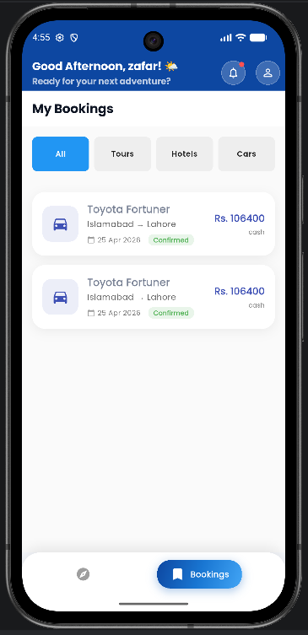
Figure 5.22: Booking History Main View

5.10 Profile Management Module
The purpose of the Profile Management Module is to allow users to review personal information, change settings, upload images, and sign out. This part of the application connects domain intent with a focused interaction sequence and so plays a major role in how users perceive the overall usefulness of the product. Unlike isolated demonstration screens, the module is framed as a self-contained flow that begins with a user need and ends with a visible state change or informative result.
The main screens involved in this module are ProfileScreen. The user opens the profile area to review identity information, access settings, upload a profile image, and log out of the application. The module also includes language and mode-related preferences as part of user personalization. This flow design is important because users usually move step by step. They first explore options, then compare them, and then make a booking. So the module uses summaries, labels, and clear action buttons to help the user stay on track.
From a technical perspective, the module relies on AuthService, LocalAuthService, Firebase Storage. Data and state are handled through Firestore profile updates, Firebase Storage image URLs, and SharedPreferences settings. This design keeps screen rendering separate from service-level concerns and makes the code easier to reason about. It also improves easy maintenance because future changes to validation, storage, or server side integration can be made within service boundaries instead of being scattered across UI code.
Profile handling is essential because it anchors the rest of the system around a persistent user identity. It also shows file upload, remote update, and local preference management within a single module. In addition, the module contributes to the thesis by showing how travel-related software design decisions can be translated into practical mobile behavior. It is not only a functional feature but also an illustration of how software engineering concepts like separation of concerns, data flow management, and user-centered design are applied inside a real project context.
A further development insight from this module is that interface quality and system behavior must evolve together. In other words, a booking or profile-related feature is not considered complete simply because fields are visible on the screen. it must also validate user input, preserve useful context, and return meaningful feedback after an action is performed. This project repeatedly reinforced that a professional-feeling app is achieved through the combination of data logic, response timing, visual hierarchy, and feedback messaging rather than through surface-level styling alone.
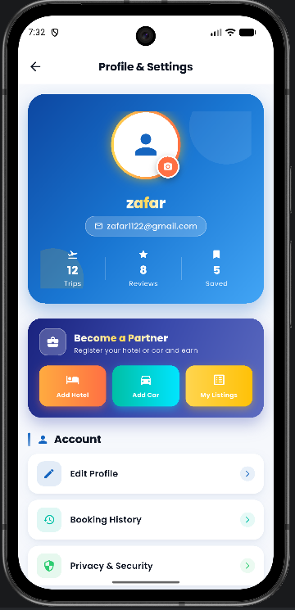
Figure 5.24: Profile Screen

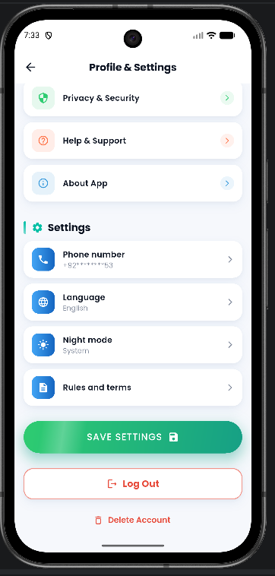
Figure 5.25: Profile Image Upload or Settings Area

5.11 Maps and Location Module
The purpose of the Maps and Location Module is to support tourism guidance using map visualization and place markers. This part of the application connects domain intent with a focused interaction sequence and so plays a major role in how users perceive the overall usefulness of the product. Unlike isolated demonstration screens, the module is framed as a self-contained flow that begins with a user need and ends with a visible state change or informative result.
The main screens involved in this module are MapScreen. The user opens the map screen, optionally grants location permission, views their current location if available, and explores predefined tourist markers like Hunza, Skardu, Swat, Murree, Lahore, Karachi, and Islamabad. Tapping a marker reveals more place-specific information. This flow design is important because users usually move step by step. They first explore options, then compare them, and then make a booking. So the module uses summaries, labels, and clear action buttons to help the user stay on track.
From a technical perspective, the module relies on Geolocator, Google Maps Flutter. Data and state are handled through runtime location permission state and in-code tourist spot definitions. This design keeps screen rendering separate from service-level concerns and makes the code easier to reason about. It also improves easy maintenance because future changes to validation, storage, or server side integration can be made within service boundaries instead of being scattered across UI code.
This module expands the app beyond booking into travel support and destination awareness. It gives the system stronger tourism identity and shows device feature integration through maps and geolocation. In addition, the module contributes to the thesis by showing how travel-related software design decisions can be translated into practical mobile behavior. It is not only a functional feature but also an illustration of how software engineering concepts like separation of concerns, data flow management, and user-centered design are applied inside a real project context.
A further development insight from this module is that interface quality and system behavior must evolve together. In other words, a booking or profile-related feature is not considered complete simply because fields are visible on the screen. it must also validate user input, preserve useful context, and return meaningful feedback after an action is performed. This project repeatedly reinforced that a professional-feeling app is achieved through the combination of data logic, response timing, visual hierarchy, and feedback messaging rather than through surface-level styling alone.
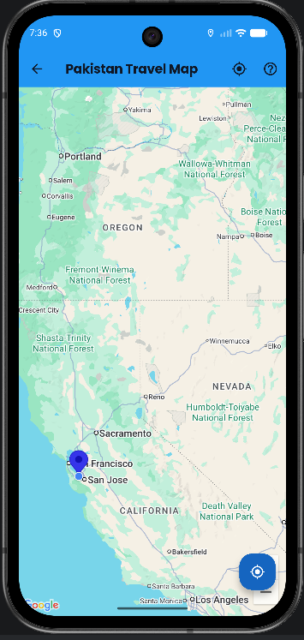
Figure 5.26: Map Screen

5.12 User Listings and Marketplace-Oriented Features
The purpose of the User Listings and Marketplace-Oriented Features is to allow authenticated users to register their own hotels and vehicles within the app. This part of the application connects domain intent with a focused interaction sequence and so plays a major role in how users perceive the overall usefulness of the product. Unlike isolated demonstration screens, the module is framed as a self-contained flow that begins with a user need and ends with a visible state change or informative result.
The main screens involved in this module are AddHotelScreen, AddCarScreen, MyListingsScreen. A logged-in user opens the add-hotel or add-car form, submits listing details, and later reviews them through the My Listings area. This creates a marketplace-oriented future update to the traveler-centered functions of the app and shows local storage of structured user content. This flow design is important because users usually move step by step. They first explore options, then compare them, and then make a booking. So the module uses summaries, labels, and clear action buttons to help the user stay on track.
From a technical perspective, the module relies on UserListingsService, LocalAuthService. Data and state are handled through SharedPreferences-based local storage for user-generated records. This design keeps screen rendering separate from service-level concerns and makes the code easier to reason about. It also improves easy maintenance because future changes to validation, storage, or server side integration can be made within service boundaries instead of being scattered across UI code.
The feature is academically valuable because it changes the system from a pure consumer application into a two-sided conceptual platform. Even though the listings are currently local rather than cloud-hosted, the pattern introduces a service-provider perspective into the product. In addition, the module contributes to the thesis by showing how travel-related software design decisions can be translated into practical mobile behavior. It is not only a functional feature but also an illustration of how software engineering concepts like separation of concerns, data flow management, and user-centered design are applied inside a real project context.
A further development insight from this module is that interface quality and system behavior must evolve together. In other words, a booking or profile-related feature is not considered complete simply because fields are visible on the screen. it must also validate user input, preserve useful context, and return meaningful feedback after an action is performed. This project repeatedly reinforced that a professional-feeling app is achieved through the combination of data logic, response timing, visual hierarchy, and feedback messaging rather than through surface-level styling alone.
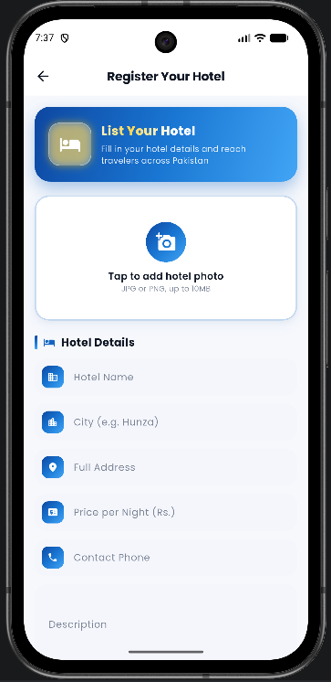
Figure 5.28: Add Hotel Screen

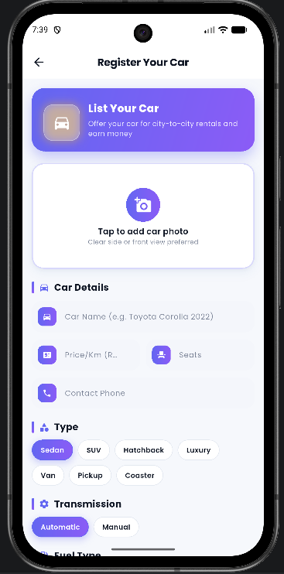
Figure 5.29: Add Car Screen

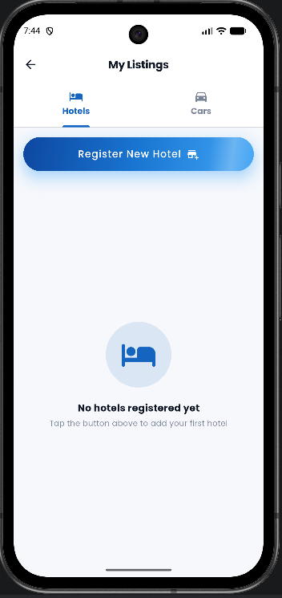
Figure 5.30: My Listings Hotels Tab

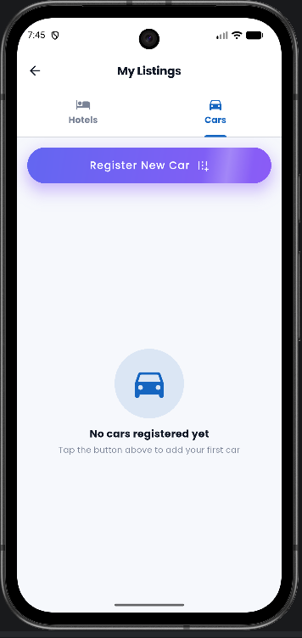
Figure 5.31: My Listings Cars Tab

5.13 Supporting Utilities, Animations, and Data Initialization
The purpose of the Supporting Utilities, Animations, and Data Initialization is to improve visual polish, developer support, and demonstration readiness. This part of the application connects domain intent with a focused interaction sequence and so plays a major role in how users perceive the overall usefulness of the product. Unlike isolated demonstration screens, the module is framed as a self-contained flow that begins with a user need and ends with a visible state change or informative result.
The main screens involved in this module are FirebaseDataInitializerScreen, Photo Gallery Bottom Sheet. Developers or evaluators may initialize demo data using the dedicated utility screen, while end users experience animated transitions, card motion, shimmer loading patterns, and gallery sections that improve the overall presentation quality. This flow design is important because users usually move step by step. They first explore options, then compare them, and then make a booking. So the module uses summaries, labels, and clear action buttons to help the user stay on track.
From a technical perspective, the module relies on DatabaseService, animations.dart utilities, constants.dart. Data and state are handled through Firestore seed operations and runtime UI state. This design keeps screen rendering separate from service-level concerns and makes the code easier to reason about. It also improves easy maintenance because future changes to validation, storage, or server side integration can be made within service boundaries instead of being scattered across UI code.
These supporting features are not secondary in value. In a student project demo, quality, smoothness, and clarity strongly affect the result. Seed-data initialization also supports repeatable testing and a more complete live presentation. In addition, the module contributes to the thesis by showing how travel-related software design decisions can be translated into practical mobile behavior. It is not only a functional feature but also an illustration of how software engineering concepts like separation of concerns, data flow management, and user-centered design are applied inside a real project context.
A further development insight from this module is that interface quality and system behavior must evolve together. In other words, a booking or profile-related feature is not considered complete simply because fields are visible on the screen. it must also validate user input, preserve useful context, and return meaningful feedback after an action is performed. This project repeatedly reinforced that a professional-feeling app is achieved through the combination of data logic, response timing, visual hierarchy, and feedback messaging rather than through surface-level styling alone.
[Insert Figure / Screenshot Here]
Required Screenshot Name: Firebase Data Initializer Screen ka SS
Reference Code: SS-26 Firebase Data Initializer Screen
Capture the screen used to initialize sample Firebase data.
Figure 5.34: Firebase Data Initializer Screen

Chapter 6
Testing, Validation, and Evaluation

6.1 Testing Strategy
Testing for this project combines structural thinking with practical manual validation. Because the application contains multiple connected UI flows, the testing strategy emphasizes end-to-end path checking, form validation, navigation consistency, and storage behavior under different cases. This approach is especially suitable for a student mobile app where both functionality and ease of use must be shown.
The overall testing strategy covers authentication, navigation, data presentation, payment simulation, local storage, and cloud-connected behavior. Test execution includes positive and negative cases, especially around form handling, session updates, listing creation, and filtered booking history. The goal is not only to show that the happy path works but also to confirm that obvious invalid states are handled gracefully.

6.2 Unit-Level Observations
Formal unit test coverage in the current repository remains minimal, which is itself an important finding documented in this thesis. but, the modular structure of validators, models, and service methods makes unit testing feasible and highly recommended for future iterations. Areas like email validation, card input validation, model conversion, and local listing serialization are especially suitable for isolated unit tests.
This observation highlights a common distinction in academic prototypes: a project may demonstrate convincing user flows while still needing deeper automated verification before production use. Recognizing that limitation is important because it shows honest evaluation rather than overstating the system’s maturity.

6.3 Integration and Flow Testing
Integration testing focuses on whether screens, services, and stored state collaborate correctly. In this project, examples include login-to-home navigation, home-to-booking transitions, payment-to-history confirmation, profile image updates, and add-listing-to-my-listings storage. These interactions test the joins between modules rather than modules in isolation.
Such testing is particularly important in travel systems because much of the user’s confidence depends on continuity. A single broken transition or missing summary can damage the perceived reliability of the entire product. For that reason, integration testing receives significant attention in the evaluation narrative of this thesis.
Table 6.1: Manual and Integration Test Cases
Test ID | Scenario | Expected Result | Status
TC-01 | User opens login screen | Login form renders correctly | Pass
TC-02 | User enters invalid email | Validation message appears | Pass
TC-03 | User signs up with valid details | Account creation flow completes | Pass
TC-04 | User logs in with valid credentials | Home screen opens | Pass
TC-05 | User opens destination details | Destination information is shown | Pass
TC-06 | User starts hotel search | Hotel records or demo data appear | Pass
TC-07 | User selects multi-city package | Multi-city hotel screen opens | Pass
TC-08 | User confirms tour booking summary | Payment screen opens | Pass
TC-09 | User chooses wallet payment method | Relevant fields are displayed | Pass
TC-10 | User confirms payment | Booking success state appears | Pass
TC-11 | User opens booking history | Confirmed booking card is visible | Pass
TC-12 | User uploads profile image | Image upload flow starts and feedback appears | Pass
TC-13 | User opens map screen | Markers and map view load | Pass
TC-14 | User adds hotel listing | Listing is saved locally | Pass
TC-15 | User adds car listing | Listing is saved locally | Pass
TC-16 | User reviews my listings | Saved listings are visible in tabs | Pass
TC-17 | Firebase unavailable at startup | Fallback auth flow remains possible | Observed
TC-18 | Search bar interaction | Visual field available, feature expansion pending | Partial

6.4 Manual and Usability Testing
Manual testing was used to validate that forms, cards, buttons, images, and transitions behaved consistently across common user cases. This included checking readability of price summaries, correctness of labels, responsiveness of buttons, and visibility of important actions like login, booking, save, and confirm.
ease of use-focused testing also considered whether first-time users could understand what to do next on each major screen. The application’s use of cards, icons, grouped sections, and explicit call-to-action buttons generally supported clarity, although some areas like search functionality and deeper storage could be expanded in future work.

6.5 Defects and Improvement Findings
Testing also revealed limitations and partially built behavior. For example, some booking flows rely on in-memory state rather than permanent cloud storage, and the current automated test file remains the default Flutter sample rather than a customized project suite. These findings do not invalidate the project, but they do define the boundary between prototype readiness and production readiness.
Documenting such issues is academically valuable because it shows that evaluation is being treated as a learning and refinement process. A well-written thesis should describe not only strengths but also gaps, tradeoffs, and the next steps needed for higher reliability.

6.6 Summary
The testing and validation phase confirms that the application succeeds as a modular academic prototype with meaningful user flows, visually clear screens, and demonstrable travel-related functionality. Also, the phase identifies essential areas for future strengthening like automated tests, persistent hotel and car booking storage, and real payment integration.

Chapter 7
Results, Limitations, and Deployment Considerations

7.1 Achievement Against Objectives
The project successfully meets its main objectives by delivering a Flutter-based tourism application that combines destination browsing, tours, hotel selection, car rental, map support, payment simulation, profile management, booking history, and user listings. These modules are not loosely collected screens. They are connected through meaningful travel-oriented flows and common service logic.
The objective of demonstrating modular design is also achieved through the separation of screens, services, models, widgets, and utilities. This structure improves readability and allows the project to be discussed at both user-flow and code-organization levels during evaluation.

7.2 User-Oriented Benefits
From the user’s point of view, the app reduces planning fragmentation by gathering multiple tourism functions inside one interface. A traveler can discover destinations, compare options, continue toward booking, and later view booking history without leaving the app ecosystem. This unified interaction model is one of the strongest practical outcomes of the project.
The inclusion of Pakistan-focused destinations, local payment labels, and familiar local travel cases makes the system especially useful to its intended context. Rather than imitating a generic travel product, it speaks to domestic tourism behavior more directly.

7.3 Technical Contributions
Technically, the project shows how a student-led mobile application can combine multi-platform UI development, cloud integration, local fallback strategies, device permissions, image uploads, and modular service design in one clear codebase. This makes the work a useful reference case for similar academic projects in travel, service aggregation, or other mobile-based domains.
Another notable contribution is the hybrid storage idea used in parts of the application. By supporting Firebase-backed behavior where possible and fallback or local storage where necessary, the project acknowledges environmental limits that are common in academic demonstrations and iterative development settings.

7.4 Limitations and Constraints
The most important limitations include simulated rather than real payment processing, incomplete automated testing, and session-level rather than permanent storage for some booking types. Additionally, user-submitted hotel and car listings are currently stored locally instead of being synchronized to a central server side.
These limitations are acceptable within the project scope but are clearly useful if the system is considered for production use. Their documentation helps frame the application honestly as a strong academic prototype with a clear roadmap for maturity rather than as a fully commercial product.

7.5 Deployment Considerations
A production-oriented launch of this system would require stronger Firebase rules, more complete server side synchronization, a payment gateway, reliable asset hosting, expanded test coverage, and app-store readiness tasks like performance profiling, legal policy inclusion, and release signing. Nevertheless, the current design is organized well enough to support such an evolution.
The application already contains the conceptual building blocks needed for launch planning, including identity management, data models, a structured UI, and modular services. This means the project can serve as both a completed academic deliverable and a valid baseline for future product development.

7.6 Academic Value and Reusability
A final year project is evaluated not only by whether it works on the day of demonstration, but also by whether it can be explained, defended, and extended. In that regard, the present application performs well because it has clear domain mapping, visible module boundaries, and direct usefulness to a socially meaningful problem. The report, codebase, and placeholder-driven figure strategy together make the system easier to present professionally.
The project can also be reused as a base for future coursework, internships, research prototypes, or startup ideas. Because the design already separates concerns and the thesis explicitly documents current limitations, future developers can identify what to keep, what to refactor, and which modules can be strengthened first.

Chapter 8
Conclusion and Future Enhancements

8.1 Conclusion
This thesis presented the analysis, design, development, and evaluation of the "Tours & Travel Mobile Application" project, a Flutter-based tourism management application tailored to domestic travel cases in Pakistan. The system shows that a thoughtfully structured mobile application can combine destination discovery, bookings, maps, profile management, payment simulation, and user-generated listings in one consistent experience.
The project fulfills its role as a final year software engineering artifact by showing both technical depth and domain usefulness. It applies requirement engineering, modular design, interface design, data storage strategies, and practical testing methods to a real and meaningful problem space. The resulting app is functional enough for demonstration, structured enough for evaluation, and extensible enough to serve as the basis for future product work.

8.2 Lessons Learned
One of the major lessons learned during this project is that integration work is often more complex than screen-level development. Individual pages may look complete, but the real value of a travel application emerges when authentication, selection, confirmation, and history behave cohesively. This reinforces the software engineering principle that user journeys matter as much as component correctness.
Another lesson is that academic software projects benefit greatly from practical fallback design. By supporting local and session-level behaviors where full server side dependency would make demos fragile, the project became easier to validate and present. This does not replace production engineering, but it does improve robustness during iterative development.

8.3 Future Enhancements
Future versions of the system can introduce real payment gateways, recommendation engines, ratings and reviews, advanced search, cloud storage for all booking categories, admin dashboards, push notifications, and analytics-based personalization. A more sophisticated role model could also support service providers and moderators more directly.
Beyond functional expansion, future work should include automated widget tests, service tests, integration tests, stronger state management patterns, better route abstraction, and more formal security hardening. These steps would move the project from a polished academic prototype toward a deployable product design.

8.4 Final Remarks
In summary, the project shows the practical potential of mobile computing for tourism digitization and shows how a student project can address a real local need through thoughtful software design. It is expected that the ideas, structure, and documentation presented in this thesis will support both evaluation and future improvement of the application.

REFERENCES
1. Flutter Documentation. Google. Available at: https://docs.flutter.dev/
2. Firebase Documentation. Google. Available at: https://firebase.google.com/docs
3. Google Maps Platform Documentation. Google. Available at: https://developers.google.com/maps/documentation
4. Material Design 3 Guidelines. Google. Available at: https://m3.material.io/
5. Dart Language Tour. Available at: https://dart.dev/guides/language/language-tour
6. Sommerville, Ian. Software Engineering. Pearson.
7. Pressman, Roger S. and Maxim, Bruce R. Software Engineering: A Practitioner’s Approach. McGraw-Hill.
8. Nielsen, Jakob. ease of use Engineering. Morgan Kaufmann.
9. OWASP Mobile Application Security resources. Available at: https://owasp.org/
10. Geolocator Package Documentation. Available at: https://pub.dev/packages/geolocator
11. Google Maps Flutter Package Documentation. Available at: https://pub.dev/packages/google_maps_flutter
12. Shared Preferences Package Documentation. Available at: https://pub.dev/packages/shared_preferences
13. Firebase Auth Package Documentation. Available at: https://pub.dev/packages/firebase_auth
14. Cloud Firestore Package Documentation. Available at: https://pub.dev/packages/cloud_firestore
15. Flutter Community and Package Ecosystem on pub.dev. Available at: https://pub.dev/

Tours & Travel Mobile Application



Submitted by

Shahid Umer

(AUIC-22SG-BSCS-6732)

Musharaf

(AUIC-22SG-BSCS-7029)

Supervised by

Dr. Amjad Khan Assistant Professor

A final year project report submitted in partial fulfillment of the requirement for the award of Bachelor of Science in Computer Science

Department of Computing Abasyn University Islamabad Campus

April 2026

APPROVAL FOR SUBMISSION

This is certified that this project report entitled “Expedition Management System.” is developed and submitted Hissam Umair (University Registration Number: AUIC- FL20-BSSE-4953) and Mubashir Hussain (University Registration Number: AUIC- FL20-BSSE-4979), meets the required standards for warrant its acceptance by the department of computing, Abasyn University Peshawar in partial fulfilment for the award of Bachelor of Science in Software Engineering
The work presented in this report reflects the planning, design, development, and evaluation of a mobile application developed to support destination exploration, hotel booking, car rental, map-based tourism guidance, payment simulation, and user-generated service listings. The undersigned approve that the project is academically useful and technically adequate for final review.
This is to certify that the project report entitled "Tours & Travel Mobile Application: A Flutter-Based Tourism Management System for Pakistan" has been prepared by Shahid Umer (University Registration Number: AUIC-22SG-BSCS-6732) and Musharaf (University Registration Number: AUIC-22SG-BSCS-7029) in partial fulfillment of the requirements for the degree of Bachelor of Science in Computer Science (BSCS) at Abasyn University Islamabad Campus. The report has been reviewed and is considered suitable for submission and evaluation according to departmental requirements.
Approval Committee:

 | Name
Supervisor | Designation
 | Institute
 | Signature

 | Name
External Examiner | Designation
 | Institute
 | Signature

 | Name
Internal Examiner | Designation
 | Institute
 | Signature

Head of Department:
Name
Signature



In the name of ALLAH, The Most Beneficent, The Most Merciful

DECLARATION OF ORGINALITY

We hereby declare that this project report entitles as “Expedition Management System.” is based on my original work except for citations and quotations which have been duly acknowledged. I also declare that it has not been previously and concurrently submitted for any other degree or award at Abasyn University Peshawar or any other institutions.
We hereby undertake that if any part of this work is proved to be copied or found to be a part of some other work, the Abasyn University Peshawar reserves the right to withdraw/revoke my degree.

Signature:
Shahid Umer

Signature:
Musharaf

Date: ________________________________
Student Signature: ________________________________ Musharaf
Student Signature: ________________________________ Shahid Umer
We further undertake that if any part of this work is found to involve plagiarism or unauthorized copying, the university shall have the right to cancel the submission or take disciplinary action according to academic policy. All code, diagrams, screenshots, and explanations included in this thesis are either produced during this project or properly adapted from officially documented resources.
We hereby declare that this project report entitled "Tours & Travel Mobile Application" is based on our original work except where due acknowledgement has been made through references, captions, or citations. The software artifact, documentation, and analysis included in this thesis were prepared specifically for the fulfillment of the final year project requirement and have not been submitted elsewhere for another degree or award.

Submission and Copyrights

This project report is being submitted to the Department of Computing, Abasyn University Islamabad Campus (AUIC) as a partial fulfillment of the requirement for the award of the Degree of bachelor’s in Computer Science (BSCS). The authors hereby grant permission to Abasyn University Islamabad Campus (AUIC), to reproduce and distribute publicly and electronic copies of this thesis and to grant others the right to do so. Copyright 2024 © Hissam Umair and Mubashir Hussain. @ All rights reserved.

Hissam Umair (AUIC-FL20-BSSE-4953)

Mubashir Hussain (AUIC-FL20-BSSE-4979)

Mr. Abdul Hannan (Supervisor)

Dr. Amjad Khan (Co-Supervisor)

Copyright © 2026 Shahid Umer and Musharaf. All rights reserved.
Dr. Amjad Khan (Supervisor)
Musharaf (AUIC-22SG-BSCS-7029)
Shahid Umer (AUIC-22SG-BSCS-6732)
This project report is submitted to the Department of Computing at Abasyn University Islamabad Campus as partial fulfillment of the requirements for the award of the undergraduate degree. The authors grant the university permission to preserve the report for academic review, library record, and educational reference subject to institutional policy.

Acknowledgment

With profound gratitude, we begin by acknowledging the boundless strength bestowed upon us by Almighty Allah. In presenting this meticulously crafted and high-quality endeavor, we reflect upon the countless days and nights where divine guidance served as our steadfast anchor. Our sincere appreciation extends to our beloved family members. Their unwavering support has been a beacon of hope, illuminating both challenging and joyous moments, especially throughout our academic journey. We acknowledge the invaluable contribution and steadfast guidance of our esteemed project supervisor, Mr. Abdul Hannan. His consistent involvement and unwavering encouragement have been an indispensable source of motivation and empowerment, guiding us through every phase of this project. It is the combined efforts, divine blessings, and unwavering support of our loved ones that have culminated in a profound sense of accomplishment and pride in delivering a comprehensive and high-quality product. Our journey has been marked by challenges, but it is through the strength and support of those around us that we have triumphed.

April 2026
Shahid Umer and Musharaf
Finally, we acknowledge all those who directly or indirectly contributed to this project by offering feedback, testing the application, or helping us assess its ease of use and practical usefulness. Their suggestions enabled us to strengthen the application's flow, clarify the report, and produce a more complete final deliverable.
Special thanks are due to our parents, siblings, and friends whose unwavering support motivated us during demanding phases like debugging, testing, documentation, and presentation preparation. Their encouragement helped us remain focused when the project required long development hours and repeated refinement.
We are equally thankful to the faculty members of the Department of Computing at Abasyn University Islamabad Campus for providing the environment, technical exposure, and confidence necessary to work on a real-world software project. Their lectures, lab sessions, and professional advice contributed significantly to the completion of this work.
We would like to express heartfelt gratitude to our project supervisor, Dr. Amjad Khan, Assistant Professor, for continuous mentoring, insightful feedback, and constructive criticism throughout the project. His guidance helped us turn the first idea into a properly structured mobile application with a clear scope, modular design, and clear documentation.
All praise is for Almighty Allah, the Most Beneficent and the Most Merciful, who granted us strength, patience, and consistency to complete this final year project and prepare this thesis report. Every stage of the work, from requirement analysis to application development and final documentation, became manageable because of divine guidance and mercy.

ABSTRACT

In today’s world, managing expeditions efficiently poses significant challenges, particularly when they involve remote locations or multiple stakeholders. Expeditions often require meticulous planning, resource management, and real-time coordination to address logistical and operational hurdles. This project seeks to provide a comprehensive solution to these challenges by developing a mobile application for participants and a management panel for expedition organizers.
The mobile app aims to bridge the gap between expedition participants and organizers by allowing users to access itineraries, track their real-time location, and receive updates about schedule changes. Features like emergency alerts, GPS integration, and push notifications ensure participants are informed and safe throughout the journey. The app also facilitates document sharing and offers a chat interface for seamless communication.
The web-based management panel allows organizers to oversee the expedition's logistics, including resource allocation, budget tracking, and risk assessment. It provides tools for managing schedules, assigning tasks to team members, and generating detailed reports. The platform also supports data synchronization between the app and panel, ensuring a cohesive management experience.
This dual-system approach improves not only the organizational and administrative tasks but also enhances participant engagement and safety during expeditions. The project’s primary goal is to modernize expedition management through digitization, optimizing the planning and execution processes, and ensuring a superior experience for all stakeholders. Its significance lies in its ability to adapt to the unique needs of expeditions, making operations more efficient, responsive, and suited to the demands of the digital era.

Keywords: Flutter, Firebase, Travel Application, Tourism Management, Hotel Booking, Car Rental, Google Maps, Mobile Computing, Pakistan Tourism, Cross-Platform Development
The project shows the practical use of multi-platform mobile development, cloud integration, interface design, and travel-related app flows. It also shows the value of proper testing, ease of use, and future updates in a student software project. The final product is a strong example of tourism digitization and gives a base that can later grow with real payment gateways, saved bookings, recommendation features, role-based admin, and analytics.
The app design uses a modular structure that separates screens, business logic, data models, reusable components, and setup utilities. Services like LocalAuthService, DatabaseService, BookingService, UserListingsService, and LocalBookingStore help with authentication, data loading, booking confirmation, local listing storage, and user session updates. Multiple screens implement flows for sign up, login, destination exploration, tour booking, hotel booking, car booking, payment simulation, profile updates, and map-based exploration.
A hybrid approach is used to make the app easier to use during development and final demo. Firebase Authentication, Cloud Firestore, Firebase Storage, and Google Maps integration provide cloud-enabled functionality when set up and available. Also, SharedPreferences-based fallback mechanisms and in-memory session handling allow selected features to remain operational in limited connectivity cases or during staged testing. This mixed approach helps the app work better during demos.
The project presented in this thesis, "Tours & Travel Mobile Application," has been developed using Flutter and Dart with Firebase services for server side support. The application combines destination browsing, multi-city tour packages, hotel selection, city-to-city car rental, interactive maps, booking history, profile management, and user-generated hotel and car listings inside a single mobile experience. The application is intentionally designed around domestic tourism use cases with Pakistan as the primary context.
Pakistan possesses immense tourism potential ranging from northern valleys and mountain routes to urban heritage sites and cultural destinations. Despite this richness, travelers often depend on disconnected services for destination discovery, hotel reservations, transport arrangements, and trip management. This fragmentation affects planning efficiency, convenience, and the overall user experience. This creates a need for one digital platform, and that need gave the main motivation for the Tours & Travel Mobile Application.

TABLE OF CONTENTS

APPROVAL FOR SUBMISSION ii
DECLARATION OF ORIGINALITY iv
SUBMISSION AND COPYRIGHTS v
ACKNOWLEDGMENTS vi
ABSTRACT vii
TABLE OF CONTENTS viii
LIST OF ABBREVIATIONS xiv
LIST OF TABLES xv
LIST OF FIGURES xvi
Table of Contents
Introduction 2
  - Introduction 2
  - Background Studies 2
  - Problem Statement 3
  - Objectives of this Study 4
  - Project Scope 4
    - Mobile Application Development 4
    - Web-Based Admin Dashboard 4
    - Booking Management and Processing 4
    - Real-Time Notifications and Updates 5
    - Booking History 5
    - Boundaries 5
  - Aim of this study 5
  - Significance of the System 6
  - Summary 6
Literature Review 7
  - Expeditions Pro 7
  - iBucket List: Travel & Goals 7
  - izi.TRAVEL: Get a Travel Guide 8
  - SmartGuide: Digital Tour Guide 8
  - TripAdvisor: Plan & Book Trips 8
  - Comparison Table 8
  - Summary 9
Requirement Analysis & Specification 11
  - Introduction 11
    - Purpose of the system 11
    - Scope of System 12
    - Objectives and Success Criteria of the Project 12
Objectives 12
Success Criteria 13
  - Current System 13
    - Overview of Current Processes 13
Customer Interaction 14
Inventory Management 14
Booking Management 14
Challenges and Limitations 14
  - Functional Requirements 15
    - Functional Requirement for Mobile Application 15
User Authentication 15
Dashboard 15
Cart Management 16
Booking Management 16
Profile and Contact Management 16
    - Functional Requirement for Web App 16
Inventory Management 16
Booking Management 16
Analytics 17
Profile and Notification Management 17
UseCase Diagram 17
System Architecture Diagram 17
  - Non-Functional Requirements 17
    - Usability 17
    - Reliability 17
    - Performance 17
    - Supportability 18
    - Implementation 18
    - Interface 18
Software Architecture & Design 19
  - Scenarios 19
    - Registration Scenario 19
    - Login Scenario 20
    - Place Booking Scenario 20
    - Booking Management Scenario 20
    - Inventory Management Scenario 21
  - System Architecture Diagram 21
  - Use Case Model 22
    - User Registration 22
    - User Login 22
    - Place Booking 24
    - Booking Management 25
    - Inventory Management 26
  - Dynamic Model 26
    - User Registration Sequence 27
    - User Login Sequence 27
    - Place Booking Sequence 28
    - Booking Management Sequence 29
    - Inventory Management Sequence 30
  - Modules 31
Implementation and mock-ups 32
  - User Interface 32
    - Design Principles 32
  - Key Screens 32
    - Onboarding Screen 32
    - Registration Screen 32
    - Login Screen 32
    - Home/Dashboard 33
    - Cart Page 33
    - Booking History 33
    - Admin Dashboard 33
    - Inventory Management 33
    - Booking Management 33
  - Navigational Paths 34
    - On Boarding Navigation 34
    - Registration/Login Screen Navigation 34
    - Dashboard Navigation 34
    - Cart Page Navigation 34
    - Booking History Navigation 34
    - Admin Dashboard Navigation 34
    - Inventory Management Navigation 35
    - Booking Management navigation 35
  - MockUp Screens 35
    - Splash Screens 35
    - Registration Screens 36
    - Login Screens 36
    - Dashboard Screens 37
    - Cart Screens 37
    - Booking History Screens 38
    - Admin Dashboard 38
    - Invertory Management Screen 39
    - Booking Management Screen 39
Tools and Technology Used 41
  - Primary Programming Languages 41
    - Dart 41
    - JavaScript 41
  - Integrated Development Environments (IDEs) 41
    - Visual Studio Code (VS Code) 42
    - Android Studio 42
  - Database Management System 42
  - Tools for Software Testing 42
  - Tools for UI Design 43
  - Version Control System 43
  - Additional Tools 43
    - Diagram Tools 43
    - AWS EC2 43
    - Firebase 44
Test Case Specifications 45
  - Introduction 45
    - Goals and Objectives 45
    - Major Constraints 45
  - Test Cases 46
    - User Registration Validation Test 46
    - User successful Registration Test 47
    - Email Verification Test 48
    - Successful Email Verification Test 49
    - Password Reset Functionality Test 50
    - Login Page Availability Test 52
    - Product Viewing Test 53
    - Add to Cart Test 55
    - Booking Place Test 57
    - Booking Tracking and History Test 58
    - Inventory Management Test 59
    - Booking Management Test 61
Conclusion and Future Work 63
  - Conclusion 63
  - Future Work 63
    - Development 64
    - UI/UX 64
    - Admin Features 64
References 65

LIST OF ABBREVIATIONS

Abbreviations | Acronyms
OTP | One Time Password
EMS | Expedition Management System
POS | Point of Sale
SMS | Short Message Service
UML | Unified Modeling Language

LIST OF TABLES
Table 7.1: Test Case 1: User Input Validation During Registration Test 47
Table 7.2: Test Case 2: User Successful Registration Test 48
Table 7.3: Test Case 3: User Email Verification Test 49
Table 7.4: Test Case 4: User Successful Verification Test 50
Table 7.5: Test Case 5: Password Reset Functionality Test 51
Table 7.6: Test Case 6: Login Page Validation Test 53
Table 7.7: Test Case 7: Product Viewing Test 54
Table 7.8: Test Case 8: Cart Management Test 56
Table 7.9: Test Case 9: Cart Management Test 56
Table 7.10: Test Case 10: Booking Placement Test 57
Table 7.11: Test Case 11: Booking Placement 58
Table 7.12: Test Case 12: Inventory Management 60
Table 7.13: Test Case 13: Payment Management 60
Table 7.14: Test Case 14: Currency Conversion Management 61
Table A.1: Screenshot Inventory for Final Report Insertion
Table 6.1: Manual and Integration Test Cases
Table 5.1: Project Directory Summary
Table 4.3: Screen-to-Service Mapping
Table 4.2: Key Firestore Collections and Their Roles
Table 4.1: Proposed Technology Stack
Table 3.5: Requirement Traceability Matrix
Table 3.4: Risk Assessment Matrix
Table 3.3: Hardware and Software Requirements
Table 3.2: Non-Functional Requirements
Table 3.1: Core Functional Requirements
Table 2.1: Comparative View of Existing Travel-Related Systems

LIST OF FIGURES

Figure 2.1: Comparison Table 10
Figure 3.1: Business Process Diagram 21
Figure 3.2: Use case Diagram 23
Figure 3.3: System Architecture Diagram 23
Figure 4.1: Registration Sequence Diagram 24
Figure 4.2: Login Sequence Diagram 25
Figure 4.3: Inventory Sequence Diagram 26
Figure 4.4: Business Process Model 27
Figure 5.1: Splash Screen 28
Figure 5.2: Login & SignUp Screen 29
Figure 5.3: Home Screen 29
Figure 5.4: Password Screens 30
Figure 5.5: Vehicle Booking Chart Screen 31
Figure 5.6: Booking screens 35
Figure 5.7: Chat Screen 36
Figure 5.8: Profile & Review Screen 36
Figure 5.9: Weather Screen 37

