**GUVI ZEN CLASS DATABASE**



A database with name GUVI_ZEN_CLASS is created as shown above.

1. The database consists of following Collections

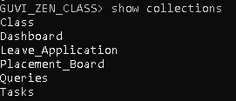

1. Class collection has following documents or data

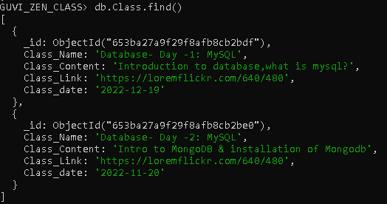

1. Dashboard collection has following documents or data

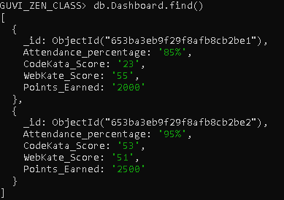

1. Leave_Application has following documents or data

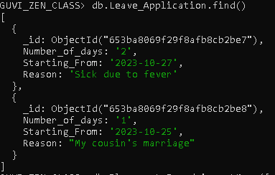

1. Placement_Board has following documents or data

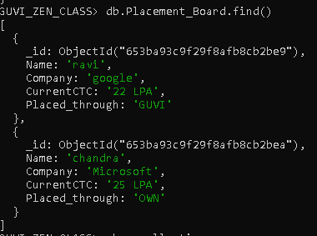

1. Queries has following documents or data

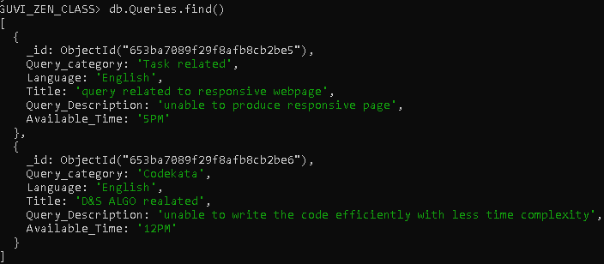

1. Tasks has following documents or data

