**COIT13230(HT2, 2021)**

**Application Development Project**

Student ID: Shahiduddin Tonmoy

Group member : Tsz Kit Choi

**Design Document**

**Link to Code Repository**

Github: https://github.com/Shahiduddin/Keppel-FM

**Project Summary**

The client requirement is for a more mobile friendly and self-managing website for Keppel FM. The project has been implemented in a way where the admins can login and make changes to the website as they see fit. The website is designed using Laravel to make it more interactive and relevant.

**Website Diagram**

The diagram used by the website is the very popular MVC which is used for building complex web services. It is a very popular for used in most modern web applications. MCV stands for Model, View and Controller.

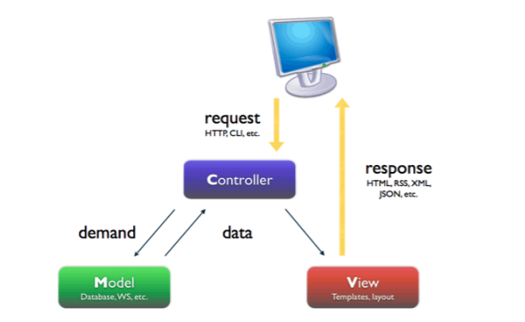

Source: http://stackoverflow .com/questions/5966905/which-mvc-diagram-is-correct-web-app

From the diagram above we can see the 3 key aspects of the diagram

**Model**:

The model is the aspect of the system where all the related data tasks are managed. It reduces the code that needs to be written by the developers.

It is the main source of data for the whole website.

**View**:

The view is responsible for the graphical user interface All forms, buttons, graphics and HLML elements are present in the view section of the web application.

This is what we can normally call the web design or template of the website.

**Controlle**r:

The controller is mainly responsible for even handing. It works as a middleman between View, Model, and the user.

It manages the relationship between a view and a model and respond to the user requests accordingly.

**Software Architecture:**

Given below is the software architecture for Laravel.

Here we can see how the software model works with the user request:

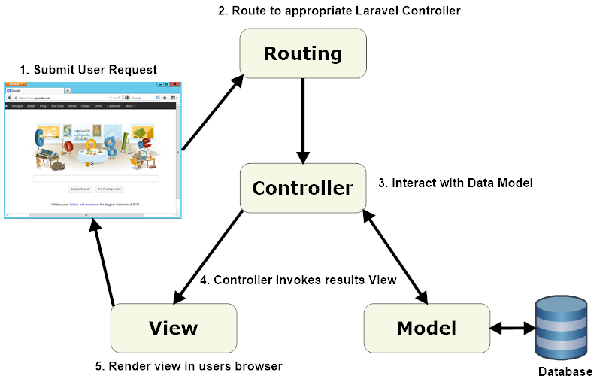

**Source: http://www.cutehits.com/2017/06/general-architecture-of-laravel-based-application/**

**Database Design:**

Given below is the database design created for the website:  
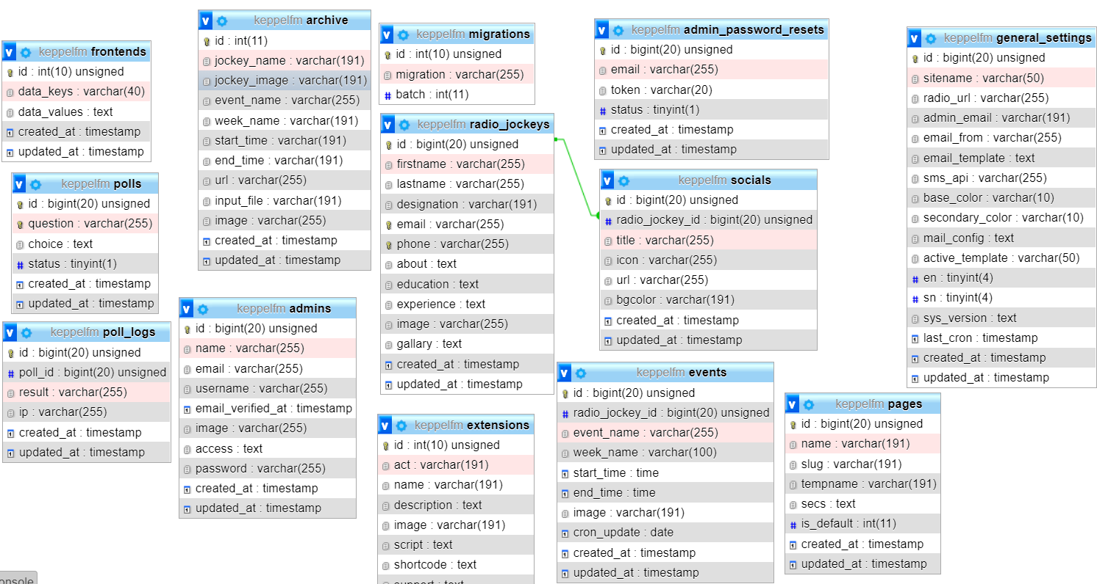

**Behavior Modelling:**

Behavior modelling shows the flow of each task the website will commit and show the workflow of the task at hand. Below is the different task the user will make:

Behavior modelling for admins:

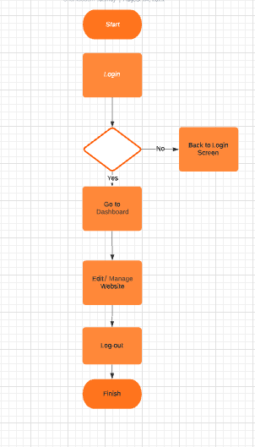

**Behavior model for Visitors:**

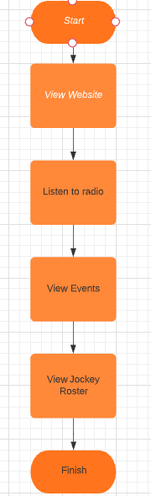

**Website Prototype**:

Here we will showcase the initial stage of the website:

**Homepage:**

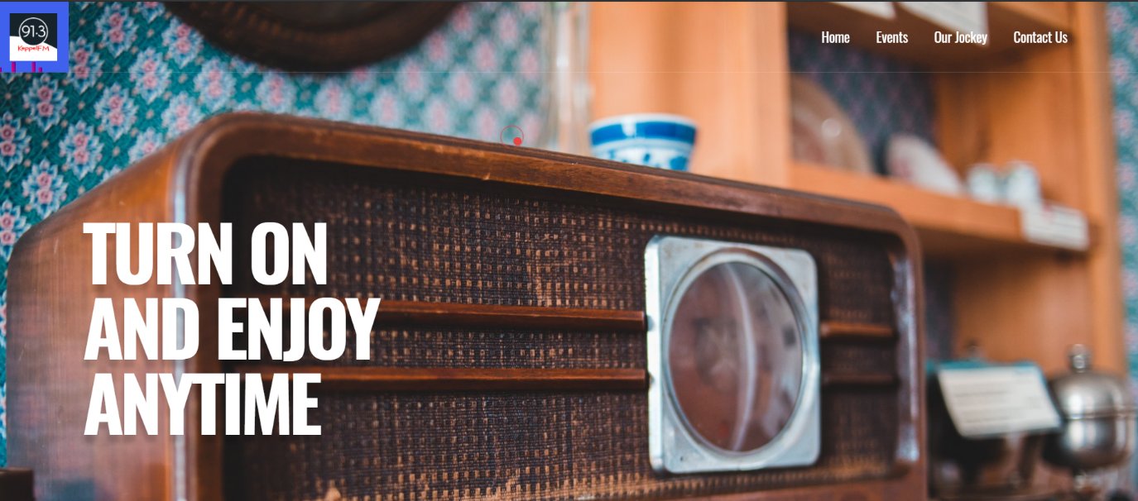

Here we can see a dynamic icon for the Keppel FM and we used blade template to create the structure of the website. Initially there is function but further into the project, more functions will be added to increase the activities of the website.

**Admin Login:**

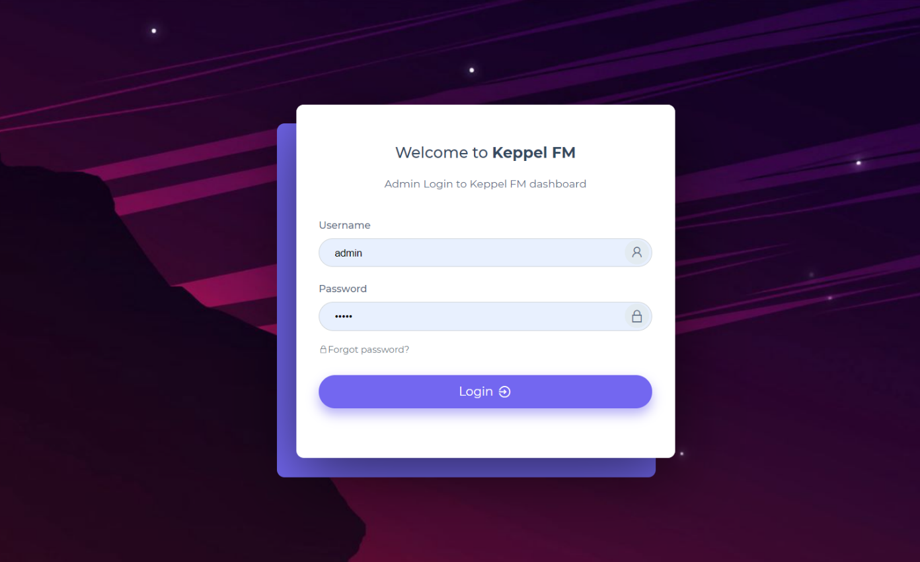

From here the admins can log-in to the website by putting in their username and password.

**Admin Dashboard:**

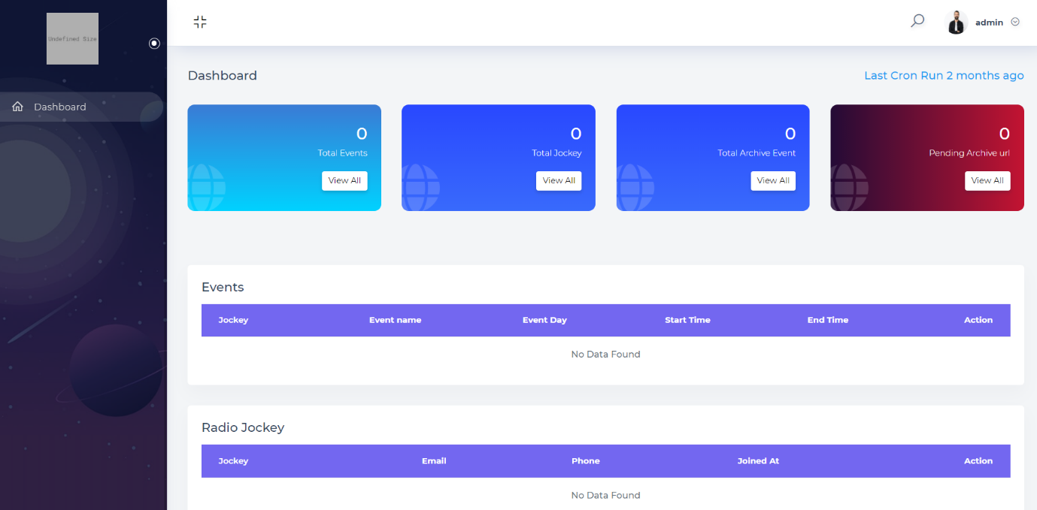

Here the admins can view the event or the activities of the website and made changes to website like set even dates and Jokey lineup. They can also make changes to the visual appeals of the website to better suit their images.

**Reference:**

Adam A. 2014. “Designing an MVC Model for Rapid Web Application Development”, 24th DAAAM International Symposium on Intelligent Manufacturing and Automation.