Statement of Work

Academic Data Extraction Automation with AI — Enroll-U

Field | Detail
Client | Enroll-U
Engagement | AWS Bridge POC — Document Intelligence for Academic Cost Updates
Prepared by | OneData
Client Stakeholders | Mario Gasca
Date | June 2026
Version | 1.0

Executive Summary
Enroll-U operates an educational marketplace with national and international presence that connects students with ~5,000 educational institutions and ~16,000 academic programs. Currently, the updating of costs and educational offerings is done entirely manually by 2 people, processing documents in heterogeneous formats (PDF, Word, Excel, free text, images) that institutions send without fixed periodicity or standard structure.
This engagement implements a Document Intelligence pipeline that automates the extraction, normalization, and loading of academic data using AWS services (Textract, Bedrock, Step Functions). The system processes any document format, extracts relevant information through generative AI, and presents it to an operator for validation before persisting it in the production database.
The work comprises:
- Serverless architecture and infrastructure design in an isolated AWS account
- Processing pipeline orchestrated with Step Functions (classification, extraction, normalization with LLM)
- Web review panel for human validation of extracted data
- Integration with the client's existing MySQL database
- Documentation and knowledge transfer
The result is a functional system that drastically reduces manual data entry time, eliminates transcription errors, and scales to any volume of institutions without requiring format-specific configuration.

Background

Current State
Enroll-U maintains an educational marketplace with the following operation:
- Volume: ~5,000 institutions, ~16,000 educational programs worldwide
- Update process: 2 people manually load data program by program
- Formats received: Digital PDFs, scanned PDFs/brochures, Word documents, Excel spreadsheets, free text messages (WhatsApp/email)
- Frequency: No fixed periodicity — institutions send updates at any time of the year, with higher concentration month to month
- Data managed: Institution, address, programs, academic periods, costs (enrollment, tuition, totals), scholarships, requirements, curriculum
- Current validations: Program registration → academic period enablement → payment installment validation
- Infrastructure: EC2, S3, MySQL on RDS (~12 GB), Laravel backend with API
- AWS administration: Account managed by an external partner
- Error rate: Not currently measured

Objective
Enroll-U seeks to automate the academic data extraction and loading process to:
- Reduce time spent on manual data entry (currently a full-time operation for 2 people)
- Eliminate human transcription errors
- Process any document format without institution-specific configuration
- Maintain human control over published data (validation before persisting)
- Establish a scalable technology foundation for marketplace growth

Target Architecture
The solution is deployed in a new AWS account, isolated from the client's production account. The pipeline is fully serverless and orchestrated with Step Functions.
Total effort: 150 hours | Duration: 7 weeks | Region: us-east-1 (or client-defined)

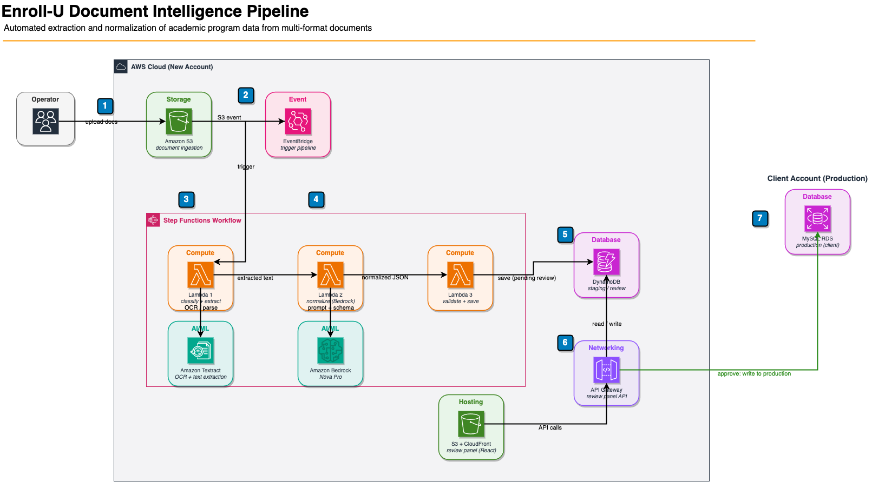

Architecture Details

Pipeline Data Flow
- Operator uploads document (any format) to the S3 ingest bucket
- EventBridge detects the upload event and initiates the Step Function execution
- Lambda 1 classifies the document by type and extracts text: Synchronous Textract (AnalyzeDocument) for single-page documents, Asynchronous Textract (StartDocumentAnalysis) with polling for multi-page, python-docx for Word, openpyxl for Excel, pass-through for plain text
- Lambda 2 sends extracted text to Amazon Bedrock (Nova Pro 2) with a structured prompt that defines the output JSON schema
- Lambda 3 validates the JSON (required fields, reasonable ranges) and saves to DynamoDB with status "pending_review"
- Operator accesses the review panel, views original document vs. extracted data, corrects if necessary and approves
- Upon approval, data is written to the client's production MySQL database

Service Breakdown
Layer | Service | Function
Storage | S3 | Ingest bucket for original documents
Event | EventBridge | Automatic trigger upon upload detection
Orchestration | Step Functions (Standard) | Pipeline with retries and error handling
Processing | Lambda (Python 3.12) | 3 functions: extraction, normalization, validation
OCR / Text | Amazon Textract | Text extraction from PDFs and images
Generative AI | Amazon Bedrock (Nova Pro 2) | Data normalization to fixed schema
Staging | DynamoDB | Data pending human review
API | API Gateway (REST) | Endpoints for review panel
Frontend | S3 + CloudFront | Static review panel (React)
Production | MySQL RDS (existing) | Marketplace database

Processing by Document Type
Type | Detection | Processing
Digital PDF (1 pg) | .pdf extension + embedded text + 1 page | Textract AnalyzeDocument (synchronous)
Digital PDF (multi-pg) | .pdf extension + embedded text + >1 page | Textract StartDocumentAnalysis (async + polling)
Image/brochure PDF | .pdf extension + no embedded text | Textract async with OCR + polling
Word (.docx) | .docx extension | python-docx (paragraphs + tables)
Excel (.xlsx) | .xlsx extension | openpyxl (sheets + cells)
Free text | .txt extension or text content | Pass-through directly to LLM
Image (.jpg/.png) | Image extension | Textract DetectDocumentText

Approach
This engagement progresses through six sequential phases, each with clear deliverables and validation gates:
Phase | Description | Hours
1 | Architecture Design and Infrastructure | 25
2 | Extraction and Normalization Pipeline | 55
3 | Web Review Panel | 25
4 | Production Database Integration | 20
5 | Testing, QA, and Prompt Tuning | 15
6 | Documentation and Knowledge Transfer | 10
 | Total | 150

Scope of Work

Phase 1 — Architecture Design and Infrastructure
Define the complete system architecture, provision the new AWS account, and establish the serverless base infrastructure required for the pipeline.

Activities:
- Design detailed pipeline architecture (services, connectivity, security, data flows)
- Create and configure new isolated AWS account (billing alerts, cost tagging)
- Provision S3 bucket for ingest with access policies
- Configure EventBridge rule for automatic trigger on uploads
- Create Step Functions state machine (ASL definition)
- Configure DynamoDB table for extracted data staging
- Establish IAM roles with least privilege principle per service
- Enable access to Amazon Textract and Amazon Bedrock (model access)
- Configure basic networking and encryption in transit
- Define infrastructure as code structure (CDK or SAM)

Deliverables:
- Architecture Design Document
- Base infrastructure provisioned and functional
- IAM roles configured
- Initial IaC repository
Effort: 25 hours

Phase 2 — Extraction and Normalization Pipeline
Implement the 3 pipeline Lambdas and complete orchestration with Step Functions, achieving an end-to-end flow from document upload to normalized data in DynamoDB.

Activities:
- Develop Lambda 1 (Classify + Extract):
- Implement document type detection by extension
- Implement embedded text vs. image detection for PDFs
- Integrate with Amazon Textract for PDFs and images (synchronous for single page, async with polling for multi-page)
- Implement DOCX parser with python-docx
- Implement Excel parser with openpyxl
- Handle plain text (pass-through)
- Create Lambda Layer with dependencies
- Develop Lambda 2 (Normalize with LLM):
- Design and refine extraction prompt with JSON schema
- Integrate with Amazon Bedrock (Nova Pro 2)
- Implement parsing and validation of LLM JSON response
- Configure retries for Bedrock throttling
- Develop Lambda 3 (Validate + Save):
- Implement business validations (required fields, cost ranges)
- Generate warnings for ambiguous cases
- Persist in DynamoDB with metadata (timestamp, original file, status, warnings)
- Implement error handling (save with "error" status if any step fails)
- Configure Step Functions with retry policies per state and global catch/error handling
- Configure appropriate timeouts per step (120-180s extraction with Textract polling, 60s Bedrock, 30s validation)
- Test end-to-end pipeline with sample documents provided by the client

Deliverables:
- 3 functional Lambdas deployed
- Step Function orchestrating the complete pipeline
- Pipeline processing test documents end-to-end
- Extraction prompt validated with known formats
Effort: 55 hours

Phase 3 — Web Review Panel
Develop a standalone web application that allows operators to review extracted data, compare it with the original document, correct fields, and approve or reject the extraction.

Activities:
- Design review panel UX (basic wireframes)
- Implement React frontend: dashboard, document list, side-by-side detail view
- Implement inline editing form to correct extracted JSON fields
- Implement actions: Approve, Reject (with reason), Reprocess
- Implement backend (API Gateway + Lambda): CRUD endpoints for documents
- Deploy static frontend on S3 + CloudFront
- Configure S3 access for original document viewing (presigned URLs)

Deliverables:
- Functional web review panel deployed
- REST API with CRUD endpoints
- Side-by-side visualization of original document + extracted data
Effort: 25 hours

Phase 4 — Production Database Integration
Implement the writing of approved data to the client's MySQL database, respecting the existing schema and marketplace business rules.

Activities:
- Analyze the client's MySQL database schema (using provided backup)
- Map extracted JSON fields to production database tables/columns
- Implement MySQL write Lambda (cross-account connectivity or VPC peering)
- Implement data transformation: normalized JSON → inserts/updates in client schema
- Handle cases of new program vs. existing program update
- Implement referential integrity validations
- Configure secure connection to RDS (credentials in Secrets Manager)
- Test end-to-end writing: approve in panel → data in production database

Deliverables:
- Functional MySQL write Lambda
- Documented mapping between extracted JSON and production schema
- Complete flow validated: upload → extraction → review → approval → data in production
- Secure cross-account connection configured
Effort: 20 hours

Phase 5 — Testing, QA, and Prompt Tuning
Validate the system with real client documents, tune prompts to improve accuracy, and fix errors found during testing.

Activities:
- Process batch of real documents provided by the client (minimum 20 varied documents)
- Measure extraction accuracy by document type
- Tune LLM prompt to improve extraction in problematic cases
- Fix bugs found in the pipeline and panel
- Validate error handling and edge cases
- Full flow testing with real client operators
- Optimize processing times if necessary

Deliverables:
- Extraction accuracy report by document type
- Optimized prompt validated with real documents
- Bugs fixed
- Stable system processing client documents
Effort: 15 hours

Phase 6 — Documentation and Knowledge Transfer
Document the implemented solution and transfer the necessary knowledge so that Enroll-U can operate the system independently.

Activities:
- Document implemented architecture (diagram + component descriptions)
- Document processing pipeline (flow, configuration, prompts, dependencies)
- Create operation guide for operators (how to upload documents, review, approve, handle errors)
- Document administration guide (how to add users, monitor costs, troubleshoot)
- Document estimated operational costs by volume
- Create extensibility guide (how to adjust schema, add fields, modify prompts)
- Conduct knowledge transfer session with the Enroll-U team

Deliverables:
- Final Architecture Document
- Operation Guide for operators
- Technical Administration Guide
- Operational costs report
- Knowledge transfer session (1 session)
Effort: 10 hours

Effort Summary
Phase | Description | Hours
1 | Architecture Design and Infrastructure | 25
2 | Extraction and Normalization Pipeline | 55
3 | Web Review Panel | 25
4 | Production Database Integration | 20
5 | Testing, QA, and Prompt Tuning | 15
6 | Documentation and Knowledge Transfer | 10
 | Total | 150

Out of Scope
- Modifications to the client's existing Laravel backend
- Modifications to the existing marketplace frontend
- Production database migration
- Chatbot development or improvement of existing chatbot (secondary use case)
- Automatic processing without human validation (full automation)
- Automatic ingestion from email (SES/IMAP integration)
- WhatsApp Business API integration for document reception
- Custom ML model training (fine-tuning)
- Production-level scalability with high availability (multi-AZ, auto-scaling)
- Post-implementation support or ongoing managed services
- Environment separation (dev/staging/prod) beyond the isolated MVP account
- Specific regulatory compliance (GDPR, LFPDPPP) beyond best practices
- Cost optimization of the client's current infrastructure
- Migration of the client's current AWS account
- Development of reports or analytics on processed data
- Support for audio or video formats

Assumptions and Client Responsibilities

Assumptions
- Enroll-U will provide access to a MySQL database backup with the current schema
- Sample documents for testing will be provided by the client (minimum 20 documents in varied formats)
- A new AWS account will be created, separate from the current production account
- Expected volume during the MVP is tens to hundreds of documents per month
- No SLA above 99% availability is required for the MVP
- The client's Laravel backend exposes usable API endpoints, or direct MySQL write access is authorized
- The engagement progresses in sequential phases; Phase N+1 begins after Phase N deliverables are accepted
- AWS infrastructure costs will be covered by the Bridge program during project execution
- Amazon Bedrock (Nova Pro 2) is available in the selected region

Client Responsibilities
- Create or authorize the creation of a new AWS account for the MVP
- Provide MySQL database backup with complete schema
- Provide real sample documents (minimum 20) in the formats typically received
- Provide access or documentation of the existing Laravel API (if used for writing)
- Define mandatory vs. optional fields for the extraction schema
- Participate in extracted data validation session during Phase 5
- Designate operators for review panel testing
- Participate in knowledge transfer session
- Provide availability for question resolution during execution
- Review and approve deliverables within 5 business days of receipt
- Sign NDA before project start (if not already signed)
- Post-implementation operational responsibilities (system operation, infrastructure costs)

Indicative Schedule
Week | Phase | Main Activities
1 | Phase 1 | Architecture design, AWS account creation, base infrastructure provisioning (S3, Step Functions, DynamoDB, IAM, Textract, Bedrock)
2 | Phase 2 | Lambda 1: classification + text extraction. Textract integration. DOCX/Excel parsers
3 | Phase 2 | Lambda 2: normalization with Bedrock. Lambda 3: validation + save. End-to-end functional pipeline
4 | Phase 3 | Review panel: frontend (dashboard, list, side-by-side detail), API Gateway, Cognito
5 | Phase 4 | Production MySQL integration. Schema mapping. Complete approval flow
6 | Phase 5 | Testing with real documents, prompt tuning, bug fixes, testing with operators
7 | Phase 6 | Documentation, cost report, knowledge transfer, closure

Total engagement duration: 7 weeks, subject to team availability, access provisioning, and AWS account availability.

Estimated Operational Costs (Post-MVP)
Monthly estimate for ~500 documents/month processed:
Service | Estimated Cost
S3 (storage + hosting) | < $2
CloudFront | < $1
Step Functions | < $1
Lambda (execution) | < $1
Amazon Textract | ~$7-10
Amazon Bedrock (Nova Pro 2) | ~$2-3
DynamoDB | < $1
API Gateway | < $1
Estimated total | ~$15-20/month

Note: These costs are estimates based on expected volume. Actual cost will depend on effective usage.

