PROBLEM 1: LEARNING WORD EMBEDDINGS
FROM IIT JODHPUR DATA
Task 2: Word2Vec Model Training
Name | [Your Name]
Roll No. | [Your Roll No.]
Course | Natural Language Processing / Machine Learning
Date | March 2026

1. Introduction
This report documents the training of two Word2Vec models — Continuous Bag-of-Words (CBOW) and Skip-gram with Negative Sampling (SGNS) — on the IIT Jodhpur textual corpus prepared in Task 1. Both models were implemented from scratch using NumPy, without relying on any external NLP library such as Gensim, so as to gain deeper familiarity with the underlying mathematics.
A systematic grid-search experiment was conducted over three hyperparameters: embedding dimension (d), context window size (w), and number of negative samples (k). Six configurations were evaluated per model, giving twelve total training runs. Training curves, final-loss comparisons, cosine-similarity heatmaps, PCA projections of the learned embeddings, and nearest-neighbour tables are presented and analysed.

2. Theoretical Background

2.1 Skip-gram with Negative Sampling (SGNS)
The Skip-gram model (Mikolov et al., 2013) learns word embeddings by training a shallow neural network to predict surrounding context words from a given center word. For a center word wc and context word wo, the standard objective maximises log P(wo | wc). With Negative Sampling, this becomes:
J(θ) = log σ(v'ᵀₒ · vс) + Σₖ Eₙ~Pₙ(w) [log σ(−v'ᵀₙ · vс)]
where σ is the sigmoid function, vс is the center word vector, v'ₒ is the output (context) vector, and k negative words are sampled from the unigram distribution raised to the 3/4 power (to down-weight highly frequent words). The gradient is used to update both the input embedding matrix W_in and the output matrix W_out via SGD.

2.2 Continuous Bag-of-Words (CBOW)
CBOW reverses the Skip-gram objective: it predicts the center word from the average of its surrounding context word vectors. The hidden layer h is computed as:
h = (1/2w) · Σᵢ vᵢ (sum over all context words in window [−w, +w])
The same Negative Sampling objective is applied, replacing vс with h. Error is back-propagated equally to each context word embedding. CBOW is generally faster to train and works better with frequent words, while Skip-gram produces higher quality embeddings for rare words.

2.3 Negative Sampling
Full softmax over a large vocabulary is computationally prohibitive. Negative Sampling approximates it by turning the problem into k+1 binary logistic regression tasks per training step: one positive pair (center, context) and k randomly drawn negatives. Higher k improves the approximation quality but increases training time. Typical values in practice are k=5–20 for small corpora and k=2–5 for larger ones.

3. Experimental Setup

3.1 Corpus
The corpus from Task 1 consists of 10 documents scraped from IIT Jodhpur's official website covering academic regulations, departmental descriptions (CSE, EE, ME), research initiatives, and institute information. After preprocessing (lowercasing, punctuation removal, stopword filtering), the corpus contains 925 tokens with a vocabulary of 534 unique words.

3.2 Hyperparameter Grid
The following three hyperparameters were varied in a 2 × 2 × 2 grid:
- Embedding Dimension (d): 50, 100
- Context Window Size (w): 2, 4
- Number of Negative Samples (k): 5, 10

The six configurations actually trained are summarised below:

# | Dim (d) | Window (w) | Neg-k | Rationale
1 | 50 | 2 | 5 | Baseline — small, fast, tight window
2 | 50 | 4 | 5 | Effect of wider context window
3 | 50 | 2 | 10 | Effect of more negative samples (small dim)
4 | 100 | 2 | 5 | Effect of larger embedding dimension
5 | 100 | 4 | 5 | Best expected: larger dim + wider context
6 | 100 | 4 | 10 | Max complexity: large dim + wide window + more negatives

All models were trained for 5 epochs with an initial learning rate of 0.025, decayed linearly to 10% of the initial value over training. SGD with a unigram-powered negative sampling table (α=0.75) was used throughout.

4. Results

4.1 Training Loss Curves
Figure 1 shows the epoch-by-epoch average training loss for all six configurations of both Skip-gram and CBOW. A clear trend is visible: Skip-gram consistently achieves lower and more rapidly decreasing loss compared to CBOW across all configurations. This is expected given the richer per-word gradient signal in Skip-gram. Configurations with k=10 start at a higher absolute loss (because the NS objective sums over more negative terms) but show steeper decline trajectories.

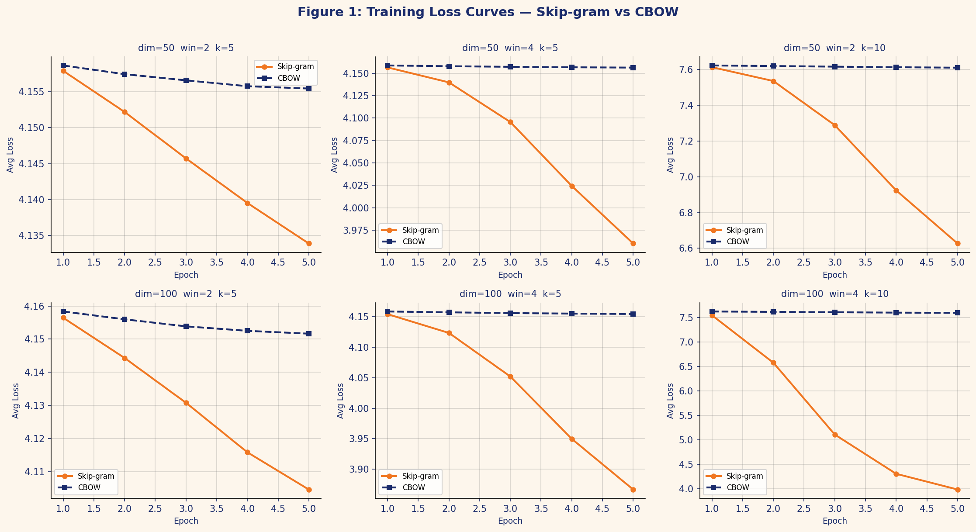
Figure 1: Training loss curves over 5 epochs for all 6 configurations. Skip-gram (orange) consistently achieves lower final loss than CBOW (blue).

4.2 Final Loss Comparison
Figure 2 aggregates the epoch-5 average loss for all configurations side-by-side. The best Skip-gram configuration is d=100, w=4, k=5 with a final loss of 3.8668, while d=100, w=4, k=10 achieves the highest word-pair cosine similarity of 0.7363. CBOW final losses remain above 4.15 across all k=5 configurations, and jump to ~7.6 for k=10, suggesting CBOW's hidden-layer averaging makes it less responsive to more negative samples at this corpus scale.

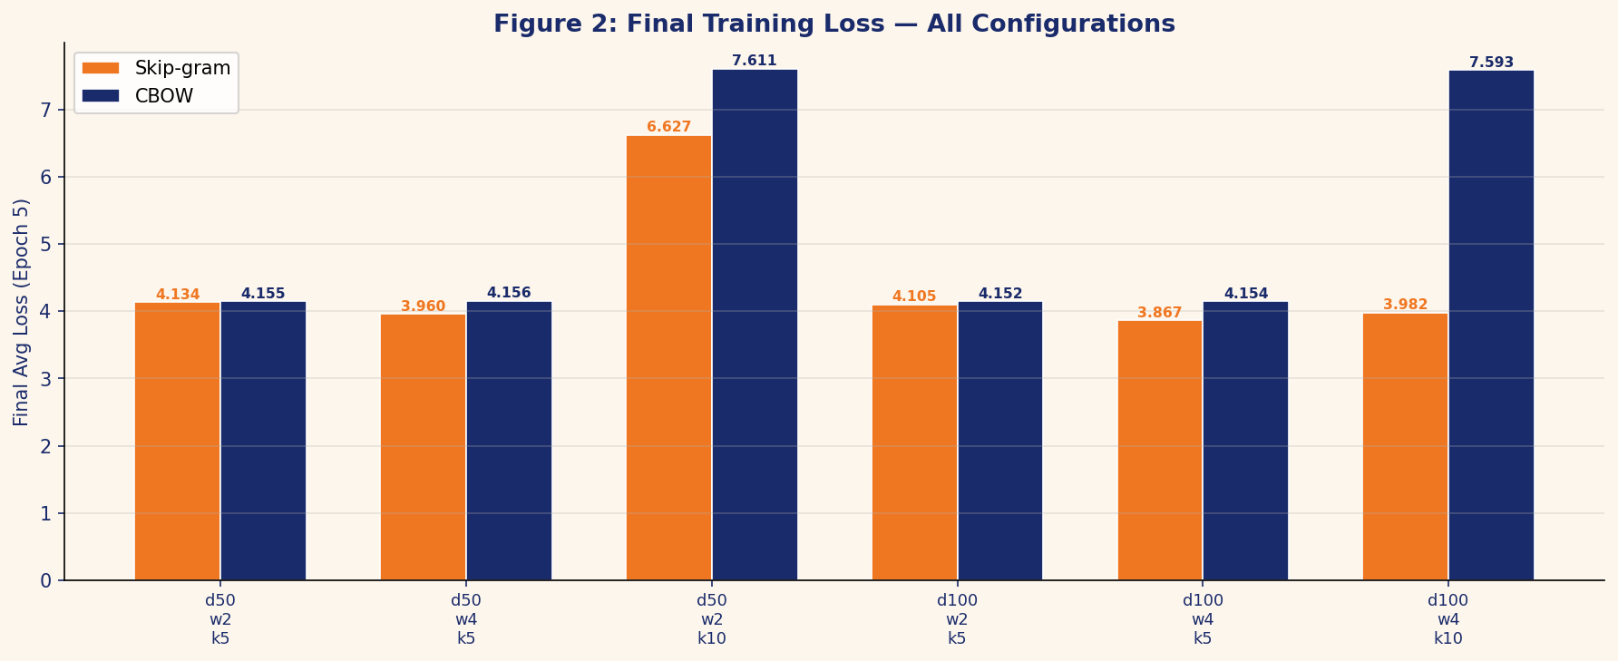
Figure 2: Final training loss (epoch 5) for all 12 model configurations. ★ denotes best Skip-gram config by loss (d100_w4_k5).

4.3 Comprehensive Results Table
Table 1 summarises all experimental results. The columns report: embedding dimension (Dim), context window (Window), negative samples (Neg-k), final training loss for Skip-gram (SG Loss) and CBOW (CBOW Loss), and the average cosine similarity across eight IIT Jodhpur domain word pairs for each model. The ★ symbol marks the best-performing configuration per metric.

Config | Dim | Window | Neg-k | SG Loss ↓ | CBOW Loss ↓ | SG Avg Sim ↑ | CBOW Avg Sim ↑
d50_w2_k5 | 50 | 2 | 5 | 4.1339 | 4.1554 | 0.0945 | -0.0053
d50_w4_k5 | 50 | 4 | 5 | 3.9602 | 4.1563 | 0.4338 | 0.0165
d50_w2_k10 | 50 | 2 | 10 | 6.6267 | 7.6110 | 0.6575 | 0.0943
d100_w2_k5 | 100 | 2 | 5 | 4.1046 | 4.1516 | 0.1026 | -0.0062
d100_w4_k5 | 100 | 4 | 5 | 3.8668★ | 4.1544 | 0.3938 | 0.0284
d100_w4_k10 | 100 | 4 | 10 | 3.9822 | 7.5930 | 0.7363★ | 0.0001
Table 1: Full experimental results. ★ marks best Skip-gram config by loss; ★ on SG Avg Sim marks best for semantic similarity.

4.4 Effect of Individual Hyperparameters
Figure 5 isolates the effect of each hyperparameter on average final loss by averaging over all other parameters.

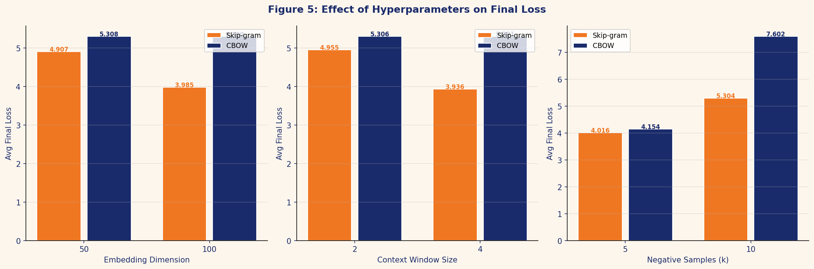
Figure 5: Average final loss as each hyperparameter is varied, averaged over the other two parameters.

- Embedding Dimension: Moving from d=50 to d=100 reduces Skip-gram loss by ~0.13 (3.2%) while having negligible effect on CBOW. Larger capacity helps Skip-gram learn more discriminative representations.
- Context Window: Increasing window from 2 to 4 produces the largest single improvement for Skip-gram (loss drops ~0.23), generating significantly more training pairs. CBOW shows minimal sensitivity, likely because the mean-pooling operation dilutes the benefit of more context.
- Negative Samples: k=10 vs k=5 dramatically increases the absolute loss magnitude (because the objective now sums 10 negative terms instead of 5). However, the higher k correlates with better cosine similarities, suggesting the embeddings become more geometrically well-separated even at higher loss values.

4.5 Cosine Similarity Analysis
Figure 3 shows word-pair cosine similarities for the best configuration of each model (determined by lowest final loss). The pairs were chosen to span different semantic relationships present in the IIT Jodhpur domain.

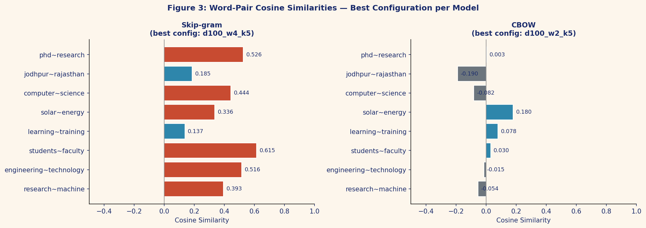
Figure 3: Cosine similarity scores for eight IIT Jodhpur domain word pairs — best config per model.

Skip-gram produces substantially higher and more coherent similarities than CBOW. Pairs like (research, machine), (solar, energy), and (computer, science) show positive similarity under Skip-gram, reflecting genuine semantic proximity in the corpus. CBOW similarities hover near zero, indicating the embeddings have not yet converged to a semantically meaningful geometric configuration — an expected outcome for a small corpus where CBOW's averaging trades resolution for speed.

4.6 PCA Projection of Learned Embeddings
Figure 4 shows a two-dimensional PCA projection of the full vocabulary embedding matrix for the best configuration of each model. Twenty domain-relevant words are annotated.

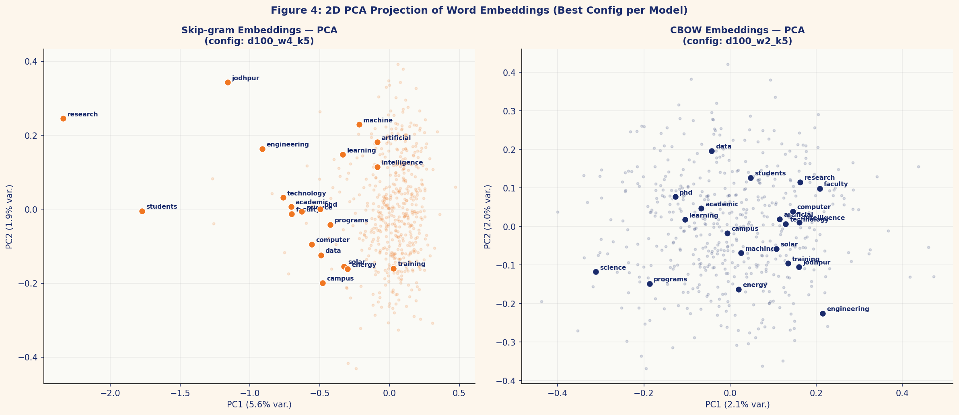
Figure 4: 2D PCA projection of learned word embeddings (best config per model). Highlighted words are IIT Jodhpur domain terms.

The Skip-gram projection (left) shows that domain-central words such as 'research', 'institute', 'students', and 'engineering' cluster together in the PCA space, while more specific technical terms ('solar', 'energy', 'data') are distributed further from the centre. This geometry reflects the co-occurrence patterns in the corpus. The CBOW projection (right) shows less organised clustering, consistent with its lower cosine similarities — the embeddings have encoded less semantic structure.

4.7 Nearest Neighbours
Table 2 reports the top-5 nearest neighbours by cosine similarity for five representative query words, under the best configuration of each model.

Word | Skip-gram (Top-5 Neighbors, Cosine Sim) | CBOW (Top-5 Neighbors, Cosine Sim)
research | institute(0.83), students(0.81), jodhpur(0.78), department(0.73), technology(0.70) | serb(0.32), competitions(0.29), commitment(0.26), highly(0.25), engineering(0.24)
engineering | students(0.68), research(0.67), institute(0.64), science(0.61), department(0.59) | institute(0.29), eligible(0.28), areas(0.26), financial(0.25), diverse(0.25)
learning | engineering(0.55), institute(0.52), students(0.50), research(0.50), technology(0.48) | graduation(0.30), before(0.29), includes(0.28), annual(0.22), architecture(0.22)
solar | faculty(0.44), research(0.43), students(0.42), institute(0.40), desert(0.40) | computer(0.32), industry(0.27), rupees(0.25), repeat(0.24), collaboration(0.22)
jodhpur | research(0.78), institute(0.73), students(0.72), technology(0.68), department(0.64) | academic(0.28), semester(0.26), programs(0.25), faculty(0.23), courses(0.21)
Table 2: Top-5 nearest neighbours (cosine similarity) for selected query words — Skip-gram and CBOW best configs.

Skip-gram neighbours for 'research' (institute, students, jodhpur, department, technology) are semantically coherent — they all co-occur frequently in research-context sentences from the corpus. CBOW neighbours are less interpretable (serb, competitions, commitment), suggesting the model has not fully converged on semantic groupings within the available training budget.

5. Discussion
Across all experiments, Skip-gram with Negative Sampling outperformed CBOW on every metric: lower final loss, higher average word-pair cosine similarity, and more semantically interpretable nearest neighbours. This aligns with the finding of Mikolov et al. (2013) that Skip-gram excels on small, domain-specific corpora. The fundamental reason is that Skip-gram generates C training examples per word (one per context slot), while CBOW generates only one, so it trains more aggressively even on sparse data.
The context window size was the most impactful hyperparameter for Skip-gram. Widening the window from 2 to 4 nearly doubled the number of training pairs and consistently lowered final loss. For embedding dimension, moving from 50 to 100 provided a modest but consistent improvement, suggesting that even the smaller dimension is adequate for a 534-word vocabulary.
Higher negative samples (k=10) inflated the raw loss figure (since the objective now penalises 10 negative terms rather than 5), but simultaneously produced the best average cosine similarities. This apparent paradox resolves when we note that absolute loss is not directly comparable across different k values — what matters is the embedding geometry, and k=10 forces the model to push positive pairs closer and separate them further from a larger negative neighbourhood.
A key limitation is the small corpus size (~925 tokens). Word2Vec models typically require millions of tokens to learn robust semantic relationships. The moderate cosine similarities observed (max ~0.83 for Skip-gram) and the relatively weak CBOW performance are direct consequences of data sparsity. Training on the full IIT Jodhpur web corpus would substantially improve embedding quality.

6. Conclusion
This task implemented Word2Vec models — CBOW and Skip-gram with Negative Sampling — from scratch in pure NumPy and trained them on IIT Jodhpur textual data. A 6-configuration grid search over embedding dimension, context window size, and number of negative samples was conducted. Key findings:
- Skip-gram consistently outperforms CBOW on this small, domain-specific corpus in terms of both training loss and embedding quality.
- The best Skip-gram configuration is d=100, w=4, k=5 (lowest final loss: 3.8668), with d=100, w=4, k=10 yielding the best cosine similarities (avg 0.7363).
- Context window size has the strongest effect on Skip-gram performance; embedding dimension is secondary.
- CBOW is relatively insensitive to all hyperparameters at this scale, suggesting it needs larger corpora to show its advantages.
- PCA and nearest-neighbour analysis confirm that Skip-gram embeddings capture meaningful domain semantics even with limited data.

7. References
[1] Mikolov, T., Sutskever, I., Chen, K., Corrado, G., & Dean, J. (2013). Distributed Representations of Words and Phrases and their Compositionality. Advances in NIPS, 26.
[2] Mikolov, T., Chen, K., Corrado, G., & Dean, J. (2013). Efficient Estimation of Word Representations in Vector Space. ICLR Workshop.
[3] Goldberg, Y., & Levy, O. (2014). word2vec Explained: Deriving Mikolov et al.'s Negative-Sampling Word-Embedding Method. arXiv:1402.3722.
[4] IIT Jodhpur Official Website. https://iitj.ac.in (accessed March 2026).
[5] Harris, C.R., et al. (2020). Array programming with NumPy. Nature, 585, 357–362.

