
BWIM815: Industry Integration Methodology- 2026

Project Proposal

What drives the ZAR/USD exchange rate (2026)

Prepared by | SPT
Date | 13 March 2026
Client | Prof Waldo Krugell
Project Team | Ms Michelle Le Roux  Ms Maroné Moolman  Mr Shahil Mathapershad
Project Supervisor | Ms Anke Steyn

TITLE PAGE
TITLE: | What drives the ZAR/USD exchange rate (2026)
CLIENT SPONSOR: | Prof Waldo Krugell
SYNOPSIS: | This project aims to develop an interpretable model for forecasting the monthly ZAR/USD exchange rate by analysing the key drivers of the ZAR and USD.
PREPARED BY: | SPT
DATE: | 13 March 2026
COURSE: | BWIM815: Industry Integrated Project
STUDENT PROJECT TEAM: | Ms Michelle Le Roux  Ms Maroné Moolman  Mr Shahil Mathapershad
ACADEMIC SUPERVISOR: | Ms Anke Steyn
DISTRIBUTION: | Prof Waldo Krugell

TABLE OF CONTENTS
Executive summary 5
1. Introduction and project concept statement 6
2. Project description and background 7
3. Project scope 9
4. Project objectives 10
5. Project approach 11
6. Project plan 13
7. Deliverables 15
8. Project fees 16
9. Assumptions and conditions 17
10. Risk 18
11. Measures of success 19
12. Conclusion 20
References 21
Appendix A: Work breakdown structure (WBS) 22
Appendix B: Gantt-chart 23
Appendix C: S-curve 25

LIST OF TABLES
Table 1: Project plan 13
Table 2: Estimated project costs 16
Table 3: Risk matrix 18
Table 4: Project success matrix 19

LIST OF FIGURES
Figure A: Work breakdown structure 22
Figure B: Gantt-chart 23
Figure C: S-curve 25

LIST OF ABBREVIATIONS
BEER: Behavioural Equilibrium Exchange Rate

FRED: Federal Reserve Economic Data
GDP: Gross Domestic Product
REER: Real Effective Exchange Rate
SA: South Africa
SPT: Student Project Team
US: United States
USD: United States Dollar
VIX: Chicago Board Options Exchange Volatility Index
WBS: Work Breakdown Structure
ZAR: South African Rand
ZAR/USD: South African Rand to United States Dollar

Executive summary
This document presents the proposal of an interpretable model for forecasting the monthly South African Rand to United States Dollar (ZAR/USD) exchange rate by analysing the key drivers of the South African Rand (ZAR) and United States Dollar (USD).
The client, Waldo Krugell, is a professor in economics at the North-West University. He is also a host for the educational broadcast ‘Economics Weekly’, where the exchange rate is often a topic of discussion. The audience of the broadcast consists mostly of local farmers. The farmers might be interested in learning more about exchange rate forecasts to make better informed business decisions regarding pricing their commodities or budgeting for production costs, such as fertiliser.
Currently, the client obtains a forecast of the exchange rate from Codera Analytics whenever the exchange rate is to be discussed. Although this estimate is accurate, it does not provide the client with any indication of which underlying factors drive this prediction, or in what way it is influenced by the factors. Furthermore, the client would like to evaluate how hypothetical changes in the underlying factors affect the prediction.
The proposed model should therefore be easy to use and capable of updating automatically as new data becomes available.
To develop the model, research will be done to gain a better understanding regarding the factors that have an influence on the South African Rand and the United States Dollar exchange rate. Different models and approaches will be assessed to identify the most suitable forecasting method.
The final deliverables of this project will be a forecasting model with a user-friendly interface, a user-manual and a report.
The successful completion of the project depends on several assumptions and conditions. It is assumed that the sourced data will be relevant and sufficient, that the future ZAR/USD exchange rates can be forecasted using historical data, that the client will have access to data from Federal Reserve Economic Data (FRED) and Statistics South Africa, and that stakeholders will provide feedback within a reasonable timeframe. Several risks that may affect the project, such as data server failures, user input errors and potential changes in external data sources have been identified.
The model will be evaluated and presented on the 13th of May 2026, and the report will be finalised in the last week of May 2026, please note no support will be provided after the final handover of the deliverables. Using a detailed project plan and assuming a rate of R500 per hour. However, the actual cost of the project is R0, therefore the project will be completely free.

Introduction and project concept statement
The client, Waldo Krugell, is an economics professor at North-West University who hosts the YouTube broadcast Economics Weekly. His primary aim is to enrich his broadcasts by providing his audience with clear, interpretable forecasts of the South African Rand to United States Dollar (ZAR/USD) exchange rate. Currently, he relies on third-party forecasts that offer numerical predictions but lack transparency regarding the underlying economic drivers. Due to the client not having access to the underlying model mechanics, he struggles to interpret the factors driving these outputs. Therefore, the objective of this project is to develop a custom, interpretable model for forecasting the monthly ZAR/USD exchange rate. By identifying and analysing key macroeconomic drivers, the final model will empower the client to explain the reasons behind currency fluctuations from a quantitative perspective.
This document consists of twelve sections that describe the different aspects of the project. In Section 2, we provide a description of the project background. In Section 3, we define the scope of the project, outlining the specific aspects of the problem we address. In Section 4, we state the specific objectives that the project achieves. In Section 5, we elaborate on the proposed approach to reach the stated objectives. In Section 6, we present the high-level tasks in the form of a project plan. In Section 7, we clearly state the project deliverables. In Section 8, we provide an estimate of the fees required to complete the project. In Section 9, we outline the assumptions and conditions necessary for a successful project. In Section 10, we identify the associated risks and mitigation strategies. In Section 11, we detail the measures of success. Finally, Section 12 concludes the document. In Appendix A, the work breakdown structure (WBS) can be found, together with the Gantt-chart in Appendix B and the S-curve in Appendix C.

Project description and background
This section provides a broader explanation of the background to the project. A big focus of the project will be forecasting the ZAR/USD exchange rate, and therefore we start with a brief literature study. Thereafter, we discuss the current system that the client utilises and consider the strengths and shortcomings thereof.
The audience of the educational broadcast consist mostly of South African (SA) farmers. They might be interested in learning more about exchange rates when they are faced with decisions on the timing of the export of their products. Through the broadcast, they may become better informed on the factors to consider in such decisions.

To predict the ZAR/USD exchange rate, it is necessary to consider the factors that previous literature has identified as important determinants of exchange rate movements. This topic is significant as the SA investment decisions, macroeconomic stability and international trade are all influenced by the movements in the exchange rate. Due to SA being a small open economy, it is especially vulnerable to external shocks, making exchange rate forecasting essential for policymakers.
Although our project aims to predict the ZAR/USD rather than compare the rand with a basket of trading partner currencies as done with the Real Effective Exchange Rates (REERs), many of the macroeconomic variables influence both measures. The REER is defined as the nominal effective exchange rates adjusted for price differentials between a country and its trading partners, and it is commonly used to measure a country’s relative price competitiveness in international trade (Walters & de Beer , 1999).
MacDonald & Ricci (2003) estimated the REER for SA and found that the main explanatory variables include commodity price movements, productivity and real interest rate differentials, measures of openness, the net foreign assets position and the size of the fiscal balance. Similarly, de Jager (2012) conducted a study to estimate the long-run equilibrium level of the REER. They found the key economic factors influencing the REER to be the same as those used by MacDonald & Ricci (2003).
Botha, et al. (2018) developed a model of the equilibrium REER and obtained somewhat different results from those of de Jager (2012). While de Jager (2012) identified openness and capital flows as a ratio of Gross Domestic Product (GDP) as the largest contributors, Botha, et al. (2018) found that productivity differentials, the real commodity price trend and the structural budget balance contributed more significant to movements in the equilibrium REER.
Another framework commonly used to analyse exchange rate behaviour is the Behavioural Equilibrium Exchange Rate (BEER) approach. BEER aims to estimate the equilibrium level of the real exchange rate based on macroeconomic fundamentals, rather than to measure the competitiveness of a country as is the case with REER (MacDonald, 1997). Using this approach, Hoosain, et al. (2017) showed that the ZAR/USD exchange rate responds to fundamental macroeconomic variables mainly in the long run, rather than in the short run. These fundamental variables include interest rate differentials, money supply differential and measures of risk. Their results further indicate that a long run equilibrium relationship exists between the BEER and variables such as terms of trade, external openness, capital flows and government expenditure.
It is important to note that the estimated equilibrium level of the exchange rate is highly influenced by the choice of variables included in the exchange rate model. Saayman (2007) estimated the BEER using three different measures of the real exchange rate: cost inflation, price inflation, and labour cost adjusted real exchange rates. Despite the differences in measurement, the results indicated that the equilibrium exchange rate followed a similar path regardless of the real exchange rate measure used. The explanatory variables included relative GDP rates, terms of trade, interest rate differentials, the gold price, net foreign assets, trade openness, the fiscal balance, gross reserves, a commodity index and government expenditure.
Overall, the literature suggests that exchange rate movements in SA are influenced by a variety of macroeconomic fundamentals. Studies focusing on the REER and the BEER consistently identify factors such as commodity prices, productivity differentials, interest rate differentials, fiscal balances, capital flows, and trade openness as important determinants of the exchange rate. Although our project focuses specifically on predicting the USD/ZAR exchange rate, the findings from previous research provide valuable insight into the macroeconomic variables that influence the value of the rand. These studies therefore guide the selection of explanatory variables to be used in the development of our exchange rate forecasting model.

Exchange rate forecasting studies typically employ several competing models as no single model consistently outperforms others. The current system, EconData (2026) predicts the exchange rate using pure forecasting time–series models such as the random walk, ARIMA model, exponential smoothing models and monthly local linear trend models. These models rely solely on past exchange rate data and perform well for short–term exchange rate forecasts. These models do not explain what drives the exchange rate. EconData (2026) further uses error correction models and vector error correction models which incorporate macroeconomic variables that influence the exchange rate. These models are useful to link the movements in the exchange rate to macroeconomic drivers. Equilibrium exchange rate models such, as the Behavioural Equilibrium Exchange Rate model (BEER) model, also forms part of the EconData (2026) analysis. This model identifies the fundamental drivers of the exchange rate but is not primarily designed for short–term forecasting. Additionally, Botha, et al., (2018) used a quasi–Bayesian estimation approach to estimate a stylised model of the real exchange rate. This method is used to estimate the model parameters, rather than to forecast the exchange rate. Saayman (2007) also made use of a BEER model to determine what the real equilibrium ZAR/USD exchange rate should be. Given the concept statement of the project is to produce monthly forecasts of the ZAR/USD exchange rate, a multi–model forecasting strategy should be applied. Instead of relying on a single model, various models should be compared and then be combined, or the best performing model should be selected.

Project scope
The scope of this project consists of three main components outlined in the background section: to understand the problem, develop a solution and communicate the results. The first component focuses on identifying and quantifying the key factors that influence movements in the ZAR/USD exchange rate. These factors will be selected based on economic reasoning and previous research. Relevant input variables will be obtained from reliable data sources such as Federal Reserve Economic Data (FRED) and Statistics South Africa. These variables may include macroeconomic indicators that reflect the economic conditions of both SA and the United States (US).
The second component involves developing an interpretable forecasting model that uses the identified drivers to predict the monthly ZAR/USD exchange rate. Different modelling approaches will be investigated and evaluated to determine which method provides the most suitable balance between predictive performance and interpretability. The aim is to ensure that the model not only generates forecasts but also provides insight into how the underlying variables influence the exchange rate.
The final component of the project focuses on presenting the results in a clear and accessible way. The forecasts and relevant information will be displayed through a user-friendly interface that allows the client to easily interpret the results and explore how changes in the underlying factors may affect the predicted exchange rate. In this way, the project addresses part of the broader challenges of exchange rate forecasting by developing an interpretable model and practical tool that can assist the client in understanding and communicating exchange rate movements.

Project objectives
The objectives of this project are closely aligned with the overall aim of identifying and modelling the key drivers of the rand-dollar exchange rate. Firstly, the project seeks to identify and analyse the macroeconomic and financial factors that contribute most significantly to movements in the exchange rate. This involves investigating a range of potential explanatory variables, including economic indicators and market variables that may influence the value of the ZAR relative to the USD.
Secondly, the project aims to collect, clean and integrate relevant data for these factors from reliable sources, such as the FRED database and Statistics South Africa, to construct a comprehensive dataset suitable for analysis and modelling.
A further objective is to develop an interpretable forecasting model that captures the relationship between the exchange rate and its key drivers. The model should not only provide forecasts of the exchange rate but also allow for hypothetical scenarios, thereby offering insight into how changes in specific economic variables may affect future exchange rate movements. In addition, the project aims to evaluate the performance and reliability of the proposed model to ensure that it provides meaningful insights.
Finally, the results of the analysis will be communicated through a user-friendly interface, enabling the client to easily interpret the forecast and understand the factors that drive changes in the rand-dollar exchange rate. A report will be delivered along with a user guide for the model.

Project approach
This section aims at achieving the objectives outlined in the previous section. The approach can be segmented into a three-phased process. Phase 1 consists of understanding the problem and performing data aggregation, exploratory data analysis and data cleaning. Phase 2 comprises of the development, validation and selection of the model. Phase 3 incorporates the outputs of the previous phases into an online dashboard and final report. The steps are discussed in further detail below.

Understanding the problem and data preparation
This step involves analysing and defining the core problem this project seeks to solve. The current procedure will first be assessed in terms of its ability to fulfil the client’s needs and the shortcomings thereof. The problem was investigated using relevant academic literature and implemented industry solutions to assess viable methodologies and approaches to the modelling process. As a result of this, the modelling prerequisites such as data and technical requirements will be identified. Prerequisites for the end-user interface also need to be researched at this step. The information obtained in this step will inform the scope of this project, ensuring it can be completed within the allocated time.
Relevant economic variables from multiple sources must be consolidated into a unified database. This involves data processing, in terms of frequency harmonisation and missing value imputation, as well as data linkage. The data aggregation process needs to be well documented, and any data quality issues need to be identified. The data exploration process will be done graphically and formally by making use of multivariate and univariate statistical techniques. Data will be explored to reveal response-predictor relationships, discover outliers, and identify multicollinearity between predictors. Any further data remediation procedures necessary will be performed. Feature engineering, informed by the exploratory data analysis, will be performed on necessary features to aid the modelling process. Unreliable and irrelevant data will be omitted based on the insights gained from the exploratory data analysis. Data will then be split into training and testing subsets for use in model development and validation. The time series nature of the data needs to be preserved in the training-testing split procedure.

Model development, validation and selection
Using insights gained from research in the initial phase, candidate models can be implemented on the training subset. Models will make use of automated variable selection techniques and regularisation to achieve parsimony. Given the time-dependent nature of the variables, specific attention will be given to autoregressive characteristics, non-stationarity, and the appropriate inclusion of macroeconomic covariates.
Models will then be validated using the testing subset, whereby model predictions will be contrasted against the testing subset. Multiple validation metrics relevant to time series modelling will be considered. A final model will be selected from the list of candidate models stipulated in the model development step. The model selection will be based on an optimal balance of predictive accuracy, computational efficiency, and interpretability, ensuring it meets the practical and analytical requirements of the project.

System integration and dashboard development
Insights and predictions from the final model will be integrated into an interactive online dashboard. This platform will be the primary graphical user interface, allowing users to visualise historical trends, view model forecasts, and interact with the underlying economic variables. The development of the dashboard must focus on exception handling, computational efficiency, and user-friendly design decisions. The dashboard allows complex statistical outputs to be translated into a format that will aid the client’s educational broadcasts. A user manual will be compiled to guide new and current users of the dashboard in using the system. The user manual is aimed at being comprehensive and will address questions we anticipate users frequently ask.

Project finalisation
The project handover will mark the end of the project. During the project handover, software deliverables and a final report will be given to the client. The software deliverables will include documented source code responsible for the data analysis, model development and validation, and the deployment of the dashboard. Alongside the source code, the finalised databases containing user information and model data will be securely transferred. The final report will serve as a reference for the complete project lifecycle.

Project plan
The project plan outlines the sequence of tasks and the estimated completion time (in hours) for the project. The three main tasks correspond to the three steps described in the approach in Section 5.
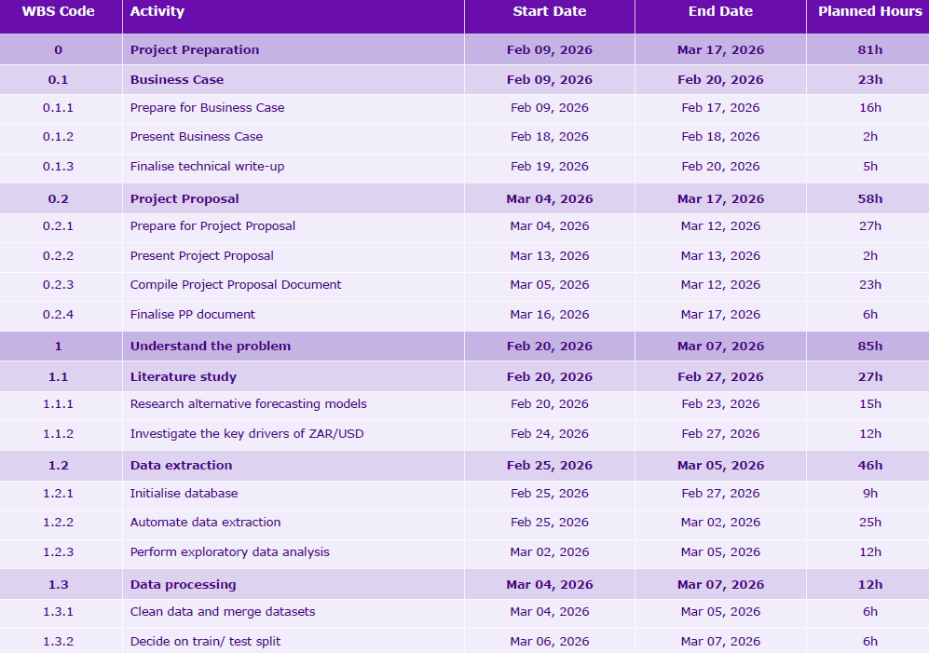
Table 1: Project plan

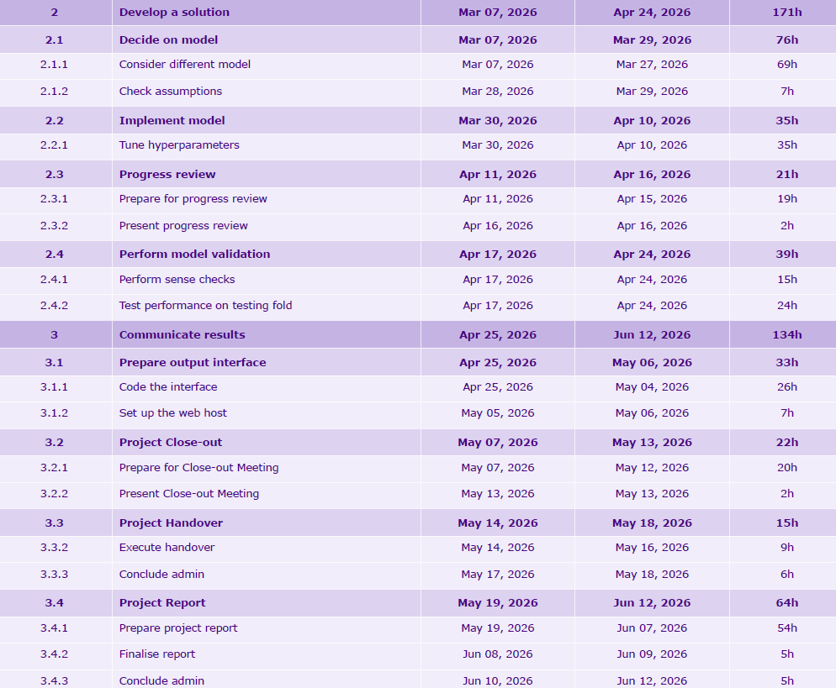
Table 1 (continued): Project plan

Deliverables
To successfully complete the project, interim and final deliverables will be provided to the client. The interim deliverables will consist of a list of the selected key drivers of the ZAR/USD exchange rate that will be used to build the proposed model. In addition, the chosen modelling approach used to develop the solution, as well as the initial dashboard and user manual, will form part of the interim deliverables. The purpose of these interim deliverables is to obtain feedback from the client and ensure that any concerns are identified and addressed at an early stage of the project.
The final deliverables will include a numerical forecast of the ZAR/USD exchange rate one month ahead, together with all the data used to generate the predictions, a user manual, and a final report. The client will also have the option to adjust the factors used in generating the forecast. The predicted exchange rate and historical exchange rates will be displayed in a line chart within a dashboard, for ease of interpretability. All data used to produce the forecasts will be displayed on the website https://www.economicsweekly.co.za and will update automatically on a monthly basis. The user manual will guide the client on how to use the model and will include suggestions for resolving common errors. The results of the project will be documented in the final report, which will also justify the selection of the model and the drivers of the rand–dollar exchange rate.

Project fees
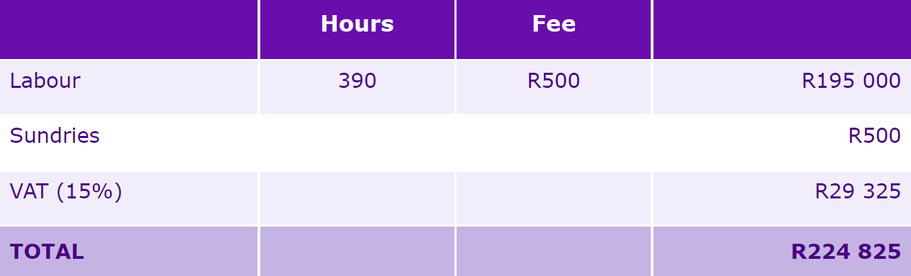
The total estimated project cost is R224 825 with the exact calculations shown in Table 2. The actual cost of the project has been determined as R0.
Table 2: Estimated project costs

Assumptions and conditions
The following assumptions and conditions must be met to ensure the successful completion of this project. It is assumed that the data sourced from available databases will be relevant and useful for analysis. In addition, it is assumed that future ZAR/USD exchange rates can be forecasted using historical data and established modelling techniques. The project further assumes that the client will have access to the required data sources, the FRED database and Statistics South Africa. Lastly, it is assumed that stakeholders will provide feedback in a timely manner throughout the project to support its progress and refinement.
Two conditions must be met for the project to proceed as planned. The project proposal must be accepted by 31 March 2026 to allow the project to move forward according to the proposed timeline. Furthermore, no additional support will be provided after the final handover of the project.

Risk
The table below summarises several risks that are outside the control of the student project team (SPT), but may influence the success of the project if they are not properly managed. It presents the identified risks, the likelihood of their occurrence, the potential impact should they occur, and the strategies that can be used to mitigate them.
Table 3: Risk matrix
Risk | Probability | Impact | Mitigation
Data collection servers down | Low | High | Include error handling
User input error | Low | Medium | User manual
Changes in external data sources | Medium | High | Include error handling

Measures of success
To evaluate the success of the project, the SPT proposes a quantitative measure in the form of a project success matrix, which will be completed at the end of the project.
This matrix serves as a guideline to evaluate the extent to which the project objectives have been achieved.
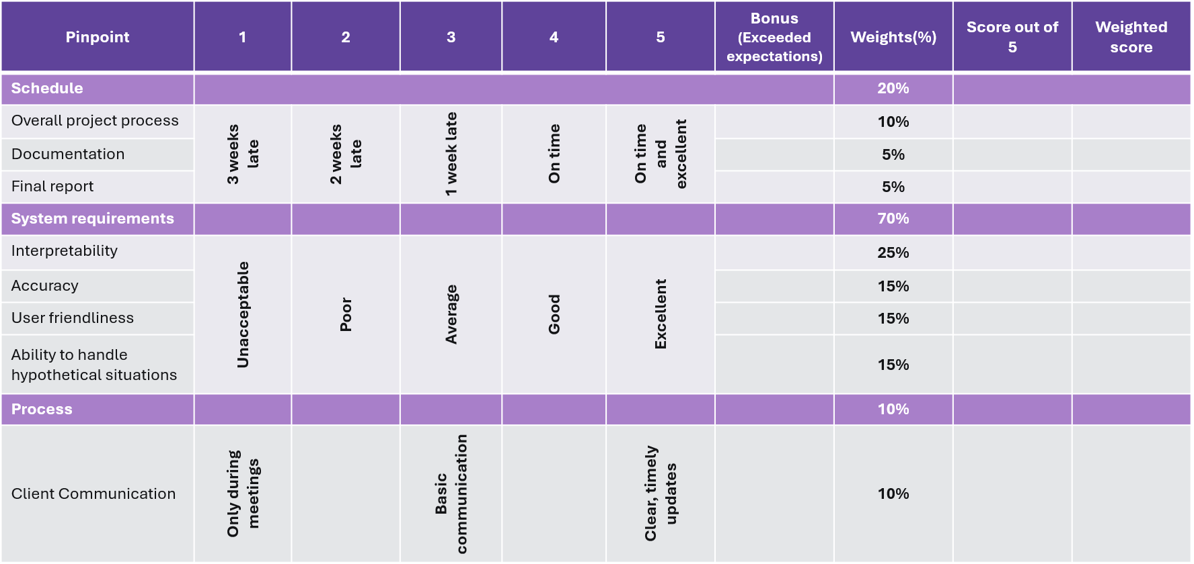
Table 4: Project success matrix

Figure B1: Work Breakdown StructureTable 6: Project Success Matrix

Conclusion
In conclusion, this project aims to address the client’s needs by developing a custom, interpretable model for forecasting the monthly ZAR/USD exchange rate. By providing explanatory insights into the underlying economic drivers of the exchange rate, the proposed model will enhance the analytical depth of the client’s broadcast. The model will be designed to be user-friendly and capable of updating automatically as new data becomes available. To ensure practical usability, the client will receive a comprehensive user manual explaining how to operate the model, as well as a final report presenting the methodology and key results of the project.
Given the allocated timeframe, the project prioritises interpretability over predictive accuracy to align with the client’s requirements. Ultimately, this project extends beyond producing a numerical forecast; it equips the client with a transparent and interpretable forecast that enables him to clearly explain exchange rate movements to his broadcast audience.

References
Analytics, C., 2026. EconData. [Online]
Available at: https://econdata.co.za/user-guide/codera/financial-markets/
[Accessed 11 March 2026].
Botha, B., Mano, K. & Ruch, F., 2019. A Stylised Semi-Structural Model of the Equilibrium REER. South African Reserve Bank, Volume 9341.
de Jager, S., 2012. Modelling South Africa’s equilibrium real effective. South African Reserve Bank Working Paper Series, Volume 5020.
Hoosain, A., Joubert, A. & Kubundi, A., 2017. Order flow and rand/dollar exchange rate dynamics. South African Reserve Bank Working Paper Series.
MacDonald, R., 1997. What determines Real Exchange Rates? The Long and Short of It. International Monetary Fund.
MacDonald, R. & Ricci, L., 2003. Estimation of the Equilibrium Real Exchange Rate for South Africa. South African Journal of Economics, 72(2), pp. 282-304.
Saayman, A., 2007. The Real Equilibrium South African Rand/US Dollar Exchange Rate: A Comparison of Alternative Measures. International Advances in Economic Research, 13(2), pp. 183-199.
Walters, S. & de Beer , B., 1999. An indicator of South Africa’s external competitiveness. South African Reserve Bank Quarterly Bulletin, Volume 213, pp. 54-67.

Appendix A: Work breakdown structure (WBS)
The WBS presents a detailed work breakdown structure of the tasks required to ensure the successful completion of the project. The three main tasks correspond to the three steps outlined in the approach described in Section 5.
Figure A: Work breakdown structure
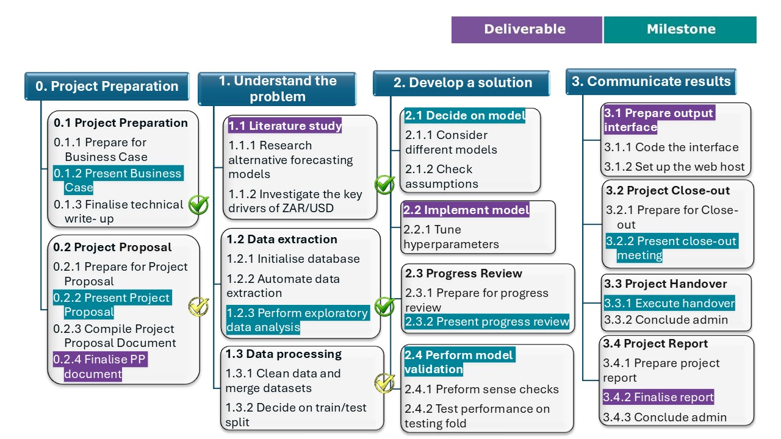

Appendix B: Gantt-chart
The Gantt-chart provides a graphical representation of the start and end dates of the individual planned activities. It also illustrates the duration of each activity and the dependencies between them.

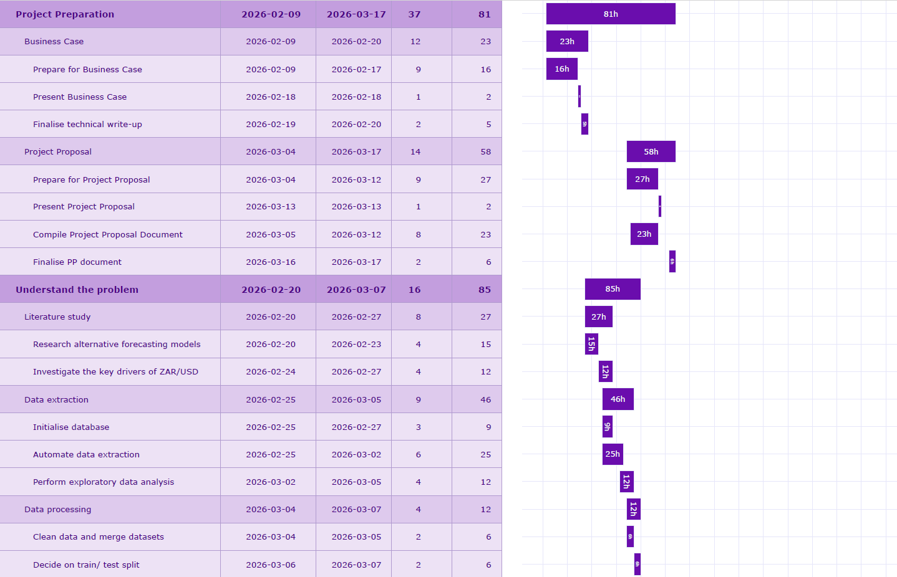
Figure B: Gantt-chart
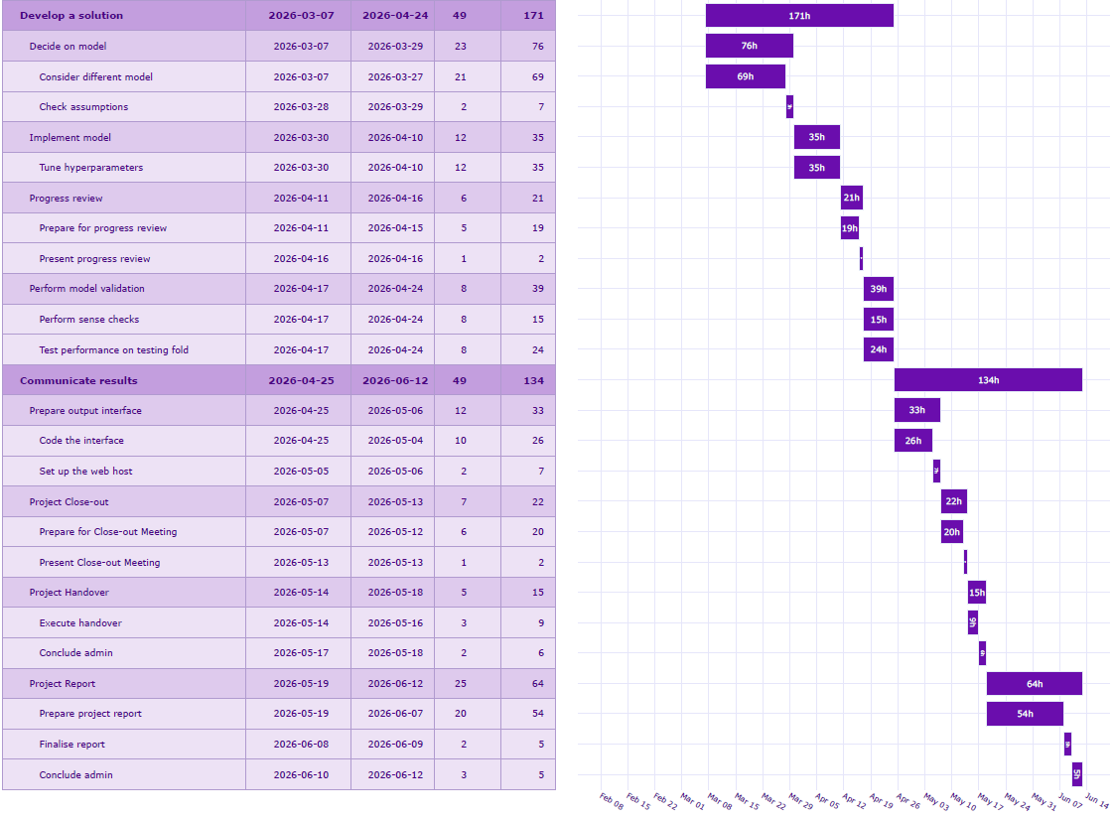
Figure B (continued): Gantt-chart

Appendix C: S-curve
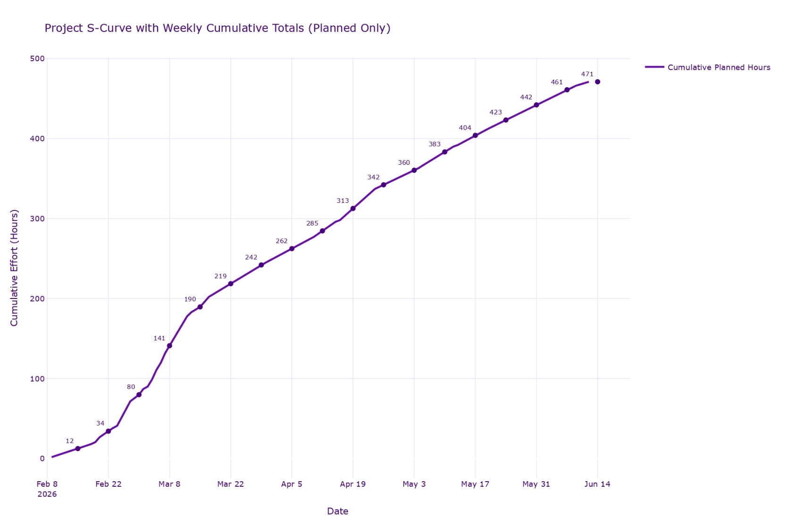
The S-curve represents the cumulative planned hours over the course of the project.
Figure C: S-curve

