Submitted in part fulfilment of the requirements for the degree of Master of Science in Business Analytics

Optimising in-Game Skip Pricing in Free-to-Play Mobile Games

*A Business Analytics Approach for "Battle Cards"*

by

Mohamed Shahil Shahul Hameed

Master of Science in Business Analytics

University of Surrey

September 2024

# ACKNOWLEDGMENT

I would like to express my deepest gratitude to all those who have supported me throughout this journey.

First and foremost, I would like to thank my supervisor, Dr. Mohammad Mahdi Tavalaei, for their invaluable guidance, continuous support, and encouragement throughout this research. Their insightful feedback and expertise have been fundamental to the development of this thesis.

I am also grateful to my committee members, [Committee Member Names], for their constructive feedback and thoughtful contributions, which have significantly enhanced the quality of my work.

I extend my sincere thanks to my family and friends for their unwavering support, understanding, and encouragement during this process. Special thanks to my parents for their constant love and belief in my abilities, which has motivated me to persevere through challenges.

Lastly, I would like to acknowledge my colleagues and fellow students, whose collaboration and camaraderie made this journey more enriching and enjoyable.

This thesis would not have been possible without the support and encouragement of all these individuals, and I am deeply appreciative of their contributions.

Thank you all.

# DECLARATION

"I hereby declare that this thesis has been composed by myself and has not been presented or accepted in any previous application for a degree. The work, of which this is a record, has been carried out by myself unless otherwise stated and where the work is mine, it reflects personal views and values. All quotations have been distinguished by quotation marks and all sources of information have been acknowledged by means of references including those of the Internet. I agree that the University has the right to submit my work to the plagiarism detection sources for originality checks. "

# Executive Summary

This thesis explores monetization strategies for free-to-play (F2P) mobile games, focusing specifically on optimizing in-game skip pricing to enhance player satisfaction and revenue generation. By employing business analytics to examine player behavior and preferences in "Battle Cards," a mobile game developed by Rockbite Games in Armenia, this research aims to identify monetization strategies that balance revenue generation with maintaining high levels of player engagement a core challenge of the F2P model.

The mobile gaming industry has expanded significantly, driven by the widespread use of smartphones and the availability of diverse game genres. The F2P model, which allows users to download and play games for free while developers earn revenue through in-app purchases (IAPs) and advertisements, dominates this market. However, this model presents challenges in balancing a positive user experience with effective monetization. Excessive monetization can lead to user dissatisfaction and churn, while too lenient an approach may result in lost revenue opportunities.

The research focuses on optimizing monetization strategies for "Battle Cards" through in-game skips, which allow players to bypass wait times or challenging stages. The study addresses three primary research questions: (1) How do different pricing strategies for in-game skips impact player satisfaction and retention? (2) What psychological factors influence players' decisions to purchase skips or continue waiting? (3) How can game designers optimize skip prices to maximize both player satisfaction and revenue? A comprehensive cross-sectional survey of the mobile gaming population was conducted to answer these questions.

The survey revealed several significant findings regarding player demographics, behaviors, and preferences. Most respondents were young (18-25 years old) and male, with a strong presence in the Asian market, reflecting the global reach of the mobile gaming industry. Players showed a clear preference for pricing strategies that provide perceived value, such as discount bundles and dynamic pricing. A substantial 37% of participants favored discount bundles, indicating a strong inclination towards deals that offer multiple skips at a reduced price. Additionally, 30.1% of respondents preferred dynamic pricing, which adjusts based on demand or player behavior, suggesting that flexible pricing models are appealing to a segment of the player base.

However, the data also highlighted a general dissatisfaction with current in-game skip pricing, with nearly 48% of respondents expressing dissatisfaction. This dissatisfaction is further reflected in player retention data, where 28.8% of participants indicated they would be "somewhat unlikely" to continue playing if skip prices were perceived as too high. These findings support the hypothesis that fair and transparent pricing is crucial for maintaining player engagement and satisfaction.

Psychological factors also play a significant role in players’ decisions to purchase in-game skips. The primary motivator for purchasing skips was accessing exclusive content, as indicated by 39.7% of respondents. This was followed by gaining a competitive advantage (26%) and saving time (19.2%). These motivations highlight the importance of perceived value and exclusivity in driving player spending. On the other hand, altruistic reasons, such as supporting developers, were less significant (6.8%), indicating that most players prioritize personal benefits over supporting game creators.

The regression analysis provided additional insights into how pricing strategies impact player satisfaction and retention. The analysis revealed a moderately positive correlation (R = 0.515) between the perceived fairness of in-game skip pricing and player satisfaction. An R-squared value of 0.266 indicates that approximately 26.6% of the variance in player satisfaction can be explained by the fairness and acceptability of the pricing strategies used. The results also showed that transparent pricing and clear communication about in-game skip benefits significantly influence purchasing decisions. A positive Durbin Watson statistic further supported the existence of a strong correlation, suggesting that players are more likely to continue engaging with a game when they perceive the pricing strategies to be fair and transparent.

Moreover, the regression analysis confirmed that unreasonable pricing of in-game skips decreases the likelihood of players continuing to play, supporting the hypothesis that monetization strategies must align with player expectations to sustain engagement and drive revenue. The findings indicate that clear communication about the costs and benefits associated with in-game purchases can enhance player trust, increase satisfaction, and boost spending.

The findings of this research have important implications for both theory and practice in the field of mobile game monetization. Theoretically, the study contributes to our understanding of player behavior in F2P models, particularly the role of perceived value, fairness, and transparency in influencing purchasing decisions. It confirms that players are more likely to engage with monetization strategies that they perceive as fair and valuable, aligning with established theories on consumer behavior and pricing psychology.

Practically, the research provides actionable insights for game developers and marketers. To optimize monetization strategies, game developers should focus on implementing pricing models that align with player preferences and psychological motivations. Strategies such as offering discount bundles, employing dynamic pricing, and ensuring transparent communication about the benefits and costs of in-game purchases can enhance player satisfaction and increase revenue. Additionally, maintaining a balance between free and paid content is crucial for sustaining player engagement and fostering a loyal player base.

In conclusion, this study demonstrates that understanding and aligning with player preferences and psychological drivers are key to successful monetization in F2P mobile games. By prioritizing fairness, transparency, and value, game developers can enhance both player satisfaction and revenue, ultimately achieving a sustainable and profitable business model in the competitive mobile gaming industry.

**Table of Contents**

ACKNOWLEDGMENT 2

DECLARATION 3

Executive Summary 4

1.1 Background 14

1.2 Problem Statement 17

1.3 Research Aim 17

1.4 Research Objective and Questions 18

1.5 Significance of the Study 18

1.6 Scope of the Study 18

1.7 Dissertation Structure 19

2 Chapter 02: Literature Review 20

2.1 Introduction 20

2.2 Application Monetisation Models 20

2.2.1 Overview of Different Monetisation Models 20

2.2.2 In-depth Analysis of the Freemium Model 22

2.2.3 Advantages and Challenges of the Freemium Model 22

2.2.4 Common Monetisation Tactics in Freemium Games 22

2.3 The Acquisition, Retention, Monetisation (ARM) Funnel 23

2.3.1 Explanation of the ARM Funnel 23

2.3.2 Importance of Each Stage in the ARM Funnel for F2P Games 25

2.4 Psychological Factors in Player Purchases 25

2.5 Ethical Considerations in Monetisation 27

2.6 Benchmarking Successful Monetisation Strategies 28

2.7 A/B Testing and Optimisation 29

2.8 Conceptual Frame 31

2.9 Conclusion 31

3 Chapter 03: Methodology 33

3.1 Introduction 33

3.2 Research Philosophy 33

3.2.1 Introduction to Research Philosophy 33

3.2.2 Explanation of Positivism 34

3.2.3 Justification for Selecting Positivism 34

3.3 Research Approach 34

3.3.1 Deductive vs. Inductive 34

3.3.2 Explanation of the Deductive Approach 35

3.3.3 Justification for Using a Deductive Approach 35

3.4 Research Strategy 35

3.4.1 Research Strategies 35

3.4.2 Questionnaire Strategy 35

3.4.3 Justification for Use 36

3.4.4 Alignment with Objectives 36

3.5 Time Horizon 36

3.5.1 Time Horizons 36

3.5.2 Justification for Cross-Sectional 37

3.6 Data Collection Methods 37

3.6.1 Primary Data Collection 37

3.6.2 Participant Recruitment 37

3.6.3 Questionnaire Design 38

3.6.4 Data Collection Process and Ethics 38

3.7 Sampling Techniques 38

3.7.1 Sampling Techniques Overview 38

3.7.2 Convenience Sampling 39

3.7.3 Rationale for Choosing Convenience Sampling 39

3.8 Sample Size and Data Validity 39

3.8.1 Initial Recruitment 39

3.8.2 Data Cleaning and Validation 40

3.8.3 Justification for Valid Responses 40

3.9 Data Analysis Procedures 40

3.9.1 Introduction to Data Analysis Methods 40

3.9.2 Using SPSS Software 41

3.9.3 Descriptive Statistics and Frequencies 41

3.9.4 Linear Regression Analysis 41

3.9.5 Justification for Analytical Methods 41

3.10 Ethical Considerations 42

3.11 Limitations of the Methodology 42

3.12 Summary 43

4 Chapter 04: Analysis 44

4.1 Introduction 44

4.2 Descriptive Analysis 44

4.3 Linear Regression Analysis 54

4.4 Interpretation of Findings 59

4.4.1 Implications of Survey Data 59

4.4.2 Connecting Findings to Hypotheses 61

4.4.3 Analysis of Patterns and Trends 62

4.4.4 Significant Insights for Optimising Monetisation Strategies 63

4.5 Discussion 63

4.6 Summary 66

5 Chapter 5: Conclusion 67

5.1 Significance of Research Findings 67

5.2 Linking Research Problem, Literature Review, and Findings 68

5.3 Managerial Implications 68

5.4 Limitations of the Research 69

5.5 Suggestions for Future Research 69

5.6 Conclusion 70

6 References 71

7 Appendix 79

7.1 Questionnaire 79

**List of Figures**

Figure 1: Mobile Games - Worldwide Revenue (Statista, 2023) 14

Figure 2: Average Revenue Per User (Statista, 2023) 15

Figure 3: Annual Global Trends in Mobile Game IAP Revenue (Ekaterina Bespyatova, 2024). 15

Figure 4: Revenue by Market (Ekaterina Bespyatova, 2024) 16

Figure 5: "Battle Cards," (Rockbite Games) (Mäkinen, 2022). 17

Figure 6: The ARM funnel (Mäkinen, 2022). 23

Figure 7: Conceptual Framework (By Author). 31

Figure 8: Research Onion Framework (Saunders , 2019). 33

**List of Tables**

Table 1:Q1: What is your age? 44

Table 2: Q2: What is your gender? 44

Table 3: Q3: What is your primary location? 45

Table 4: Q4:How often do you purchase in-game skips in mobile games? 46

Table 5: Q5: On a scale of 1 to 5, how satisfied are you with the pricing of in-game skips in mobile games you play? 46

Table 6: Q6: What type of pricing strategy do you find most appealing for in-game skips? 47

Table 7: Q7: What motivates you most to purchase in-game skips? 48

Table 8: Q8: How often do you make impulsive purchases of in-game skips? 48

Table 9: Q9: Do you feel that the availability of in-game skips affects your overall satisfaction with the game? 49

Table 10: Q10: Would you prefer a one-time purchase for in-game skips or a subscription model that offers unlimited skips for a period? 50

Table 11:Q11: On a scale of 1 to 5, how fair do you find the current pricing of in-game skips in mobile games? 50

Table 12:Q12: How likely are you to continue playing a game if you find the pricing for in-game skips unreasonable? 51

Table 13: Q13: Do you believe that the availability of reasonably priced in-game skips can enhance your gaming experience? 52

Table 14:Q14: How often do you stop playing a game due to frustration from not being able to skip certain parts? 52

Table 15:Q15: Would transparent pricing and clear communication about the benefits of in-game skips influence your purchasing decisions? 53

Table 16: Q16: How important is it to you that a game maintains a balance between free and paid content? 54

**List of Abbreviations**

1. F2P - Free to Play
2. IAP - In-App Purchases
3. ARM - Acquisition, Retention, Monetisation
4. SNS - Social Networking Sites
5. SPSS - Statistical Package for the Social Sciences
6. CSR - Corporate Social Responsibility
7. FOMO - Fear Of Missing Out
8. CoC - Clash of Clans
9. MMORPG - Massively Multiplayer Online Role-Playing Game
10. LTV - Lifetime Value

**Chapter 01: Introduction**

## Background

Mobile gaming has clearly evolved as a fast-growing sector with capability to commanding billions of dollars in the last decade (Jiang, 2021). By having smartphones more accessible and that there are many different games available, mobile gaming became the important part of entertainment and this is why this growth is rapid. By the latest statistics available, the income from mobile games was $92.46 billion in 2020 and predicted to rise to $118.90 billion by 2027, a compound annual growth rate of 11 %. As a result of COVID-19 lock-downs, people used mobile games for leisure and this trend was further amplified (Mäkinen, 2022).

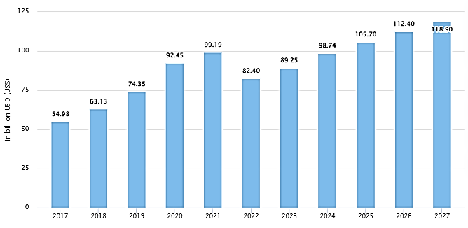

Figure 1: Mobile Games - Worldwide Revenue (Statista, 2023)

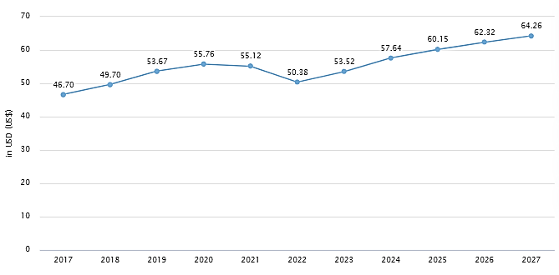

Figure 2: Average Revenue Per User (Statista, 2023)

Mobile games monetisation is mainly carried out through a free-to-play business model. IAPs and ads make F2P games, games that are free with regard to the download and first play. This model opens the door and admits all comers; it draws a lot of people and supports itself, at least in part, in several different ways. Another is the F2P concept has enabled both “Clash of Clans” and “Candy Crush Saga” to earn a lot of money (Mäkinen, 2022).

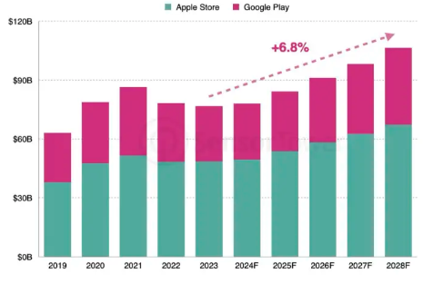

Figure 3: Annual Global Trends in Mobile Game IAP Revenue (Ekaterina Bespyatova, 2024).

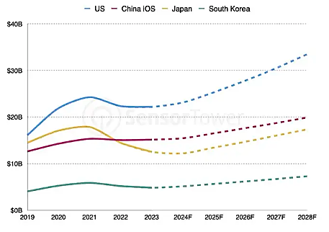

Figure 4: Revenue by Market (Ekaterina Bespyatova, 2024)

As much as F2P models are viewed as the successful freemium business setting, it showcases different concerns of maintaining the quality and offer while making money. He also established that to make the users spend money, developers have to create entertaining content without using force (Alha, 2020). That is why ethics matter: aggressive monetisation may damage users and trigger their backlash.

Armenian mobile game development company Rockbite Games was established in 2016 and created “Battle Cards,” which this thesis adjusts for monetisation. Attributed to their effective freemium approach, such companies as Rockbite Games have to adapt their schemes of bringing revenue and can barely be unprofitable in the sphere of games. This paper aims to provide Rockbite Games and other industry firms with information and suggestions (Mai and Hu, 2022).

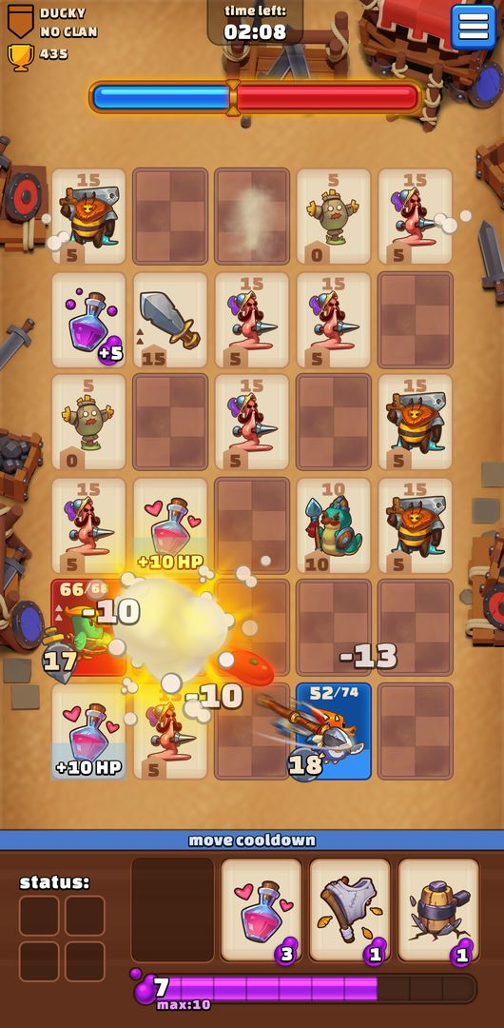

Figure 5: "Battle Cards," (Rockbite Games) (Mäkinen, 2022).

## Problem Statement

This paper will specifically concentrate on the best strategies for the monetisation of F2P mobile games with the aim to generate the maximum of revenues and players’ satisfaction. The use of in-app purchases should therefore be combined with fun gameplay since aggressive techniques d/train game reputation (Coutinho, 2021). The literature review also shows that clear and fair pricing and knowledge of players’ behaviors enhance users’ satisfaction and churn rates (Alha, 2020; Grønstad, 2021). Therefore, when there is increased COVID-19 pandemic engagement (Jiang, 2021), adequate methods are required. In the case of “Battle Cards” this paper focuses on the psychological antecedents of play and buys to enhance revenues and fun.

## Research Aim

The research aims to optimise monetisation strategies for free-to-play mobile games, focusing on in-game skips, to enhance both player satisfaction and revenue generation. The in-game skip pricing can be regarded as the additional charges that are paid by gamers to access exclusive content and features within the game.

## Research Objective and Questions

The main research objective is to optimise monetisation strategies for free-to-play mobile games, specifically through in-game skips, to improve both player satisfaction and revenue. To this aim, this study attempts to answer the following questions:

1. How do different pricing strategies for in-game skips affect player satisfaction and retention in mobile games?
2. What are the underlying psychological factors driving players' decisions to purchase skips or continue waiting?
3. How can game designers optimise skip prices to maximise both player happiness and revenue?

## Significance of the Study

This study is significant for several reasons. It addresses a critical aspect of the mobile gaming industry monetisation which directly influences the financial viability of game development companies. Through providing insights into effective monetisation strategies, this research can help developers optimise their revenue models and enhance profitability. The findings from this study will contribute to the academic literature on game monetisation, a field with limited publicly available research. Most game developers conduct internal research on monetisation but rarely publish their findings. This study aims to fill that gap by sharing empirical data and insights that can benefit other researchers and practitioners in the industry. From Rockbite Games, the commissioning company, this work provides recommendations which can be implemented to enhance the app monetisation of “Battle Cards.” Such actions can work to ensure that the firm earns high revenues while at the same time more importantly keeping the positive user experience that is integral for the long-term sustainability (Mäkinen, 2022).

## Scope of the Study

In this study, monetisation strategies for “Battle Cards”, a free-to-play mobile game, developed by Rockbite Games are optimised. In this we will assess the various in game skip pricing strategies, the psychological factors in players and identify the most appropriate skip price. Cross-sectional data will be gathered with surveys, and conclusions will be made with the help of A/B testing (Sardana et al., 2023).

Though the primary concentration is on ‘’Battle Cards’’ this game was selected due to its rich statistics as it will be useful for analysis. That is why it is possible to consider ‘’Battle Cards’’ to be one of the leaders in its category in terms of the income and the number of players. These characteristics ensure a robust dataset, enabling comprehensive and reliable analyses. While findings and recommendations will be specifically tailored to "Battle Cards," they may also be applicable to other F2P mobile games with similar characteristics.

## Dissertation Structure

This dissertation is structured as follows: Chapter 1 provides the introduction, including the background, problem statement, research aim, objectives, questions, significance, scope, and structure of the study. Chapter 2 presents a comprehensive literature review, covering the mobile gaming industry, monetisation models, ethical considerations, psychological factors, and benchmarking of successful strategies. Chapter 3 outlines the methodology, including research design, data collection methods, A/B testing framework, survey design, and data analysis techniques. Chapter 4 details the findings and analysis, discussing survey results, A/B testing outcomes, and their impact on player satisfaction and retention. Chapter 5 offers recommendations for optimised monetisation strategies, implementation plans, and ethical considerations. Also, concludes the study with a summary of findings, contributions to theory and practice, limitations, and suggestions for future research. Finally, references and appendices are included.

# Chapter 02: Literature Review

## Introduction

Smartphone use and gaming have made MTV a multi-billion-dollar business in the previous decade. Most games in this sector are free-to-play (F2P) and make money via In App Purchases and Ads. This failed in user experience and income creation despite a massive user base. In Part II of the model, I noted that developers need effective monetisation techniques to succeed short- and long-term. The following study addresses ways to increase F2P mobile game monetisation, player happiness, and income creation utilising in-game skips. It covers market monetisation, ARM funnel, psychological elements in player purchases, ethics, benchmarking, and A/B testing for improvement. The study's main finding concludes the review.

## Application Monetisation Models

### Overview of Different Monetisation Models

#### Premium

The most well-known example is the so-called ‘premium’ model, in which the user has to pay in order to download the game and play it. Hyam (2021) indicates that this technique makes developers to begin with a quality product because money is garnered from first-users. However, this strategy restricts revenues and undermines the possibility to finance development and regular maintenance costs for the long term. A premium game that was poorly priced will not be able to provide for the cost of development, which in turn sets up an entry fee that needs to be scrutinised by the target demographic.

#### Subscription

it is flexible for subscription, for video games that require a constant stream of service like live service games. The paid-virtual-world Game of RuneScape that offers memberships on a monthly basis is an example of the success (Symcox, 2021). The constant revenue stream guarantees sustainability, though it poses a challenge to developers who need to deliver fresh content to retain the members: It will prove challenging to engage the audience.

#### Hybrid Models

There are two kinds of monetisation: premium and subscription with microtransactions in-between. The AppLovin (2021) shows that survey found that having multiple streams of revenue optimises LTV. This idea has been employed by Electronic Arts in FIFA Ultimate Team as well as Activision-Blizzard in World of Warcraft. In this research, Parker (2021) pointed out that for premium and microtransactions, substantial revenue can still be obtained despite the complaints of the users. This paradigm is much criticised, but lucrative, proving the need for moderation in monetisation.

#### Free with Donations

The free-with-donations model is based on donations from fans of particular games, as for Kontsevoi (2020). This model is typically not lucrative for developers, as it depends on the goodwill of players. Games using this model are often passion projects developed by small teams and tend to attract a loyal user base if the game resonates deeply with its audience. However, its financial sustainability is limited compared to other models.

#### Sponsorship

Sponsorship involves partnering with companies that want to advertise their products within the game. Tode (2017) highlights a case where Subway sponsored a Super Bowl mobile game to attract viewers, integrating branding throughout the app. Users complete tasks within the game to earn rewards from sponsors, generating revenue for developers and visibility for advertisers. Sponsorships offer a controlled and targeted advertising method, providing a straightforward integration into the game’s ecosystem.

#### Free-to-Play (Freemium) Model

Among the mobile games, freemium with IAP and ads is the most popular business model, AppBrain (2022) notes. Both Fields (2014) and Barnes (2021) describe how this approach reduces the entry barriers and attract a large number of players as they can play and enjoy the games without the need of staking any money. Thus freemium models work on the idea of maximising the user engagement while at the same time also using monetisation techniques in such a way that they do not offend the free users but motivate them to spend money.

### In-depth Analysis of the Freemium Model

According to Mäkinen (2022), freemium model allows players to play the game without charge, but they have an option of paying for enhanced experience. Items, virtual commodities, and virtual cash are example of commodities used in a restrictive manner and most of which can be bought. According to Venturebeat (2020), the in-game ad from non-spending players will be at $56 billion by 2024. The free to play games have to provide good content and at the same time make money. In 2018 the DB spending of mobile gamers was $70.27 on average, but only 3.8% of them made in-app purchases (AppsFlyer, 2018). From this approach it is evident that it is a platform on which most user is unable to invest money but those who do can increase their earnings.

### Advantages and Challenges of the Freemium Model

According to Petrovskaya and Zendle (2021), the freemium business model’s entry-level does not restrict the performers’ access to others. Players can test the game and since it is free to play, the number of players to the game will go up. But problems of ethical and fair monetisation emerge with this paradigm. There may then be a players’ backlash if “pay-to-win” systems and the like are deemed predatory. These ethical issues have to be managed by developers in order to maintain users’ trust and their attention.

### Common Monetisation Tactics in Freemium Games

There are a number of ways that are employed by developers to generate revenue from freemium games. Special products or necessity compels them to spend money on virtual or real money in the application. Most of the contents are free but come with advert videos, the users can watch the advert to gain in incentives or they can pay to remove the advert. Loose definition and rewards for purchases in form of the loot boxes are haphazard, like gambling leading to ethical issues (Close & Lloyd, 2021). According to Robson (2019), decoy products work on the users’ cognitive biases to make them shift to higher income solutions. These strategies need to be well coordinated as to meet users’ needs and produce revenues.

This model is active because of the combination of the monetisation, ethics, and constant optimisation of freemium. Unfortunately, developers can get good and financially useful mobile games with a help of in-app purchases, ads, and psychology. To ensure an informed approach to freemium game, monetisation the Acquisition, Retention, Monetisation (ARM) funnel is discussed next.

## The Acquisition, Retention, Monetisation (ARM) Funnel

### Explanation of the ARM Funnel

The ARM funnel helps the free to play (F2P) mobile game business by providing the solutions for acquisition, retention, and monetisation. This model used to press on Lewis’s AIDA model as outlined by Fields (2014) to explain the player journey from the first time they encounter the game to the stage where they are committed fully and are operators financially. The ARM funnel shows how a developer could make the most of the profits and the game’s players’ satisfaction by examining and optimising the experience throughout each stage.

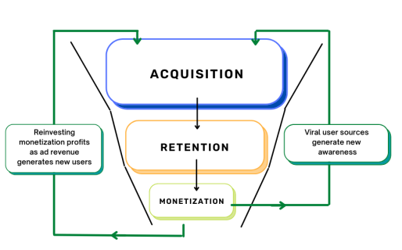

Figure 6: The ARM funnel (Mäkinen, 2022).

#### Acquisition: Strategies to Attract New Players

Acquisition is procuring new gamers. Recruiting a user base is a highly important for the initial stage of the ARM funnel. The acquisition strategies are viral and non-viral in nature. As Fields pointed out (2014), viral acquisition employed word of mouth and share free acquisition to enable the developers look for new gamers. Affiliate programmes reward the gamers for contributing to the recruitment of new players. For every recommended product, it is possible to increase the number of users, for example, with in-game currency or exclusive products. Non-viral acquisition employs the use of the ads, sponsorships, and the cross-selling of applications. Most of these strategies are expensive and can help reach a certain group of people. Sometimes, through the use of social media, search engine and gaming network ads, an increased number of visitors to the game can be attained as supported by Hyam (2021), especially if the content created is attractive.

#### Retention: Methods to Keep Players Engaged

Retention aims at determining how engaging is the game in a way that players continue to play the game repeatedly. Don’t lose users: User retention reduces the cost of acquiring users and increases their monetisation. Retention strategies enhance the gaming experience and drives traffic to the game. Enhance the first experience, provide a good first-level experience and utilise push notifications to urge people to avail themselves. As highlighted by Goff (2020), it is necessary to have an obvious rewarding onboarding process of the video game that rapidly ensures the worth of its existence. Other ways of sustaining the flow of active players that developers can employ are use of daily rewards, activities and content updates. There are interesting consequences when players know they are being fairly paid: they will stay because unethical methods may make them quit and leave poor ratings, as Petrovskaya and Zendle (2021) found.

#### Monetisation: Techniques to Convert Players into Paying Users

The last step of the ARM funnel is monetisation, the process of turning players into paying users. This is very vital in the generation of overall revenues for the game. These are good options, successfully used: advertisements, premium subscriptions, and in IAPs. IAPs should offer value and things that are interesting that make the game better to play and avoiding offering factors that make the game depend on the in-app products, as noted by Mäkinen (2022). The provision of cheaper units and packages meets the needs of different pocket sizes. Advertising, another important monetisation method, must be easily implemented in the game not to interfere with users. Options such as rewarded ads, where players can choose to watch an ad in exchange for in-game rewards, have proven to be effective (Fields, 2014). Subscriptions can provide a steady revenue stream, offering exclusive content, ad-free experiences, or premium support to subscribers. The balance between free and paid content must be managed carefully to maintain player satisfaction and prevent alienation of non-paying users.

### Importance of Each Stage in the ARM Funnel for F2P Games

Each stage of the ARM funnel plays a critical role in the overall success of F2P games. Acquisition brings in new users, setting the foundation for a potentially large player base. Without effective acquisition strategies, the game may struggle to gain visibility and attract players in a highly competitive market (Management Association, Information Resources, 2022). Retention ensures that these acquired users continue to engage with the game, reducing churn and increasing the likelihood of long-term players. High retention rates are indicative of a compelling and enjoyable game experience. Last, monetisation strategies bring ‘qualified traffic’ – interested gamers – to become paying customers and bolster game revenues. Monetisation practice generates cash and funds development and marketing hence a cycle of growth and improvement. Maybe, maximising the employment of free-to-play in each stage of the ARM funnel will help to sustain a long-lasting and highly-profitable game for a diverse audience who will stick to this game (Management Association, Information Resources, 2022).

## Psychological Factors in Player Purchases

Since the buy options are integrated within the game environment and players could easily make purchases at any one time, in-game purchases are therefore occasioned by impulse (Cao and Xu, 2024). Sudden buys are prompted through low hindrances to purchase small items in particular. The ‘buy now’ mechanisms incorporated in mobile games act based on the player’s longing for quick gratification and protracted upgrades. Some research found that elements of purchasing which can be found from game interface decrease psychological purchase barriers and thus lead to impulsive buying (Barnes, 2021; Adams, 2022). Buying mechanisms within the games are such that they depend on the emotion of the player and not the rationality of the player (Cao and Xu, 2024).

Gamer’s expenditure are relatively a function of perceived value and entertainment. When in-game things are hard to obtain, limited or essential then players can be expected to purchase them. Aspects of game design which further stress on the positive aspects and desirability of paid content increases this perceived worth. Free gifts, tie-in products, or products with product placements can create a feeling of urgency to the players (Mundee, 2020). According to the evidence, the players’ satisfaction with the products they bought is a function of the perceived value, which, in return, determines future purchasing decisions. This can explain why the real positive consequences and improvements that buys bring to the gamers make players feel justified and satisfied (ElHady, 2021).

Gamification and incentives are particularly used to enhance rewards and encourage many purchases in the game (Che et al., 2023). Such systems promote achievement and growth through daily-login gifts, achievement-related rewards, and performance-based gifts. Games make consumers use their money to maintain or enhance better results by offering rewards. Hence timely, incremental and free extrinsic motivation systems improve gameplay and spending through gamification. Such mechanisms compel users to purchase more in an effort to get to the next ‘level’ or point that accrues more benefits to the gamer and an increment in their play experience and pleasure (Che et al., 2023).

Pricing methods influence player actions and behaviours as well as microtransactions. Strategies such as dynamic pricing, bundled pricing, and tiered pricing strategies influence the valuation of in game items among the players (Kakko, 2024). Having priced in that top end, where prices fluctuate depending on the demand or players’ behaviours, the strategy creates a sense of urgency and scarcity, thus making customers to purchase before they are priced out. Pricing it as a menu that is based on the player’s willingness to pay helps to maximise the income, makes pricing structures discussed by Mäkinen (2022). According to Fields (2014), it is good that well-detail developed pricing strategies compel spending by offering value related perceptions and timing of spending offers that are within the players’ capacity and inducements. For example, products used in the framework of some pricing strategies may affect the players’ value estimation; thus, guiding them towards high priced variants which seem to represent a higher value proposition compared to deliberately unattractive offers (Grasset, 2015; Robson, 2019).

## Ethical Considerations in Monetisation

The ethical issues connected with F2P monetisation mainly pertains to income and fun. One disadvantage of pay-to-win is that it drives a wedge between those who are willing to spend and those who aren’t. Paid players receive higher stats, gear, or rank from these mechanics. It may lead to unfairness and frustration of non-paying players This destroys the game fairness and integrity (Barnes, 2021; Parker, 2021). The social issue is monopolistic lens etc using players desire to compete and succeed to compel them to buy in order to remain relevant on the market.

Another F2P monetisation model of concern is the so-called loot boxes since they are similar to gambling. Loot boxes are virtual assets bought with real money and contain items and prises of chance. These variable rewards might lead to the development of pathological gaming behaviours, particularly among the youth (Petrovskaya & Zendle, 2021; Close & Lloyd, 2021). The inability to see odds of items makes users spend more money on rare items, thereby aggravating the ethical problem. These methods have been criticised and, in some countries, even prohibited because they resemble gambling (Kalirai & Yu, 2019).

There is one more very important ethical rule that cannot be ignored when it comes to F2P monetisation – the topic of prices. Readers normally get confused with price or value of in-game item. Due to such privacy constraints, players might feel cheated or swindled thus leading to a loss of confidence in the game producer (Grasset, 2015: Robson, 2019). These costs should be obviously conveyed at the micro level so that the players can clearly ascertain the opportunity costs of playing the games. Ensuring the positive player experience also means using the correct and fair pricing strategies that allow for achieving the good players’ value without compromising the players themselves (Fields, 2014; Hyam, 2021).

F2P game producers work under the ethics of money vs. player entertainment. As much as money is important for forming and running games, it should not be at the cost of the players’ fun time and fairness. There ought to be strategies regarding the monetisation strategies that the developers have to put in place to ensure that though they make their profits, they do not overpower those of the players (Petrovskaya, 2021). This can however be achieved through non-intrusive advertising, realistic rewards for in game achievements, and enabling non-paying players to play and progress (ElHady, 2021). Being a fun and fair game, ethical monetisation methods should be assessed and adapted based on players’ responses and input, as well as their behaviour.

## Benchmarking Successful Monetisation Strategies

In 2022 according to Visma, the benchmarking addresses the fact that firms can only benchmark their performance with that of the leaders so as to identify the best practices to embrace and the gaps to fill. This encompasses falling into researching various games’ monetisation and applying them in one’s own game. Thus, the developers may enhance the revenues while maintaining the players’ enjoyment and avidity.

Now let me explain how benchmarking works with reference to Supercell’s Clash of Clans. AppLovin (2022) shows that Clash of Clans is for the most part accessible at no cost, but has microtransactions which enhance the gameplay. Purchases and downloads which are available in the game enable users buy in-game currency to level up. This method takes advantage of players’ intolerance and eagerness to make the next move; it makes quite a lot of money. This game also has seasonal pass that allow for special promotions and subscription-based revenues. The continual creation of content uplifts both, the income and player interaction (AppBrain, 2022; ElHady, 2021).

Candy Crush Saga by King is another game that add more supports to the freemium model. According to Alcanja (2019), Candy Crush Saga has a lot of free levels of gameplay but has erected barriers that are intellectually solved through a payment system. This strategy takes advantage of the participants’ frustrations in order to force them to spend money in order to level up. The game also incorporates sale prices which are less than the normal prices and special occasions that afford players the feeling that they should purchase exclusive content quickly. According to (Fields, 2014; Oke, 2015) have pointed out that there are other methods which have supported player engagement and revenue.

Some critical points may be learnt from benchmarking of successful games. One is the correct system of incentives covering purchase of new items and not annoying casual non-paying players. Like Clash of Clans and Candy Crush Saga the games are made more fun to play for all and all paid customers are considered. This balance is critical for sustainable development and possession of a large number of players (Fields, 2014; Oke, 2015).

Some of the benchmarking best practices involves the use of specific psychological cueing to affect the buying decision. Alerts work in timely intervals, and incentives add scarcity in both games. Clash of Clans’ seasonal passes and Candy Crush Saga’s limited time events are good examples of FOMO to make people spend within the application. Psychological triggers are also portrayed by Robson (2019) and Grasset (2015) as a determinant to enhanced consumer behaviour leading to increased income.

Benchmarking advocates for constant update of the content of the site. Popular games such as Clash of Clans and Candy Crush Saga keep adding content to the game as more and more content keeps the consumer interested. This technique helps maintain and increase the revenues by retaining the individuals who participate in the share offering and attracting new ones. According to AppBrain (2022), new content retains the gamers and makes them willing to spend on in-game items.

## A/B Testing and Optimisation

A/B testing is the process of comparing variation of a feature to a control to determine that performs better regarding to conversion rate, user retention, and so on. An industry that thrives on data and whose success can turn on a user’s behaviour or preferences requires this strategy. In their view, based on Gallo (2017), A/B testing enables the developers to make substantive decisions based on the underlying data rather than staking a guess.

Mobile game A/B testing is not chaotic when it begins with a premise about how a change might alter users’ behaviours patterns. A game developer may have the impression that increasing the quantities of in-game currency they offer or decreasing the price on them will increase the quantities bought. The developer makes two game versions: A control version with the normal pricing and a treatment version with the lower pricing to support this hypothesis would be used. These versions are viewed and the consequent behaviour of randomly selected user groups is then observed and recorded. According to Kohavi and Thomke (2017) the above tests should be conducted using a large number of samples in order to attain a higher level of reliability and validity.

Mobile game pricing optimisation is one of the areas that you will have the best results with when using A/B testing. A/B is applied in Supercell’s “Clash of Clans”, for instance, to determine prices for in-app purchases. Since the price level is sensitive to players, Supercell can analyse several models to arrive at the optimum level of income not affecting its clients. Concerning this strategy, they can perfectly balance monetisation and players’ satisfaction. AL testing is used by King, the company behind ‘Candy Crush Saga to optimise what they call special offers and in-game boosters to enhance players satisfaction and revenues (AppBrain, 2022).

In fact, use of data in decision-making applies significantly to elaboration of measures meant for increasing the level of the advertisement monetisation. Kohavi and Thomke (2017) criticised the game development’s methods saying that data enables them to adapt their methods based on performance, not guesswork. In a dynamic market the strategy allows testing, analysis and optimisation of the monetisation strategies to remain effective. It can in fact reveal subtle patterns and preferences that players have that market research and guesswork cannot, for example.

## Conceptual Frame

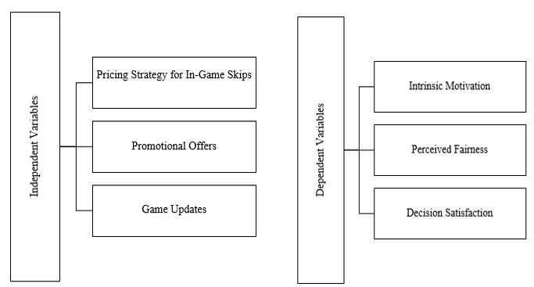

Figure 7: Conceptual Framework (By Author).

## Conclusion

Comparing writers' views on F2P mobile game monetisation strategies reveals several parallels. Hyam (2021) and Symcox (2021) describe the best and subscribe strategies' pros and cons. The end goods must be high-quality and the income sources predictable, yet content delivery and financial entrance obstacles are genuine. New hybrid models combine premium, microtransactions, and subscriptions, according AppLovin and Parker (2021). They are all lucrative and may stimulate user reaction, hence this study advocates reasonable monetisation approaches. Less lucrative but different, free with contributions and sponsorship choices provide varied engagement experiences and skilfully integrated advertising, per Kontsevoi (2020) and Tode (2017). AppBrain (2022), Fields (2014), and Barnes (2021) agree that freemium rules mobile gaming. It does so because to the low entrance barrier, many in-app spending and advertising options, and the danger of angering non-spenders. Sources 1 and 2 illustrate Mäkinen (2022) and Venturebeat (2020) initiatives to engage players and be profitable. Close and Lloyd (2021) and Petrovskaya and Zendle (2021) study pay-to-win and treasure box monetisation. It helps them be upfront, impartial, and preserve player trust to prevent long-term business backlashes. Fields (2014) and Hyam (2021) were used to note the ethicality of revenue creation and player pleasure. Gallo (2017) and Kohavi and Thomke (2017) emphasise the importance of customisation, suggestion, A/B testing, and benchmarking in monetisation strategy improvement.

# Chapter 03: Methodology

## Introduction

In this chapter, we explain how we learned about the nature and the preferences of the players of free to play (F2P) mobile games in order to enhance the players’ spending. By following the Research onion Framework, the research philosophy adopted is positivism which informs the research approach and favours a deductive approach (Phair and Warren, 2021). The chapter also defines why a questionnaire was employed as the research technique and how convenient sampling was employed to get a representative sample. It also looks at the ethics of data collection and analysis in order to protect the rights of the participants (Mesek, 2023). Last of all, the influence of methodological limitations and their implications on the research findings are discussed in order to facilitate the understanding of the outcome.

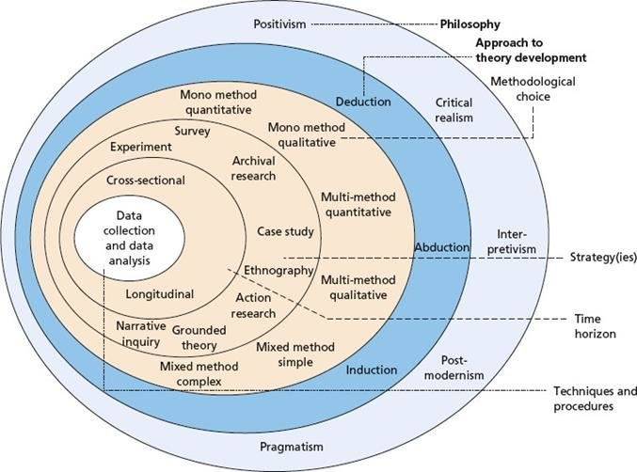

Figure 8: Research Onion Framework (Saunders , 2019).

## Research Philosophy

### Introduction to Research Philosophy

The research onion framework is the basis of the study, and the research philosophy controls the path and approach to the study. This pertains to the assumptions made toward the production of knowledge and that of interpretation of the same. Research philosophy has an implication on study, design, strategy and methodology since it encompasses the right approach to tackle a research issue (Mbanaso, Abrahams and Okafor, 2023).

### Explanation of Positivism

The research philosophy employed in this research study is positivism. Positivism puts central focus on being objective, on measurement and on the use of the seemingly accurate quantitative data in the sciences of society (Jamieson, Govaart and Pownall, 2023). In this philosophy, knowledge obtained from observable and measurable occurrences, and the reality is objective and does not depend on the senses. Positive research formulate research questions from hypothesis and gain hypothesis out of ideas and supported by empirical evidence and observation often through a process of survey or experiment.

### Justification for Selecting Positivism

Positivism is suitable for this study, which focuses on players’ behaviour and preferences to advance monetisation strategies of F2P mobile games. Positivism’s emphasis on objectivity corresponds with the study’s desire for measurable and generalisable implications from real facts. As a positivist study, it can employ surveys to gather empirical information and can employ quantification to evaluate hypotheses. There is an approach which makes it possible to obtain generalise results, showing the mobile game industry monetisation patterns. Positivism provides reliable, credible results that can help in recommendation to game developers (Jamieson, Govaart and Pownall, 2023).

## Research Approach

### Deductive vs. Inductive

Types of studies are described in the research modalities. There are two leading methodologies including Deductive, Inductive. Fixed idea of deductive approach comes from the fact that this method of identifying aspects of a phenomenon involves developing a theory or hypothesis, and then designing a research method to investigate it using particular evidence. This method works in the opposite order that is; it goes broad then goes narrow in order to support or reject hypotheses. On the other hand, Inductive method started with facts and came up with a new theory or establish a pattern from the data without attaining generality; from the particular to the general (Barroga et al., 2023).

### Explanation of the Deductive Approach

In this subject deductive reasoning is used. The idea of the structured deductive approach is to start with hypotheses which stem from some concepts and is evaluated through observation. This is a quantitative research strategy that is useful in analysed theoretical propositions with tools of statistics (Hall, Savas-Hall and Shaw, 2022).

### Justification for Using a Deductive Approach

To more systematically analyse the monetary strategies used in F2P mobile games and advance hypothesis regarding the behaviour of the consumers of such games, the paper uses the Deductive approach. Starting with theories of game monetisation, the deductive approach applies them to a certain context with the help of quantitative data of a structured questionnaire. A coherent procedure for hypothesising and using empirical, transportable data for helping the producers of the games to make tactical steps in enhancing players’ entertainment and revenue (Hall, Savas-Hall and Shaw, 2022).

## Research Strategy

### Research Strategies

Research methodologies serve as a roadmap when conducting research as far as gathering and or analysing research data is concerned. Due to the purpose and objectives of the conducted research as well as the type of data being collected, experimental, and case study methods, ethnography, and questionnaires are selected (Creswell and Creswell, 2017).

### Questionnaire Strategy

This study is questionnaire-based. In the field of conducting research, a questionnaire is a planned set of questions to which the respondents are asked. This is because it effectively gathers large quantitative data from large numbers of people. SPSS are essential for quantitative research as well as searching for relationships between variables in form of numerical patterns of responses (Creswell and Creswell, 2017).

### Justification for Use

In order to learn players’ behaviours and preferences, which is the aim of this research that aims at identifying the best strategies for using F2P mobile game monetisation, using a questionnaire is more appropriate. Enumerating in-game purchasing and monetisation related sentiments can be done from a diverse participant base and the questionnaire method can be utilised for doing so. This type of delivery is cheap and fast, more so when delivered online the reach out is large thus appropriate for large audiences (Collet et al., 2022).

### Alignment with Objectives

The research objectives are fulfilled through the use of a questionnaire containing questions on how often the gamers purchase in-game items, reasons for spending as well as recognition of monetisation strategies (Muhammad Zhafir, 2022). For this reason, the participants were sourced through social media to ensure that the gaming community was represented. The design of the questionnaire permits the organised collection of data and its analysis in compliance with the aims of the study, as well as the hypotheses testing with the help of SPSS software. It makes it possible to increase the mobile game monetisation and user satisfaction with practical recommendations.

## Time Horizon

### Time Horizons

Research time frames are data collection period. These are: cross sectional, which collect data on variables at a single point in time; longitudinal, which follow the processes or variables in some cases over time. Cross-sectional studies take data at a single point in time for the study of a phenomena or a population. This is helpful in the analysis of variables and the correlation and differences between the variables in particular. Longitudinal studies, on the other hand, examine changes with periods of time hence appropriate in studies that reveal trends and causal relationships (Kesmodel, 2018).

### Justification for Cross-Sectional

For this study, cross-sectional research was adopted. This technique is backed since the study looks at F2P mobile game player behaviour and preferences in order to evaluate monetisation options. What is gathered at one point facilitates behaviour analysis without long observation periods being necessary (Kesmodel, 2018). It is good for the creation of a comprehensive report on players’ engagement and spending that can be used in decision making. Cross-sectional insights are applicable, affordable, and suitable for the study aim of giving game developer practical knowledge (Kesmodel, 2018).

## Data Collection Methods

### Primary Data Collection

Primary data is gathered by this study on F2P consumer behaviour and their preference when playing mobile games. It is important how directly the data is gained from the participants of the study as the collected data is pertinent and in accord with the study’s objectives. The quantitative data on player engagement and spending behaviour for this study was derived using a systematic questionnaire (Mazhar et al., 2021).

### Participant Recruitment

For increase diversification of the participants, Facebook, Twitter, and Instagram were employed for the purpose of invitation. Social media was selected because of the large coverage capabilities and opportunities to address the study participants, especially mobile game (Battle Cards) enthusiasts of 18–46 years old. Posters with the details of the study and an invitation to fill the online questionnaire were sent to recruitment listserv/ mailing list and relevant discussion forums. This method also helped to achieve a short turnover for participants recruitment that gave 100 responders, where after cleaning of the data, 73 gave credible responses (Darko, Kleib and Olson, 2022).

### Questionnaire Design

In order to tackle study objectives, the questionnaire changed with player behaviour and monetisation options. The study administered questionnaire data in the multiple choice, Likert scale and open-ended form. The questions included how often the participants made in-game purchases, what kinds of purchases, why they made the purchases, the perceived value of monetisation strategy and how much fun they had playing the game. This design was useful for accumulating a great deal of data for further analysis of player behaviour aspects (Petrovskaya and Zendle, 2021).

### Data Collection Process and Ethics

Data collection accredited members to fill the questionnaire at their own convenient; therefore, getting higher response rates than conventional methods. The designed questionnaire was supposed to require 10-15 minutes to fill in, thus limiting the weariness of the participants. There was also a need to ensure cleansing of the data was done right, data which had incomplete or contradicting answers were thereby eliminated from the final analysis (Dobakhti, 2020).

Ethics were very important to us in the course of the investigation. All participants were made aware of the purpose of the study and users of these games and almost all played Battle Cards, the fact that they were willing to participate, and other details that assured them that their identities and information which would be provided would not be disclosed to anyone (Dobakhti, 2020). All participants signed an informed consent before they begun the questionnaire and hence they had the right to withdraw at any time without any forms of being penalised. Based on principles of research ethics, no participants’ information was used and all info garnered was kept confidential (Dobakhti, 2020).

## Sampling Techniques

### Sampling Techniques Overview

Sources of sampling decide how individuals for the study are selected; influences reliability and generality. Two types of sampling techniques are; Probability and Non-probability sampling. Probability sampling uses random selection in a way that give every population a equal opportunity in being studied. It also enhances the findings”; Sample generalisability or ‘externality’. Non-probability sampling involves choosing participants with criteria or convenience or judgement, which may introduce bias but is more practicable in a certain line of research (Md. Mizanur Rahman, 2023).

### Convenience Sampling

Among the specialised sampling techniques, the convenience sampling is employed in this study. Convenience sampling is suitable for specificity and/or time or resource limited inquiries since the subjects selected are willing and easy to find. It was easier to recruit subject for this study from social networking sites because of the diversity of the participants (Adeoye, 2023).

### Rationale for Choosing Convenience Sampling

Convenience Sampling is quite suitable for the study’s objectives and applicability. This sample strategy was suitable for immediately and effectively reaching a great number of participants, which would help in recognising players’ behaviour and preferences regarding free-to-play (F2P) mobile games. Convenience sampling by social media to attain the target group of 18-46 years mobile gamers was done (Adeoye, 2023). This method may give selection bias but is good for exploratory research that aims at a snapshot view of the population rather than the whole population of the study. Due to the use of Convenience sampling, this kind of study was able to amass a significant quantity of data by disproving certain assumptions in relation to in-game purchase behaviours and monetisation strategies, with valuable insights for prospect research projects and strategic manures (Adeoye, 2023).

## Sample Size and Data Validity

### Initial Recruitment

It is with 100 participants that a questionnaire was administered aiming at identifying players’ demographic data, as well as their tendencies and choices in relation to F2P mobile games’ monetisation models. These were Facebook, Twitter and Instagram and these were employed to recruit active mobile gaming players between the age of 18 and 46. This recruitment strategy was widespread to capture a large population of mobile gaming utility to increase its usage (McEwan, 2020).

### Data Cleaning and Validation

This was done with a view of checking validity and reliability of the data that had been collected. There were several steps taken, during the identification of inadequate response, conflicting data, and bias. To maintain the Cleanliness of the dataset some of the responses that were either missing or not consistent were dismissed. It is always important to exclude outlying and anomalous cases that could distort the data and thus, such cases were scrutinised and removed if deemed appropriate. These responses had to be cleaned in order to ensure that the responses that were left provided a good sample of the target population (McEwan, 2020).

### Justification for Valid Responses

Out of the total number of 73 valid responses, data cleaning and validation were conducted and the number of valid replies left for analysis were seventy-three. These 73 responses were selected for different reasons. First responses were complete and homogeneous, which indicated the health of data obtained. Second, the subjects involved in the sample are 73, which is sufficient enough to provide sufficient strength to the statistics, such as descriptive statistics and the frequency analysis, in a manner that serves the objectives of the study. This sample size is optimal in a way as it still provides maximal statistical power while keeping the data relatively simple. The subsequent response rate of 73 valid replies answers the goal of this study to provide real and beneficial information on player behaviours and tendencies out of fear of false data. This helps in ensuring that findings of the study are founded on dependable and quality data hence increasing the credibility of the study (Roni and Djajadikerta, 2021).

## Data Analysis Procedures

### Introduction to Data Analysis Methods

Research entails data analysis which means using statistics to make conclusions with regards to data. For the purpose of this research, data analysis method is applied to determine the player preferences on the monetisation strategies of F2P mobile games. This procedure of coding categorises, synthesises and analyses data for the confirmation of hypotheses and generation of conclusions in the monetisation drive (Roni and Djajadikerta, 2021).

### Using SPSS Software

For the purpose of this study, data analysis was done using SPSS. While using SPSS, test can be done from simple summary statistics to complex hypothesis test. Since it was easy to operate, very powerful when dealing with large data sets, and offered the ability to perform most statistical tests and analyses, it was selected. SPSS assist researchers in arrangement and data analysis and provides guarantee to the accuracy and concurrency of results (Roni and Djajadikerta, 2021). The research utilised SPSS for descriptive statistics and frequency analysis in order to present the 73 valid responses.

### Descriptive Statistics and Frequencies

The results of descriptive statistics enabled to briefly summarise and describe the given aspects of the dataset. Frequency, graphs, and tables are nominal scale measures while mean, median, mode, and standard deviation are measures of central tendency. These statistics help make precise the character of such data as average rates of in- app purchases or a consumer’s choice monetisation options. The frequency of specific responses was further analysed to give the percentage. That analysis is particularly useful for categorical data, helping to identify the distribution of player preferences and behaviors across different variables, such as age groups, spending habits, and game types (Roni and Djajadikerta, 2021).

### Linear Regression Analysis

The linear regression analysis is also conducted in this assessment for predicting the values of the main dependent variable of this study based on the key independent variables. The purpose is to look at the satisfaction and motivation levels of respondents based on the fairness and acceptability of in-game pricing features of free-to-play particularly considering the case of “Battle Cards” video game.

### Justification for Analytical Methods

Descriptive statistics and the frequency of F2P mobile game player behaviour and preferences can be justified by the study’s goals. Descriptive statistics summarise data in simple figures that could easily indicate vital trends and patterns. This aids in defining purchase and monetisation behaviour and attitude during gameplay. Frequency analysis can be used to estimate the relative use of the different forms of monetisation across different types of players, as it shows the distribution of responses and their frequency (Roni and Djajadikerta, 2021). The linear regression analysis method helps in finding out the relationship between the main dependent variable and independent variable of the study to assess the impact of these independent variables in predicting the values of the dependent variable. Furthermore, it helps in answering whether the hypothesis of this study is statistically significant or not, meaning whether the availability of the reasonably priced in-game skips increases player satisfaction in free-to-play (F2P) mobile games. Or the unreasonable pricing of in-game skips decreases the likelihood of players continuing to play a game. Moreover, understanding whether transparent pricing and communication about in-game skips increase the likelihood of players making purchases

## Ethical Considerations

Several ethical issues were followed in this research. All the participants agreed to complete the self-administered questionnaires once they were told of the details of the study. Concerning the participants, they were told the aim of the study, their voluntary participation, and the ability to withdraw from the study without any consequences. Some response questions were deleted in order to have no personally identifiable information collected for data safety. The collected data was kept confidential and only allowed to the extent, to allow those who are authorised study workers ensuring the ethical standards as well as the participants’ anonymity (Hesta Friedrich-Nel and Aarthi Ramlaul, 2020).

## Limitations of the Methodology

Despite that the chosen approach enables meeting the set study aims, it has its limitations that may influence the study findings. The results could also not be directly generalised to mobile gaming because the participants were chosen because they were available and willing to respond. Survey data that is collected through questionnaires also experience response bias where respondents provide responses that are acceptable in the society instead of their true opinions. These constraints may reduce the external validity of the study since participants may not capture all the players’ demographics and behaviour. With sample procedure and self-reporting data conclusions: may be influenced. The following are possible limitations that future work could consider as a way of enhancing the current study: The current study relied solely on self-completed questionnaires; future study could use randomised sample and other method of data collection; for example, observational studies or interviews (Theofanidis and Fountouki, 2018).

## Summary

This chapter included the explanation of the research philosophy, approach, strategy, sample methods, data collecting, and analysis. Measures of ethics were taken in order to make the study ethical. Some of the weaknesses of the methodology might have been realised and hence influenced the outcome of the research. These insights pave way for the next chapter to present the results of the data analysis in the aim of uncovering player behaviours and their preferences in Free-to-play mobile games, and the likely hood of informed monetisation strategies.

# Chapter 04: Analysis

## Introduction

In Chapter 4, the survey response results are used to scrutinise player attitudes and activities concerning in-game skips in F2P mobile games. The chapter begins with descriptive survey which involved making of frequencies distribution tables and other important findings. In that case, observations are explained with reference to the where, what, when, who, and why of players’ happiness, purchases, and monetisation strategies. The last part addresses the study issues: it demonstrates how the pricing strategies impact F2P game player retention and revenue, and what psychological factor and the most suitable optimal pricing models have to be used to attain the best results. The justification of this chapter is that it links data analysis with real-world implications for monetisation.

## Descriptive Analysis

Table 1:Q1: What is your age?

|  |  |  |  |  |  |
| --- | --- | --- | --- | --- | --- |
| **Q1: What is your age?** | | | | | |
|  | | Frequency | Percent | Valid Percent | Cumulative Percent |
| Valid | 18-25 | 56 | 76.7 | 76.7 | 76.7 |
| 26-35 | 17 | 23.3 | 23.3 | 100.0 |
| Total | 73 | 100.0 | 100.0 |  |

The frequency table below point that 56 out of 73 valid responders, 76.7%, were 18-25. Consequently, it is right that the study has targeted youth with a strong presence in mobile gaming and in-app purchasing. The remaining 23.3%, 17 players, are 26–35. It allows determining the target population and their behaviours and preferences to enhance the free-to-play (F2P) mobile game monetisation strategies. sector

Table 2: Q2: What is your gender?

|  |  |  |  |  |  |
| --- | --- | --- | --- | --- | --- |
| **Q2: What is your gender?** | | | | | |
|  | | Frequency | Percent | Valid Percent | Cumulative Percent |
| Valid | Female | 9 | 12.3 | 12.3 | 12.3 |
| Male | 64 | 87.7 | 87.7 | 100.0 |
| Total | 73 | 100.0 | 100.0 |  |

The frequency table shows this, moreover, the highest percentage of the participants is male. Out of 73 valid responses, 64 are male, 87.7%. Only 12.3&% percent means 9 individuals are female. This gender distribution presents a rather significant bias towards the male participants. This is not untypical of gaming studies, given that males are more involved with mobile gaming than the females. This imbalance provides context for analysing behaviors and preferences in the study, as it may reflect gender-specific trends and insights relevant to optimising monetisation strategies in the free-to-play (F2P) mobile gaming industry.

Table 3: Q3: What is your primary location?

|  |  |  |  |  |  |
| --- | --- | --- | --- | --- | --- |
| **Q3: What is your primary location?** | | | | | |
|  | | Frequency | Percent | Valid Percent | Cumulative Percent |
| Valid | Africa | 1 | 1.4 | 1.4 | 1.4 |
| Asia | 62 | 84.9 | 84.9 | 86.3 |
| Europe | 4 | 5.5 | 5.5 | 91.8 |
| Other | 5 | 6.8 | 6.8 | 98.6 |
| South America | 1 | 1.4 | 1.4 | 100.0 |
| Total | 73 | 100.0 | 100.0 |  |

The frequency table displays the primary locations of the participants, showing a significant concentration in Asia. 84.9% of the respondents, or 62 individuals, are based in Asia, indicating that the majority of the sample is from this region. Smaller proportions of participants are from Europe (5.5%), labeled as "Other" locations (6.8%), Africa (1.4%), and South America (1.4%). This distribution suggests that the study predominantly reflects the behaviors and preferences of individuals in Asia, which is relevant given the large mobile gaming market in this region. The geographic diversity, albeit limited, provides some insights into the global engagement with free-to-play (F2P) mobile games, although the results are heavily influenced by the Asian market.

Table 4: Q4:How often do you purchase in-game skips in mobile games?

|  |  |  |  |  |  |
| --- | --- | --- | --- | --- | --- |
| **Q4:How often do you purchase in-game skips in mobile games?** | | | | | |
|  | | Frequency | Percent | Valid Percent | Cumulative Percent |
| Valid | Always | 4 | 5.5 | 5.5 | 5.5 |
| Never | 22 | 30.1 | 30.1 | 35.6 |
| Often | 3 | 4.1 | 4.1 | 39.7 |
| Rarely | 29 | 39.7 | 39.7 | 79.5 |
| Sometimes | 15 | 20.5 | 20.5 | 100.0 |
| Total | 73 | 100.0 | 100.0 |  |

The frequency table indicates how often participants purchase in-game skips in mobile games. The majority of respondents, 39.7% (29 participants), reported that they "Rarely" make such purchases, while 30.1% (22 participants) stated they "Never" buy in-game skips. A smaller group, 20.5% (15 participants), purchases skips "Sometimes." Only 5.5% (4 participants) consistently buy in-game skips ("Always"), and 4.1% (3 participants) do so "Often." This distribution suggests that while a portion of players occasionally engages in purchasing skips, the overall frequency is low, indicating a potential area for optimisation in monetisation strategies within free-to-play (F2P) mobile games.

Table 5: Q5: On a scale of 1 to 5, how satisfied are you with the pricing of in-game skips in mobile games you play?

|  |  |  |  |  |  |
| --- | --- | --- | --- | --- | --- |
| **Q5: On a scale of 1 to 5, how satisfied are you with the pricing of in-game skips in mobile games you play?** | | | | | |
|  | | Frequency | Percent | Valid Percent | Cumulative Percent |
| Valid |  | 1 | 1.4 | 1.4 | 1.4 |
| Extremely dissatisfied | 19 | 26.0 | 26.0 | 27.4 |
| Extremely satisfied | 3 | 4.1 | 4.1 | 31.5 |
| Neither satisfied nor dissatisfied | 23 | 31.5 | 31.5 | 63.0 |
| Somewhat dissatisfied | 16 | 21.9 | 21.9 | 84.9 |
| Somewhat satisfied | 11 | 15.1 | 15.1 | 100.0 |
| Total | 73 | 100.0 | 100.0 |  |

The frequency table shows participants' satisfaction levels with the pricing of in-game skips in mobile games on a scale of 1 to 5. The most common response, 31.5% (23 participants), was "Neither satisfied nor dissatisfied," indicating a neutral stance towards the pricing. 26.0% (19 participants) were "Extremely dissatisfied," and 21.9% (16 participants) were "Somewhat dissatisfied," showing a considerable portion of participants are unhappy with current pricing strategies. Conversely, 15.1% (11 participants) were "Somewhat satisfied," and a small percentage, 4.1% (3 participants), were "Extremely satisfied." This distribution suggests a general dissatisfaction with the pricing of in-game skips, highlighting an opportunity for adjustment to enhance player satisfaction in free-to-play (F2P) mobile games.

Table 6: Q6: What type of pricing strategy do you find most appealing for in-game skips?

|  |  |  |  |  |  |
| --- | --- | --- | --- | --- | --- |
| **Q6: What type of pricing strategy do you find most appealing for in-game skips?** | | | | | |
|  | | Frequency | Percent | Valid Percent | Cumulative Percent |
| Valid |  | 2 | 2.7 | 2.7 | 2.7 |
| Discount bundles (multiple skips for a lower price) | 27 | 37.0 | 37.0 | 39.7 |
| Dynamic pricing (prices change based on demand) | 22 | 30.1 | 30.1 | 69.9 |
| Fixed price | 16 | 21.9 | 21.9 | 91.8 |
| Subscription-based | 6 | 8.2 | 8.2 | 100.0 |
| Total | 73 | 100.0 | 100.0 |  |

The frequency table reflects participants' preferences for different pricing strategies for in-game skips. The most appealing option is "Discount bundles (multiple skips for a lower price)," favored by 37.0% (27 participants), indicating a preference for perceived value deals. "Dynamic pricing (prices change based on demand)" is the next most preferred strategy, chosen by 30.1% (22 participants), suggesting that some players appreciate flexible pricing models. 21.9% (16 participants) favor a "Fixed price" approach, while a smaller group, 8.2% (6 participants), prefers a "Subscription-based" model. These findings highlight that bundled and dynamic pricing strategies may be more effective in enhancing player satisfaction and maximising revenue in free-to-play (F2P) mobile games.

Table 7: Q7: What motivates you most to purchase in-game skips?

|  |  |  |  |  |  |
| --- | --- | --- | --- | --- | --- |
| **Q7: What motivates you most to purchase in-game skips?** | | | | | |
|  | | Frequency | Percent | Valid Percent | Cumulative Percent |
| Valid |  | 3 | 4.1 | 4.1 | 4.1 |
| Impulse buying | 3 | 4.1 | 4.1 | 8.2 |
| To access exclusive content | 29 | 39.7 | 39.7 | 47.9 |
| To gain an advantage in the game | 19 | 26.0 | 26.0 | 74.0 |
| To save time | 14 | 19.2 | 19.2 | 93.2 |
| To support the developers | 5 | 6.8 | 6.8 | 100.0 |
| Total | 73 | 100.0 | 100.0 |  |

The frequency table highlights the primary motivations for participants to purchase in-game skips. The leading motivator is "To access exclusive content," chosen by 39.7% (29 participants), indicating that players are most motivated by unique, restricted in-game items or experiences. "To gain an advantage in the game" follows, with 26.0% (19 participants) indicating a desire to enhance their gameplay competitively. "To save time" motivates 19.2% (14 participants), reflecting a preference for convenience and faster progression. A smaller portion, 6.8% (5 participants), purchases skips to "Support the developers," while 4.1% (3 participants) are driven by "Impulse buying." These insights can help refine monetisation strategies to align more closely with player motivations in free-to-play (F2P) mobile games.

Table 8: Q8: How often do you make impulsive purchases of in-game skips?

|  |  |  |  |  |  |
| --- | --- | --- | --- | --- | --- |
| **Q8: How often do you make impulsive purchases of in-game skips?** | | | | | |
|  | | Frequency | Percent | Valid Percent | Cumulative Percent |
| Valid |  | 4 | 5.5 | 5.5 | 5.5 |
| Always | 1 | 1.4 | 1.4 | 6.8 |
| Never | 17 | 23.3 | 23.3 | 30.1 |
| Often | 6 | 8.2 | 8.2 | 38.4 |
| Rarely | 25 | 34.2 | 34.2 | 72.6 |
| Sometimes | 20 | 27.4 | 27.4 | 100.0 |
| Total | 73 | 100.0 | 100.0 |  |

The frequency table shows the frequency of impulsive purchases of in-game skips among participants. The most common response is "Rarely," with 34.2% (25 participants) indicating infrequent impulsive purchases. 27.4% (20 participants) reported making impulsive purchases "Sometimes," while 23.3% (17 participants) stated they "Never" make impulsive purchases. A smaller group, 8.2% (6 participants), reported impulsive buying "Often," and only 1.4% (1 participant) does so "Always." This distribution suggests that impulsive purchasing of in-game skips is relatively uncommon among most players, which could indicate an opportunity for game developers to explore strategies that encourage more frequent impulsive buying behaviors in free-to-play (F2P) mobile games.

Table 9: Q9: Do you feel that the availability of in-game skips affects your overall satisfaction with the game?

|  |  |  |  |  |  |
| --- | --- | --- | --- | --- | --- |
| **Q9: Do you feel that the availability of in-game skips affects your overall satisfaction with the game?** | | | | | |
|  | | Frequency | Percent | Valid Percent | Cumulative Percent |
| Valid |  | 7 | 9.6 | 9.6 | 9.6 |
| Definitely not | 14 | 19.2 | 19.2 | 28.8 |
| Definitely yes | 6 | 8.2 | 8.2 | 37.0 |
| Might or might not | 22 | 30.1 | 30.1 | 67.1 |
| Probably not | 13 | 17.8 | 17.8 | 84.9 |
| Probably yes | 11 | 15.1 | 15.1 | 100.0 |
| Total | 73 | 100.0 | 100.0 |  |

The frequency table reflects participants' views on whether the availability of in-game skips affects their overall satisfaction with the game. The most common response, 30.1% (22 participants), is "Might or might not," indicating uncertainty about the impact of skips on their gaming experience. 19.2% (14 participants) believe that skips "Definitely not" affect their satisfaction, while 17.8% (13 participants) lean towards "Probably not." On the other hand, 15.1% (11 participants) feel that skips "Probably yes" enhance their satisfaction, and 8.2% (6 participants) are certain ("Definitely yes") that skips positively impact their gaming experience. These responses suggest mixed feelings among players about the role of in-game skips, highlighting a potential area for further exploration in optimising game satisfaction and engagement strategies.

Table 10: Q10: Would you prefer a one-time purchase for in-game skips or a subscription model that offers unlimited skips for a period?

|  |  |  |  |  |  |
| --- | --- | --- | --- | --- | --- |
| **Q10: Would you prefer a one-time purchase for in-game skips or a subscription model that offers unlimited skips for a period?** | | | | | |
|  | | Frequency | Percent | Valid Percent | Cumulative Percent |
| Valid |  | 6 | 8.2 | 8.2 | 8.2 |
| One-time purchase | 48 | 65.8 | 65.8 | 74.0 |
| Subscription model | 19 | 26.0 | 26.0 | 100.0 |
| Total | 73 | 100.0 | 100.0 |  |

Top of Form

The frequency table illustrates participants' preferences between a one-time purchase or a subscription model for in-game skips. The majority, 65.8% (48 participants), prefer a one-time purchase option, indicating a stronger inclination towards making single payments rather than recurring ones. Conversely, 26.0% (19 participants) favor a subscription model that offers unlimited skips for a specific period. A small percentage, 8.2% (6 participants), did not express a preference. This distribution suggests that most players prefer the flexibility and control of a one-time purchase over the commitment of a subscription model, highlighting a potential focus area for developers to tailor their monetisation strategies in free-to-play (F2P) mobile games.

Table 11:Q11: On a scale of 1 to 5, how fair do you find the current pricing of in-game skips in mobile games?

|  |  |  |  |  |  |
| --- | --- | --- | --- | --- | --- |
| **Q11: On a scale of 1 to 5, how fair do you find the current pricing of in-game skips in mobile games?** | | | | | |
|  | | Frequency | Percent | Valid Percent | Cumulative Percent |
| Valid |  | 6 | 8.2 | 8.2 | 8.2 |
| 1 (Very unfair) | 17 | 23.3 | 23.3 | 31.5 |
| 2 | 24 | 32.9 | 32.9 | 64.4 |
| 3 | 18 | 24.7 | 24.7 | 89.0 |
| 4 | 7 | 9.6 | 9.6 | 98.6 |
| 5 (Very fair) | 1 | 1.4 | 1.4 | 100.0 |
| Total | 73 | 100.0 | 100.0 |  |

The frequency table assesses participants' perceptions of the fairness of current pricing for in-game skips in mobile games, using a scale from 1 to 5. The majority of participants, 32.9% (24 participants), rated the pricing as a 2, indicating that they find it somewhat unfair. 24.7% (18 participants) gave a neutral rating of 3, while 23.3% (17 participants) rated it as 1 (Very unfair). A smaller portion of participants felt positively about the pricing, with 9.6% (7 participants) rating it as 4, and only 1.4% (1 participant) finding it very fair (5). This distribution suggests a general perception that the pricing of in-game skips could be more equitable, indicating an opportunity for developers to reassess their pricing strategies to improve player satisfaction.

Table 12:Q12: How likely are you to continue playing a game if you find the pricing for in-game skips unreasonable?

|  |  |  |  |  |  |
| --- | --- | --- | --- | --- | --- |
| **Q12: How likely are you to continue playing a game if you find the pricing for in-game skips unreasonable?** | | | | | |
|  | | Frequency | Percent | Valid Percent | Cumulative Percent |
| Valid |  | 6 | 8.2 | 8.2 | 8.2 |
| Extremely likely | 2 | 2.7 | 2.7 | 11.0 |
| Extremely unlikely | 9 | 12.3 | 12.3 | 23.3 |
| Neither likely nor unlikely | 19 | 26.0 | 26.0 | 49.3 |
| Somewhat likely | 16 | 21.9 | 21.9 | 71.2 |
| Somewhat unlikely | 21 | 28.8 | 28.8 | 100.0 |
| Total | 73 | 100.0 | 100.0 |  |

The frequency table captures the players’ likelihood to continue playing if ‘in-game skip cost’ is astronomically high. The majority, 28.8 % (21 participants) were “Somewhat unlikely” with 26.0% (19) participants from that none of the 19 participants, who chose “Neither likely nor unlikely.” 21.9% (16 participations) are “Somewhat likely” to continue playing 12.3% (9 participants) are “Extremely unlikely”. Only 2.7% (2 players) said they are “Extremely likely” to participate despite high prices. Charging patented price for in game skips is thus disadvantageous for players and could affect the established retention of the F2P mobile games necessitating economically fair price policies.

Table 13: Q13: Do you believe that the availability of reasonably priced in-game skips can enhance your gaming experience?

|  |  |  |  |  |  |
| --- | --- | --- | --- | --- | --- |
| **Q13: Do you believe that the availability of reasonably priced in-game skips can enhance your gaming experience?** | | | | | |
|  | | Frequency | Percent | Valid Percent | Cumulative Percent |
| Valid |  | 6 | 8.2 | 8.2 | 8.2 |
| Definitely not | 10 | 13.7 | 13.7 | 21.9 |
| Definitely yes | 6 | 8.2 | 8.2 | 30.1 |
| Might or might not | 22 | 30.1 | 30.1 | 60.3 |
| Probably not | 16 | 21.9 | 21.9 | 82.2 |
| Probably yes | 13 | 17.8 | 17.8 | 100.0 |
| Total | 73 | 100.0 | 100.0 |  |

According to the frequency table, the following is participants’ perceptions regarding the effects of affordable in-game skips on gaming. The largest portion of respondents, 30. 1%, that is, 22 participants, answered “Might or might not” when referring to reasonably priced skips 21.19% (16) participants. “Probably not” with 17.8% (13 people). ‘Probably yes’ have only 13.7% (10 people) responded. ‘Definitely not.’ 8.2% (6 participants) strongly agree with the statement “Definitely yes.” This is the distribution that reflects that players found the in-game skip very useful and would pay fairly for them, but at the same time, there is the general F2P audience that is rather sceptical about it.Top of FormBottom of Form

Table 14:Q14: How often do you stop playing a game due to frustration from not being able to skip certain parts?

|  |  |  |  |  |  |
| --- | --- | --- | --- | --- | --- |
| **Q14: How often do you stop playing a game due to frustration from not being able to skip certain parts?** | | | | | |
|  | | Frequency | Percent | Valid Percent | Cumulative Percent |
| Valid |  | 6 | 8.2 | 8.2 | 8.2 |
| Always | 6 | 8.2 | 8.2 | 16.4 |
| Never | 8 | 11.0 | 11.0 | 27.4 |
| Often | 18 | 24.7 | 24.7 | 52.1 |
| Rarely | 14 | 19.2 | 19.2 | 71.2 |
| Sometimes | 21 | 28.8 | 28.8 | 100.0 |
| Total | 73 | 100.0 | 100.0 |  |

The following is the frequency table that indicates how often players quit a game because they cannot skip segments. The most common response, 28.8% (21 participants), is "Sometimes," indicating occasional frustration leading to quitting. 24.7% (18 participants) report they "Often" stop playing, while 19.2% (14 participants) do so "Rarely." A smaller number of participants, 11.0% (8 participants), "Never" stop playing due to this frustration, whereas 8.2% (6 participants) "Always" quit under these conditions. This distribution suggests that a significant portion of players is affected by the inability to skip certain game parts, which can lead to disengagement, highlighting a potential area for developers to address in order to maintain player retention and satisfaction in free-to-play (F2P) mobile games.

Table 15:Q15: Would transparent pricing and clear communication about the benefits of in-game skips influence your purchasing decisions?

|  |  |  |  |  |  |
| --- | --- | --- | --- | --- | --- |
| **Q15: Would transparent pricing and clear communication about the benefits of in-game skips influence your purchasing decisions?** | | | | | |
|  | | Frequency | Percent | Valid Percent | Cumulative Percent |
| Valid |  | 7 | 9.6 | 9.6 | 9.6 |
| Agree | 17 | 23.3 | 23.3 | 32.9 |
| Disagree | 4 | 5.5 | 5.5 | 38.4 |
| Neutral | 27 | 37.0 | 37.0 | 75.3 |
| Strongly agree | 14 | 19.2 | 19.2 | 94.5 |
| Strongly disagree | 4 | 5.5 | 5.5 | 100.0 |
| Total | 73 | 100.0 | 100.0 |  |

The frequency table indicates participants' views on whether transparent pricing and clear communication about the benefits of in-game skips would influence their purchasing decisions. The majority, 37.0% (27 participants), remain "Neutral" on this matter, indicating neither agreement nor disagreement. 23.3% (17 participants) "Agree," and 19.2% (14 participants) "Strongly agree" that such transparency would influence their decisions. A smaller percentage, 5.5% (4 participants), "Disagree" or "Strongly disagree." This distribution suggests that while a notable portion of players is open to being influenced by clear pricing and benefits, many remain uncertain, emphasising the importance of transparency and communication to potentially enhance purchasing behaviors in free-to-play (F2P) mobile games.

Table 16: Q16: How important is it to you that a game maintains a balance between free and paid content?

|  |  |  |  |  |  |
| --- | --- | --- | --- | --- | --- |
| **Q16: How important is it to you that a game maintains a balance between free and paid content?** | | | | | |
|  | | Frequency | Percent | Valid Percent | Cumulative Percent |
| Valid |  | 7 | 9.6 | 9.6 | 9.6 |
| Extremely important | 15 | 20.5 | 20.5 | 30.1 |
| Moderately important | 20 | 27.4 | 27.4 | 57.5 |
| Not at all important | 8 | 11.0 | 11.0 | 68.5 |
| Slightly important | 8 | 11.0 | 11.0 | 79.5 |
| Very important | 15 | 20.5 | 20.5 | 100.0 |
| Total | 73 | 100.0 | 100.0 |  |

In light of this the frequency table demonstrates the level of importance attached to a game’s free-paid content balance to the players. 27. 4% (20 players) sampled it as ‘Moderately important’ which further goes to support the fact that balance of play was a strong focus among the players. An equal 20.5% (15 participants) of the participants stated that it is the ‘Extremely important’ or ‘Very important’ factor. 11.0% (8 participants) of the respondents argue that this balance is either ‘Not at all important’ or ‘Slightly important,’ meaning low importance. Again, players are in favour of the split of the content: most of it should be free, but rewarding players for their further interactions with the game through paywalls has to be reasonable and challenging enough.

## Linear Regression Analysis

The linear regression analysis is also conducted in this assessment for predicting the values of the main dependent variable of this study based on the key independent variables. The purpose is to look at the satisfaction and motivation levels of respondents based on the fairness and acceptability of in-game pricing features of free-to-play particularly considering the case of “Battle Cards” video game. The linear regression analysis method helps in finding out the relationship between the main dependent variable and independent variable of the study to assess the impact of these independent variables in predicting the values of the dependent variable. Furthermore, it helps in answering whether the hypothesis of this study is statistically significant or not, meaning whether the availability of the reasonably priced in-game skips increases player satisfaction in free-to-play (F2P) mobile games. Or the unreasonable pricing of in-game skips decreases the likelihood of players continuing to play a game. Moreover, understanding whether transparent pricing and communication about in-game skips increase the likelihood of players making purchases.

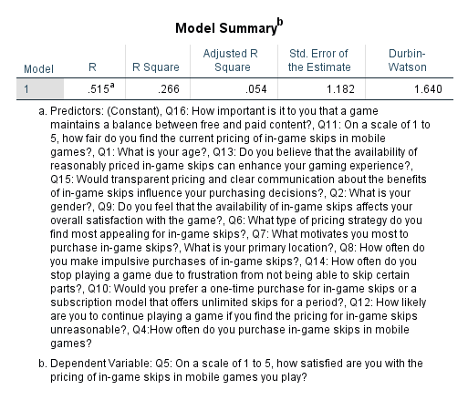

**Figure-1:** Model Summary.

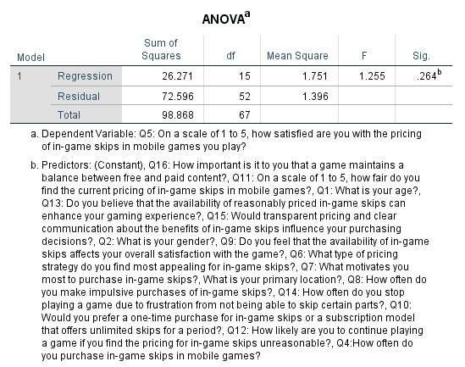

**Figure-2:** The ANOVA table.

According to the linear regression model summary and ANOVA table illustrated in figure-1 and figure-2 above, the R value basically represents the relationship (correlation) between the dependent and independent variables of the study. The strength of this correlation or association is determined with the value between −1 and +1 respectively with zero meaning there is not any correlation among the study variables and 1 means the perfect or complete correlation. The R value of this linear regression analysis is 0.515, which is a moderately positive correlation value, indicating that there is a moderately positive correlation among the predictor variables and the dependent variable of this study. Furthermore, looking at the R-squared value of 0.266 of this regression model, indicating that this regression model mainly explains 0.266 percent of the observed data or 0.266 percent variability that is observed in target variable is particularly explained by this regression model. Moreover, the results of the Durbin Watson statistic in the Model Summary of 1.640 indicates that there is a positive autocorrelation among the variables and the value is below 2.0 respectively.

Also, considering the output presented in the ANOVA table in figure-2 above, the significance value of 0.264 indicates that the null hypothesis of this study is rejected and the alternative hypothesis of the study is accepted. As the p-value of the regression is not below the significance level of 0.05 respectively.

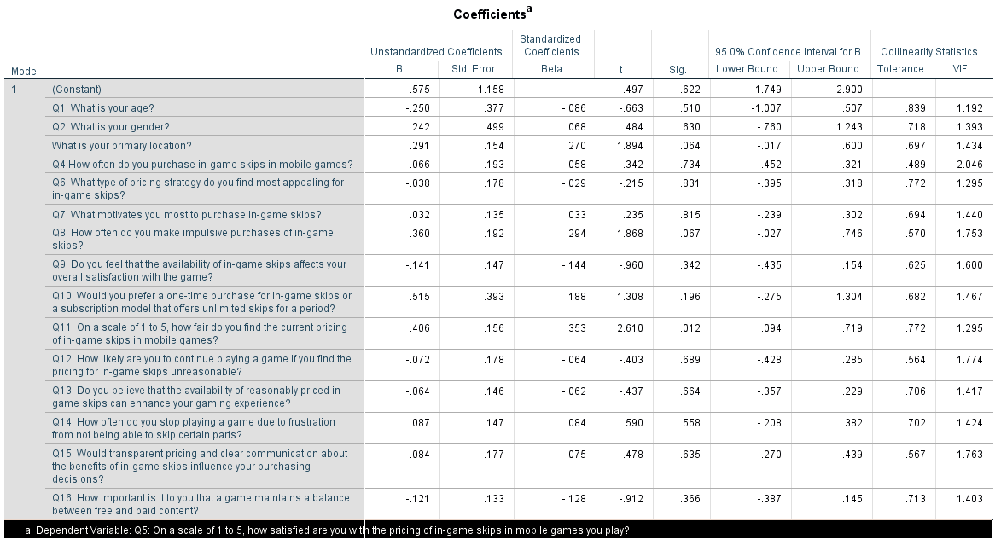

**Figure-3:** The coefficients table.

The coefficients table in figure-3 above shows that there is high collinearity tolerance and low VIF among all the study variables, indicating their high collinearity among the study variables, and it is important to include all the collinear variables in this analysis. Because the exclusion of any can cause the worse coefficient estimates, stronger confounding, and the downward-biased estimates mainly of the standard errors.

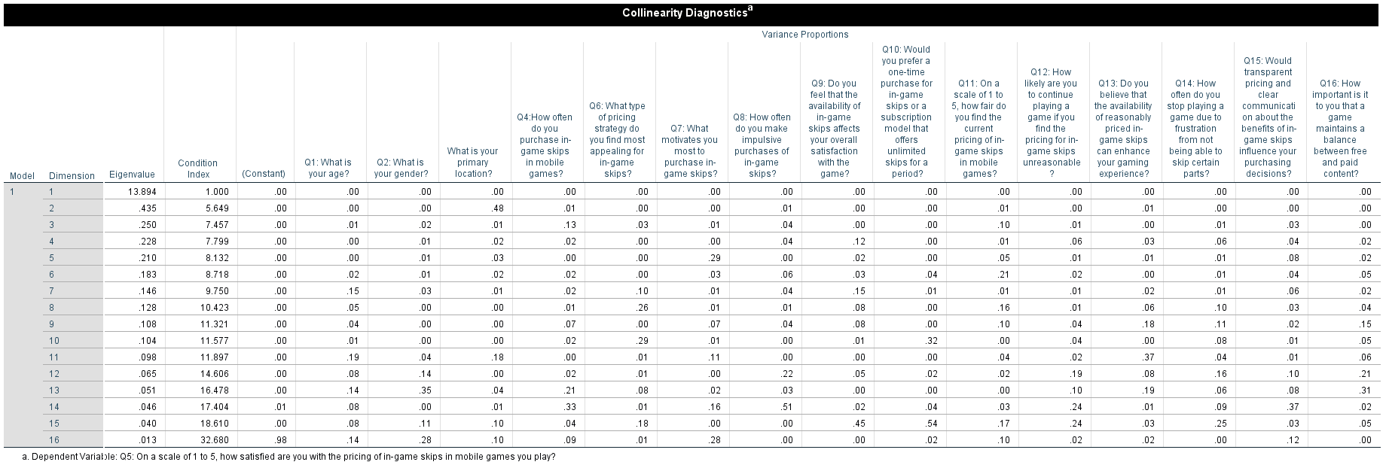

**Figure-4:** The collinearity analysis.

These findings are also proven by the figure-4 above collinearity analysis table, indicating that there is a high collinearity among the study variables and each of them are significant in predicting the value of the main dependent variable of this study.

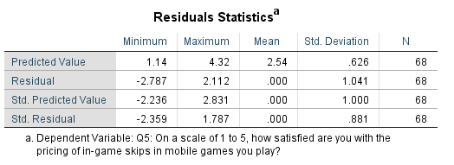

**Figure-5:** Residual statistics table.

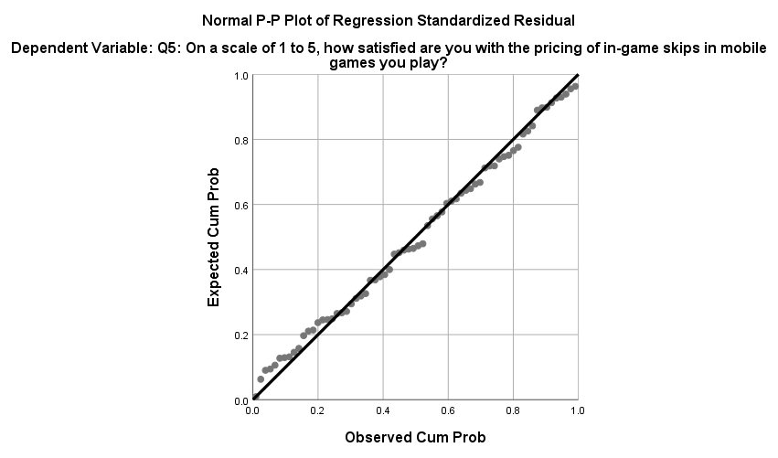

**Figure-6:** The normal probability plot.

The figure-5 above presents the residual statistics and the figure-6 above illustrates the normal probability plot. The normal probability plot output main illustrates that majority of the values are closer to mean indicating there is less variability in the data, especially in case of the main dependent variable of this study.

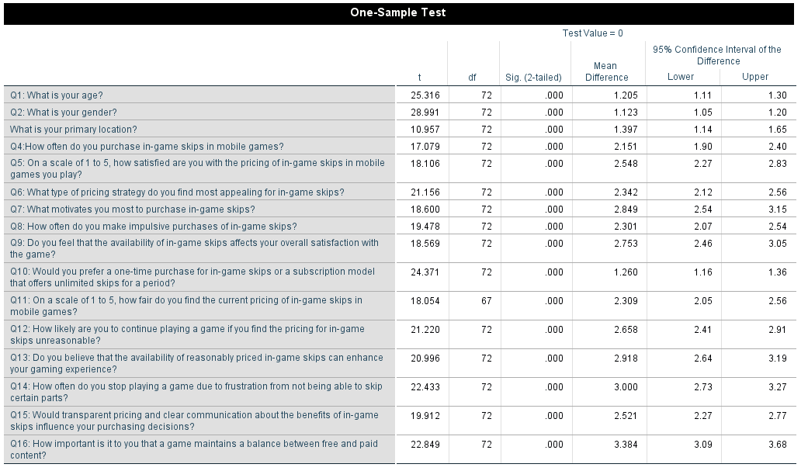

**Figure-7:** The one-sample T-test.

Lastly, the results of the one-sample T-test as illustrated in figure-7 above, indicates that the mean value of the sample has not much difference and the tested model is effective in predicting the values of the dependent variable of “Q5” the satisfaction level of gamers with the various features and in-game offers in the free-to-play games like “Battle Cards” respectively. Therefore, it can be stated that the availability of the reasonably priced in-game skips increases the player satisfaction in free-to-play (F2P) mobile games and the unreasonable pricing of in-game skips decreases the likelihood of players continuing to play a game. Moreover, the transparent pricing and communication about in-game skips do improve the likelihood of players making a purchase.

## Interpretation of Findings

### Implications of Survey Data

Using survey data, it is possible to determine major patterns in player’s expectations and behaviour regarding in-game skipping in F2P mobile games and show how game creators need to enhance their monetisation strategies. One major finding is the very high interest shown in certain pricing strategies namely discount packages with many skips at a far lower price than usual. This respondents’ preference of 37% is consistent to the theory that in-game purchases are considered according to the perceived value. Discount packages prove that players feel comfortable with monetisation schemes which are, in essence, a sale of an improved, cheaper gaming experience. Additionally, 30.1% of the sample selected dynamic pricing which suggest that there is an awareness of variable price adjustments based on in game behaviour or spending to allow for more control on the part of the players.

Approximately equal to the previous answers, 48% of the participants expressed their dissatisfaction toward current in-game skip prices meaning that prices that are ordinary to most F2P games do not meet player expectations. This disappointment leads me to one shorter and more unambiguous conclusion. In-game skips are more expensive than beneficial. A mismatch proves that players can perceive that the costs are too high or that the costs do not reflect the benefits; this leads to reduced engagement and even anger. Designers of games must adopt strategies of pricing for customers based on which the company’s profitability will be ensured, while the customers will be satisfied. Create pricing strategies that align the players’ expectation with the overall game revenue to increase the player satisfaction and revenues due to the high levels of engagement and repurchase incidences.

The survey also helps to reveal why players buy skip in-game, if they have it. Consequently, exclusivity is the source of 39.7% mark among the gamers as it was considered a primary aspect of the gamers, game advantage endian 26% and time savings endian 19.2%. Thus, the findings suggest that gamers are interested in the buy items which would give them some advantage over the opponents or which grant them exclusive content. This conclusion is very important for the developers because it states that the exclusivity and the value addition are the valuable in-game purchases. The diminished desire to fund developers (6. 8%) means that being charitable does not come into play when purchasing these goods. To encourage spending, developers should write clear descriptions of the in-game items that customers can expect in return which will replace the many generic examples.

The study also shows that disappointment may also cost from price displeasure and it also leads to the reduced number of the players. In particular, 28. 8% of respondents said that they were ‘somewhat unlikely’ to go on playing a game with an inflated in-game skip price. Such a strategy mitigates perhaps the biggest challenge that might face gambling firms and that is the fact that players may be noneroded by unfair or exorbitant charges. The results indicate that the accessibility of cheap in-game skips can increase the self-pleasure of the players and, thus, retain them. This often lays stress on the pertinent issue of relevant detail involvement and fair pricing. It is important for the creators of games to pay careful attention to their prices so as not to lose those players and, consequently, the cumulative, long-term profitability of the game.

Pervasive insights regarding the price structure acknowledge a need for clear pre-purchase costs and good information relating to in-game skip advantages. This supports the previous hypothesis that increased levels of price information improve the probability of a purchase, with 42.5% of participants using ‘’transparency and communication’’ in influencing their purchases. Players want to know about the thing that they are buying and felt that the price that was offered was reasonable. We desire transparency and that is why developers should adopt reasonable disclosure especially in their strategies towards monetisation of the products in the market in order to increase confidence and spending. There is however a possibility for developers of games to increase both the level of satisfaction of the players and their revenues through giving reasons on the usefulness and value of the in- game purchases.

### Connecting Findings to Hypotheses

The survey data provides a very high level of support to the study’s basic hypotheses. Based on the prior literature, this paper formulated the following hypothesis: Hypothesis 1 (H1): Affordable in-game skips enhance F2P mobile game player pleasure. The tendency toward offering more discount bundles and various pricing schemes promotes this idea: players are happier dissing dozens of the in-game distractions when they believe the skips are warranted. Players are more willing to engage with monetisation strategies they can rationalise as saving or gaining more as 37% of respondents preferred the discount packages. This is because the angst with present pricing modes seems to be striking 47. 9% of the respondents supports H1 thus highlighting the research finding that a significant proportion of player is unhappy with prices that are offered and is likely to be satisfied if the prices are made more reasonable.

Hypothesis 2 (H2) proposed that if the in-game skip pricing is unfair players will drop out of playing. For the most part, survey data bears out this hypothesis. A significant 28. 8% of the participant revealed they are ‘’Somewhat Unlikely’’ to continue with the game if in-game skip prices are high. This negative perception about something high or unfair price is connected with the low rate of users, which shows that the pricing strategies have to be thought through with regard to gamers. From the analysis of the data collected, there is a clear implication that player pricing fairness significantly relates to extended players’ stay proposing a crucial factor for consideration of pricing acquit to ensure players remain engaged.

According Hypothesis 3 (H3), it was hypothesised that transparent pricing as well as in-game skip communication increases sales. According to the survey, 42.5% of fire officers that participated in the survey have developed PTSD as a result of their work. With pricing transparency and clearer communication of the respondents stated that there will be an impact on the purchases. The need for fairness and; frankly, implies that players are willing to purchase the products as long as they know what exactly their money will get them. Pricing also has a highly positive factor with the argument that providing clear and accurate information is useful in increasing player credibility and therefore increasing spending.

The results of the linear regression analysis also provided relevant evidence regarding the satisfaction and motivation levels of respondents based on the fairness and acceptability of in-game pricing features of free-to-play particularly considering the case of “Battle Cards” video game. The results show that the p-value of this regression is 0.264, which is higher than the 0.05 significance alpha level, indicating that the null hypothesis of this study is rejected and the alternative hypothesis of the study is accepted. Therefore, it is stated that the availability of the reasonably priced in-game skips increases the player satisfaction in free-to-play (F2P) mobile games and the unreasonable pricing of in-game skips decreases the likelihood of players continuing to play a game. Moreover, the transparent pricing and communication about in-game skips do improve the likelihood of players making a purchase.

### Analysis of Patterns and Trends

Patterns and trends in survey results reveal players' preferences, particularly with demographics like age, gender, and geography. Females, BAs, and 18-25-year-olds spend more on in-game purchases. This suggests that teenage players may spend more on in-game assets or upgrades owing to their varied spending habits or increased interest in the game. This requires adjusting monetisation strategies for various age groups and creating value propositions for young kids, who are more inclined to spend on microtransactions. Male respondents made up 87.7% of the sample, which is helpful. The all-male group said winning-edge items were the greatest value. This matches evidence showing that men favour competitive play. They claim that male gamers may choose monetisation tactics that provide them special power-ups or quicker level progression. The stated components might be added to guys' monetisation targeting methods to increase engagement and expenditure. The majority of responders (84.9%) were Asian, suggesting that geography influences monetisation tactics. Along with Asia's vast mobile gaming industry and players' purchasing habits, pricing strategy approval may differ by area. Regional diversity of monetisation methods is necessary since gamers from various regions spend money differently. Game makers should consider regional trends and preferences to build a regional monetisation scheme.   
The study shows the necessity to sell certain resources and allow unlimited access to others. Some respondents said the best way to make a game is to provide a certain proportion of fundamental functions for free and the rest with some anticipated payments. Game producers must aim to keep people playing without overusing monetisation. Offline events that provide paying players secret perks and non-monetary participation seem significant might increase player retention and pay to play model satisfaction.

### Significant Insights for Optimising Monetisation Strategies

The data provides insights for F2F and F2P mobile game monetisation methods. First, the popularity of low-price packages and variable pricing suggests that developers should use more price-sensitive tactics. Developers may address purchase habits and improve players' well-being by employing bundles of in-game things that are somewhat cheaper or making item costs rely on involvement. This strategy meets perceived value demand and increases buy frequency and revenue. All price should be explicit and communicated. Players will spend a penny if they receive a good return. Another aspect of transparent monetisation is vividly explaining what customers are paying for and how it will change the game. This strategy promotes player spending, satisfaction, and income stability. The ratio of free and paid content must be maintained. In a sophisticated and somewhat confusing game, players desire fair play without having to buy to learn and enjoy. All game creators must provide both free and paid content to benefit all players and progress non-subscribers. This is crucial for long-term healthy competition and attracting participants from a variety of settings. Players' happiness important. The survey found that monetisation plans must match expectations and prices must be acceptable. Since many players like such features, developers may boost player contentment, retention, and income. This will ensure monetisation techniques produce money and strengthen gamer relationships.

## Discussion

***RQ1: How do different pricing strategies for in-game skips affect player satisfaction and retention in mobile games?***

The survey found that F2P mobile gaming players responded differently to skip pricing schemes. Another notable finding was that 37% of respondents favoured discount packages. This preference shows that players favour valuable pricing models. Players choose packages with several skips at a reduced price since they receive more for their money. This supports H1 that cheap in-game skips improve user satisfaction. Players choose pricing schemes that enable them to obtain game content or progress at a lower cost and satisfy their desire for value and fairness. Additionally, 30.1% of respondents favour dynamic pricing, which adjusts charges based on demand or player behaviour. This decision implies players care about alternatives and money management, which may increase enjoyment. Dynamic pricing might connect price with players' involvement and expenditure, giving them greater influence over their game experience and preventing exploitative, poorly moving, or expensive pricing. This confirms research showing that different pricing methods improve consumer satisfaction by meeting their desire and capacity to pay. However, 47.9% of respondents were unsatisfied with existing pricing techniques, indicating that most gamers believe in-game skip prices are too costly or unjust. Player retention depends on discontent; 28.8% of participants were "somewhat unlikely" to play a game with unjust prices. This supports H2 that high prices deter players. When advancement charges seem unjust, players become irritated and abandon the game, lowering retention. In research, pricing' fairness and worth affect players' contentment and inclination to remain. Discounts and dynamic pricing, which adjusts prices based on supply and demand, also perform well for gamers (Li, 2023). However, unjust or costly pro-rationing might deter players. Game designers could adopt a more behavioural and value-based pricing strategy to better match user conduct (Stephens, 2024). This helps users feel like they got good value for their money and improves their gaming experience.

***RQ2: What are the underlying psychological factors driving players' decisions to purchase skips or continue waiting?***

Self-enhancement elements identified by survey data include psychological factors that influence in-game skip purchases or natural advancement. Exclusive content 39.7% The respondents' main goal was purchasing skips. This shows that unique and rareness makes gamers buy unusual gaming gear. Scarcity theory proposes that gamers buy in to alleviate FOMO when something is limited. The need to compensate for rivals' cups was the second motivation for buying skips, although only 26% of respondents agreed. Players buy skips to level up quicker than their friends and improve their game rank. Social comparison theory, where people compare their ability to others, drives this competition. Many players buy skips in games because they improve their performance. Other efficiency advantages in the temporal domain, 19.5% participants, effect in-game skip purchases. Particularly in rapid games where players desire instant reward. Players may buy skips and tough difficulties to advance faster. Impulsivity, when killing in-game chores is fun, pays. Interestingly, just 6.8% of respondents indicated they bought skips to support developers. This shows that self-interest, whether in the form of selected and particular material, time saved, or superior to rivals' benefit, motivates purchases more than helping others. Lack of altruism shows most players buy stuff for themselves, not game progress. Players also wait rather than purchase skips due to purchasing value and price fairness. If a skip is expensive or worthless, players may not buy it. Value perception justifies a purchase when perceived benefits outweigh perceived costs (Bahrekhasari, 2023).

***RQ3: How can game designers optimise skip prices to maximise both player happiness and revenue?***

The survey showed that game designers may maximise player pleasure and income by aligning skip fees to demand and psychological considerations. They also found that gamers like "discount bundles" containing multiple skips at a discount. Game designers may take advantage of players' need for a deal and give cheaper skips, making them spend more and be happier. This strategy increases enjoyment and revenue by seeming to provide value to players. Another effective skip price optimisation method is dynamic pricing. A self-administered survey found that 30.1% of respondents employ dynamic pricing models that adjust rates based on demand or player activities. Game designers may charge less to numerous players to boost their spending power and more to devoted players. It also gives players the VIP sensation that a price hike is impending and they must get the games. As more spending is recorded and consumers are satisfied with the fair flexible pricing strategy, this approach improves Gross Profit. The correct information regarding in-game skip advantages and price transparency may optimise skip pricing. If participants liked the structure's pricing, 42.5%. People who answered ‘Not Sure’ were more inclined to purchase. These games' developers should emphasise skip cost and retracting benefit information to help players make confident purchases. By building confidence via designer openness, buyers are more inclined to buy, increasing designer revenue and player delight. Since part of the material must be free and half paid, skip pricing must be optimised. Players want a plan between extreme free and extreme premium stuff, according to research. Game designers should let non-pay-to-win gamers to enjoy the game without pressure (Stanislav Stanković, 2024). This reduces iconoclasm and ensures a big, diverse player base for a long, profitable company. Free, useful content and optional paid skips boost user pleasure and game profit (Muhammad Faisal Shahzad and Salo, 2023).

## Summary

In this chapter, survey results are analysed to identify player attitudes and behaviours surrounding in-game skips in F2P mobile games. A descriptive examination of demographics and buying trends begins the chapter. Young, Asian male gamers with various in-game skip price choices dominate the findings. Players seldom buy skips because to cost displeasure. Access to unique material and competitive advantage are psychological drivers of purchasing, according to the chapter. To optimise player pleasure and income, it recommends discount packages, dynamic pricing, and clear communication. Fair pricing and clear communication improve player retention and engagement in F2P games, as does balancing free and paid content to ensure a healthy player base and long-term profitability.

# Chapter 5: Conclusion

This study contributes to the understanding of free-to-play (F2P) mobile game monetisation strategies, and more precisely, on how to most effectively price the skip in-game to enhance users’ satisfaction and revenues. This paper considered strategies used in pricing with an emphasis placed on players’ behavioural aspects with reference to psychosocial determinants of purchase, and gaming designers’ points of view on aspects to balance to achieve maximum user satisfaction as well as profiting. Based on the findings of the survey and the preceding literature review, we may draw multiple essential recommendations for the game developers, marketers, and significant stakeholders.

## Significance of Research Findings

This research I aim to do contributes to the understanding of the impact of F2P mobile game monetisation strategies on players’ behaviour and enjoyment. The research identified that gamers are aware of price profiling and it is preferred to value based methods such as promotions/ bundle pricing and dynamic pricing. Game developers and marketers require this information to design and formulate monetisation models that would satisfy the players.

Such findings underlined the importance of such pricing strategies that increase a revenue and user satisfaction and engagement for games developers. There are some key things that developers may do to enhance players’ attentiveness and constant play with fair and valuable pricing policies subsisting. Claiming that the study focuses only on honest information and fair price corresponds to the principles of game design where player trust and long-term engagement are considered to be more important than one shot profit.

The collected knowledge of player behaviour and psychological triggers for consumptions of in-game products assist marketers to design effective campaigns. To sum it all, it is easier to market to the players by acknowledging the fact of exclusivity, competitive advantage and time-saving that players consider while choosing a particular game. Marketing communicational messages can also be utilised by companies in developing player trust and loyalty by stressing fairness in the pricing strategy.

## Linking Research Problem, Literature Review, and Findings

This research maximises incremental income while keeping player enjoyment in F2P mobile games. Literature review showed that developers struggle to optimise for these two qualities, especially when excessive monetisation may cause end-user dissatisfaction. Previous study shows that players dislike exploitative or unjust pricing that dilutes interactions and drops out rate. Real data on players' pricing tactics from this study is used to explain these points. The study also found that discounts and price methods make games more fun and gratifying. This highlights the literary concept of ‘fairness’ and ‘reasonableness’ of pricing, encouraging gamers to buy in-game stuff. In addition to exclusivity, competition, and convenience studies, the study examines psychological aspects that motivate players to buy gaming products. In view of the research challenge, player-favoring monetisation solutions should improve game experience and give transparent and acceptable charges.

## Managerial Implications

Previous studies on mobile game monetization have often focused on broad monetization models without delving deeply into the nuances of player psychology and behavior. Many papers have highlighted the effectiveness of different monetization strategies, such as in-app purchases and ads, but they lack comprehensive analysis on how these strategies align with player satisfaction and engagement over time. Moreover, there has been limited exploration of the ethical implications of aggressive monetization tactics and their impact on player trust and loyalty.

This research advances the theoretical understanding of mobile game monetization by integrating insights from behavioral economics and psychology. It provides empirical evidence on how different pricing strategies (e.g., dynamic pricing, discount bundles) influence player satisfaction and retention, filling a critical gap in the literature. By focusing on the psychological antecedents of purchase decisions, such as exclusivity, competition, and time-saving, the study offers a more nuanced understanding of what drives player engagement and spending in F2P games.

Furthermore, this research introduces a novel perspective on the ethical considerations in game monetization, emphasizing the need for fairness and transparency. It challenges the traditional view that maximizes revenue at the expense of player satisfaction, proposing instead that sustainable monetization must balance profitability with a positive user experience. This approach not only contributes to the academic discourse on ethical monetization practices but also provides actionable insights for industry practitioners.

Building on the foundational work of scholars like Alha (2020) and Fields (2014), who explored the basic dynamics of F2P monetization, this study extends their frameworks by incorporating player-centric factors and ethical considerations. It also aligns with recent findings by Mäkinen (2022) and Grønstad (2021), who advocate for more player-friendly monetization strategies. Through synthesizing these diverse strands of research, the study offers a more holistic view of the mobile gaming ecosystem and its monetization potential.

## Limitations of the Research

This study helps analyse player behaviour and monetise users, but it has limits. First, much of the data in this study came from questionnaires, which are prone to social desirability and memory bias. People may report what they believed the society would approve of or misremember how they spent their in-game pounds, which might be problematic. The convenience sample that targeted SNS users may not apply to all gamers. Such a sampling approach may have caused sample bias in player ages, playtime, and gaming forum visits, lowering external validity of the results. The study relied on numerical data rather than qualitative information to better understand players' demands. Quantitative cross-sectional surveys of players and interviews may be used in future study. Focus group follow-up might reveal player conduct and attitudes.

## Suggestions for Future Research

Moreover, based on the result and the limitation of this study, the following suggestions could be given for the future research in the topic of monetisation strategies in F2P mobile games. An area of study for future research is the exploration of demographic factors including age, gender and location on player preferences and behaviours. This aspect could help developers to get better insights in how various demographic groups behave towards various pricing models.

One more line of work that is worth investigating in the future studies is a comparison of the long-term effects of various approaches to monetisation on users’ loyalty and management of their attention. Of course, this study gives only a cross-sectional picture of player preferences; it can be interesting to look at how these preferences change over time and how varying price structures affect players’ loyalty and lifetime value in longitudinal research.

More broadly, it could be hypotheses that more insights into the underlying concepts of narrative, visuals and mechanics of game design in relation to the perception of monetisation can be obtained in the future studies. Perceiving how these factors relate to the pricing approaches could bring additional information about what may lead to players’ enthusiasm and expending in F2P mobile games.

There is a requirement for more work to be conducted on the ethical issues linked with game monetisation, with an increasing extent of focus on controversy like loot boxes and pay-to-win systems criticised due to the frequent violence of exploitative. Further research could be aimed at finding out which of the existing ethical theories can be used in order to create a viable model for monetising games that will be ethical and appropriate to maximise their potential economic efficiency to the benefit of players and game creators.

## Conclusion

This research has revealed critical aspects of analysing the monetisation strategies of F2P mobile games, embracing the core principles of value, fairness, and transparency on the pricing. When monetisation trends are in sync with the players’ wants and purchase motivation, the level of satisfaction is boosted and so is the number of retained players and, simultaneously, revenues are optimised. Taken together, these outcomes indicate the necessity of the Player-Centric strategies based on longer-term perspectives, which will build the solid ground for the sustainable development in the highly competitive gaming environment. The future studies must further investigate how players’ behaviours, game mechanisms, and revenue models compose the possibilities in terms of the preferable tactics for players and developers.

# References

Adeoye, M.A. (2023). Review of Sampling Techniques for Education. *ASEAN Journal for Science Education*, [online] 2(2), pp.87–94. Available at: <https://ejournal.bumipublikasinusantara.id/index.php/ajsed/article/view/230>.

Alcanja, D. (2019). *Why Freemium Is The Most Popular Way Of Mobile App Monetization*. [online] Medium. Available at: <https://medium.com/swlh/why-freemium-is-the-most-popular-way-of-mobile-app-monetization-691de28943f4> [Accessed 24 Aug. 2024].

Alha, K. (2020). *The Rise of Free-to-Play: How the Revenue Model Changed Games and Playing*. [online] *trepo.tuni.fi*. Tampere University. Available at: <https://trepo.tuni.fi/handle/10024/123848>.

Appbrain (2022). *Google Play Ranking: Top Grossing Overall in the United States*. [online] AppBrain. Available at: <https://www.appbrain.com/stats/google-play-rankings/top_grossing/all/us>.

AppLovin (2021). *What is Hybrid Monetization?* [online] AppLovin. Available at: <https://www.applovin.com/blog/what-is-hybrid-monetization/> [Accessed 24 Aug. 2024].

AppsFlyer (2018). *THE CORNERSTONE OF APP MARKETING Lifetime Value 2018 LTV Benchmarks*. [online] Available at: <https://www.appsflyer.com/gatedpdfs/pdfs/Lifetime_Value_The_Cornerstone_of_App_Marketing.pdf> [Accessed 24 Aug. 2024].

Bahrekhazari, A. (2023). *Player concerns about MMORPG monetization*. [online] bora.uib.no. Available at: <https://bora.uib.no/bora-xmlui/handle/11250/3072343>.

Barnes (2021). *11 in-game currencies you need to know about*. [online] Medium. Available at: <https://medium.com/ironsource-levelup/11-in-game-currencies-you-need-to-know-about-8775c6724bcb>.

Barroga, E., Matanguihan, G.J., Furuta, A., Arima, M., Tsuchiya, S., Kawahara, C., Takamiya, Y. and Izumi, M. (2023). Conducting and Writing Quantitative and Qualitative Research. *Journal of Korean Medical Science*, [online] 38(37), pp.1–16. doi: <https://doi.org/10.3346/jkms.2023.38.e291>.

Benji Hyam (2021). *App Monetization: Freemium vs Premium, In-App Purchase vs Paid*. [online] Build Blog by ThinkApps | Content on Entrepreneurship, Mobile Apps, Web Platforms and more. Available at: <https://thinkapps.com/blog/post-launch/monetize-apps-paid-apps-vs-app-purchases-vs-freemium-vs-subscription> / [Accessed 24 Aug. 2024].

Cao, S. and Xu, X. (2024). Competition, Emotion, and Socialization: A Study on the In-Game Purchase Mechanism and Player Motivation in Onmyoji. *Palgrave games in context*, pp.143–161. doi: <https://doi.org/10.1007/978-3-031-41504-3_8>.

Che, T., Peng, Y., Zhou, Q., Dickey, A. and Lai, F. (2023). The impacts of gamification designs on consumer purchase: A use and gratification theory perspective. *Electronic Commerce Research and Applications*, [online] 59, p.101268. doi: <https://doi.org/10.1016/j.elerap.2023.101268>.

Close, J. and Lloyd, J. (2021). *Lifting the Lid on Loot-Boxes Chance-Based Purchases in Video Games and the Convergence of Gaming and Gambling*. [online] Available at: <https://www.gambleaware.org/sites/default/files/2021-03/Gaming_and_Gambling_Report_Final.pdf>.

Collet, O.A., Orri, M., Tremblay, R.E., Boivin, M. and Côté, S.M. (2022). Psychometric properties of the Social Behavior Questionnaire (SBQ) in a longitudinal population-based sample. *International Journal of Behavioral Development*, 47(2), pp.180–189. doi: <https://doi.org/10.1177/01650254221113472>.

Coutinho (2021). *The Microtransaction Business Model: A Study on Modern Videogame Monetization and the Economic Sustainability of Microtransactions - ProQuest*. [online] www.proquest.com. Available at: <https://www.proquest.com/openview/77ff644f4e3ba4769ee3e027242a8d4b/1?pq-origsite=gscholar&cbl=2026366&diss=y>.

Creswell, J.W. and Creswell, J.D. (2017). *Research design: Qualitative, quantitative, and Mixed Methods Approaches*. 5th ed. Thousand Oaks, California: SAGE Publications.

Darko, E.M., Kleib, M. and Olson, J. (2022). Social Media Use for Research Participant Recruitment: Integrative Literature Review. *Journal of Medical Internet Research*, [online] 24(8), p.e38015. doi: <https://doi.org/10.2196/38015>.

Dobakhti, L. (2020). The process of enhancing validity, reliability, and ethics in research. *Iranian Journal of Applied Language Studies*, [online] 12(2), pp.59–88. doi: <https://doi.org/10.22111/IJALS.2020.5978>.

Ekaterina Bespyatova (2024). *Sensor Tower: In 2024, IAP revenue of the global mobile gaming market will grow to $78 billion*. [online] app2top.com. Available at: <https://app2top.com/news/sensor-tower-in-2024-iap-revenue-of-the-global-mobile-gaming-market-will-grow-to-78-billion-269311.html> [Accessed 24 Aug. 2024].

Fields, T. (2014). *Social game design : monetization methods and mechanics*. Boca Raton: Ak Peters/Crc Press.

Gallo, A. (2017). *A Refresher on A/B Testing*. [online] Harvard Business Review. Available at: <https://hbr.org/2017/06/a-refresher-on-ab-testing>.

Grasset, G. (2015). *Decoy Pricing Definition*. [online] www.lokad.com. Available at: <https://www.lokad.com/decoy-pricing-definition>.

Grønstad, M. (2021). *Consumer psychology and purchasing behavior in free-to-play games*. [online] ntnuopen.ntnu.no. Available at: <https://ntnuopen.ntnu.no/ntnu-xmlui/handle/11250/2832847>.

Hady ElHady (2020). *The Mobile Game Monetization Guide | Instabug*. [online] Instabug.com. Available at: <https://www.instabug.com/blog/mobile-game-monetization>.

Hall, J.R., Savas-Hall, S. and Shaw, E.H. (2022). A Deductive Approach to a Systematic Review of Entrepreneurship Literature. *Management Review Quarterly*, 73(1), pp.1–30. doi: <https://doi.org/10.1007/s11301-022-00266-9>.

Hesta Friedrich-Nel and Aarthi Ramlaul (2020). Ethical Considerations. *Springer eBooks*, pp.81–97. doi: <https://doi.org/10.1007/978-3-030-37944-5_6>.

Jamieson, M.K., Govaart, G.H. and Pownall, M. (2023). Reflexivity in Quantitative research: a Rationale and beginner’s Guide. *Social and Personality Psychology Compass*, 17(4), pp.1–15.

Jiang, C. (2021). Gaming on the Go: Examining the Resurgence and Growth of the Mobile and VR Games Markets During the Pandemic. *Proceedings of the 2021 3rd International Conference on Economic Management and Cultural Industry (ICEMCI 2021)*. doi: <https://doi.org/10.2991/assehr.k.211209.115>.

Kakko, K. (2024). *The Impact of Microtransactions on Consumer Behaviour in Free-to-play Video Games*. [online] www.theseus.fi. Available at: <https://www.theseus.fi/handle/10024/860473>.

Kalirai , K. and Yu, M. (2019). *Simmons & Simmons*. [online] www.simmons-simmons.com. Available at: <https://www.simmons-simmons.com/en/publications/ck0a3qu8hmz760b33l0vul474/240519-regulating-loot-boxes---open-your-beginner-crate>.

Kesmodel, U.S. (2018). Cross-sectional Studies - What Are They Good for? *Acta Obstetricia Et Gynecologica Scandinavica*, 97(4), pp.388–393. doi: <https://doi.org/10.1111/aogs.13331>.

Kohavi, R. and Thomke, S. (2017). *A/B Testing: How to Get It Right*. [online] Harvard Business Review. Available at: <https://hbr.org/2017/09/the-surprising-power-of-online-experiments>.

Kontsevoi, B. (2024). Council Post: Mobile App Monetization Part 4: Revenue Generation Models. *Forbes*. [online] 12 Aug. Available at: <https://www.forbes.com/councils/forbestechcouncil/2020/06/30/mobile-app-monetization-part-4-revenue-generation-models> /[Accessed 24 Aug. 2024].

Li, W. (2023). Pricing Strategies in a Dynamic Market. *Management for professionals*, pp.183–209. doi: <https://doi.org/10.1007/978-981-99-5253-3_8>.

Mai, Y. and Hu, B. (2022). Optimizing Free-to-Play Multiplayer Games with Premium Subscription. *Management Science*. doi: <https://doi.org/10.1287/mnsc.2022.4510>.

Mäkinen, J. (2022). *Creating a Monetization Model for a Free-to-play Mobile Game*. [online] Available at: <https://www.theseus.fi/bitstream/handle/10024/779991/Makinen_Joona.pdf?sequence=2>.

Management Association, Information Resources (2022). *Research Anthology on Game Design, Development, Usage, and Social Impact*. IGI Global.

March 27, https://www revenera com/blog/software-monetization/what-is-user-retention/ (2020). *What Is User Retention? Measure, Analyze, Improve*. [online] Revenera Blog. Available at: <https://www.revenera.com/blog/software-monetization/what-is-user-retention/>.

Mazhar, S.A., Anjum, R., Anwar, A.I. and Khan, A.A. (2021). Methods of Data Collection: A Fundamental Tool of Research. *Journal of Integrated Community Health (ISSN 2319-9113)*, [online] 10(1), pp.6–10. Available at: <https://medicaljournalshouse.com/index.php/ADR-CommunityHealth/article/view/631>.

Mbanaso, U.M., Abrahams, L. and Okafor, K.C. (2023). Research Philosophy, Design and Methodology. *Research Philosophy, Design and Methodology*, [online] 1(1), pp.81–113. Available at: <https://link.springer.com/chapter/10.1007/978-3-031-30031-8_6>.

McEwan, B. (2020). Sampling and Validity. *Annals of the International Communication Association*, [online] 44(3), pp.235–247. doi: <https://doi.org/10.1080/23808985.2020.1792793>.

Md. Mizanur Rahman (2023). *Sample Size Determination for Survey Research and Non-Probability Sampling Techniques: A Review and Set of Recommendations | Journal of Entrepreneurship, Business and Economics*. [online] www.scientificia.com. Available at: <http://www.scientificia.com/index.php/JEBE/article/view/201>.

Mesek, M. (2023). *How to understand the language of business research methods*. [online] ResearchOnline. Available at: <https://researchonline.gcu.ac.uk/en/publications/how-to-understand-the-language-of-business-research-methods>.

Muhammad Faisal Shahzad and Salo, J. (2023). Factors affecting psychological ownership in playful consumption experience. *Journal of Contemporary Marketing Science*, 6(3), pp.189–209. doi: <https://doi.org/10.1108/jcmars-09-2022-0025>.

Muhammad Zhafir (2022). Are Gamers Satisfied with Their Money Spent on Virtual Goods in Online Games? Understanding Gamers Satisfaction based on Perceived Values and Purchasing Motivation. *Management and Economics Review*, [online] 7(2), pp.119–140. Available at: <https://www.ceeol.com/search/article-detail?id=1048876> [Accessed 24 Aug. 2024].

Mundee, J. (2020). *Monetization & Skyrim, Appropriation & Play*. [online] Available at: <https://unbscholar.dspace.lib.unb.ca/server/api/core/bitstreams/060370c7-a2df-4a3a-bbba-5a75c783fc9f/content>.

Oke, K. (2015). *Pay-to-play vs. free-to-play: when does premium work?* [online] Canada Media Fund. Available at: <https://cmf-fmc.ca/now-next/articles/pay-to-play-vs-free-to-play-when-does-premium-work/>.

Parker, J. (2021). *World of Warcraft’s New Microtransactions Are Greedier Than Ever*. [online] Esports Talk. Available at: <https://www.esportstalk.com/news/world-of-warcraft-new-microtransactions-greedier-than-ever> / [Accessed 24 Aug. 2024].

Petrovskaya, E. (2021). *‘Very sneaky tactics’: we asked gamers how they feel about monetisation in digital gaming*. [online] The Conversation. Available at: <https://theconversation.com/very-sneaky-tactics-we-asked-gamers-how-they-feel-about-monetisation-in-digital-gaming-173030>.

Petrovskaya, E. and Zendle, D. (2021). Predatory Monetisation? A Categorisation of Unfair, Misleading and Aggressive Monetisation Techniques in Digital Games from the Player Perspective. *Journal of Business Ethics*, 181(4). doi: <https://doi.org/10.1007/s10551-021-04970-6>.

Phair, D. and Warren, K. (2021). *Saunders’ Research Onion: Explained Simply*. [online] Grad Coach. Available at: <https://gradcoach.com/saunders-research-onion/>.

Robson, D. (2019). *The trick that makes you overspend*. [online] www.bbc.com. Available at: <https://www.bbc.com/worklife/article/20190801-the-trick-that-makes-you-overspend>.

Roni, S.M. and Djajadikerta, H.G. (2021). *Data Analysis with SPSS for Survey-based Research*. Singapore: Springer Singapore. doi: <https://doi.org/10.1007/978-981-16-0193-4>.

Sardana, N., Shekoohi, S., Cornett, E.M. and Kaye, A.D. (2023). *Chapter 6 - Qualitative and quantitative research methods*. [online] ScienceDirect. Available at: <https://www.sciencedirect.com/science/article/abs/pii/B9780323988148000081>.

Saunders (2019). *Research Onion Framework*. [online] Google.com. Available at: <https://www.google.com/url?sa=i&url=https%3A%2F%2Fwww.researchgate.net%2Ffigure%2FSaunders-et-als-Research-Onion-30_fig2_349316382&psig=AOvVaw2ADDb4LU_l_cC-fW5MUopz&ust=1724594739462000&source=images&cd=vfe&opi=89978449&ved=0CBcQjhxqFwoTCJCPz7nmjYgDFQAAAAAdAAAAABAE> [Accessed 24 Aug. 2024].

Stanislav Stanković (2024). *Game Design for Free-to-Play Live Service*. *Synthesis lectures on image, video, and multimedia processing*. Morgan & Claypool Publishers. doi: <https://doi.org/10.1007/978-3-031-56156-6>.

Statista (2023). *Mobile Games - Worldwide | Statista Market Forecast*. [online] Statista. Available at: <https://www.statista.com/outlook/dmo/digital-media/video-games/mobile-games/worldwide>.

Stephens, D. (2024). Balancing multiplayer games design using deep learning techniques. *figshare*. [online] doi: <https://doi.org/10.34961/researchrepository-ul.26509015.v1>.

Symcox, J. (2021). *Inside UK’s £1 billion videogame franchise RuneScape - BusinessCloud*. [online] BusinessCloud. Available at: <https://web.archive.org/web/20210419195008/https:/businesscloud.co.uk/inside-uks-1-billion-videogame-franchise-runescape> / [Accessed 24 Aug. 2024].

Theofanidis, D. and Fountouki, A. (2018). Limitations and delimitations in the research process. *Perioperative Nursing - Quarterly scientific, online official journal of G.O.R.N.A.*, [online] Volume 7 (2018)(Issue 3 September-December 2018), pp.155–163. doi: <https://doi.org/10.5281/zenodo.2552022>.

Tode, C. (2017). *Subway sponsors mobile game to attract Super Bowl viewers | Marketing Dive*. [online] Marketingdive.com. Available at: <https://www.marketingdive.com/ex/mobilemarketer/cms/news/gaming/12007.html> [Accessed 24 Aug. 2024].

venturebeat (2020). *In-game ad revenue will reach $56B in 2024, but getting your share depends on genre (VB Live)*. [online] venturebeat. Available at: <https://venturebeat.com/business/in-game-ad-revenue-will-reach-56b-in-2024-but-getting-your-share-depends-on-genre-vb-live/>.

# Appendix

## Questionnaire

**What is your age?**

18-25

26-35

36-45

46 and above

**What is your gender?**

Male

Female

**What is your primary location?**

North America

Europe

Asia

South America

Africa

Australia

Other

**How often do you purchase in-game skips in mobile games?**

Never

Rarely

Sometimes

Often

Always

**On a scale of 1 to 5, how satisfied are you with the pricing of in-game skips in mobile games you play?**

Extremely dissatisfied

Somewhat dissatisfied

Neither satisfied nor dissatisfied

Somewhat satisfied

Extremely satisfied

**What type of pricing strategy do you find most appealing for in-game skips?**

Fixed price

Dynamic pricing (prices change based on demand)

Discount bundles (multiple skips for a lower price)

Subscription-based

**What motivates you most to purchase in-game skips?**

To save time

To gain an advantage in the game

To support the developers

To access exclusive content

Impulse buying

**How often do you make impulsive purchases of in-game skips?**

Never

Rarely

Sometimes

Often

Always

**Do you feel that the availability of in-game skips affects your overall satisfaction with the game?**

Definitely not

Probably not

Might or might not

Probably yes

Definitely yes

**Would you prefer a one-time purchase for in-game skips or a subscription model that offers unlimited skips for a period?**

One-time purchase

Subscription model

**On a scale of 1 to 5, how fair do you find the current pricing of in-game skips in mobile games?**

1 (Very unfair)

2

3

4

5 (Very fair)

**How likely are you to continue playing a game if you find the pricing for in-game skips unreasonable?**

Extremely unlikely

Somewhat unlikely

Neither likely nor unlikely

Somewhat likely

Extremely likely

**Do you believe that the availability of reasonably priced in-game skips can enhance your gaming experience?**

Definitely not

Probably not

Might or might not

Probably yes

Definitely yes

**How often do you stop playing a game due to frustration from not being able to skip certain parts?**

Never

Rarely

Sometimes

Often

Always

**Would transparent pricing and clear communication about the benefits of in-game skips influence your purchasing decisions?**

Strongly agree

Agree

Neutral

Disagree

Strongly disagree

**How important is it to you that a game maintains a balance between free and paid content?**

Not at all important

Slightly important

Moderately important

Very important

Extremely important

<https://surreyfbel.qualtrics.com/jfe/form/SV_80lUUw3Zv8Ssslw>