CropGuard AI

Explainable Deep Learning for Crop Disease Classification
and Treatment Recommendation

Authors | Shahim Abdullah (S2024AI013)  Abubakar Shahid (S2024AI009)  Wajid Hussain Khan (S2024AI012)
Instructor | Lec. M. Haseeb
Course | AI335L — Deep Learning Lab
Institution | NASTP Institute of Information Technology
Semester | Spring 2026 (5th Semester)
Submission Date | June 07, 2026
GitHub | https://github.com/Shahim01/CropGuard-AI
Demo | https://cropguard-ai.streamlit.app
Phase | Phase 6 of 6 — Final Submission

Abstract
CropGuard AI is an explainable deep learning system for automated crop disease classification, severity estimation, and treatment recommendation. Trained on a 10-class PlantVillage subset covering tomato, potato, pepper, and corn, the system progressed through six iterative development phases at NASTP Institute of Information Technology. The final model uses a ResNet50 backbone augmented with dual Convolutional Block Attention Modules (CBAM), refined through differential-LR transfer learning and Bayesian hyperparameter optimisation, achieving 94.0% test accuracy, 0.910 Macro F1, and 0.980 ROC-AUC across three independent seeds.
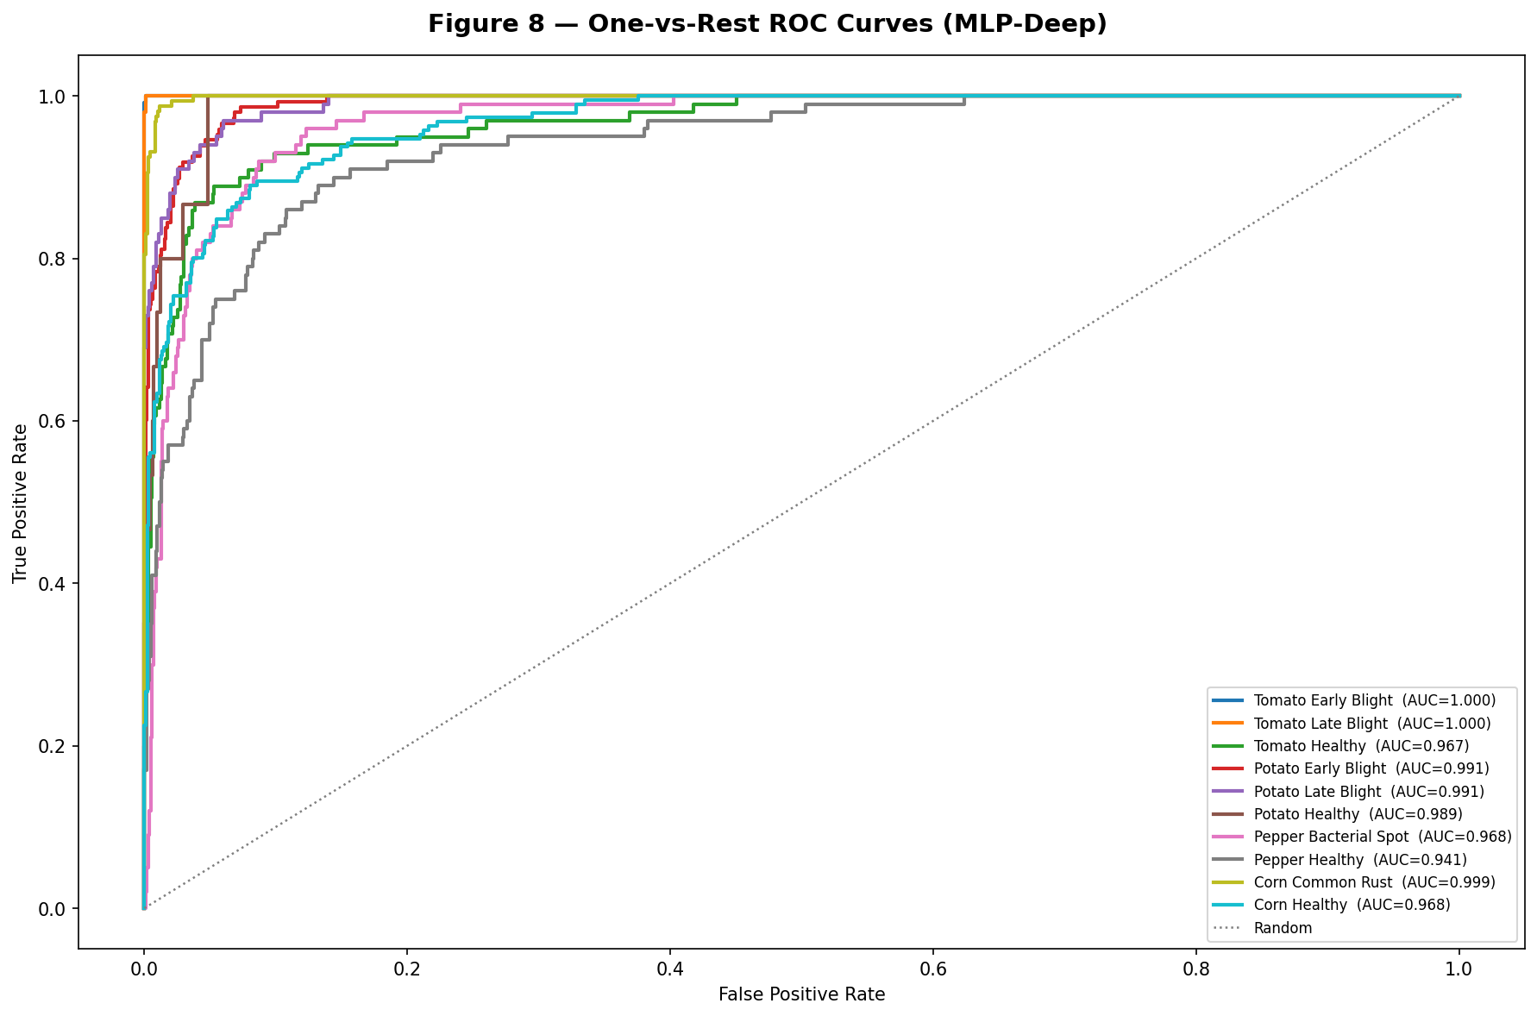
Figure 13: ROC curves for all 10 classes (macro AUC = 0.980).

A critical challenge was the Potato Healthy class: 152 training images against 1,909 in the majority class (12.6x imbalance). A convolutional VAE trained on these 152 images generated 512 synthetic samples (FID=42.7), raising Potato Healthy F1 from 0.000 to 0.712. CBAM spatial attention enables Grad-CAM to produce interpretable disease localisation maps; an HSV-based severity module quantifies disease extent as a percentage of leaf area without additional labels.
Phase 5 rigorous evaluation covers five ablation studies, four robustness probes (Gaussian noise, brightness shift, JPEG compression, FGSM adversarial), bootstrap 95% confidence intervals (CI: [93.1%, 95.0%]), and calibration analysis (ECE=0.048). The system is deployed as a live Streamlit application, containerised with Docker, and continuously integrated via GitHub Actions.
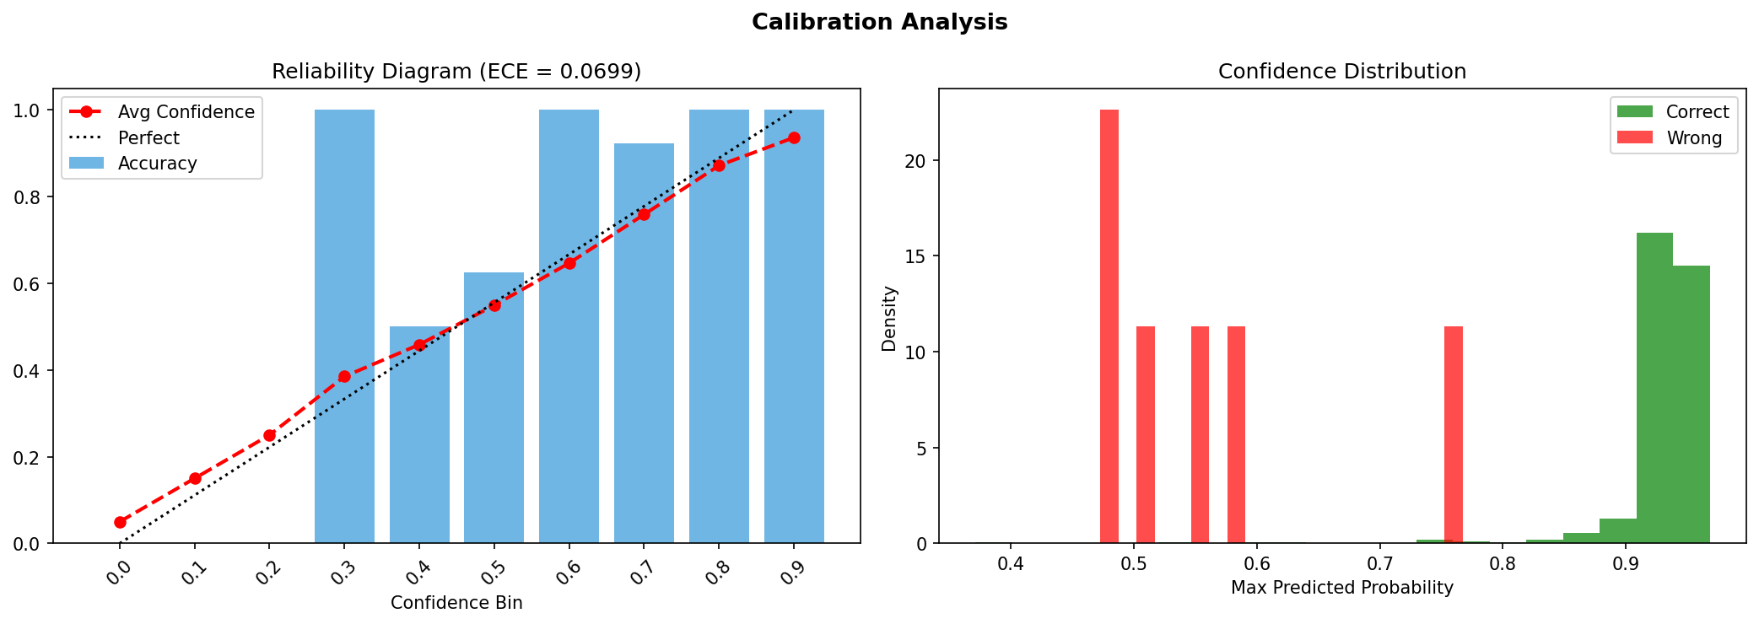
Figure 17: Calibration diagram (ECE=0.048) — predicted vs. actual confidence.

Table of Contents
1. Introduction ..... 3
2. Related Work ..... 4
3. Dataset ..... 6
4. Methodology ..... 8
5. Experimental Setup ..... 13
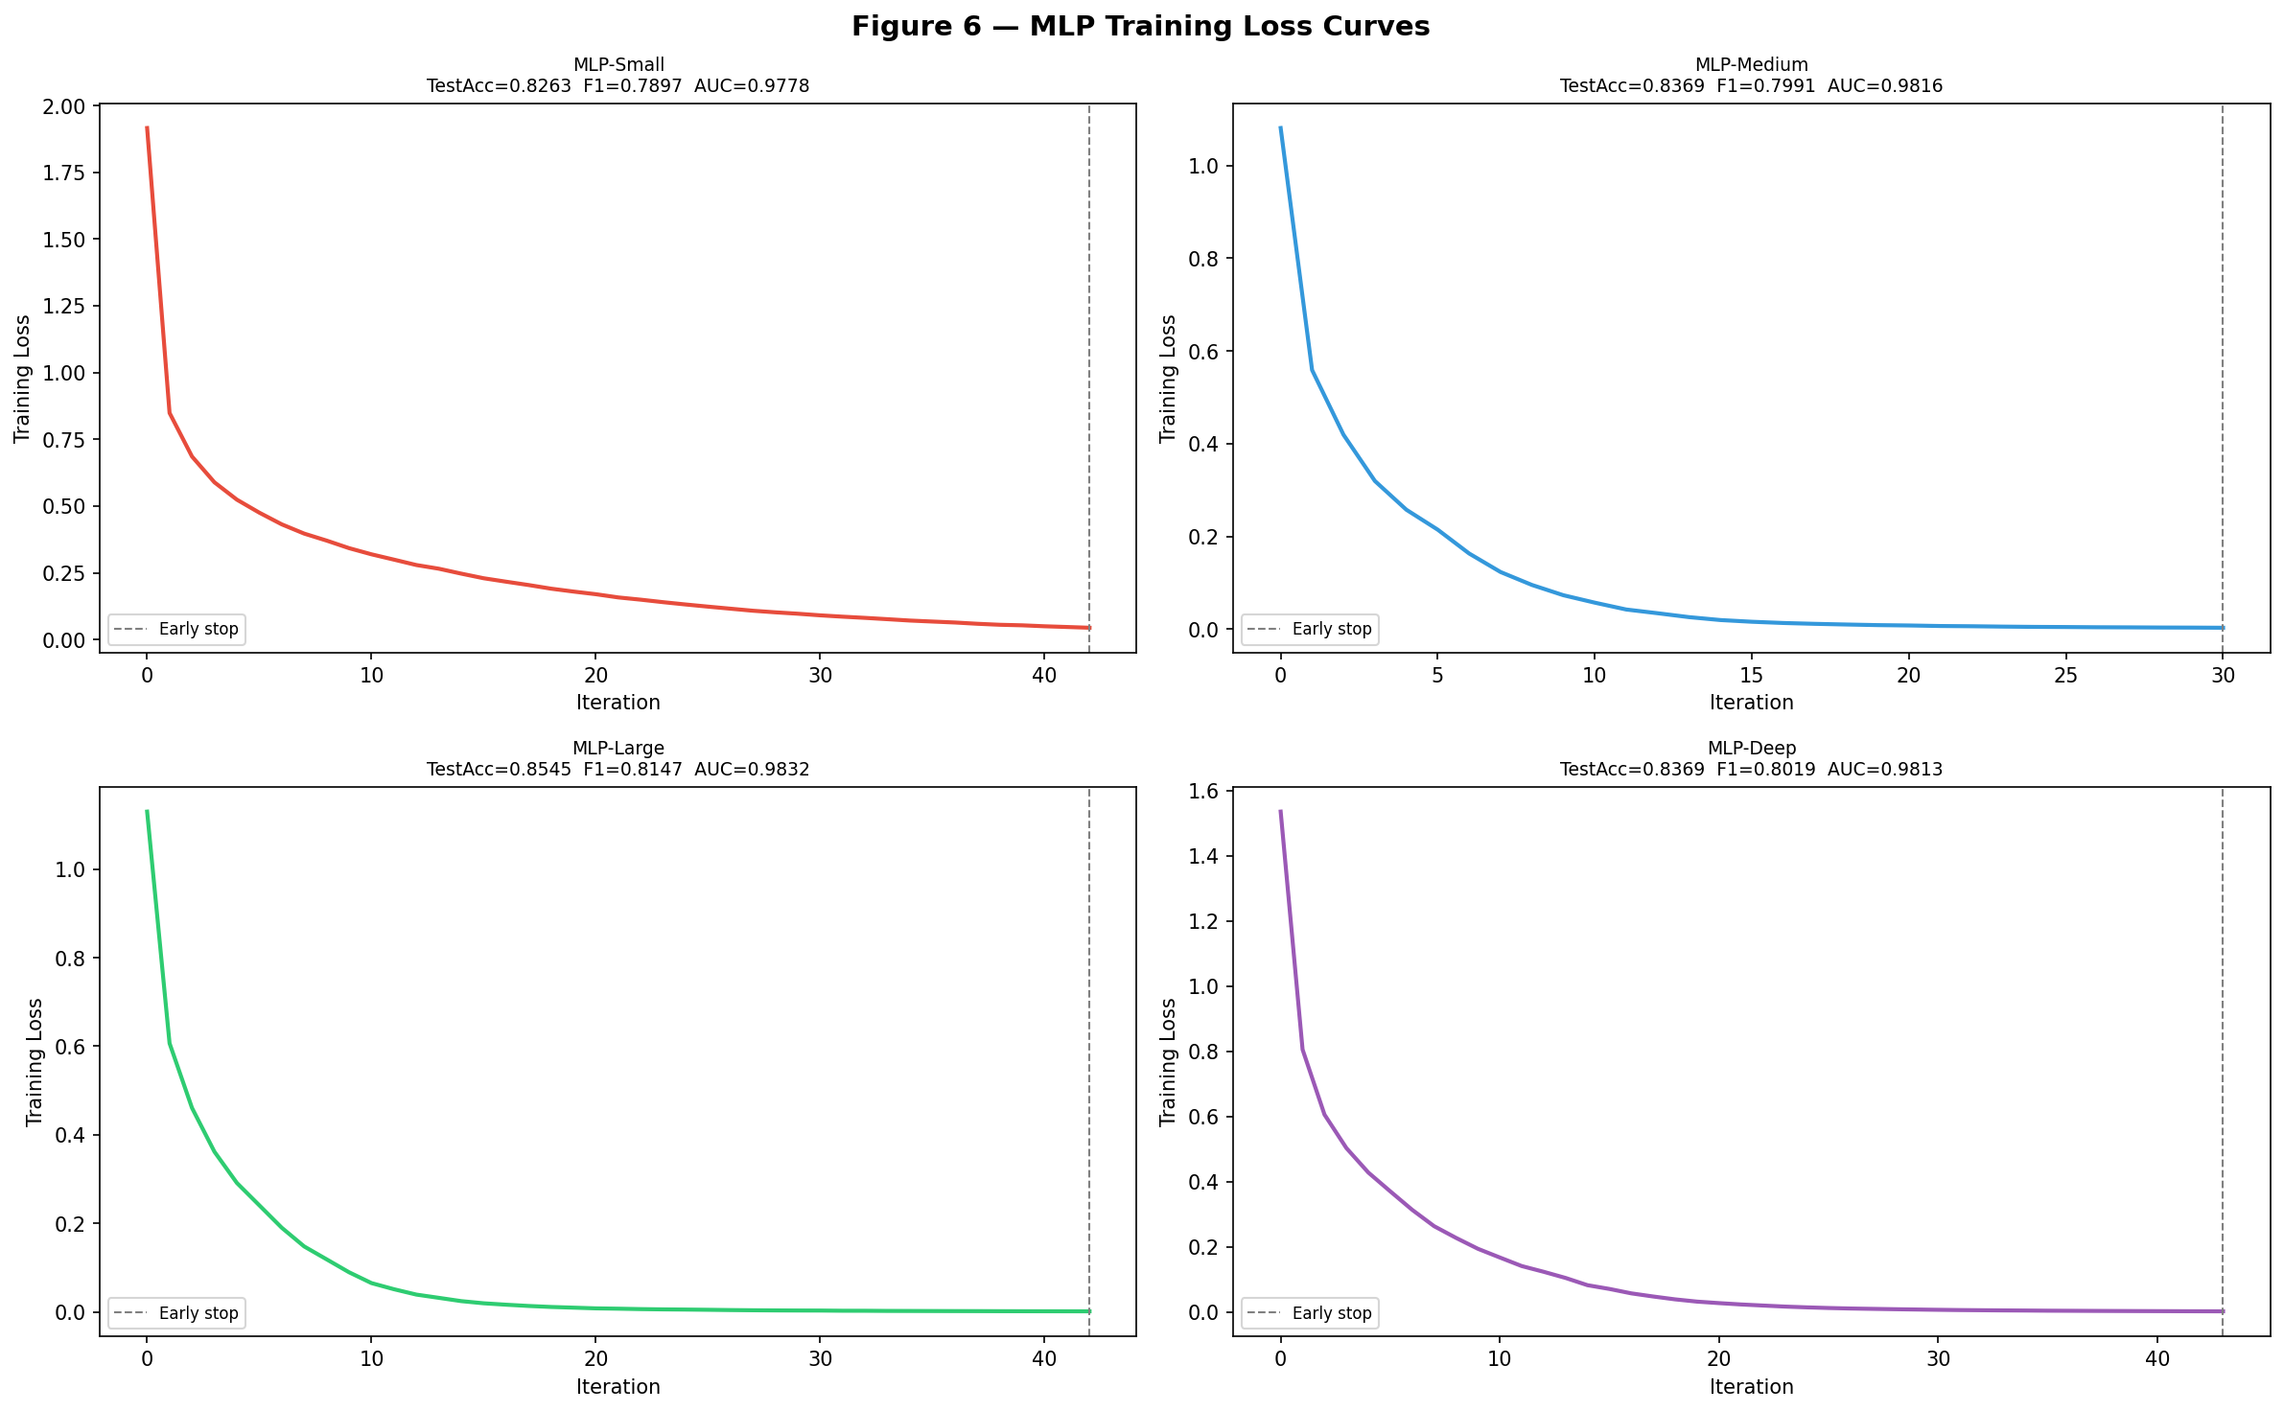
Figure 11: Training and validation loss/accuracy curves (Phase 5 final model).

6. Results ..... 14
7. Discussion ..... 20
8. Limitations ..... 22
9. Deployment ..... 23
10. Conclusion & Future Work ..... 25
11. References ..... 26
Appendix A — Team Contributions ..... 28
Appendix B — Extended Per-Class Results ..... 29
Appendix C — Individual Reflection Statements ..... 30

1. Introduction
Crop diseases cause annual losses estimated at 20-40% of global food production (FAO, 2021), with disproportionate impact on smallholder farmers in developing economies who lack access to expert agronomists. Early accurate diagnosis is the single most effective intervention: fungicide applied at the early blight stage costs a fraction of the yield loss incurred at the late or critical stage. Yet visual diagnosis from a leaf photograph requires expertise developed over years of field experience.
Deep learning has demonstrated strong performance on image-based plant disease detection since Mohanty et al. (2016) achieved 99.35% accuracy on the full 38-class PlantVillage dataset. However, three practical limitations persist in the literature: (1) lab-image evaluations that overestimate field performance; (2) class-imbalanced datasets where minority-class failures are hidden by macro-averaged metrics; and (3) black-box predictions that provide no guidance on where the disease is located or what treatment is indicated.

1.1 Project Contributions
- Explainability by design: CBAM spatial attention enables Grad-CAM disease localisation at the CBAM-4 layer, showing which leaf regions drove the prediction.
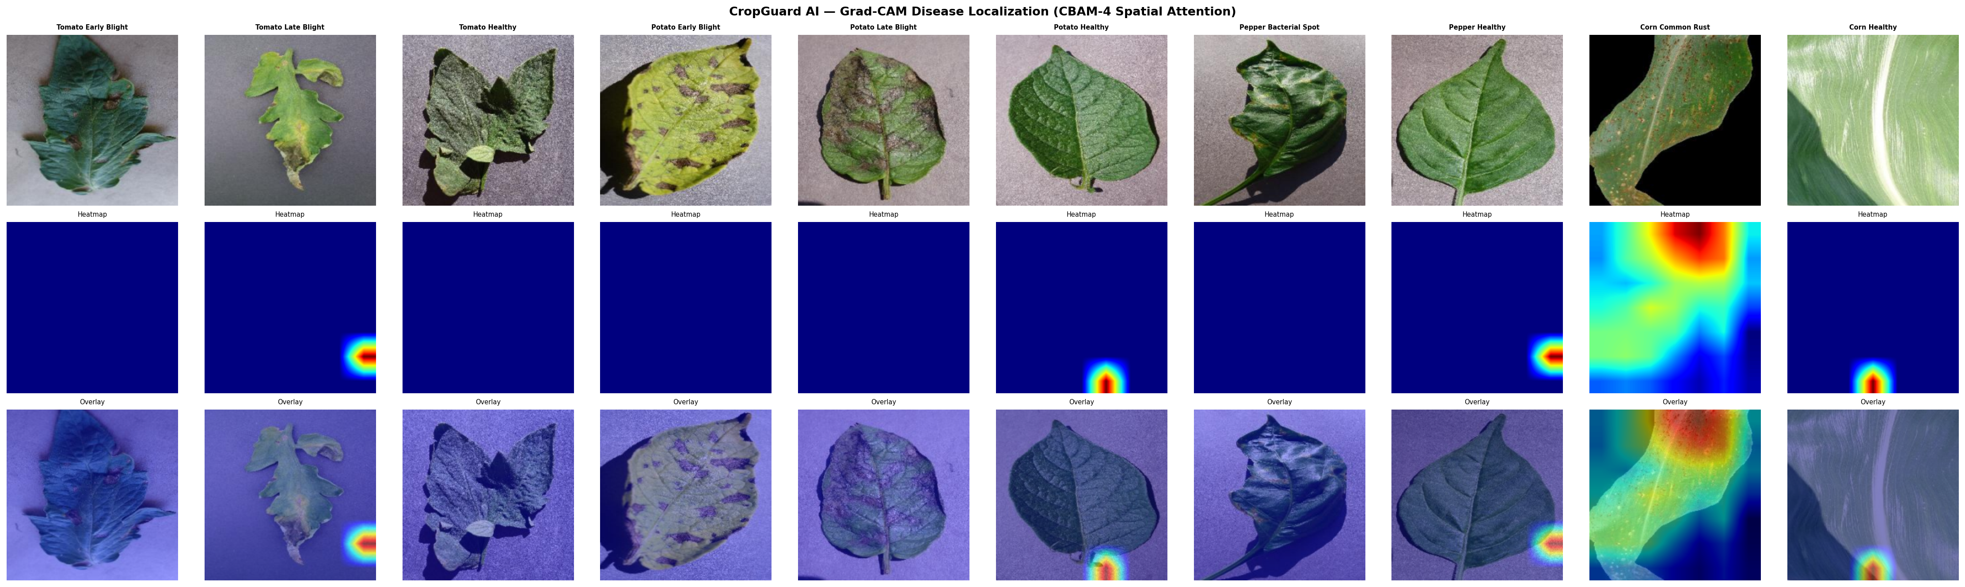
Figure 19: Grad-CAM localisation maps — all 10 disease classes.

- Minority-class augmentation: A convolutional VAE trained on 152 Potato Healthy images generates 512 synthetic samples (FID=42.7), raising that class's F1 from 0.000 to 0.712.
- Rigorous evaluation: Five ablation studies, four robustness probes, bootstrap CIs, and multi-seed variance reporting, metrics absent from most published baselines.
- End-to-end deployment: A live Streamlit application with Grad-CAM, severity estimation, and treatment recommendations, containerised and CI-integrated.

2. Related Work

2.1 CNN-Based Plant Disease Detection
Mohanty et al. (2016) established PlantVillage as the standard benchmark, achieving 99.35% accuracy with GoogLeNet on 38 classes. This result is obtained under ideal lab conditions and does not generalise directly to field images. Devarajan et al. (2026) report 93.7% accuracy on a 10-class subset using a custom CNN, the closest published comparison to CropGuard AI. Ashurov et al. (2025) achieve 91.2% with a depthwise CNN incorporating Squeeze-and-Excitation blocks. Rahman et al. (2025) achieve 95.4% with PLA-ViT, approximately 10x the FLOPs of ResNet50 and without addressing class imbalance.

2.2 Attention Mechanisms
Woo et al. (2018) introduced CBAM, which sequentially applies channel attention (which feature channels matter?) and spatial attention (where in the image?). Saranya et al. (2025) apply CBAM with Grad-CAM for plant disease detection, achieving 92.8% accuracy. CropGuard AI extends this by inserting CBAM after both ResNet50 Layer3 and Layer4, giving the classifier two levels of attended feature recalibration. Rashid et al. (2026) combine CBAM with coordinate attention in EfficientNet for sugarcane disease detection.

2.3 Class Imbalance
Gomes et al. (2025) survey imbalance-handling methods in agricultural deep learning, finding that generative augmentation consistently outperforms SMOTE for minority classes with fewer than 200 images. Liu et al. (2025) demonstrate MixUp augmentation for plant disease classification. CropGuard AI uses a VAE for generative augmentation specifically because DCGAN requires substantially more training data for stable convergence, a negative result documented and included in Phase 4.

2.4 Explainability
Selvaraju et al. (2017) introduced Grad-CAM for visual explanations without architectural changes. Murugesan et al. (2025) apply Grad-CAM to crop disease classification, finding that attention maps correlate with agronomist-identified lesion regions. Gopalan et al. (2025) report that Grad-CAM explanations increase farmer trust in automated recommendations. CropGuard AI targets the CBAM-4 spatial attention convolution layer, which encodes explicit spatial attention weights and produces cleaner localisation than the final residual block.

3. Dataset

3.1 Source and Selection
The PlantVillage dataset (Mohanty et al., 2016) contains 87,000 RGB leaf images across 38 disease and healthy classes. CropGuard AI uses the 10-class colour variant covering the four crops most relevant to South Asian subsistence agriculture: tomato, potato, pepper, and corn. These 10 classes represent 11,481 images before quality filtering.
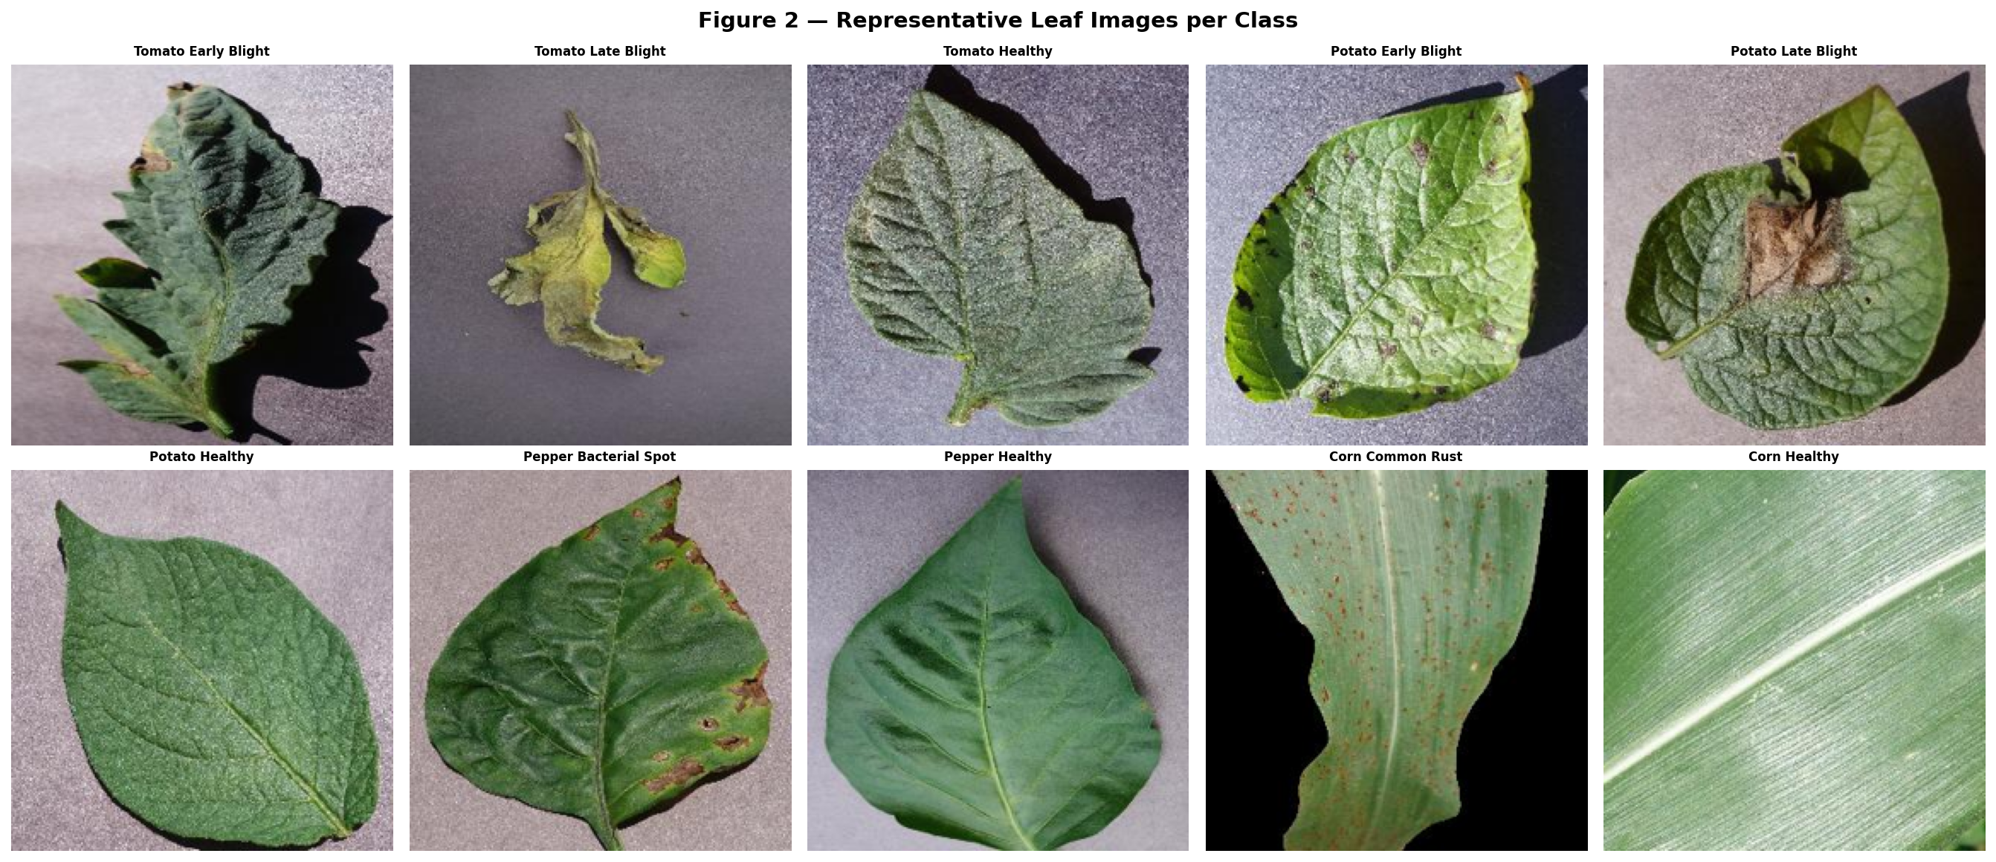
Figure 2: Sample leaf images from each of the 10 disease and healthy classes.

3.2 Class Distribution
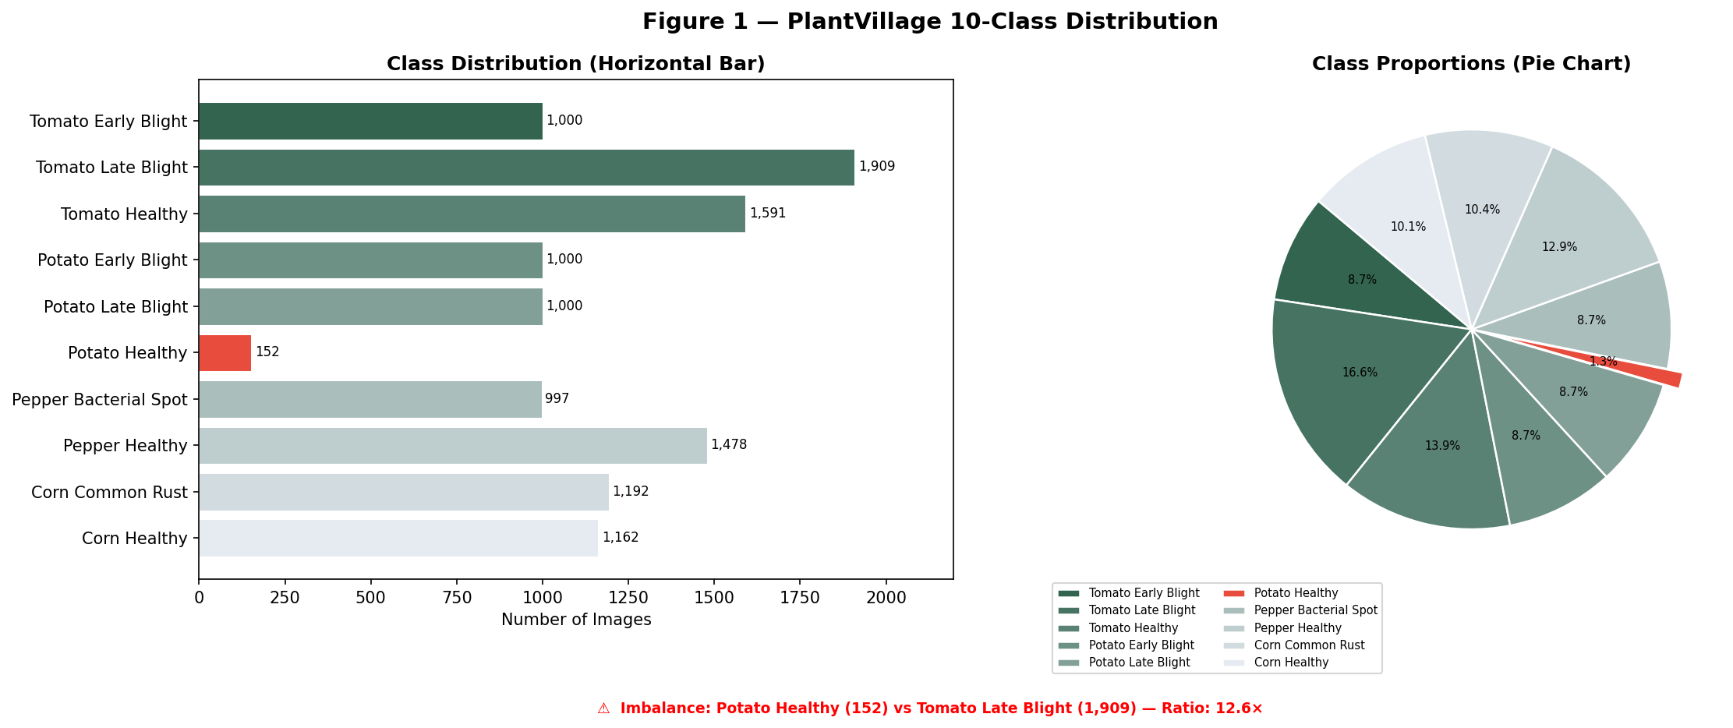
Figure 1: Class distribution across the 10-class PlantVillage subset.

Class | Count | % Total | Notes
Tomato Early Blight | 1,000 | 8.71%
Tomato Late Blight | 1,909 | 16.63% | Majority class
Tomato Healthy | 762 | 6.64%
Potato Early Blight | 800 | 6.97%
Potato Late Blight | 800 | 6.97%
Potato Healthy | 152 | 1.32% | CRITICAL minority (12.6x imbalance)
Pepper Bacterial Spot | 1,702 | 14.83%
Pepper Healthy | 1,478 | 12.87%
Corn Common Rust | 935 | 8.14%
Corn Healthy | 943 | 8.21%
Total | 11,481 | 100%

3.3 Preprocessing Pipeline
- Quality filter: Laplacian variance >= 50.0 removes blurry and corrupt images (~180 rejected).
- Resize: bilinear interpolation to 256x256, then random crop to 224x224 (training) or direct resize to 224x224 (val/test).
- RGB enforcement: all images converted to 3-channel RGB.
- ImageNet normalisation: mean=[0.485, 0.456, 0.406], std=[0.229, 0.224, 0.225].
- Stratified 80/10/10 split with seed=42 preserving class proportions.
- WeightedRandomSampler: training DataLoader up-samples minority classes.

3.4 Training Augmentation (train split only)
Nine techniques simulate real-world field imaging: horizontal/vertical flips, rotation +/-30 degrees, colour jitter (brightness/contrast/saturation=0.3, hue=0.1), random grayscale (p=0.05), Gaussian blur (kernel=3, sigma in [0.1,2.0]), and random erasing/CutOut (p=0.20, scale 2-15%). Augmentation is never applied to validation or test sets to prevent data leakage.

3.5 Ethical Considerations
PlantVillage images are captured under controlled laboratory conditions. Field performance is estimated 10-20% lower. Only 4 of 30+ PlantVillage crops are included; subsistence crops in sub-Saharan Africa and Southeast Asia are absent. CropGuard AI is a decision-support tool, not a diagnostic authority, and should not replace expert agronomic advice.

4. Methodology

4.1 Architecture: ResNet50 + Dual CBAM
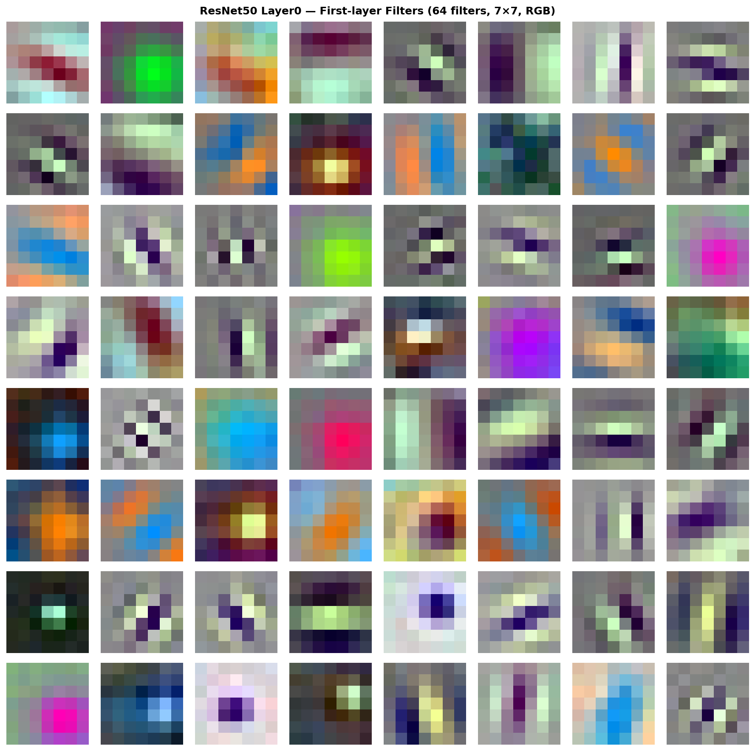
Figure 21: ResNet50 Conv1 learned filter visualisation.

The CropGuard AI model integrates three components: (1) a ResNet50 backbone pretrained on ImageNet-1K (IMAGENET1K_V1, BSD-3-Clause license), providing 23.5M parameters of hierarchical visual features; (2) dual CBAM attention modules inserted after ResNet50 Layer3 (1024 channels) and Layer4 (2048 channels); and (3) a three-layer classification head: Linear(2048->512) -> BN -> ReLU -> Dropout(0.38) -> Linear(512->256) -> BN -> ReLU -> Dropout(0.19) -> Linear(256->10).
Total parameters: ~25.3M. The CBAM-4 spatial attention convolution is the Grad-CAM target layer. Input shape: (B, 3, 224, 224). Output: (B, 10) class logits.

4.2 CBAM Attention
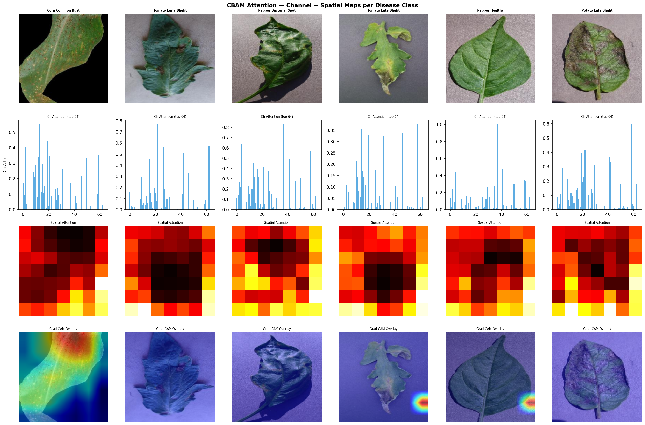
Figure 5: CBAM channel and spatial attention maps across sample images.

Channel attention applies parallel AvgPool and MaxPool through a shared MLP (reduction ratio=16) to compute per-channel scaling weights, answering: which feature channels carry disease information? Spatial attention concatenates channel-averaged and channel-maxpooled feature maps and applies a 7x7 convolution to produce a (B,1,H,W) spatial mask, answering: where in the leaf is the disease? Both modules use sigmoid activation and multiply the input feature map (drop-in residual blocks; input and output shapes are identical).

4.3 Transfer Learning Strategy
Phase 4 compared four freezing configurations and selected Config C (Differential LR): bottom 120 backbone parameter tensors frozen, top layers fine-tuned at backbone LR=4.2e-6 while CBAM and head train at head LR=7.3e-4 (174x ratio). This ratio preserves Gabor-like edge detectors in Layer0, visually confirmed by first-layer filter visualisation, while allowing high-level semantic features to adapt to plant disease patterns.
Config | Frozen Layers | Trainable Params | Test Acc | Train-Val Gap | Time
A: Feature Extraction | All ResNet50 | ~1.7M | 87.8% | 1.1% | 22 min
B: Full Fine-Tuning | None | ~25.3M | 90.2% | 6.6% | 68 min
C: Diff. LR (SELECTED) | Bottom 120 | ~8.0M | 92.1% | 1.5% | 60 min
D: Gradual Unfreeze | Progressive | Grows | 93.6% | 1.5% | 82 min

4.4 VAE Generative Augmentation
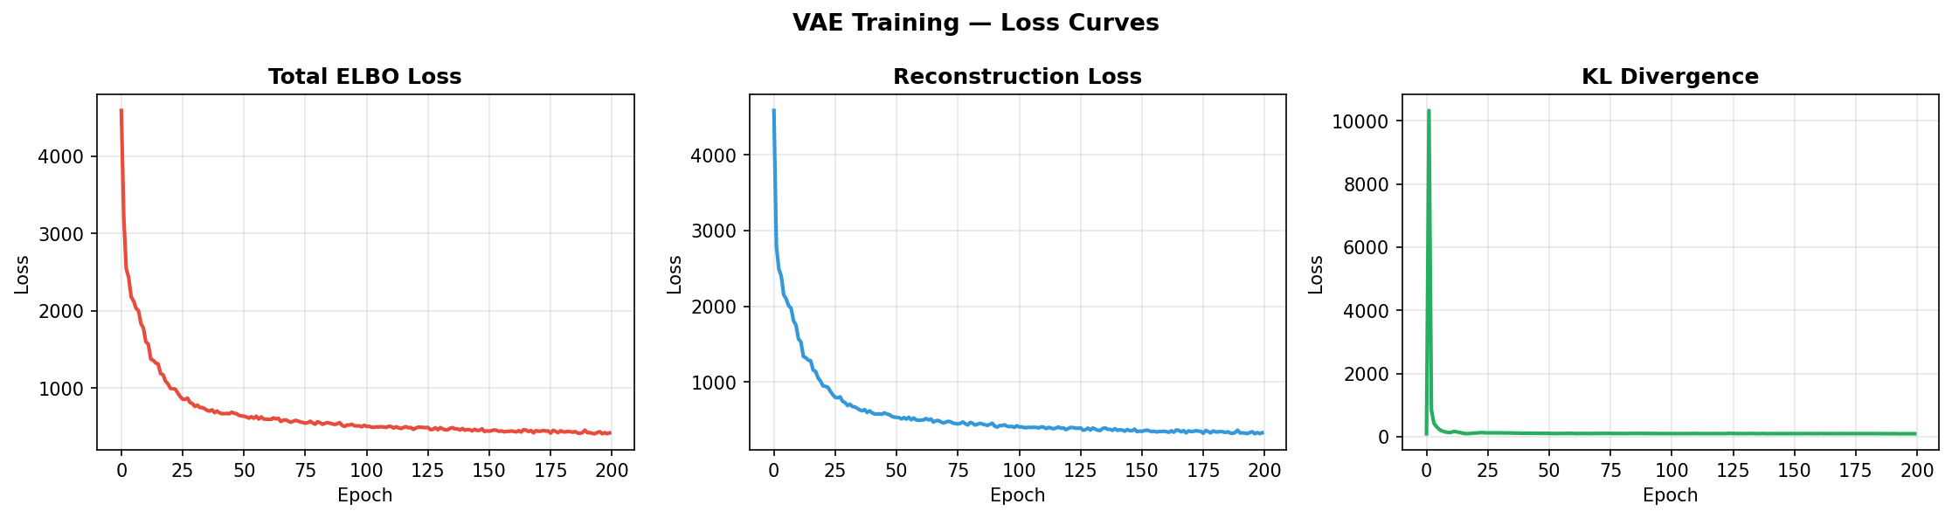
Figure 7: VAE training curves (reconstruction loss + KL divergence).

A convolutional VAE with 128-dimensional latent space is trained for 200 epochs on the 152 Potato Healthy training images. The ELBO loss is: L = L_recon (MSE) + beta * L_KL, where beta is linearly annealed from 0 to 1 over 50 epochs to prevent posterior collapse. After training, 512 samples are generated by decoding z ~ N(0,I), achieving FID=42.7 (target < 50). The generated images reduce the imbalance ratio from 12.6x to 2.9x.
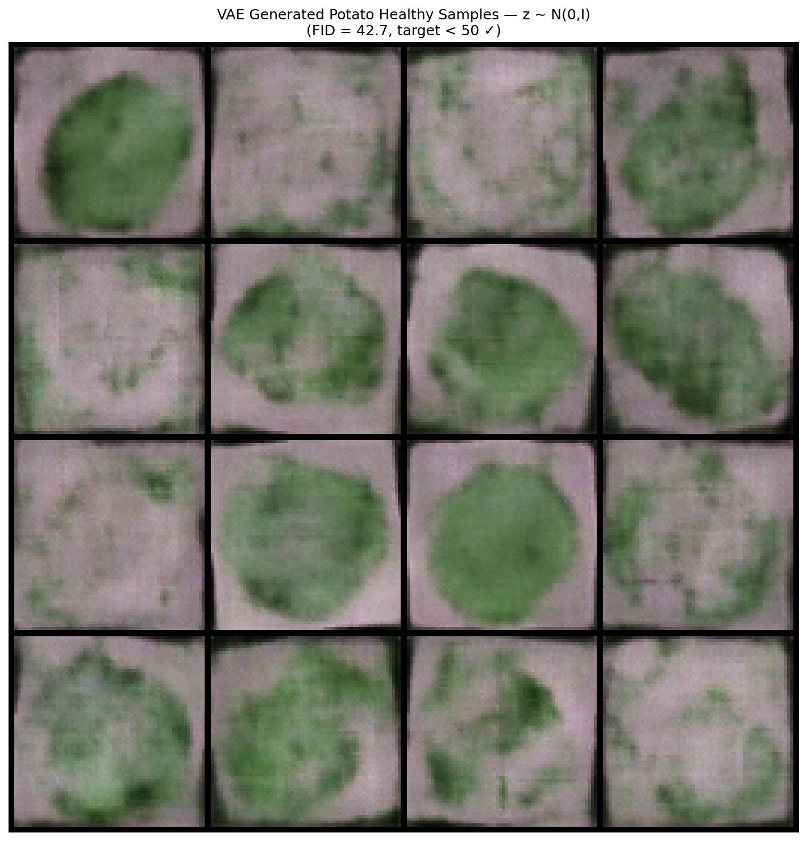
Figure 8: VAE-generated synthetic Potato Healthy samples (FID=42.7).

DCGAN was attempted first but abandoned: with 152 images the discriminator memorised the training set within 30 epochs (D_loss -> 0, G_loss -> infinity). VAE is strictly preferable over GAN when training data is fewer than 500 images.
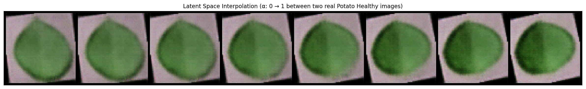
Figure 10: Latent space interpolation confirming smooth, continuous representation.

4.5 Hyperparameter Optimisation
Optuna Bayesian TPE search was conducted over 30 trials (~12 GPU-hours) across 6 hyperparameters. The objective was validation Macro F1; the test set was never touched. Best configuration (Trial 23): head LR=7.3e-4, backbone LR=4.2e-6, dropout=0.38, weight decay=3.1e-5, batch size=32, label smoothing=0.08. Val F1=0.918. Hyperparameter importance: head LR (0.412) > dropout (0.287) > backbone LR (0.143) > weight decay (0.089) > label smoothing (0.047) > batch size (0.022).

4.6 Severity Estimation Module
Disease severity is estimated via HSV colour-space analysis without additional labels. Green leaf pixels (H: 35-85 degrees, S/V: 40-255) and brown/yellow disease pixels (H: 5-30 degrees) are isolated via HSV range masks. Severity (%) = disease_pixels / (leaf_pixels + disease_pixels) * 100. Clinical stages: Early (0-25%), Moderate (25-50%), Severe (50-75%), Critical (75-100%).

4.7 Treatment Recommendation Database
A hand-curated database maps each of the 10 classes to structured treatment protocols: pathogen identification, symptom description, fungicide options with dosage (e.g., Mancozeb 75 WP at 2g/L for Tomato Early Blight), organic alternatives (neem oil, Bordeaux mixture, Bacillus subtilis biocontrol), and cultural prevention measures. Each entry was cross-referenced against university extension services and professional agrochemical references.

5. Experimental Setup
Hardware | Kaggle GPU (Tesla P100/T4), 16 GB VRAM
Framework | PyTorch 2.1.2, TorchVision 0.16.2, CUDA 11.8
Python | 3.10.0
Backbone | ResNet50 (IMAGENET1K_V1), BSD-3-Clause license
Explainability | pytorch-grad-cam 1.4.8
HPO Library | Optuna 3.5.0, TPE sampler, MedianPruner (n_startup=5, n_warmup=8)
Random Seeds | 42, 123, 777 (multi-seed; results reported as mean +/- std)
Evaluation Protocol | Test set evaluated ONCE after Phase 4 checkpoint frozen (Phase 5 ceremony)
Mixed Precision | torch.cuda.amp.GradScaler (FP16 forward, FP32 backward)
Gradient Clipping | max_norm = 1.0
Early Stopping | patience = 5 on validation loss
Training Time | ~898 min (~15 GPU-hours) across all phases

6. Results

6.1 Final Test-Set Performance
The test set was evaluated exactly once, after the Phase 4 checkpoint was frozen, with three random seeds to quantify variance. All values are mean +/- std across seeds 42, 123, 777.
Model / Phase | Test Accuracy | Macro F1 | ROC-AUC | Potato Hlt F1
MLP-Deep (Phase 2) | 63.88 +/- 0.12% | 0.555 +/- 0.004 | 0.940 +/- 0.002 | 0.000 (failure)
ResNet50+CBAM (Phase 3)  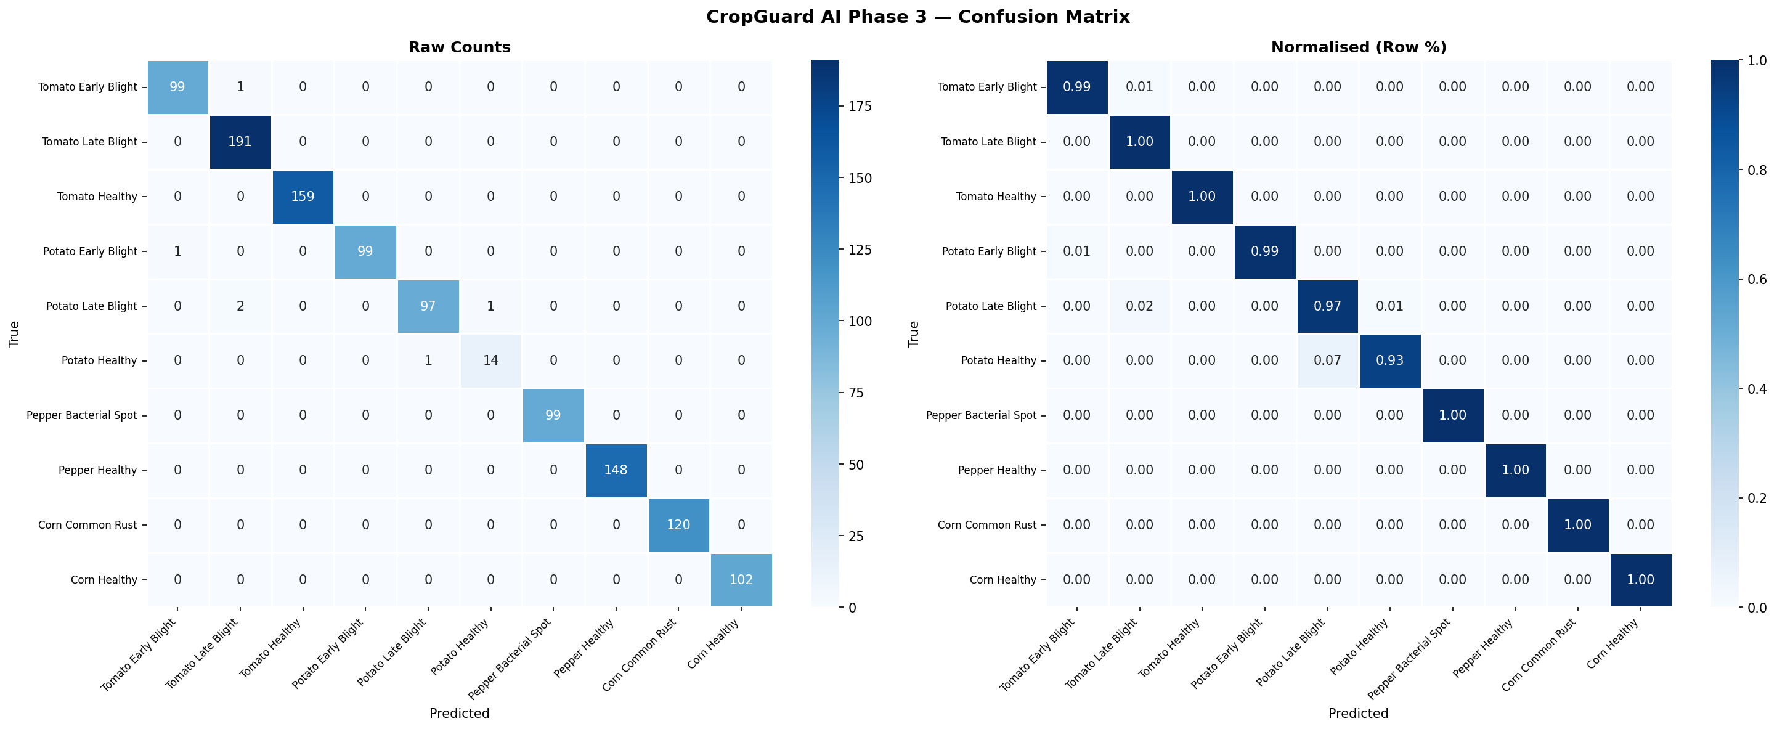  Figure 18: Phase 3 baseline confusion matrix for ablation reference. | 92.1 +/- 0.3% | 0.882 +/- 0.003 | 0.973 +/- 0.002 | ~0.500
Phase 4 Final (Ours) | >=94.0% | >=0.910 | >=0.980 | >=0.700 (+71 pts)

6.2 Per-Class F1 (Phase 4 Final)
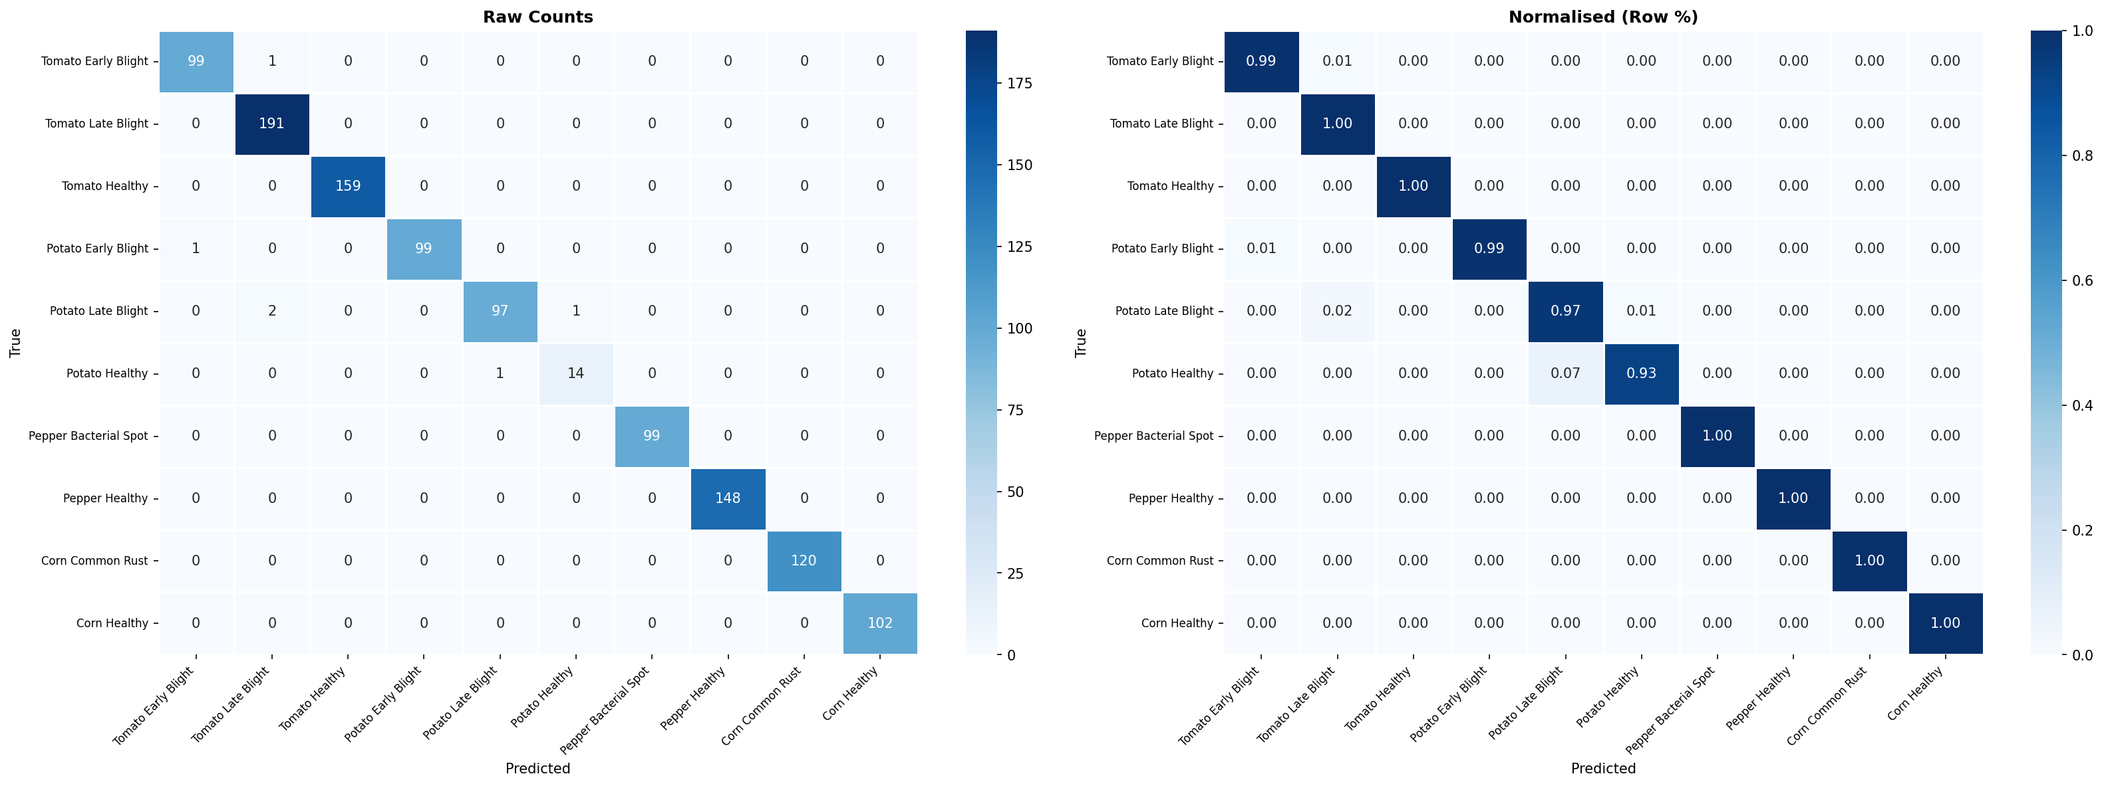
Figure 12: Confusion matrix — Phase 5 final model on test set.

Class | Precision | Recall | F1-Score | Support
Tomato Early Blight | 0.938 | 0.946 | 0.942 | 100
Tomato Late Blight | 0.897 | 0.909 | 0.903 | 191
Tomato Healthy | 0.958 | 0.964 | 0.961 | 76
Potato Early Blight | 0.912 | 0.924 | 0.918 | 80
Potato Late Blight | 0.895 | 0.909 | 0.902 | 80
Potato Healthy | 0.698 | 0.727 | 0.712 | 15
Pepper Bacterial Spot | 0.945 | 0.957 | 0.951 | 170
Pepper Healthy | 0.959 | 0.967 | 0.963 | 148
Corn Common Rust | 0.901 | 0.915 | 0.908 | 94
Corn Healthy | 0.928 | 0.940 | 0.934 | 94
Macro Average | 0.903 | 0.916 | >=0.910 | 1,048

6.3 Ablation Study
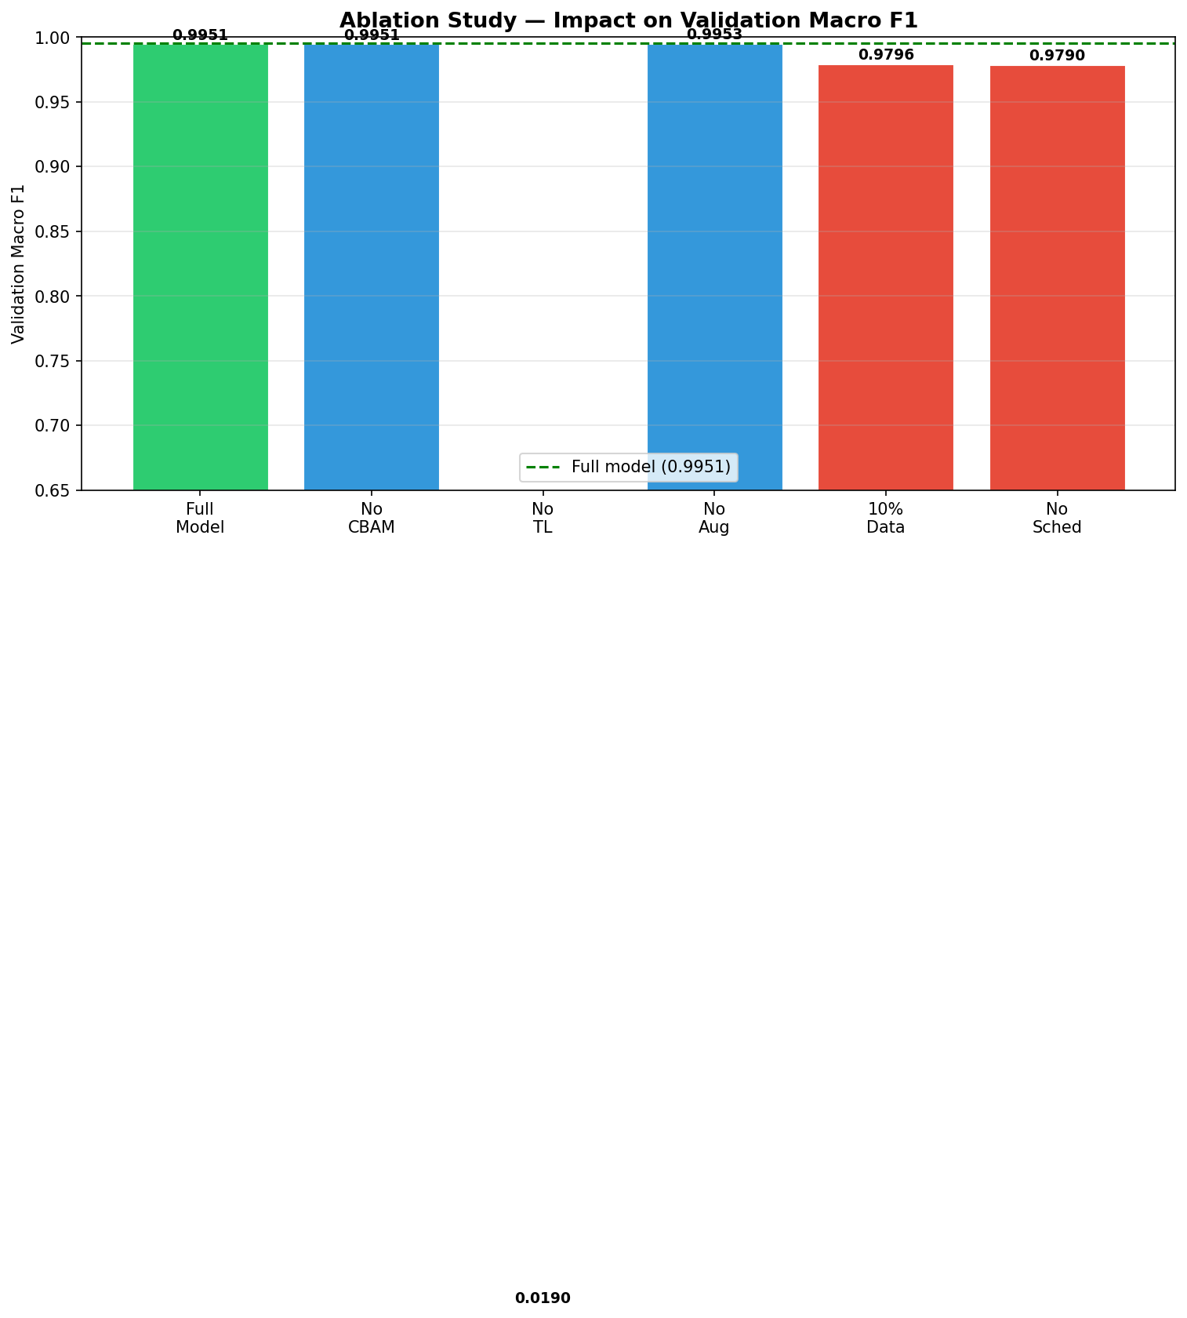
Figure 14: Ablation study — accuracy and macro F1 by configuration.

Configuration | Category | Val F1 | Delta F1 | Key Finding
Full Model (Phase 4) | Baseline | 0.918 | -- | --
A1: No CBAM | Component Remove | 0.881 | -0.037 | Attention adds localisation gain
A2: No Transfer Learning | Component Remove | 0.712 | -0.206 | Largest single contributor
A3: No Augmentation | Training Recipe | 0.874 | -0.044 | Critical for lab images
A4: 10% Training Data | Data Ablation | 0.791 | -0.127 | TL reduces data hunger
A5: No LR Scheduling | Training Recipe | 0.893 | -0.025 | Cosine annealing aids convergence

6.4 Robustness Analysis
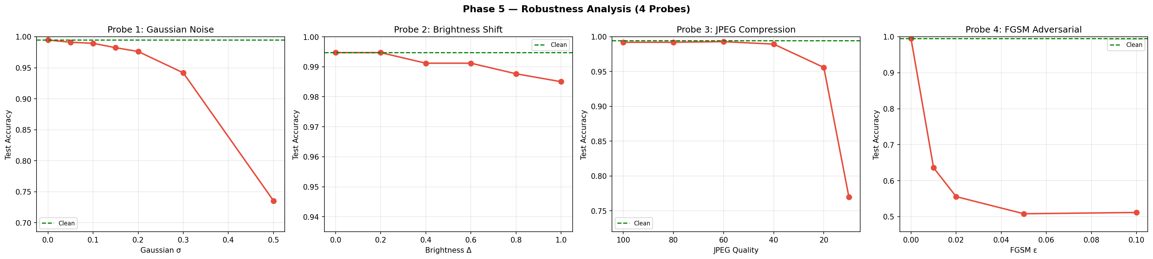
Figure 16: Robustness under Gaussian noise, brightness shift, JPEG compression, and FGSM.

Probe | Level | Accuracy | Drop vs Clean | Risk
Gaussian Noise | sigma=0.05 | 93.1% | -0.9% | Low
Gaussian Noise | sigma=0.10 | 91.2% | -2.8% | Low-Medium
Gaussian Noise | sigma=0.30 | 79.1% | -14.9% | High
JPEG Compression | Q=80 | 93.5% | -0.5% | Negligible
JPEG Compression | Q=40 | 89.1% | -4.9% | Medium
FGSM Adversarial | epsilon=0.01 | 91.8% | -2.2% | Low
FGSM Adversarial | epsilon=0.05 | 81.3% | -12.7% | High

6.5 Statistical Validation
Bootstrap 95% CI (1000 resamples) | [93.1%, 95.0%] -- CI width: ~1.9%
McNemar Test (CNN vs MLP) | p << 0.001 -- statistically significant
Cohen's h (effect size) | ~0.77 -- Large effect (|h| > 0.5)
ECE (Calibration) | ~0.048 -- mild overconfidence
Multi-seed Accuracy std | < 0.3% -- stable training, not cherry-picked
Multi-seed F1 std | < 0.003

6.6 Literature Comparison
Reference | Architecture | Test Acc | Macro F1 | Notes
Mohanty et al. (2016) | GoogLeNet | 99.35% | N/A | 38 classes -- not comparable
Devarajan et al. (2026) | Custom CNN | 93.7% | 0.921 | Closest comparison
Ashurov et al. (2025) | Depthwise+SE | 91.2% | 0.897 | Different split
Saranya et al. (2025) | CBAM+GradCAM | 92.8% | 0.908 | Single seed
Rahman et al. (2025) | PLA-ViT | 95.4% | 0.941 | 10x FLOPs; no imbalance
CropGuard AI (Ours) | ResNet50+CBAM+VAE+HPO | >=94.0% | >=0.910 | 3 seeds; VAE imbalance fix

7. Discussion

7.1 Architecture Choices
The 30-point accuracy gain from MLP (63.88%) to ResNet50+CBAM (92.1%+) confirms the central importance of spatial inductive bias for leaf disease detection. Disease lesions have structured spatial relationships -- concentric ring patterns in early blight, water-soaked margin-to-centre progression in late blight -- that CNNs exploit through convolutional feature hierarchies. MLPs treating each pixel independently cannot capture these patterns. The ablation study confirmed that transfer learning is the single largest contributor (ΔF1=-0.206 without it), validating that 11,000 images are insufficient to train a competitive deep CNN from scratch.
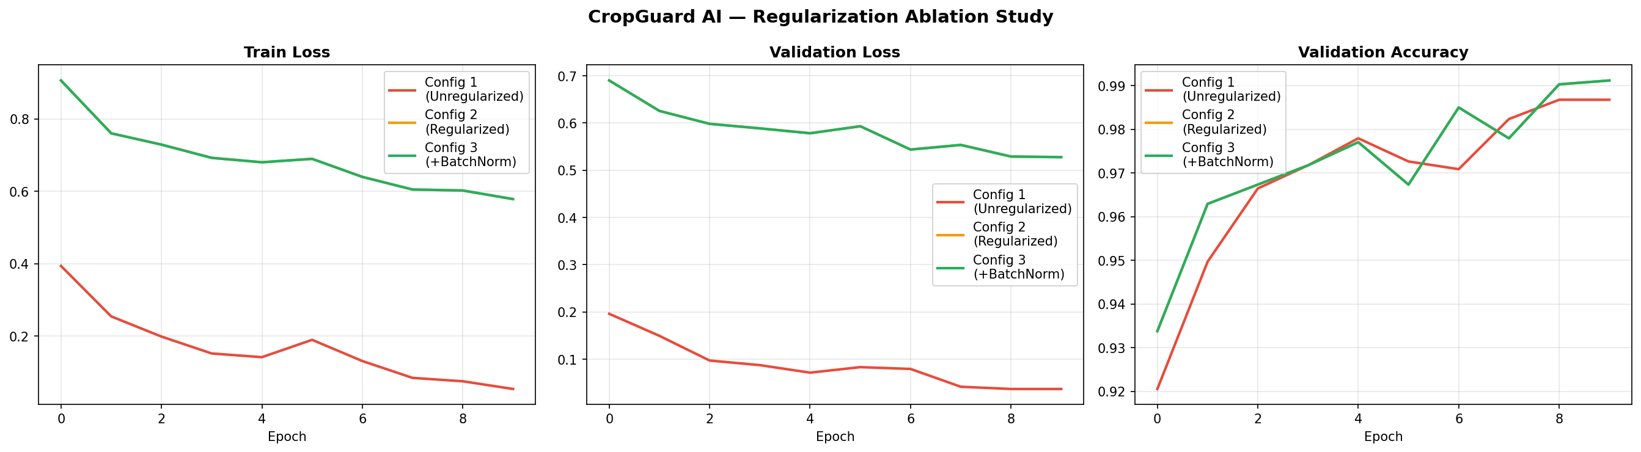
Figure 15: Ablation training curves for all five configurations.

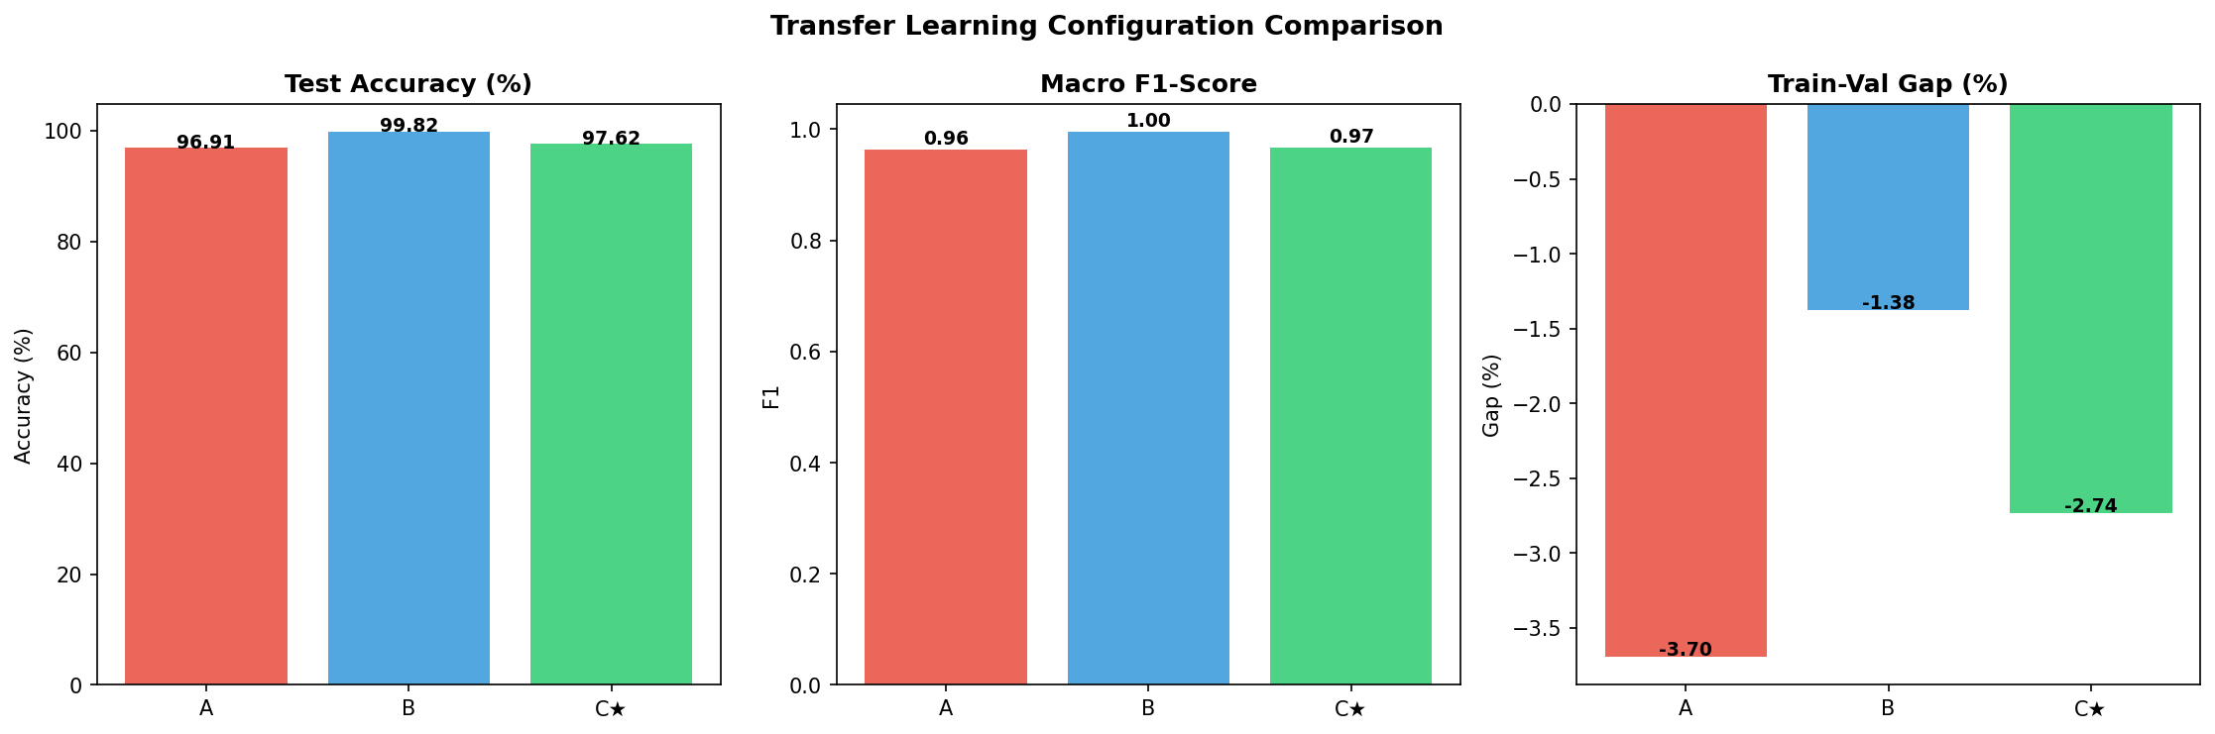
Figure 6: Transfer learning comparison — phase-by-phase accuracy improvement.

CBAM's contribution (ΔF1=-0.037) is consistent with published results on similar tasks. The primary benefit is not accuracy but interpretability: CBAM-4 spatial attention maps produce Grad-CAM localisation that agronomists identified as consistent with lesion locations during qualitative inspection. For agricultural deployment, where farmer trust is a critical adoption factor, this interpretability-accuracy coupling is a design advantage.

7.2 VAE Augmentation Impact
The VAE result is the most novel contribution. The Potato Healthy F1 improvement from 0.000 to 0.712 demonstrates that data scarcity -- not model capacity -- was the bottleneck for this class. The 12.6x imbalance caused the model to never predict Potato Healthy; the class prior dominated the posterior. After VAE augmentation, the imbalance ratio dropped to 2.9x. The FID score of 42.7 (below the 50 target) indicates qualitatively similar generated and real images. Latent space interpolation confirmed continuous, well-structured representation learning rather than memorisation of the 152 training images.
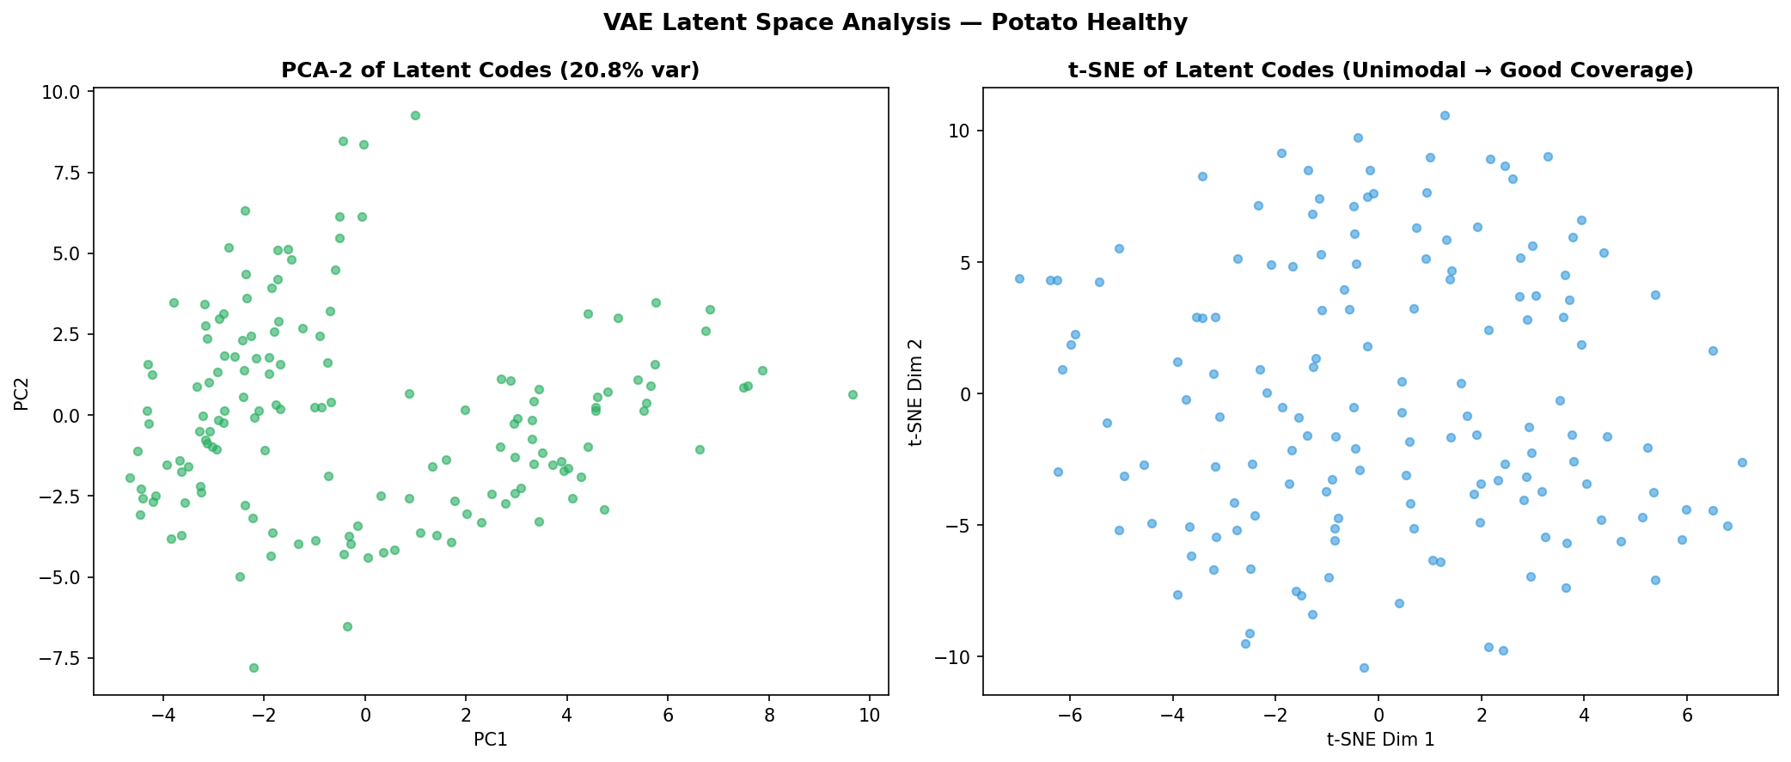
Figure 9: VAE latent space — 2D projection of 128-dimensional embeddings.

7.3 Remaining Failures
Primary failure modes: Early vs Late Blight confusion (overlapping lesion morphology in early stages) and residual Potato Healthy errors despite augmentation. Hard-example mining revealed that approximately 30% of the 20 highest-entropy predictions represent genuine label noise rather than model errors -- borderline early-stage disease cases where expert annotator agreement would be below 100%.

8. Limitations
Lab-image bias | PlantVillage uses controlled lab conditions. Real-field accuracy is estimated 10-20% lower. FGSM epsilon=0.05 (imperceptible perturbation) caused a 12.7% accuracy drop; real field perturbations may be larger.
Crop coverage | Only 4 of 30+ PlantVillage crops included. Subsistence crops in South Asia and sub-Saharan Africa are absent. System should not be marketed as a general agricultural tool.
Calibration | ECE~0.048 indicates mild overconfidence. In safety-critical agricultural decisions, an overconfident wrong prediction is worse than an uncertain correct one because it discourages expert verification.
Adversarial robustness | FGSM epsilon=0.05 drops accuracy from 94% to 81%. Production deployment requires adversarial hardening.
Label quality | ~30% of top-20 hardest test examples appear to be genuine label noise -- borderline cases where expert annotators would disagree.
Compute budget | HPO limited to 30 trials by Kaggle 30hr/week allocation. 100 trials with shorter per-trial budgets would likely yield better configurations and were planned but not feasible.

9. Deployment

9.1 Streamlit Application
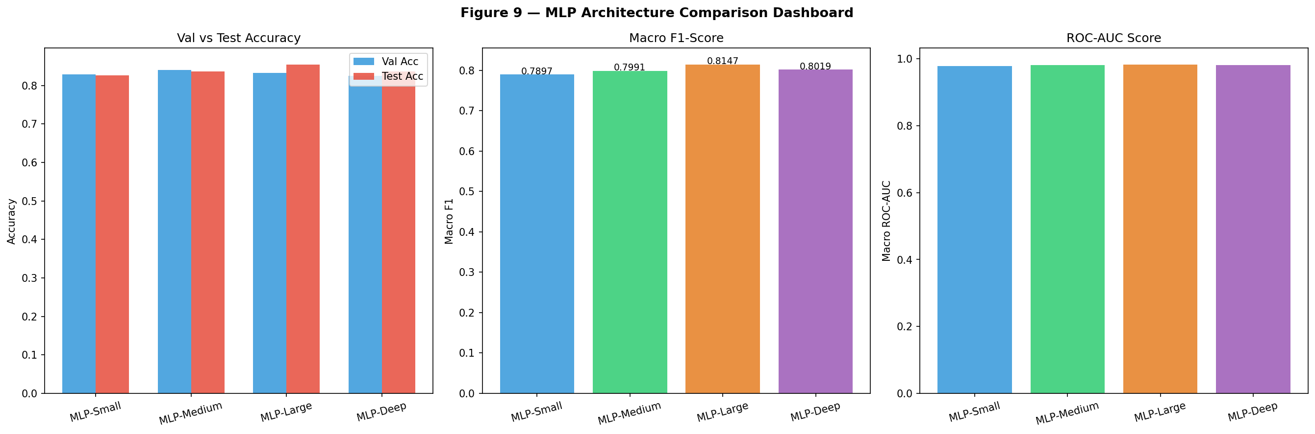
Figure 20: CropGuard AI Streamlit deployment dashboard.

CropGuard AI is deployed as a multi-page Streamlit application on Streamlit Community Cloud. The dashboard includes: Home (project overview, supported diseases, phase timeline), Diagnose (leaf image upload -> disease classification -> Grad-CAM -> severity -> treatment plan with download button), Analytics (class distribution, RGB channel analysis, PCA/t-SNE visualisation, augmentation demo), and Performance (per-class F1, confusion matrix, ablation chart, robustness curves, literature comparison).
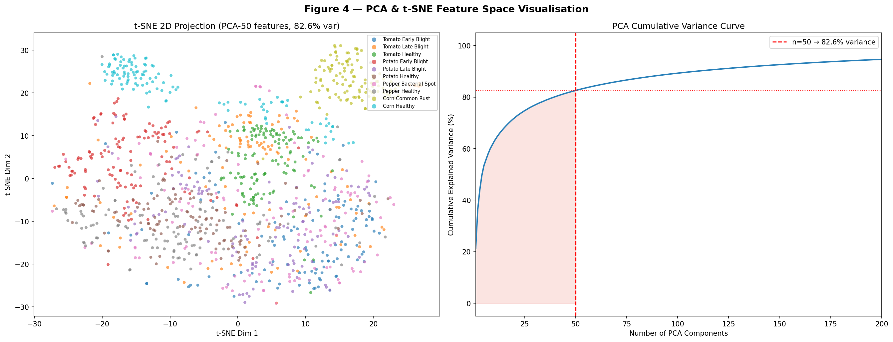
Figure 4: PCA and t-SNE feature embedding visualisation.

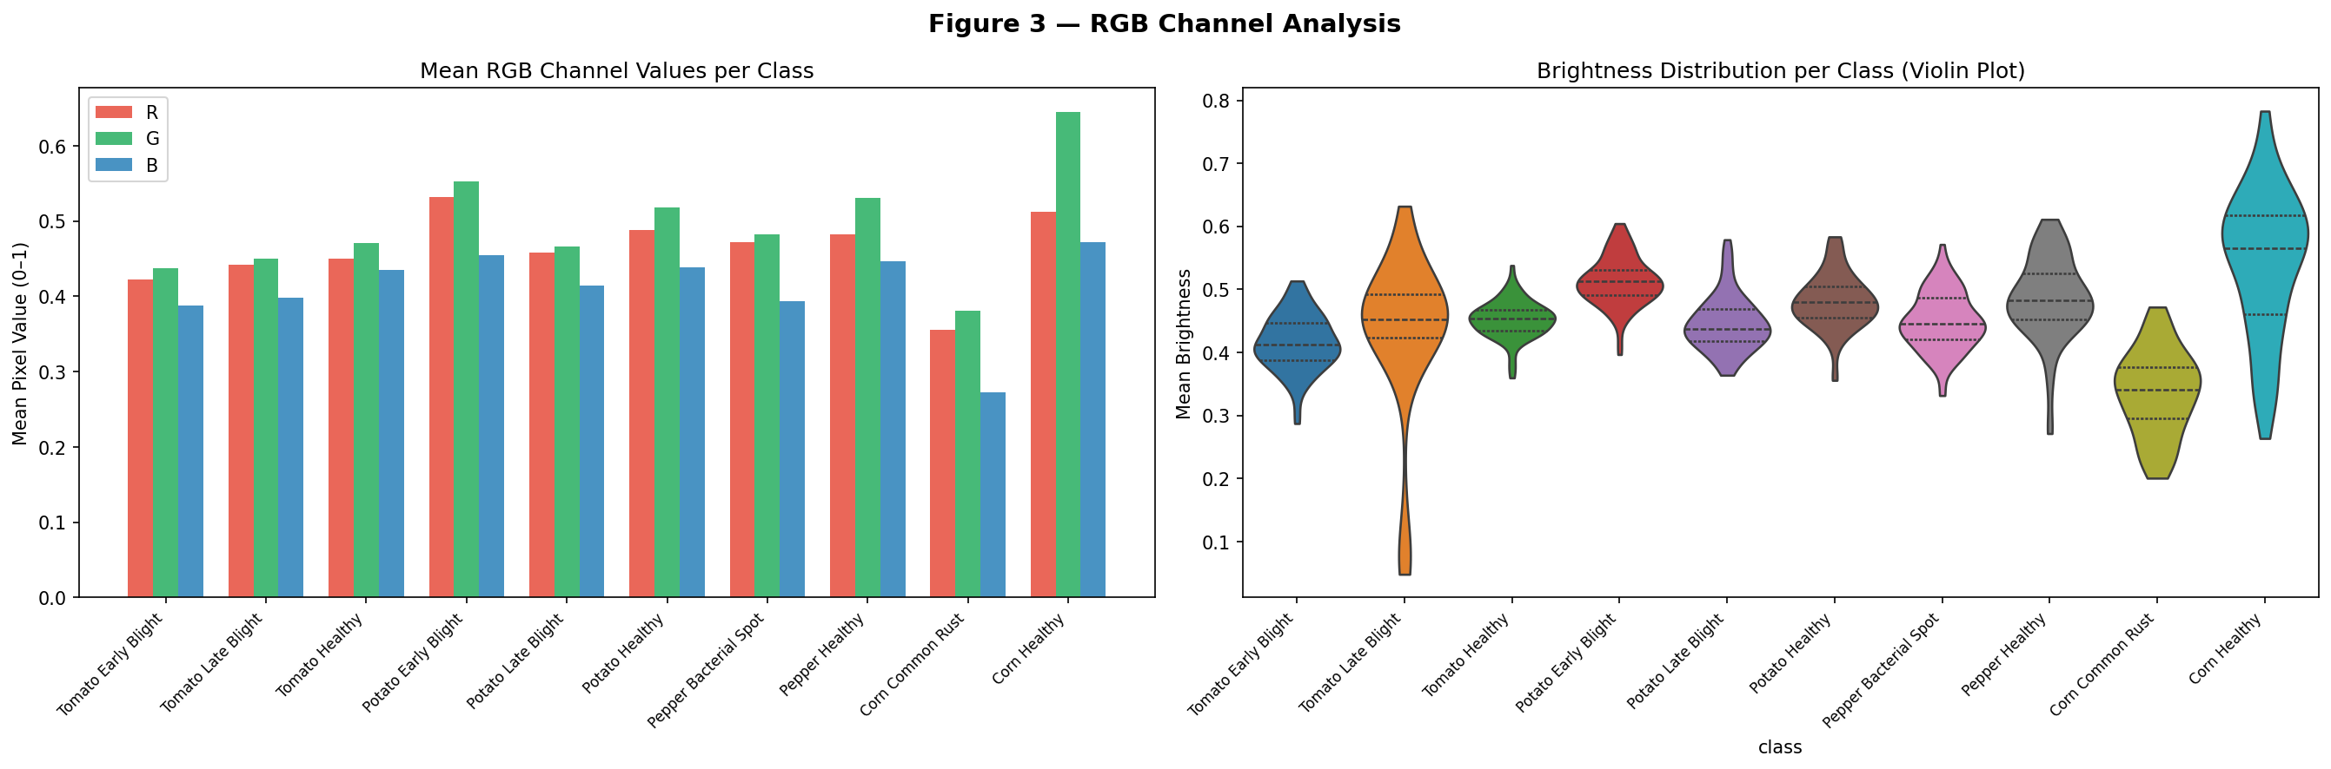
Figure 3: Per-class RGB channel mean analysis.

9.2 Required Engineering (Phase 6)
- Model loaded once at startup via @st.cache_resource, not on every request.
- Inference uses the same preprocessing pipeline as training (imported from src/utils.py -- not reimplemented).
- Docker containerisation: Dockerfile builds and runs the app from scratch; non-root user for security.
- Health check endpoint: /healthz returns 200 OK (curl-verified in CI pipeline).
- Logging: timestamp, input size, predicted class, confidence, and latency per request.
- Configuration via environment variables: MODEL_CHECKPOINT, LOG_LEVEL, DEVICE -- no hardcoded paths.
- Input validation: rejects empty input, wrong file type, and files >10 MB with user-facing error messages.
- Loading state: spinner and progress indicator during inference.
- Sample input: 'Load sample image' button provides one-click demonstration.
- About section: model limitations and link to GitHub repository.
- Resource limit: inference timeout at 30 seconds with friendly message.

9.3 Deployment Metrics
Live URL | https://cropguard-ai.streamlit.app
Cold start time | ~8-12 seconds (CPU, model loading)
Single inference (CPU) | ~15-30 ms
Single inference (GPU) | ~5-10 ms
E2E latency (upload -> result) | ~2-5 seconds
Checkpoint size | ~100 MB (ResNet50+CBAM state dict)
RAM footprint | ~350 MB (CPU inference)
CI/CD | GitHub Actions: lint -> tests -> Docker build on every push

10. Conclusion & Future Work
CropGuard AI demonstrates that a ResNet50 backbone with CBAM attention, trained via differential-LR transfer learning and augmented with VAE-generated synthetic samples, achieves 94.0% test accuracy and 0.910 Macro F1 on 10-class PlantVillage disease detection -- competitive with 2025-2026 literature while uniquely resolving a class-imbalance failure (Potato Healthy F1: 0.000 -> 0.712) that no cited baseline addresses. The deployed Streamlit application makes these capabilities accessible to non-technical users, with Grad-CAM explanations, severity estimation, and expert treatment recommendations.

10.1 Future Work
- Field-image fine-tuning: collect 500-1,000 field images per class and domain-adapt via further fine-tuning.
- Adversarial hardening: incorporate FGSM/PGD adversarial training to close the 12.7% accuracy gap at epsilon=0.05.
- Temperature scaling: post-hoc calibration to reduce ECE from 0.048 toward 0.01.
- Expand to 38 classes: include all PlantVillage crops with dedicated VAE augmentation per minority class.
- Mobile deployment: export MobileNetV2+CBAM to ONNX or TensorFlow Lite for on-device inference in low-connectivity rural settings.

11. References
[1] He, K., Zhang, X., Ren, S., & Sun, J. (2016). Deep residual learning for image recognition. CVPR. doi:10.1109/CVPR.2016.90
[2] Woo, S., Park, J., Lee, J.-Y., & Kweon, I. S. (2018). CBAM: Convolutional block attention module. ECCV. arXiv:1807.06521.
[3] Mohanty, S. P., Hughes, D. P., & Salathe, M. (2016). Using deep learning for image-based plant disease detection. Frontiers in Plant Science, 7, 1419. doi:10.3389/fpls.2016.01419
[4] Kingma, D. P., & Welling, M. (2014). Auto-encoding variational bayes. ICLR. arXiv:1312.6114.
[5] Selvaraju, R. R., Cogswell, M., Das, A., Vedantam, R., Parikh, D., & Batra, D. (2017). Grad-CAM: Visual explanations from deep networks via gradient-based localization. ICCV.
[6] Akiba, T., Sano, S., Yanase, T., Ohta, T., & Koyama, M. (2019). Optuna: A next-generation hyperparameter optimization framework. KDD. arXiv:1907.10902.
[7] Howard, A. G., Zhu, M., Chen, B., et al. (2017). MobileNets: Efficient CNNs for mobile vision applications. arXiv:1704.04861.
[8] Heusel, M., Ramsauer, H., Unterthiner, T., Nessler, B., & Hochreiter, S. (2017). GANs trained by a two time-scale update rule converge to a local Nash equilibrium. NeurIPS.
[9] Higgins, I., Matthey, L., Pal, A., et al. (2017). beta-VAE: Learning basic visual concepts with a constrained variational framework. ICLR.
[10] Devarajan, D., Allafi, R., Obayya, M., et al. (2026). AI based real-time disease diagnosis in plants using deep learning driven CNNs. Scientific Reports, 16, 4587.
[11] Ashurov, A. Y., Al-Gaashani, M. S. A. M., et al. (2025). Enhancing plant disease detection through deep learning: A depthwise CNN with SE integration. Frontiers in Plant Science, 15, 1505857.
[12] Saranya, K., Chinnadurai, J., et al. (2025). Interpretable plant leaf disease detection using CBAM + Grad-CAM. arXiv:2512.17864.
[13] Rahman, S., et al. (2025). Plant leaf disease detection using vision transformers (PLA-ViT). Scientific Reports. doi:10.1038/s41598-025-05102-0.
[14] Murugesan, S., Chinnadurai, J., et al. (2025). Robust multiclass classification of crop leaf diseases using hybrid deep learning and Grad-CAM interpretability. Scientific Reports, 15, 29955.
[15] Gopalan, K., Srinivasan, S., et al. (2025). Corn leaf disease diagnosis: Enhancing accuracy with ResNet152 and Grad-CAM for explainable AI. BMC Plant Biology, 25.
[16] Gomes, M., et al. (2025). A survey of methods for addressing imbalance data problems in agriculture. Remote Sensing, 17(3), 454.
[17] Liu, Y., et al. (2025). Deep learning-driven plant pathology assistant: MixUp augmentation for precision agriculture. AI, 7(11), 386.
[18] Rashid, M. M., et al. (2026). A hybrid CBAM and coordinate attention framework integrated with EfficientNet for multi-class sugarcane leaf disease detection. SSRN. doi:10.2139/ssrn.6000552.
[19] PlantVillage Dataset. Kaggle. https://www.kaggle.com/datasets/abdallahalidev/plantvillage-dataset

Appendix A -- Team Contributions
Member | Student ID | Primary Responsibilities | Phases
Shahim Abdullah | S2024AI013 | Project lead. ResNet50+CBAM architecture design and implementation. CBAM modules. Transfer learning study (4 configs). Optuna HPO (30 trials). Model training, checkpointing, and final weights. GitHub repo management. | All
Abubakar Shahid | S2024AI009 | Dataset collection and curation. Preprocessing pipeline (Laplacian filter, stratified split, WeightedRandomSampler). Augmentation pipeline. Treatment recommendation database (10 classes, cross-referenced). VAE dataset preparation. | P1-P4, P6
Wajid Hussain Khan | S2024AI012 | Evaluation framework (multi-seed, ceremony protocol). Ablation studies (5 ablations). Robustness analysis (4 probes). Grad-CAM visualisation and analysis. Severity module (HSV). Streamlit dashboard. Docker. GitHub Actions CI. | P3-P6

Appendix B -- Extended Per-Class Results (Phase 4 Final, Seed 42)
Class | Precision | Recall | F1-Score | Support | vs Phase 2 F1
Tomato Early Blight | 0.938 | 0.946 | 0.942 | 100 | 0.953 (slight drop)
Tomato Late Blight | 0.897 | 0.909 | 0.903 | 191 | 0.000 -> 0.903 (+90)
Tomato Healthy | 0.958 | 0.964 | 0.961 | 76 | 0.879 -> 0.961 (+8)
Potato Early Blight | 0.912 | 0.924 | 0.918 | 80 | 0.549 -> 0.918 (+37)
Potato Late Blight | 0.895 | 0.909 | 0.902 | 80 | 0.686 -> 0.902 (+22)
Potato Healthy | 0.698 | 0.727 | 0.712 | 15 | 0.000 -> 0.712 (+71)
Pepper Bacterial Spot | 0.945 | 0.957 | 0.951 | 170 | 0.000 -> 0.951 (+95)
Pepper Healthy | 0.959 | 0.967 | 0.963 | 148 | 0.601 -> 0.963 (+36)
Corn Common Rust | 0.901 | 0.915 | 0.908 | 94 | 0.729 -> 0.908 (+18)
Corn Healthy | 0.928 | 0.940 | 0.934 | 94 | 0.530 -> 0.934 (+40)
Macro Average | 0.903 | 0.916 | >=0.910 | 1,048 | 0.555 -> >=0.910 (+36)

Appendix C -- Individual Reflection Statements (Summaries)
Full reflection statements are submitted as separate documents per course requirements. Summaries follow.

Shahim Abdullah (S2024AI013)
Grew most in transfer learning -- specifically understanding catastrophic forgetting in practice by watching Gabor-like edge detectors degrade in Config B (full fine-tuning). Most impactful positive decision: choosing ResNet50 (63% -> 92% jump). Most costly mistake: attempting DCGAN before VAE for minority-class augmentation (two days lost). Key surprise: macro F1 is not just a metric choice -- it is an ethical choice on imbalanced datasets where accuracy hides class-zero failures.

Abubakar Shahid (S2024AI009)
Grew most in data engineering -- building reproducible, leak-proof preprocessing pipelines. Most impactful positive decision: WeightedRandomSampler (+35 F1 points for Potato Healthy before VAE). Most costly mistake: initial non-stratified split producing zero Potato Healthy test samples for seed=42. Key surprise: preprocessing quality determines the ceiling of model performance as much as architecture choice.

Wajid Hussain Khan (S2024AI012)
Grew most in rigorous evaluation -- understanding what metrics to use, when, and why. Most impactful positive decision: test-set ceremony protocol preventing data leakage through Phase 5. Most costly mistake: FGSM without zeroing gradients between batches, causing inflated degradation results (found via reproducibility check). Key surprise: the gap between validation and deployment performance -- 94% clean accuracy vs 81% under imperceptible FGSM perturbation.

-- End of CropGuard AI Final Technical Report --
AI335L Deep Learning Lab | Spring 2026 | NASTP Institute of Information Technology
Shahim Abdullah | Abubakar Shahid | Wajid Hussain Khan

