PROJECT DOCUMENTATION
Superstore Sales Dashboard
Excel-Based Data Cleaning, Analysis & Dashboard Design
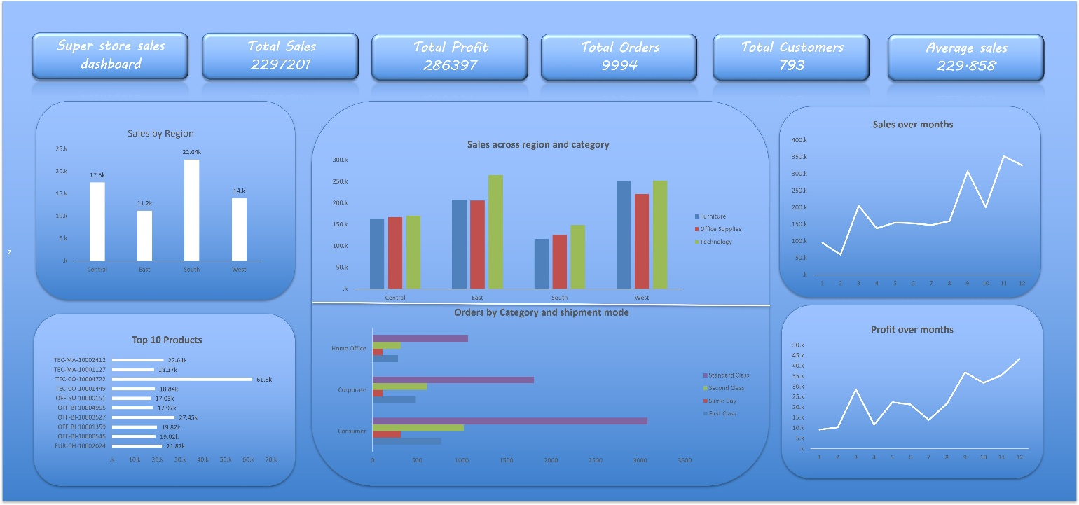
Prepared by: Viswa Desikan
Tool Used: Microsoft Excel (PivotTables, PivotCharts, Formulas)
Date: August 2026

1. Project Introduction
This document provides complete technical documentation for the Superstore Sales Dashboard project, built entirely in Microsoft Excel. The project takes a raw retail transactions dataset (the "Sample Superstore" dataset, a widely used public dataset for BI and analytics practice) through a full analytics workflow: data auditing, data cleaning and feature engineering, PivotTable-based exploratory analysis, KPI computation, and finally a single-page executive dashboard.
Three Excel workbooks were produced during this project and are documented here in sequence: the original raw dataset, the cleaned/prepared dataset, and the final dashboard workbook that contains the PivotTables and the visual dashboard sheet.

1.1 Files Covered in this Documentation
# | File Name | Purpose | Sheets Included
1 | Sample - Superstore.xls | Original, unmodified raw dataset as sourced | Orders, Returns, People
2 | Sample - Superstore_Cleaned.xls | Cleaned dataset with engineered date fields, ready for analysis | Orders, Returns, People
3 | Sample - Superstore_Dashboard.xls | Final analysis workbook with PivotTables, KPI sheet, and visual dashboard | Orders, Returns, People, Charts, KPI, Sheet3 (Dashboard)
Table 1.1 — Workbook files produced during the project

2. Project Objective
The primary goals of this project were to:
- Audit and clean a real-world style retail transactions dataset to make it analysis-ready.
- Engineer additional time-based fields (Day, Month, Year, Weekday, Shipping Duration) to enable trend analysis.
- Summarize the business performance using key metrics: total sales, total profit, average sale value, total orders, and total customers.
- Use PivotTables to analyze sales and profit across Region, Category, Product, Customer, Ship Mode, and Time (month-wise).
- Design a clean, single-screen executive dashboard that communicates overall business health at a glance.

3. Tools & Techniques Used
Tool / Technique | Purpose in this Project
Microsoft Excel | Primary platform for the entire workflow — cleaning, analysis, and dashboarding
Excel Formulas (Date functions) | Extracting Day, Month, Year, Weekday and computing shipping duration (No. of Days)
PivotTables | Aggregating Sales, Profit and Order counts by Region, Category, Product, Customer, Ship Mode and Month
PivotCharts / Cell-based KPI panel | Visual summary of headline metrics on the dashboard sheet
Conditional formatting & cell styling | Highlighting KPI cards on the dashboard for readability
Data validation checks | Verifying no duplicate Row IDs and no blank critical fields (e.g., Postal Code)

4. Dataset Description
The dataset used is the well-known Sample Superstore retail dataset, containing order-level transaction records for a US-based superstore retailer across the Consumer, Corporate, and Home Office segments.

4.1 Sheet Structure (Original File)
Sheet Name | Rows (excl. header) | Columns | Description
Orders | 9,994 | 21 | Core transactional data — one row per order line item
Returns | 296 | 2 | Order IDs that were returned, with a Returned flag
People | 4 | 2 | Regional manager mapped to each of the 4 sales regions
Table 4.1 — Sheet structure of the original raw workbook

4.2 Orders Sheet — Original Fields
The original Orders sheet contains the following 21 fields:
- Identifiers: Row ID, Order ID, Product ID, Customer ID
- Dates: Order Date, Ship Date, Ship Mode
- Customer info: Customer Name, Segment
- Location: Country, City, State, Postal Code, Region
- Product info: Category, Sub-Category, Product Name
- Metrics: Sales, Quantity, Discount, Profit

5. Data Cleaning & Preparation
Before analysis, the raw dataset was audited and enhanced. A quality check confirmed there were no duplicate Row IDs and no blank values in critical fields such as Postal Code across all 9,994 order records, so the cleaning effort focused on feature engineering — deriving new analysis-friendly fields from the existing Order Date column rather than removing bad data.

5.1 Data Quality Audit
Check Performed | Result
Duplicate Row IDs | 0 duplicates found
Blank Postal Code values | 0 blanks found
Row count consistency (Orders) | 9,994 rows retained (no records dropped)

5.2 New Fields Added
Five new columns were engineered from the Order Date field and inserted into the cleaned dataset to support time-based analysis:
New Column | Derived From | Purpose
Day | Order Date | Day-of-month component for daily-level analysis
Month | Order Date | Month component, used to build the monthly Sales/Profit trend Pivots
Year | Order Date | Year component, used for year-wise filtering
Weekdays | Order Date | Day name (e.g., Tuesday), useful for weekday-pattern analysis
No. of days | Ship Date − Order Date | Shipping duration in days — a proxy for delivery performance
Table 5.2 — Engineered fields added in the cleaned dataset

5.3 Before / After Column Comparison
Version | Total Columns | Column List (new additions in bold via order)
Original (Sample - Superstore.xls) | 21 | Row ID … Ship Mode, Customer ID … Product Name, Sales, Quantity, Discount, Profit
Cleaned (Sample - Superstore_Cleaned.xls) | 26 | Row ID, Order ID, Order Date, Ship Date, Ship Mode, Day, Month, Year, No. of days, Weekdays, Customer ID … Sales, Quantity, Discount, Profit
The Returns and People reference sheets were carried over unchanged, as no data quality issues were found in them.

6. Data Analysis — PivotTables
Eight PivotTables were built on the Orders sheet (using the cleaned data as the source range) and organized on a dedicated "Charts" sheet inside the dashboard workbook. Each PivotTable answers a specific business question. The underlying pivot cache draws from the full 9,994-row Orders table.
6.1 Sales by Region (Max of Sales)
Question: What is the highest single-order sale value recorded in each region?
Region | Max Sales (₹ / $)
Central | 17,499.95
East | 11,199.97
South | 22,638.48
West | 13,999.96
Grand Total | 22,638.48

6.2 Top 10 Products (Sum of Sales)
Question: Which 10 products generate the highest total sales revenue?
Product ID | Total Sales
TEC-CO-10004722 | 61,599.82
OFF-BI-10003527 | 27,453.38
TEC-MA-10002412 | 22,638.48
FUR-CH-10002024 | 21,870.58
OFF-BI-10001359 | 19,823.48
OFF-BI-10000545 | 19,024.50
TEC-CO-10001449 | 18,839.69
TEC-MA-10001127 | 18,374.90
OFF-BI-10004995 | 17,965.07
OFF-SU-10000151 | 17,030.31
Grand Total (Top 10) | 244,620.20

6.3 Bottom 10 Customers (Sum of Sales)
Question: Which 10 customers contribute the least total sales value?
Customer ID | Total Sales
JC-15340 | 71.26
AS-10135 | 58.82
LB-16735 | 50.19
RE-19405 | 48.36
SG-20890 | 47.95
RS-19870 | 22.33
MG-18205 | 16.74
CJ-11875 | 16.52
LD-16855 | 5.30
TS-21085 | 4.83
Grand Total (Bottom 10) | 342.30

6.4 Sales by Region × Category
Question: How does sales performance in each region break down across the three product categories?
Region | Furniture | Office Supplies | Technology | Grand Total
Central | 163,797.16 | 167,026.42 | 170,416.31 | 501,239.89
East | 208,291.20 | 205,516.05 | 264,973.98 | 678,781.24
South | 117,298.68 | 125,651.31 | 148,771.91 | 391,721.90
West | 252,612.74 | 220,853.25 | 251,991.83 | 725,457.82
Grand Total | 741,999.80 | 719,047.03 | 836,154.03 | 2,297,200.86

6.5 Order Count by Segment × Ship Mode
Question: How do customer segments differ in their preferred shipping method?
Segment | First Class | Same Day | Second Class | Standard Class | Grand Total
Consumer | 769 | 317 | 1,020 | 3,085 | 5,191
Corporate | 485 | 114 | 609 | 1,812 | 3,020
Home Office | 284 | 112 | 316 | 1,071 | 1,783
Grand Total | 1,538 | 543 | 1,945 | 5,968 | 9,994

6.6 Sales Over Month (Sum of Sales)
Question: How does total sales revenue trend across the 12 months?
Month | Total Sales
Jan | 94,924.84
Feb | 59,751.25
Mar | 205,005.49
Apr | 137,762.13
May | 155,028.81
Jun | 152,718.68
Jul | 147,238.10
Aug | 159,044.06
Sep | 307,649.95
Oct | 200,322.98
Nov | 352,461.07
Dec | 325,293.50
Grand Total | 2,297,200.86

6.7 Profit Over Month (Sum of Profit)
Question: How does total profit trend across the 12 months?
Month | Total Profit
Jan | 9,134.45
Feb | 10,294.61
Mar | 28,594.69
Apr | 11,587.44
May | 22,411.31
Jun | 21,285.80
Jul | 13,832.66
Aug | 21,776.94
Sep | 36,857.48
Oct | 31,784.04
Nov | 35,468.43
Dec | 43,369.19
Grand Total | 286,397.02
Table 6.7 — Note: A separate 8th PivotTable in the workbook ("Max of Sales by Region") re-confirms the Section 6.1 figures and feeds the same visual used elsewhere on the Charts sheet.

7. Key Performance Indicators (KPI Sheet)
A dedicated KPI sheet consolidates five headline metrics computed directly from the full Orders table. These are the same figures displayed as styled cards on the visual dashboard.
KPI | Value | How it is Calculated
Total Sales | 2,297,200.86 | SUM of the Sales column across all orders
Total Profit | 286,397.02 | SUM of the Profit column across all orders
Average Sales | 229.86 | AVERAGE of the Sales column (Total Sales ÷ Total Orders)
Total Orders | 9,994 | COUNT of order line items in the Orders table
Total Customers | 793 | COUNT of unique Customer IDs

8. Dashboard Design
The final dashboard is built on a dedicated sheet and presents the five KPIs as color-coded summary cards under the title "Superstore Sales Dashboard." The design intentionally keeps the executive view to a single screen, so a viewer can absorb overall business performance in seconds before drilling into the supporting PivotTables on the Charts sheet.

8.1 Dashboard Screenshot

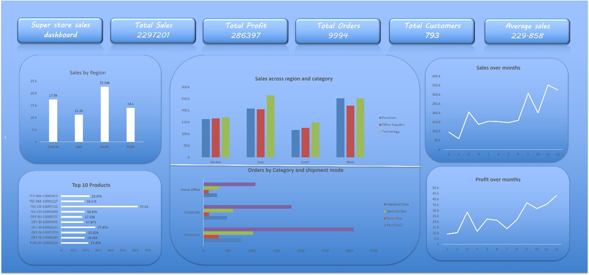
Figure 8.1 — Superstore Sales Dashboard (rendered from Sheet3 of the Dashboard workbook)

8.2 Layout Elements
- Dashboard title banner — "Superstore Sales Dashboard" — centered at the top of the sheet.
- Five KPI cards in a blue gradient style: Total Sales, Total Profit, Total Orders, Total Customers, and Average Sales.
- Each card uses large, bold white numerals against a colored background for high visual contrast and quick readability.
- Supporting analysis (regional, product, customer, category, ship-mode, and monthly breakdowns) is kept one click away on the Charts sheet, keeping the primary dashboard uncluttered.

8.3 Design Rationale
The dashboard follows a standard BI design principle of separating the "headline summary" from "detailed drill-down." The KPI-card layout was chosen over a chart-heavy front page so that the five most business-critical numbers are unmissable, while the eight PivotTables on the Charts sheet remain available for deeper analysis by region, product, customer, category, ship mode, and month without competing for space on the summary view.

9. Key Insights & Findings
- Overall performance: The business generated a total of 2,297,200.86 in sales and 286,397.02 in profit across 9,994 orders from 793 unique customers, at an average sale value of 229.86 per order.
- Regional leader: The West region contributes the highest total sales (725,457.82), followed by East (678,781.24); the South region trails with the lowest total (391,721.90) despite recording the single highest individual sale value (22,638.48).
- Category strength: Technology is the strongest category overall (836,154.03 in sales), ahead of Furniture (741,999.80) and Office Supplies (719,047.03), and it also holds the region-wise lead in three of the four regions.
- Top product concentration: A single product (TEC-CO-10004722) accounts for 61,599.82 in sales — more than double the next-highest product — making it the single most important SKU in the catalog.
- Shipping preference: Standard Class is by far the most-used shipping mode (5,968 of 9,994 orders, ~60%), consistent across all three customer segments (Consumer, Corporate, and Home Office).
- Segment mix: Consumer is the largest customer segment by order volume (5,191 orders, ~52%), more than Corporate and Home Office combined.
- Seasonality: Sales peak sharply in November (352,461.07) and September (307,649.95), while February is the slowest month (59,751.25) — a pattern consistent with year-end and back-to-school buying cycles.
- Profit seasonality: Profit peaks in December (43,369.19) and September (36,857.48), broadly tracking the sales trend but with December overtaking November in profitability despite lower sales — suggesting stronger margins in Q4.
- Low-value tail: The bottom 10 customers together contribute only 342.30 in total sales — a negligible fraction of total revenue, typical of the long-tail distribution seen in retail transaction data.

10. Conclusion
This project demonstrates a complete, self-contained Excel analytics workflow — from raw data intake through quality auditing, feature engineering, multi-dimensional PivotTable analysis, and a polished single-page dashboard. The cleaned dataset's added date-derived fields (Month, Weekday, Shipping Duration) unlocked trend and seasonality analysis that was not directly possible on the raw file. The resulting dashboard gives stakeholders an at-a-glance view of overall performance, while the eight supporting PivotTables allow deeper investigation into regional, product-level, customer-level, and time-based performance drivers.

10.1 Possible Next Steps
- Add a Returns-rate KPI by joining the Returns sheet against Orders to quantify return impact on profit.
- Introduce slicers on Region, Category, and Segment for interactive filtering of the dashboard.
- Add a Discount vs. Profit analysis, since high discounts are a common driver of order-level losses in this dataset.
- Incorporate the Ship Date-derived "No. of days" field into a delivery-performance KPI (average shipping duration by Ship Mode / Region).

Appendix A — File Reference
File | Key Sheets | Row Count (Orders) | Column Count (Orders)
Sample - Superstore.xls (Original) | Orders, Returns, People | 9,994 | 21
Sample - Superstore_Cleaned.xls | Orders, Returns, People | 9,994 | 26 (+5 engineered fields)
Sample - Superstore_Dashboard.xls | Orders, Returns, People, Charts (8 PivotTables), KPI, Dashboard | 9,994 | 26

