ZEPTO SALES
ANALYTICS DASHBOARD
Excel Data Analytics & Dashboard Project — Project Documentation

Prepared by: Viswa Desikan
B.Tech, Artificial Intelligence & Data Science
Mahendra Engineering College (Autonomous), Namakkal
August 2026
1. Executive Summary
This document describes the end-to-end Excel analytics workflow built for Zepto, an instant-commerce (quick-commerce) sales dataset covering business-customer orders placed across Bangalore, Delhi and Mumbai between January and March 2025. The project moves raw transactional data through validation, structured aggregation, and a final interactive dashboard, all inside a single, self-contained Excel workbook.
The finished workbook analyses 1,498 orders worth ₹5,63,332.74 in total sales, placed by 300 distinct business customers across 200 products, and answers 21 distinct business questions through PivotTables and native Excel charts before rolling the key visuals into a dark-themed, presentation-ready dashboard sheet.

2. Project Objective
The objective of this project is to demonstrate a complete data analytics workflow inside Microsoft Excel — from raw data intake through cleaning, exploratory analysis, and dashboard storytelling — using order-level sales data from a quick-commerce platform. Specifically, the project aims to:
- Validate and structure raw order-level transactional data for analysis.
- Quantify overall business performance through headline KPIs.
- Break down sales performance by time, geography, customer type, payment method, and product.
- Identify top- and bottom-performing orders, customers, and SKUs.
- Present findings through an interactive, single-screen dashboard suitable for stakeholder review.

3. Project Workflow
The project was executed in four stages, each captured in a dedicated sheet within the analysis workbook:
Stage | Sheet | Purpose
1. Data Intake | Sheet1 | Raw transactional order data imported and validated (1,498 rows × 25 columns).
2. KPI Summary | KPIs | Six headline metrics calculated as single-cell summary figures.
3. Exploratory Analysis | Charts | 21 PivotTables paired with native Excel charts answering specific business questions.
4. Dashboard | Sheet2 / Dashboard | Five key visuals consolidated into a single dark-themed dashboard view.

4. Data Source & Structure

4.1 File Overview
Attribute | Detail
Source file | zepto_sales_raw.xlsx
Analysis workbook | zepto_sales_Analysis.xlsx
Records (orders) | 1,498
Fields (columns) | 25
Date range | 1 Jan 2025 – 1 Mar 2025 (March represented by a single day)
Distinct customers | 300
Distinct products (SKUs) | 200
Cities covered | Bangalore, Delhi, Mumbai

4.2 Column Dictionary
The dataset is order-level (one row per order line), combining order metadata, customer attributes, product detail, and a full pricing breakdown:
Group | Columns | Description
Order metadata | Order_ID, Order_Date, Days, Date, Day, Month, Year | Unique order identifier and date parts pre-split for time-based analysis.
Customer attributes | Customer_Name, Customer_Type, Customer_Segment, City | Buyer identity, order frequency tier (Bulk / New / Returning), business category (e.g. Bakery, Café, Office), and delivery city.
Product detail | SKU, Product_Name, Category, Qty | Item ordered, its catalogue category (Veg, Dairy, Frozen, etc.), and quantity purchased.
Pricing breakdown | Price, Discount, Subtotal, Tax, Delivery_Fee, Surge_Fee, Sales | Unit price through to the final billed amount; Sales = Subtotal + Tax + Delivery_Fee + Surge_Fee.
Fulfilment | Payment_Method, Delivery_Status, Delivery_Time | Payment channel used, final order outcome, and delivery duration in minutes.

5. Data Cleaning & Preparation
Before analysis, the raw dataset was validated for structural and logical integrity. The checks performed and their outcomes are summarised below:
Check performed | Outcome
Duplicate Order_ID check | No duplicate order records found across 1,498 rows.
Data type validation | Dates, numeric fields (Qty, Price, Sales, etc.) and text fields confirmed to be correctly typed.
Missing value scan | City was the only field with gaps — 28 rows (≈1.9%) had no city recorded.
Missing value treatment | Blank City values were retained (not dropped or imputed) and grouped under an explicit “N/A” category in all city-based PivotTables, preserving the associated order and revenue data instead of discarding valid transactions.
Derived field cross-check | Sales was verified to reconcile exactly with Subtotal + Tax + Delivery_Fee + Surge_Fee, and Subtotal with (Qty × Price) − Discount, confirming the pricing logic is internally consistent.
Date decomposition | Order_Date was already broken into Day / Month / Year / weekday-name columns, enabling direct PivotTable grouping without additional formulas.

Because the missing-city rows still contain valid order, product and payment data, they were deliberately kept in the analysis rather than removed — dropping them would have understated total sales by roughly ₹12,171 (about 2.2% of revenue).

6. Key Performance Indicators
Six headline metrics are calculated on the KPIs sheet and referenced throughout the dashboard:
KPI | Value
Total Sales | ₹5,63,332.74
Total Orders | 1,498
Total Customers | 300
Total Products | 200
Total Quantity Sold | 4,199 units
Average Sales per Order | ₹376.06

7. Pivot Table & Chart Analysis
The Charts sheet contains 21 PivotTable-driven analyses, each paired with a native Excel chart, addressing a specific business question:
# | Business Question | Chart Type
1 | Top 10 orders by sales value | Bar chart
2 | Sales trend across months | Line chart
3 | Top 10 customers by sales value | Bar chart
4 | Top 10 SKUs by sales value | Bar chart
5 | Bottom 10 orders by sales value | Bar chart
6 | Bottom 10 customers by sales value | Bar chart
7 | Bottom 10 SKUs by sales value | Bar chart
8 | Unit price trend across months | Line chart
9 | Quantity sold trend across months | Line chart
10 | Daily sales volume across the period | Area chart
11 | Sales by customer segment (business type) | Bar chart
12 | Quantity contribution by customer type | Doughnut chart
13 | Daily subtotal volume | Area chart
14 | Daily quantity volume | Area chart
15 | Sales by city | Bar chart
16 | Sales by payment method | Bar chart
17 | Sales by customer type | Bar chart
18 | Order-count contribution by payment method | Doughnut chart
19 | Customer distribution by city | Doughnut chart
20 | Customer type performance by city / payment method (cross-tab) | PivotTable (matrix)
21 | Delivery outcome by customer segment (cross-tab) | PivotTable (matrix)

Each PivotTable aggregates Sheet1 using SUM, COUNT, or DISTINCT COUNT depending on the question, and every chart references its PivotTable directly, so the whole sheet recalculates automatically if the source data changes.

8. Interactive Dashboard
The final dashboard (Sheet2) consolidates the five most decision-relevant visuals from the exploratory analysis into a single dark-themed view titled “Zepto Sales Analysis,” designed for at-a-glance stakeholder review:
- Payment Methods Distribution — doughnut chart showing order share across Card, Cod, Gpay, Netbanking, Phonepe, UPI and Wallet.
- Quantity of Sales Over Days — area chart tracking daily unit volume across the reporting period.
- Top 10 Orders — horizontal bar chart ranking the highest-value individual orders.
- Top 10 Products — horizontal bar chart ranking SKUs by total sales contribution.
- Customers by City — doughnut chart showing customer distribution across Bangalore, Delhi and Mumbai.
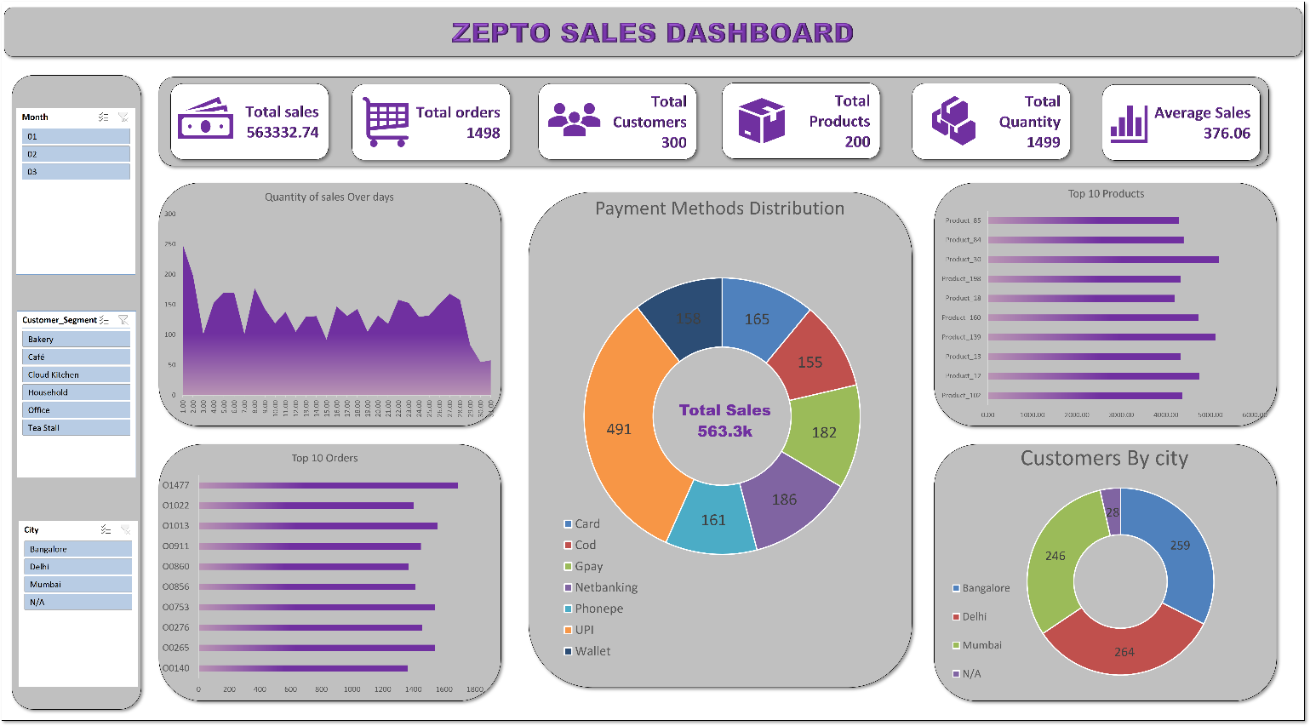
Dashboard title panel and Payment Methods Distribution chart
The dashboard uses a consistent dark-navy background with a pink-to-purple accent palette, chosen to give the sheet a polished, presentation-ready appearance distinct from the working analysis tabs.

9. Key Insights
- UPI is the dominant payment channel, used in 491 of 1,498 orders (32.8%) and contributing ₹1,88,178.74 in sales (33.4% of total revenue) — more than double any other single channel.
- Bulk customers drive the business: the Bulk customer type accounts for ₹4,69,386.34 in sales (83.3% of total revenue) versus a combined 16.7% from New and Returning customers.
- Bangalore is the top-performing city by revenue (₹2,01,206.68, 35.7%), narrowly ahead of Delhi (₹1,80,570.60, 32.1%) and Mumbai (₹1,69,384.46, 30.1%).
- The Office customer segment generates the highest sales among business types (₹1,03,708.09), ahead of Tea Stall, Café, Household, Cloud Kitchen and Bakery, which are all clustered between ₹87,000 and ₹96,000.
- 83.7% of orders (1,254 of 1,498) were successfully delivered; the remaining 16.3% split across Cancelled (7.6%), Failed (5.5%) and Returned (3.2%) — a useful baseline for fulfilment-quality tracking.
- Sales activity is concentrated in January and February (₹2,82,163.61 and ₹2,70,486.75 respectively); March is represented by only one day of data (₹10,682.38) and should be excluded from month-over-month trend comparisons.
- Order values are highly variable — the largest single order (O1477) totalled ₹1,688.83, while several bottom-decile orders closed under ₹2, indicating a long tail of very small basket sizes.

10. Tools & Techniques Used
Tool / Technique | Application in this project
Microsoft Excel PivotTables | Aggregating 1,498 rows of order data into 21 summarised views (sums, counts, distinct counts, cross-tabs).
Native Excel Charts | Bar, line, area and doughnut charts bound directly to PivotTable output for live-updating visuals.
Formula-based validation | Cross-checking Sales and Subtotal against their component fields to confirm pricing-logic integrity.
Dashboard design | A single consolidated sheet using a dark theme and consistent accent colours for stakeholder-facing presentation.

11. Conclusion & Future Scope
This project demonstrates a complete, self-contained Excel analytics workflow — from raw data validation through 21 exploratory analyses to a polished executive dashboard — applied to a realistic quick-commerce sales dataset. The workbook is fully formula- and PivotTable-driven, so it will recalculate automatically if refreshed with new order data.
Potential extensions for future iterations include:
- Adding slicers or a date-range control to the dashboard for interactive filtering by month, city, or customer segment.
- Extending the time range beyond Q1 2025 to support genuine month-over-month trend analysis.
- Building a customer-retention or cohort view using the existing Customer_Type field (New vs. Returning vs. Bulk).
- Migrating the workbook logic to Power BI or Python (pandas) for larger-scale or automated refreshes.

