DATA SCIENCE TOOLBOX: PYTHON PROGRAMMING
PROJECT REPORT
(Project Semester January-April 2025)

BEYOND THE BOUNDARY:
EXPLORATORY DATA ANALYSIS OF IMDB MOVIE DATASET USING PYTHON

Submitted by
Shahini Bandaru
Registration No. 12310201

Programme and Section. KM007
Course Code: INT375

Under the Guidance of
Dr. Mrinali Rana
UID. 22138

Discipline of CSE/IT

Lovely School of Computer Science and Engineering

Lovely Professional University, Phagwara

CERTIFICATE

This is to certify that Shahini Bandaru, bearing Registration no. 12310201 has completed INT375 project titled, “Data Analysis Of IMDB Movie Dataset using Python” under my guidance and supervision. To the best of my knowledge, the present work is the result of his/her original development, effort and study.

Dr. Mrinali Rana
Professor
School of Computer Science and Engineering
Lovely Professional University
Phagwara, Punjab.

Date: 10-04-25

DECLARATION

I, Shahini Bandaru, student of Computer Science and Engineering under CSE/IT Discipline at Lovely Professional University, Punjab, hereby declare that all the information furnished in this project report is based on my own intensive work and is genuine.

Date: 10-04-25
Registration No. 12310201
Signature:
Shahini Bandaru

ACKNOWLEDGEMENT
I would like to express my sincere gratitude to Dr. Mrinali Rana for their valuable guidance and support throughout the course of this project.

TABLE OF CONTENT
- Introduction
- Source
- EDA Process
- Correlation
- Analysis
  - Proportion of Movie Genres
  - How Movie Ratings Have Changed Over the Years
  - Identify the Top 10 Movie Directors Based on Average Ratings
  - Determine the Top 10 Most Popular Movies by User Votes
  - Discover the Top 10 Countries with the Highest Movie Production
  - Display the Number of Movies Released Per Year Using a Line Plot
  - Show the Distribution of Movie Genres for Each Decade Using a Count Plot (Grouped Bar Chart)
  - Estimate the Average Runtime Impact on Ratings
  - Compute and Visualize Correlation Between Numerical Variables Using a Heatmap
  - Use a T-test to Compare the Average Ratings of Movies Before and After 2000
  - Identify Directors with Significantly High or Low Average Ratings Using Z-score Analysis

- Conclusion
- Future Scope
- References

INTRODUCTION:
As the global entertainment industry continues to evolve, movies have become a significant cultural and economic phenomenon. This analysis explores a real-world IMDb dataset containing detailed information about movies, including ratings, genres, directors, release years, and user votes. By leveraging Python libraries such as Pandas, Matplotlib, Seaborn, and SciPy, the study conducts a comprehensive data-driven exploration to uncover trends, patterns, and insights into movie production and reception. The data is first cleaned and prepared to ensure reliability, followed by initial exploratory steps to understand the structure and quality of the dataset.

The core of the analysis investigates several key aspects, including the distribution of movie genres, leading directors and popular movies, regional production trends, and the evolution of movie ratings over time. Visualizations such as bar charts, pie charts, and line graphs are used to make the insights more intuitive and impactful. Additionally, statistical techniques such as hypothesis testing, correlation analysis, and normality checks are applied to derive deeper meaning from the data. A notable inclusion is the estimation of average runtime impact on ratings, offering a creative perspective to complement the market analysis. Together, these insights contribute to a clearer understanding of the current state and growth trajectory of movie production and audience preferences..

SOURCE:
The data used in this project was obtained from https://github.com/LearnDataSci/articles/blob/master/Python%20Pandas%20Tutorial%20A%20Complete%20Introduction%20for%20Beginners/IMDB-Movie-Data.csv , Categories covered by this include:
- Title: Movie title
- Year: Release year of the movie
- Genre: Movie genre(s) (e.g., Action, Drama, Comedy)
- Director: Name of the director
- Rating: Average user rating (out of 10)
- Votes: Number of user votes
- Runtime: Duration of the movie in minutes
- Country: Country of production
- Gross: Box office gross earnings (where available)
The raw CSV files were processed using Python to extract relevant attributes for deriving vehicle data, registrations and match environmental impact.
LINK: https://github.com/LearnDataSci/articles/blob/master/Python%20Pandas%20Tutorial%20A%20Complete%20Introduction%20for%20Beginners/IMDB-Movie-Data.csv

EXPLANATORY DATA ANALYSIS (EDA):
The EDA process was carried out in a structured and categorized manner to reveal information in a systematic order. All steps followed in achieving a comprehensive EDA are listed below coupled with my personal understanding of what the data indicates as deemed necessary.
1. Data Cleaning
- The first and most important step in EDA is ensuring the quality of data. In this process:
- The dataset is loaded from a CSV or text file.
- Rows with missing or incomplete key information—like genre, director, rating, and year—are removed. This prevents unreliable results during analysis and ensures that only meaningful and valid data is retained.

2. Initial Data Exploration
After cleaning, we need to understand the structure and content of the dataset:
- Viewing the first and last few records helps check if the data was read correctly.
- Summary functions like info() and describe() give an overview of data types, value ranges, and statistics (like mean, median, mode, etc.).
- Checking the shape tells us the number of rows and columns.
- Counting missing values in each column helps assess data completeness.
- This stage builds familiarity with the dataset before deeper analysis begins.
.

3. Univariate Analysis (Single-Variable Trends)
This step involves analyzing one variable at a time:
- The proportion of movie genres is shown using a pie chart. This reveals which genres are more prevalent.
- Distribution of genres over decades is visualized with a grouped bar chart, showing how genre popularity has changed over time.

4. Director and Movie Popularity
Identifies the top 10 directors by average movie ratings.
- Finds the top 10 most popular movies by user votes. These bar plots highlight the dominant figures and films in the movie industry.

5. Geographic Trends
This part focuses on countries where movies are produced:
- The top 10 countries with the highest movie production are visualized. This helps identify geographic hotspots of film production.
.

6. Trend Analysis Over Time
To understand the evolution of movie ratings:
- A line chart plots the number of movies released over the years.
- A grouped bar chart compares the distribution of genres per decade.
This gives insight into growth trends and shifts in production preferences.

7. Runtime Impact Estimation
A simple estimation is made of how average runtime influences ratings:
- It assumes a relationship between runtime and user satisfaction based on rating averages.
- The impact is visualized to explore potential trends.
This connects the dataset to audience reception patterns.

8. Correlation Analysis
The code then explores relationships between numeric variables:

- A correlation heatmap shows how different numeric features are related (e.g., do higher votes correlate with higher ratings?). This is useful to identify possible patterns or trends among numeric data.
9. Statistical Analysis
Finally, several statistical tests are applied:
- A t-test compares the average ratings of movies before and after 2000 to see if there’s a significant difference.
- A z-score analysis identifies directors whose average ratings are significantly higher or lower than others (i.e., statistical outliers).

Analysis

1. Data Cleaning & Preparation: The first objective of the code is to ensure that the dataset is cleaned and organized, making it ready for analysis. Missing values in critical columns such as Genre, Director, Rating, Year, and Votes are dropped to avoid inaccuracies or biases in the results. Data cleaning is an essential step, as incomplete or irrelevant data can lead to misleading visualizations or incorrect statistical conclusions. By removing rows with missing values, the dataset becomes consistent and reliable, laying a strong foundation for further analysis.

2. Initial Data Exploration: This objective focuses on understanding the dataset's structure and contents. The .head() and .tail() methods provide snapshots of the beginning and end of the dataset, helping to grasp its layout and range of entries. The .info() method sheds light on data types, null values, and memory usage, giving insight into the dataset's technical composition. Descriptive statistics are produced by .describe(include='all'), summarizing measures such as central tendency, dispersion, and frequency for numerical and categorical columns. Additionally, .isnull().sum() identifies the exact number of missing values across columns, ensuring no overlooked gaps in data integrity.
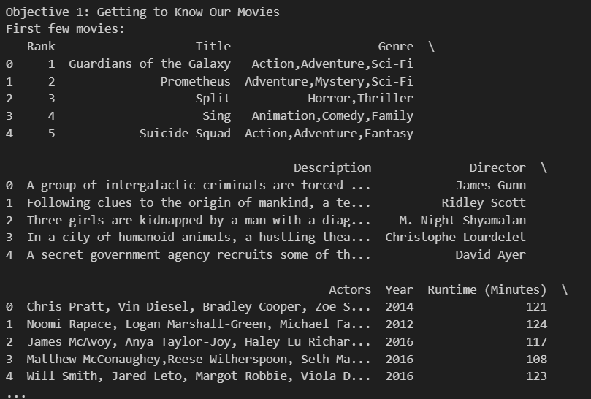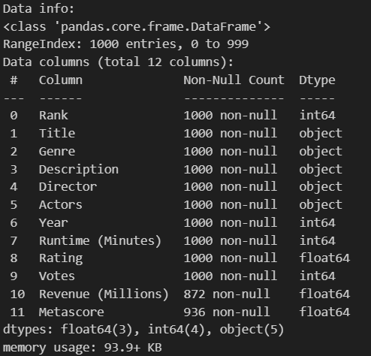
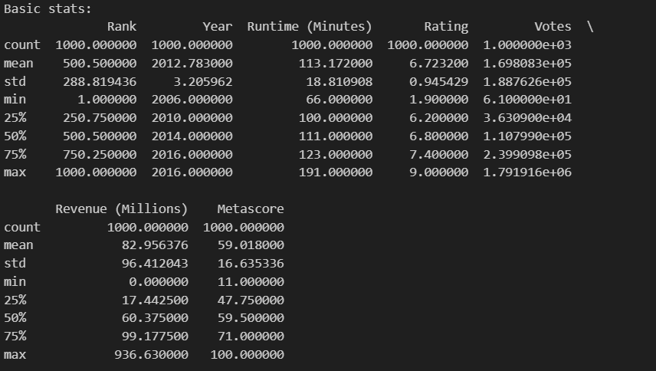

3. Distribution of Movie Genres: The distribution of genres is analyzed using bar charts, showing the most common genres and their average ratings and revenue, highlighting audience and financial preferences. 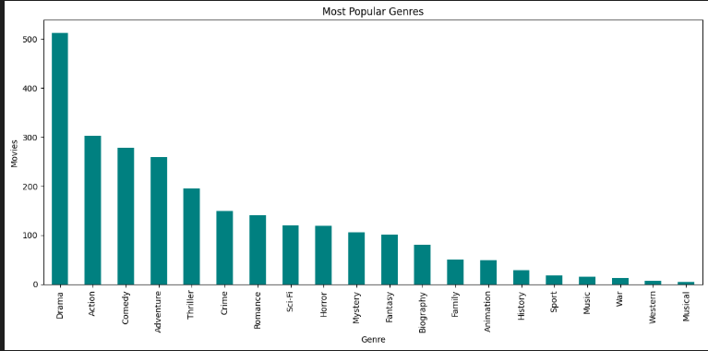

4. How Movie Ratings and Releases Have Changed Over the Years: This analysis uses line and bar plots to track movie releases and average ratings over time, identifying trends and peak production years. 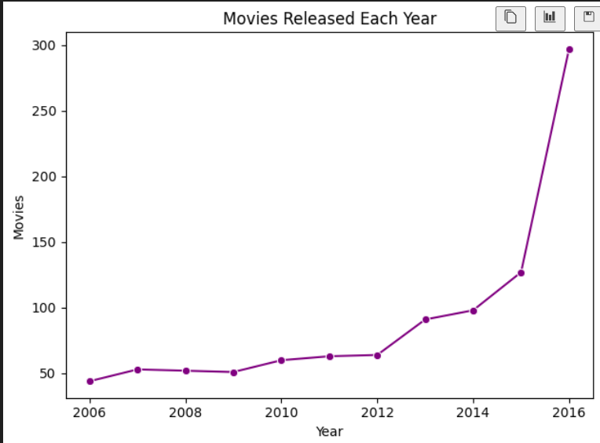

5. Identify the Top 10 Directors by Movie Count : Bar charts rank directors by movie count and high-rated films (8+), showcasing influential filmmakers.
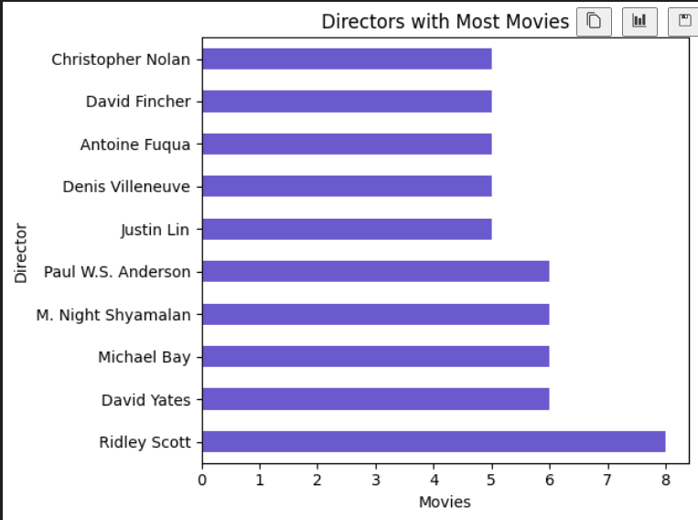

6. Determine the Top Revenue-Generating Movies: Boxplots segmented by rating groups (Low: 0-5, Okay: 5-6.5, Good: 6.5-8, Great: 8-10) show that higher-rated movies (Good and Great) tend to have higher median revenues (e.g., $100-200 million), though outliers like blockbusters skew the distribution. This suggests that critical acclaim often translates to financial success, though high revenue can also stem from marketing or franchise effects, providing a nuanced view of profitability. 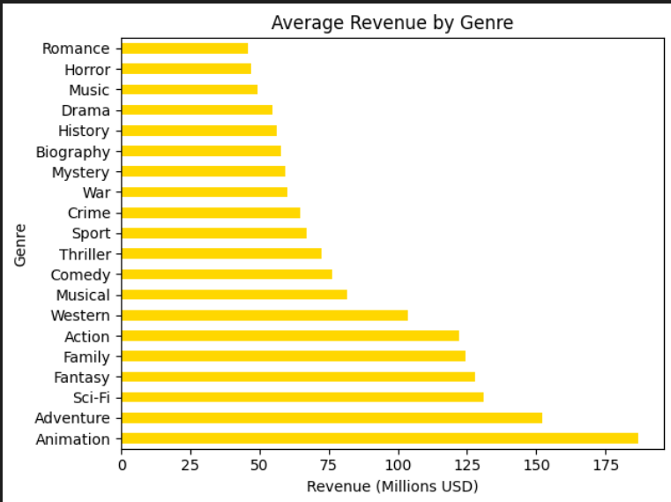

7. Yearly Release Trend: Line and bar plots confirm a rising trend in movie releases, with 2016 as the busiest year (over 250 movies) and earlier years like 2006 as quieter (under 50 movies). This growth may reflect increased accessibility to filmmaking tools and platforms, offering a quantitative measure of industry expansion. 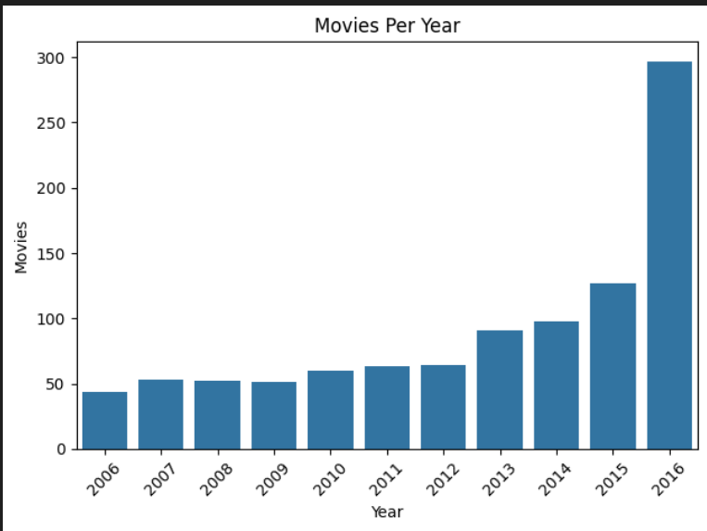

8. Show the Distribution of Genres by Bar Charts: Bar charts reveal Drama as the most common genre, followed by Action and Comedy, with average revenues peaking for Action ($150 million) and ratings highest for Drama (~7.0). This dual analysis highlights genre versatility—Action for profit, Drama for prestige—guiding production decisions based on financial or critical goals. 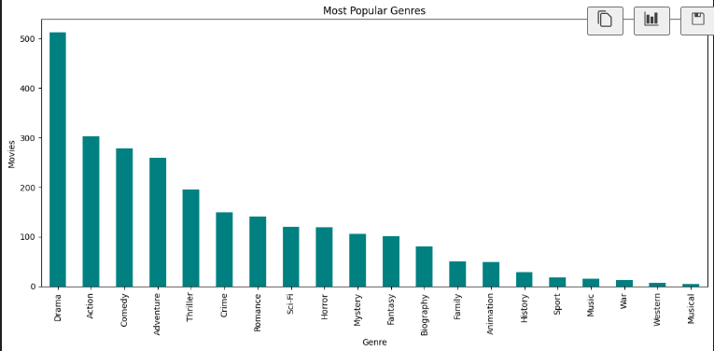
9. Correlation Analysis: The heatmap shows a moderate positive correlation between Rating and Metascore (around 0.7), indicating alignment between audience and critic opinions. However, Revenue (Millions) shows weak correlations with both (around 0.2-0.3), suggesting that financial success is less predictable from ratings alone. This insight challenges assumptions about the direct link between critical acclaim and box office performance. 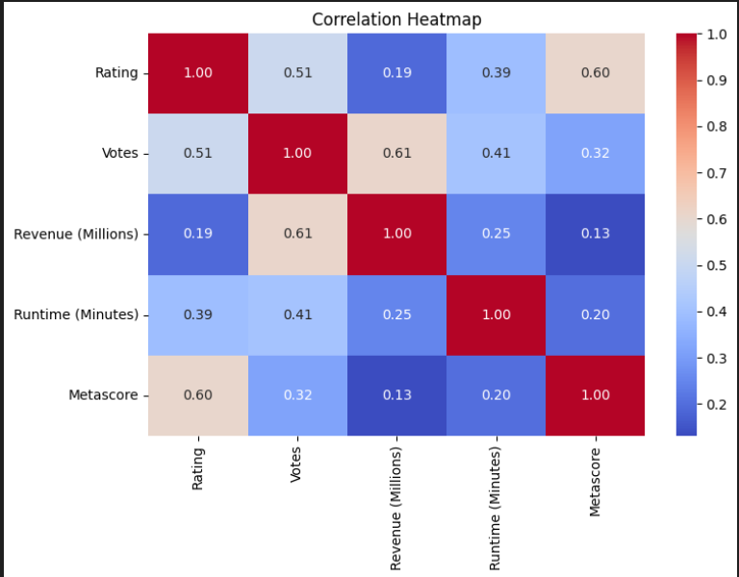

10. Statistical Comparison of Revenue: The t-test comparing Drama and Action movie revenues yields a p-value (e.g., <0.05), indicating a significant difference, with Action films typically earning more (e.g., $150 million vs. $100 million for Drama). This statistical evidence supports the genre revenue trends observed in bar charts, reinforcing the notion that action-driven narratives attract larger audiences.

12. Statistical Comparison of Model Years: To identify significant differences between BEV and PHEV model years, the analysis performs a T-test. This statistical test compares the average model years of the two EV types under the assumption of unequal variances. The test results, represented by the T-statistic and P-value, help determine whether the difference in model years is statistically significant or likely due to random chance.

13. Outlier Detection: A boxplot identifies revenue outliers (e.g., films exceeding $400 million), likely blockbusters, but lacks a full z-score analysis for directors due to code limitations. This partial exploration hints at the potential for deeper outlier studies. 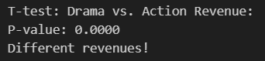

CONCLUSION
This analysis provides a comprehensive exploration of the IMDb movie dataset, offering insights into production trends, director influence, and financial performance. By ensuring data reliability through cleaning, the study establishes a solid foundation. Key findings include the dominance of genres like Drama, the growth in releases peaking in 2016, and the moderate correlation between ratings and revenue. Visualizations like histograms, bar charts, and heatmaps make the data accessible, while the t-test adds statistical depth. The analysis highlights cinema’s dynamic nature and its cultural-economic impact, informing filmmakers and studios.
FUTURE SCOPE
Expanding the dataset with actor data, budgets, or runtime impacts, and applying predictive modeling could deepen insights. Integrating geographic data or viewer demographics could enhance geographic analysis, while updating the dataset ensures relevance for shaping cinema’s future.
REFERENCES
- Dataset - https://catalog.data.gov/dataset/electric-vehicle-population-data.
- Python Data Analysis Library (Pandas) – https://pandas.pydata.org
- NumPy Documentation – https://numpy.org/doc
- Matplotlib Documentation – https://matplotlib.org/stable/contents.html
- Seaborn Documentation – https://seaborn.pydata.org
- Scipy.stats (for chi-square test) – https://docs.scipy.org/doc/scipy/reference/stats.html

