

Department: Electronics and Communications Engineering
Course Title: Microprocessor and Microcomputer Laboratory
Course no: ECE 2204

Project Title: Palindrome Checker Using 8086 Assembly Language in EMU8086

Submitted By:
Name | Roll
Md. Shahinur Hasan | 2009049
 | 20090xx
 | 20090xx
 | 20090xx

Contents

1) Objectives 3
2) Introduction 3
3) Theory 3
3.1) Architecture of the 8086 Microprocessor 3
3.2) DOS Interrupt INT 21h 4
3.3) Addressing Modes and Instructions 4
3.4) Algorithm (Two Pointer Method) 4
3.5) Program Code 5
4) Apparatus 5
5) Result Analysis 6
5.1) Palindrome: Input "radar" 6
5.2) Not Palindrome: Input "Word" 7
6) Discussion 7
7) Conclusion 8
8) References 8
1. Objectives
- To write an 8086 assembly language program that reads a word from the keyboard and checks whether it is a palindrome.
- To run and test the program in the EMU8086 emulator.
2. Introduction
A palindrome is a word, phrase or number that reads the same from the left and from the right. Common examples are "radar", "level", "madam" and "noon". In a high level language such as C or Python, checking for a palindrome takes only a few lines, but doing the same job in assembly language feels very different. There is no string data type, no built in reverse function and no ready made input routine. Every character has to be read, stored and compared by hand, and that is exactly why this problem makes a good exercise for a microprocessor course.
The Intel 8086 is a 16 bit microprocessor that was released in 1978, and its instruction set became the base of the x86 family that still runs most personal computers today [1]. Its architecture is still simple enough to be studied in detail. Working with it gives a clear picture of how registers, memory segments, addressing modes and interrupts work together inside a processor. Assembly language sits directly on top of this hardware, so almost every line of code turns into one machine instruction [2].
In this project a small program was written in 8086 assembly language and tested in EMU8086, an emulator that lets the user assemble the code, run it step by step and watch the registers, flags and memory change after every instruction. The program shows a prompt, takes a word from the keyboard one character at a time until the Enter key is pressed, and then compares the first character with the last one, the second with the second last, and so on. If every pair matches, the message "PALINDROME" is shown. If any pair is different, the program prints "NOT PALINDROME" and stops checking.
3. Theory
3.1 Architecture of the 8086 Microprocessor
The 8086 has a 16 bit data bus and a 20 bit address bus, so it can address 1 MB of memory. Internally it is divided into two parts. The Bus Interface Unit (BIU) fetches instructions and data from memory and calculates the physical addresses, while the Execution Unit (EU) decodes and executes the instructions. The BIU keeps a 6 byte instruction queue filled while the EU is busy, so the two units work in a simple pipelined way [1], [4].
Memory is reached through segments. A physical address is formed by shifting a 16 bit segment register four bits to the left and adding a 16 bit offset to it. For example, when DS = 0700h and the offset is 012Fh, the physical address becomes 07000h + 012Fh = 0712Fh. The registers used in this program are listed in Table 1.
Table 1: Registers used in the program
Register | Role in the palindrome program
AX (AH, AL) | AH: DOS function number. AL: typed character, then the left character.
BX (BL) | BL holds the right character during comparison.
DX | Offset of the message string printed by function 09h.
SI | Points to the next free byte during input, then to the left end.
DI | Points to the right end of the word during comparison.
DS | Base segment for the messages and the word buffer.

3.2 DOS Interrupt INT 21h
Talking directly to the keyboard and display hardware is tedious, so the program uses the DOS services that are available through software interrupt 21h [5], [6]. The required service is chosen by loading a function number into AH before executing INT 21h. Three services are used in this program, as shown in Table 2.
Table 2: INT 21h functions used in the program
Function (AH) | Purpose | Input / Output
01h | Read one key with echo | Output: ASCII code in AL
09h | Display a '$' terminated string | Input: DS:DX points to the string
4Ch | Terminate and return to DOS | Input: AL = return code

Function 01h waits for a key, shows it on the screen and returns its ASCII code in AL. When the Enter key is pressed, AL contains 0Dh (decimal 13), the carriage return code, and the program uses this value as the end of input marker. Function 09h prints characters starting from DS:DX until it finds a '$'. The messages msg2 and msg3 start with the bytes 13 and 10 (carriage return and line feed), so the result always appears on a new line.
3.3 Addressing Modes and Instructions
The typed word is stored in a 20 byte array named word, which is filled with '$' characters at the start. The program reaches each byte through register indirect addressing, written as [SI] or [DI], where the register holds the offset of the operand. Immediate addressing (mov ah,09h) and register addressing (cmp al,bl) are also used. Decisions are made with the CMP instruction, which subtracts the second operand from the first without saving the result and only updates the flags. The conditional jumps JE, JNE and JGE then look at the Zero, Sign and Overflow flags to decide whether to branch [3]. INC and DEC move the pointers forward and backward through the array.
3.4 Algorithm (Two Pointer Method)
The check is done with a two pointer approach. One pointer starts at the first character and the other one at the last character. They move towards each other, and the process stops either when a mismatch is found or when the pointers meet or cross. A word with n characters needs at most n/2 comparisons, so the method is fast and does not need a second, reversed copy of the string. The steps are:
- Load DS with the data segment address and display the prompt "Enter a word:" using function 09h.
- Point SI to the start of the buffer word.
- Read a character with function 01h. If it is 0Dh (Enter), go to step 5.
- Store the character at [SI], increase SI and go back to step 3.
- Set DI = SI - 1 so that it points to the last character, and reset SI to the first character.
- If SI is greater than or equal to DI, go to step 8.
- Load [SI] into AL and [DI] into BL. If they differ, go to step 9. Otherwise increase SI, decrease DI and repeat step 6.
- Display "PALINDROME" and go to step 10.
- Display "NOT PALINDROME".
- Terminate the program with function 4Ch.
3.5 Program Code
The complete source code that was assembled and run in EMU8086 is given in Table 3, split into two columns to save space.
Table 3: Source code of the palindrome checker
org 100h | check:
.stack 100h | mov di,si
.data | dec di
msg1 db "Enter a word: $" | mov si,offset word
msg2 db 13,10,"PALINDROME$" | compare:
msg3 db 13,10,"NOT PALINDROME$" | cmp si,di
word db 20 dup('$') | jge palindrome
.code | mov al,[si]
main proc | mov bl,[di]
mov ax,@data | cmp al,bl
mov ds,ax | jne notpal
; show message | inc si
mov dx,offset msg1 | dec di
mov ah,09h | jmp compare
int 21h | palindrome:
; input word | mov dx,offset msg2
mov si,offset word | mov ah,09h
input: | int 21h
mov ah,01h | jmp exit
int 21h | notpal:
cmp al,13 | mov dx,offset msg3
je check | mov ah,09h
mov [si],al | int 21h
inc si | exit:
jmp input | mov ah,4ch
 | int 21h
 | main endp
 | end main

4. Apparatus
Since this is a software based project, no physical trainer kit was needed. All the work was done on a personal computer with the items listed in Table 4. EMU8086 was chosen because it puts the editor, assembler and emulator in one place [7], and it can run a program at full speed or one instruction at a time.
Table 4: Apparatus used
SL | Apparatus | Specification / Use
1 | Personal computer (laptop) | Windows 11, used to run all the software
2 | EMU8086 | Version 4.08, assembler and 8086 emulator

5. Result Analysis
The program was assembled without any errors and run in the emulator. To check both possible outcomes, two words were tested: "radar", which is a palindrome, and "Word", which is not. The output screen for each run is shown in Figure 1 and Figure 2.
5.1 Palindrome: Input "radar"
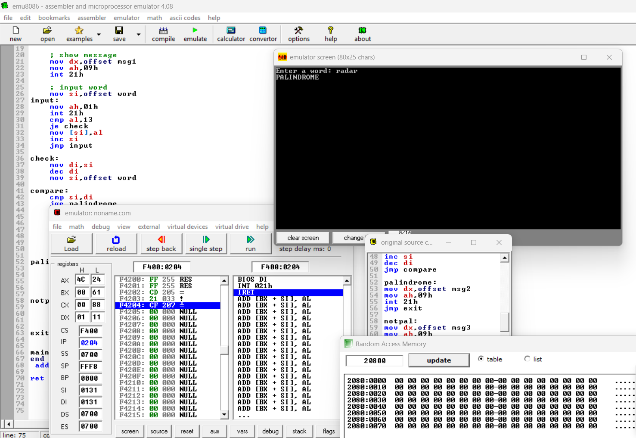
Figure 1: Output of the program for the palindrome input "radar"
A word is a palindrome when it reads exactly the same from left to right and from right to left. In other words, the first letter must match the last letter, the second letter must match the second last letter, and so on until the middle of the word is reached. The word "radar" meets this condition, so the program printed "PALINDROME" on the line below the input, as shown in Figure 1.
The checking for "radar" goes like this. The first letter 'r' is compared with the last letter 'r', and they match. Next, the second letter 'a' is compared with the fourth letter 'a', and they match as well. The two pointers then meet at the middle letter 'd'. In a word with an odd number of letters, the middle letter reads the same from either side, so it never needs to be compared. Since no mismatch was found, the word was accepted as a palindrome. Reading it backwards gives "radar" again, which confirms the result.
5.2 Not Palindrome: Input "Word"
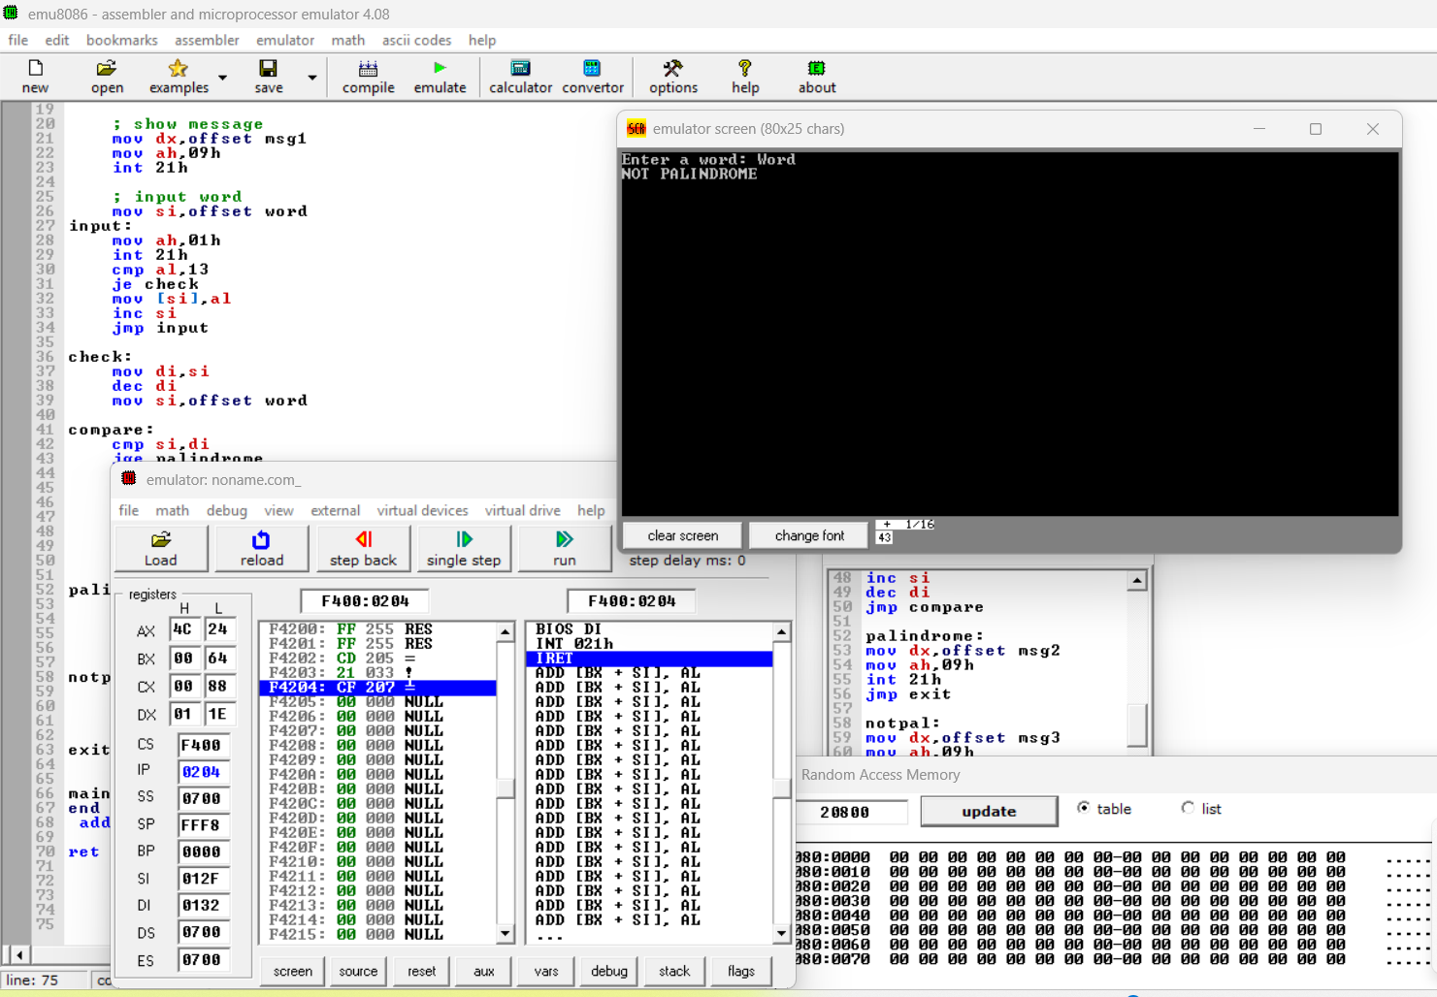
Figure 2: Output of the program for the non palindrome input "Word"
A word is not a palindrome when at least one pair of letters in matching positions is different. A single mismatch is enough to reject the word, so the program does not need to check the remaining pairs once a difference is found. For the input "Word", the program printed "NOT PALINDROME", as shown in Figure 2.
Here the first letter 'W' is compared with the last letter 'd'. These two letters are different, so the word fails on the very first comparison and the middle letters are never checked. Reading "Word" backwards gives "droW", which is not the same as the original word. Together, the two test cases show that the program correctly tells a palindrome apart from a word that is not one.
6. Discussion
The program worked as expected for both test words. It printed "PALINDROME" for "radar" and "NOT PALINDROME" for "Word", which is exactly what a hand check of the two words gives. A few weak points also showed up while testing. First, the comparison is case sensitive. The word "Radar" would be reported as NOT PALINDROME because 'R' (52h) and 'r' (72h) have different codes. This can be fixed by converting every letter to the same case before storing it, for example by clearing bit 5 of each lowercase letter with AND AL,0DFh. Second, the buffer has room for only 20 characters and the input loop never checks the length, so a longer word would overwrite whatever memory comes after the array. A simple counter in CX would stop this from happening. Third, the Backspace key is not handled. Its code 08h is stored like any other character, so one typing mistake gives a wrong result.
Another detail is the use of JGE to compare the two pointers. JGE is meant for signed numbers, while SI and DI hold unsigned offsets. It works here because the offsets are small, but JAE would be the more correct choice. If the user presses Enter without typing anything, DI ends up one byte below SI, the loop exits at once and the program prints PALINDROME. An empty string is technically a palindrome, so this is acceptable.
7. Conclusion
In this project an 8086 assembly language program was developed to check whether a word typed on the keyboard is a palindrome. The program reads characters with INT 21h function 01h, stores them in memory through SI, and then compares the word from both ends using SI and DI as pointers. Testing in EMU8086 with "radar" and "Word" gave the correct output in both cases. The work helped me understand register indirect addressing, handling strings byte by byte, the role of the flags in conditional jumps and the use of DOS interrupts for input and output. With a few small changes such as case conversion, a length limit and Backspace handling, the same program could reliably check any normal word or even a full sentence.
8. References
[1] B. B. Brey, The Intel Microprocessors: 8086/8088, 80186/80188, 80286, 80386, 80486, Pentium, Pentium Pro Processor, Pentium II, Pentium III, Pentium 4, and Core2 with 64-bit Extensions, 8th ed. Upper Saddle River, NJ, USA: Pearson Prentice Hall, 2009.
[2] D. V. Hall, Microprocessors and Interfacing: Programming and Hardware, 2nd ed. New York, NY, USA: McGraw-Hill, 1992.
[3] M. A. Mazidi, J. G. Mazidi and D. Causey, The x86 PC: Assembly Language, Design, and Interfacing, 5th ed. Upper Saddle River, NJ, USA: Pearson, 2010.
[4] Y. Liu and G. A. Gibson, Microcomputer Systems: The 8086/8088 Family, Architecture, Programming and Design, 2nd ed. Englewood Cliffs, NJ, USA: Prentice Hall, 1986.
[5] P. Abel, IBM PC Assembly Language and Programming, 5th ed. Upper Saddle River, NJ, USA: Prentice Hall, 2001.
[6] R. Brown, "Ralf Brown's Interrupt List: INT 21h DOS function calls," Carnegie Mellon University, Pittsburgh, PA, USA, 2000.
[7] Emu8086, "8086 assembler tutorial for beginners and emulator documentation," EMU8086 Microprocessor Emulator, version 4.08.

