CSIT 696 Research Methods in Computing – Arista Network Telemetry Anomaly Detection

¹Shahira Aslam Khan, B.E., ²Jithendra Amudalapalli, B.E., ³Rohith Golkonda, B.E., ⁴Osazee Obazee, B.E.
*¹²³⁴College of Science and Mathematics, School of Computing, Montclair State University, NJ, USA
¹aslamkhans1@montclair.edu, ²amudalapallj1@montclair.edu, ³golkondar1@montclair.edu, ⁴obazeeo1@montclair.edu
https://github.com/Shahira-Aslam-Khan/CSIT696_Research_Methods_In_Computing
Abstract
Millions of logs are generated every second across the world – from system logs, SNMP logs, and application logs to security logs. When analysed individually these logs provide operationally significant information; when correlated, the resulting patterns unlock a far more powerful predictive capability that could fundamentally change the future of anomaly detection in network telemetry. This report documents the research, design, and experimental validation of an AI-driven anomaly detection system applied to Arista network telemetry data. The project trains a composite deep-learning pipeline comprising a Denoising Autoencoder (DAE), Graph Neural Network (GNN), Multi-Head Attention mechanism, and a 1D Convolutional Neural Network (CNN1D) on CTGAN-synthesised telemetry data. Two pipeline iterations are compared – an older prototype and a refined newer version – with the objective of evaluating model correctness, generalisation, stability, and fitness for future production deployment. The work remains a research and validation effort rather than a production deployment, with emphasis on feasibility, correctness, interpretability, and documentation.

1. Project Goals and Success Criteria
1.1 Primary Goals
The project is structured around four sequential phases:
- Phase 1: Research and mathematical model validation.
- Phase 2: Prototype development and data ingestion.
- Phase 3: Training and behavioural validation.
- Phase 4: Documentation and technical review.

1.2 Success Criteria
- A clearly defined project idea with a validated implementation pathway.
- Experiments across multiple model families to identify the architecture best suited to the project requirements.
- A fully functional, end-to-end data ingestion pipeline.
- Identification of limitations and documented solutions to address them.

2. Stakeholders and Review Roles
2.1 Faculty Reviewer
- Evaluates technical validity of the proposed models and experimental methodology.
- Reviews methodology rigour and alignment with accepted research standards.
- Provides structured feedback on feasibility and research direction.

2.2 Student Research Team
- Explores available computational resources and formulates an actionable project plan.
- Analyses the synthetic dataset and evaluates multiple model architectures.
- Documents findings, limitations, and future recommendations.

2.3 Project Lead / Group Leader
- Coordinates task assignment and accountability across team members.
- Tracks progress and flags blockers for timely resolution.
- Consolidates outputs into cohesive reports and milestone updates.

3. Scope, Constraints, and Assumptions
3.1 Current Scope
- Synthetic Arista network telemetry data analysis.
- Sequence modelling for event prediction and severity classification.
- Unsupervised and prediction-based anomaly detection.
- Algorithm exploration across four model families: LSTM, GRU, CNN1D+LSTM, and AE+GNN+Attn.
- Notebook-based experimentation, presentation, and documentation.

3.2 Current Constraints
- Only synthetic data is used in the current phase; real production logs are not yet available.
- The production-level data ingestion pipeline exists but has not yet been made portable.
- No production deployment requirement applies to the current phase.
- Confirmed anomaly ground-truth labels are not available, limiting supervised evaluation.

3.3 Assumptions
- Sequence-based deep learning models are appropriate because Arista telemetry data is time-ordered by nature.
- Synthetic telemetry data refined, normalised, and balanced using a Conditional Tabular GAN (CTGAN) is sufficient for early experimentation, though not fully representative of live production logs.
- Portions of the time-ordered dataset are assumed to be predominantly normal when applying unsupervised anomaly detection.
- The data ingestion pipeline is structured for local execution and assumes input as .csv files; support for raw log collection tools such as FluentBit and SNMP poller is planned for a future phase.

4. Project Plan, Execution, and Observed Results
4.1 Phase 1: Research and Mathematical Model Validation
A Neural Processing Engine (NPE) is a specialised component built to handle AI tasks such as pattern recognition, temporal event prediction, and anomaly detection – the focus of this project. Unlike general-purpose processors, an NPE is designed from the ground up to efficiently execute the mathematical operations that underpin machine learning. Four model architectures were identified as candidates for the anomaly detection and prediction engine: LSTM, GRU, CNN1D+LSTM, and AE+GNN+Attn.
Mathematical evaluation varies by model family. Common metrics across all models include precision, recall, F1-score, and macro F1-score. Threshold-based evaluation involves computing reconstruction error, attention discrepancy scores, and probability outputs. Where thresholds are to be avoided, ROC-AUC or PR-AUC curves are preferred. For Graph Neural Network (GNN) models, node-level anomaly scores and edge deviation metrics provide the most informative evaluation signal. Log-likelihood and KL divergence are used to quantify how ‘unlikely’ a given observation is relative to the learned distribution.

4.2 Phase 2: Prototype Development and Data Ingestion
The project is split into two principal engineering tasks: (1) building a data ingestion pipeline that collects log information from diverse sources, transforms and processes it, and delivers it to a storage layer for consumption by the NPE; and (2) designing a model architecture capable of learning normal network behaviour patterns and predicting future anomalies to prevent system malfunctions.
The four candidate model architectures are described below.
CNN1D (1D Convolutional Neural Network). Uses sliding kernels to extract local spatial and temporal patterns from sequence data, such as specific signatures or metric spikes. In the Arista telemetry notebook it operates as an initial feature extractor, processing embeddings before passing them to downstream layers.
LSTM (Long Short-Term Memory). A specialised Recurrent Neural Network (RNN) using input, forget, and output gates to learn long-term dependencies in sequence data. It maintains a memory of previous network events to predict the next event or detect deviations that signal an anomaly.
GRU (Gated Recurrent Unit). A streamlined LSTM variant that combines the forget and input gates into a single update gate and merges the cell state and hidden state. GRU has fewer parameters than LSTM and often achieves comparable performance on temporal anomaly detection tasks at lower computational cost.
CNN1D + LSTM (Hybrid Model). Combines CNN1D for initial dimensionality reduction and local feature extraction with LSTM layers for modelling the long-term temporal evolution of those features. This hybrid approach is particularly effective for complex telemetry data where both local fluctuations and long-term trends are critical signals for anomaly identification.

4.2.1 Data Ingestion Pipeline: Current Progress
The data ingestion pipeline has been fully designed, implemented, and validated as a working end-to-end system running on a local Windows environment. The pipeline ingests three categories of telemetry log – system logs, simple logs, and application logs – from CSV files, applies a multi-step transformation process, and loads the resulting clean, feature-enriched dataset into a database for downstream consumption by the Neural Processing Engine. All nine unit and integration tests pass successfully, confirming the correctness of each pipeline stage.
Stage 1 – Extract. The extraction layer reads CSV log files from a designated input directory, automatically discovering files by type using configurable filename patterns. It handles real-world CSV messiness including encoding variations (UTF-8 and latin-1), inconsistent column naming conventions, and multiple files per log type. Common header variants such as “time”, “datetime”, and “event_time” are automatically normalised to a canonical “timestamp” column. Similarly, “level”, “log_level”, and “priority” are all mapped to “severity”. A sample data generator script produces 6,500 realistic test rows (2,000 system, 1,500 simple, 3,000 application) to enable end-to-end testing without requiring the full production dataset.
Stage 2 – Transform. The transformation layer merges all log types into a single unified DataFrame and applies a sequential cleaning and feature-engineering process. Timestamps are parsed and normalised to timezone-naive UTC. Free-text severity labels are canonicalised – variants such as “warn”, “fatal”, “emerg”, and “err” are mapped to their standard equivalents (WARNING, CRITICAL, ERROR). Rows with null timestamps, severity, or message fields are dropped, and exact duplicate log lines are removed. Five anomaly-detection features are then engineered for each row: a numeric severity ordinal (DEBUG=0 through CRITICAL=4), a binary error flag (is_error), message character length, hour of day, and day of week. These features provide the NPE with the temporal and severity signals required to identify deviations from normal network behaviour.
Stage 3 – Load. The loading layer writes the clean dataset to a PostgreSQL database in configurable batch sizes to avoid memory spikes on large inputs. An automatic SQLite fallback is implemented: if the PostgreSQL instance is unavailable, the loader transparently redirects output to a local SQLite file, enabling the pipeline to run in environments where a database server is not installed. Two load modes are supported – a full-replace mode that recreates the target table on each run, and an incremental-append mode that queries the maximum existing timestamp and loads only rows newer than that value, preventing duplicate ingestion across scheduled runs.
Automation and Scheduling. The pipeline is executed via a single command (python pipeline.py) and produces timestamped log files for each run. On the current Windows development environment, automated scheduling is configured using Windows Task Scheduler, which invokes a batch file wrapper at the specified cadence. Optional email alerting on pipeline failure is implemented via SMTP and is activated by setting the relevant environment variables. Docker containerisation has been designed and documented: a Dockerfile defines the Python 3.12 environment, and a docker-compose.yml file orchestrates the pipeline container, a PostgreSQL container, and an optional pgAdmin browser interface as a unified stack launchable with a single command.
Remaining Work. The pipeline currently ingests pre-processed CSV files. Integration with live collection agents – Fluent Bit for log forwarding, Telegraf for metrics, and SNMP Poller for network device queries – is planned for the next phase. Apache Kafka will be introduced as the message bus between collection agents and the processing layer, and Apache Spark Streaming will replace the current batch transformer to handle high-throughput real-time event volumes. This transition will make the pipeline portable and suitable for production-scale Arista telemetry ingestion.
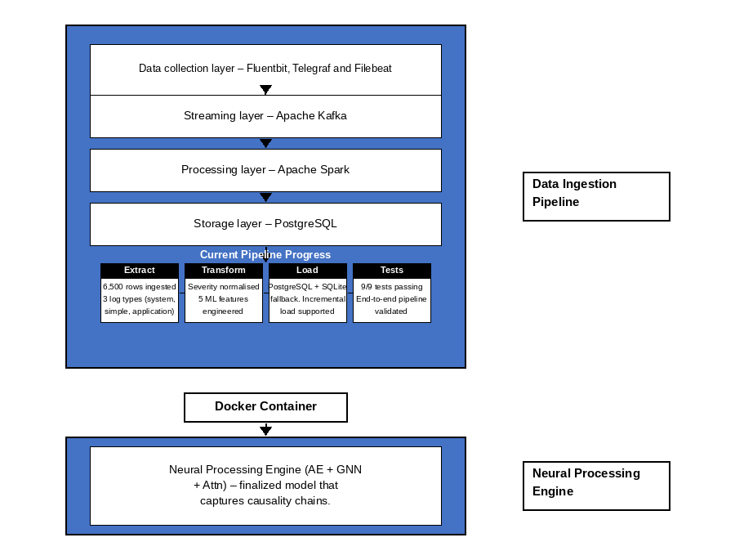
4.3 Phase 3: Training and Behavioural Validation
The final selected architecture is a composite pipeline: Denoising Autoencoder (DAE) → Graph Attention Network (GAT) → Multi-Head Self-Attention → 1D Convolutional encoder → Severity Classifier. Two iterations of this pipeline were trained and compared.
Training Configuration
Parameter | Value
AE Epochs | 20
Fine-tune Epochs | 30
Window Length | 16 events
Embedding Dimension | 32
Attention Heads | 4
Cross-Validation Folds | 5 (Stratified)
Noise α (DAE) | 0.15
Optimiser | Adam (lr=1e-3, wd=1e-5)
Scheduler (AE) | CosineAnnealingLR
Scheduler (Fine-tune) | OneCycleLR

4.4 OLD vs NEW: Comparative Results
Two pipeline variants were trained and evaluated. The OLD pipeline used the arista_synthetic_telemetry_data.csv dataset (10,250 events, 3 features). The NEW pipeline used the ctgan_mixed_training_data.csv dataset (19,747 events, 2 features) and incorporated a corrected encode() method with all layers fully wired.

Metric | OLD Dataset | NEW Dataset
Dataset Events | 10,250 | 19,747
Feature Columns | 3 | 2
Training Windows | 10,130 | 19,627
Model Parameters | 13,904 | 12,832
AE Final MSE | 7.9205 | 6.9724
Mean Macro F1 | 0.9900 | 0.9292
F1 Std Dev | ±0.0198 | ±0.0048
Overall Accuracy | 99% | 93%
Error Class F1 | 0.98 | 0.91
Info Class F1 | 1.00 | 0.94
Warning Class F1 | 0.99 | 0.94
Anomaly Threshold (95th pct) | 11.73501 | 10.88947
Anomalies Flagged | 507 / 10,130 (5.0%) | 982 / 19,627 (5.0%)
encode() correctness | Incomplete (bug) | Complete

Old Dataset – generated by ChatGPT was too deterministic causing a 1.00 recall, indicating the model lacked learning.
New Dataset – Old Dataset was refined, normalized and a CTGAN was used generate a synthetic data that is more diverse than the earlier version, recall dropped but the learning curve improved.
4.5 Phase 4: Documentation and Technical Review
All experimental code is maintained as structured Jupyter notebooks with inline documentation of architecture decisions, training configuration, metric results, and observed limitations. The two pipeline versions and their outputs are the primary artefacts for faculty review.

5. Analysis and Key Findings
5.1 Code Correctness: Critical Bug Fixed in NEW
The most significant structural difference between the two pipelines is the completeness of the encode() method inside the TelemetryAE class. In the OLD notebook, only the initial embedding layer is executed; the Conv1D, GAT, Multi-Head Attention, and mean-pooling operations are absent from the method body. The NEW notebook contains a complete implementation. The OLD pipeline’s high accuracy figures must therefore be interpreted with caution, as they may reflect a structurally degraded model rather than the intended composite architecture.

5.2 Data Volume and Feature Composition
The NEW pipeline trains on 92.7% more events (19,747 vs 10,250) and 93.8% more temporal windows (19,627 vs 10,130). However, the ctgan_mixed dataset does not include the numeric value column present in the OLD dataset. This reduces the feature space from 3 dimensions to 2 (event_id and source_id only) and partially explains the drop in error-class precision from 0.97 to 0.89, as the numeric signal is a strong discriminator for severity classification.

5.3 Autoencoder Pretraining Quality
The NEW pipeline achieves a lower final AE reconstruction MSE (6.97 vs 7.92) and converges faster – near-flat after epoch 10 compared to gradual descent throughout training in the OLD pipeline. This indicates that the ctgan_mixed dataset contains more learnable structure and that the corrected encoder extracts richer latent representations, a positive signal for production readiness.

5.4 Cross-Validation Stability
OLD fold F1 scores range from 0.9503 to 1.0000 (std = 0.0198). Four of five folds returning a perfect 1.0000 is statistically unlikely for a genuine generalisation result and strongly suggests overfitting or data leakage on the compact 10K-row synthetic dataset. NEW fold scores range from 0.9227 to 0.9344 (std = 0.0048) – tight, consistent, and indicative of a model that generalises reliably. High fold variance is operationally dangerous in a network anomaly detection system where false negative rates carry a direct business cost.

6. Recommendation
Although the OLD pipeline produces higher headline accuracy (99% vs 93%) and macro F1 (0.99 vs 0.93), the NEW pipeline is recommended as the correct foundation for the next phase of the project for the following reasons:
- The OLD encode() bug means the OLD model is not executing the intended architecture. Its results cannot be attributed to the designed pipeline.
- The NEW pipeline’s 4× lower fold variance provides statistically meaningful evidence of genuine generalisation rather than memorisation.
- The NEW pipeline trains on nearly double the data with a correctly implemented encoder, producing a more reliable performance estimate on harder, mixed-source telemetry.

6.1 Recommended Next Steps
- Re-introduce the numeric value feature by ensuring the ctgan_mixed dataset includes it, or by engineering equivalent proxy metrics (e.g., inter-event time deltas, rolling event counts).
- Apply class-weighted CrossEntropyLoss during fine-tuning to improve error-class recall, which is the most operationally critical class in a network monitoring context.
- Run the OLD notebook with the corrected encode() on the ctgan_mixed dataset to establish a fair baseline comparison.
- Evaluate label smoothing and mixup augmentation to further close the gap on error-class performance.
- Begin planning the portable data ingestion pipeline to support raw log input via FluentBit and SNMP poller ahead of Phase 3 production trials.

7. Limitations
- All experiments use synthetic CTGAN-generated data. Synthetic distributions may not fully replicate the statistical properties of live Arista production telemetry.
- The absence of confirmed ground-truth anomaly labels limits the evaluation of the anomaly detection component to proxy labels derived from severity classifications.
- The data ingestion pipeline is not yet portable and assumes pre-processed .csv input rather than raw log streams.
- The GNN component currently implements a simplified adjacency-based aggregation rather than a full graph attention mechanism with learnable edge weights.
- All training was performed on CPU; GPU-accelerated training may be required for production-scale datasets.

8. Conclusion
This report documents the research, design, and experimental comparison of two iterations of a composite AI pipeline for Arista network telemetry anomaly detection. The work validates that a DAE → GNN → Multi-Head Attention → CNN1D architecture is a viable approach for severity classification and anomaly detection on time-ordered network event sequences. The NEW pipeline, despite a modest reduction in headline accuracy, represents a more robust and correctly implemented foundation due to its complete encoder architecture, greater training data volume, and significantly improved cross-fold stability. Future phases will focus on restoring the numeric feature dimension, integrating real production log sources, and evaluating the system under live network conditions.

References
[1] Hochreiter, S., & Schmidhuber, J. (1997). Long short-term memory. Neural Computation, 9(8), 1735–1780.
[2] Kipf, T. N., & Welling, M. (2017). Semi-supervised classification with graph convolutional networks. ICLR 2017.
[3] Vaswani, A., et al. (2017). Attention is all you need. NeurIPS 2017.
[4] Xu, L., et al. (2019). Modeling tabular data using conditional GAN. NeurIPS 2019.
[5] Wang, Z., et al. (2022). A comprehensive survey on graph neural networks for anomaly detection. arXiv. https://arxiv.org/abs/2209.07869.
[6] Guo, Y., et al. (2024). Deep learning for network telemetry: A survey. arXiv. https://arxiv.org/abs/2412.15445.
[7] Velarde, G., Brañez, P., Bueno, A., Heredia, R., & Lopez-Ledezma, M. (2025). An open-source and reproducible implementation of LSTM and GRU networks for time series forecasting
[8] https://www.kaggle.com/code/mrkmakr/covid-ae-pretrain-gnn-attn-cnn/input
[9] What is a Neural Processing Unit (NPU)? Complete 2026 Guide

Acknowledgement
The author used Claude for code generation and ChatGPT, Gemini, and Perplexity for resource discovery, image support, and dataset preparation. All AI-assisted outputs were reviewed, verified, and edited by the author, who assumes full responsibility for the accuracy and integrity of the final work.

