Shahiraj B Lakade

1. Add the current date to the text file today.txt as a string.

Ans 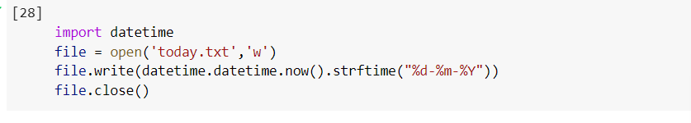

1. Read the text file today.txt into the string today_string

Ans

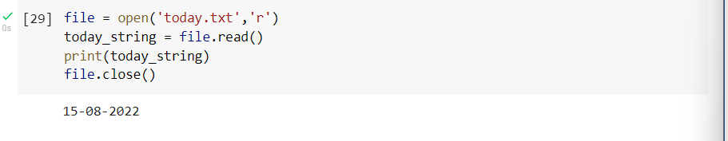

1. Parse the date from today_string.

Ans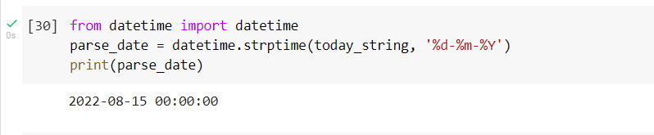

4. List the files in your current directory

5. Create a list of all of the files in your parent directory (minimum five files should be available).

6. Use multiprocessing to create three separate processes. Make each one wait a random number of seconds between one and five, print the current time, and then exit.

8. What day of the week was your day of birth?

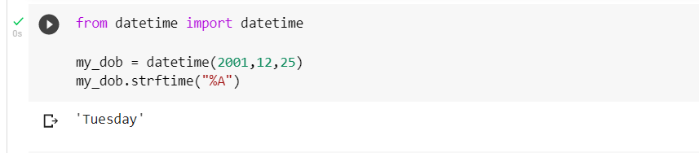

9. When will you be (or when were you) 10,000 days old?

