Defect Report

Automation Project – Orange HRM

Defect Id : D_01

Reporting Date : 11/11/2021

Project Name : Orange HRM

Project Version : OrangeHRM 4.8

Module Name : Email TextField in Subscribe Button

Type of Defect : Functional

Phase : Testing

Summary : Email Id is not validated

Description : Expected Result: Email Id should contain

Valid domain name

Actual Result : It’s accepting any String

Severity : High

Priority : High

Status : Opened

Reported By : Suvarna Bansode

Reported To : Priyanka Desale

Screenshot :

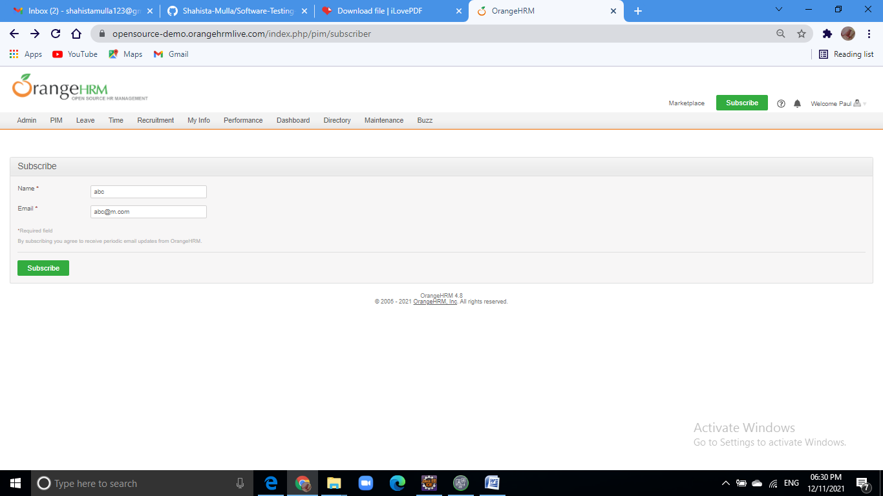

Defect Id : D_02

Reporting Date : 11/11/2021

Project Name : Orange HRM

Project Version : OrangeHRM 4.8

Module Name : MyInfo

Type of Defect : Functional

Phase : Testing

Summary : name contains number

Description : Expected Result : String

Actual Result : Number

Severity : High

Priority : High

Status : Opened

Reported By : Suvarna Bansode

Reported To : Priyanka Desale

Screenshot :

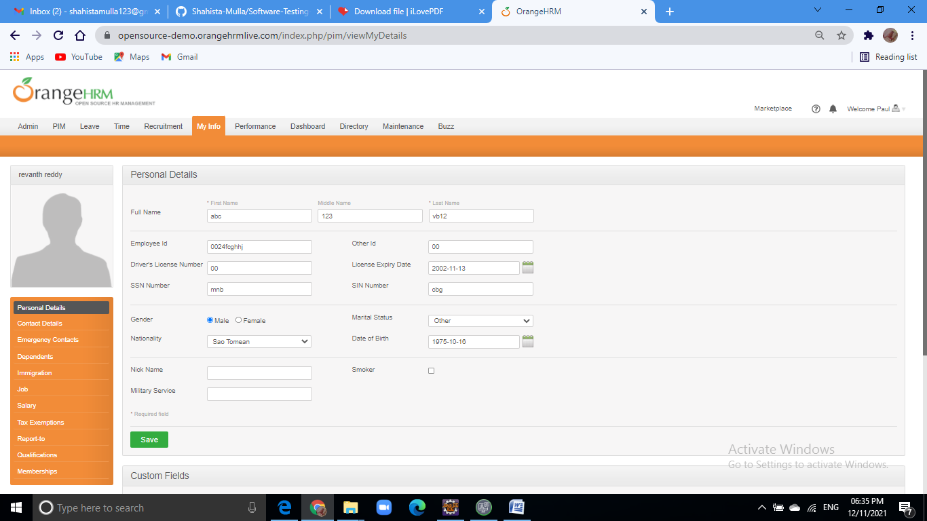

Defect Id : D_03

Reporting Date : 11/11/2021

Project Name : Orange HRM

Project Version : OrangeHRM 4.8

Module Name : Myinfo

Type of Defect : Functional

Phase : Testing

Summary : Number textfield contains string

Description : Expected Result: Number textfield should contains

integer value

Actual Result : Number textfield contains string also

Severity : High

Priority : High

Status : Opened

Reported By : Suvarna Bansode

Reported To : Priyanka Desale

Screenshot :

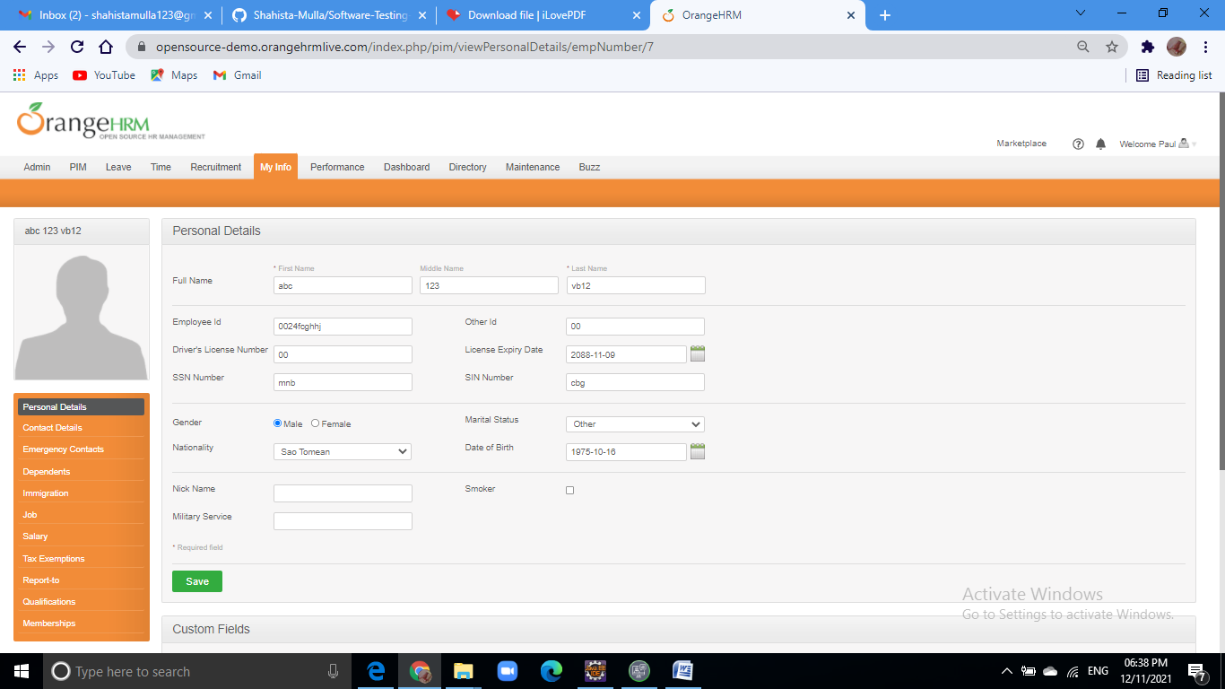

Defect Id : D_04

Reporting Date : 11/11/2021

Project Name : OrangeHRM

Project Version : OrangeHRM 4.8

Module Name : Directory

Type of Defect : Functional

Phase : Testing

Summary : Search button is not shown wrong details

Description : Expected Result : search button should shown related details

Actual Result: search button should shown wrong details

Severity : High

Priority : High

Status : Opened

Reported By : Suvarna Bansode

Reported To : Priyanka Desale

Screenshot :

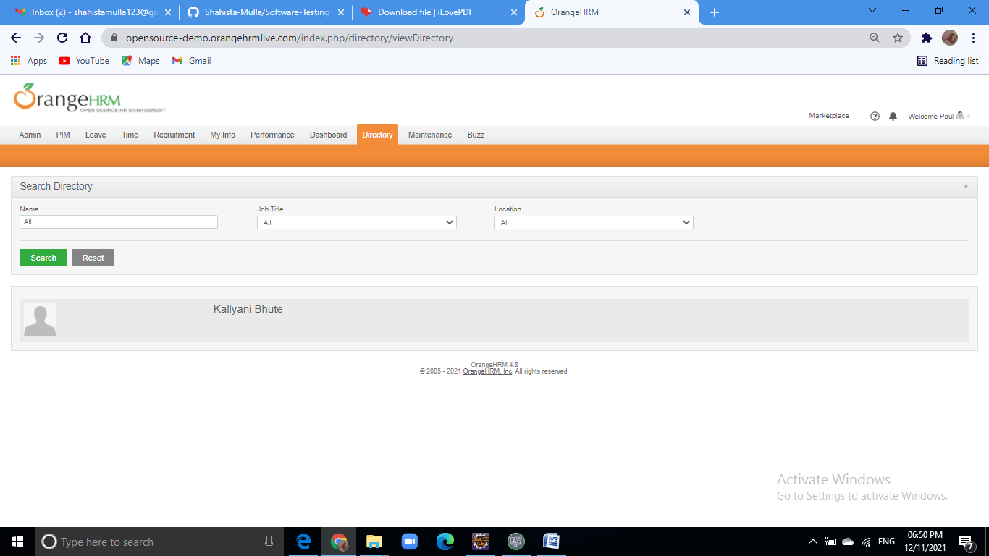

Defect Id : D_05

Reporting Date : 11/11/2021

Project Name : OrangeHRM

Project Version : OrangeHRM 4.8

Module Name : Maintenance

Type of Defect : Functional

Phase : Testing

Summary : search button is not working

Description : Expected Result : If click then search related data of textfield

Actual Result : search button is not work

Severity : High

Priority : High

Status : Opened

Reported By : Suvarna Bansode

Reported To : Priyanka Desale

Screenshot :

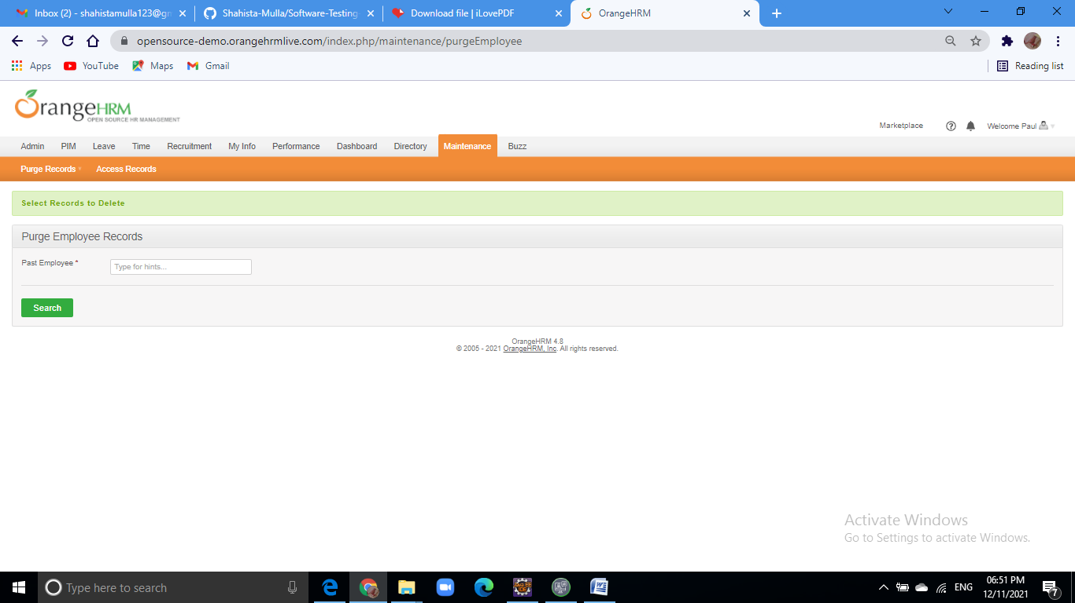

Defect Id : D_06

Reporting Date : 11/11/2021

Project Name : OrangeHRM

Project Version : OrangeHRM 4.8

Module Name : maintenance

Type of Defect : Functional

Phase : Testing

Summary : textfield contains any data after enter delete record

Description : Expected : textfield contains past employee details

Actual : textfield contains any data and delete records

Severity : High

Priority : High

Status : Opened

Reported By : Suvarna Bansode

Reported To : Priyanka Desale

Screenshot :

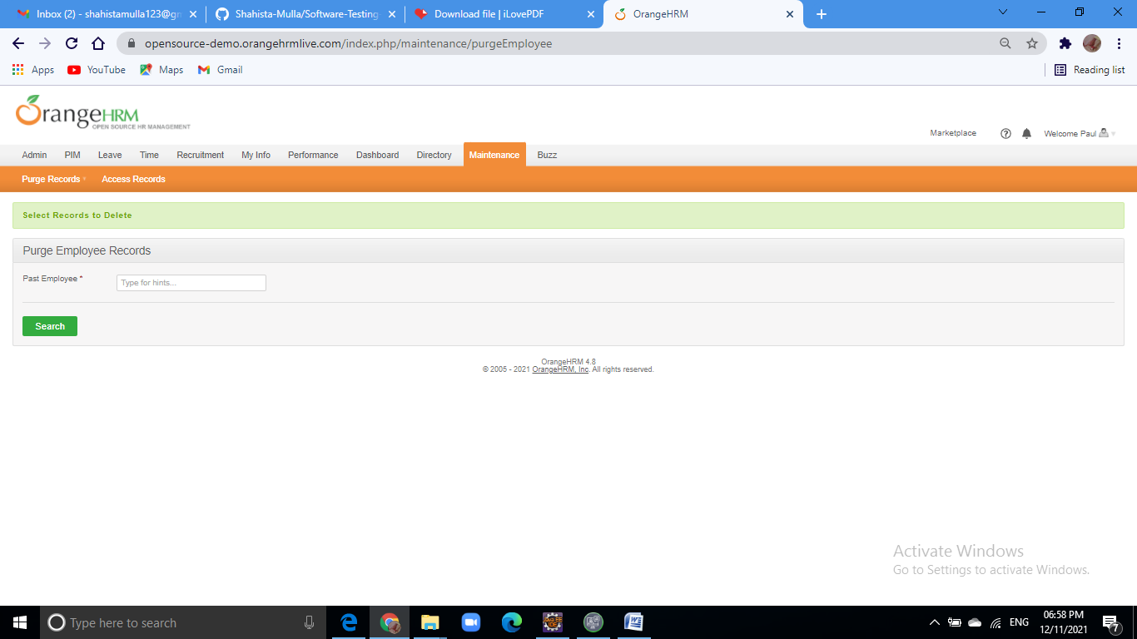

Defect Id : D_07

Defect management tool used – **Jira**

