1. DESIGN: SYSTEM DESIGN AND DATABASE DESIGN
Project Work: Community Lending Platform for Sharing and Borrowing Household Resources — Second Review
1. System Design Specification
The system design defines the architecture and data flows of the Community Lending Platform. The platform provides an intuitive, neighborhood-level web application where community members can easily share household items, reduce waste, and borrow resources safely.
1.1 Layered Architectural Design
- Presentation Tier (Client): Built with responsive HTML5, CSS3, and JavaScript, ensuring smooth operation across desktop, tablet, and mobile web browsers.
- Web Gateway Tier (Server): Managed by Gunicorn WSGI server on Render Cloud to handle incoming HTTPS requests and SSL termination.
- Application Tier (Business Logic): Python Flask controllers in `app.py` managing user login, password hashing, file uploads, and loan state transitions.
- Persistence Tier (Database): TiDB Serverless Cloud relational database (MySQL 8.0 protocol) for ACID transactions, alongside disk storage for item photos.
1.2 Data Flow Diagrams (DFD) — Levels 0, 1, and 2
Data Flow Diagrams illustrate how information moves through the application across three levels:
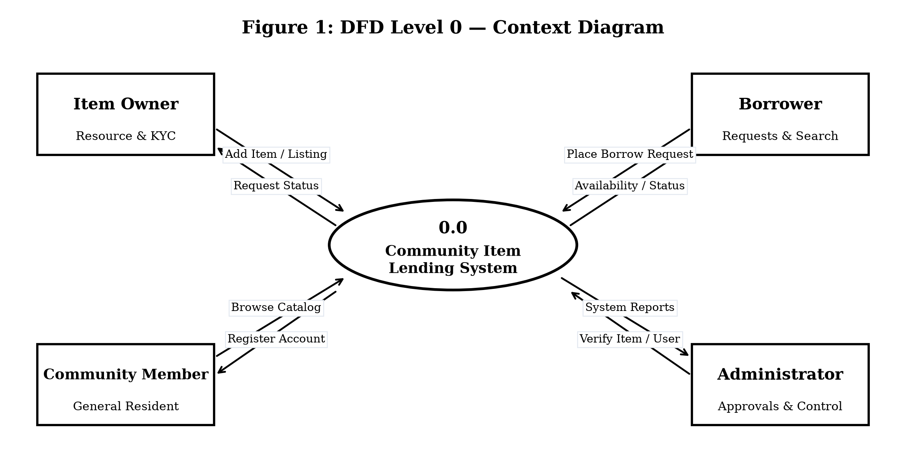
Figure 1: DFD Level 0 — Context Diagram
The Context Level Diagram (Level 0) represents the platform interacting with Item Owners, Borrowers, Community Members, and Administrators.
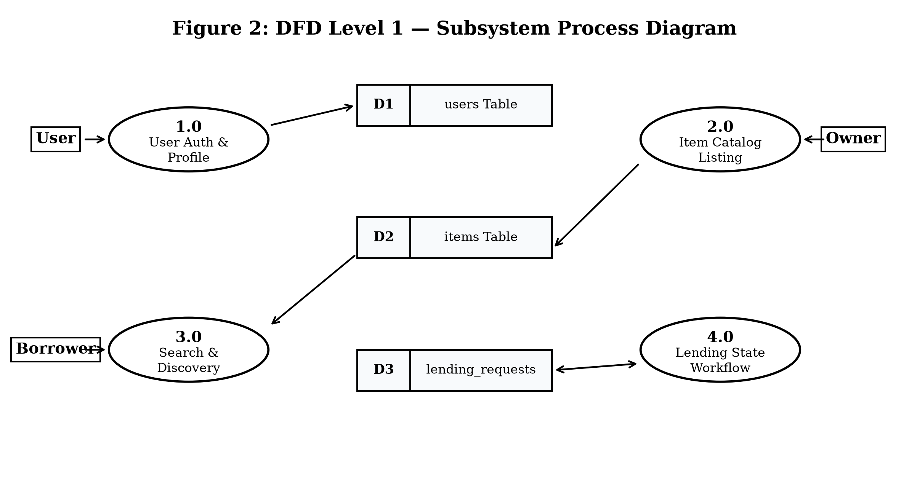
Figure 2: DFD Level 1 — Subsystem Process Diagram
The Level 1 DFD decomposes the system into four functional subsystems: (1.0) User Auth, (2.0) Item Catalog, (3.0) Search Engine, and (4.0) Lending Workflow Engine interacting with data stores D1, D2, and D3.
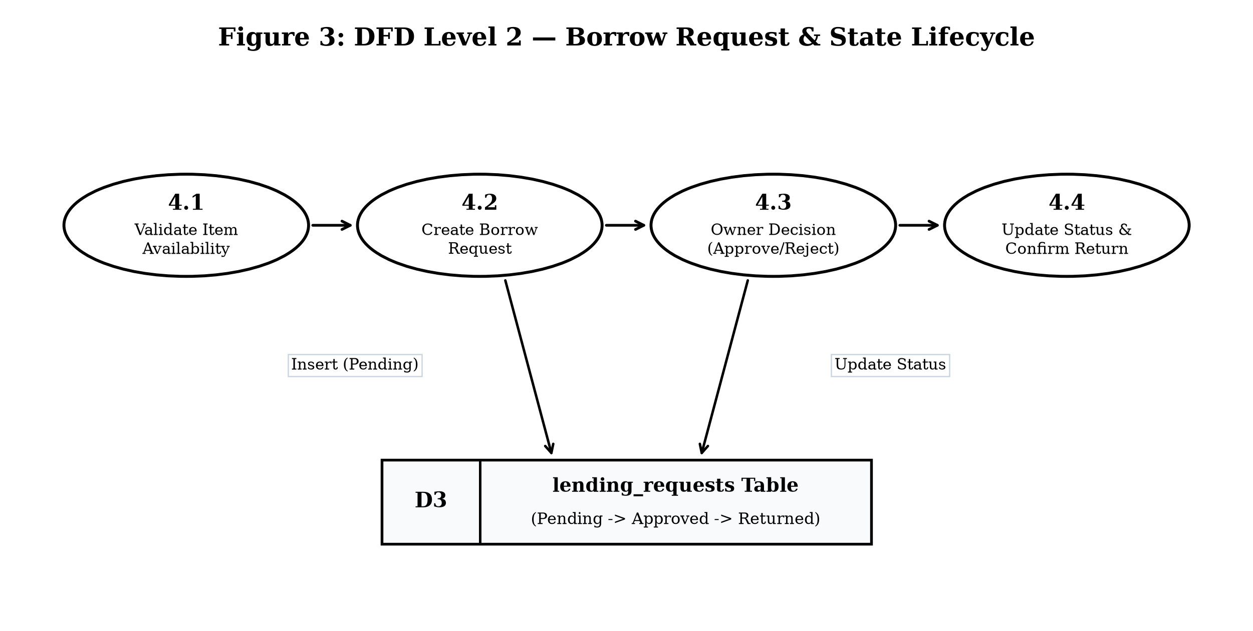
Figure 3: DFD Level 2 — Borrow Request & State Lifecycle
The Level 2 DFD outlines the complete borrow request lifecycle: checking item availability, creating a pending request, owner decision, and return confirmation.
1.3 Unified Modeling Language (UML) Diagrams
UML models depict system functional interactions and object structures:
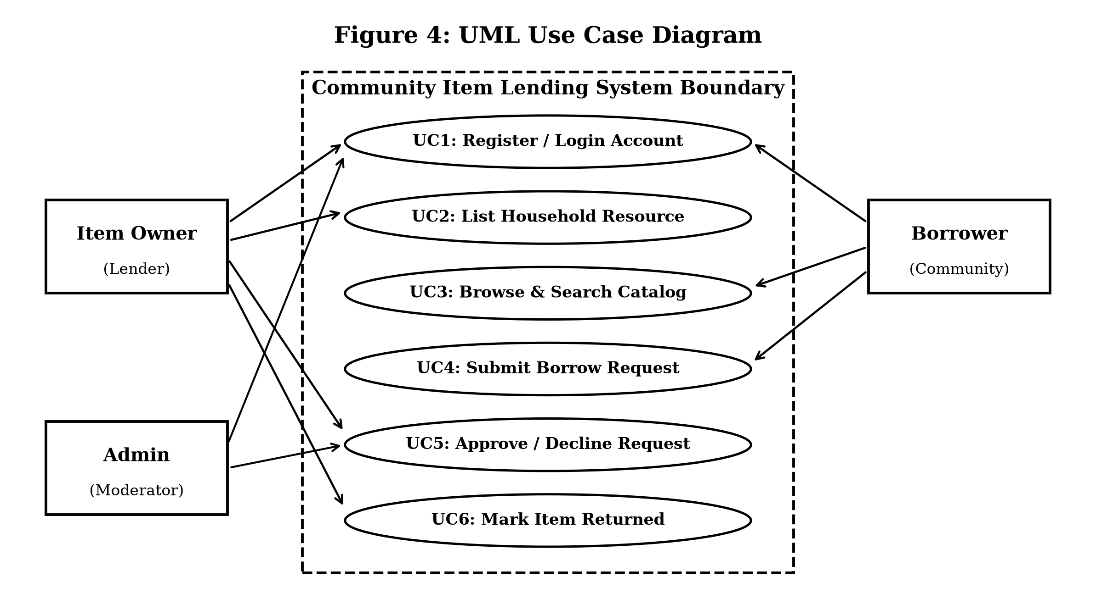
Figure 4: UML Use Case Diagram
The Use Case Diagram defines functional interactions across Item Owner, Borrower, and Administrator roles within the system boundary.
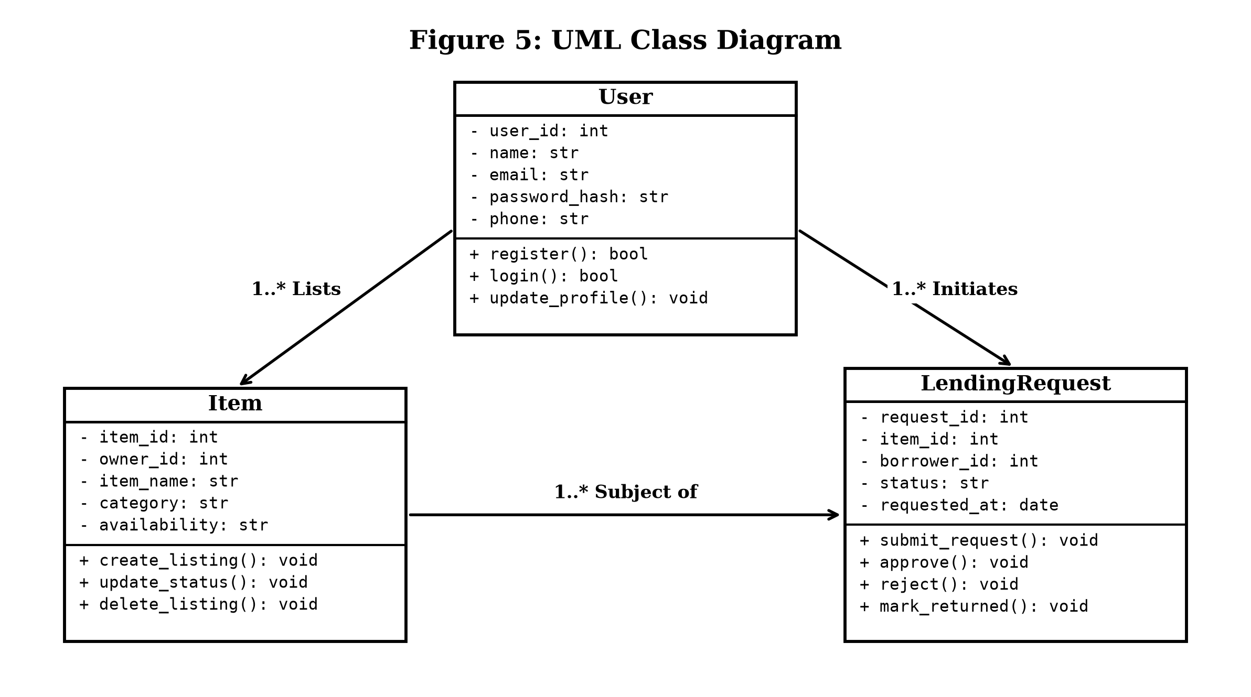
Figure 5: UML Class Diagram
The Class Diagram details the core entity classes: `User`, `Item`, and `LendingRequest` with attributes, methods, and associations (`1..* Lists`, `1..* Initiates`).
1.4 Design Rationale and Trade-off Studies
A modular monolith web architecture using Python Flask was selected instead of complex microservices. This choice allows faster development, keeps all database transactions reliable with ACID guarantees, and makes cloud deployment simple and cost-effective on free-tier services:
Evaluation Metric | Weight | Modular Monolith (Selected) | Microservices Architecture
Development Velocity | 25% | 9 / 10 (Rapid sprint cycles) | 5 / 10 (Heavy setup overhead)
Operational Simplicity | 25% | 10 / 10 (Single deployment) | 4 / 10 (Multi-container setup)
Hosting & Cloud Cost | 25% | 10 / 10 (Free tier compatible) | 4 / 10 (Multiple VMs needed)
Transactional Consistency | 25% | 10 / 10 (ACID DB transactions) | 6 / 10 (Eventual consistency)
Weighted Final Score | 100% | 9.75 / 10.0 (SELECTED) | 4.75 / 10.0
2. Database Design Specification
The database tier uses MySQL 8.0 on TiDB Serverless Cloud. A relational DBMS was selected over NoSQL for strict ACID transaction consistency and foreign key constraints.
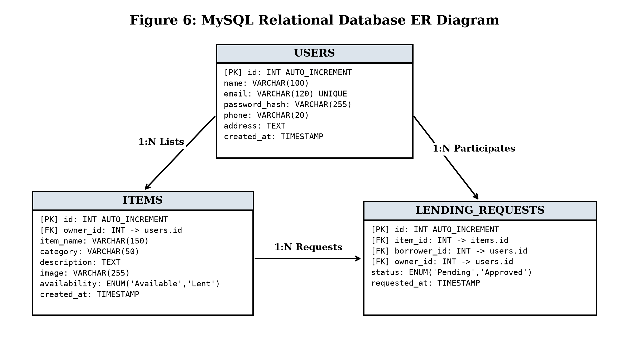
Figure 6: MySQL Relational Database ER Diagram
The ER Diagram illustrates the relational entities (`USERS`, `ITEMS`, `LENDING_REQUESTS`), primary keys, foreign keys, and 1:N cardinalities.
2.1 Schema Normalization (1NF, 2NF, 3NF)
- 1NF (First Normal Form): All table columns contain atomic, indivisible values; repeating groups are eliminated with primary keys (`id`).
- 2NF (Second Normal Form): Satisfies 1NF with zero partial key dependencies; all non-key columns depend on the entire primary key.
- 3NF (Third Normal Form): Satisfies 2NF with zero transitive dependencies; non-key columns depend solely on primary keys.
2.2 Physical Data Dictionaries
Users Table: Table 1: Data Dictionary for `users` Table
Field Name | Data Type | Constraints | Default | Description
id | INT | PK, AUTO_INCREMENT | None | Unique member ID
name | VARCHAR(100) | NOT NULL | None | Full name of user
email | VARCHAR(120) | NOT NULL, UNIQUE | None | Login email address
password_hash | VARCHAR(255) | NOT NULL | None | PBKDF2:SHA256 password hash
phone | VARCHAR(20) | NULLABLE | NULL | Contact phone number
created_at | TIMESTAMP | NOT NULL | CURRENT_TIMESTAMP | Account creation timestamp
Items Table: Table 2: Data Dictionary for `items` Table
Field Name | Data Type | Constraints | Default | Description
id | INT | PK, AUTO_INCREMENT | None | Unique item listing ID
owner_id | INT | NOT NULL, FK (users.id) | None | References item owner
item_name | VARCHAR(150) | NOT NULL | None | Title of listed item
category | VARCHAR(50) | NOT NULL | None | Resource category
image | VARCHAR(255) | NULLABLE | NULL | UUID image filename on disk
availability | ENUM | NOT NULL | 'Available' | 'Available' or 'Lent'
created_at | TIMESTAMP | NOT NULL | CURRENT_TIMESTAMP | Listing creation timestamp
Lending Requests Table: Table 3: Data Dictionary for `lending_requests` Table
Field Name | Data Type | Constraints | Default | Description
id | INT | PK, AUTO_INCREMENT | None | Unique request transaction ID
item_id | INT | NOT NULL, FK (items.id) | None | References requested item
borrower_id | INT | NOT NULL, FK (users.id) | None | References borrowing user
owner_id | INT | NOT NULL, FK (users.id) | None | References item owner
status | ENUM | NOT NULL | 'Pending' | 'Pending','Approved','Rejected','Returned'
requested_at | TIMESTAMP | NOT NULL | CURRENT_TIMESTAMP | Request timestamp
2.3 Database Indexing, Integrity, and Security
- Indexing Strategy: B-Tree primary key indexes provide O(1) lookups. Foreign keys (`owner_id`, `borrower_id`, `item_id`) are indexed to optimize relational JOIN performance.
- Security Controls: All cloud database connections use TLS 1.2+ encryption over port 4000. Parameterized SQL queries completely eliminate SQL injection threats.

