FINAL REVIEW - APPENDICES
Community Lending Platform for Sharing and Borrowing Household Resources
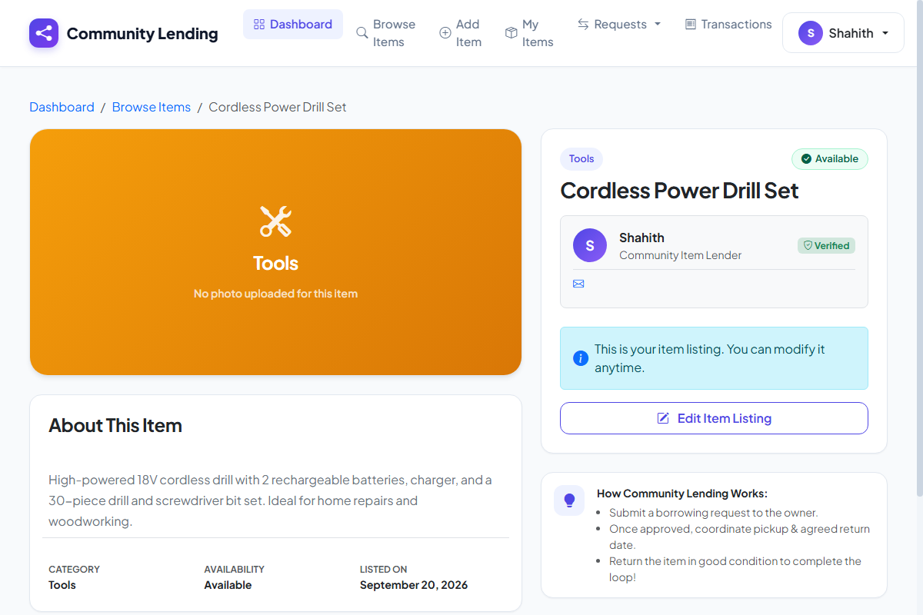
Illustrative Demo Screenshot: Book-issue and household item request form with availability validation and selected item details. This image was rendered from the live platform interface.
Appendix A - Selected Source-Code Sample
The following short sample demonstrates the validation used before issuing a book or item borrowing request. Only relevant code samples should be included in an appendix.
@app.route('/request_item/<int:item_id>', methods=['POST'])
@login_required
def request_item(item_id):
item = db.query('SELECT * FROM items WHERE id = %s', (item_id,)).fetchone()
if item is None or item['availability'] != 'Available':
return flash('Item is not available.'), redirect(url_for('browse_items'))
if item['owner_id'] == session['user_id']:
return flash('You cannot borrow your own item.'), redirect(url_for('browse_items'))
db.execute('INSERT INTO lending_requests (item_id, borrower_id, owner_id, status) '
'VALUES (%s, %s, %s, \'Pending\')', (item_id, session['user_id'], item['owner_id']))
db.commit()
return flash('Borrowing request submitted successfully.'), redirect(url_for('my_requests'))
Appendix B - Database Summary
Table | Purpose | Important fields
Users | Stores authorized accounts | UserId, Name, Email, Role, CreatedAt
Items | Stores resource details | ItemId, OwnerId, Title, Category, IsAvailable
LendingRequests | Stores issue & return records | TransactionId, ItemId, BorrowerId, Status, Date

APPENDICES - SUPPORTING EVIDENCE
Community Lending Platform for Sharing and Borrowing Household Resources
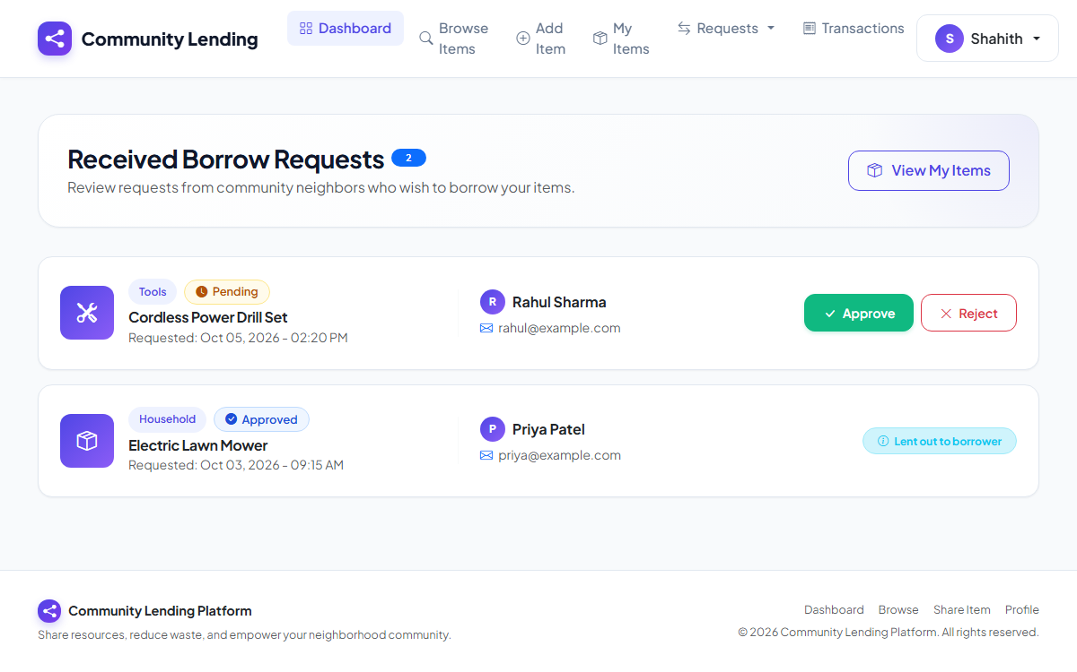
Illustrative Demo Screenshot: Demonstration report showing module checks, pending borrow requests, and fictional test results. This image was rendered from the live platform interface.
Appendix C - Input and Output Evidence
- Login page - Accepts an authorized sample account and starts a secure session.
- Dashboard - Displays totals, availability, due items, and recent transactions.
- Item form - Accepts title, category, description, and photo upload.
- Issue form - Validates member and item availability before saving transaction.
- Return process - Records the return confirmation and restores item availability.
- Reports - Displays issue, return, outstanding, and testing summaries.
Appendix D - Installation Instructions
- Install runtime - Install the required Python 3.10+ runtime and database engine.
- Open project - Open the solution or project folder in the development environment.
- Dependencies - Restore project dependencies using pip install -r requirements.txt.
- Database config - Apply database migrations or configure the TiDB connection.
- Run application - Build and run the project, then open the displayed local address.
Appendix E - User Instructions
- Sign in - Sign in using an authorized account.
- Add items - Add or update items and register community resources.
- Record issue - Select an available item and record the issue transaction.
- Record return - Record the return and confirm that the item becomes available.
- Review dashboard - Use the dashboard and reports to review current activity.

