FINAL REVIEW - CONCLUSION
Community Lending Platform for Sharing and Borrowing Household Resources
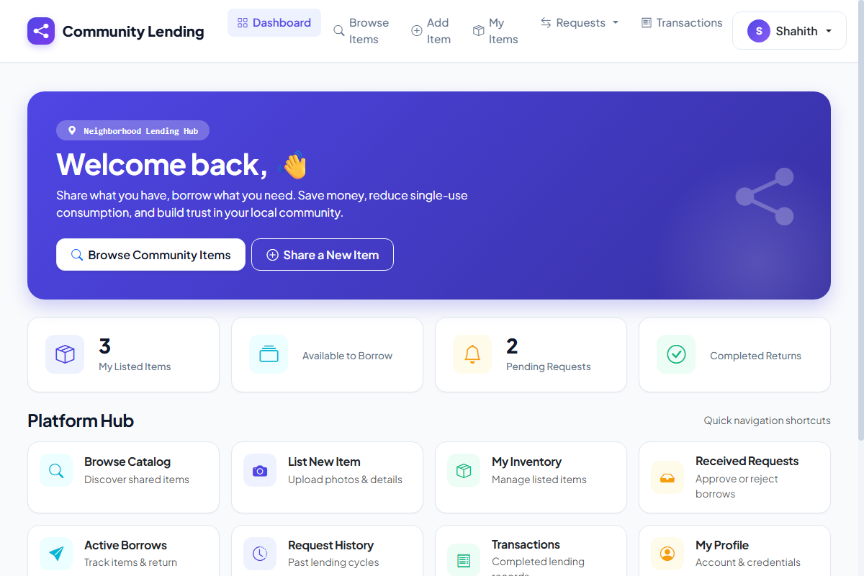
Illustrative Demo Screenshot: Library and community dashboard showing item availability and recent transactions. This image was rendered from the live platform interface.
Conclusion
The Community Item Lending System was developed as an academic prototype to simplify the management of shared items, members, and borrowing transactions. It replaces repetitive manual registers with a structured interface for maintaining records, issuing available items, recording returns, and reviewing transaction history.
The demonstration prototype achieved the main project objectives. It maintains item-availability information, connects transactions with registered members, and summarizes recent activity. Functional checks covered login, item creation, member registration, item issue, item return, and status updates. The observed results matched the expected outcomes.
Limitations and Lessons Learned
The current version is designed for a small community environment and uses demonstration data. It does not include barcode scanning, reservations, fine calculation, notifications, or institutional login integration. The work provided practical understanding of requirements, database relationships, validation, transaction processing, testing, and interface design.
Further Enhancements
- Barcode / QR-code - Add barcode or QR-code support for faster item issue and return.
- Reservations & alerts - Provide reservation, renewal, fine-calculation, and reminder facilities.
- Role-based access - Introduce role-based access for administrator, owner, and borrower users.
- Advanced reporting - Add advanced reports, backup facilities, and institutional login integration.

