FINAL REVIEW - REFERENCES
Community Lending Platform for Sharing and Borrowing Household Resources
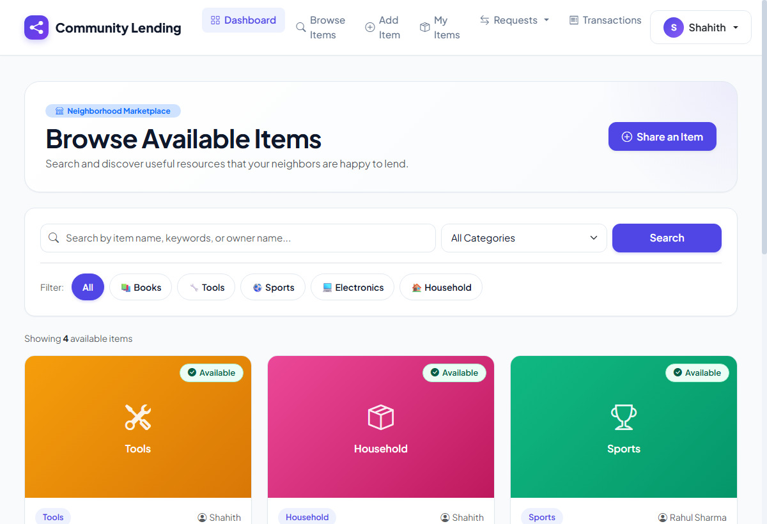
Illustrative Demo Screenshot: Fictional module-verification report and catalog search used in this academic sample. This image was rendered from the live platform interface.
References
The following examples are arranged alphabetically by author or organization name. Students should retain only the sources genuinely used for their own work:
- Microsoft / Python - Python 3.10 and Flask Web Framework Documentation, accessed October 2026.
- PingCAP - TiDB Serverless Cloud Relational Database Documentation, accessed October 2026.
- Pressman, Roger S. - and Bruce R. Maxim. Software Engineering: A Practitioner's Approach. McGraw-Hill Education.
- Sommerville, Ian - Software Engineering. Pearson.
- Werkzeug Team - Werkzeug Security and Password Hashing Library Documentation, accessed October 2026.
Reference Preparation Notes
- Consistent format - Use one consistent format throughout the reference list.
- Clear author names - Write author or organization names clearly.
- Complete details - Include the title, publisher or website, and publication year where available.
- Alphabetical order - Arrange the final list alphabetically by author name.
- Genuine sources - Do not list sources that were not used in the project or internship.

