2. IMPLEMENTATION APPROACH AND TECHNIQUES
Project Work: Community Lending Platform for Sharing and Borrowing Household Resources — Second Review
1. Implementation Methodology and Development Approach
The implementation follows an iterative development lifecycle centered on modular sprint milestones. Development was managed using a disciplined Git feature-branching workflow, ensuring isolation between experimental changes and stable production code.
1.1 Feature-Branch Git Workflow
- Main Branch (`main`): Hosts verified, deployable production releases. Pushes automatically trigger continuous deployment webhooks on Render Cloud.
- Development Branch (`develop`): Acts as the staging integration branch where completed features are merged and tested before production deployment.
- Feature Branches (`feature/*`): Created for specific modules (`feature/auth`, `feature/catalog`, `feature/requests`), keeping work-in-progress code isolated.
- Bugfix Branches (`bugfix/*`): Created directly to resolve specific edge-case defects identified during testing.
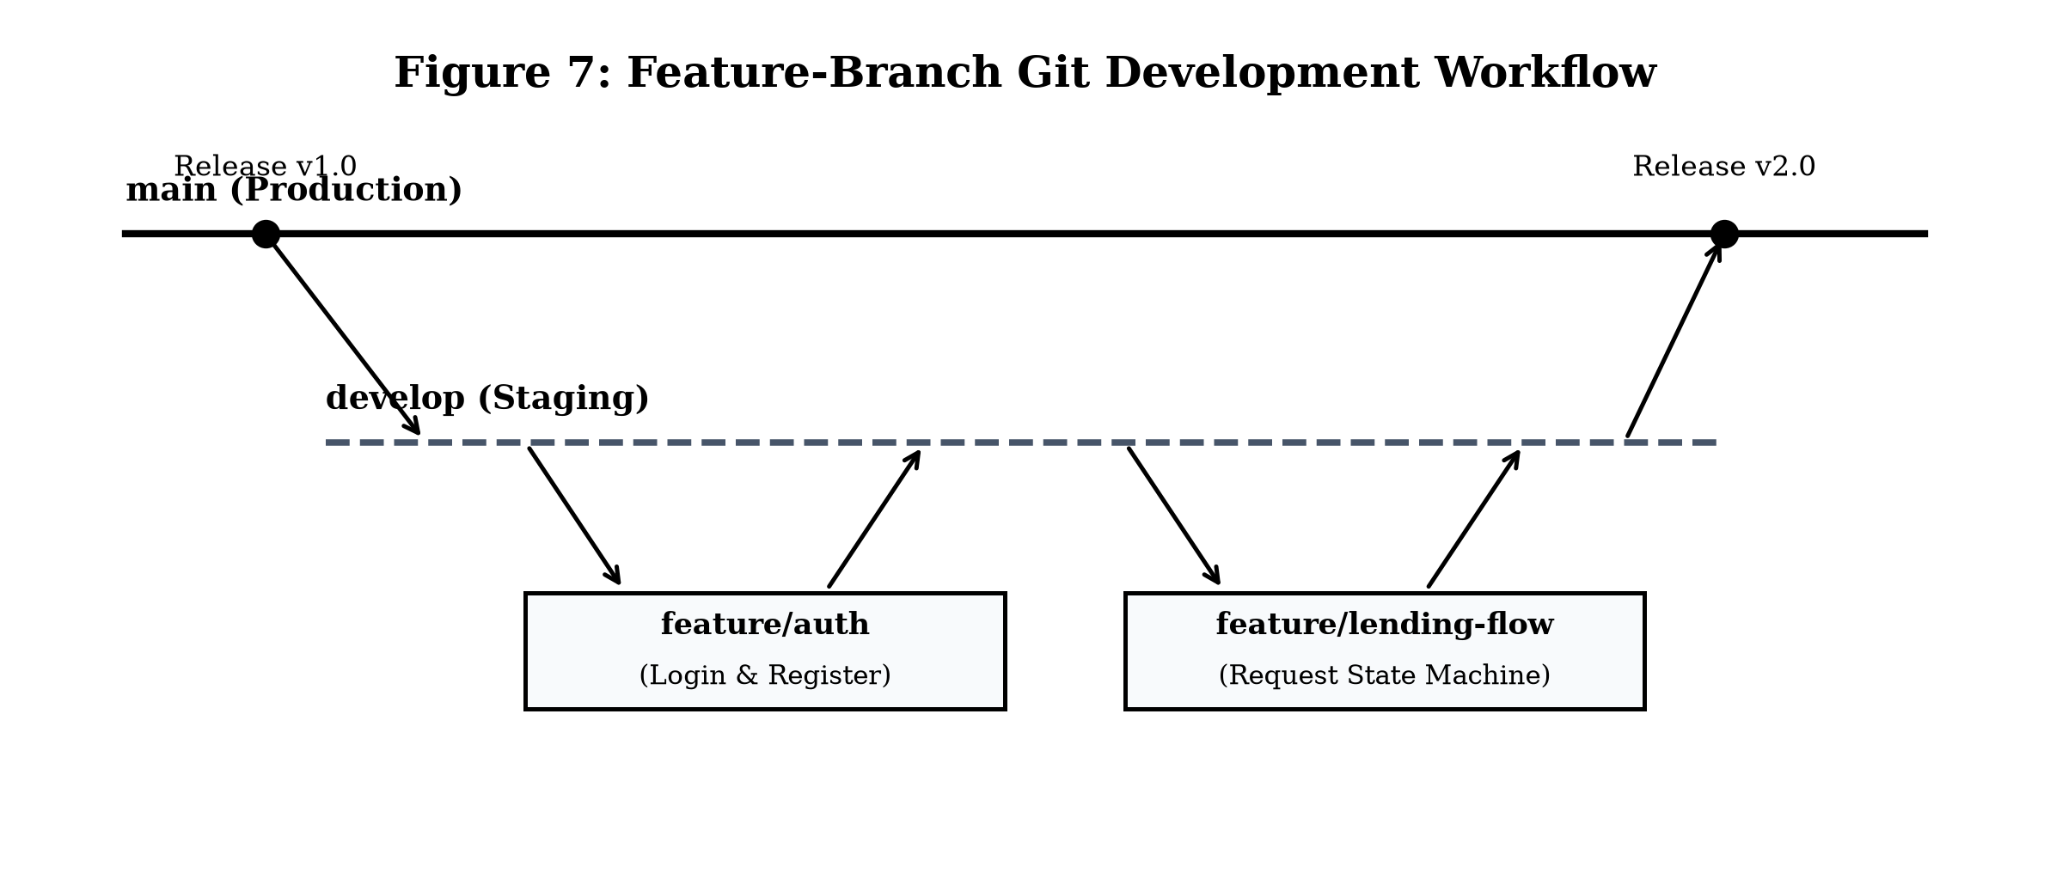
Figure 7: Feature-Branch Git Development Workflow
2. Software Reuse Across Three Architectural Levels
Software reuse accelerates development velocity, minimizes software defects, and guarantees security across three distinct levels:
- Library-Level Reuse: Werkzeug Security (`generate_password_hash`, `check_password_hash`) for PBKDF2:SHA256 password hashing; Werkzeug `secure_filename()` for path sanitization; PyMySQL for DB-API 2.0 communication; and python-dotenv for environment secret management.
- Framework-Level Reuse: Flask micro-framework routing engine, request context dispatching, secure session cookies, and Jinja2 server-side templating with automatic XSS escaping.
- Internal Module Reuse: Centralized `get_db_connection()` connection pool helper, `@login_required` middleware decorator, and master `base.html` template inheritance.
3. Architectural Design Patterns Applied
- Model-View-Controller (MVC): Model represents MySQL tables; View comprises Jinja2 HTML templates; Controller represents Flask route functions coordinating business logic and database interactions.
- Repository Pattern: Centralizes data query routines (`get_user_items`, `fetch_pending_requests`), decoupling business routing from low-level SQL execution.
- Singleton Pattern: Global connection configuration manages TiDB host credentials and SSL settings through a centralized lifecycle, preventing socket leaks.
4. Special Coding Techniques and Defensive Programming
- Parameterized SQL Queries: All database commands strictly use parameterized substitution (`cursor.execute(sql, (param,))`), treating user inputs purely as literal data and eliminating SQL injection.
- UUID Photo Handling: Uploaded photos are renamed using cryptographic UUID v4 (e.g., `3f8a9b12-4c21.jpg`), eliminating collisions and overwrites.
- Path Traversal Defense: Upload paths are sanitized using `secure_filename()` to keep assets restricted within `static/uploads/`.
- Orphan Asset Cleanup: Deleting an item listing automatically deletes the associated image file from disk storage, preventing storage bloat.
- State Machine Enforcement: Lending requests transition strictly through: `Pending` -> `Approved` or `Rejected` -> `Returned`, preventing invalid status changes.
5. Code Quality Enforcement and Special Tools
Coding standards and production stability were enforced using automated developer tooling:
- PEP 8 Compliance & Flake8: Backend Python code was verified against PEP 8 style standards using Flake8 to eliminate unused imports and syntax errors.
- Environment Secret Isolation: Sensitive database credentials and secret keys are stored in a local `.env` file and excluded from Git via `.gitignore`.
Special Tool | Category | Role in Implementation
Gunicorn WSGI Server | Application Server | Production HTTP server running worker processes on Render Cloud.
Visual Studio Code | IDE / Editor | Primary development environment with Python, Jinja2, and Git extensions.
Postman | Testing & QA | API testing platform used to construct, execute, and verify HTTP route handlers.
Jinja2 Template Engine | Frontend Templating | Server-side templating engine providing automated XSS escaping and layout reuse.

