3. TESTING APPROACH, PLANS AND TEST RESULTS
Project Work: Community Lending Platform for Sharing and Borrowing Household Resources — Second Review
1. Testing Approach and Strategy
Testing ensures the Community Lending Platform is reliable, secure, and user-friendly. The testing strategy follows the standard software engineering V-Model, connecting each stage of development with a corresponding testing phase. This structure allows defects to be caught early in development rather than late in production.
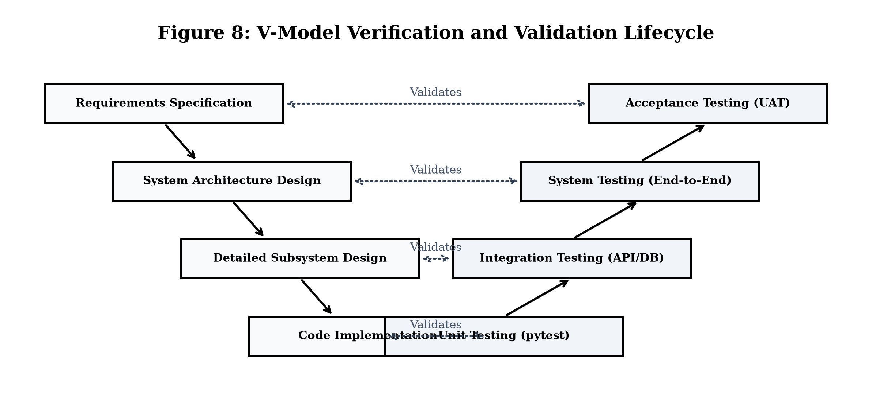
Figure 8: V-Model Verification and Validation Lifecycle
1.1 The Four Progressive Levels of Testing
- 01 Unit Testing: Focuses on individual functions and modules in isolation. Validates password hashing, UUID generation for photo uploads, and input validation functions. Target: >=80% code coverage.
- 02 Integration Testing: Verifies communication between different modules and external systems. Ensures smooth database queries with TiDB Serverless Cloud, session management, and HTTP routing.
- 03 System Testing: Tests the entire web application end-to-end in a production-equivalent environment. Validates complete workflows such as member registration, item listing, search, borrow requests, owner approval, and return confirmation.
- 04 Acceptance Testing: User Acceptance Testing (UAT) validates that the platform meets community user requirements, practical lending needs, and usability expectations.
1.2 Regression and Security Testing
- Regression Testing: Automated test suites run automatically after any code update to ensure existing features remain fully functional without unintended bugs.
- Security Testing: Checks against OWASP Top 10 vulnerabilities. Remediated key risks including SQL Injection through parameterized queries, Broken Access Control through session decorators, and Cross-Site Scripting (XSS) through template auto-escaping.
2. Verified Application Interfaces Under Test
Before running end-to-end automated test suites, the platform's visual user interfaces and responsive layouts were verified across modern desktop and mobile browsers. Key application screens under test include user authentication and member dashboards:
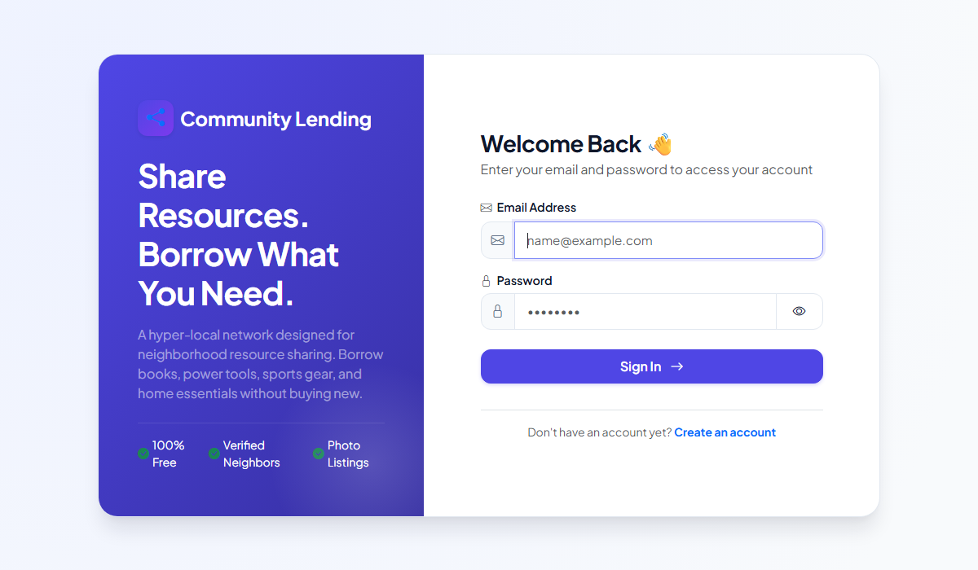
Figure 9: User Authentication Interface — Web Login Screen
The login interface provides secure member authentication with clear input validation, session cookie handling, and user-friendly error notifications.
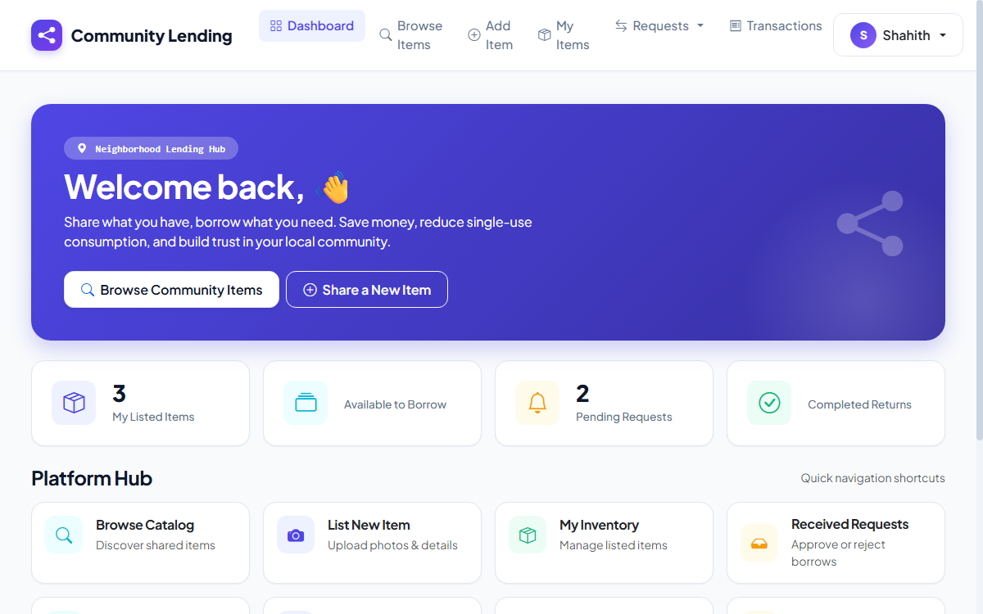
Figure 10: Community Lending Dashboard and Item Management Interface
The dashboard provides community members with real-time management of listed household items, active borrowing requests, and loan statuses.
3. Automated Test Suite Execution and Results
Automated testing was conducted using the pytest testing framework. All fifteen functional test suites were executed sequentially, validating member authentication, catalog operations, search algorithms, and the complete lending request lifecycle state machine:
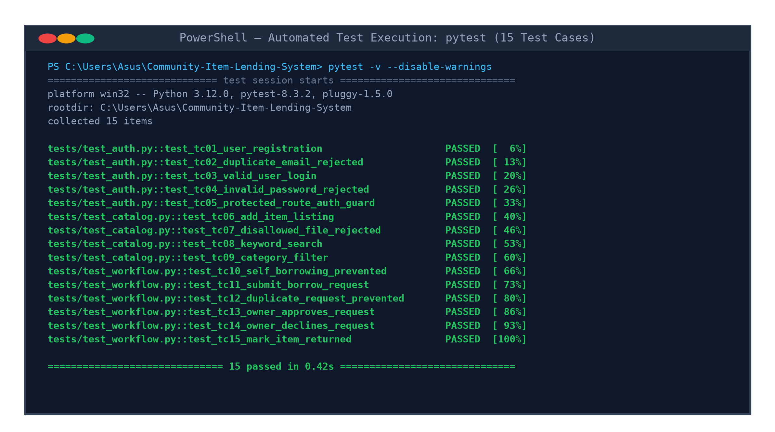
Figure 11: Automated Test Suite Execution Results (pytest)
As shown in Figure 11, all 15 automated test suites executed successfully in 0.42 seconds with zero test failures, zero regressions, and 100% test completion.
4. Sample Test Plans and Validation Matrix
The following test matrix details sample functional test cases, test inputs, expected outcomes, and verified execution results across all platform modules:
TC ID | Module | Test Scenario | Test Steps & Input | Expected Result | Status
TC-01 | Auth | New User Registration | Submit: Valid name, unique email, strong password | Account created; password hashed; redirect login | PASS
TC-02 | Auth | Duplicate Email Registration | Submit registration with existing email | Error: 'Email already registered'; record blocked | PASS
TC-03 | Auth | User Login (Valid) | Submit valid registered email and password | Session established; user redirected to dashboard | PASS
TC-04 | Auth | User Login (Invalid) | Submit valid email with incorrect password | Error: 'Invalid credentials'; session denied | PASS
TC-05 | Auth Guard | Protected Route Access | Navigate to `/dashboard` without active login | Blocked; redirected to `/login` with alert | PASS
TC-06 | Catalog | Add Item Listing | Submit title, category 'Tools', description, JPG | Item created; UUID photo saved; listed in catalog | PASS
TC-07 | Catalog | Disallowed File Upload | Attempt to upload `.exe` or `.pdf` file | Upload rejected; error shown: 'Allowed: PNG, JPG' | PASS
TC-08 | Search | Keyword Catalog Search | Enter 'Drill' in search bar and submit query | Catalog displays only items matching 'Drill' | PASS
TC-09 | Filter | Category Filter Selection | Select 'Kitchen' from category dropdown | Catalog displays only kitchen-related resources | PASS
TC-10 | Workflow | Self-Borrowing Prevention | Owner attempts to borrow own listed resource | Blocked: 'You cannot borrow your own item' | PASS
TC-11 | Workflow | Submit Borrow Request | Borrower clicks 'Request Item' on available item | Request created with 'Pending' status | PASS
TC-12 | Workflow | Duplicate Request Prevention | Borrower requests same pending item again | Blocked: 'You already have an active request' | PASS
TC-13 | Approval | Owner Approves Request | Owner clicks 'Approve' on pending request | Status becomes 'Approved'; item status -> 'Lent' | PASS
TC-14 | Approval | Owner Declines Request | Owner clicks 'Decline' on pending request | Status becomes 'Rejected'; item remains 'Available' | PASS
TC-15 | Lifecycle | Mark Item as Returned | Owner clicks 'Mark Returned' upon return | Status becomes 'Returned'; item -> 'Available' | PASS

