**Histogram Analysis:**

By analyzing the image histogram the cryptanalyst can get very useful information from the cipher image. In which, the good encryption algorithm should generate uniformly distribution of the histogram. In our tests, it’s very difficult to get any information from the histogram. The histogram analysis of three channels (red, green and blue) of lena image and its encrypted image is shown below in figure x.y

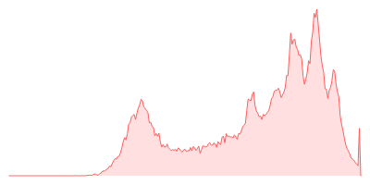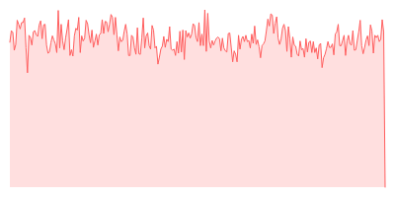

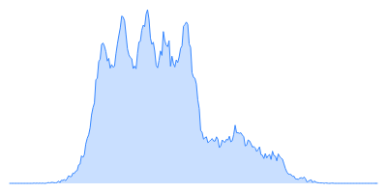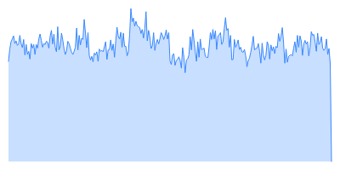

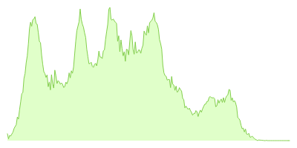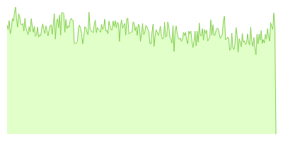

Hostograms are generated using: http://pinetools.com/image-histogram