Symbol | Name | Description
Oval / Rounded shape | External Entity | A person, organization, or system outside the project that sends or receives data (e.g., Customer, Payment Gateway).
Rectangle with numbered header | Process | An activity that transforms incoming data into outgoing data (e.g., Validate Request, Process Order).
Rectangle (solid fill, no number) | Data Store | A place where data is held for later use (e.g., Customer Database, Inventory).
Labeled arrow | Data Flow | The movement of data between entities, processes, and data stores, labeled with what data is
Project Design Phase-II Data Flow Diagram & User Stories
Date | 28-10- 2026
Team ID | EN25IT3010095
Project Name | EV Market Performance and Insights
Maximum Marks | 4 Marks
Data Flow Diagrams:
A Data Flow Diagram (DFD) is a traditional visual representation of the information flows within a system. A neat and clear DFD can depict the right amount of the system requirement graphically. It shows how data enters and leaves the system, what changes the information, and where data is stored.
DFD Symbol Legend

being passed.
DFD Level 0: EV Market Performance and Insights
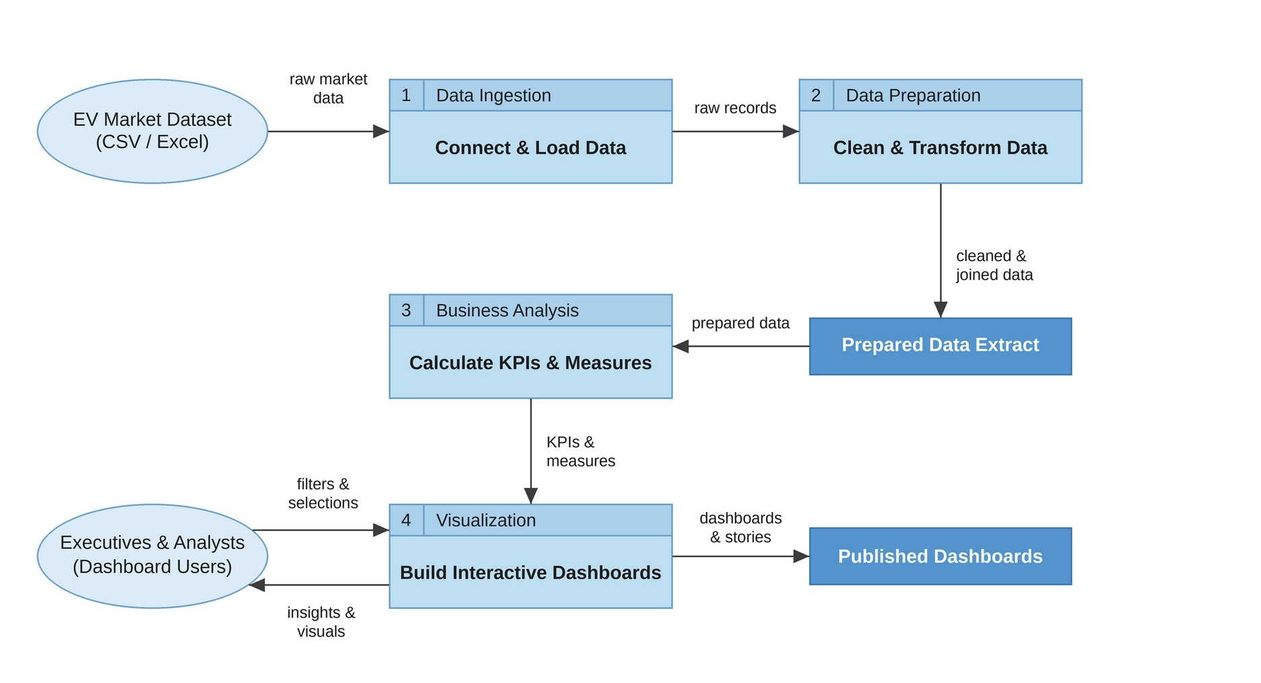
User Stories
Use the below template to list all the user stories for the product.
User Type | Functional  Requirement  (Epic) | User Story  Number | User Story / Task | Acceptance criteria | Priority | Release
Market Strategy Director | Market  Performance  Overview | USN-1 | As a market strategy director, I can view total EV sales, average vehicle price, average range and CO2 saved as KPI cards, so that I can assess overall market performance at a glance. | KPI cards on Dashboard 1 show correct values and respond to filters | High | Sprint-1
Market Strategy Director | Market  Performance  Overview | USN-2 | As a market strategy director, I can see annual sales units by vehicle category from 2017 to 2027, so that I can identify highgrowth segments. | Sales trend chart shows every vehicle category by model year | High | Sprint-1
Market Strategy Director | Customer Satisfaction | USN-3 | As a market strategy director, I can compare top manufacturers by customer review and sales units, so that I can judge manufacturer performance and customer satisfaction. | Chart compares manufacturers by customer review and annual sales units | Medium | Sprint-2
Business  Intelligence  Manager | Manufacturer Analysis | USN-4 | As a business intelligence manager, I can compare manufacturers by annual sales and  market share, so that I can identify competitive advantages. | Manufacturer matrix ranks manufacturers by annual sales units | High | Sprint-1
Business  Intelligence  Manager | Production Analysis | USN-5 | As a business intelligence manager, I can view production output by country and vehicle category, so that I can understand geographic production trends. | Stacked bar chart shows annual sales units by  country, split by vehicle category | High | Sprint-1

User Type | Functional  Requirement  (Epic) | User Story  Number | User Story / Task | Acceptance criteria | Priority | Release
Business  Intelligence  Manager | Battery  Technology  Analysis | USN-6 | As a business intelligence manager, I can see which battery technologies lead in annual sales, so that I can advise clients on product positioning. | Chart shows annual sales for LFP, NCA, NMC, Sodium-Ion and SolidState batteries | Medium | Sprint-2
Sustainable  Mobility  Research  Analyst | Battery & Range Analysis | USN-7 | As a research analyst, I can compare battery technologies by sales and average battery cycle life, so that I can evaluate technology trends. | Dual-axis chart shows sales bars with a cycle life line for each battery type | High | Sprint-2
Sustainable  Mobility  Research  Analyst | Battery & Range Analysis | USN-8 | As a research analyst, I can view the driving range distribution by vehicle category, so that I can assess range improvements. | Box plot shows the range (km) spread for every vehicle category | Medium | Sprint-2
Sustainable  Mobility  Research  Analyst | Charging  Performance | USN-9 | As a research analyst, I can compare maximum DC charging power with energy efficiency, so that I can study charging performance across categories. | Scatter plot shows charging kW against Wh per km with average reference lines | Medium | Sprint-3
Sustainable  Mobility  Research  Analyst | Environmental Impact | USN-10 | As a research analyst, I can see CO2 saved per year by market region and drivetrain, so that I can support sustainability and policy recommendations. | Regional chart shows CO2 saved (tons per year) for  AWD, FWD and RWD in every region | High | Sprint-2
Dashboard  User (All Roles) | Interaction & Filtering | USN-11 | As a dashboard user, I can filter and highlight by vehicle category using the shared legend, so that I can focus on one segment across all charts. | Selecting a category  updates every chart on the dashboard | Medium | Sprint-3
Dashboard Administrator | Data  Management | USN-12 | As a dashboard administrator, I can connect and refresh the EV dataset, so that dashboards always show current data. | Refreshing the data source updates all worksheets without errors | High | Sprint-1

