Ideation Phase Define the Problem Statements
Date | 28 -10-2026
Team ID | EN25IT3010095
Project Name | EV Market Performance and Insights
Maximum Marks | 2 Marks
Customer Problem Statement Template:
Create a problem statement to understand your customer's point of view. The Customer Problem Statement template helps you focus on what matters to create experiences people will love.



A well-articulated customer problem statement allows you and your team to find the ideal solution for the challenges your customers face. Throughout the process, you’ll also be able to empathize with your customers, which helps you better understand how they perceive your product or service.
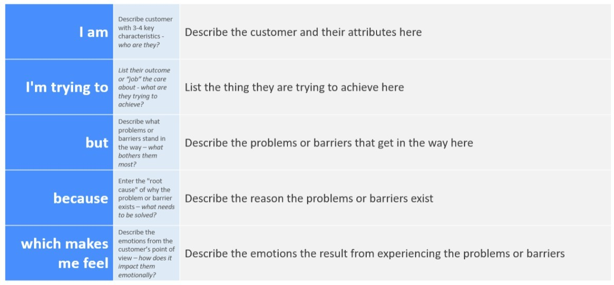
Reference: https://miro.com/templates/customer-problem-statement/ Example:
Problem Stateme  nt (PS) | I am  (Customer) | I’m trying to | But | Because | Which makes me feel
PS-1 | Emily Johnson,  Market Strategy Director at a global EV manufacturer | understand which vehicle categories drive annual sales, who the leading manufacturers are, and how satisfied customers are in each segment | sales, price, range and review data are scattered, so I cannot see category trends and high-growth segments in one place | there is no interactive executive dashboard that consolidates market performance, manufacturer results and customer preferences | overwhelmed and uncertain when making portfolio and investment decisions
PS-2 | David Chen,  Business  Intelligence  Manager at an automotive consulting firm | benchmark EV manufacturers on market share, sales, ratings and battery technology to advise clients  entering the EV market | I cannot quickly compare manufacturers, see where production is concentrated or tell which battery  technologies dominate | manufacturer, country and  battery data sit in large unconnected datasets, and manual comparison is  slow and errorprone | frustrated and worried that my recommendations rest on incomplete evidence
PS-3 | Dr. Sarah  Williams,  Sustainable  Mobility  Research Analyst | compare battery technologies, track driving-range  improvements and global manufacturing distribution, and link them to adoption and CO2  savings | I cannot see how battery type, range, charging performance and customer  satisfaction relate to each other and to environmental impact | technical, regional and sustainability metrics are not presented together in a  comparable, visual form | concerned and held back, because policy advice needs clear evidence I cannot easily produce

