Business Question and Visualization Report
Date | 28 October 2026
Team ID | EN25IT3010095
Project Name | EV Market Performance and Insights
Maximum Marks | 5 Marks

Visualization development refers to the process of creating graphical representations of data to facilitate understanding, analysis, and decision-making. The goal is to transform complex datasets into visual formats that are easy to interpret, enabling users to gain insights and make informed decisions. Visualization development involves selecting appropriate visual elements, designing layouts, and using interactive features to enhance the user experience. This process is commonly associated with data visualization tools and platforms, and it plays a crucial role in business intelligence, analytics, and reporting Business Questions and Visualisation
The process involves defining specific business questions to guide the creation of meaningful and actionable visualizations in Tableau. Well-framed questions help in identifying key metrics, selecting relevant data, and building visualisation that provide insights.
1. Which countries and vehicle categories lead EV production and annual sales?
o Visualization: Stacked bar chart of annual sales units by country and vehicle category.

o Screenshot of visualisation
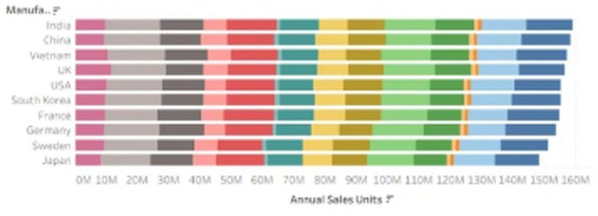
- Which manufacturers perform best on customer reviews and sales units?
  - Visualization: Packed bubble chart of manufacturers by customer review and sales units. o Screenshot of visualisation
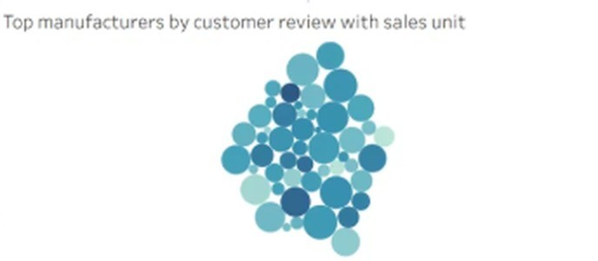
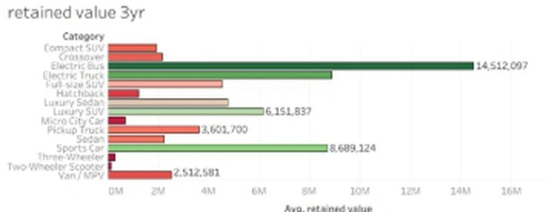
- How does driving range vary across vehicle categories?
  - Visualization: Box plot of driving range (km) by vehicle category.

o Screenshot of visualisation
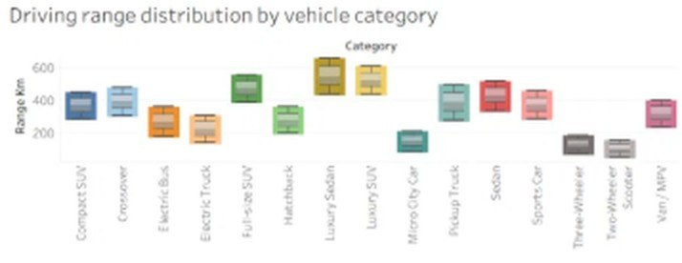
4. Which vehicle categories retain the most value after 3 years?
o Visualization: Bar chart of average retained value by vehicle category.

o Screenshot of visualisation
- How have annual sales trended over the years for each category? o Visualization: Multi-line chart of annual sales units by model year. o Screenshot of visualisation
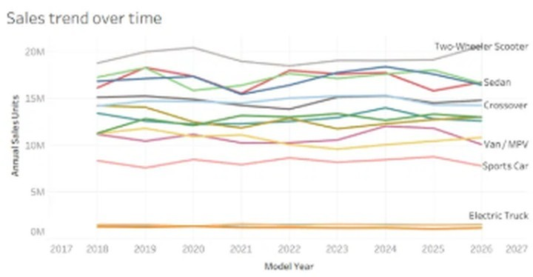
- Which battery technologies dominate sales, and how do they compare on cycle life?
o Visualization: Dual-axis bar and line chart of sales units and average cycle life by battery type.

o Screenshot of visualisation
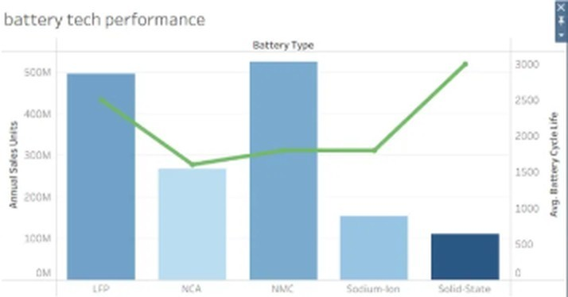
7. How do charging speed and energy efficiency relate across vehicles?
o Visualization: Bubble (scatter) chart of max DC charging kW vs efficiency Wh per km.

o Screenshot of visualisation
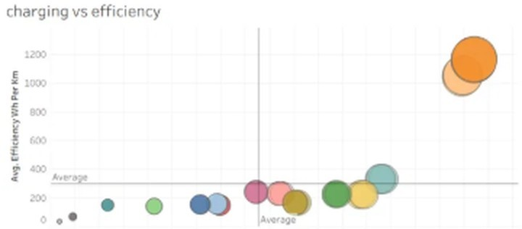
8. How much CO2 is saved across regions and drivetrains?
o Visualization: Regional stacked area chart of CO2 saved (tons per year) by drivetrain.

o Screenshot of visualisation


