Dashboard Design
Date | 28-10-2026
Team ID | EN25IT3010095
Project Name | EV Market Performance and Insights
Maximum Marks | 5 Marks
Creating an effective dashboard involves thoughtful design to ensure that the presented information is clear, relevant, and easily understandable for the intended audience.
Here are some key principles and best practices for dashboard design

Activity 1: Interactive and visually appealing dashboards

Creating interactive and visually appealing dashboards involves a combination of thoughtful design, effective use of visual elements, and the incorporation of interactive features. Here are some tips to help you design dashboards that are both visually appealing and engaging for users so take care of below points
- Clear and Intuitive Layout
- Use Appropriate Visualizations
- Colour and Theming
- Interactive Filters and Slicers
- Drill-Down Capabilities
- Responsive Design
- Custom Visuals and Icons
- Use of Infographics
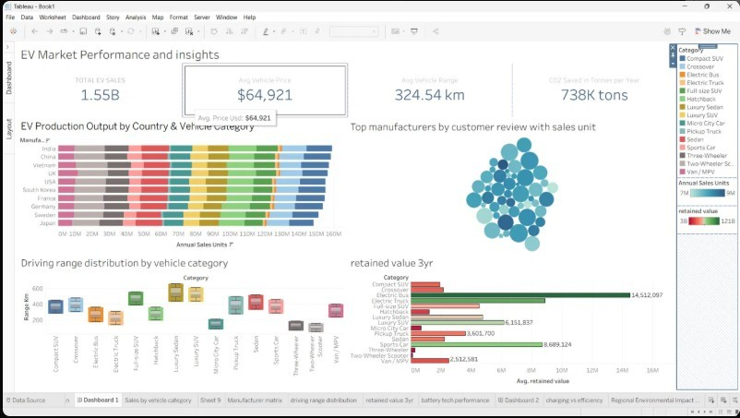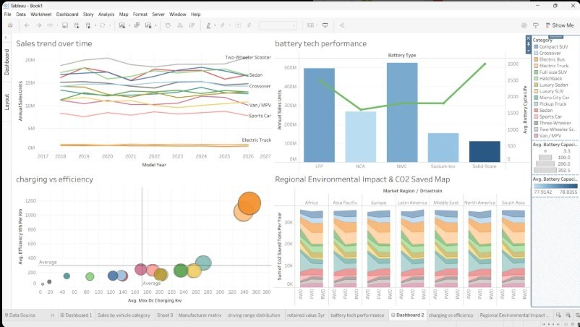
Major outcomes from the EV Market Performance and Insights dashboards:
- KPI Overview: Total EV sales are 1.55B units, with an average vehicle price of $64,921, an average range of 324.54 km and 738K tons of CO2 saved per year.
- Production Leaders: India, China and Vietnam lead annual production output, with the production mix spread across all vehicle categories.
- Retained Value: Electric Bus holds the highest 3-year retained value (14.5M), followed by Electric Truck, Sports Car (8.69M) and Luxury SUV (6.15M).
- Driving Range: Luxury Sedans and Luxury SUVs offer the longest range (about 550-600 km), while micro city cars and two/three-wheelers offer the shortest.
- Battery and Charging: NMC and LFP dominate battery sales; faster-charging vehicles (up to about 350 kW) consume more energy per km, and CO2 savings are spread across all regions.

Activity 2
Publish Dashboard on Tableau Public and Paste the Dashboard Public link below:
https://public.tableau.com/views/
HarshalParetadataanalyticswithtableauSmartbridge/
Dashboard1?:language=en-
US&:sid=&:redirect=auth&:display_count=n&:origin=viz_share_link

